# EXPERIMENT – 9

**Aim: Creating Multiple EC2 Instances with for each in Terraform.**

1. Create a Terraform Configuration File (main.tf)
2. Create new file name as “instance.tf”

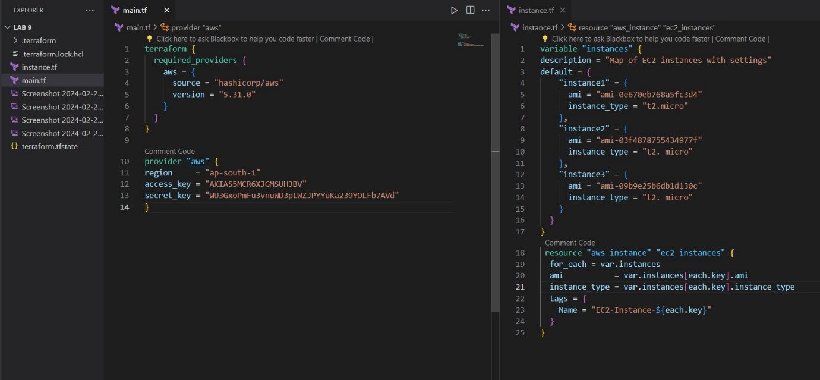

1. Initialize Terraform using command “terraform init”

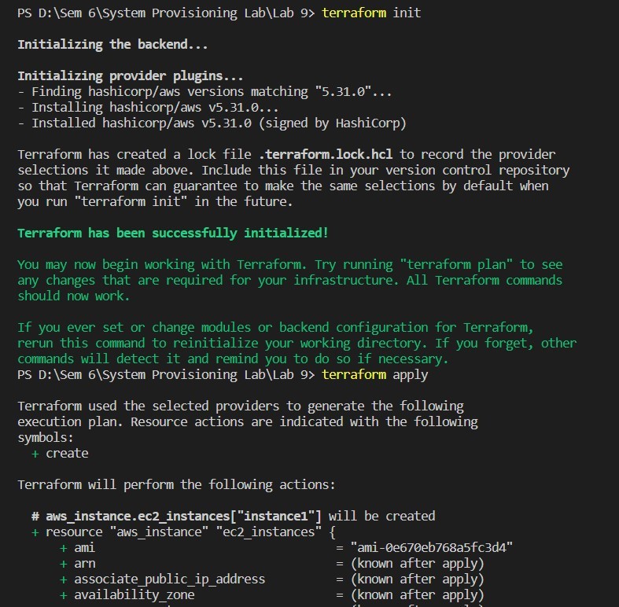

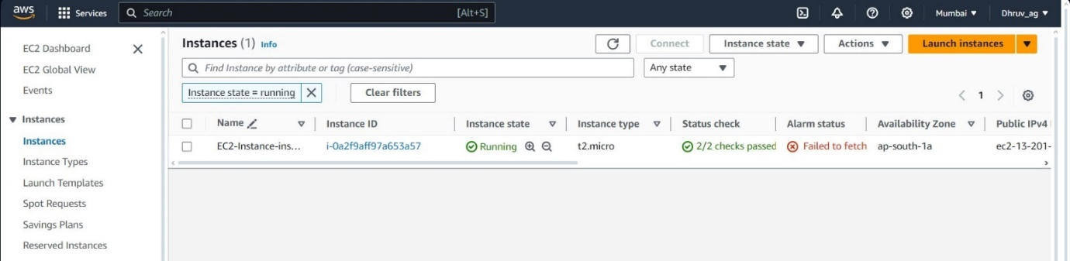

1. Check the Plan using command “terraform plan”

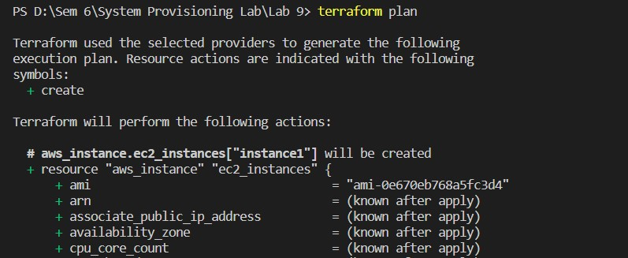

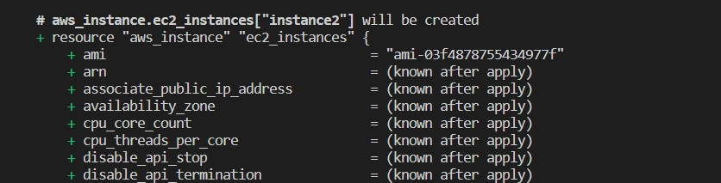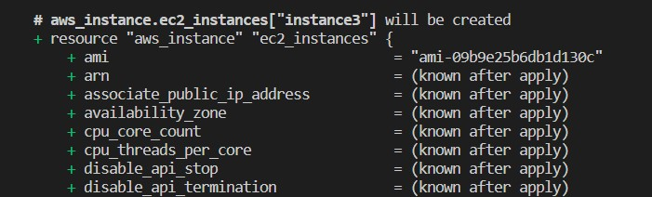

# EXPERIMENT – 10

**Aim: Creating an AWS RDS Instance in Terraform.**

1. Create a Terraform Configuration File (main.tf)



1. Create a Terraform RDS File (rds.tf)



1. Initialize Terraform using command “terraform init”



1. Check the Plan using command “terraform plan”

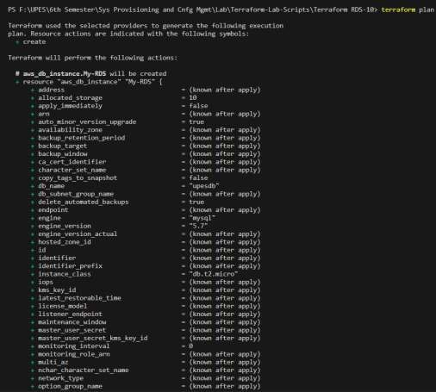

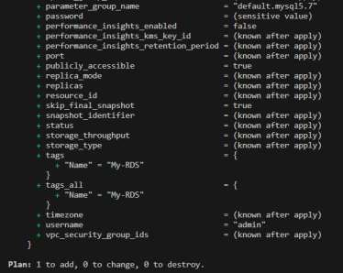

1. Apply it using command “Terraform apply -auto-approve”

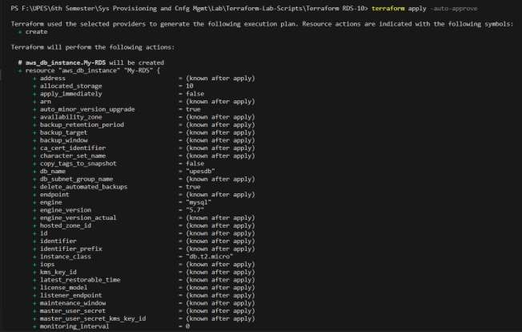

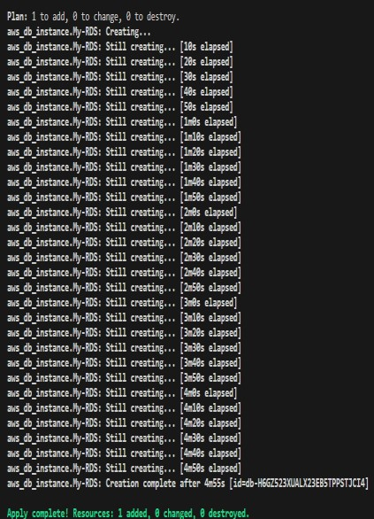

1. Verify Resources on AWS Management Console.

1. Connect with MySQL Workbench with proper Configuration and save it.

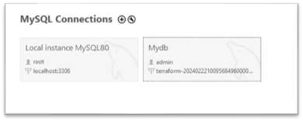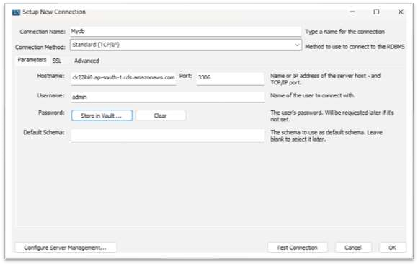

1. Cleanup Resources using command “Terraform destroy”

