**School of Computer Science**

**UNIVERSITY OF PETROLEUM AND ENERGY STUDIES DEHRADUN, UTTARAKHAND**



System Provisioning And Configuration Management

Lab File (2022-2023)

for  
6th Semester

**SUBMITTED TO SUBMITTED BY**

DR. HITESH KUMAR SHARMA Priyanshi Tyagi

B.TECH CSE – 6th SEM

DEVOPS - BATCH 1

500091994

**Lab Exercise 11– Configure Ansible Setup in Linux**

**Steps**

1. **Create two Amazon Linux t2.micro instance - Ansible Server & Node**

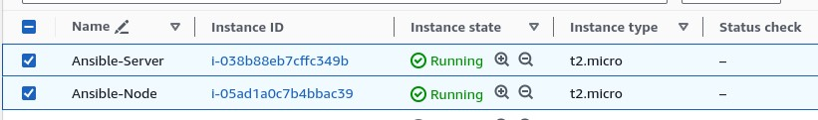

1. **Install ansible on Ansible Server**

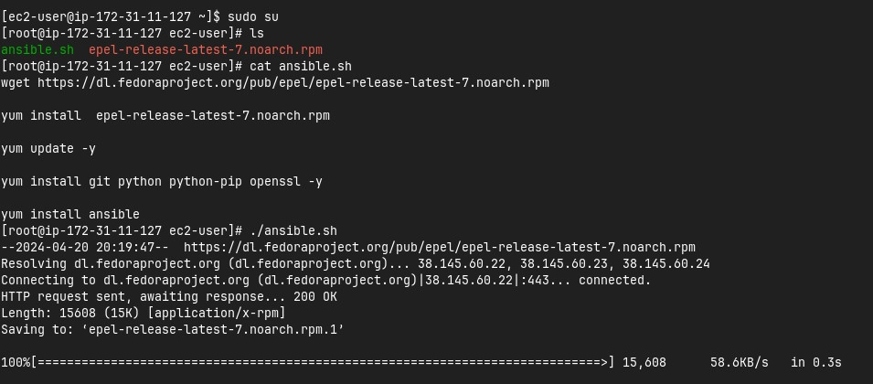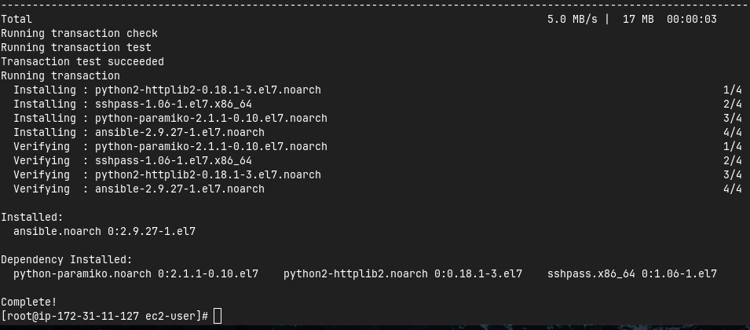

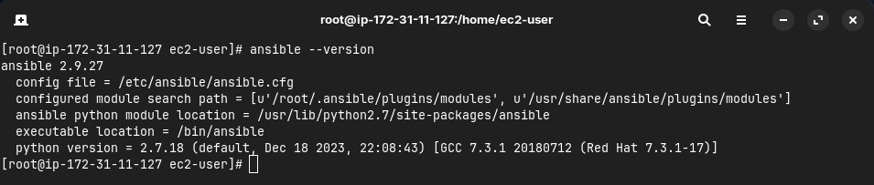

1. **Add Private IP of node to the Ansible server’s inventory file**

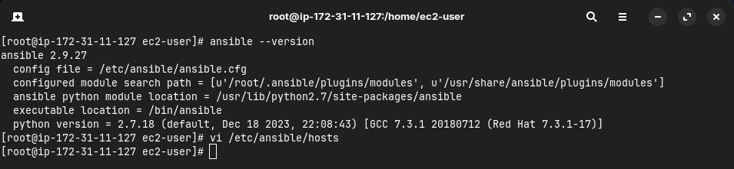

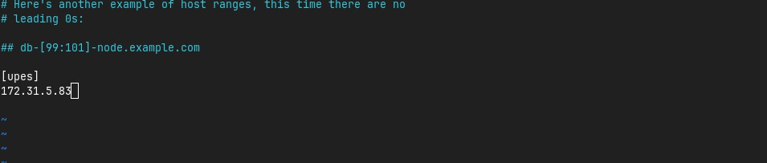

1. **Create super user in both the machines**

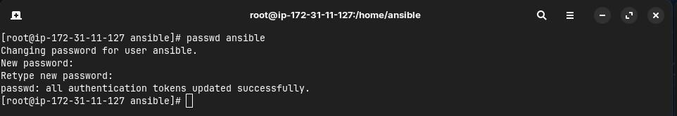

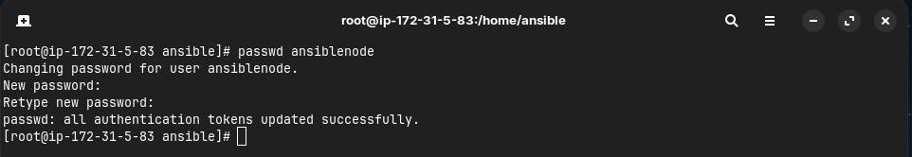

1. **Give sudo user permissions to both users**

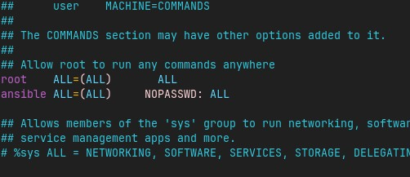

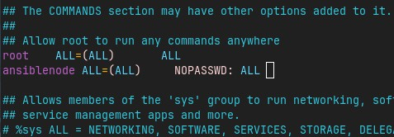

1. **Edit the sshd_config file in the node server**

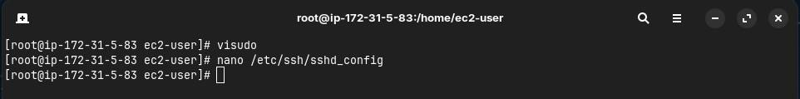

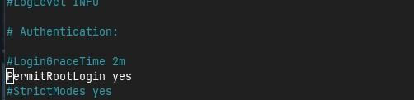

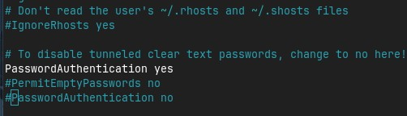

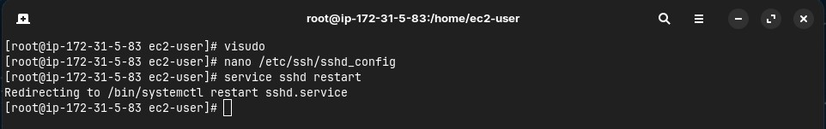

1. **Generate key pair in Ansible server and copy the key to node server**

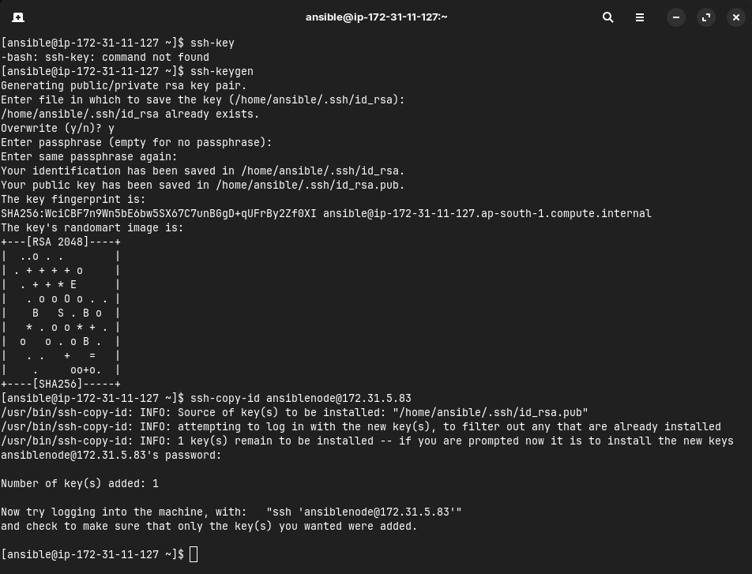

1. **Connect to node server from ansible server**

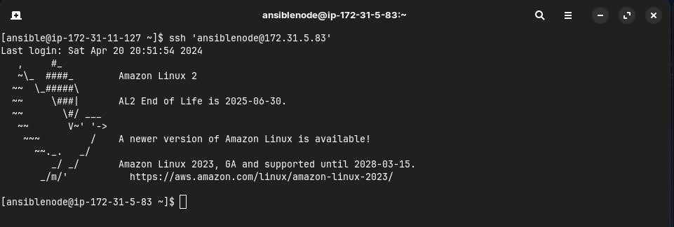

**Lab Exercise 12– Create Run Ansible Playbooks**

**Steps**

1. **Repeat the steps in Experiment 11 to create the initial setup**
2. **Test adhoc commands**

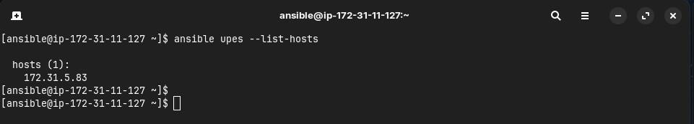

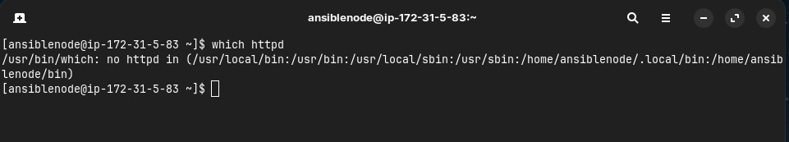

1. **Install Apache server on node server using adhoc command**

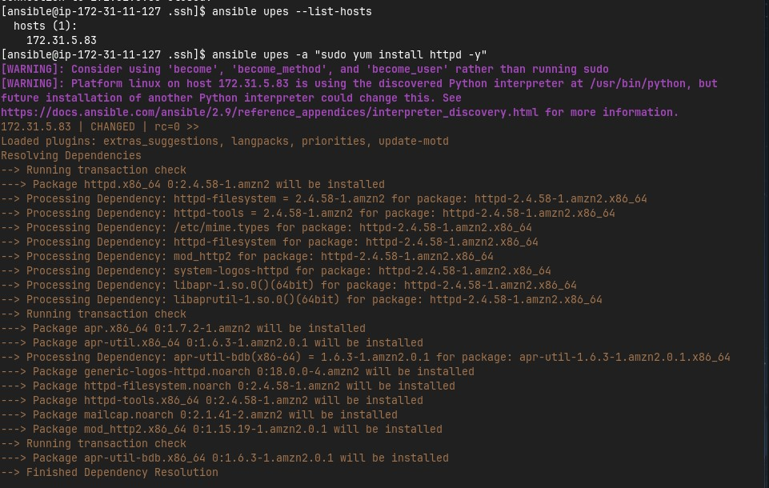

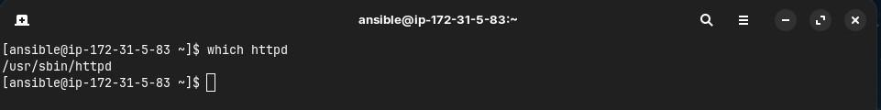

1. **Start the httpd service using ansible**

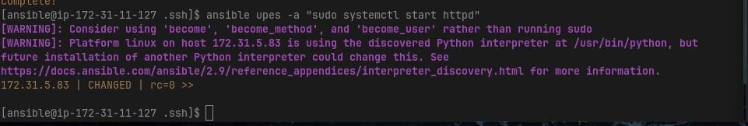

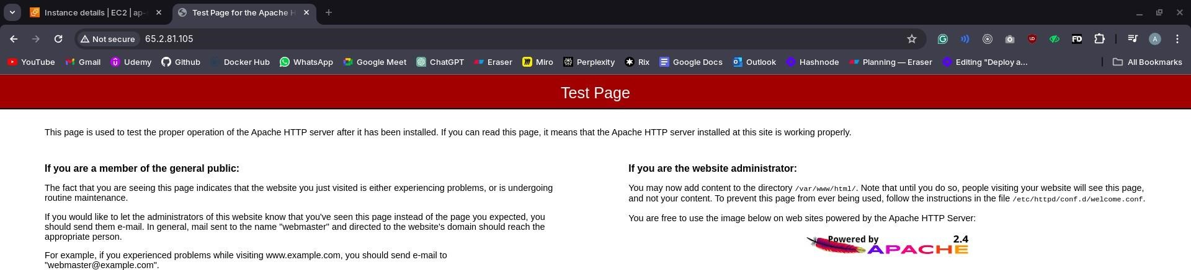

1. **Remove ansbile and then reinstall using ansible playbook**

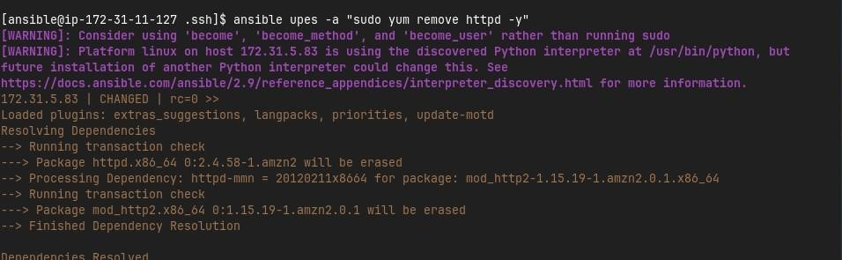

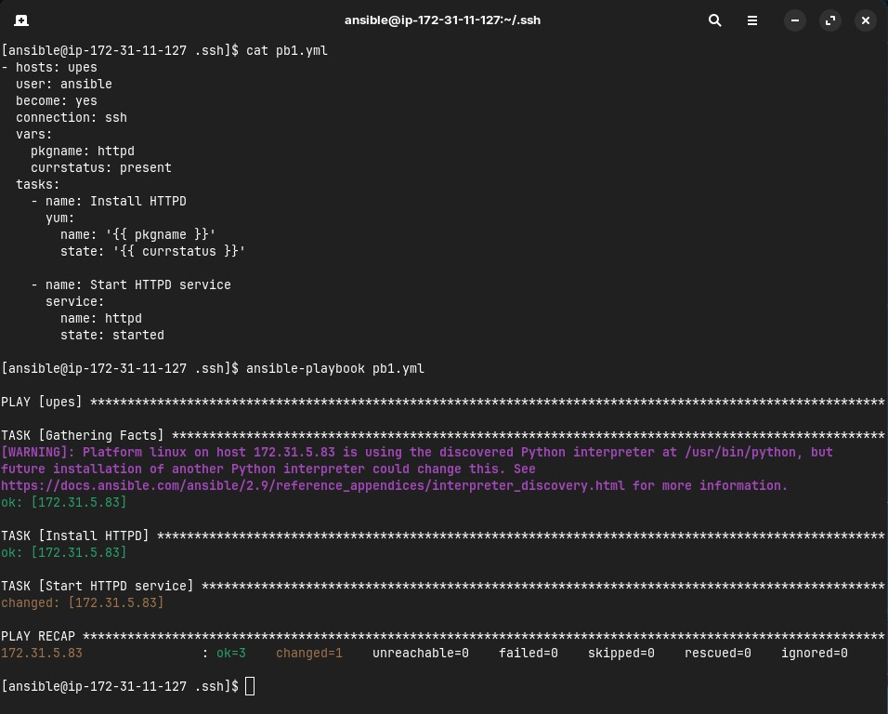



1. **Testing other playbooks**

