**School of Computer Science**

**UNIVERSITY OF PETROLEUM AND ENERGY STUDIES DEHRADUN, UTTARAKHAND**



**System Provisioning and Configuration**

# Management

**Lab File(2024) for 6th Semester**

Submitted To:  Submitted By:

Dr. Hitesh Kumar Sharma Rohanshu Garwal

B. Tech. CSE DevOps B2

Sap ID – 500093945

R2142210655

**LAB EXERCISE 11 Aim-** Configure Ansible Setup In Linux

**Steps**

1. Create two Amazon Linux t2.micro instance - Ansible Server & Node

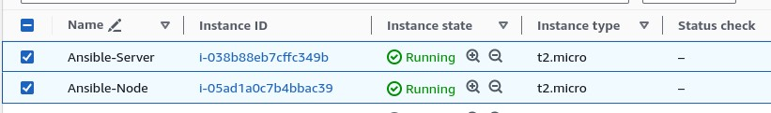

1. Install ansible on Ansible Server

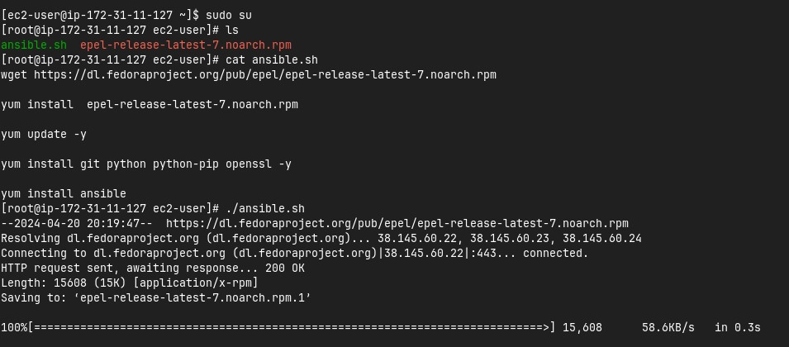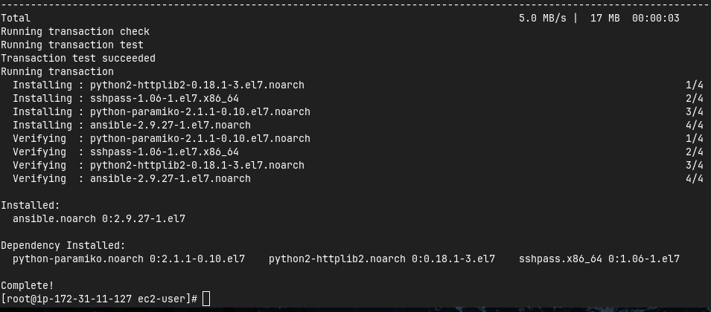

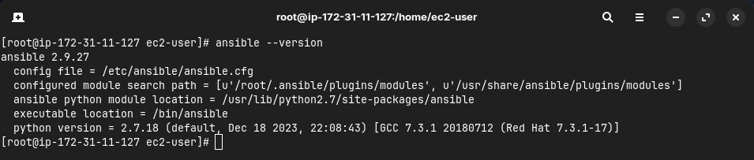

1. Add Private IP of node to the Ansible server’s inventory file

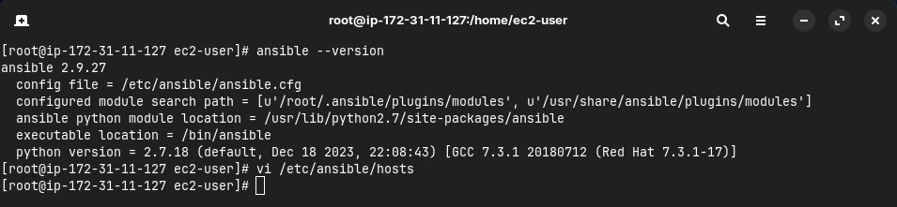

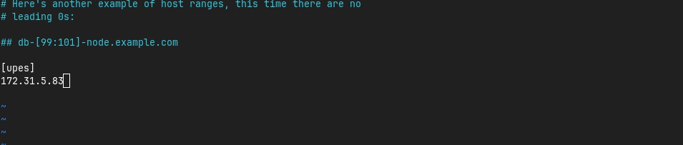

1. Create super user in both the machines

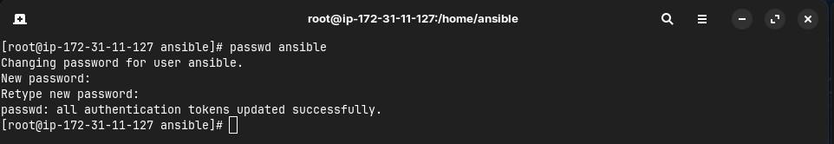

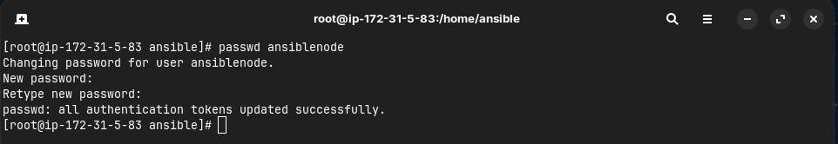

1. Give sudo user permissions to both users

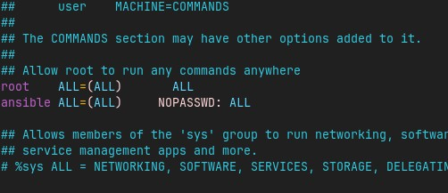

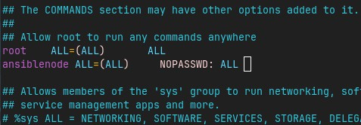

1. Edit the sshd_config file in the node server

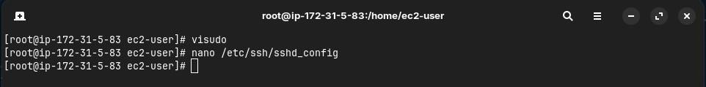

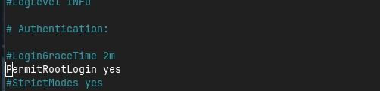

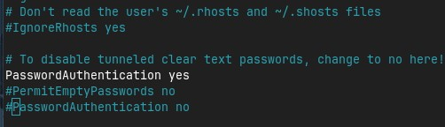

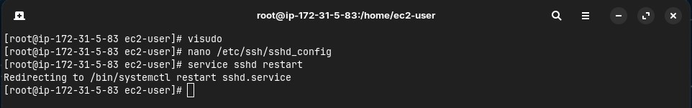

1. Generate key pair in Ansible server and copy the key to node server

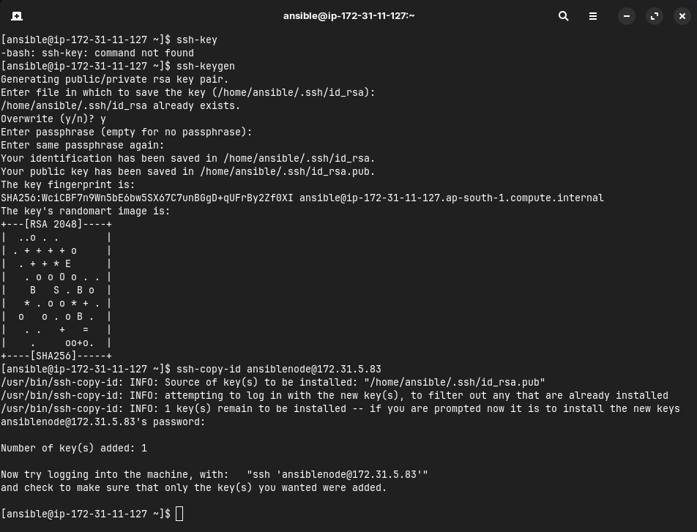

1. Connect to node server from ansible server

