**School of Computer Science**

**UNIVERSITY OF PETROLEUM AND ENERGY STUDIES DEHRADUN, UTTARAKHAND**



**System Provisioning and Configuration**

**Management**

**Lab File (2024) for 6th Semester**

Submitted To:  Submitted By:

Dr. Hitesh Kumar Sharma Rohanshu Garwal

B. Tech. CSE DevOps B2

Sap id- 500093945

Batch 2

R2142210655

**LAB EXERCISE 12**

**Aim-**Create Run Ansible Playbooks

**Steps**

1. Repeat the steps in Experiment 11 to create the initial setup
2. Test adhoc commands

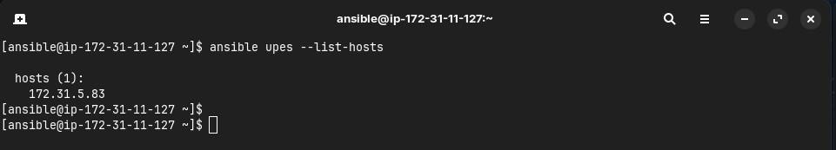

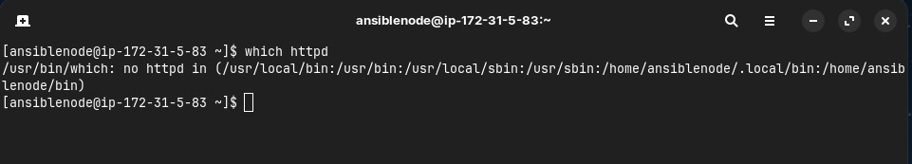

1. Install Apache server on node server using adhoc command

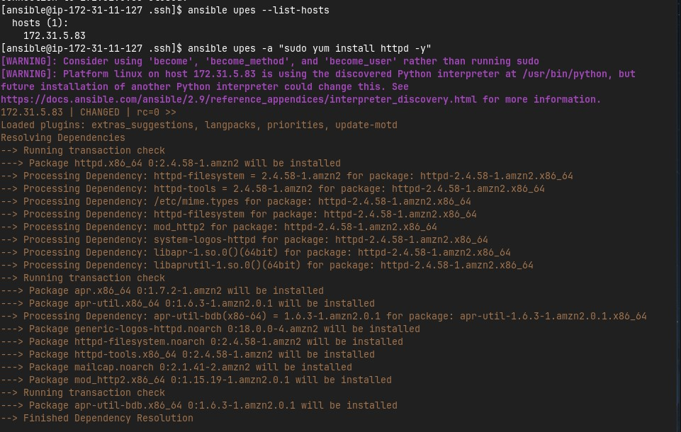

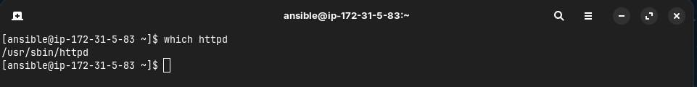

1. Start the httpd service using ansible

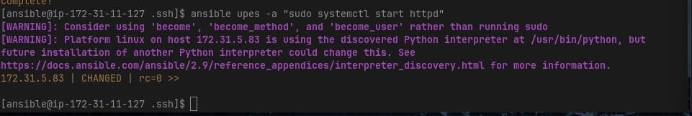

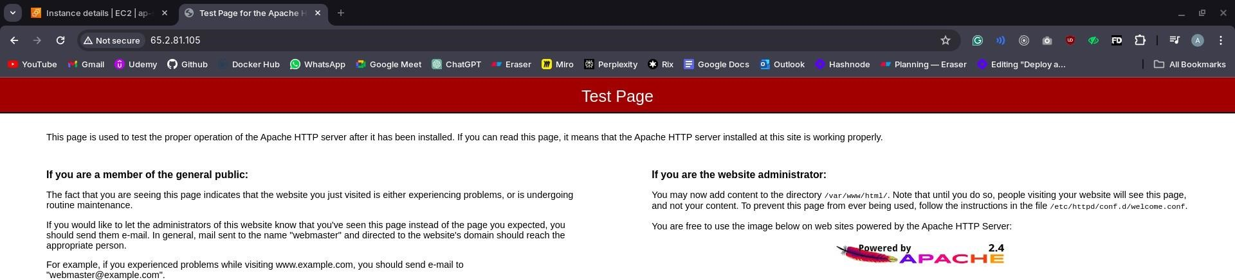

1. Remove ansbile and then reinstall using ansible playbook

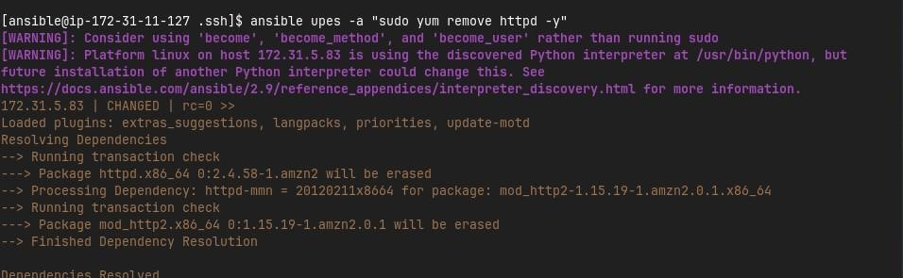

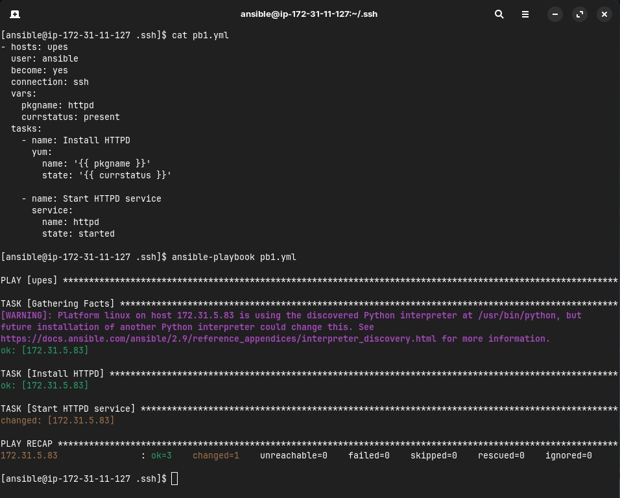



1. Testing other playbooks

