# School of Computer Science

## UNIVERSITY OF PETROLEUM AND ENERGY STUDIES DEHRADUN, UTTARAKHAND

System Provisioning and Configuration Management

# Lab File (2024)

**for**

# 6th Semester

### Submitted To:

Dr. Hitesh Kumar Sharma

### Submitted By:

Sahil Goyal

B. Tech. CSE DevOps

[6h Semester]

Sap id- 500093973

Batch 2

R2142210674

LAB EXERCISE 11

Aim- Configure Ansible Setup In Linux

## Steps

1. Create two Amazon Linux t2.micro instance - Ansible Server & Node

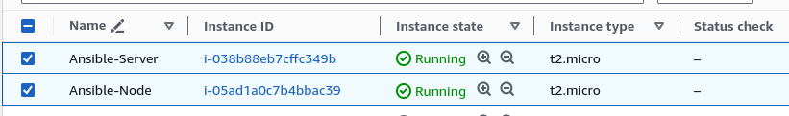

1. Install ansible on Ansible Server

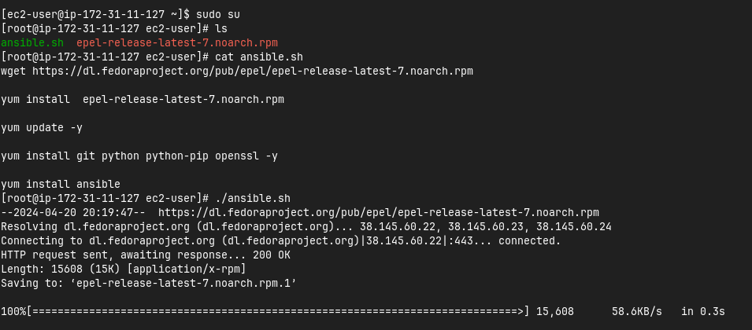

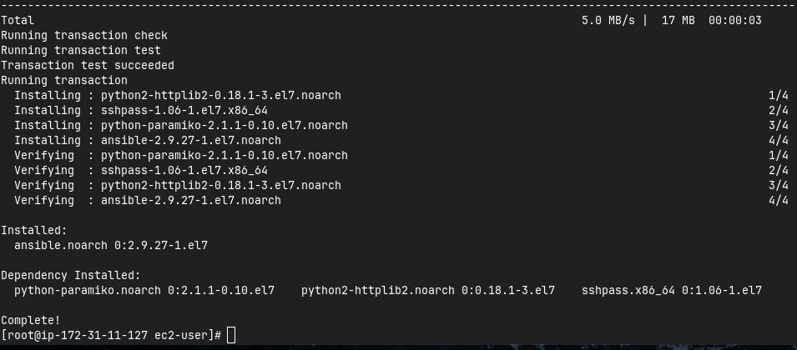

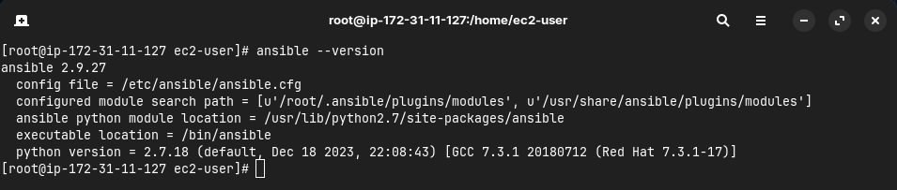

1. Add Private IP of node to the Ansible server’s inventory file

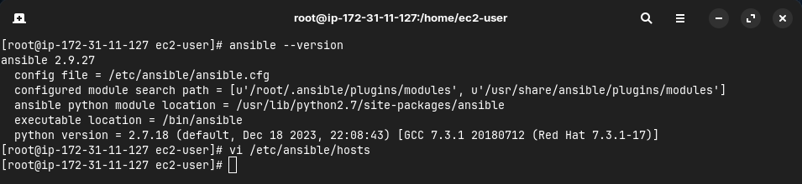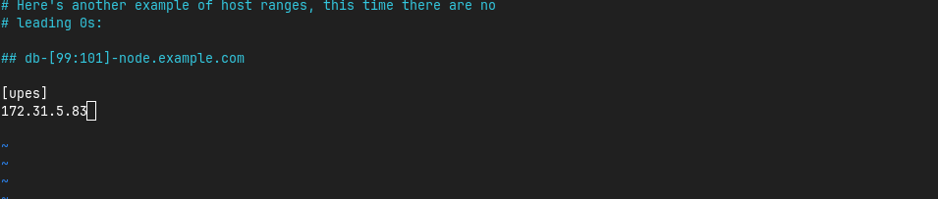

1. Create super user in both the machines

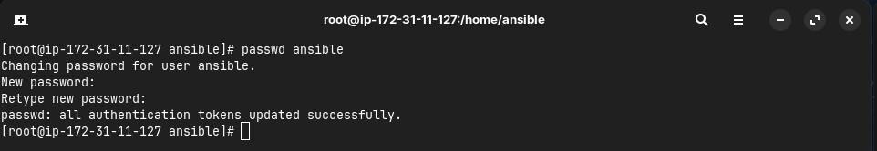

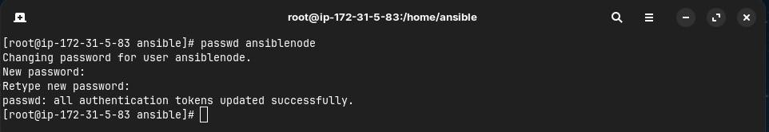

1. Give sudo user permissions to both users

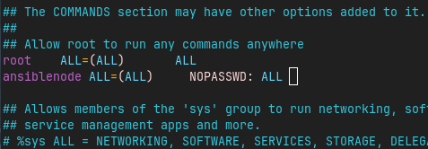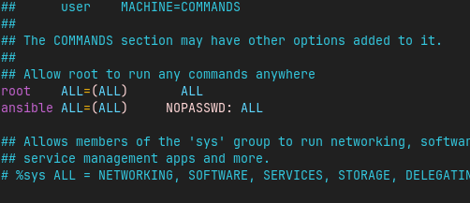

1. Edit the sshd_config file in the node server

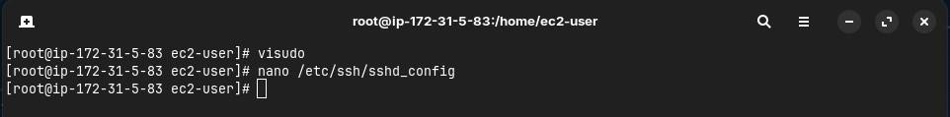

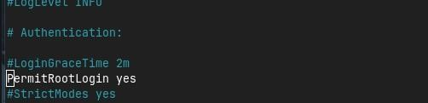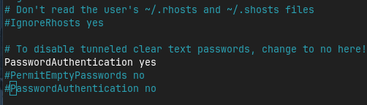

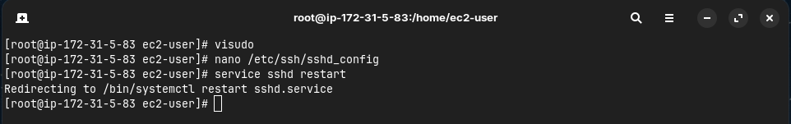

1. Generate key pair in Ansible server and copy the key to node server

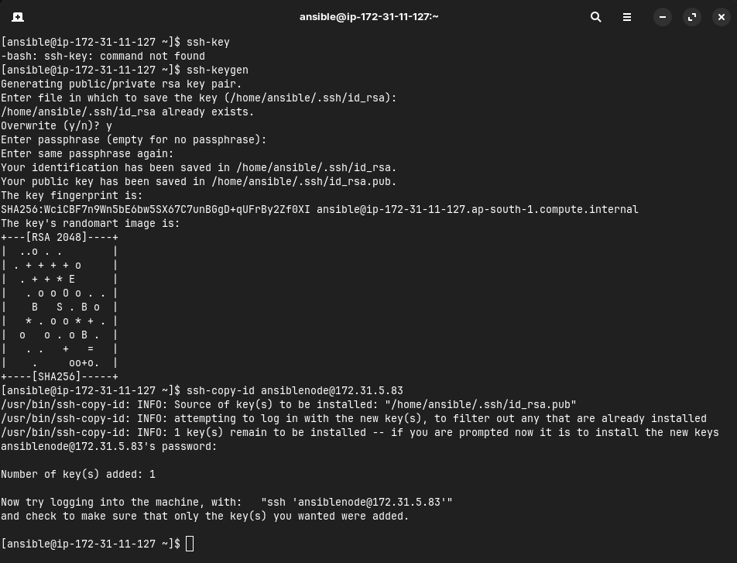

1. Connect to node server from ansible server

