**School of Computer Science**

**UNIVERSITY OF PETROLEUM AND ENERGY STUDIES DEHRADUN, UTTARAKHAND**



System Provisioning and Configuration Management

**Lab File (2024)**

**for**

**6th Semester**

# Submitted To:

Dr. Hitesh Kumar Sharma

# Submitted By:

Siddhanth Verma

B. Tech. CSE DevOps

[6h Semester]

Sap id- 500094460

Batch 2

R2142210766

LAB EXERCISE 12

Aim-Create Run Ansible Playbooks

Steps

1. Repeat the steps in Experiment 11 to create the initial setup
2. Test adhoc commands

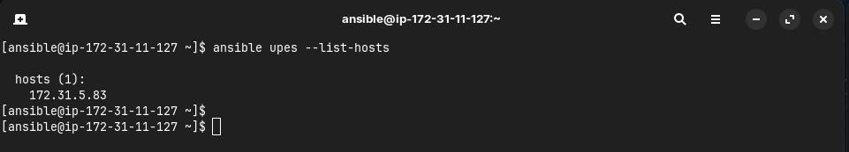

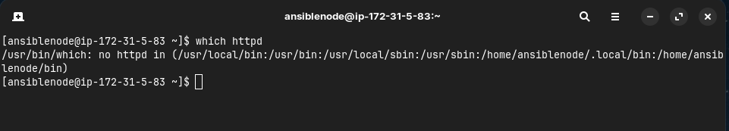

1. Install Apache server on node server using adhoc command

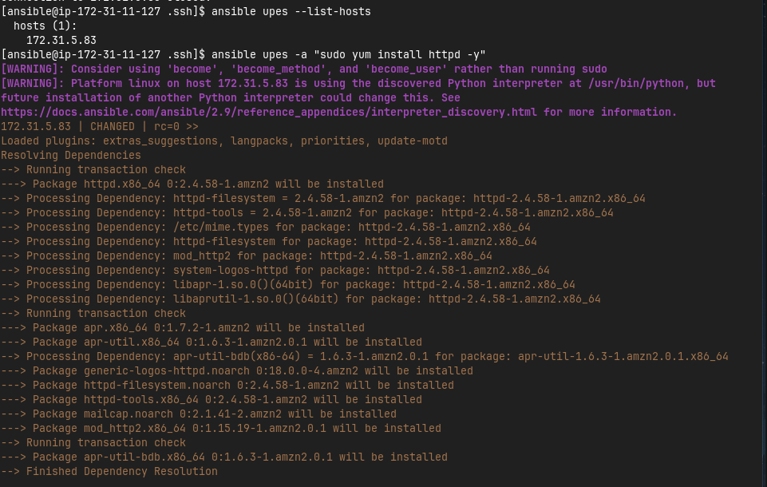

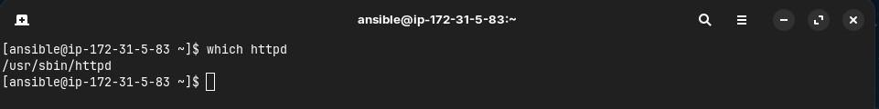

1. Start the httpd service using ansible

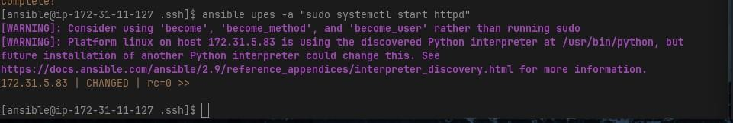

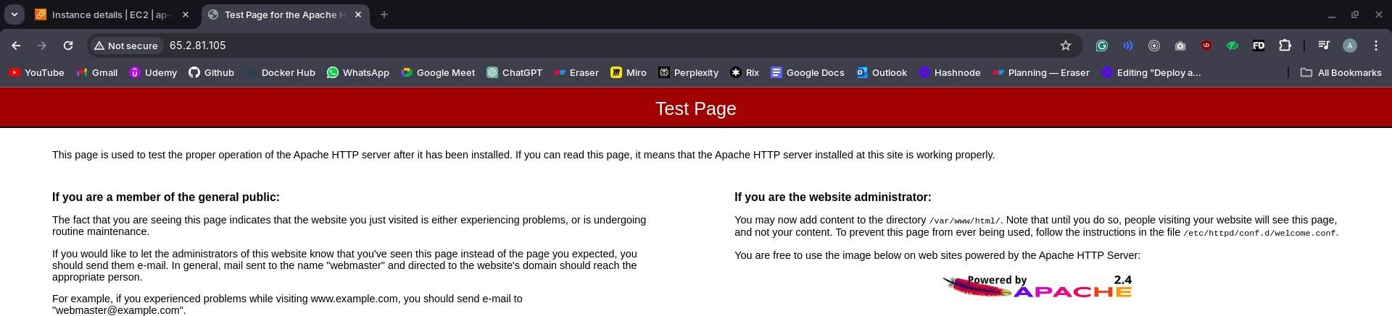

1. Remove ansbile and then reinstall using ansible playbook

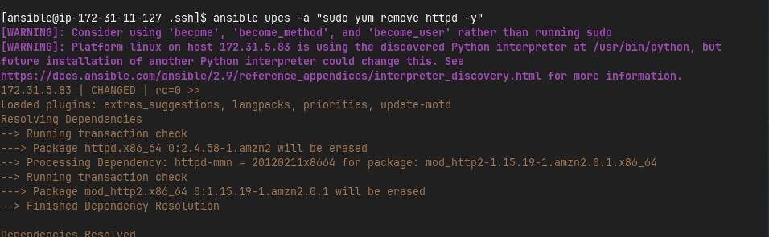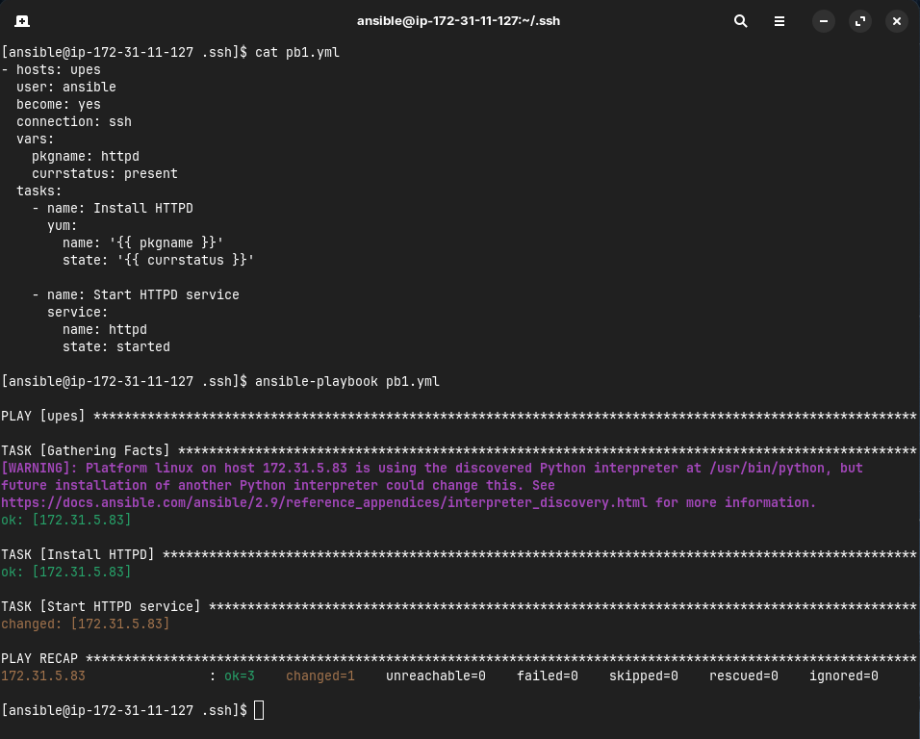

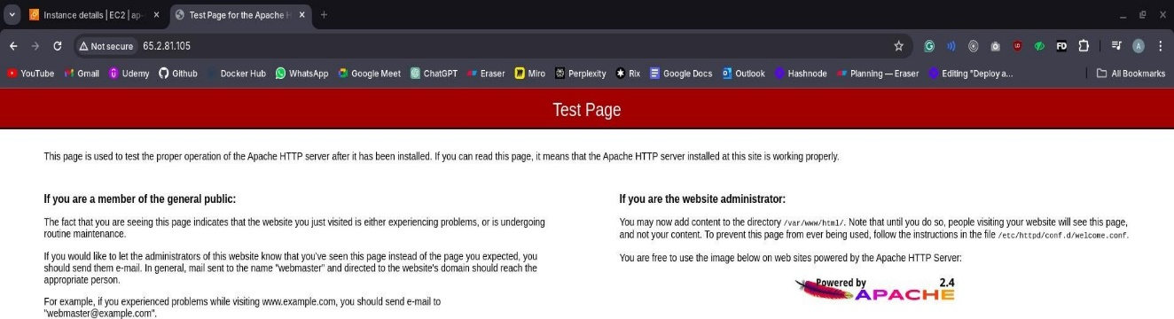

1. Testing other playbooks

