Submitted by – Toshit Gaba Batch – B2 DevOps

Roll no – R2142210814 Sap id - 500094568

Submitted To: Dr. Hitesh Kumar Sharma sir

**Experiment 12 – Create and Run Ansible Playbooks:**

Steps

1. Repeat the steps in Experiment 11 to create the initial setup 2. Test adhoc commands

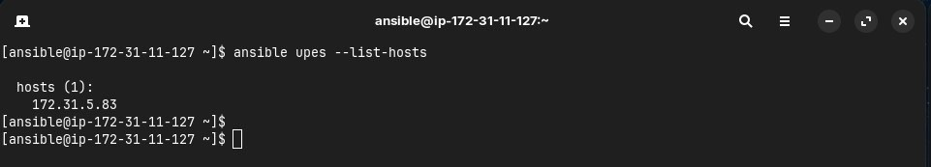

1. Install Apache server on node server using adhoc command

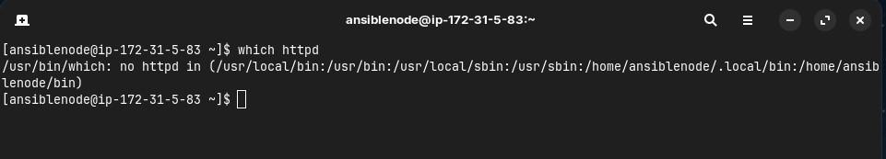

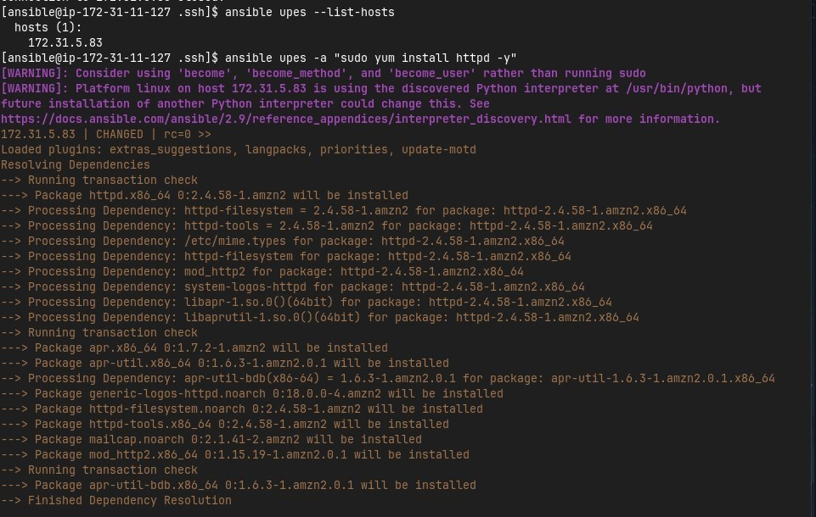

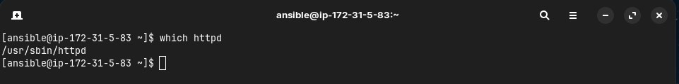

1. Start the httpd service using ansible

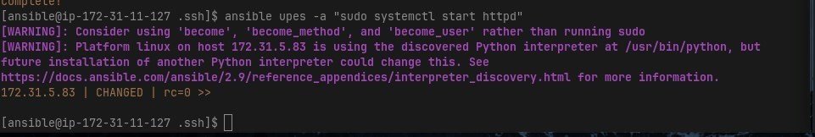

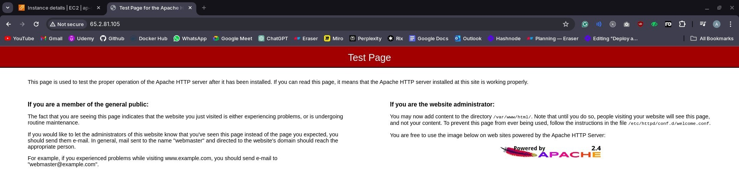

1. Remove ansbile and then reinstall using ansible playbook

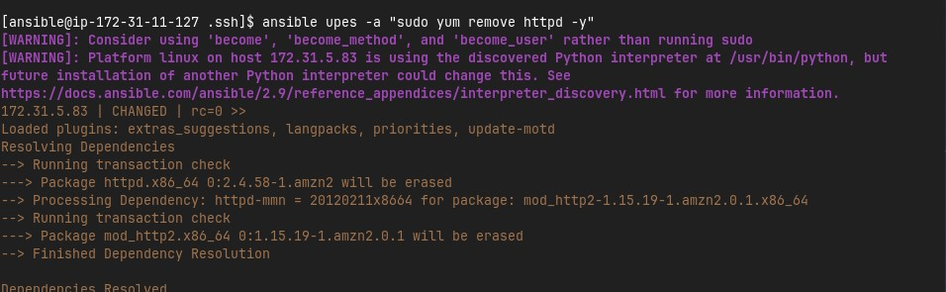

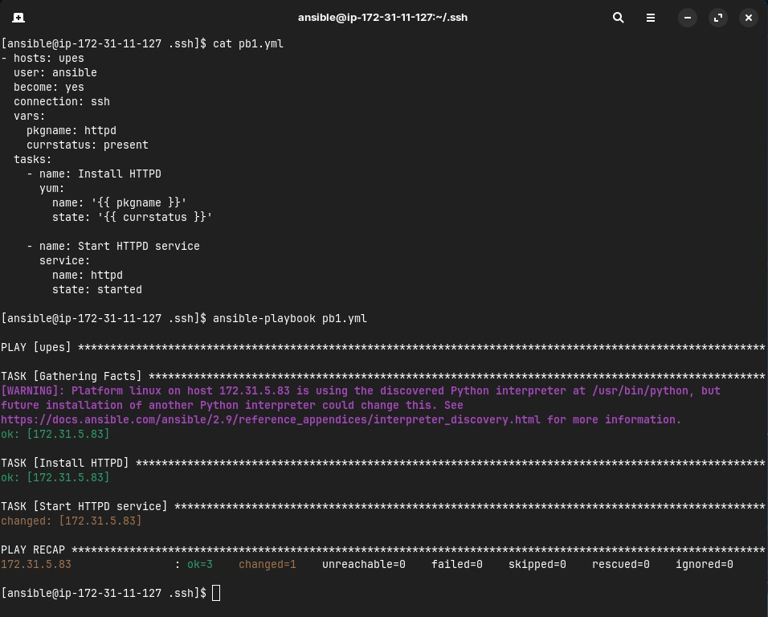



1. Testing other playbooks

