LAB-6

Terraform Multiple tfvars Files

**Step 1:** Create dev.tfvars and prod.tfvars

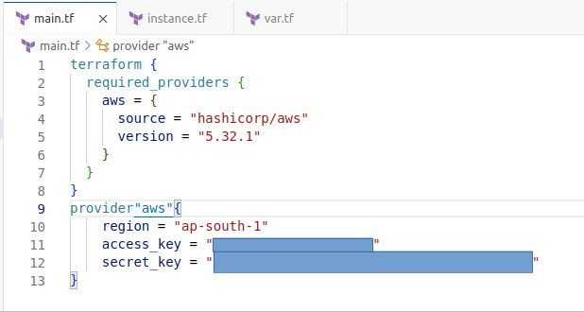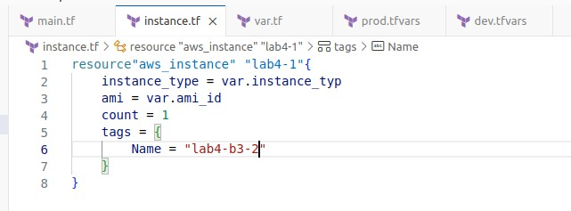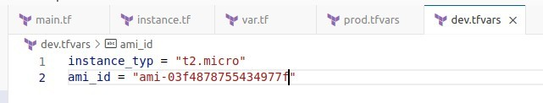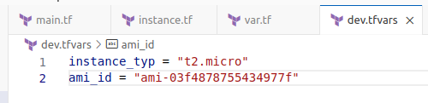

**Step 2:** Now run terraform cycle

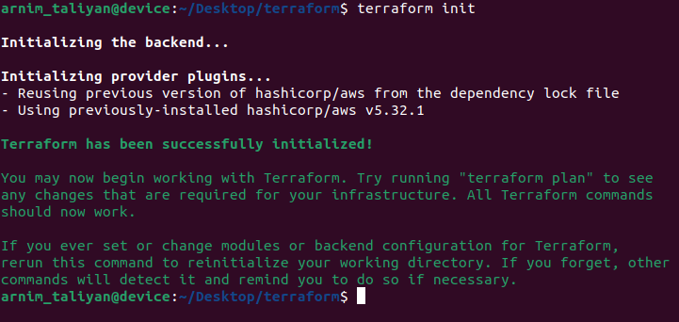

**Step 3:** To run terraform plan we need to use -var-file=dev.tfvars or -var- file=prod.tfvars

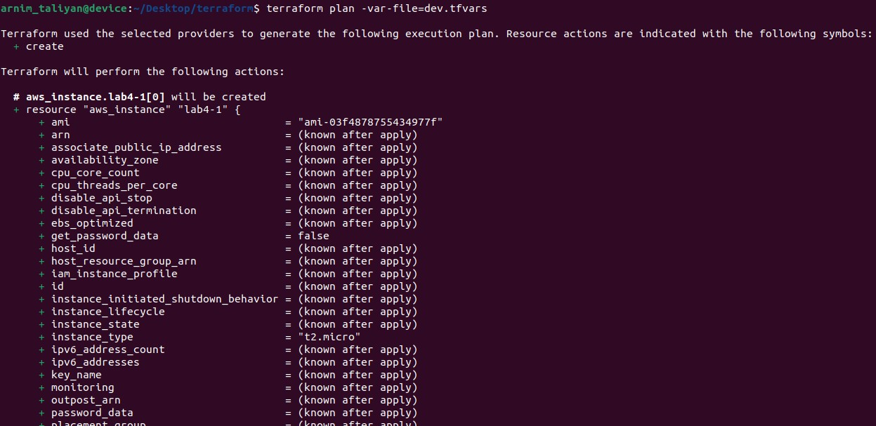

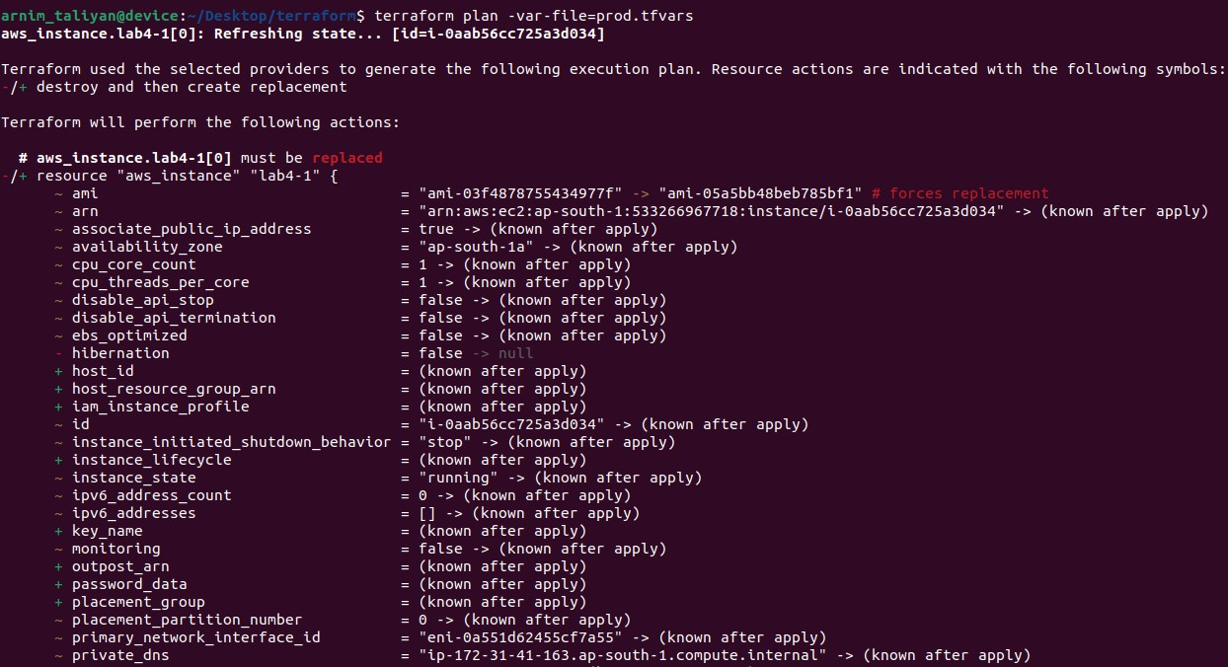

**Step 4:** To run terraform apply and destroy we need to use -var- file=dev.tfvars or -var-file=prod.tfvars

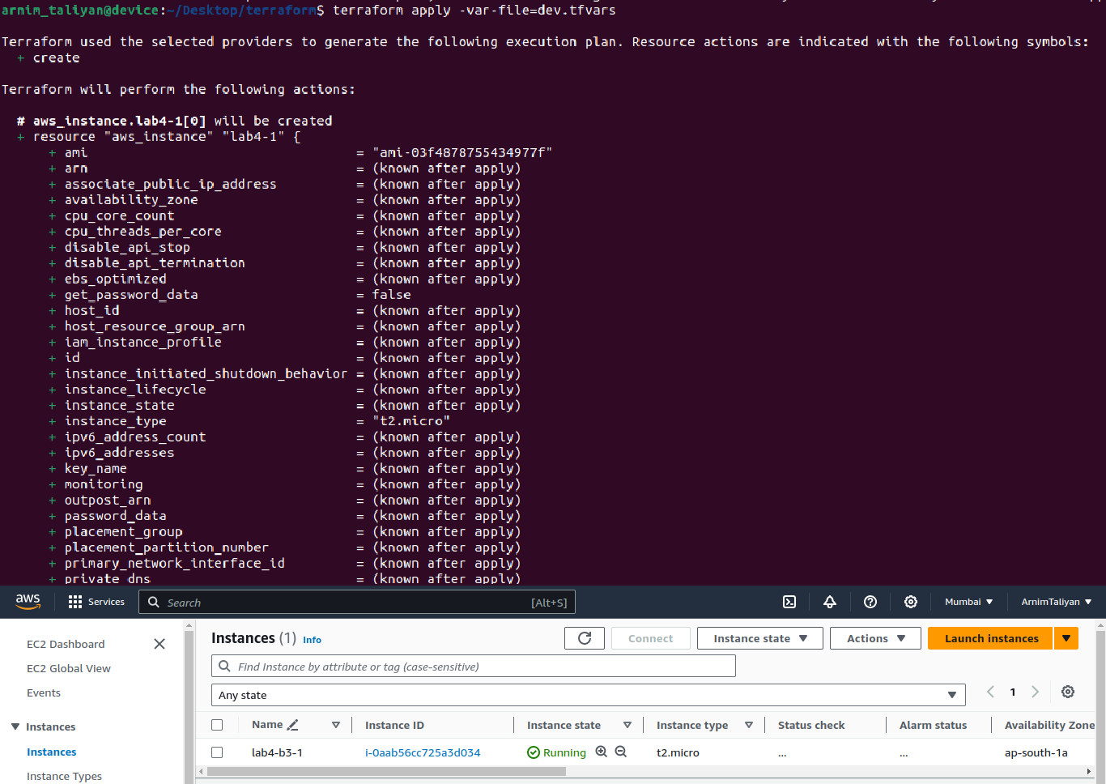

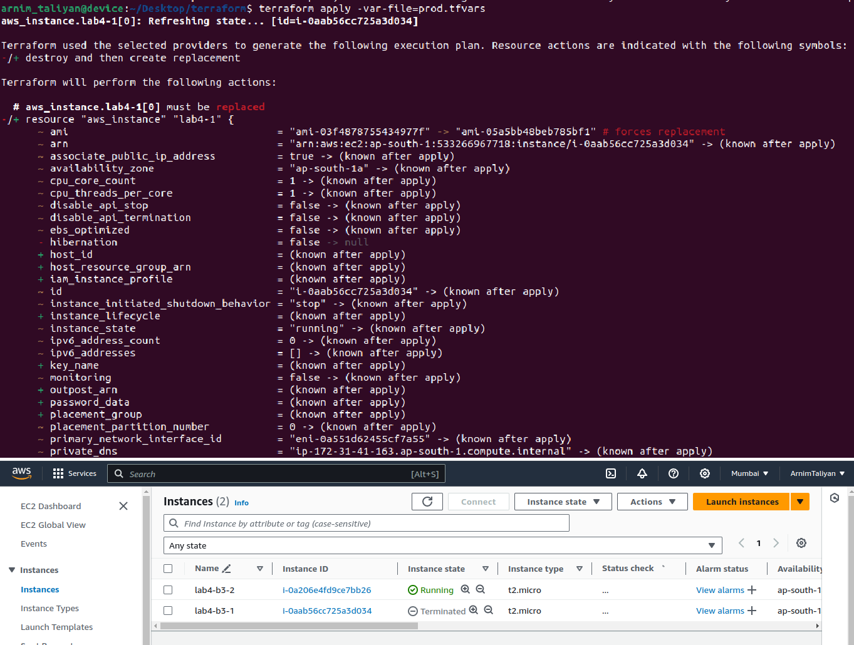

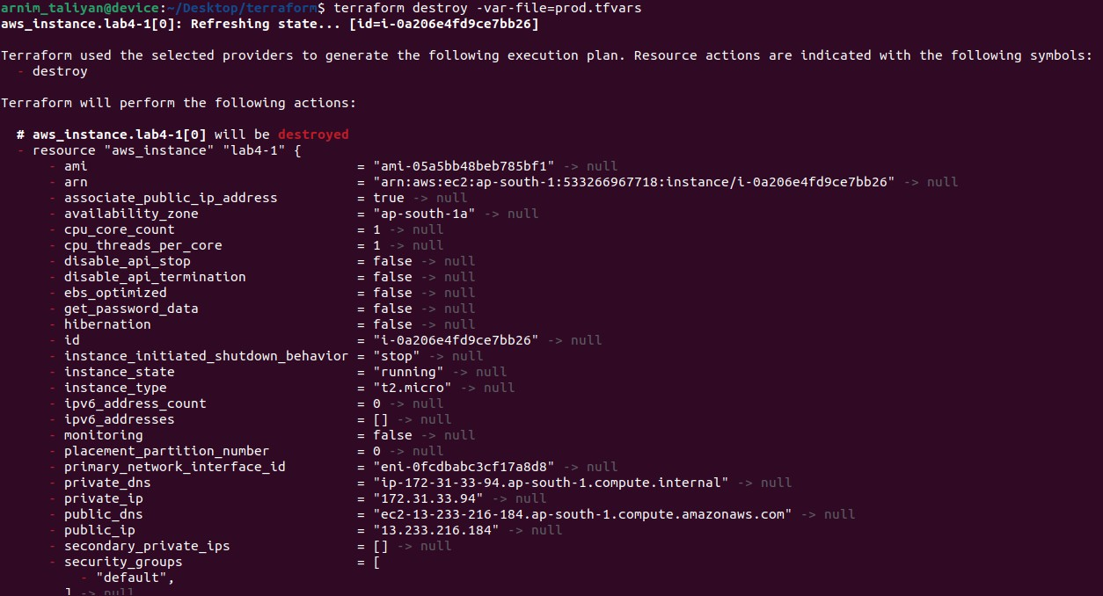

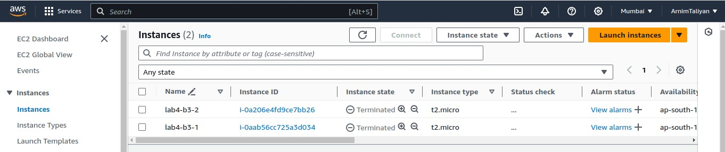

**When we run terraform apply -var-file=prod.tfvars previously created terraform apply -var-file=dev.tfvars automatically destroy.**