# Acceptance Test Cases

**What is Functional Testing?**

Functional testing is a sort of software testing that determines whether a software programme or system meets its requirements and functional specifications. It is a black-box testing technique that focuses on testing the system or application's functionality. Manual or automated testing technologies can be used to do functional testing. The testing approach chosen is determined by the system or application's complexity, available resources, and project deadline. Role of User in Functional Testing: The role of a user in functional testing might vary depending on the type of testing done and the project's specific objectives. Users, in general, can play a key part in ensuring that the system or application works well and meets their needs. These are some examples of how users can participate in functional testing: Clients may be requested to engage in User Acceptance Testing (UAT), which is a sort of testing in which end-users test the system or application in a real-world setting to confirm that it satisfies their needs and is functional. Users can provide feedback on the functionality of the system or application, as well as report any bugs or issues they encounter while using it. What is Acceptance Criteria? The acceptance criteria (Expected Outcomes) are used as a basis for building test cases and validating that the program meets the requirements stated by the stakeholders throughout the testing process. When all of the acceptance requirements are met, the software is declared accepted and ready for release.

**What is Acceptance Criteria?**

The acceptance criteria (Expected Outcomes) are used as a basis for building test cases and validating that the program meets the requirements stated by the stakeholders throughout the testing process. When all of the acceptance requirements are met, the software is declared accepted and ready for release.

## UAT (In scope - Out of scope)

UAT In Scope

* Story points LF1 - LF27 of sprint 1 are covered again as part of regression testing.
* Story points LF8, LF19, LF20, LF21, LF22, LF36, LF40 - LF47 from sprint 2 are covered as part of regression testing.
* Story points LF 54, LF 55, LF 56, LF 13, LF 49, LF 43 and LF21 from sprint 3 are covered as part of UAT Testing.

## UAT Assumptions:

1. All the test cases are performed manually from a user’s perspective.
2. All UAT are documented.

## UAT Constraints

1. Testing Operating System- Windows
2. Testing Browser- Chrome.

## UAT Acceptance Test Cases

The test cases are already written in the excel uploaded as “UserAcceptanceTestCase_sprint2”.

## UAT Summary

The Acceptance Criteria for the user stories is the same as the expected results column in the uploaded excel “UserAcceptanceTestCase_sprint3”.

## Test Cases and Coverage

We were able to get around 100% test coverage with the test cases that we wrote, as shown in the following figures.

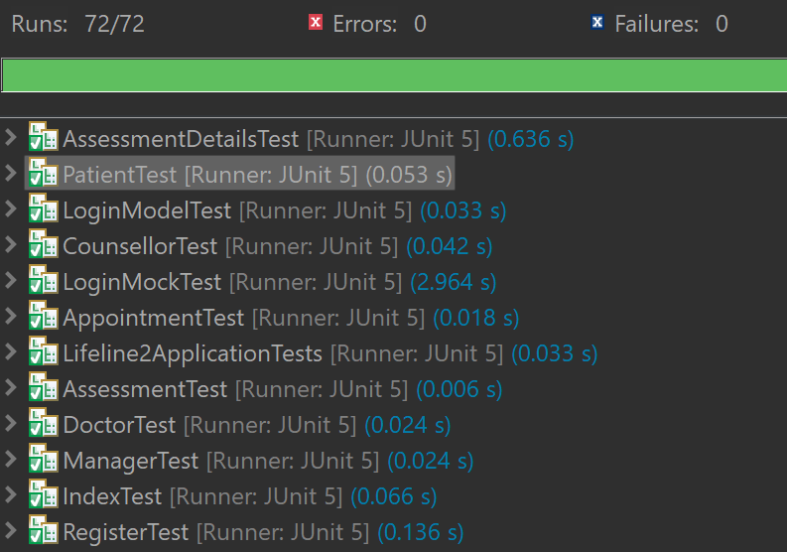

Fig: Available Test Cases

## User Acceptance Testing Screenshots

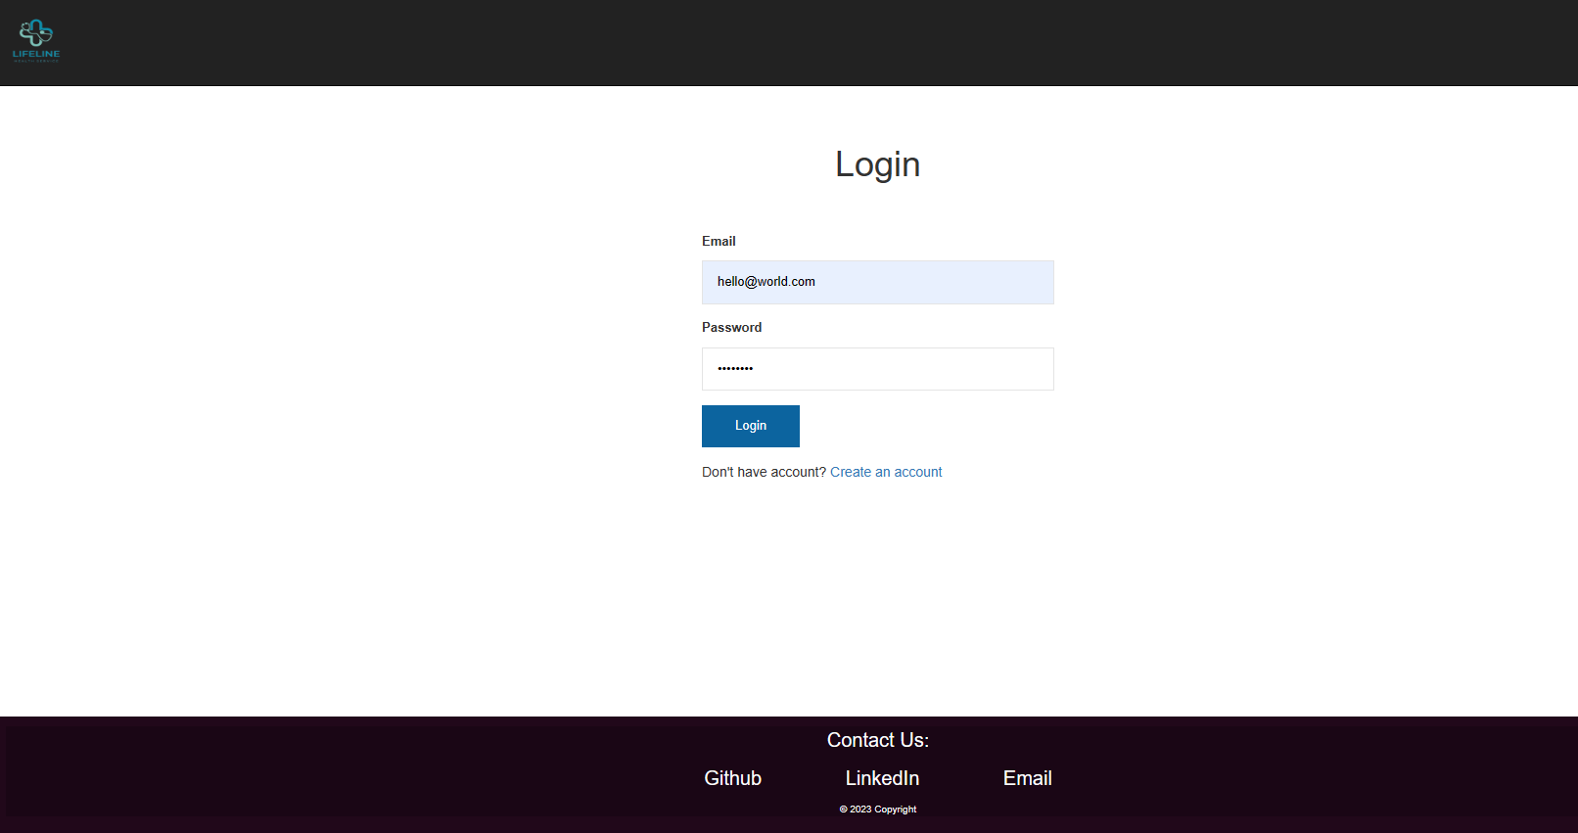

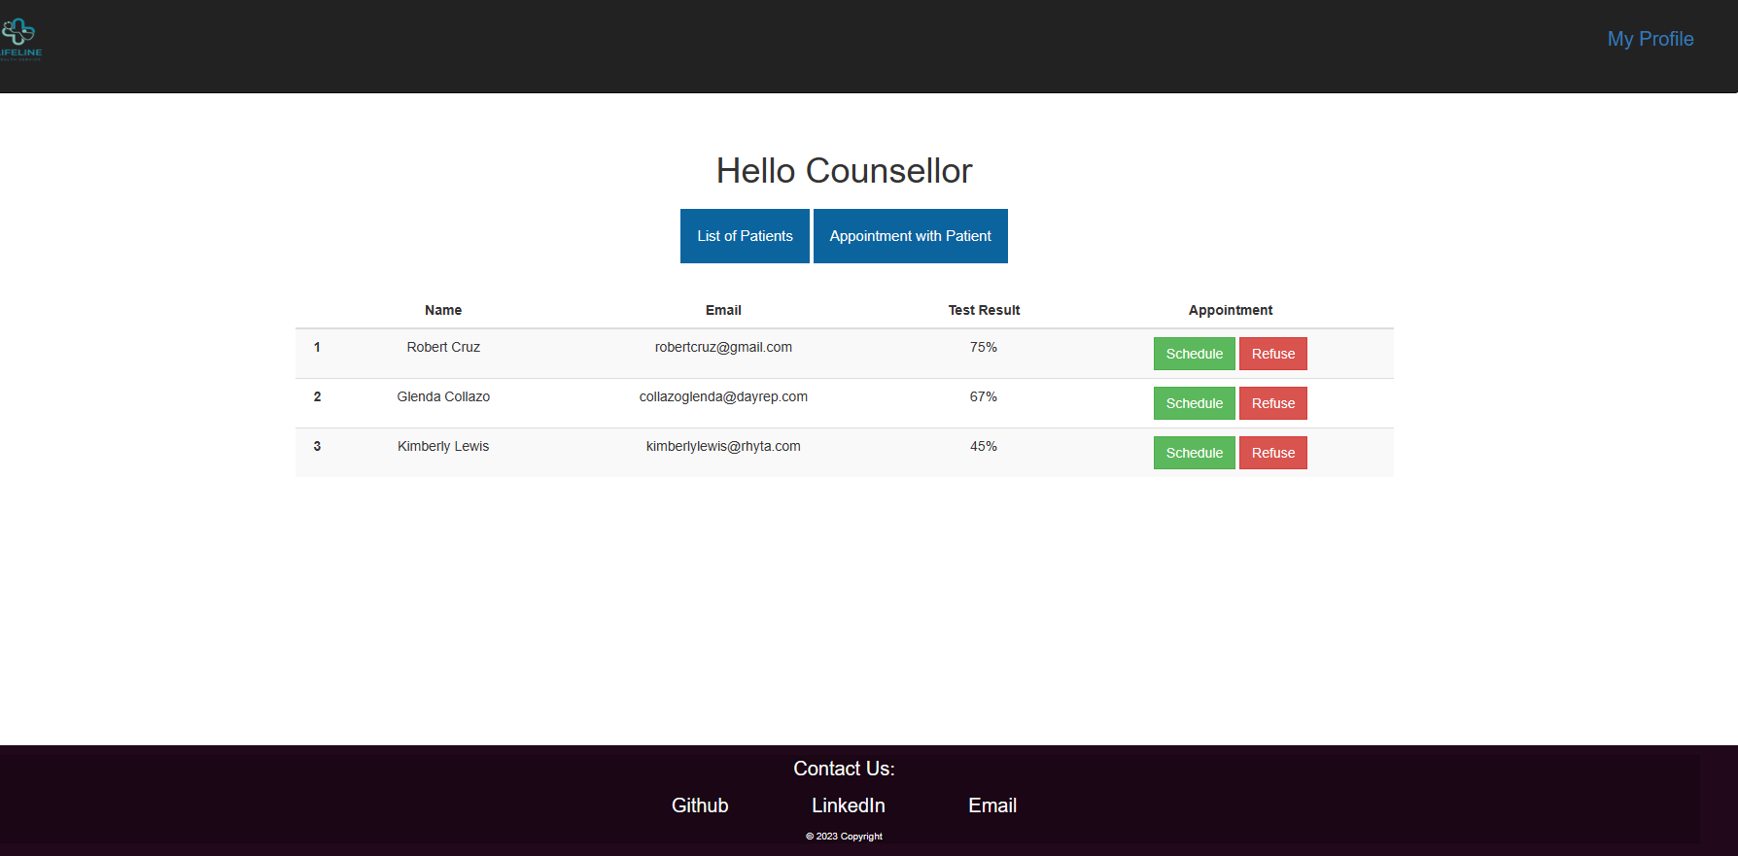

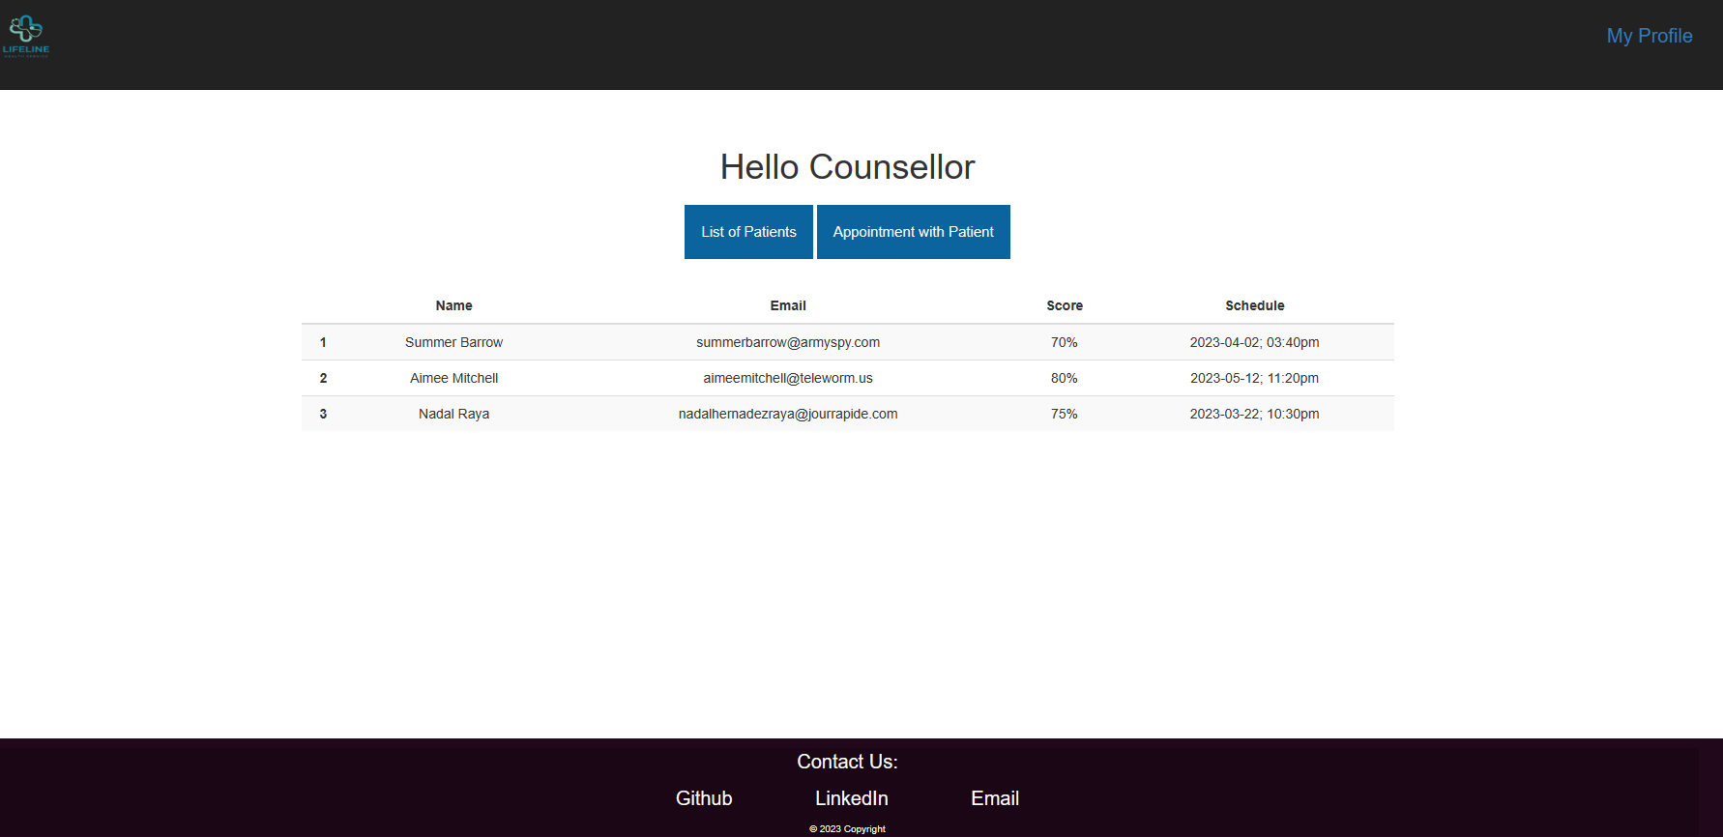

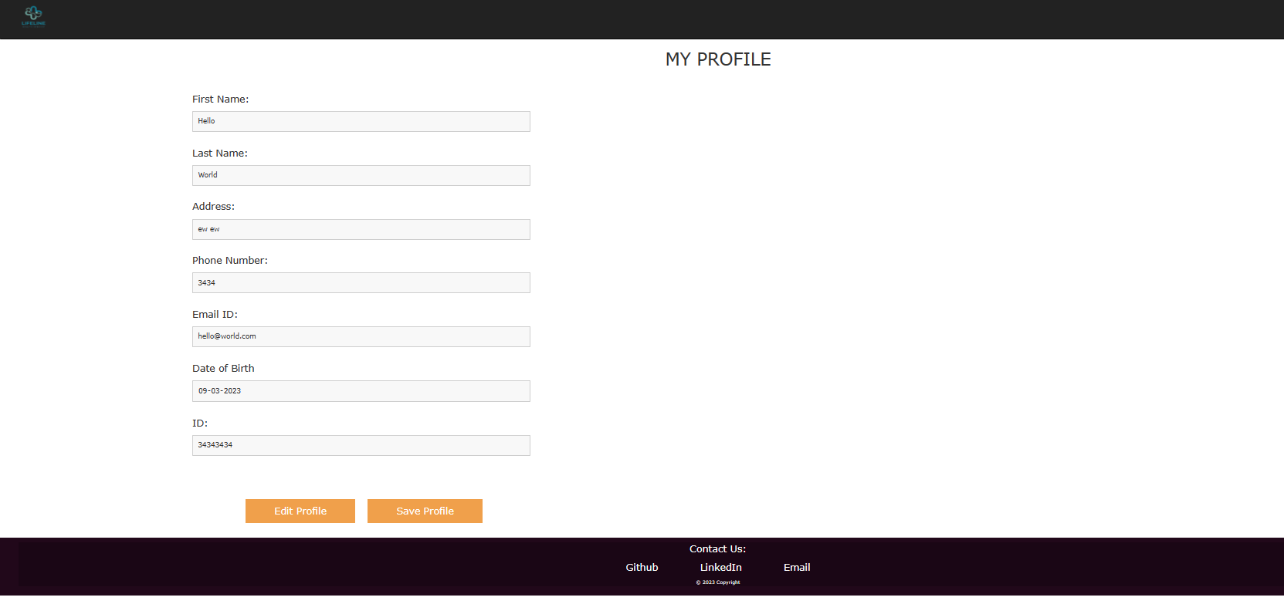

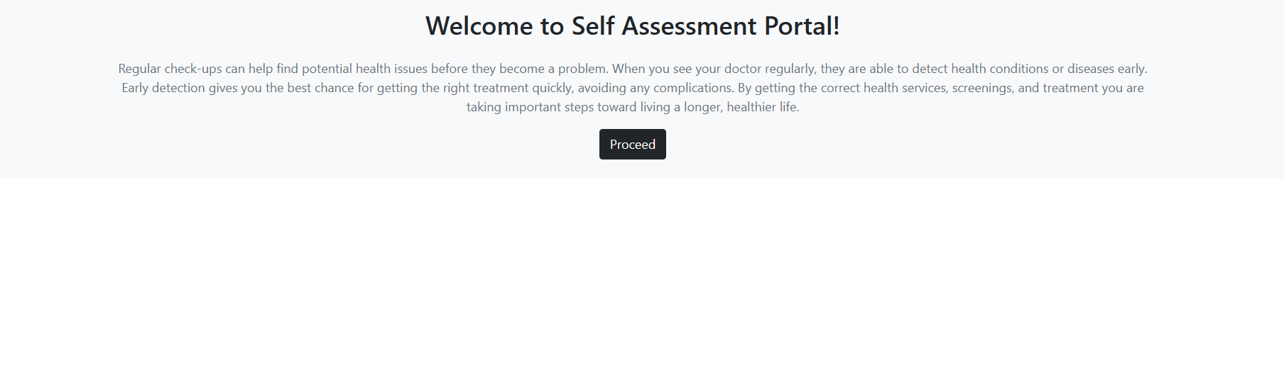

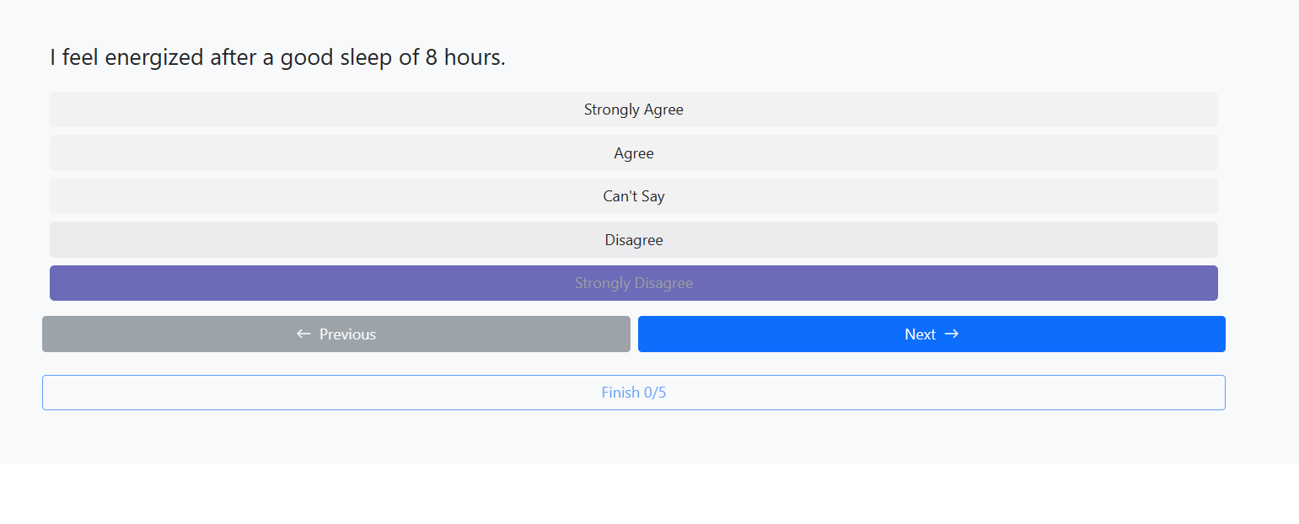

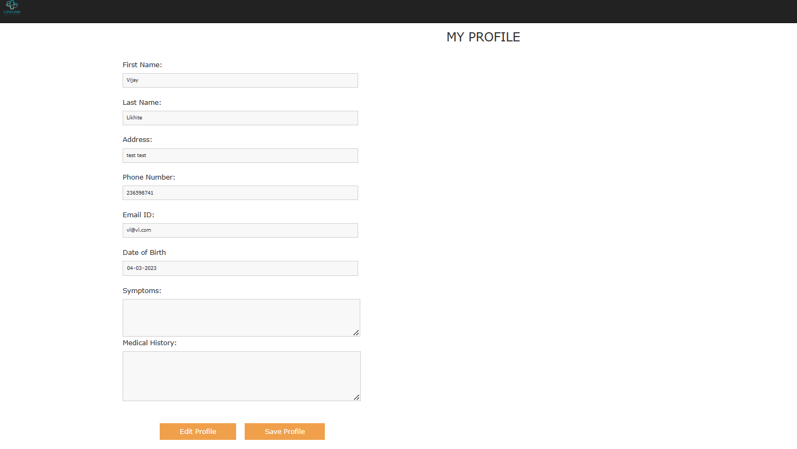

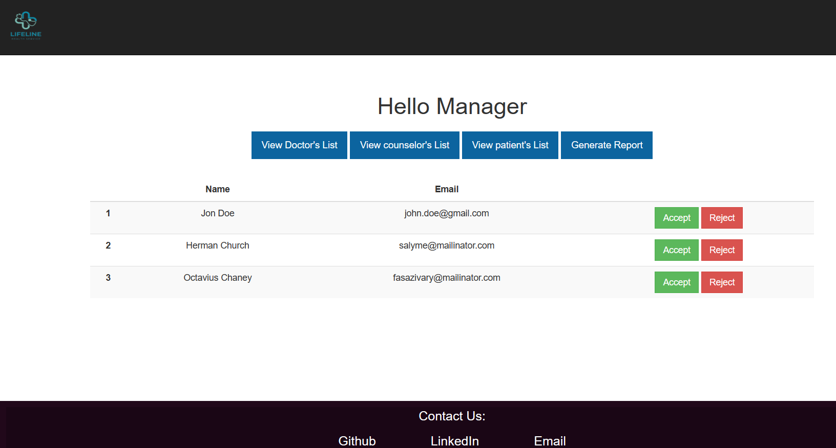

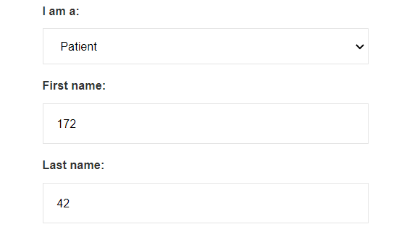

Fig : Failed test case - accepting numerical values for string field