STUDENT PERFORMANCE ANALYZER
Project Report
Submitted By
Name: Pragya Tripathi
Registration Number: 26MIB10093
Branch: M.Tech integrated ai and bioinformatics
Semester: First Semester
Submitted To
Faculty Name: Anjalimathur
Course/Subject: computer science 1021

Institution
VIT Bhopal University
Academic Year
2026–2027

Table of Contents
1. Introduction
2. Problem Statement
3. Functional Requirements
4. Non-Functional Requirements
5. System Architecture
6. Design Diagrams
7. Design Decisions & Rationale
8. Implementation Details
9. Screenshots / Results
10. Testing Approach
11. Challenges Faced
12. Learnings & Key Takeaways
13. Future Enhancements
14. Limitations
15. References
Conclusion

1. Introduction
The Student Performance Analyzer is a Python-based console application developed to manage student academic records and perform class-level and subject-wise performance analysis.
The application provides a menu-driven environment in which a teacher or user can add student records, view registered students, search for an individual student using a unique roll number, calculate student performance, and perform different types of academic analysis.
The project demonstrates the practical application of fundamental Python programming concepts including variables, expressions, functions, conditional statements, loops, lists, tuples, dictionaries, searching, counting, summation, maximum finding, array reversal, duplicate removal, and frequency counting.
The application currently works with four subjects:
- Python
- Mathematics
- EVS
- English
Each subject is evaluated out of 100 marks.
A unique 6-digit roll number is used to identify every student. Individual student performance is accessed through this roll number rather than through the student's name. This avoids ambiguity when students may have the same name.
The application calculates total marks, average marks, grade, and overall pass/fail status. It also provides class statistics and subject-wise analysis.

2. Problem Statement
Managing student academic records manually can make it difficult to calculate results, compare student performance, and obtain useful class-level and subject-level statistics.
Manual calculations can also increase the possibility of errors while calculating totals, averages, pass/fail results, and highest-performing students.
The Student Performance Analyzer provides a simple Python-based solution for organizing student information and marks and performing different academic calculations through a menu-driven system.
The system allows users to:
- Add student records.
- View all registered students.
- Search for students using unique roll numbers.
- View complete student performance.
- Calculate class statistics.
- Analyze subject-wise performance.
- Find subject-wise highest scorers.
- Calculate subject-wise pass/fail counts.
- Find the top performer.
- Find the lowest performer.
- Perform basic array/list analysis.

3. Functional Requirements
The functional requirements define what the application should perform.

3.1 Add Student
The system allows the user to add a new student by entering:
- 6-digit roll number
- Student name
- Python marks
- Mathematics marks
- EVS marks
- English marks
The system validates the roll number and prevents duplicate roll numbers.

3.2 View All Students
The system displays all registered students along with their:
- Roll number
- Name
The roll number acts as the unique identifier.

3.3 View Student by Roll Number
The system allows an individual student to be searched using their unique 6-digit roll number.
After entering a valid roll number, the system displays:
- Roll number
- Student name
- Subject-wise marks
- Total marks
- Average marks
- Grade
- Pass/Fail result

3.4 Class Statistics
The system calculates:
- Total number of students
- Class average
- Number of passed students
- Number of failed students

3.5 Subject-wise Analysis
The system calculates the average marks obtained by students in each subject.
This allows the user to examine overall class performance across the different subjects.

3.6 Subject-wise Highest Scorer
The system compares student marks and identifies the highest scorer in each subject.
The result displays:
- Student name
- Roll number
- Highest marks

3.7 Subject-wise Pass/Fail Count
The system calculates the number of students who passed and failed in each subject.
The criteria used are:
- Marks ≥ 40 → PASS
- Marks < 40 → FAIL

3.8 Top Performer
The system compares the average marks of students and identifies the student with the highest overall average.

3.9 Lowest Performer
The system compares the average marks of students and identifies the student with the lowest overall average.

3.10 Array Analysis
The application demonstrates fundamental array/list operations including:
- Finding maximum values
- Reversing an array
- Counting elements
- Removing duplicate values
- Finding frequency of values

4. Non-Functional Requirements

4.1 Usability
The application uses a simple menu-driven console interface so that users can easily select the required operation.

4.2 Reliability
The application validates important inputs such as roll numbers and marks and checks whether a student exists before displaying their information.

4.3 Performance
The application uses straightforward algorithms and sequential processing suitable for the size of data handled by the console application.

4.4 Maintainability
The application is organized using functions and separate logical operations, making the program easier to understand and modify.

4.5 Error Handling
The application handles invalid inputs such as incorrect roll-number formats, invalid marks, non-numeric values, duplicate roll numbers, and searches for non-existing students.

4.6 Resource Efficiency
The application is a lightweight Python console application and does not require a database server or external graphical framework.

5. System Architecture
The application follows a simple top-down architecture.
STUDENT PERFORMANCE ANALYZER
|
+---------------+---------------+
| |
STUDENT MANAGEMENT PERFORMANCE ANALYSIS
| |
+-------+-------+ +-------+--------+
| | | | | |
Add View All Search Student Class Subject
Student Students by Roll Analysis Analysis Analysis
|
+------------+-------------+
| | |
Total Marks Average Grade
|
Pass / Fail
The main components are:

Student Management
Responsible for:
- Adding students
- Viewing students
- Searching students by roll number

Performance Calculation
Responsible for:
- Total marks
- Average marks
- Grade
- Pass/fail status

Class Analysis
Responsible for:
- Class average
- Passed students
- Failed students

Subject Analysis
Responsible for:
- Subject averages
- Highest scorer
- Subject-wise pass/fail count

Overall Performance
Responsible for:
- Top performer
- Lowest performer

Array Analysis
Responsible for:
- Maximum finding
- Array reversal
- Counting
- Duplicate removal
- Frequency analysis

6. Design Diagrams

6.1 Use Case Diagram
+-----------------------------+
| Student Performance |
| Analyzer |
+-----------------------------+
|
+-----------------------+-----------------------+
| | |
Add Student View Students Search Student
|
By Roll Number
| | |
+-----------------------+-----------------------+
|
Analyze Performance
|
+--------------------+--------------------+
| | |
Class Statistics Subject Analysis Student Analysis
| | |
+------+------+ +-----+------+ +-----+------+
| | | | | |
Average Pass/Fail Average Highest Total Grade
| Average Result
Actor: User/Teacher
Main Use Cases:
- Add Student
- View All Students
- Search by Roll Number
- View Student Performance
- Calculate Class Statistics
- Perform Subject Analysis
- Find Highest Scorer
- Calculate Pass/Fail Count
- Find Top Performer
- Find Lowest Performer
- Perform Array Analysis

6.2 Workflow Diagram
START
|
v
Display Main Menu
|
v
Enter User Choice
|
+------------------+------------------+
| | |
v v v
Add Student View Students Search by Roll
| | |
+------------------+------------------+
|
v
Performance Analysis
|
+----------------+----------------+
| | |
v v v
Class Statistics Subject Analysis Overall Analysis
| | |
| +-----+-----+ +----+----+
| | | | | |
| Average Highest Pass Top Lowest
| Scorer Fail Performer Performer
| Count
+----------------+----------------+
|
v
Display Result
|
v
Return to Menu
|
+------+------+
| |
v v
Exit Continue

6.3 Sequence Diagram
Example: Searching for a student's performance.
User Main Program Student Records
| | |
| Select Search | |
|--------------------->| |
| | Request Roll Number |
|<---------------------| |
| Enter Roll Number | |
|--------------------->| |
| | Search Roll Number |
| |--------------------->|
| | |
| | Student Found |
| |<---------------------|
| | |
| | Calculate Total |
| | Calculate Average |
| | Calculate Grade |
| | Calculate Result |
| | |
| Display Performance | |
|<---------------------| |

6.4 Class / Component Diagram
+--------------------------------------+
| Student Performance Analyzer |
+--------------------------------------+
| |
| Student Management |
| - Add Student |
| - View All Students |
| - Search by Roll Number |
| |
| Performance Calculation |
| - Total Marks |
| - Average Marks |
| - Grade |
| - Pass/Fail |
| |
| Class Analysis |
| - Class Statistics |
| |
| Subject Analysis |
| - Subject Average |
| - Highest Scorer |
| - Pass/Fail Count |
| |
| Overall Analysis |
| - Top Performer |
| - Lowest Performer |
| |
| Array Analysis |
| - Maximum |
| - Reverse |
| - Count |
| - Duplicate Removal |
| - Frequency |
+--------------------------------------+

6.5 Data / Record Structure
The student record is represented using a dictionary structure.
{
"roll_no": "123456",
"name": "Rahul",
"marks": [85, 78, 91, 82]
}
The marks correspond to:
- Python
- Mathematics
- EVS
- English
Lists are used for student records, marks and performance values, while tuples are used for fixed subject names and dictionaries represent student records and frequency values.

7. Design Decisions & Rationale

7.1 Roll Number as Unique Identifier
The system uses a unique 6-digit roll number as the primary method of identifying a student.
Searching by name was not selected as the primary identification method because different students may have the same name.
Therefore, individual student performance is accessed using the unique roll number.

7.2 Menu-Driven Interface
A menu-driven console interface was selected because it provides a simple way to access multiple operations from a single program.

7.3 Lists for Student Data
Lists are suitable for storing multiple student records and collections of marks.

7.4 Dictionaries for Student Records
Dictionaries allow student information to be represented using meaningful keys such as roll_no, name, and marks.

7.5 Functions
Functions are used to divide the application into logical operations and improve code organization and maintainability.

7.6 Input Validation
Input validation is used to reduce incorrect data entry and ensure that roll numbers and marks follow the required format.

8. Implementation Details

8.1 Programming Language
The project is implemented using Python 3.x.

8.2 Subjects
The application currently supports four subjects:
Subject | Maximum Marks
Python | 100
Mathematics | 100
EVS | 100
English | 100

8.3 Roll Number Validation
Every student must have a unique 6-digit numerical roll number.
Example of valid roll number: 123456
Examples of invalid roll numbers:
- 12345
- 1234567
- 12A456
The program also checks whether the roll number already exists.

8.4 Total Marks
The total marks are calculated by adding the marks obtained in all four subjects.
Total Marks = Python + Mathematics + EVS + English

8.5 Average Marks
The average is calculated by dividing total marks by the number of subjects.
Average = Total Marks / 4

8.6 Grade Calculation
The application uses the following grading system:
Average Marks | Grade
90–100 | A+
80–89 | A
70–79 | B
60–69 | C
50–59 | D
Below 50 | F

8.7 Pass/Fail Calculation
For overall student performance, the student must score at least 40 marks in every subject to be considered passed.
Every subject >= 40 -> PASS
Any subject < 40 -> FAIL
For subject-wise analysis:
Marks >= 40 -> PASS
Marks < 40 -> FAIL

8.8 Class Statistics
The application calculates:
- Total students
- Class average
- Passed students
- Failed students

8.9 Subject-wise Analysis
The program calculates the average marks for each subject.

8.10 Highest Scorer
The application compares marks of all students and identifies the highest scorer for every subject.

8.11 Top and Lowest Performer
The average marks of students are compared to identify:
- Top performer
- Lowest performer

8.12 Array Algorithms
The application demonstrates:
- Maximum finding
- Counting
- Array reversal
- Duplicate removal
- Frequency counting

8.13 Algorithm Efficiency
For n students, operations requiring traversal of all students have approximately:
Time Complexity: O(n)
Searching for a student by roll number uses sequential searching, with worst-case complexity: O(n)
Finding a subject-wise highest scorer also requires checking the students: O(n)
Subject-wise pass/fail counting similarly requires: O(n)

9. Screenshots / Results
The following screenshots show the execution and output of the Student Performance Analyzer.

Figure 1: Program Execution – Adding a Student
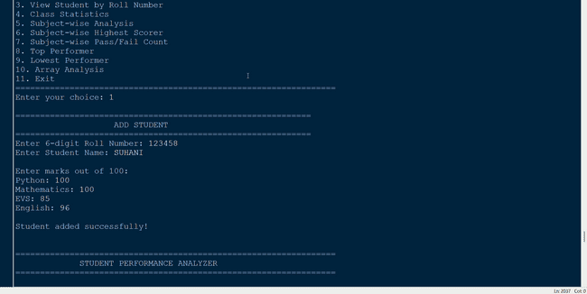
Caption: Figure 1: Main menu of the Student Performance Analyzer and adding a new student record.

Figure 2: Viewing All Registered Students
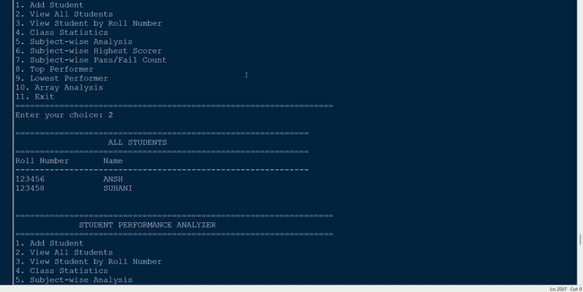
Caption: Figure 2: Viewing the list of all registered students with their roll numbers and names.

Figure 3: Student Search and Performance
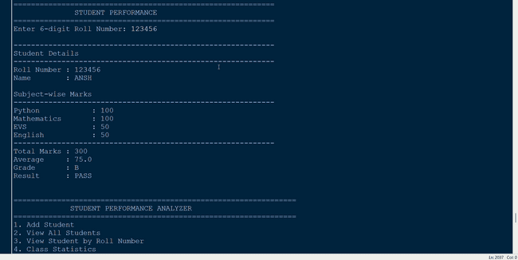
Caption: Figure 3: Viewing individual student performance using the unique roll number.
The displayed performance includes the student's name, subject-wise marks, total marks, average, grade and pass/fail result.

Figure 4: Subject-wise Analysis
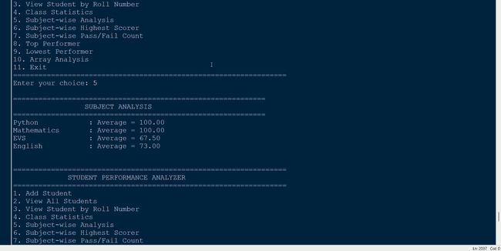
Caption: Figure 4: Subject-wise average marks across all registered students.
The system calculates the average marks obtained in each subject.

Figure 5: Subject-wise Pass/Fail Count
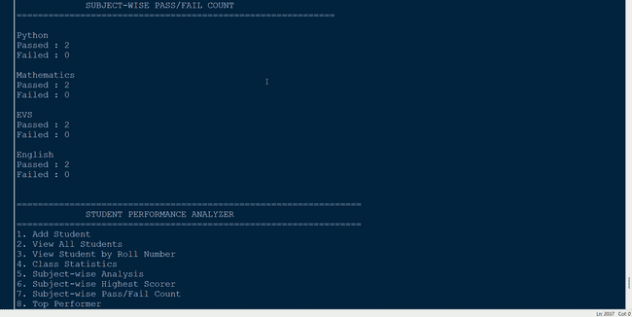
Caption: Figure 5: Subject-wise pass and fail counts for all students.

Figure 6: Lowest Performer
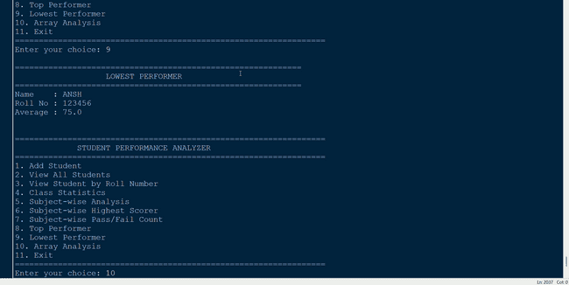
Caption: Figure 6: Identifying the student with the lowest overall average.

Figure 7: Array Analysis and Program Exit
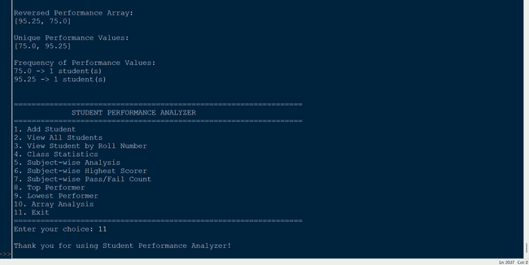
Caption: Figure 7: Array analysis results (reversal, unique values, frequency) and program exit.

10. Testing Approach
Testing was performed using different valid and invalid inputs to verify the functionality of the application.

10.1 Student Registration Testing
Test | Input | Expected Result
Valid roll number | 123456 | Accepted
Invalid roll number | 12345 | Rejected
Invalid roll number | 1234567 | Rejected
Alphabetic roll number | 12A456 | Rejected
Duplicate roll number | Existing roll | Rejected
Valid student name | Valid text | Accepted

10.2 Marks Testing
Test | Input | Expected Result
Valid marks | 0–100 | Accepted
Negative marks | Below 0 | Rejected
Excess marks | Above 100 | Rejected
Non-numeric marks | Text | Handled as invalid input

10.3 Student Search Testing
Test | Input | Expected Result
Existing roll number | Registered roll | Student details displayed
Non-existing roll number | Unregistered roll | Student not found
Invalid roll number | Incorrect format | Validation message

10.4 Performance Testing
Test | Expected Result
All subjects ≥ 40 | PASS
Any subject < 40 | FAIL
High average | Appropriate high grade
Low average | Appropriate lower grade

10.5 Analysis Testing
The following modules were tested:
- Class statistics
- Subject averages
- Subject-wise highest scorer
- Subject-wise pass/fail count
- Top performer
- Lowest performer
- Array operations

11. Challenges Faced
During development of the project, several implementation challenges were encountered.

11.1 Managing Student Identification
A reliable method was required to identify individual students. A unique 6-digit roll number was therefore used instead of relying on names.

11.2 Input Validation
The application needed to handle incorrect roll-number formats, duplicate roll numbers and invalid marks.

11.3 Performance Calculation
The program needed to correctly calculate totals, averages, grades and pass/fail results for individual students.

11.4 Subject-wise Analysis
The subject analysis required processing marks across multiple student records and comparing values to calculate averages and highest scores.

11.5 Multiple Analysis Operations
Several different algorithms had to work together within a single menu-driven program while keeping the interface understandable.

11.6 Array Operations
Implementing reversal, counting, duplicate removal and frequency calculations helped demonstrate fundamental algorithmic operations.

12. Learnings & Key Takeaways
This project provided practical experience with fundamental Python programming and algorithmic problem solving.
The major learning outcomes were:
- Understanding Python variables and data types.
- Using expressions and statements.
- Creating and calling functions.
- Using parameters and arguments.
- Applying if, elif and else.
- Using for and while loops.
- Working with lists.
- Working with tuples.
- Working with dictionaries.
- Implementing searching.
- Implementing counting.
- Calculating sums and averages.
- Finding maximum values.
- Reversing arrays/lists.
- Removing duplicate values.
- Calculating frequencies.
- Validating user input.
- Designing menu-driven applications.
- Organizing a project using GitHub.
- Documenting software using README and project reports.
The project also helped demonstrate how fundamental programming concepts can be combined to solve a practical academic record-management problem.

13. Future Enhancements
The current application can be expanded in several ways.

13.1 File-Based Storage
Student records can be stored permanently in files so that information is not lost when the program closes.

13.2 Database Integration
A database can be introduced for scalable student record management.

13.3 Graphical User Interface
The console application can be converted into a GUI application to provide a more interactive user experience.

13.4 CSV Export
Student results can be exported into CSV files for further analysis.

13.5 PDF Report Generation
The system can automatically generate individual or class-level performance reports in PDF format.

13.6 Data Visualization
Charts and graphs can be added to visually represent class and subject performance.

13.7 Additional Subjects
The system can be extended to support more academic subjects.

13.8 Attendance Analysis
Attendance information can be incorporated along with academic performance.

14. Limitations
The current version of the application has the following limitations:
- Student data is stored only during program execution.
- Data is not permanently stored in a database or file.
- The application is console-based.
- A graphical user interface is not currently included.
- The current implementation supports four fixed subjects.
- The application does not currently provide graphical data visualization.
- PDF and CSV report generation are not currently implemented.
These limitations also provide possible directions for future development.

15. References
- Python Documentation — Python programming language documentation and reference material.
- VITyarthi Build Your Own Project Guidelines — Project requirements, repository requirements and project-report structure.
- Course Learning Material — Fundamental Python programming concepts, algorithms and data structures provided as part of the course.
- GitHub Documentation — Repository management and version-control concepts.

Conclusion
The Student Performance Analyzer demonstrates how fundamental Python programming concepts can be applied to solve a practical academic record-management problem.
The application provides functionality for adding students, viewing student records, searching students through unique roll numbers, calculating individual performance, generating class statistics, performing subject-wise analysis, identifying highest scorers, calculating pass/fail counts, identifying top and lowest performers, and demonstrating fundamental array/list algorithms.
The use of a unique 6-digit roll number ensures that individual student performance can be accessed reliably and without ambiguity, even when multiple students share the same name.

