Trader Behaviour vs. Market Sentiment

Summary
This analysis merges 211,224 Hyperliquid trade executions from 32 accounts (May 2023 - May 2025) with the daily Bitcoin Fear & Greed Index to test whether crowd sentiment is linked to trader profitability, positioning, and risk-taking. Three headline findings emerge:
- Sentiment extremes outperform the middle. Traders were most profitable and had the highest win rates during Extreme Greed and Fear not during calm, Neutral markets.
- Short positions are the profit driver in this dataset. Across every sentiment regime, short trades produced higher average PnL and a larger share of total profit than longs - most pronounced during Greed, where shorts generated $3.65M of PnL vs. $1.16M for longs.
- Traders size up during Fear. Average position size peaks during Fear ($7,182) - roughly 57% larger than during Greed ($4,574) or Neutral ($4,784) - suggesting conviction-driven, contrarian-leaning behavior rather than panic-driven de-risking.

Datasets
- Hyperliquid Historical Trader Data: 211,224 trade-level records across 32 accounts and 246 traded assets, including execution price, size (tokens and USD), side, direction, closed PnL, fees, and timestamps.
- Bitcoin Fear & Greed Index: Daily sentiment classification (Extreme Fear, Fear, Neutral, Greed, Extreme Greed) with a 0-100 numeric score, spanning 2018-2025.

Processing Steps
- Converted trade timestamps to calendar dates (IST) and joined each trade to that day's Fear & Greed classification. 211,218 of 211,224 rows (99.997%) matched successfully.
- Classifications were also grouped into three simplified buckets - Fear (Fear + Extreme Fear), Neutral, and Greed (Greed + Extreme Greed) - for cleaner comparisons alongside the five-level breakdown.
- Profitability metrics (average PnL, win rate) were computed on the 104,408 trade rows carrying a nonzero Closed PnL, since most 'open' fills correctly show $0 PnL until a position is closed.
- Trade direction was bucketed into Long (Open/Close Long, Buy) and Short (Open/Close Short, Sell) to compare directional performance.

Key Findings:
- Profitability by Market Sentiment: Average PnL per trade and win rate both follow a U-shaped (non-linear) pattern across the sentiment spectrum, peaking at the emotional extremes rather than moving in a straight line from Fear to Greed.
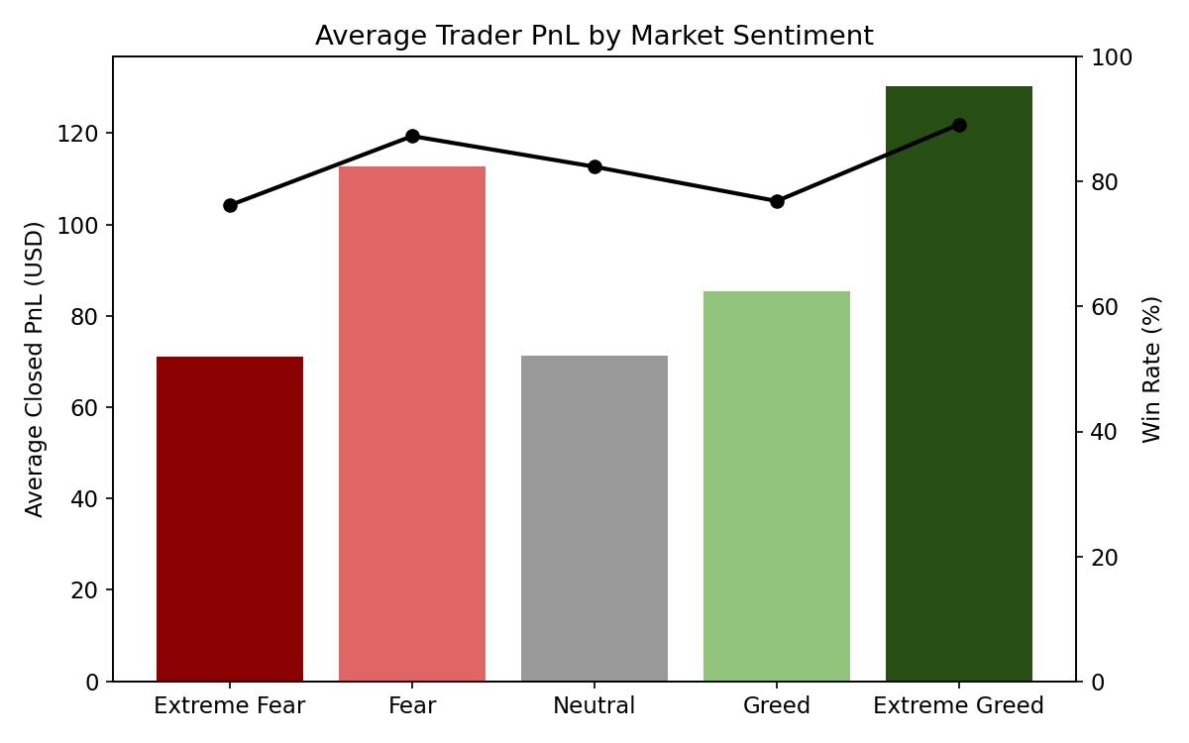
Figure 1: Average Closed PnL (bars) and win rate (line) by sentiment classification.
Sentiment | Closed Trades | Avg. PnL ($) | Win Rate | Total PnL ($)
Extreme Fear | 10,406 | 71.03 | 76% | 739,110
Fear | 29,808 | 112.63 | 87% | 3,357,155
Neutral | 18,159 | 71.20 | 82% | 1,292,921
Greed | 25,176 | 85.40 | 77% | 2,150,129
Extreme Greed | 20,853 | 130.21 | 89% | 2,715,171

2. Trading Volume & Activity
Trading volume is heavily concentrated in Fear regimes: $598M of the roughly $1.19B total notional volume in this dataset was traded while the market was fearful, compared to $413M during Greed and $180M during Neutral conditions - despite Fear windows not being the majority of calendar days. This indicates elevated activity and larger position sizes when sentiment turns negative.
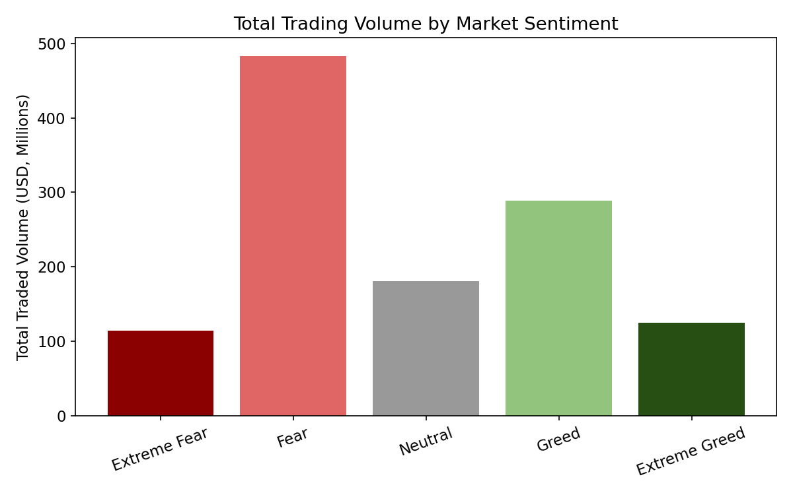
Figure 2: Total notional trading volume (USD) by sentiment classification.

3. Long vs. Short Positioning
Short positions consistently generated higher average PnL per trade than longs across every sentiment regime, though longs had a modestly higher win rate (more frequent, smaller wins vs. less frequent, larger wins for shorts).
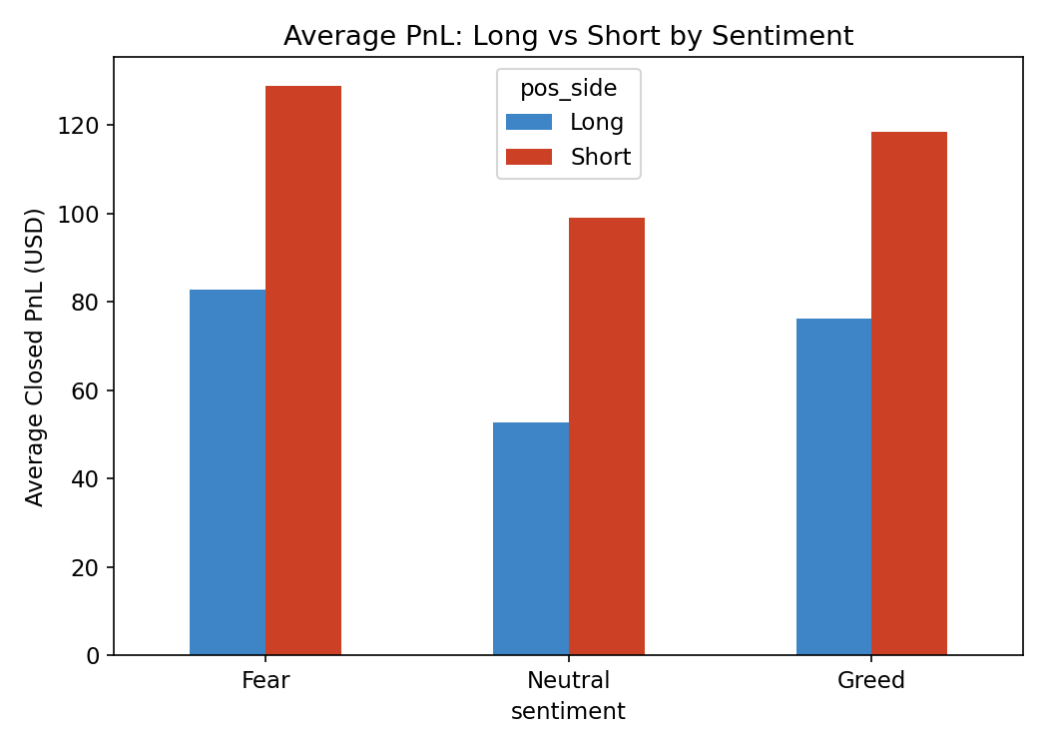
Figure 3: Average Closed PnL for Long vs. Short trades, by sentiment.
Sentiment | Side | Trades | Avg. PnL ($) | Win Rate | Total PnL ($)
Fear | Long | 23,544 | 82.73 | 88% | 1,947,900
Fear | Short | 16,670 | 128.88 | 79% | 2,148,365
Greed | Long | 15,204 | 76.26 | 88% | 1,159,459
Greed | Short | 30,816 | 118.39 | 80% | 3,648,392
Neutral | Long | 10,012 | 52.77 | 86% | 528,355
Neutral | Short | 8,153 | 98.99 | 78% | 807,038

The Greed regime stands out: traders placed roughly twice as many short trades as long trades and shorts contributed 76% of total PnL generated during Greed. This is consistent with a 'fade the euphoria' style of trading - selling into strength - being the more profitable stance historically, rather than chasing upside momentum.

4. Position Sizing by Sentiment
Average trade size swells to $7,182 during Fear, versus $4,574 during Greed and $4,784 during Neutral markets - a ~57% increase in typical conviction/exposure when the market is fearful. This pattern held for both long and short trades individually, indicating it is a broad behavioral shift rather than one large outlier account skewing the average.

5. Sentiment vs. Time-Series Relationship
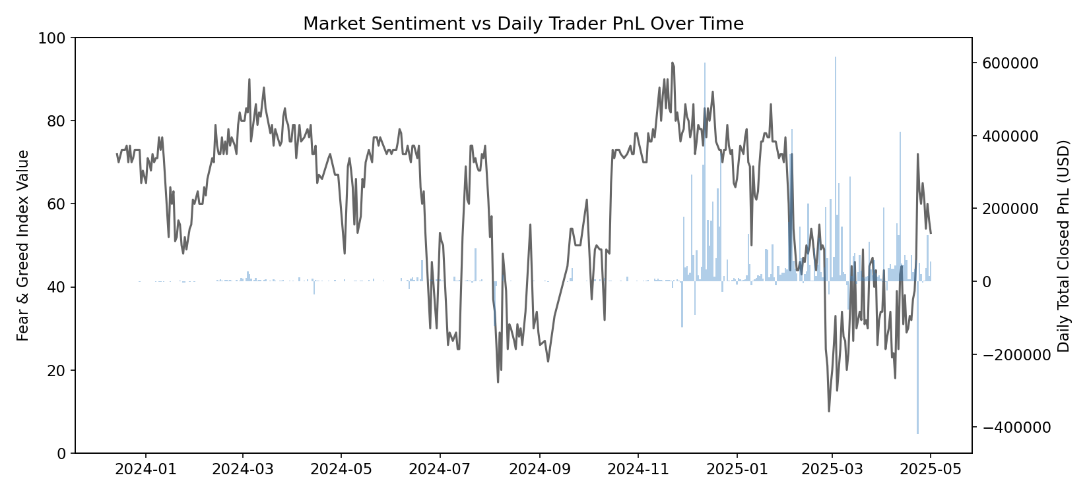
Figure 4: Fear & Greed Index (line) overlaid with daily total Closed PnL (bars) over the trading window.
The day-level correlation between the numeric Fear & Greed score and same-day total PnL is weak and slightly negative (r ≈ -0.10), and the correlation with daily trade count is more clearly negative (r ≈ -0.25) - i.e., traders in this sample trade somewhat more, not less, as sentiment moves toward Fear. This corroborates the volume finding in 3.2: activity and profitability do not simply rise with 'greedy' bullishness.

Limitations:
- Small account universe: only 32 unique accounts are represented, so account-level findings (Section 3.6) may reflect the strategies of a few individuals rather than the broader market.
- No explicit leverage field: position size in USD was used as a proxy for conviction/risk; true leverage or margin usage could shift the risk-taking narrative.

Data Summary:
Metric |  | Value
 | Total trade records |  | 211,224
 | Records with nonzero Closed PnL |  | 104,408
 | Date range |  | 2023-05-01 to 2025-05-01
 | Unique trading accounts |  | 32
 | Unique assets traded |  | 246
 | Sentiment match rate to trades |  | 99.997%

