Automated Diagnosis of Coronary Artery Disease Based on Data Mining and Fuzzy Modeling

Markos G. Tsipouras*, Student Member, IEEE*, Themis P. Exarchos*, Student Member, IEEE*, Dimitrios I. Fotiadis*, Senior Member, IEEE*, Anna P. Kotsia, Konstantinos V. Vakalis, Katerina K. Naka, and Lampros K. Michalis

***Abstract*—A fuzzy rule-based decision support system (DSS) is presented for the diagnosis of coronary artery disease (CAD). The system is automatically generated from an initial annotated dataset, using a four stage methodology: 1) induction of a decision tree from the data; 2) extraction of a set of rules from the decision tree, in disjunctive normal form and formulation of a crisp model;**

1. **transformation of the crisp set of rules into a fuzzy model; and**
2. **optimization of the parameters of the fuzzy model. The dataset used for the DSS generation and evaluation consists of 199 subjects, each one characterized by 19 features, including demographic and history data, as well as laboratory examinations. Tenfold cross validation is employed, and the average sensitivity and specificity obtained is 62% and 54%, respectively, using the set of rules ex- tracted from the decision tree (first and second stages), while the average sensitivity and specificity increase to 80% and 65%, re- spectively, when the fuzzification and optimization stages are used. The system offers several advantages since it is automatically gen- erated, it provides CAD diagnosis based on easily and noninva- sively acquired features, and is able to provide interpretation for the decisions made.**

***Index Terms*—Coronary artery disease (CAD), data mining, decision trees, fuzzy modeling, optimization.**

* 1. INTRODUCTION

**C**

ORONARY artery disease (CAD) is the development of atherosclerotic plaques in coronary arteries, resulting in coronary luminal narrowing, and subsequently, occlusion, and thus leading to myocardial infarction (MI) or sudden cardiac death. The CAD is the leading cause of death in western coun- tries. The understanding of the pathophysiology of CAD, the prevention of its development, the identification and effective modification of cardiovascular risk factors, its diagnosis and

Manuscript received September 20, 2006. This work was supported by the European Commission as part of the project NOESIS: Platform for wide scale integration and visual representation of medical intelligence under Grant IST- 2002-507960.

M. G. Tsipouras and D. I. Fotiadis are with the Unit of Medical Technology and Intelligent Information Systems, Department of Computer Science, Uni- versity of Ioannina, Ioannina GR 45110, Greece (e-mail: markos@cs.uoi.gr; fotiadis@cs.uoi.gr).

T. P. Exarchos is with the Unit of Medical Technology and Intelligent In- formation Systems, Department of Computer Science, University of Ioannina, Ioannina GR 45110, Greece, and also with the Department of Medical Physics, Medical School, University of Ioannina, Ioannina GR 45110, Greece (e-mail: exarchos@cc.uoi.gr).

A. P. Kotsia, K. V. Vakalis, K. K. Naka, and L. K. Michalis are with the Department of Cardiology, Medical School, University of Ioannina, Ioannina, GR 45110, Greece, and also with the Michaelidion Cardiology Centre, Uni- versity of Ioannina, Ioannina, GR 45110, Greece (email: hcsanna@cc.uoi.gr; me01970@cc.uoi.gr; anaka@cc.uoi.gr; lmihalis@cc.uoi.gr).

Digital Object Identifier 10.1109/TITB.2007.907985

treatment in early, and reversible stages are of great impor- tance [1]. Coronary angiography (CA) is considered to be the “gold standard” method for the diagnosis of CAD and it is widely used. However, CA is an invasive and costly proce- dure that needs high-level technical experience and technol- ogy and cannot be used for screening of large populations or close follow-up of treatment [2]. Therefore, other noninvasive methods are being used in the clinical setting for the diag- nosis of CAD. The most popular of those include exercise electrocardiogram (ECG) [3] testing, stress echocardiography (ECHO), and single photon emission computed tomography (SPECT or scintigraphy) [4], while electron-beam computerized tomography (EBCT) or multislice spiral computerized tomog- raphy (MSCT) and coronary magnetic resonance angiography (CMRA) are also being currently used [2].

Computer-aided diagnosis methodologies have also been pro- posed in the literature; in this case, the data obtained by some of the aforementioned methods or other sources (i.e., laboratory ex- aminations, demographic and/or history data, etc.) are evaluated from a computer-based application, leading to a CAD diagno- sis. These methodologies can be divided into various categories, based on the type of data they use for subject characterization: 1) methods that employ the resting or exercise ECG of the patient, extracting features from it, such as the ST segment [5], [6], the QT interval [7], the T wave amplitude [8], the R wave [9], and the heart rate variability (HRV) [10]; 2) methods using medical images such as SPECT [11]–[14]; 3) methods based on heart sounds associated with coronary occlusions [15]–[18]; 4) meth- ods based on arterio-scillography [19]; 5) methods based on Doppler ultrasound signals [20]; 6) methods employing demo- graphic, history, and laboratory data (subject’s data) [21]–[24]; and 7) methods combining more than one type of data such as ECG, scintigraphy, and subject’s data [25], [26].

Some of the noninvasive methods, such as computerized to- mography or magnetic resonance imaging, suffer from similar problems as CA, i.e., being costly and requiring specialized tech- nology and expertise, while they are not widely available [2]. Most of the computer-based methods are based on the analy- sis of data obtained by examinations, such as stress ECHO and SPECT, which are also expensive and not widely available, but, furthermore, they suffer from technical limitations [27]. Exer- cise stress testing is inexpensive and widely available, but cannot be applied to all patients and has low sensitivity and specificity in the diagnosis of CAD. Cardiovascular risk factor assessment during history acquisition combined with demographic data and simple laboratory examinations may provide a measure for the

1089-7771/$25.00 © 2008 IEEE

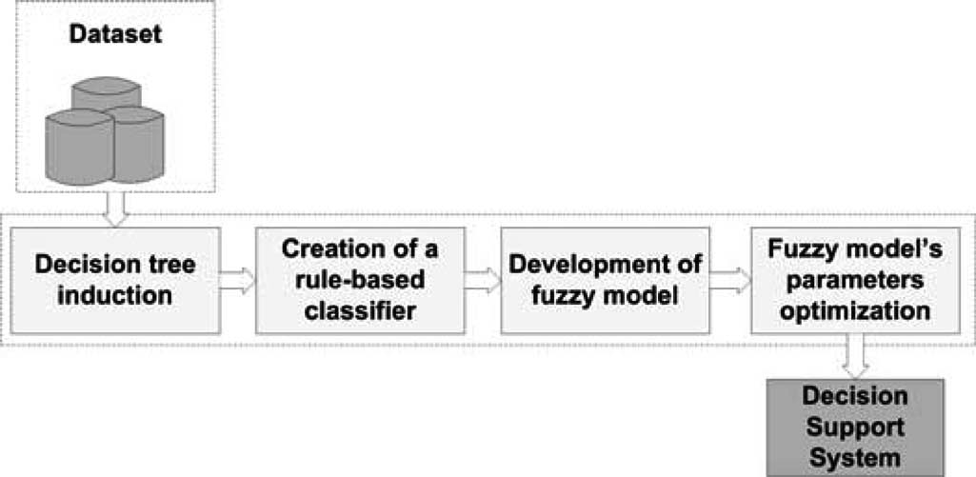

Fig. 1. Four-stage methodology used to create the DSS.

estimation of CAD risk [2]. Furthermore, the usage of arterial stiffness indices, recently proved to be related with the develop- ment of atherosclerosis [28], may improve the diagnostic pro- cedure. Only few of the proposed computer-based methods use this type of data, i.e., subject’s data that can be noninvasively and easily obtained, for the analysis. Concerning the methods used for data analysis, most of the proposed approaches are based on neural networks that cannot provide clear and direct interpretation for the decisions made. Therefore, a method able to predict noninvasively the presence of CAD using easily ob- tained features and providing interpretation for the decisions made would be of great clinical value.

In this paper, we propose a decision support system (DSS)

[29] for the diagnosis of CAD. The DSS is automatically gener- ated using a data-driven innovative methodology, which is im- plemented in four stages (see Fig 1). In the first stage, a decision tree is induced from the dataset using the C4.5 algorithm [30], while in the second stage, a set of rules is extracted from it. This set of rules is in disjunctive normal form (DNF) [31], and it formulates a crisp rule-based classifier. In the third stage, the crisp model is fuzzyfied, i.e., the crisp rules are transformed into fuzzy ones, using a fuzzy membership function instead of the crisp and S and T norms definitions, which are fuzzy equivalents of the binary OR and AND operators [32]. Finally, in the fourth stage, the parameters entering the fuzzy model are optimized using a global optimization technique [33]. The methodology is fully automated and starting from the initial annotated dataset generates a DSS, which is actually a fuzzy model with its param- eters optimized subject to a specific dataset. The features that are used in the dataset are demographic and history data along with some basic laboratory examinations and indices of arterial stiffness, thus being very easily obtained. Furthermore, CA was conducted to all subjects, and their clinical statuses (presence or absence of CAD) were determined by two experienced car- diologists. The employment of fuzzy modeling is able to deal with the fuzziness, which is inherent in biomedical problems, while its combination with data mining provides the desired interpretation for the obtained decisions.

* 1. MATERIALS AND METHODS

The four-stage methodology that is proposed for the auto- mated creation of the DSS is presented in Fig. 1. An unknown case can be fed into the generated DSS to produce a diagnosis.

The dataset and the stages of the methodology are described in detail later.

1. *Dataset*

The clinical data were collected in the Invasive Cardiology Department of the University Hospital of Ioannina. We included 199 subjects referred for their first CA because of suspected CAD. Patients with acute coronary syndrome, known CAD, or more than mild valvular heart disease were excluded from the study. In order to diagnose the presence or absence of CAD, CA was performed using Judkins technique. All coronary an- giograms were visually assessed by two experienced angiog- raphers and a consensus was reached. Significant CAD was defined as at least one 50% or greater diameter stenosis in at least one coronary artery vessel. The absence of CAD was de- fined as completely smooth epicardial coronary arteries without any narrowing visible in CA. For the total 199 subjects, 89 were normal and CAD was present in the other 110 subjects. Demo- graphic, clinical, and vascular data were also acquired from all subjects prior to CA, while laboratory investigations from a fast- ing blood sample were also performed. Table I presents the 19 features selected. All patients were studied while taking regular medication (drugs were not withheld before measurements) and gave written informed consent. The study was approved by our local ethics committee.

Two demographic features were recorded: the age and sex of the patient. From the subject’s history, the family history of CAD (FH), smoking history (Smok), history of diabetes mel- litus (DM), and hypertension (HT) or hyperlipidaemia were used. Family history of CAD was defined as the presence of CAD in the father or brother aged *<*55 years or mother or sis- ter aged *<*65 years. Current and ex-smokers were defined as having smoked the last cigarette less than a week and less than a year before CA, respectively. Diabetes mellitus was defined as a fasting blood glucose concentration (FBGC) 126 mg/dl or antihyperglycemic drug treatment, hypertension as systolic blood pressure (SBP) *>*140 mmHg, and/or diastolic blood pres- sure (DBP) *>*90 mmHg or use of antihypertensive agents, and hyperlipidemia as fasting total cholesterol *>*220 mg/dl or use of lipid-lowering agents (statins or fibrates). Other clinical data were also recorded; body mass index (BMI), calculated as weight (kg) divided by the square of height (square me- ter), waist perimeter measured in centimeter, resting heart rate (HR), measured in beats per minute (b/min), resting SBP and DBP measured in mmHg. The laboratory investigations also incorporated were creatinine (Cre), glucose (Glu), total choles- terol (Tchol), high-density lipoprotein (HDL), and triglycerides (TRG) measured in milligrams per deciliter (mg/dL). All the aforementioned features are considered to be traditional cardio- vascular risk factors widely used to assess the risk of CAD. In addition, carotid–femoral pulse wave velocity (PWVcf) and augmentation index (AIx) expressed in meter per second and percentage, respectively, were also used as noninvasive indices of arterial stiffness [34], [35].

≥

The assessment of arterial stiffness was performed noninva- sively, using the Sphygmocor system [35]. Pressure waveforms

TABLE I DATASET’S FEATURES

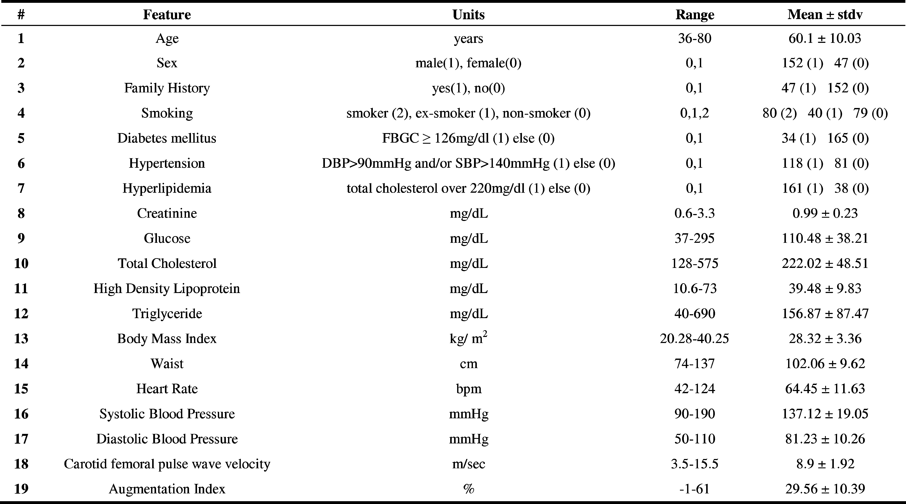

were recorded from the radial, carotid, and femoral arteries using applanation tonometry. Pulse wave velocity (PWV) was calcu- lated as distance/transit time and was assessed by measuring both carotid–femoral arteries and carotid–radial arteries. Anal- ysis of the central waveform allows systemic arterial stiffness to be assessed by calculating the AIx [36]. The AIx was defined as the aortic pressure divided by the pulse pressure and expressed as a percentage. The AIx is influenced by the HR [37]; therefore, an index, which normalized the AIx for 75 b/min (derived by the Sphygmocor software) was used.

1. *Decision Tree Induction*

The construction of the decision tree is implemented using the C4.5 inductive algorithm [30], which generates a decision tree from the training data that minimizes the expected value of the number of tests for data classification. Each internal node of the tree corresponds to a principal component, while each outgoing branch corresponds to a possible range of that component. The leaf nodes represent the class to be assigned to a sample.

The most important factor in the C4.5 algorithm is its ability to automatically select the feature, which is appropriate at each node. The feature of each node is selected in order to divide input samples effectively. The *information gain* [30] is used as a measure of effectiveness. After the induction of the decision tree, we apply a pruning method to reduce the tree’s size and complexity. The two pruning methods that are often used are prepruning and postpruning [30]. In our problem, we followed the postpruning method. The postpruning tends to give better results than the prepruning since it makes pruning decisions based on a fully grown tree, unlike prepruning, which can suffer

from early termination of the tree growing process. In our case, postpruning is performed by replacing a subtree with a new leaf node whose class label is determined from the majority class of records associated with the subtree (subtree replace- ment). The subtree replacement was performed by calculating the pessimistic error.

1. *Creation of a Rule-Based Classifier*

In this stage, we construct a rule-based classifier. A rule based classifier is a technique for classifying records using a collection of “if *...* then *.. .*” rules. The rules for the model are crisp and form the set of rules, which is represented in a DNF, (*r*1 *r*2

∨ ∨

*rk* ), where *ri* are the classification rules or disjuncts. Each classification rule is expressed as: *ri* : (*Condi*) *y*, where *y* is the predicted class. The left-hand side of the rule is the rule antecedent or precondition. It contains a conjunction of fea- ture tests *Condi* = (*a*1 *op θ*1 ) (*a*2 *op θ*2 ) (*am op θm* ), where (*aj , θj* ) is a feature-value (threshold) pair and *op* is a com- parison operator chosen from the set (=*, , <, >, ,* ). Each feature test *aj op θj* is a conjunct. The right-hand side of the rule is the rule consequent, which contains the predicted class *yi*. A rule *r*covers a record *A* if the precondition of

→

···

∧ ∧ ··· ∧

≤ ≥

*r*matches the features of *A*, where *A* = *a*1 *, a*2 *,..., anf* is the feature vector and *nf* is the number of features character- izing a record. *r* is also said to be fired or triggered when- ever it covers a given record. The quality of a classification rule can be evaluated using measures such as coverage and accuracy.

{ }

There are two important aspects to consider when construct- ing the set of rules of a rule-based classifier. First, the set of rules

should be composed by mutually exclusive rules. The rules in a set are mutually exclusive if a record triggers only one rule. This property ensures that every record is covered by at most one rule in the set. Second, the set of rules should be exhaustive. A set of rules has exhaustive coverage if there is a rule for each combination of feature values. This property ensures that every record is covered by at least one rule in the set. Together, these properties ensure that every record is covered by exactly one rule. A well-known method to construct a set of rules satisfying the earlier two aspects is to extract rules from a decision tree. The crisp set of rules is created from the final decision tree as follows.

* 1. One condition is created for every leaf of the tree by pars- ing the tree from the root node to the leaf. The tests encoun- tered along the path form the conjuncts of the condition, while the class label at the leaf node is assigned to the rule consequent

*Condi*(*A,* Θ) = *c*root(*a*root*, θ*root)

∧ *cj* (*aj , θj* ) ∧ ··· ∧ *ck* (*ak , θk* ) (1)

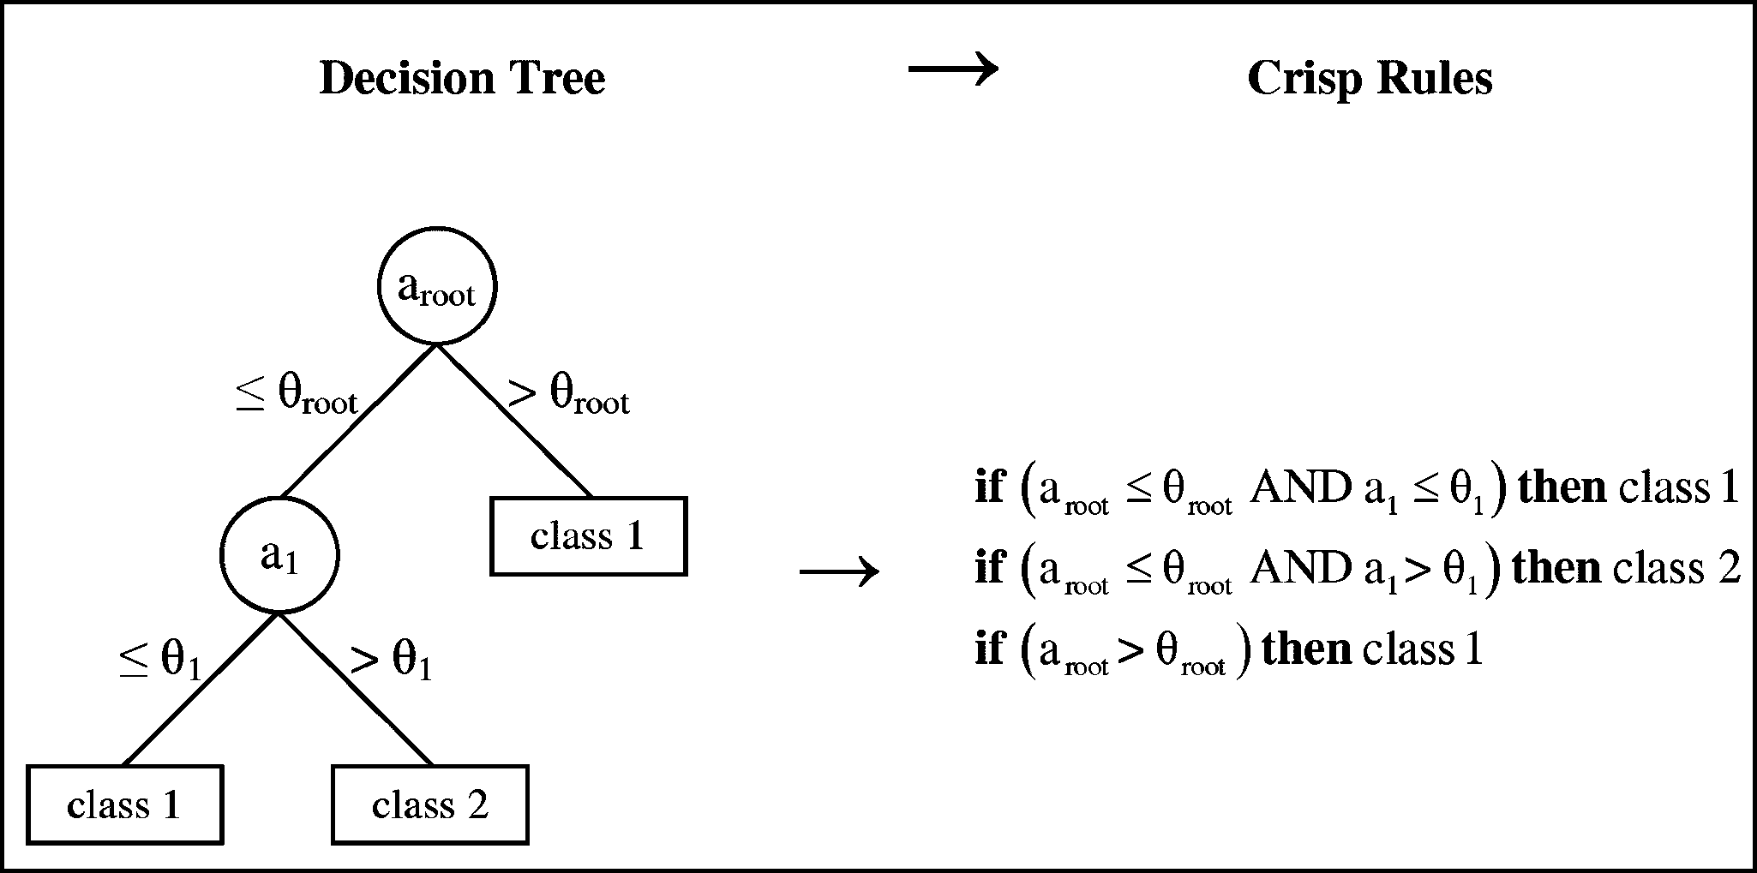

Fig. 2. Extraction of a set of crisp rules from a decision tree.

1. *Development of a Fuzzy Model*

The crisp set of rules is transformed into a fuzzy model us- ing a fuzzy membership function instead of the crisp one, and fuzzy equivalents of the binary AND ( ) and OR ( ) operators, which are the T and S norms [32]. In our approach, the sigmoid function, defined as

∧ ∨

1

*s*

where *Condi* is a condition, Θ = {*θ*root*, θ*1 *, θ*2 *,..., θnt* }

*g*inc(*a, θ*1 *, θ*2 ) =

1 + *eθ*1 (*θ*2 −*a* )

(increasing) or

is a vector containing all thresholds, *nt* is the total number

*g*dec(*a, θ ,θ* ) = 1

(decreasing) (4)

of thresholds, *aj* and *θj* are the feature and the threshold

*s* 1 2

1 + *eθ*1 (*a* −*θ*2 )

used in the conjunct *j*, and *cj* (*aj , θj* ) is the respective conjunct, expressed as *cj* (*aj , θj* ) = *gc* (*aj , θj* ), where *gc* is the crisp membership function, defined as

is used as fuzzy membership function, while the T and S norms are defined as the minimum and maximum operators, respec- tively. Among several alternative functions that can be used

inc

0*, a* ≤ *θ*

for monotonic fuzzy membership function, we selected the sig-

moid function since it uses only two parameters (*θ*1 *, θ*2 ) and performs better as compared to the linear membership function

dec ( ) = 1*, a* ≤ *θ*

*gc* (*a, θ*) =

1*, a > θ* (increasing) or

*g a, θ*

*c* 0*, a > θ*

(decreasing)*.* (2)

(also using only two parameters) [38].

According to these, each crisp conjunct (*cj* ) is transformed to

a fuzzy one (*cf* ) as follows: *cf* (*aj , θ*1*,j ,θ*2*,j* ) = *gs*(*aj , θ*1*,j ,θ*2*,j* ),

*j j*

It should be mentioned that the number of conjuncts *cj* , the features, and the thresholds that are used are different

in every condition *Cond* and depend on the depth of the

*i*

and the crisp conditions are transformed to fuzzy ones as

*f* ot (*a*root *, θ*1*,*root *, θ*2*,*root)

 *c*

ro

*i*

*f f*  *f* 

corresponding leaf and the tests that are encountered along

*k*

the path from the root to this leaf.

2) A general rule (*Ry* ) is created for each class (*y*), using all

*Cond*

*A,* Θ

= min



{ }

*cj* (*aj , θ*1*,j , θ*2*,j* ) *, ...*

*cf* (*ak , θ*1*,k , θ*2*,k* )

(5)



*t*

the conditions *Condi*(*A,* ) having as consequent this class

*Ry* (*A,* Θ) = *Condi*1 (*A,* Θ) ∨ *Condi*2 (*A,* Θ)

∨ *...Condin* (*A,* Θ) (3)

where Θ*f* = *θ*1*,*root *, θ*2*,*root *, θ*1*,*1 *, θ*2*,*1 *,..., θ*1*,n , θ*2*,n* is a

vector containing all parameters used in the fuzzy model. Also, we define a rule evaluation metric, based on the coverage and the accuracy of the rules, in order to introduce a bias to the “stronger” rules. For this reason, the likelihood ratio is used:

*t*

where *y* is the class. Therefore, the number of the general rules is the same with the number of the classes. These general rules comprise the crisp set of rules, which is

*ny*

*pi* = 2

Σ

*y* =1

fr*i,y* log

fr*i,y*

*ei,y*

→

(6)

exhaustive and mutually exclusive. Thus, for each feature vector *A*, one and only one of the general rules is true, defining its class. An example of the transformation of the decision tree to a set of crisp rules is presented in Fig. 2. The application of the first two stages (decision tree induction and creation of a rule-based classifier) to the aforementioned dataset generates a crisp set of rules. Indicative rules are shown in Fig. 3.

where *ny* is the number of classes, fr*i,y* is the observed frequency of class *y* records that are covered by a rule *Condi* (*A,* Θ) *y*, and *ei,y* is the expected frequency of a rule that makes ran- dom predictions. A large *pi* suggests that the number of correct predictions made by the rule is significantly larger than that expected by random guessing. Other metrics for rule evalua- tion could be considered; however, the metric shown in (6) was preferred since it takes into account both the accuracy and the

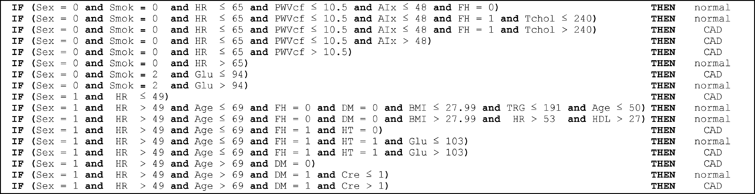

Fig. 3. Indicative crisp rules.

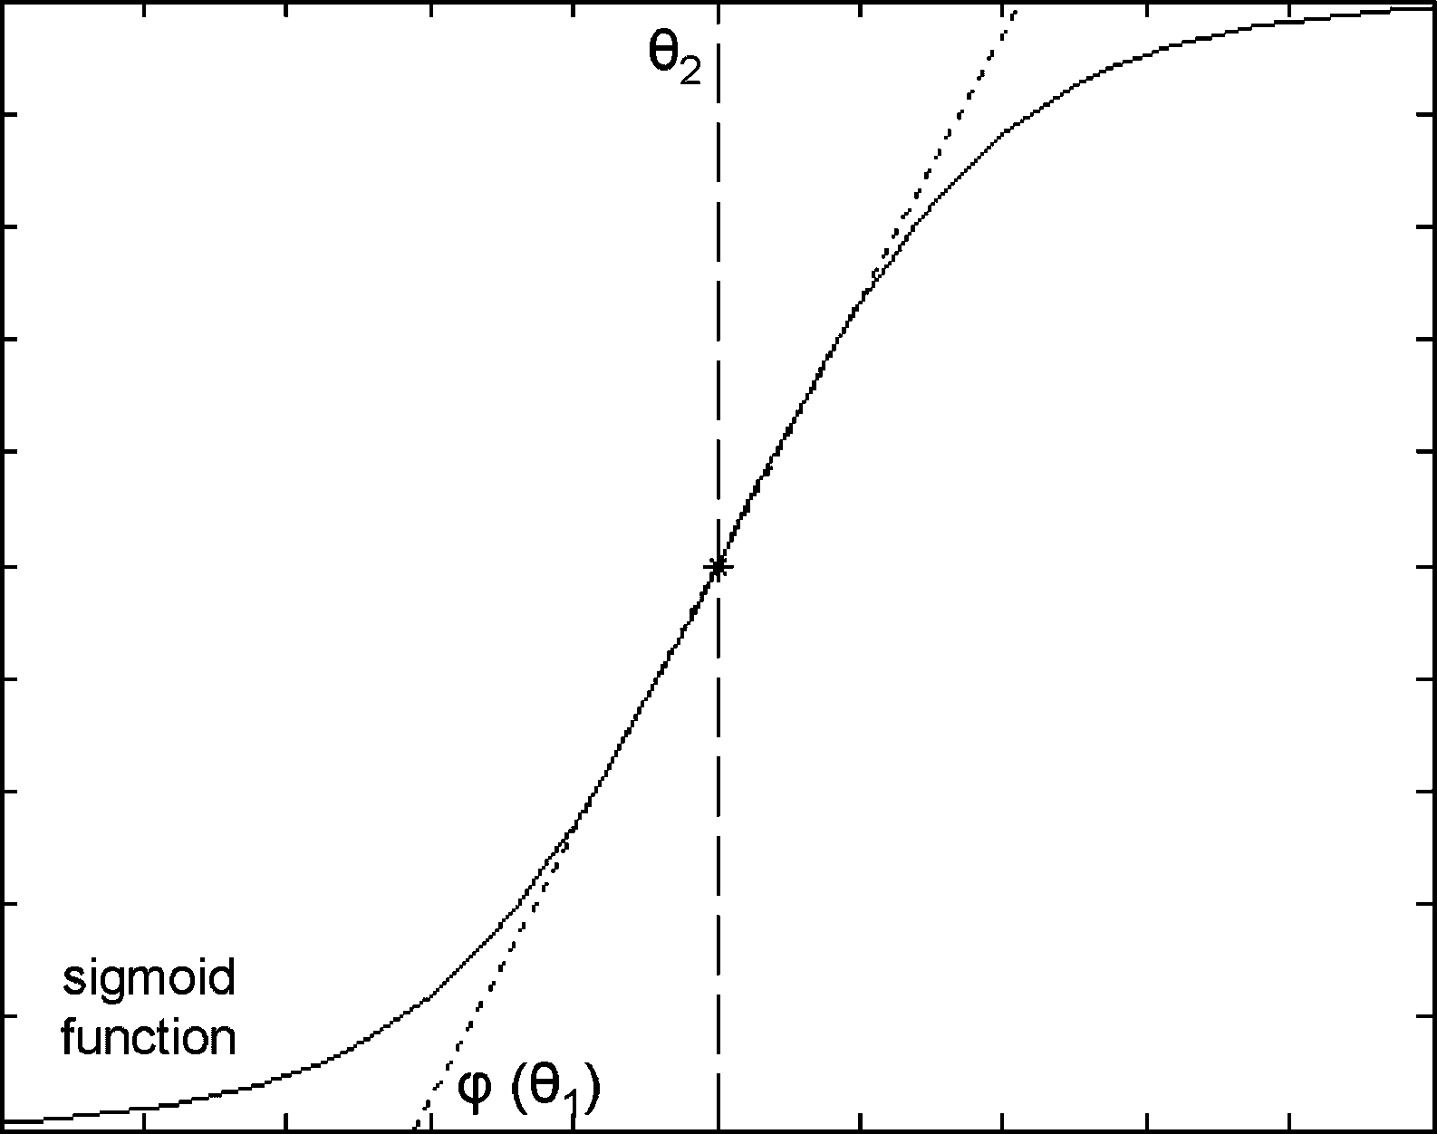

Fig. 4. Optimization parameters for the fuzzy membership function (sigmoid—increasing).

coverage of the rules. This metric is applied to each *Condf* . The general crisp rules are transformed to fuzzy ones as

*i*

The optimization method used is the healed topographical multilevel single linkage (HTMLSL) [33], a stochastic algo- rithm based on multilevel single linkage (MLSL). The algo- rithm attempts iteratively to find all local minima of an objective function *F* (*x*) inside a bounded set *S* R*n* , which are poten- tially global. These local minima are obtained by a local-search procedure, starting from suitably chosen points in a properly maintained sample. Stochastic algorithms in the framework of multistart suffer from the problem of recovering the same local minima repeatedly, a fact that diminishes their efficiency. The HTMLSL is constructed in such a way so as to avoid this unde- sirable repetition. The HTMLSL algorithm, at the *k*th iteration:

1. constructs a sample of points by selecting *N* random points from the bounded set *S* and evaluates at each point the objective function;

⊂

1. chooses a subset of points to be used as starting points for local searches from the earlier sample;
2. performs a local search from each starting point. If a new minimum is discovered, the algorithm stores it;

*pi*1 *Rf* (*A,* Θ*f* ) = max *pi*

*y*

2



 *pin*

× *Condf* (*A,* Θ*f* ) 

× *Cond* (*A,* Θ*f* ) 

*i*1

*i*2

*in*

× *Cond* (*A,* Θ*f* )*, ...*  *.* (7)

*f*

*f*

1. determines whether to stop or not, using suitable stopping criteria. If not, repeats starting from step (1);
2. from the stored local minima, the one with the lowest value is considered to be the global minimum.

These fuzzy general rules comprise the fuzzy model:

*Mf A,* Θ*f* = arg max

*y* =1*,...,ny*

*Rf* (*A,* Θ*f* ) *.* (8)

* 1. RESULTS

The tenfold stratified cross validation method [39] was used

As shown in (8), for each feature vector *A,* the fuzzy general rule with the higher value defines its class.

*y*

1. *Fuzzy Model’s Parameter Optimization*

The fuzzy model *Mf A,* Θ*f* is optimized with respect to its parameters Θ*f* , using a training dataset (*D*train ). For every con- junct, a parameter *θ*1 (analogous to the slope *ϕ*) and the center *θ*2 of the fuzzy membership function (sigmoid) are optimized (see Fig. 4). If *X* is the normalized confusion matrix

# of patterns in *y* classified to *Mf* (*A,* Θ*f* )

for evaluation. The stratification was implemented by dividing the subjects into two subsets: those with CAD and those with no CAD. The procedure was applied to each fold, generating ten different sets of crisp rules (the result after stages 1 and 2) and fuzzy models (the result after all stages). Both the crisp set of rules and the optimized fuzzy models have been evaluated. Table II presents the true positive (TP), true negative (TN), false positive (FP), and false negative (FN) results for each fold. In addition, the sensitivity (Se), specificity (Sp), and accuracy (Acc) of each fold and in overall, using gross statistics, are provided.

*XM f* (*A,*Θ*f* )*,y* =

total # of patterns in *y*

(9)

From the obtained results, it is clear that the last two stages (i.e., fuzzification and optimization) of the proposed methodol-

then the cost function, used for this purpose, is defined as

trace(*X*)

*F* (Θ*, D*train ) = (10)

|*D*train |

ogy improved the efficiency of the crisp model generated using only the first two stages (decision tree induction and crisp model formulation). The optimized fuzzy model results to 73.4%

TABLE II

RESULTS FOR THE CRISP RULE BASED CLASSIFIER, THE PROPOSED DSS, THE ANNS, AND THE ANFIS

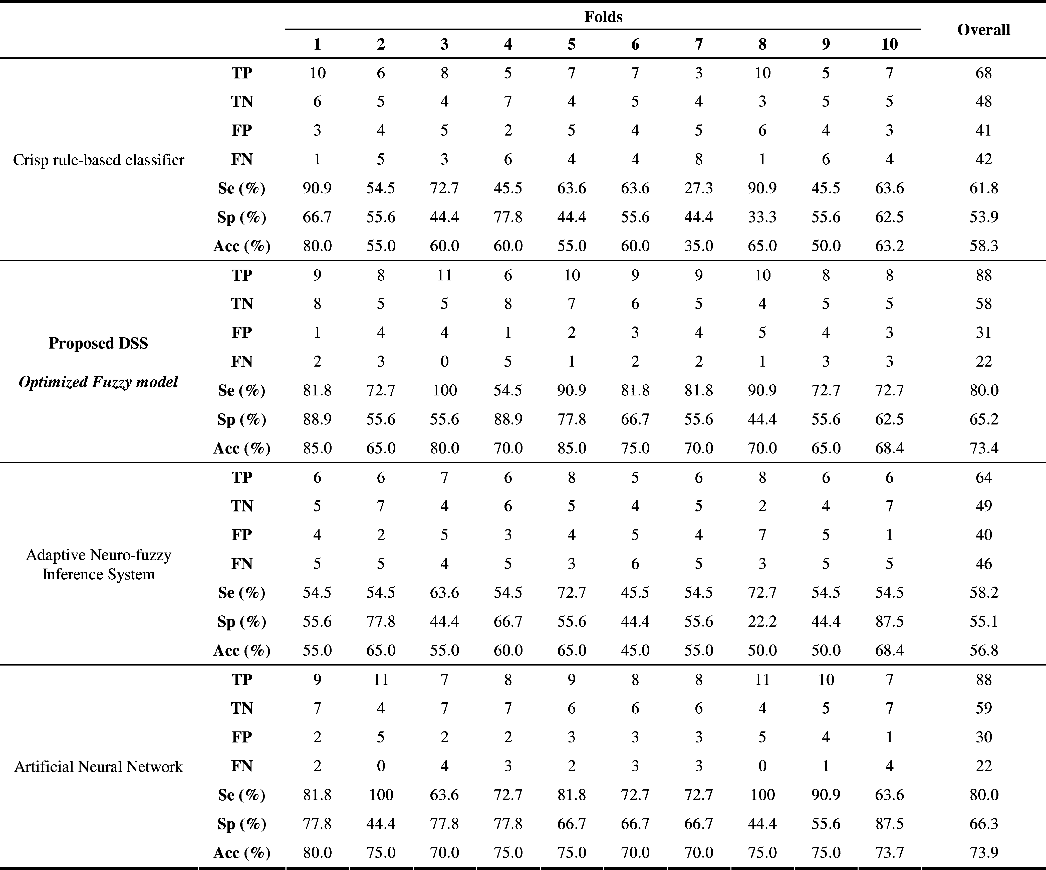

accuracy, improving by 15.1% the corresponding accuracy of the crisp model (58.3%). The error rates for each fold are defined as *em,i* = 1 acc*m,i*, where acc*m,i* is the accuracy of the model *m* (crisp or fuzzy) using fold *i* and can be approximated us- ing normal distributions [39]. Defining *di* = *e*fuzzy*,i e*crisp*,i* as the difference between the error rates of the two mod- els during the *i*th fold, then *di* is also normally distributed, with mean value *dt*, which is the true difference of the error

−

| − |

Σ=

does not span the zero value, and thus, the observed difference is statistically significant.

To compare the proposed method, we also employed two widely used classification methodologies: feed-forward artifi- cial neural networks (ANNs) and adaptive neuro-fuzzy infer- ence system (ANFIS) [40]. The ANNs are well known and widely used classifiers. They have proven to be very effective in many applications. On the other hand, the neuro-fuzzy tech-

rates, and variance *℘*ˆ2

*d*

*t*

*k*

*i*=1

(*di* − *d*¯)2 */*(*k*2 − *k*), where *k*

niques, such as ANFIS, have emerged from the fusion of arti-

is the number of degrees of freedom (i.e., number of folds) ficial neural networks and fuzzy inference systems and form a

and *d*¯ = 1*/k* Σ*k di*. In this case, the confidence interval of popular framework for solving real-world problems. They com-

*i*=1

¯

*d*

±

2

*t* is defined as *dt* = *d tcl,k*−1 *℘*ˆ*dt* , where *tcl,k*−1 is the *t*-

distribution at confidence level *cl* and with the number of de- grees of freedom *k*. At 95% confidence level and using ten folds, *t*0*.*95*,*9 = 2.26 [39], and thus, the confidence interval for the difference *dt* is given as *dt* = *d*¯ 2.26 *℘*ˆ*d* . Comparing the crisp model with the fuzzy optimized model, the confidence

interval for *dt* at 95% confidence level is 0.15 ± 0.075, which

±

bine the effectiveness and the optimization framework of the

ANNs with interpretability of fuzzy inference systems. Both

the ANNs and ANFIS classification methodologies were cre- ated and evaluated using the same tenfold training and test sets. The ANNs architecture was an input layer consisting of 19 neurons (one for each of the 19 features shown in Table II), one hidden layer with 10 hidden neurons, and one output layer with a

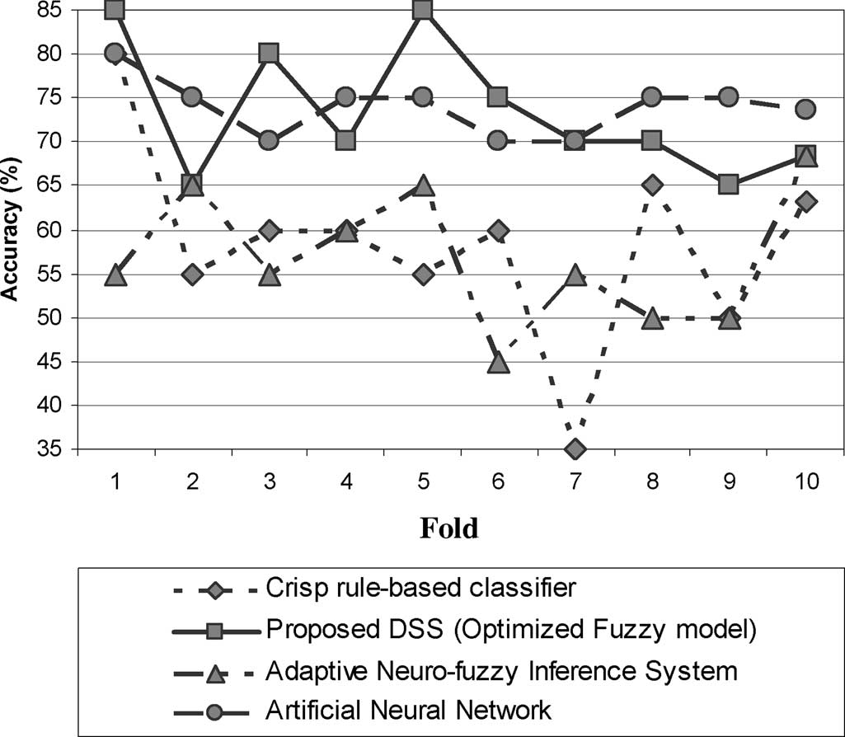

Fig. 5. Graphical representation of the obtained results presented in Table II.

single neuron. The activation functions were sigmoid functions except for the output layer, which was a linear function. The number of training epochs was set to 100, and the mean square error was used as cost function. For every fold, ten different initializations of the weights were made, and the one with the best results is reported in Table II. The ANFIS is based on a Sugeno type fuzzy system. The 19 features, described before, are used as inputs, and the fuzzy inference system is created using subtractive clustering. For optimization, the back propa- gation algorithm was employed, with 100 epochs. The results are presented in Table II, while a graphical representation of them is shown in Fig. 5. The results obtained from the crisp rule based classifier and the ANFIS are similar (58.3% and 56.8%, respectively), while the ANNs and the proposed DSS presented significantly better results (73.9% and 73.4%, respectively).

* 1. DISCUSSION

In this paper, we introduced a DSS for the diagnosis of CAD, which is automatically generated from a novel data-driven four- stage methodology. Initially, a set of rules is constructed from a decision tree induced by the training records, and crisp rules are extracted from this tree, forming a crisp model. Then, the crisp model is transformed to fuzzy, and, finally, the parameters of this fuzzy model are optimized. The classification results of the crisp rule-based classifier are significantly improved when it is transformed to a fuzzy model and its parameters are optimized. The improvement in accuracy ranges from 5% to 35% (see Table II) when considering each fold separately, while the over- all improvement in accuracy is 15%. Furthermore, the proposed methodology reported comparable performance with the ANNs (73.4% vs. 73.9%, respectively) and significantly better results than the ANFIS.

The crisp model is based on axis-parallel decision boundaries. This is a limitation that can be treated with the fuzzyfication of the crisp rules, which introduces flexibility in the decision

boundaries [41]. The fuzzy model is a generalization of the crisp model (since the parameters of the fuzzy model can be set so as to resemble the crisp model) having a larger number of parameters that can be tuned in order to create non-axis-parallel decision boundaries, which reflect the underline properties of a given dataset more accurately. The ANNs have proven to be very efficient and effective classifiers; in our problem, slightly outperformed the proposed optimized fuzzy model by 0.5%. However, the proposed approach is able to provide interpretation for its decisions, while the ANNs cannot provide clear and direct interpretation [42]. The incorporation of decision trees in the first stage of the proposed methodology bestows an advantage as compared to the ANFIS (which is a methodology having several similarities with our approach), since it provides an initialization of the fuzzy model [41]; this feature is not present in the ANFIS, thus requiring high-complexity fuzzy models in order to achieve high classification accuracy.

The proposed DSS requires only easily obtained data, such as patient’s demographic and clinical data, that may derive from the patient’s medical history, routine blood tests, physical ex- amination, and noninvasive simple investigations to determine arterial stiffness. All these variables may be obtained very fast and at a low cost in an out-patient clinic, do not require special training or expertise, and, most importantly, do not expose the patient to any potential harm. All of them constitute a major advantage of the proposed DSS for CAD diagnosis. Another very important issue is the quality of the dataset. The proposed DSS is generated using a high-quality initial dataset; CA was performed to all subjects, ensuring, thus, the correctness of the final diagnosis (normal or CAD) since CA is considered to be the “gold standard” for the diagnosis of CAD.

Arterial stiffness that can be assessed noninvasively using PWVcf (i.e., PWV along the aorta) and AIx has been strongly related to atherosclerosis at various sites in the vascular tree [26] and future cardiovascular events in several patient groups [43]– [45]. The PWVcf is a simple reproducible, noninvasive mea- surement, which has been shown to be a reliable predictor of cardiovascular risk in end-stage renal disease [43], essential hypertension [44], diabetes, and glucose intolerance [45]. A correlation of the PWV with the extent of CAD in patients un- dergoing diagnostic CA has also been shown [46], [47]. The AIx is an independent predictor of all-cause, including cardio- vascular, mortality in end-stage renal disease patients [48], and is also strongly and independently correlated with the pres- ence and the extent of CAD in males, especially in younger populations [49]. However, in our dataset, these indices have not been valuable contributors in the diagnostic process. They have not been included in any of the rules derived to diagnose CAD in males, and they are only used to a limited extent in females.

Gender is the most important feature in the produced set of rules; it is used in all induced trees in the root. However, this is partially driven from the dataset since 64% of our male popula- tion (98/152) was diagnosed with CAD as compared with 25% (12/47) in the female population. Smoking has also been proven to be an important marker for CAD prediction in women; 77% of nonsmoking women did not suffer from CAD (33/42). In

TABLE III

TRADITIONAL METHODS USED IN THE CLINICAL SETTING FOR THE DIAGNOSIS OF CAD

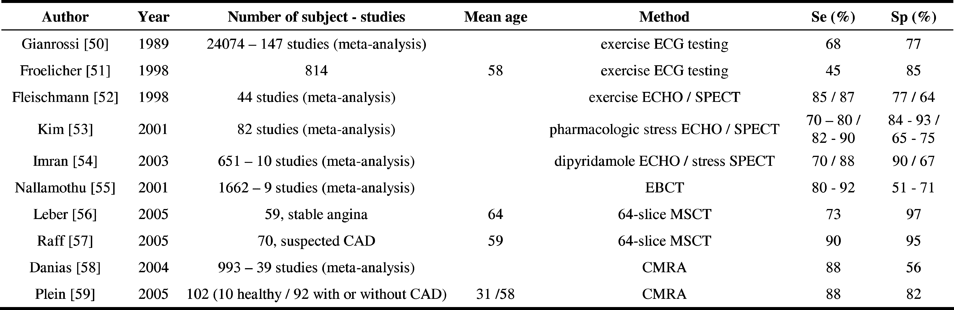

general, the smoking history was included in almost all induced trees (excluded in only one tree). In the male population, low HR (i.e., *<*=49 beats per minute) was found to be an impor- tant predictor of CAD; this might be explained by the use of *β*-blockers (antianginal medications that lower HR) in subjects with very high clinical suspicion of CAD. Also, it appears that elderly males (i.e., age *>*69 years) with symptoms and signs of CAD have high probability to be diagnosed with CAD, since CAD was found in 92% (24/26) of our elderly male population. In males aged less than 69 years, family history of CAD appears to be a relatively important diagnostic feature for CAD (76% of those with positive family history had CAD, i.e., 26/34). However, some of the derived rules cannot be fully explained based on standard medical knowledge, mainly due to the data- driven nature of the proposed method, which can also discover unimportant and spurious rules.

In Table III, noninvasive methods used in the clinical set- ting for the diagnosis of CAD are presented. Exercise ECG testing is the most commonly used method for the diagnosis of CAD mainly because of its low cost and wide availability. However, it cannot be applied to all patients with suspected CAD (e.g., patients with disabilities) and has a relatively low sensitivity and specificity [50], [51]. Stress ECHO and scintig- raphy (using exercise or pharmacological stimuli) are methods of low-to-moderate cost, as they use special technical equip- ment that is available in cardiological centers, and therefore, are used widely for the diagnosis of CAD and at low risk for the patient, except for scintigraphy that involves radiation and cannot be used very frequently. However, the sensitivity and specificity reported in several studies vary largely among them, explained partially by differences in stress protocols used and expertise in results’ interpretation [52]–[54]. The EBCT is a method that needs highly specialized equipment, confers high radiation doses, and reveals the calcium burden of the coronary tree, thus limiting its value mainly for risk stratification and not for diagnostic purposes [55]. Finally, the MSCT and CMRA are both rapidly evolving, promising methods for the diagnosis of CAD. Despite their effectiveness, the CMRA and MSCT are methods of very high cost that require specialized equipment

and highly trained personnel, and thus, with very low avail- ability. Furthermore, they cannot be applied to a considerable percentage of patients due to several technical limitations (e.g., motion and respiratory artifacts, claustrophobia and metallic devices for the CMRA), while the MSCT involves significant radiation exposure [56]–[59]

In Table IV, we present a comparison of several computer- aided diagnosis methodologies for CAD. Again, direct compar- ison cannot be derived since different features and datasets have been used and also the populations vary significantly. In some of the studies, only male subjects were included [5], [6], [21], [24], while the mean age and age range of subjects that could ex- plain differences in results is not mentioned in most of them. Our study population included patients without known CAD referred for angiography, while in some studies, subjects with previous MI or coronary artery bypass grafting (CABG) were also included [21], [23], [26]. The parameters collected and an- alyzed also differ among studies. In our approach, only demo- graphic data, laboratory investigations, and indices of arterial stiffness are used; these are of low cost, easily, rapidly, and safely obtained in an out-patient basis, without the need of spe- cially trained personnel. In [22], a subset of our dataset has been used and comparable performance has been reported, us- ing neural networks and support vector machines. However, the employment of exercise ECG imposes a limitation to use it to patients with disabilities. The work presented in [20] attained higher sensitivity and specificity in predicting artery disease in ophthalmic or internal carotid artery by using a number of pa- rameters obtained from the specific artery. On the contrary, we do not use only vascular data acquired from the radial, carotid, and femoral arteries, but also demographic and clinical ones, to address CAD diagnosis. It should be mentioned that most of the methods reported in Table IV are based on neural networks [13], [14], [17], [20]–[24], [26]. These methods are not able to pro- vide clear interpretation for their decisions. On the other hand, our DSS is able to provide the desired comprehensibility since it is based on a set of rules.

However, the proposed methodology presents some limita- tions. The studied population was of high risk for CAD, and

TABLE IV

COMPARISON OF SEVERAL COMPUTER-AIDED DIAGNOSIS-BASED METHODOLOGIES FOR CAD DIAGNOSIS

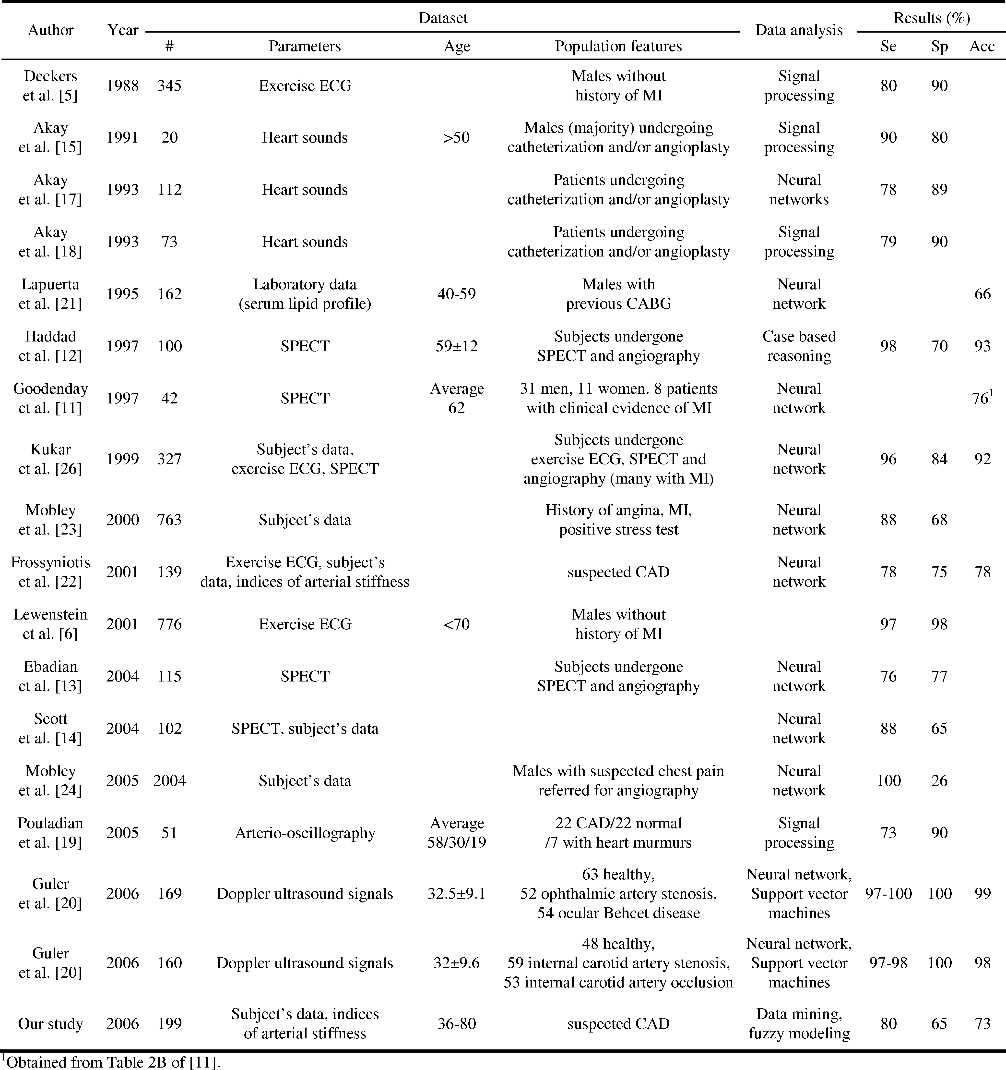

thus, the results are not representative for the general population. However, the percentage of subjects with normal vessels was rather high for high-risk population; 35,53% in males and 74,47% in females, especially as compared to other studies that report a percentage incidence of normal vessels among subjects without known CAD referred on an elective basis for their first CA. Further studies need to be performed in order to create a DSS that could accurately diagnose CAD in the general popu-

lation. Also, the extension of the DSS to the determination of CAD’s severity is of great interest.

* 1. CONCLUSION

We have presented a novel DSS for the diagnosis of CAD. The employment of easily obtained features with the interpretation ability proves the efficiency and the reliability of the method.

The obtained results indicate that the proposed optimized fuzzy model DSS improves by 15% in terms of accuracy the results of the crisp rule-based classifier, while it compares well with other widely used classification schemes such as the ANFIS and ANNs. Furthermore, the proposed DSS is automatically generated using the proposed data-driven methodology; only an initial annotated dataset is needed in order to create a DSS for a specific domain of application. This allows our methodology to be easily applied to other domains, medical or not.

ACKNOWLEDGMENT

The authors would like to thank Prof. M. Akay for his support during this research.

REFERENCES

1. G. De Backerxs, E. Ambrosioni, K. Borch-Johnsen, C. Brotons,

R. Cifkova, J. Dallongeville, S. Ebrahim, O. Faergeman, I. Graham,

G. Mancia, V. M. Cats, K. Orth-Gomer, J. Perk, K. Pyorala, J. L. Rodicio,

S. Sans, V. Sansoy, U. Sechtem, S. Silber, T. Thomsen, and D. Wood, “Eu- ropean guidelines on cardiovascular disease prevention in clinical practice: Third joint task force of European and other societies on cardiovascular disease prevention in clinical practice (constituted by representatives of eight societies and by invited experts),” *Eur. J. Cardiovasc. Prev. Reha- bil.*, vol. 10, no. 4, pp. S1–S10, 2003, European Society of Cardiology Committee for Practice Guidelines.

1. E. Escolar, G. Weigold, A. Fuisz, and N. J. Weissman, “New imaging techniques for diagnosing coronary artery disease,” *CMAJ*, vol. 174, no. 4, pp. 487–495, 2006.
2. L. Goldberger and E. Goldberger, *Clinical Electrocardiography*. Saint Louis, MO: Mosby Company, 1977.
3. R. J. Gibbons, G. J. Balady, J. T. Bricker, B. R. Chaitman, G. F. Fletcher,

V. F. Froelicher, D. B. Mark, B. D. McCallister, A. N. Mooss,

M. G. O’Reilly, W. L. Winters, Jr, R. J. Gibbons, E. M. Antman,

J. S. Alpert, D. P. Faxon, V. Fuster, G. Gregoratos, L. F. Hiratzka,

A. K. Jacobs, R. O. Russell, and S. C. Smith, Jr, “ACC/AHA 2002 guide- line update for exercise testing: Summary article: A report of the American college of cardiology/American heart association task force on practice guidelines (committee to update the 1997 exercise testing guidelines),” *Circulation*, vol. 106, no. 14, pp. 1883–1892, 2002, American College of Cardiology/American Heart Association Task Force on Practice Guide- lines (Committee to Update the 1997 Exercise Testing Guidlines).

1. J. W. Deckers, B. J. Rensing, R. V. H. Vinke, and M. L. Simoons, “Com- parison of exercise algorithms for diagnosis of coronary artery disease,” in *Proc. Comput. Cardiology*, 1988, pp. 231–234.
2. K. Lewenstein, “Radial basis function neural network approach for the diagnosis of coronary artery disease based on the standard electrocardio- gram exercise test,” *Med. Biol. Eng. Comput.*, vol. 39, pp. 1–6, 2001.
3. F. Ng, S. Wong, F. Mora, G. Passariello, and D. Almeida, “Diagnostic value of QT interval hysteresis loop in coronary artery disease,” in *Proc. Comput. Cardiol.*, 1998, pp. 417–420.
4. M. Sabry-Rizk, S. El-Khafif, E. Carson, W. Zgallai, K. Grattan, C. Morgan, and P. Hardiman, “Suspicious polyphase patterns of normal looking ECGs provide fast early diagnoses of a coronary artery disease,” in *Proc. IEEE Eng. Med. Biol.*, Oct. 1999, vol. 2, pp. 1391–1393.
5. S. M. Szildgyi, L. Szildgyi, and L. David, “Assessment of R wave ampli- tude changes in coronary artery disease,” in *Proc. IEEE Eng. Med. Biol.*, Oct.–Nov. 1997, vol. 1, pp. 272–274.
6. E. J. Tkacz and P. Kostka, “An application of wavelet neural network for classification of patients with coronary artery disease based on HRV analysis,” in *Proc. IEEE Eng. Med. Biol.*, 2000, vol. 2, pp. 1391– 1393.
7. L. S. Goodenday, K. J. Cios, and I. Shin, “Identifying coronary stenosis using an image recognition neural network,” *IEEE Eng. Med. Biol. Mag.*, vol. 16, no. 5, pp. 139–144, Sep./Oct. 1997.
8. M. Haddad, K. P. Adlassnig, and G. Porenta, “Feasibility analysis of a case-based reasoning system for automated detection of coronary heart disease from myocardial scintigrams,” *Artif. Intell. Med.*, vol. 9, pp. 61– 78, 1997.
9. H. B. Ebadian, H. S. Zadeh, S. Setayeshi, and S. T. Smith, “Neural network and fuzzy clustering approach for automatic diagnosis of coronary artery disease in nuclear medicine,” *IEEE Trans. Nucl. Sci.*, vol. 51, no. 1, pp. 184–192, Feb. 2004.
10. J. A. Scott, K. Aziz, T. Yasuda, and H. Gewirtz, “Integration of clinical and imaging data to predict the presence of coronary artery disease with the use of neural networks,” *Coron. Artery Dis.*, vol. 15, no. 7, pp. 427–434, 2004.
11. M. Akay, W. Welkowitz, J. L. Semmlow, and J. Kostis, “Application of the ARMA method to acoustic detection of coronary artery disease,” *Med. Biol. Eng. Comput.*, vol. 37, no. 11, pp. 1095–1104, 1991.
12. M. Akay, W. Welkowitz, J. L. Semmlow, Y. M. Akay, and J. Kostis, “Non- invasive acoustical detection of coronary artery disease using the adaptive line enhancer method,” *Med. Biol. Eng. Comput.*, vol. 30, pp. 147–154, 1992.
13. M. Akay and W. Welkowitz, “Acoustical detection of coronary occlusions using neural networks,” *J. Biomed. Eng.*, vol. 15, pp. 469–473, 1993.
14. Y. M. Akay, M. Akay, W. Welkowitz, J. L. Semmlow, and J. Kostis, “Noninvasive acoustical detection of coronary artery disease: A compar- ative study of signal processing methods,” *IEEE Trans. Biomed. Eng.*, vol. 40, no. 6, pp. 571–578, Jun. 1993.
15. M. Pouladian, M. R. H. Golpayegani, A. A. Tehrani-Fard, and M. Bubvay- Nejad, “Noninvasive detection of coronary artery disease by arterio- oscillography,” *IEEE Trans. Biomed. Eng.*, vol. 52, no. 4, pp. 743–747, Apr. 2005.
16. I. Gu¨ler and E. D. U¨ beyli, “Automated diagnostic systems with diverse and composite features for Doppler ultrasound signals,” *IEEE Trans. Biomed. Eng.*, vol. 53, no. 10, pp. 1934–1942, Oct. 2006.
17. P. Lapuerta, S. P. Azen, and L. Labree, “Use of neural networks in predict- ing the risk of coronary artery disease,” *Comput. Biomed. Res.*, vol. 28, pp. 38–52, 1995.
18. D. Frossyniotis, S. Vrettos, D. Vogiatzis, A. Stafulopatis, C. Konstantinopoulos, D. I. Fotiadis, A. Likas, G. Potamias, A. Naka,

T. Tzimas, and L. K. Michalis, “An intelligent system for the early diag- nosis of coronary artery disease,” presented at the Int. Conf. NNESMED, 2001, Milos Island, Greece.

1. B. A. Mobley, E. Schechter, W. E. Moore, P. A. McKee, and J. E. Eichner, “Predictions of coronary artery stenosis by artificial neural network,” *Artif. Intell. Med.*, vol. 18, pp. 187–203, 2000.
2. B. A. Mobley, E. Schechter, W. E. Moore, P. A. McKee, and J. E. Eichner, “Neural network predictions of significant coronary artery stenosis in men,” *Artif. Intell. Med.*, vol. 34, pp. 151–161, 2005.
3. M. Kukar and C. Groselj, “Reliable diagnostics for coronary artery dis- ease,” in *Proc. IEEE Comput. Based Med. Syst.*, 2002, pp. 7–12.
4. M. Kukar, I. Kononenko, C. Groselj, K. Kralj, and J. Fettich, “Analysing and improving the diagnosis of ischaemic heart disease with machine learning,” *Artif. Intell. Med.*, vol. 16, pp. 25–50, 1999.
5. N. B. Merz, “Assessment of patients at intermediate cardiac risk,” *Amer.*

*J. Cardiol.*, vol. 96, (Suppl.), pp. 2J–10J, 2005.

1. N. M. van Popele, D. E. Grobee, M. L. Bots, R. Asmar, J. Topouchian,

R. S. Reneman, A. P. G. Hoeks, A. M. van der Kuip, A. Hofman, and

J. C. M. Witteman, “Association between arterial stiffness and atheroscle- rosis: The Rotterdam study,” *Stroke*, vol. 32, pp. 454–460, 2001.

1. D. I. Fotiadis, Y. Goletsis, A. Likas, and A. Papadopoulos, *Clinical De- cision Support Systems*. New York: Encyclopedia of Biomedical Engi- neering, Wiley, 2006.
2. J. R. Quinlan, *C4.5: Programs for Machine Learning*. San Mateo, CA: Morgan Kauffman, 1993.
3. F. M. Brown, *Boolean Reasoning: The Logic of Boolean Equations*, 2nd ed. New York: Dover Publications, 2003.
4. L. X. Wang, *A Course in Fuzzy Systems and Control*. Englewood Cliffs, NJ: Prentice-Hall, 1986.
5. F. V. Theos, I. E. Lagaris, and D. G. Papageorgiou, “PANMIN: Sequential and parallel global optimization procedures with a variety of options for the local search strategy,” *Comput. Phys. Commun*, vol. 159, pp. 63–69, 2004.
6. R. J. Woodman and G. F. Watts, “Measurement and application of arterial stiffness in clinical research: Focus on new methodologies and diabetes mellitus,” *Med. Sci. Monit.*, vol. 9, pp. RA101–RA109, 2003.
7. L. M. van Bortel, D. Duprez, M. J. Starmans-Kool, M. E. Safar,

C. Giannattasio, J. Cockroft, D. R. Kaiser, and C. Thuillez, “Clinical applications of arterial stiffness, task force III: Recommendations for user procedures,” *Amer. J. Hypertens.*, vol. 15, pp. 445–452, 2002.

1. M. F. O’Rourke and D. E. Gallagher, “Pulse wave analysis,” *J. Hypertens.*, vol. 14, pp. 147–157, 1996.
2. I. B. Wilkinson, H. M. Callum, L. Flint, J. R. Cockcroft, D. E. Newby, and D. J. Webb, “The influence of heart rate on augmentation index and central arterial pressure in humans,” *J. Physiol.*, vol. 525.1, pp. 263–270, 2000.
3. M. G. Tsipouras, C. Voglis, and D. I. Fotiadis, “A framework for fuzzy expert system creation—Application to cardiovascular diseases,” *IEEE Trans. Biomed. Eng.*, vol. 54, no. 11, pp. 2089–2105, 2007.
4. P. N. Tan, M. Steinbach, and V. Kumar, *Introduction to Data Mining*. Reading, MA: Addison-Wesley, 2005.
5. J.-S. R. Jang and C.-T. Sun, “Neuro-fuzzy modeling and control,” *Proc. IEEE*, vol. 83, pp. 378–406, 1995.
6. J. Abonyi, H. Roubos, and F. Szeifert, “Data-driven generation of compact, accurate, and linguistically sound fuzzy classifiers based on a decision tree initialization,” *Int. J. Approx. Reason.*, vol. 31, no. 1, pp. 1–21, 2003.
7. V. Kecman, *Learning and Soft Computing: Support Vector Machines, Neural Networks and Fuzzy Logic Models*. Cambridge, MA: MIT Press, 2000.
8. J. Blacher, A. P. Guerin, B. Dannier, S. J. Marchais, M. E. Safar, and

G. M. London, “Impact of aortic stiffness on survival in end-stage renal disease,” *Circulation*, vol. 99, pp. 2434–2439, 1999.

1. S. Laurent, P. Boutouyrie, R. Asmar, I. Gautier, B. Laloux, L. Guize,

P. Ducimetiere, and A. Benetos, “Aortic stiffness is an independent pre- dictor of all-cause and cardiovascular mortality in hypertensive patients,” *Hypertension*, vol. 37, pp. 1236–1241, 2001.

1. K. Cruickshank, L. Riste, S. E. Anderson, J. S. Wright, G. Dunn, and
2. E. Gosling, “Aortic PWV and its relationship to mortality in diabetes and glucose intolerance: An integrated index of vascular function?,” *Cir- culation*, vol. 106, pp. 2085–2090, 2002.
3. Y. Koji, H. Tomiyama, H. Ischihashi, T. Nagae, N. Tanaka, K. Takazawa,
4. Ishimaru, and A. Yamashima, “Comparison of ankle-brachial pressure index and pulse wave velocity as markers of the presence of CAD in subjects with a high-risk of atherosclerosic cardiovascular disease,” *Amer. J. Cardiol.*, vol. 94, pp. 868–872, 2004.
5. Y. Oushi, K. Terashita, T. Nakamura, K. Yamaoki, Y. Yazaki, E. Toda,
6. Yamanushi, and H. Orimo, “Aortic PWV in patients with coronary atherosclerosis—A comparison with coronary angiographic findings,” *Nippon Igakkai Zasshi*, vol. 28, pp. 40–45, 1991.
7. G. M. London, J. Blacher, B. Pannier, A. P. Guerin, S. J. Marchais, and

M. E. Safar, “Arterial wave reflections and survival in end-stage renal failure,” *Hypertension*, vol. 38, pp. 434–438, 2001.

1. T. Weber, J. Auer, M. F. O’Rourke, E. Kvas, E. Lassnig, R. Berent, and

B. Eber, “Arterial stiffness, wave reflections, and the risk of coronary artery disease,” *Circulation*, vol. 109, pp. 184–189, 2004.

1. R. Gianrossi, R. Detrano, D. Mulvihill, K. Lehmann, P. Dubach,

A. Colombo, D. MacArthur, and V. Froelicher, “Exercise-induced ST depression in the diagnosis of coronary artery disease. A meta-analysis,” *Circulation*, vol. 80, pp. 87–98, 1989.

1. V. Froelicher, K. Lehmann, R. Thomas, S. Goldman, D. Morrison,

R. Edson, P. Lavori, J. Myers, C. Dennis, R. Shabetai, D. Do, and

J. Froning, “The electrocardiogrphic exercise test in a population with reduced workup bias: Diagnostic performance, computerized interpre- tation, and multivariate prediction,” *Ann. Int. Med.*, vol. 128, no. 12, pt. 1, pp. 965–974, 1998, The Veterans Affairs Cooperative Study In Health Services #016 (QUEXTA) Study Group.

1. K. E. Fleischmann, M. G. Hunink, K. M. Kuntz, and P. S. Douglas, “Exercise echocardiography or exercise SPECT imaging? A meta-analysis of diagnostic test performance,” *JAMA*, vol. 280, no. 10, pp. 913–920, 1998.
2. C. Kim, Y. S. Kwok, P. Heagerty, and R. Redberg, “Pharmacologic stress testing for coronary disease diagnosis: A meta-analysis,” *Amer. Heart J.*, vol. 142, no. 6, pp. 934–44, 2001.
3. M. B. Imran, A. Palinkas, and E. Picano, “Head-to-head comparison of dipyridamole echocardiography and stress perfusion scintigraphy for the detection of coronary artery disease: A meta-analysis. Comparison be- tween stress echo and scintigraphy,” *Int. J. Cardiovasc. Imag.*, vol. 19, no. 1, pp. 23–28, 2003.
4. B. K. Nallamothu, S. Saint, L. F. Bielak, S. S. Sonnad, P. A. Peyser,

M. Rubenfire, and A. M. Fendrick, “Electron-beam computed tomography in the diagnosis of coronary artery disease: A meta-analysis,” *Arch. Int. Med.*, vol. 161, no. 6, pp. 833–838, 2001.

1. A. W. Leber, A. Knez, F. von Ziegler, A. Becker, K. Nikolaou,

S. Paul, B. Wintersperger, M. Reiser, C. R. Becker, G. Steinbeck, and

P. Boekstegers, “Quantification of obstructive and nonobstructive coro- nary lesions by 64-slice computed tomography: A comparative study with

quantitative coronary angiography and intravascular ultrasound,” *J. Amer. Coll. Cardiol.*, vol. 46, no. 1, pp. 147–54, 2005.

1. G. L. Raff, M. J. Gallagher, W. W. O’Neill, and J. A. Goldstein, “Di- agnostic accuracy of noninvasive coronary angiography using 64-slice spiral computed tomography,” *J. Amer. Coll. Cardiol.*, vol. 46, no. 3, pp. 552–557, 2005.
2. P. G. Danias, A. Roussakis, and J. P. Ioannidis, “Diagnostic performance of coronary magnetic resonance angiography as compared against con- ventional X-ray angiography: A meta-analysis,” *J. Amer. Coll. Cardiol.*, vol. 44, no. 9, pp. 1867–1876, 2004.
3. S. Plein, A. Radjenovic, J. P. Ridgway, D. Barmby, J. P. Greenwood,

S. G. Ball, and M. U. Sivananthan, “Coronary artery disease: Myocar- dial perfusion MR imaging with sensitivity encoding versus conventional angiography,” *Radiology*, vol. 235, no. 2, pp. 423–430, 2005.

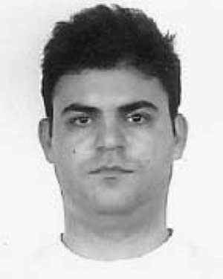**Markos G. Tsipouras** (S’07) was born in Athens, Greece, in 1977. He received the Diploma, M.Sc., and Ph.D. degrees in computer science from the De- partment of Computer Science, University of Ioan- nina, Ioannina, Greece, in 1999, 2002, and 2008, respectively.

He is currently a Researcher at the Unit of Medi- cal Technology and Intelligent Information Systems, University of Ioannia. His research interests include biomedical engineering, decision support and medi- cal expert systems, and biomedical applications.

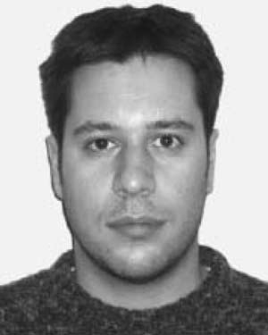**Themis P. Exarchos** (S’07) was born in Ioannina, Greece, in 1980. He received the Diploma degree in computer engineering and informatics from the University of Patras, Patras, Greece, in 2003. He is currently working toward the Ph.D. degree in med- ical physics at the Department of Medical Physics, Medical School, University of Ioannina, Ioannina.

He is with the Unit of Medical Technology and Intelligent Information Systems, Department of Computer Science, University of Ioanniana. His cur- rent research interests include medical data min-

ing, decision support systems in healthcare, and biomedical applications and bioinformatics.

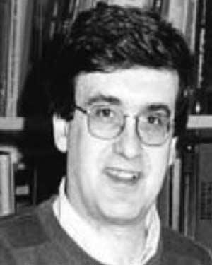**Dimitrios I. Fotiadis** (M’01–SM’06) was born in Ioannina, Greece, in 1961. He received the Diploma degree in chemical engineering from the National Technical University of Athens, Athens, Greece, and the Ph.D. degree in chemical engineering from the University of Minnesota, Twin Cities.

Since 1995, he has been with the Unit of Medi- cal Technology and Intelligent Information Systems, Department of Computer Science, University of Ioan- nina, Ioannina, where he is currently the Director and an Associate Professor. His current research interests

include biomedical technology, biomechanics, scientific computing, and intel- ligent information systems.

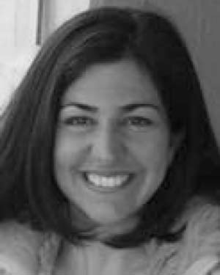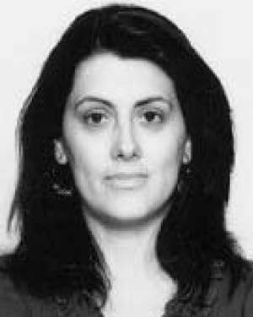**Anna P. Kotsia** was born in Ioannina, Greece, in 1977. She received the Graduate degree (with distinc- tion) in 2002 from the Medical School, University of Ioannina, Ioannina, where she is currently working toward the Ph.D. degree in cardiology.

She was a Trainee in internal medicine. Her cur- rent research interests include interventional cardiol- ogy and vascular endothelial function.

**Katerina K. Naka** was born in Ioannina, Greece, in 1971. She received the M.D. degree (with dis- tinction) from the Medical School, University of Ioannina, Ioannina, in 1994, and the Ph.D. degree in cardiology from the University of Wales College of Medicine, Cardiff, Wales, U.K., in 2003.

She was a Trainee in Cardiology. She is currently with the Medical School, University of Ioannina, as a Lecturer in Cardiology. Her current research interests include vascular endothelial function, large arterial mechanics, heart failure, and bioengineering.

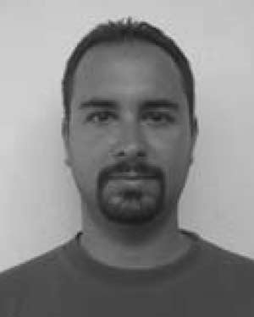**Konstantinos V. Vakalis** was born in Ioannina, Greece, in 1979. He received the Graduate degree in 2004 from the Medical School, University of Ioannina, Ioannina, where he is currently working toward the Ph.D. degree in cardiology.

He is with the Michaelidion Cardiology Centre, University of Ioannina. His current research interests include arterial stiffness and coronary artery disease.

**Lampros K. Michalis** was born in Arta, Greece, in 1960. He received the M.D. (with distinction) and Ph.D. degrees (with distinction) in cardiology from the Medical School, University of Athens, Athens, Greece, in 1984 and 1989, respectively.

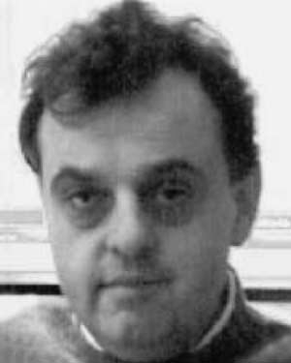Since 1995, he has been with the Medical School, University of Ioannina, Ioannina, Greece, where he is currently a Professor of Cardiology. He is the In- charge of the Coronary Care Unit and the Catheter Laboratory, University Hospital, Medical School, University of Ioannina. His current research inter-

ests include bioengineering and interventional cardiology.