Expert Systems with Applications 36 (2009) 7675–7680



Contents lists available at [ScienceDirect](http://www.sciencedirect.com/science/journal/09574174)

Expert Systems with Applications

journal homepage: [www.elsevier.com/locate/eswa](http://www.elsevier.com/locate/eswa)

Effective diagnosis of heart disease through neural networks ensembles

Resul Das a,*, Ibrahim Turkoglu b, Abdulkadir Sengur b

a *Department of Informatics, Firat University, 23119 Elazig, Turkey*

b *Department of Electronics and Computer Science, Firat University, 23119 Elazig, Turkey*

# a r t i c l e i n f o

*Keywords:*

Heart disease

SAS base software Neural networks Ensemble based model

# a b s t r a c t

In the last decades, several tools and various methodologies have been proposed by the researchers for developing effective medical decision support systems. Moreover, new methodologies and new tools are continued to develop and represent day by day. Diagnosing of the heart disease is one of the impor- tant issue and many researchers investigated to develop intelligent medical decision support systems to improve the ability of the physicians. In this paper, we introduce a methodology which uses SAS base

software 9.1.3 for diagnosing of the heart disease. A neural networks ensemble method is in the centre of the proposed system. This ensemble based methods creates new models by combining the posterior

probabilities or the predicted values from multiple predecessor models. So, more effective models can be created. We performed experiments with the proposed tool. We obtained 89.01% classiﬁcation accu- racy from the experiments made on the data taken from Cleveland heart disease database. We also obtained 80.95% and 95.91% sensitivity and speciﬁcity values, respectively, in heart disease diagnosis.

© 2008 Elsevier Ltd. All rights reserved.

1. Introduction

Heart disease, which is usually called coronary artery disease (CAD), is a broad term that can refer to any condition that affects the heart (http://yourtota[lhealth.ivillage.com/heart-disease-fast-](http://yourtotalhealth.ivillage.com/heart-disease-fast-) facts.html, 2008). CAD is a chronic disease in which the coronary arteries gradually harden and narrow and the most common form of cardiovascular disease in the United States and the leading cause of heart attacks. Moreover, cardiovascular disease is the leading

killer of American women, causing almost 500,000 deaths every

year (http://yourtota[lhealth.ivillage.com/heart-disease-fast-facts.](http://yourtotalhealth.ivillage.com/heart-disease-fast-facts) html, 2008).

While many people with heart disease have symptoms such as

chest pain and fatigue, as many as 50% have no symptoms until a

heart attack occurs. According to the American heart association (AHA), CAD is the leading killer of American men and women, responsible for more than one of every ﬁve deaths in 2001 (http://www.[americanheart.org,](http://www.americanheart.org/) 2008). Many statistics show CAD as the leading cause of premature and permanent disability among

American workers.

There are many risk factors associated with CAD. Some risk fac-

tors for CAD, such as your sex, age and family history, cannot be

changed. Other risk factors for CAD that are related to lifestyle

often can be changed (http://yourtota[lhealth.ivillage.com/heart-](http://yourtotalhealth.ivillage.com/heart-) disease-fast-facts.html, 2008). For example, smoking, high choles-

* Corresponding author.

*E-mail address:* [rdas@ﬁrat.edu.tr](mailto:rdas@firat.edu.tr) (R. Das).

high blood pressure and physical inactivity are all risk factors for coronary artery disease that can be modiﬁed and in some cases eliminated with lifestyle changes and medication. Diabetes and

obesity can sometimes be prevented when lifestyle changes are made early in life.

terol,

Having so many factors to analyze to diagnose the heart dis- eases, physicians generally make decisions by evaluating the cur- rent test results of the patients. The previous decisions made on other patients with the same condition are also examined by the physicians. These complex procedures are not easy when consider- ing the number of factors that the physician has to evaluate. So, diagnosing the heart disease of a patient involves experience and

highly skilled physicians.

Recent advances in the ﬁeld of artiﬁcial intelligence have led to the emergence of expert systems for medical applications. More- over, in the last few decades computational tools have been de- signed to improve the experiences and abilities of physicians for making decisions about their patients. Motivated by the need of such an expert system, in this study, we propose a method to efﬁ- ciently diagnose the heart disease. The proposed system uses neu- ral networks ensemble model. Ensemble based methods enable an increase in generalization performance by combining several indi- vidual neural networks train on the same task. We realized our proposal with SAS base software 9.1.3 (licence number: 291468). SAS enterprise miner streamlines the entire data mining process from data access to model assessment. It supports all necessary tasks within a single, integrated solution while providing the ﬂex- ibility for efﬁcient collaborations. We obtained 89.01% classiﬁca- tion accuracy from the experiments made on the data taken from

***acer***

*2018-05-21 17:39:04*

--------------------------------------------

risk factors

***acer***

*2018-05-21 17:40:40*

--------------------------------------------

challenge

0957-4174/$ - see front matter © 2008 Elsevier Ltd. All rights reserved. doi:10.1016/j.eswa.2008.09.013

7676 *R. Das et al. / Expert Systems with Applications 36 (2009) 7675–7680*

Cleveland heart disease database. We also obtained 80.95% and 95.91% sensitivity and speciﬁcity values, respectively, in heart dis- ease diagnosis.

The remaining of the paper is organized as follows. We present a brief overview on related work, dataset description, neural net- works and ensemble based methods in the background section. Basic descriptions for this study can be found in this section. Methodology and implementation of the proposed system is de- scribed in Section 3. The components of the SAS base software are introduced brieﬂy. The implementation constraints are also gi- ven in this section. Experimental results are discussed in Section

4. The SAS base software represents several statistical evaluation tests and different graphics for the users. Brief explanation can also be found in this section. In Section 5, we ﬁnally conclude our study.

1. Background
   1. *A brief overview on related works*

So far a great variety of classiﬁcation algorithms have been em- ployed on Cleveland heart disease database and high classiﬁcation accuracies have been reported in the last decades (ftp://ftp.ics.u- ci.edu/pub/ma, 2008; Cheung, 2001; Polat et al., 2005; Ozsen & Gunes, in press; [http://www.phys.uni.toru,](http://www.phys.uni.toru/) 2008). Robert Detrano, who constructed the Cleveland heart disease database, used logis-

tic regression algorithm and obtained 77.0% classiﬁcation accuracy (ftp://ftp.ics.uci.edu/pub/ma, 2008). Newton Cheung utilized C4.5,

Naïve Bayes, BNND and BNNF algorithms and reached the classiﬁ- cation accuracies of 81.11%, 81.48%, 81.11% and 80.96%, respec- tively ( Cheung, 2001). Polat et al. proposed a method that uses artiﬁcial immune system (AIS) and obtained 84.5% classiﬁcation accuracy (Polat et al., 2005). Then, a similar method was used by Ozsen and Gunes and 87.0% classiﬁcation accuracy was reported (Ozsen & Gunes, in press). Moreover, more results were reported by using ToolDiag, RA and WEKA tools in the following reference (http://www.[phys.uni.toru,](http://www.phys.uni.toru/) 2008). As can be seen from the related reference the reached higher classiﬁcation accuracy was 77% when these tools were used.

* 1. *Database description*
  2. *Neural networks*

Artiﬁcial neural networks were originally developed by researchers who were trying to mimic the neurophysiology of the human brain (Bishop, 1995). By combining many simple com- puting elements (neurons or units) into a highly interconnected system, a complex phenomenon such as intelligence was indented to produce. A schematic diagram for an artiﬁcial neuron model is shown in Fig. 1. Nowadays, neural network researchers have incor- porated methods from statistics and numerical analysis into their networks. More speciﬁcally, feedforward neural networks are a class of ﬂexible nonlinear regression, discriminant and data reduc- tion models. By detecting complex nonlinear relationships in data, neural networks can help to make predictions about real-world problems (Sengur et al., 2007).

The neural network node provides a variety of feedforward net-

works that are commonly called backpropagation networks. Back- propagation refers to the method for computing the error gradient for a feedforward network, a straightforward application of the chain rule of elementary calculus (Hanbay et al., 2008). By exten- sion, backpropagation refers to various training methods that use backpropagation to compute the gradient. By further extension, a backpropagation network is a feedforward network trained by any of various gradient descent techniques. There are numerous algorithms available for training neural network models; most of them can be viewed as a straightforward application of optimiza- tion theory and statistical estimation. Most of the algorithms used in training artiﬁcial neural networks are employing some form of gradient descent. This is done by simply taking the derivative of the cost function with respect to the network parameters and then changing those parameters in a gradient-related direction. The most popular of them is the back propagation algorithm, which has different variants. Standard backpropagation is a gradient des- cent algorithm. It is very difﬁcult to know which training algorithm will be the fastest for a given problem, and the best one is usually chosen by trial and error. An ANN with a back propagation algo- rithm learns by changing the connection weights, and these changes are stored as knowledge.

Neural networks are trained by experience, when applied an

unknown input to the network it can generalize from past experi- ences and product a new result. The output of the neuron net is gi- ven by the following equation:

The heart disease database was taken from UCI machine learn- ing repository (ftp://ftp.ics.uci.edu/pub/ma, 2008). The Cleveland heart disease data was obtained from V.A. Medical Center, Long Beach and Cleveland Clinic Foundation from Dr. Robert Detrano.

*m*

*y*ð*t* þ 1Þ¼ *a*

X

*j*¼1

*m*

X

*Wijxj*ð*t*Þ— h*i*!

The database contains 303 samples of which 297 are complete samples and six are samples with missing attributes. Origi- nally, the database has 76 raw attributes. However, all the published experiments only refer to 13 of them, and are listed as follows:

*f*1 , net*i* ¼ *wijxj* — h*i* ð1Þ

*j*¼1

* + 1. age,
    2. sex,
    3. chest pain type (four values),
    4. resting blood pressure,
    5. serum cholestoral in mg/dl,
    6. fasting blood sugar>120 mg/dl,
    7. resting electrocardiographic results (values 0, 1 and 2),
    8. maximum heart rate achieved,
    9. exercise induced angina,
    10. old peak = ST depression induced by exercise relative to rest,
    11. the slope of the peak exercise ST segment,
    12. number of major vessels (0–3) colored by ﬂourosopy,

## inputs

x1



wi1

outputs

wi2

f(.) a(.)

yi

wim

bias

x2

xm

## weights

i

* + 1. thal: 3 = normal; 6 = ﬁxed defect and 7 = reversable defect.

***acer***

*2018-05-21 17:41:51*

-------------------------------------------- BNND BNNF

Fig. 1. Artiﬁcial neuron model (Hanbay et al., 2008).

*R. Das et al. / Expert Systems with Applications 36 (2009) 7675–7680* 7677

where X = (*X*1, *X*2, .. ., *Xm*) represent the *m* input applied to the neu- ron, *Wi* represent the weights for input *Xi*, h*i* is a bias value and *a*(.) is activation function. There are many kind of activation function. Usually nonlinear activation functions such as sigmoid, step are used.

* 1. *Ensemble based methods*

The ensemble based methods creates new models by combining the posterior probabilities (for class targets) or the predicted val- ues (for interval targets) from multiple predecessor models. The new model is then used to score new data. Thus, this new model obtains an increase in generalization performance by combining several individual models trained on the same task (http://sup-

port.sas.com/d, 2008). A schematic illustration of ensemble model can be seen in Fig. 2.

The creation of an ensemble approach is often divided into two steps; (1) generate individual members, and (2) appropriately combine individual members’ outputs to constitute a new output. The basic method for forming ensemble based methods is to train each member model using random parameters. In the neural net- work context, these methods include techniques for training with different network topologies, different initial weights, different learning parameters, and learning different portions of the training set (Anastasiadis & Magoulas, 2006).

Moreover, methods for creating ensembles focus on creating classiﬁers that disagree on their decisions. In general terms, these methods alter the training process in an attempt to produce classi- ﬁers that will generate different classiﬁcations.

1. The proposed methodology and implementation

The proposed methodology, which is illustrated in Fig. 3, is implemented with the SAS base software 9.1.3. SAS enterprise

miner streamlines the entire data mining process from data access to model assessment. It supports all necessary tasks within a sin- gle, integrated solution while providing the ﬂexibility for efﬁcient collaborations (http://sup[port.sas.com/d,](http://support.sas.com/d) 2008). SAS enterprise miner is designed for data miners, marketing analysts, database marketers, risk analysts, fraud investigators, business managers, engineers and scientists who play strategic roles in identifying and solving critical business or research issues (http://sup- port.sas.com/d, 2008).

SAS base software 9.1.3 includes two different programs. These programs are called SAS enterprise guide 4.3 and SAS enterprise miner 5.2. While SAS enterprise guide 4.3 program was used for data preprocessing, SAS enterprise miner 5.2 program was used to analyze and recognize the heart disease by combining several neural networks with ensemble node. As can be seen from Fig. 3, the performed system is composed of ﬁve components. The brief description of each component is given in the following.

*Heart database* component holds the features that are used to characterize healthy persons and patients. As it was mentioned earlier, the database composed of 14 columns and 297 rows. About 13 columns indicate the features and one column indicates the class labels. Heart disease data set was transferred by using SAS

enterprise guide 4.3 to analyze in SAS enterprise miner 5.2.

*Data partition* component was used to partition the input data into train and validation data sets. Partitioning provides mutually exclusive data sets. Two or more mutually exclusive data sets share no observations with each other. Partitioning the input data re- duces the computation time of preliminary modeling runs.

*Variable selection* component was used in reducing the number of inputs by setting the status of the input variables that are not related to the target as rejected. Although rejected variables were passed to subsequent nodes in the process ﬂow, these vari- ables were not used as model inputs by a successor modeling node.

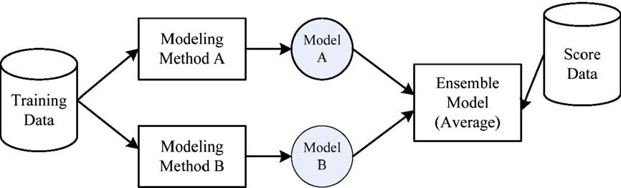

Fig. 2. A schematic illustration of ensemble model (http://support.sas.com/d, 2008).

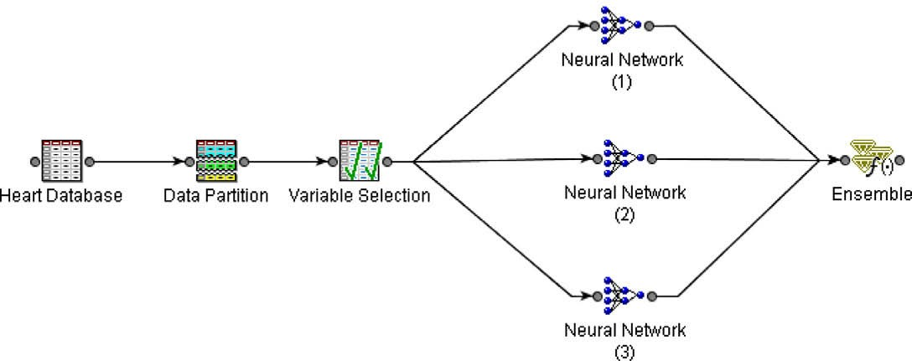

Fig. 3. Proposed system for heart disease recognition.

7678 *R. Das et al. / Expert Systems with Applications 36 (2009) 7675–7680*

*Neural networks block* component was used to classify the fea- ture space. Three independent neural networks models were used to construct this component. There are many types of neural net- works architectures; however, multi-layer feedforward neural net- work is the most widely used for prediction. A multi-layer feedforward neural network typically has an input layer, an output layer and one or more hidden layers. In multi-layer feedforward networks, neurons are arranged in layers and there is a connection among the neurons of other layers. The inputs are applied to the input layer the output layer contributes to the output directly. Other layers between input and output layers are called hidden layers. Inputs are propagated in gradually modiﬁed form in the for- ward direction, ﬁnally reaching the output layer. The backpropaga- tion learning algorithm has been used in the feedforward, single hidden layer neural network. The variants of the algorithm used in the study are the Levenberg–Marquardt (LM), scaled conjugate gradient (SCG) and Pola–Ribiere conjugate gradient (CGP) algo- rithms. A tangent sigmoid transfer function has been used for both the hidden layer and the output layer. We used 14 neurons in the hidden layer. The initial weights were chosen randomly.

*Ensemble* component was used to create new models by com-

bining the posterior probabilities (for class targets) or the pre- dicted values (for interval targets) from multiple predecessor models. The new model is then used to score new data.

1. Experimental results and discussion

In this study, there were two diagnosis classes: healthy and a patient who is subject to possible heart disease. As it was noted earlier in the background section, several researchers proposed various methods for diagnosing the heart disease. The reported accuracies vary between 50% and 87%. The database contains 303 samples of which 297 are complete samples and six are samples with missing attributes. While 70% of the heart disease database was used for training the neural networks ensemble model, the rest of the heart disease database (30%) was used for validation of the proposed system. As we mentioned earlier, three different independent neural networks models were combined for con- structing the ensemble model. We also increased the number of neural networks node in the ensemble model but no performance improvement was obtained.

Classiﬁcation results of the system were displayed by using a

confusion matrix. In a confusion matrix, each cell contains the raw number of exemplars classiﬁed for the corresponding combi- nation of desired and actual network outputs. Table 1 gives the confusion matrix showing the classiﬁcation results of this network. SAS enterprise miner 5.2 represents several performance evalu- ation tests for the users. Here, we only examined these test methods brieﬂy; meanwhile we represented our experimental results and the related displays and tables. Moreover a comparison table was constructed and can be found in this section. SAS enterprise miner

5.2 produces the following tables and plots in its results window: ﬁt statistics table, classiﬁcation chart, score rankings overlay chart, score rankings matrix chart, score distribution chart and ROC.

The ﬁt statistics table in the ensemble results window displays the several statistics for the train and validates data sets. This table is composed of 5 coulombs and 13 rows, respectively. The cou- lombs of the table are called as the target, ﬁt statistics, statistical labels, train and validation, respectively. The rows indicated the each statistical evaluation method. As can be seen from Table 2, the average proﬁt which can be called as accuracy was 86.4% and 89.011% for training and validation data sets, respectively. Another observation from Table 2 is that, while 10 of the validation data set were wrongly classiﬁed, 81 of the validation data set were cor- rectly classiﬁed.

Table 1

Classiﬁcation table

|  |  |  |  |  |  |  |  |  |
| --- | --- | --- | --- | --- | --- | --- | --- | --- |
| Target | Outcome | Target percentage | (%) | Outcome percentage | (%) | Count | Total percentage | (%) |
| 0 | 0 | 85.4545 | 95.9184 | | 47 | | 51.6484 | |
| 1 | 0 | 14.5455 | 19.0476 | | 8 | | 8.7912 | |
| 0 | 1 | 5.5556 | 4.0816 | | 2 | | 2.1978 | |
| 1 | 1 | 94.4444 | 80.9524 | | 34 | | 37.3626 | |

Table 2

Fit statistics for ensemble model

|  |  |  |  |  |
| --- | --- | --- | --- | --- |
| Target | Fit statistics | Statistics label | Train | Validation |
| sinif | _ERR_ | Error function | 124.2403 | 78.6215 |
| sinif | _SSE_ | Sum of squared errors | 39.16356 | 19.27484 |
| sinif | _MAX_ | Maximum absolute error | 0.927191 | 0.999591 |
| sinif | _DIV_ | Divisor for ASE | 412 | 182 |
| sinif | _NOBS_ | Sum of frequencies | 206 | 91 |
| sinif | _WRONG_ | Number of wrong classiﬁcations | 28 | 10 |
| sinif | _DISF_ | Frequency of classiﬁed cases | 206 | 91 |
| sinif | _MISC_ | Misclassiﬁcation rate | 0.135922 | 0.10989 |
| sinif | _PROF_ | Total proﬁt | 178 | 81 |
| sinif | _APROF_ | Average proﬁt | 0.864078 | 0.89011 |
| sinif | _ASE_ | Average squared error | 0.095057 | 0.105906 |
| sinif | _RASE_ | Root average squared error | 0.308313 | 0.325432 |
| sinif | _AVERR_ | Average error function | 0.301554 | 0.431986 |

Another evaluation display is the classiﬁcation table chart which displays a stacked bar chart of the classiﬁcation results for a categorical target variable. The following display shows an exam- ple of the classiﬁcation table chart (Fig. 4).

The horizontal axis displays the target levels that observations actually belong to. The color of the stacked bars identiﬁes the tar- get levels that observations are classiﬁed into. The height of the stacked bars represents the percentage of total observations.

In the score rankings chart, several statistics for each group of observations are plotted on the vertical axis. For a binary target, all observations in the scored data set are sorted by the posterior probabilities of the event level in descending order. For a nominal

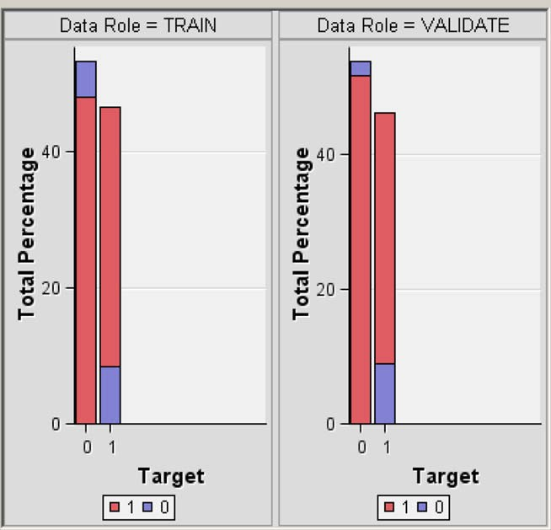

Fig. 4. Classiﬁcation table chart.

*R. Das et al. / Expert Systems with Applications 36 (2009) 7675–7680* 7679

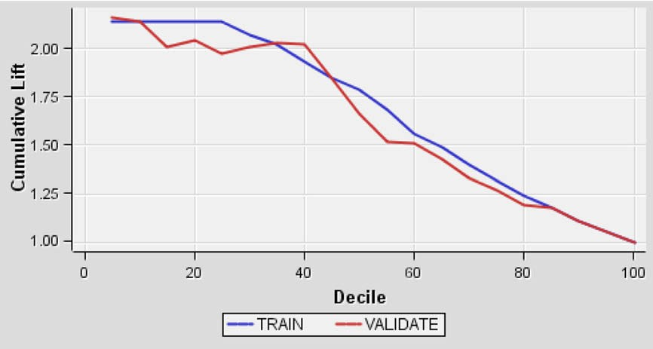

Fig. 5. Score ranking chart.

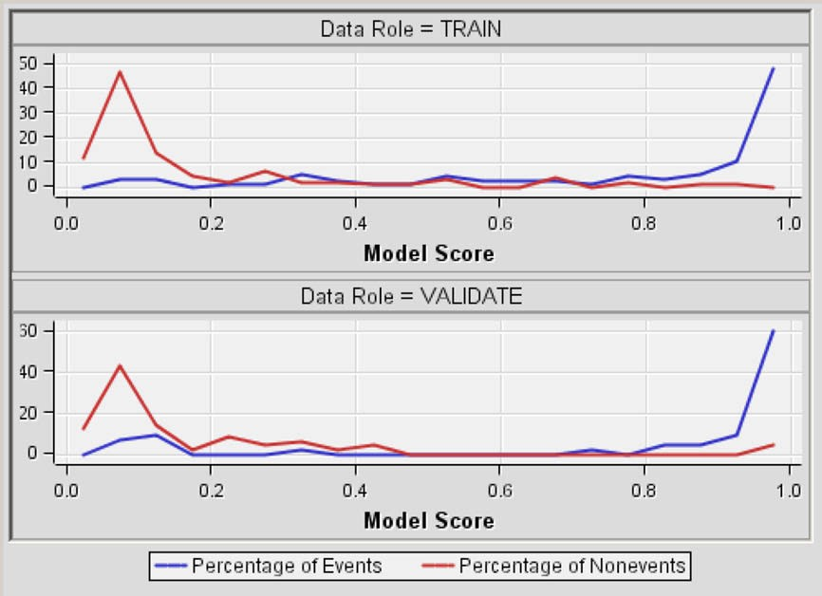

Fig. 6. The score distribution chart.

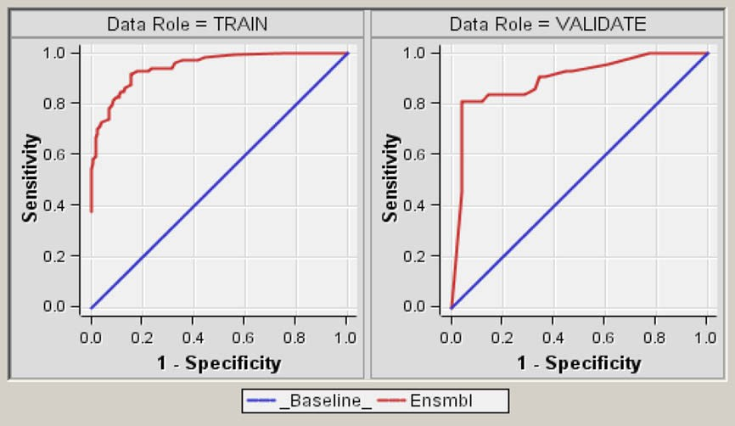

Fig. 7. ROC chart.

7680 *R. Das et al. / Expert Systems with Applications 36 (2009) 7675–7680*

Table 3

Classiﬁcation accuracies obtained with our proposed system and other classiﬁers from literature

|  |  |  |  |
| --- | --- | --- | --- |
| Author (year) | Method | Accuracy | (%) |
| ToolDiag | IB1-4 | 50.00 | |
| WEKA, RA | InductH | 58.50 | |
| ToolDiag, RA | RBF | 60.00 | |
| WEKA, RA | FOIL | 64.00 | |
| ToolDiag, RA | MLP + BP | 65.60 | |
| WEKA, RA | T2 | 68.10 | |
| WEKA, RA | 1R | 71.40 | |
| WEKA, RA | IB1c | 74.00 | |
| WEKA, RA | K* | 76.70 | |
| Robert Detrano | Logistic regression | 77.00 | |
| Newton Cheung (2001) | C4.5 | 81.11 | |
| Newton Cheung (2001) | Naive Bayes | 81.48 | |
| Newton Cheung (2001) | BNND | 81.11 | |
| Newton Cheung (2001) | BNNF | 80.96 | |
| WEKA, RA | Naive Bayes | 83.60 | |
| Polat et al. (2005) | AIRS | 84.50 | |
| Polat et al. (2006) | Fuzzy–AIRS–Knn based system | 87.00 | |
| Our proposal – SAS base (2008) | Neural networks ensemble | 89.01 | |

or ordinal target, observations are sorted from highest expected proﬁt to lowest expected proﬁt. Then the sorted observations are grouped into deciles based on the group bin property and observa- tions in a group are used to calculate the statistics that are plotted in deciles charts. By default, the horizontal axis of a score rankings chart displays the deciles (groups) of the observations. The vertical axis displays the following values, and their mean, minimum and maximum. The related ﬁgure can be seen in Fig. 5.

The score distribution chart plots the proportions of events, nonevents and other values on the vertical axis. The values on the horizontal axis represent the model score of a bin. The model score depends on the prediction of the target and the number of buckets used. For categorical targets, observations are grouped into bins, based on the posterior probabilities of the event level and the number of buckets. For interval targets, observations are grouped into bins, based on the actual predicted values of the target. The score distribution chart of a useful model shows a higher percent- age of events for higher model score and a higher percentage of nonevents for lower model scores. Fig. 6 shows the score distribu- tion chart for the heart disease detection system.

The receiver operating characteristic (ROC) chart is a graphical

display that gives the measure of the predictive accuracy of a logis- tic model. The chart displays the sensitivity and speciﬁcity. Sensi- tivity is a measure of accuracy for predicting events that is equal to the true positive/total actual positive. Speciﬁcity is a measure of accuracy for predicting nonevents that is equal to the true nega- tive/total actual negative of a classiﬁer for a range of cutoffs. Fig. 7 displays the ROC chart for a binary target.

We compared our results with the previous results reported by earlier methods. Table 3 gives the classiﬁcation accuracies of our method and the previous proposed methods.

1. Conclusions

Up to now, several studies have been reported focusing on heart disease diagnosis (http://www.ph[ys.uni.toru,](http://www.phys.uni.toru/) 2008). These studies applied different methods to the given problem and achieved high classiﬁcation accuracies using the dataset taken from UCI machine learning repository. In this study, SAS enterprise miner 5.2 was used to construct a neural networks ensemble based methodology for diagnosing of the heart disease. Experiments were conducted on the heart disease dataset to diagnose heart disease in a fully automatic manner. Three independent neural networks models were used to construct the ensemble model. The number of neural networks node in the ensemble model was also increased but no performance improvement was obtained. The experimental results gained 89.01% classiﬁcation accuracy, 80.95% sensitivity and 95.91% speciﬁcity values for heart disease diagnosis.

SAS enterprise miner 5.2 supports all necessary tasks within a

single, integrated solution while providing the ﬂexibility for efﬁ- cient collaborations. It also gives opportunities to the user to deal with various performance evaluation test methods. This allows the user to evaluate their system performance from many different points of views. Thus, SAS base software can be used in many ma- chine intelligence applications.

Acknowledgement

The authors gratefully acknowledge the ﬁnancial support from the Scientiﬁc Research Projects Administration Unit of Firat Uni- versity for this study performed under project with Grant No. 1526.

References

[<http://yourtotalhealth.ivillage.com/heart-disease-fast-facts.html>](http://yourtotalhealth.ivillage.com/heart-disease-fast-facts.html) (last accessed: February 13, 2008.).

[<http://www.americanheart.org>](http://www.americanheart.org/) (last accessed: February 13, 2008). ftp://ftp.ics.uci.edu/pub/machine-learning-databases (last accessed: February 5,

2008).

Cheung, N. (2001). *Machine learning techniques for medical analysis*. School of Information Technology and Electrical Engineering, B.Sc. Thesis, University of Queenland.

Polat, K., Sahan, S., Kodaz, H., Günes, S. (2005). A new classiﬁcation method to diagnosis heart disease: Supervised artiﬁcial immune system (AIRS). In *Proceedings of the Turkish Symposium on Artiﬁcial Intelligence and Neural Networks (TAINN)*.

Ozsen, S., Gunes, S. (in press). Attribute weighting via genetic algorithms for attribute weighted artiﬁcial immune system (AWAIS) and its application to heart disease and liver disorders problems. *Expert Systems with Applications*.

[<http://www.phys.uni.torun.pl/kmk/projects/datasets.html>](http://www.phys.uni.torun.pl/kmk/projects/datasets.html) (last accessed: February 15, 2008).

Bishop, Christopher M. (1995). *Neural networks for pattern recognition*. Oxford University Press.

Sengur, A., Turkoglu, I., & Ince, M. C. (2007). Wavelet packet neural networks for texture classiﬁcation. *Expert Systems with Applications, 32*(2).

Hanbay, D., Turkoglu, I., & Demir, Y. (2008). An expert system based on wavelet decomposition and neural network for modeling Chua’s circuit. *Expert Systems with Applications, 34*(4), 2278–2283.

[<http://support.sas.com/documentation>](http://support.sas.com/documentation) (last accessed: January 20, 2008).

Anastasiadis, Aristoklis D., & Magoulas, George D. (2006). Analysing the localisation sites of proteins through neural networks ensembles. *Neural Computing and Applications, 15*(3–4), 277–288.