

Journal of Bionic Engineering 8 (2011) 191–200

**An Improved Particle Swarm Optimization for Feature Selection**

## Yuanning Liu1,2, Gang Wang1,2, Huiling Chen1,2, Hao Dong1,2, Xiaodong Zhu1,2, Sujing Wang1,2

1. *College of Computer Science and Technology*, *Jilin University*, *Changchun* 130012, *P*. *R*. *China*
2. *Key Laboratory of Symbolic Computation and Knowledge Engineering of Ministry of Education*, *Jilin University*, *Changchun* 130012, *P*. *R*. *China*

## Abstract

Particle Swarm Optimization (PSO) is a popular and bionic algorithm based on the social behavior associated with bird flocking for optimization problems. To maintain the diversity of swarms, a few studies of multi-swarm strategy have been reported. However, the competition among swarms, reservation or destruction of a swarm, has not been considered further. In this paper, we formulate four rules by introducing the mechanism for survival of the fittest, which simulates the competition among the swarms. Based on the mechanism, we design a modified Multi-Swarm PSO (MSPSO) to solve discrete problems, which consists of a number of sub-swarms and a multi-swarm scheduler that can monitor and control each sub-swarm using the rules. To further settle the feature selection problems, we propose an Improved Feature Selection (IFS) method by integrating MSPSO, Support Vector Machines (SVM) with F-score method. The IFS method aims to achieve higher generalization capa- bility through performing kernel parameter optimization and feature selection simultaneously. The performance of the proposed method is compared with that of the standard PSO based, Genetic Algorithm (GA) based and the grid search based methods on 10 benchmark datasets, taken from UCI machine learning and StatLog databases. The numerical results and statistical analysis show that the proposed IFS method performs significantly better than the other three methods in terms of prediction accuracy with smaller subset of features.

**Keywords:** particle swarm optimization, feature selection, data mining, support vector machines

Copyright © 2011, Jilin University. Published by Elsevier Limited and Science Press. All rights reserved. doi: 10.1016/S1672-6529(11)60020-6

# Introduction

Feature selection is one of the most important fac- tors which can influence the classification accuracy rate. If the dataset contains a number of features, the dimen- sion of the space will be large and non-clean, degrading the classification accuracy rate. An efficient and robust feature selection method can eliminate noisy, irrelevant and redundant data[1].

Feature subset selection algorithms can be catego- rized into two types: filter algorithms and wrapper al- gorithms. Filter algorithms select the feature subset be- fore the application of any classification algorithm, and remove the less important features from the subset. Wrapper methods define the learning algorithm, the performance criteria and the search strategy. The learn- ing algorithm searches for the subset using the training data and the performance of the current subset.

Particle Swarm Optimization (PSO) was motivated

from the simulation of simplified social behavior of bird flocking, firstly developed by Kennedy and Eberhart[2–3]. It is easy to implement with few parameters, and it is widely used to solve the optimization problems, as well as feature selection problem[4–5]. Various attempts have been made to improve the performance of standard PSO in recent years. However, few studies have put emphasis on researching into multi-swarm strategy. Usually, the PSO-based algorithms only have one swarm that con- tains a number of particles. The PSO-based algorithms using multi-swarm strategy have more exploration and exploitation abilities due to the fact that different swarms have the possibility to explore different parts of the so- lution space[6]. On the other hand, standard PSO con- verges over time, thereby losing diversity, and thus their ability to quickly react to a peak’s move. The multi-swarm PSO can sustain the diversity of swarms, and ensure its adaptability, thereby improving the per- formance of PSO.

**Corresponding author:** Xiaodong Zhu

**E-mail:** [zhuxiao](mailto:zhuxiaodong.jlu@gmail.com)[dong.jlu@gmail.com](mailto:dong.jlu@gmail.com)

Blackwell and Branke[7] split the population of particles into a set of interacting swarms. They used a simple competition mechanism among swarms that are close to each other. The winner is the swarm with the best function value at its swarm attractor. The loser is expelled and reinitialized in the search space, otherwise the winner remains. Parrott and Li[8] divided the swarm population into species subpopulations based on their similarity. Additional duplicated particles are removed when particles are identified as having the same fitness with the species seed within the same species. After destroying the duplicated ones, the new particles are added randomly until its size is resumed to its initial size. Niu *et al*.[9] proposed Multi-swarm Cooperative Particle Swarm Optimizer (MCPSO) based on a master-slave model, in which a population consists of one master swarm and several slave swarms. MCPSO is based on an antagonistic scenario, where the master swarm enhances its particles by a series of competitions with the slave warms. The master swarm enhances its particles based on direct competition with the slave swarms, and the most fitted particles in all the swarms possess the op- portunity to guide the fight direction of the particles in the master swarm.

However, the studies mentioned above have only solved the traditional optimization problems, namely continuous parameter optimization. Our proposed Multi-Swarm Particle Swarm Optimization (MSPSO) can not only solve the continuous parameter problems but also the discrete problems. Moreover, to maintain the diversity of swarms, they do not change the number of particles, as well as the number of swarms, thereby ig- noring the competition among the swarms. In this paper, we propose MSPSO algorithm based on a modified multi-swarm PSO through introducing the mechanism

sists of a number of sub-swarms and a scheduling mod- ule. The survival of the fittest is introduced to decide whether a sub-swarm should be destroyed or reserved. To achieve that goal, 4 rules are designed. The sched- uling module monitors and controls each sub-swarm according to the rule during the iterations.

* 1. The F-score[10], which can calculate the score of each feature, was introduced to evaluate the results of the feature selection. The objective function is designed according to classification accuracy rate and the feature scores.
  2. An Improved Feature Selection (IFS) method was proposed, which consists of two stages. In the first stage, both the Support Vector Machines (SVM) pa- rameter optimization and the feature selection are dy- namically executed by MSPSO. In the second stage, SVM model performs the classification tasks using these optimal values and selected features via 10-fold cross validation.

The remainder of this paper is organized as follows. Section **2** reviews basic principles of PSO and SVM. Section **3** describes the objective function, multi-swarm scheduling module and IFS approach in detail. Section **4** presents the experimental results on 10 benchmark date sets. Finally, section **5** summarizes the conclusion.

# Basic principles

## Particle swarm optimization

PSO originated from the simulation of social be- havior of birds in a flock[2–3]. In PSO, each particle flies in the search space with a velocity adjusted by its own flying memory and its companion’s flying experience. Each particle has its objective function value which is decided by a fitness function:

for survival of the fittest to describe the competition

*vt*  *w*  *vt*1  *c*  *r* ( *pt*

* *xt* )  *c*
* *r* ( *pt*
* *xt* ),

(1)

among the swarms. Four rules are designed according to

*id id*

1. 1 *id id*
2. 2 *gd id*

the mechanism, in which the number of sub-swarms is allowed to reduce during the iterations, namely, that some of the sub-swarms are destroyed during the itera- tions, and the destroyed sub-swarms can not be recon- structed any more.

To the best of our knowledge, this is the first paper

to apply multi-swarm PSO to feature selection problem.

*gd*

*id*

*id*

where *i* represents the *i*th particle and *d* is the dimension of the solution space, *c*1 denotes the cognition learning factor, and *c*2 indicates the social learning factor, *r*1 and *r*2 are random numbers uniformly distributed in (0,1), *pidt* and *p t* stand for the position with the best fitness found so far for the *i*th particle and the best position in the neighborhood, *v t* and *v t*−1 are the velocities at time *t*

and time *t* − 1, respectively, and *x t* is the position of *i*th

The main innovations in this paper are described as follows:

* 1. A MSPSO algorithm was proposed, which con-

*id*

particle at time *t*. Each particle then moves to a new potential solution based on the following equation:

*xt* 1  *xt*

 *vt* , *d*  1, 2,..., *D*,

SVM parameters, feature values and system parameters

*id id id*

Kennedy and Eberhart[11] proposed a binary PSO in which a particle moves in a state space restricted to 0 and 1 on each dimension, in terms of the changes in prob- abilities that a bit will be in one state or the other:

are described in detail. We modify the PSO to solve discrete problem according to Ref. [11].

The proposed method consists of two stages. In the first stage, both the SVM parameter optimization and the feature selection are dynamically executed by MSPSO.

1,

*xid*  

0

*rand* ( )  *S* (*vi*,*d* ) ,

In the second stage, SVM model performs the classifi- cation tasks using these optimal values and selected feature subsets via 10-fold cross validation.

*S* (*v*) 

1 .

1  *e**v*

An efficient objective function is designed ac- cording to classification accuracy rate and F-score. The

The function *S*(*v*) is a sigmoid limiting transformation and *rand*( ) is a random number selected from a uniform distribution in [0.0, 1.0].

## Support vector machines

SVM is specifically designed for two-class prob- lems[12–13]. Given a training set of instance-label pairs (*xi*, *yi*), *i* = 1, 2, . . ., *m*, where *xi* belongs to ***R****n* and *yi* belongs to (+1, −1), the generalized linear SVM finds an optimal separating value *f*(*x*) = (*w* × *x*) + *b*. The classifier is:

objective function consists of two parts: one is classifi- cation accuracy rate and the other is the feature score. Both of them are summed into one single objective function by linear weighting. The two weights are *θa* and *θb*, and each controls the weight of the specific part.

## Classification accuracy

The classification accuracy for the dataset was measured according to following equation:

 | ***N*** |



 *assess*(*ni* )

*f* (*x*)  sgn{

*n*

*a y* (*x*  *x*)  *b*}.

*accuracy*(***N*** ) *i*1 , *n*  ***N***

*i i i*

*i* 1

 | ***N*** | *i* , (7)

For the non-linear case, SVM will map the data in a lower dimensional space into a higher-dimensional space through kernel trick. The classifier is:

*n*

 1 if classify(*n*) = *nc*

*assess*(*n*)  0 otherwise

 

where ***N*** is the set of data items to be classified (the test set), *n****N***, *nc* is the class of the item *n*, and classify(*n*)

*f* (*x*)  sgn{*ai yi K* (*xi*  *x*)  *b*},

*i* 1

returns the classification accuracy rates of *n* by IFS.

where sgn{} is the sign function, *ai* is Lagrange multi- plier, *xi* is a training sample, *x* is a sample to be classified, *K*(*xi*×*x*) is the kernel function. Example kernel function includes polynomial function, linear function, and Ra- dial Basis Function (RBF). In this work, we investigated the RBF kernel function.

# IFS approach

## F-score

F-score is a simple technique which measures the discrimination of two sets of real numbers. Given train- ing vectors ***X****k*, *k* = 1.2,…,*m*, if the number of positive and negative instances are *n*+ and *n*−, respectively, then the F-score of the *i*th feature is defined as follows[10]:

(*x* ()  *x* )2  (*x* ()  *x* )2

*F* (*i*)  *i i i i* , (8)

(*x*  *x* ) 

(*x*  *x* )

We have proposed the IFS approach, which com- bines the parameter optimization and the feature selec- tion, in order to obtain the higher classification accuracy

1

*n* 1

*n*

() () 2

*k* ,*i i*

*k*1

1

*n* 1

*n*

() () 2

*k* ,*i i*

*k*1

rate. A modified PSO algorithm named MSPSO is pro-

where *x* , *x* () , *x* () are the averages of the *i*th feature of

*i i i*

*k* ,*i*

posed, which holds a number of sub-swarms scheduled by the multi-swarm scheduling module. The multi- swarm scheduling module monitors all the sub-swarms, and gathers the results from the sub-swarms.

*k* ,*i*

The storage of MSPSO is shown in Fig. 1. The

the whole, positive, and negative datasets, respectively. *x* () is the *i*th feature of the *k*th positive instance, and *x*() is the *i*th feature of the *k*th negative instance. The numerator shows the discrimination between the posi- tive and negative sets, and the denominator defines the

one within each of the two sets. The larger the F-score is, the more this feature is discriminative.

Both features of this data have low F-scores as in Eq. (8) denominator (the sum of variances of the positive and negative sets) is much larger than numerator.

Xie and Wang[20] proposed the improved F-score to

curacy rate, *accuracyi* the classification accuracy rate for the selected features, *θb* the weight for the score of se- lected features, *F*(*FS*(*i*)) the function for calculating the score of the current features, and the total score of the selected features and all features respectively are

*N*

measure the discrimination between them. Given train- ing vectors *xk*, *k* = 1, 2,…, *m*, and the number of datasets,

*b*

 *F* (*k* )

*b*

*k* 1

*N*

and  *F* (*FS* (*i*))

*j* 1

if the number of the *j*th dataset is *nj*, *j* = 1, 2,…, *l*, then the F-score of the *i*th feature is defined as:

*l*

(*x*  *x* )

( *j* ) 2

*i i*

## 3.4 Multi-swarm scheduling module

MSPSO is proposed, which holds a number of swarms scheduled by the multi-swarm scheduling

module. Each swarm controls its iteration procedure,

*F* 

*i*

*l*

*j* 1 ,

1 *nj*

position updates, velocity updates, and other parameters

 (*x*( *j* )  *x*( *j* ) )2

respectively. Each swarm selects different occasions

*j* 1 *nj*

− 1 *k* 1

*k* ,*i i*

from current computing environment, then, sends the

where *x* , *x* ( *j*) are the average of the *i*th feature of the

current results to the multi-swarm scheduling module to

*i i*

whole dataset and the *j*th dataset respectively, *x*( *j*) is the *i*th feature of the *k*th instance in the *j*th dataset. The numerator indicates the discrimination between each dataset, and denominator indicates the one within each of dataset. The larger the F-score is, the more this feature is discriminative.

*k* ,*i*

In this study, we utilize F-score to calculate the score of each attribute in order to get the weights of the features according to *F*(*FS*(*i*)). Eq. (9) is responsible for calculating the scores of the feature masks. If the *i*th feature is selected (“1” represents that feature *i* is se- lected and “0” represents that feature *i* is not selected), *FS*(*i*) equals the instance of feature *i*, otherwise *FS*(*i*) equals 0.

instance *i*, if *i* is selected

decide whether it affects other swarms. The scheduling module monitors all the sub-swarms, and gathers the results from the sub-swarms.

Fig. 1 shows the structure of multi-swarm sched- uling model, which consists of a multi-swarm scheduler and some sub-swarms. Each sub-swarm contains a number of particles. The multi-swarm scheduler can send commands or data to sub-swarms, and vice versa.

1. The swarm request rule

If the current sub-swarm meets the condition ac- cording to Eq. (11), it sends the results which correspond *pbest* (local best fitness) and *gbest* (global best fit- ness)values to the multi-swarm scheduler. If *Si* = 1, the current swarm sends records which contain the *pbest* and *gbest* values, otherwise the current swarm does not send

*FS* (*i*)  0, if



,

*i* is not selected

(9)

the results.





*titi*  *iti*

## 3.3 Objective function definition

We design an objective function which combines

1, if





*Si* 

*di* 

*tit*

*titi*

* *it*
* *rand* ()  *Fitness*

,

(11)

classification accuracy rate and F-score. Objective

0, if *d*

 *i*

 *i i*  *rand* ()  *Fitness titi*

function is the evaluation criteria for the selected fea- tures. To get accuracy rate, we need to train and test the dataset according to the selected features.

⬆ *Nb* 



⬇ *F*(*FS*(*i*))

In Eq. (11), *d* represents a threshold, *tit* the maximal iteration number, *it* the current iteration number. *rand*( ) is a random number uniformly distributed in U (0, 1).

1. The multi-swarm scheduler request rule

The multi-swarm scheduler monitors each sub-

*fitness*  

 *accuracy* 

 *j*1

. (10)

*i a i b*



*N*

 *F*(*k*) 

*b*



 *k* 1 

swarm, and sends a request in order to obtain a result form current sub-swarm when the current sub-swarm is valuable. If sub-swarm has sent the swarm request rules

In Eq. (10), *θa* is the weight for SVM classification ac- more than *k × n* times, where *k* = 3, *n* = 1, 2, 3, ... ,100,

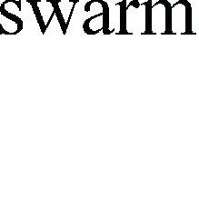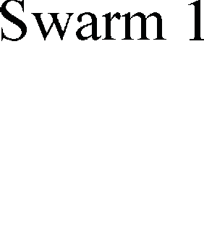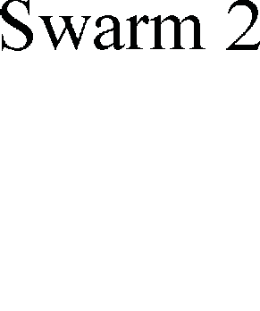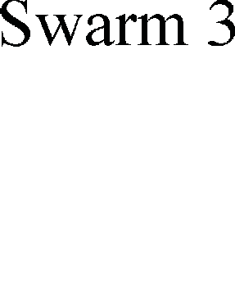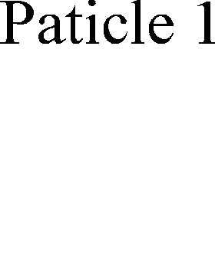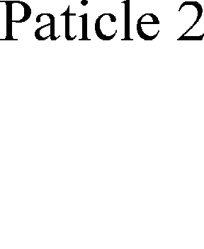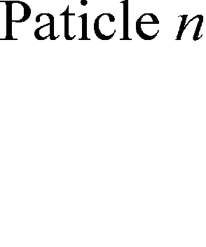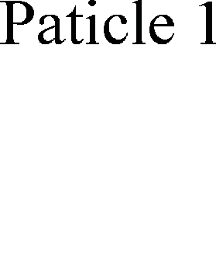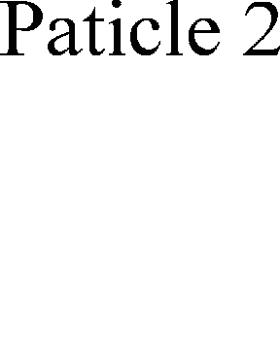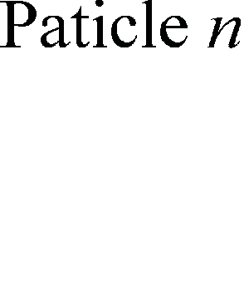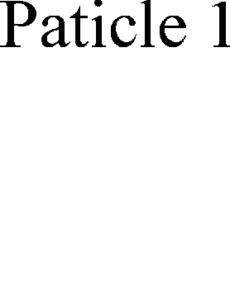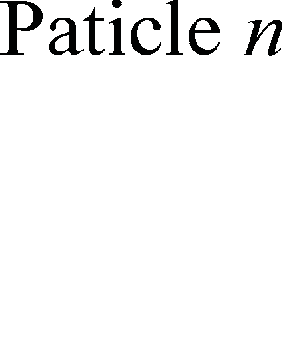

**Fig. 1** The structure

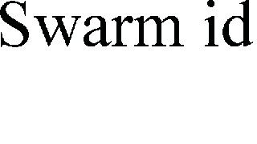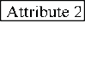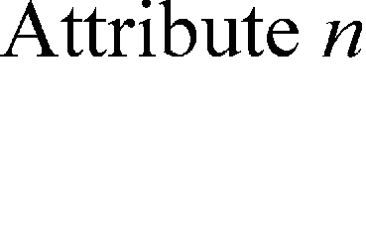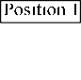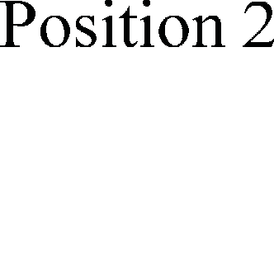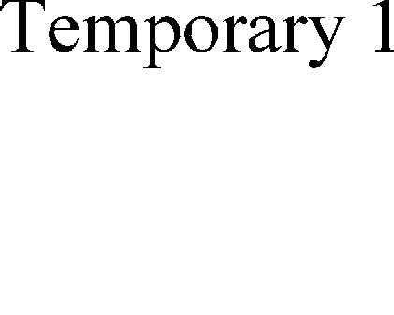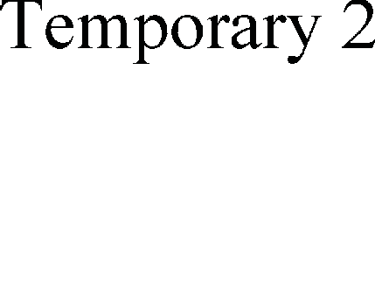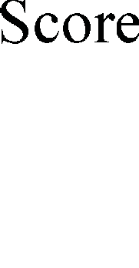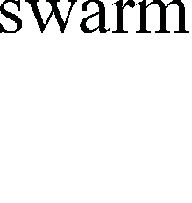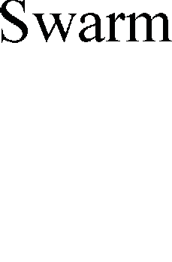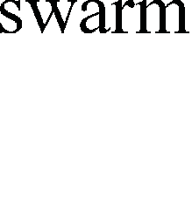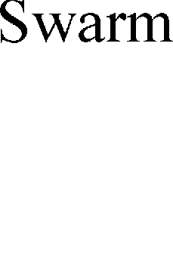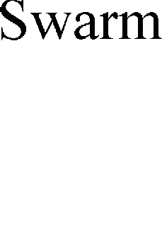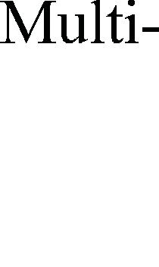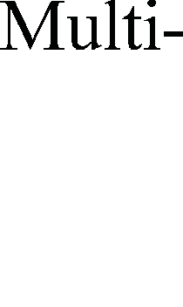

of multi-swarm scheduling.

the multi-swarm scheduler will send the rule. The multi-swarm scheduler request rule is touched off ac- cording to evaluating the activity level of the current sub-swarm. The more active the sub-swarm is, the more valuable it is, since the best result may be in it.

1. The multi-swarm collection rule

The multi-swarm scheduler collects results from the alive sub-swarm and updates *pbest* and *gbest* from storage table.

1. The multi-swarm destroying rule
2. If the swarm sends the swarm request rule *k* times and *k* < *fi* according to Eq. (12), then the multi-swarm scheduler destroys the current sub-swarm.
3. If the swarm does not change the *gbest* in *pn* it- erations, then the multi-swarm scheduler destroys the current sub-swarm. We set *pn* in the initialization of PSO.

*n*

*ite*(*l*)  *m*

## MSPSO algorithm

Step 1: Load the dataset from the text file and convert the dataset from stream format to object format. Store the formatted memory data to temporary table for the initialization of PSO. Initialize the size of swarms randomly, and assign different memory to each swarm. Initialize all particle positions *xij* and velocities *vij* of each swarm with random values, then calculate objec- tive function. Update *pbest* (local best) and *gbest* (global best) of each swarm from the table. Go to Step 2.

Step 2: Specify the parameters of each swarm in- cluding the lower and upper bounds of the velocity, the size of particles, the number of iterations, *c*1(the cogni- tion learning factor), *c*2(social learning factor), *di* (in Eq. (11)), *m*(in the multi-swarm destroying rule) and *pn*(in Eq.(12)). Set iteration number = 0, current particle number = 1, *titi* = size of particles, and *iti* = current par- ticle number. Go to Step 3.

Step 3: In each swarm, if current iteration number <

*f*  *l* 1 .

*i pl*

(12)

iteration number or *gbest* keeps no changes less than 45 iterations, go to Step 4, otherwise destroy the swarm, and

In Eq. (12), *ite*( ) is the function for calculating how many times the sub-swarm sends swarm request rule, *m* a threshold, *pl* the alive sub-swarm size.

go to Step 10. The main scheduling module updates the *pbest*, and compares the *gbest* of current swarm with the previous one in the module, then judge whether to

update *gbest* using multi-swarm scheduler request rule or not. If *gbest* or *pbest* is changed, execute multi-swarm collection rule.

Step 4: In each swarm, if current particle number < particle size, go to Step 5, otherwise, go to Step 9.

Step 5: In each swarm, get *gbest* and *pbest* from the table and each particle updates its position and velocity. Go to Step 6.

Step 6: Restrict position and velocity of each indi- vidual. Go to Step 7.

Step 7: Each particle calculates its fitness and up- dates *pbest* and *gbest*. Execute swarm request rule, and go to Step 8. If the current swarm needs to be destroyed according to multi-swarm destroying rule, dispose the current swarm, and exit.

Step 8: current particle number = current particle number + 1. Go to Step 4.

Step 9: current iteration number = current iteration number + 1. Go to Step 3.

Step 10: Execute multi-swarm collection rule, and

exit.

## Convergence and complexity analysis

400 and 50 respectively. The searching ranges for *c* and *γ* are as follow: *c*  [2−15, 215], *ß*  [2−15, 215], [−*v*max, *v*max] is predefined as [−1000, 1000] for parameter *c*, as [−1000, 1000] for parameter *γ*, and as [−6, 6] for feature mask. For objective function, we set *wa* and *wb* to 0.8 and

0.2 according to our experience. The following datasets taken from the UCI machine learning and StatLog da- tabases are used to evaluate the performance of the proposed IFS approach: Australian, German, Cleveland

heart, breast cancer, heart disease, vehicle silhouettes, hill-valley, landsat satellite, sonar, and Wisconsin Di- agnostic Breast Cancer (WDBC).

The 10-fold cross validation was used to evaluate the classification accuracy. Then the average error across all 10 trials was computed. Because hill-valley and landsat satellite datasets have pre-defined training/test splits. Thus, except these datasets, all of the experi- mental results are averaged over the 10 runs of 10-fold Cross-Validation (CV).

**Table 1** Dataset description

No. Dataset Classes Instances Features Missing

value

Convergence analysis and stability studies have been reported by Clerc and Kennedy[14], Trelea[15],

1. Australian (Statlog

project)

1. German

(Statlog project)

2 690 14 Yes

2 1000 24 No

Kadirkamanathan *et al*.[16], and Jiang *et al*.[17]. The above

1. Cleveland heart 2 303 13 Yes

studies proved conditions which could lead PSO to converge in limited iterations. In order to guarantee the

1. Breast cancer (Wisconsin)

Heart disease

2 699 9 Yes

convergence of the proposed method, we set the pa-

1. (Statlog project) 2 270 13 No

rameters of PSO as *ω* = 0.9, *c*1 = 2, *c*2 = 2 (according to

1. Vehicle silhouettes

(Vehicle)

4 846 17 No

Refs. [18] and [19]).

1. Hill-valley 2 1212 100 No

The time complexity of the proposed method is

1. Landsat satellite ( Landsat )

6 6435 36 No

|  |  |  |  |  |  |  |
| --- | --- | --- | --- | --- | --- | --- |
| *O*(*M*×*N*×*K*), where *M*, *N*, *K* are the number of iterations, | 9 | Sonar | 2 | 208 | 60 | No |
| the number of sub-swarms, the number of particles re- | 10 | WDBC | 2 | 569 | 30 | No |
| spectively. In the worst case, if the number of sub- |  |  |  |  |  |  |

swarms remains unchanged and the number of iteration reaches the maximum iteration number, the time com- plexity is *O*(*M*×*N*×*K*). In general, the number of sub-swarms is reduced after some iterations, and thus the time complexity is

*M*

*O*( *L*  *K* ) , where 1 ≤ *L* ≤ *N*.

*i* 1

# Experiments and results

## Experimental setting

The numbers of iterations and particles are set to

## Results

Table 2 shows the classification accuracy rates of IFS with and without feature selection. As shown in Table 2, the IFS with feature selection performs sig- nificantly better than IFS without feature selection in almost all cases examined at the significance level of 0.05, except the Australian dataset. The average classi- fication accuracy rate for each dataset improved sig- nificantly after feature selection.

The results show that the classification accuracy rates of the IFS approach with and without feature se- lection were better than those of grid search in all cases

as shown in Table 3. Grid search is a local search method which is vulnerable to local optimum. Grid search can supply local optimal parameters to SVM, but the search region is small, and it can not lead SVM to higher clas- sification accuracy rate. The empirical analysis indicates that the developed IFS approach can obtain the optimal parameter values, and find a subset of discriminative features without decreasing the SVM classification ac- curacy.

**Table 2** Results of the proposed IFS with and without feature selection

The comparison between IFS and GA + SVM by using feature selection is shown in Table 4. The detail parameter settings for GA+SVM were as follows: population size = 500, crossover rate = 0.7, mutation rate

= 0.02. The classification accuracy rates of IFS with feature selection were higher than GA + SVM for all datasets, whereas the classification accuracy rates of GA

+ SVM were higher than IFS without feature selection as shown in Table 4. Therefore, it is important to eliminate noisy, irrelevant features for increasing the classification accuracy rates.

With feature selection

|  |  |  |  |
| --- | --- | --- | --- |
| of Number |  | Number |  |
| Dataset original of | Accuracy | of | Accuracy |
| features selected | rate(%) | selected | rate(%) |
| features |  | features |  |

Without feature

**Table 4** Comparison between the IFS and GA + SVM approach

Dataset Number of origi- nal fea-

tures

Number of selected features

Accuracy rate (%)

selection

Accuracy rate (%)

Pair *t* test

*P*-value

Number

IFS GA + SVM

Hill-valley 100 40.1 ±

1.264

74.1 71.2 < 0.001

Hill-valle y

0.949

7.1 ± 0.432

|  |  |  |  |  |  |  |  |
| --- | --- | --- | --- | --- | --- | --- | --- |
| ease |  |  |  |  |  | disease |  |
| Vehicle | 17 | 7.1 ± 0.432 | 89.6 | 85.8 | < 0.001 | Vehicle | 17 |

100 40.1 ±

1.264

7.9 ± 0.432

10.1 ± 0.986

|  |  |  |  |  |  |  |  |
| --- | --- | --- | --- | --- | --- | --- | --- |
| Australian | 14 | 8.4 ± 2.318 | 90.9 | 86.4 | 0.06 | Australian | 14 8.4 ± 90.9  2.318 |
| German | 23 | 12.7 ± 1.025 | 80.2 | 75.9 | < 0.001 | German | 23 12.7 ± 80.2  1.025 |
| Cleveland  heart | 13 | 6.1 ± 1.103 | 91.1 | 85.7 | < 0.001 | Cleveland  heart | 13 6.1 ± 91.1  1.103 |
| Breast cancer | 9 | 4.9 ± 0.734 | 99.1 | 96.9 | < 0.001 | Breast cancer | 9 4.9 ± 99.1  0.734 |
| Heart dis- | 13 | 7.8 ± 0.949 | 91.5 | 84.4 | < 0.001 | Heart | 13 7.8 ± 91.5 |

6.9 ± 2.011

5.5 ± 0.988

8.1 ± 0.445

89.6 11.5 ±

0.664

74.1 55.9 ±

1.981

88.1

77.4

86.8

98.2

86.7

88.1

73.5

Landsat 36 13 ± 0.668 95.4 91.9 < 0.001

Landsat 36 13 ±

0.668

95.4 18.3 ±

1.498

93.4

Sonar 60 25.1 ±

0.977

93.7 90.1 < 0.001

Sonar 60 25.1 ±

0.977

93.7 31.0 ±

1.212

91.6

WDBC 30 13 ± 1.331 99.4 97.8 0.011

WDBC 30 13 ±

1.331

99.4 17.3 ±

0.991

98.9

**Table 3** Experimental results summary of IFS with feature se- lection, IFS without feature selection and grid search algorithm

|  |  |  |  |  |  |
| --- | --- | --- | --- | --- | --- |
| (1) IFS with (2) IFS  without | | | (3) Grid | Pair *t* test | Pair *t* test |
| Dataset feature feature | | | search | (1)vs(3) | (2)vs(3) |
|  |  | selection |  |  |  |
| Australian | 90.9 | 86.4 | 84.7 | < 0.001 | < 0.001 |
| German | 80.2 | 75.9 | 75.7 | < 0.001 | < 0.001 |
| Cleveland  heart | 91.1 | 85.7 | 82.3 | < 0.001 | < 0.001 |
| Breast cancer | 99.1 | 96.9 | 95.2 | < 0.001 | < 0.001 |
| Heart  disease | 91.5 | 84.4 | 83.6 | < 0.001 | < 0.001 |
| Vehicle | 89.7 | 85.8 | 84.2 | < 0.001 | 0.21 |
| Hill-valley | 74.1 | 71.2 | 69.8 | 0.01 | < 0.001 |
| Landsat | 95.4 | 91.9 | 91.1 | < 0.001 | 0.012 |
| Sonar | 93.7 | 90.1 | 88.9 | 0.028 | < 0.001 |
| WDBC | 99.4 | 97.8 | 97.4 | < 0.001 | 0.531 |

selection

Fig. 2a and Fig. 2b show the global best classifica- tion accuracies with different iterations on Australian and German datasets using IFS, PSO+SVM, GA+SVM respectively. Fig. 2e and Fig. 2f show the local best classification accuracies with different iterations on Australian and German datasets using IFS, PSO+SVM and GA+SVM respectively. The convergence speeds of PSO+SVM and GA +SVM were faster than IFS, whereas the resultant classification accuracies of PSO+SVM and GA+SVM were lower than IFS. Moreover, PSO+SVM and GA+SVM prematurely converged to local optimum, and thus it convinces that IFS has more exploration capability. The numbers of selected features with evolution on German and Austra-

lian datasets using three methods are shown in Fig. 3 and Fig. 4 respectively. Fig. 2c and Fig. 2d show the number

of sub-swarms with different iterations on Australian and German datasets using IFS. With different numbers of initial sub-swarms, a great number of sub-swarms were reduced, and only a small number of sub-swarms were remained at the final iteration. Most of the week sub-swarms are eliminated during the evolution, and thus it can be seen that excellent sub-swarms are pre- served after competition, as enhance the exploration ability of the whole swarm to obtain more important features.

The comparison between IFS and PSO+SVM using

feature selection in terms of number of selected features and average classification accuracy rates is shown in Table 5. For comparison purpose, we implemented the PSO+SVM approach using the standard PSO algorithm, and the parameter settings were described as follows: iteration size was set as 500, number of particles as 100. The classification accuracy rate was adopted as the ob- jective function. The analytical results reveal that IFS with feature selection performs significantly superior to the standard PSO with feature selection in all datasets in terms of the classification accuracy rates.

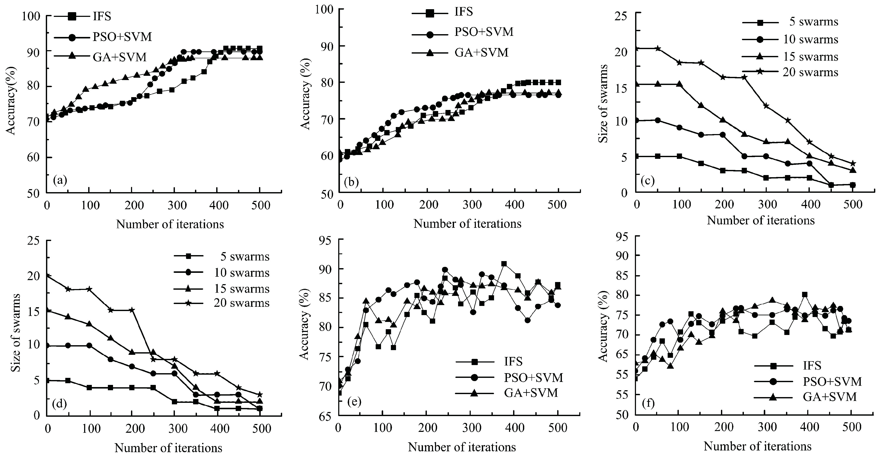

**Fig. 2** Prediction accuracies and number of sub-swarm with different iterations. (a) Global best accuracies with different iterations on Australian dataset using IFS, PSO+SVM and GA+SVM. (b) Global best accuracies with different iterations on German dataset using IFS, PSO+SVM and GA+SVM. (c) Each curve corresponding to a number of initial sub-swarms on Australian dataset using IFS. (d) Each curve corresponding to a number of initial sub-swarms on German dataset using IFS. (e) Local best accuracies with different iterations on Australian dataset using IFS, PSO+SVM and GA+SVM. (f) Local best accuracies with different iterations on German dataset using IFS, PSO+SVM and GA+SVM.

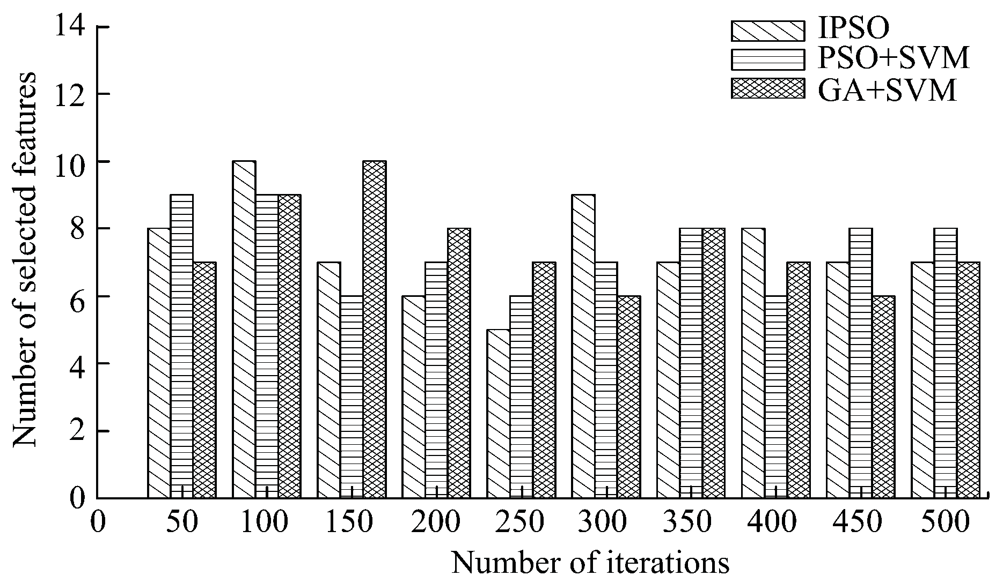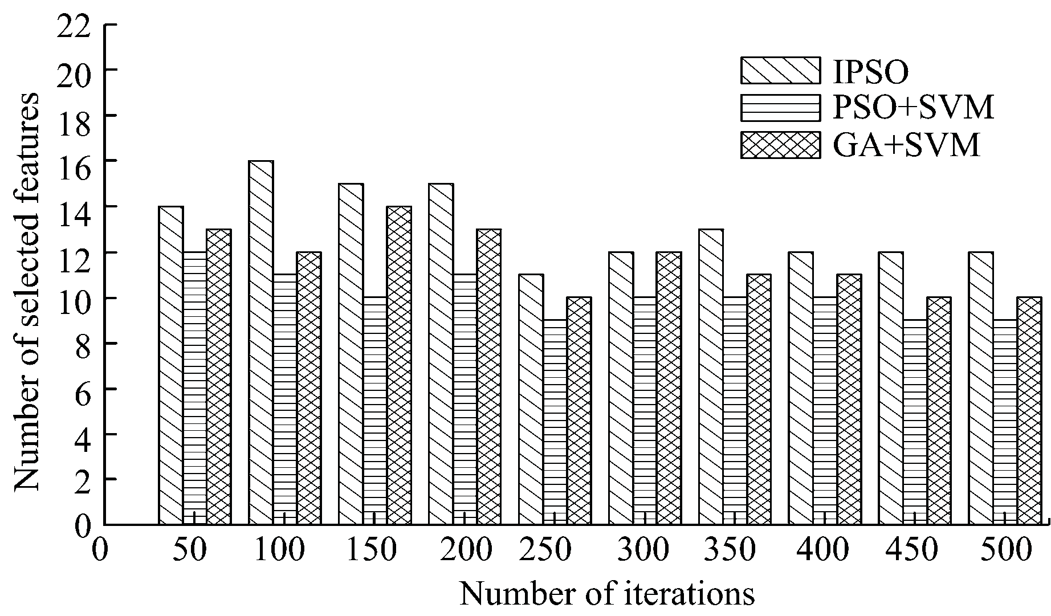

**Fig. 3** Number of selected features with different iterations on Australian dataset using IFS, PSO+SVM and GA+SVM.

**Fig. 4** Number of selected features with different iterations on German dataset using IFS, PSO+SVM and GA+SVM.

**Table 5** Comparison between the IFS and standard PSO

# References

Number

IFS PSO+SVM

* + 1. Guyon I, Elisseeff A. An introduction to variable and feature

Dataset

of original

Number of selected

Accuracy

Number of selected

Accuracy

selection. *Journal of Machine Learning Research*, 2003, **3**, 1157–1182.

* + 1. Kennedy J, Eberhart R. Particle swarm optimization. *Pro- ceedings of the IEEE International Conference on Neural Network*, Perth, Australia, 1995, 1942–1948.

|  |  |  |  |  |  |
| --- | --- | --- | --- | --- | --- |
|  | features | features | rate (%) | features | rate (%) |
| Australian | 14 | 8.4 ± 2.318 | 90.9 | 7.1 ± 0.798 | 89.9 |
| German | 23 | 12.7 ± 1.025 | 80.2 | 9.4 ± 1.233 | 76.8 |

Cleveland

heart

Breast cancer

Heart

disease

13 6.1 ± 1.103 91.1 6.4 ± 0.558 87.4

9 4.9 ± 0.734 99.1 5.8 ± 0.447 97.6

13 7.8 ± 0.949 91.5 6.2 ± 0.976 85.3

* + 1. Eberhart R, Kennedy J. A new optimizer using particle swarm theory. *Proceedings of the Sixth International Sym- posium on Micro Machine and Human Science*, Nagoya, Japan, 1995, 39–43.
    2. Lin S W, Ying K C, Chen S C, Lee Z J. Particle swarm optimization for parameter determination and feature selec- tion of support vector machines. *Expert Systems with Ap- plications*, 2008, **35**, 1817–1824.

|  |  |  |  |  |  |  |
| --- | --- | --- | --- | --- | --- | --- |
| Vehicle | 17 | 7.1 ± 0.432 | 89.66 | 10.2 ± 1.298 | 86.2 |  |
| Hill-Valley | 100 | 40.1 ± 1.264 | 74.12 | 61.3 ± 2.110 | 72.3 |
| Landsat | 36 | 13 ± 0.668 | 95.44 | 15.1 ± 0.975 | 93.4 | [5] |
| Sonar | 60 | 25.1 ± 0.977 | 93.71 | 35.2 ± 1.123 | 90.8 |  |
| WDBC | 30 | 13 ± 1.331 | 99.41 | 16.9 ± 1.652 | 98.2 | [6] |

Huang C L, Dun J F. A distributed PSO-SVM hybrid system with feature selection and parameter optimization. *Applied Soft Computing*, 2008, **8**, 1381–1391.

Blackwell T. Particle swarms and population diversity. *Soft Computing*, 2005, **9**, 793–802.

# Conclusion

In this study, a novel multi-swarm MSPSO algo- rithm is proposed to solve discrete problem, an efficient objective function of which is designed by taking into consideration classification accuracy rate and F-score. In order to describe the competition among the swarms, we introduced the mechanism for survival of the fittest. To further settle the feature selection problem, we put for- ward the IFS approach, in which both the SVM pa- rameter optimization and the feature selection are dy- namically executed by MSPSO algorithm, then, SVM model performs the classification tasks using the optimal parameter values and the subset of features. The evaluation on the 10 benchmark problems by comparing with the standard PSO based, genetic algorithm based, and grid search based methods indicates that the pro- posed approach performs significantly advantageously over others in terms of the classification accuracy rates.

# Acknowledgments

This work was supported by National Natural Science Foundation of China (Grant no. 60971089), National Electronic Development Foundation of China (Grant no. 2009537), Jilin Province Science and Tech- nology Department Project of China (Grant no. 20090502).

1. Blackwell T, Branke J. Multiswarms, exclusion, and anti-convergence in dynamic environments. *IEEE Transac- tions on Evolutionary Computation*, 2006, **10**, 459–472.
2. Parrott D, Li X D. Locating and tracking multiple dynamic optima by a particle swarm model using speciation. *IEEE Transactions on Evolutionary Computation*, 2006, **10**, 440–458.
3. Niu B, Zhu Y L, He X X, Wu H. MCPSO: A multi-swarm cooperative particle swarm optimizer. *Applied Mathematics and Computation*, 2007, **185**, 1050–1062.
4. Chen Y W, Lin C J. Combination of feature selection ap- proaches with SVM in credit scoring. *Expert Systems with Applications*, 2006, **37**, 315–324.
5. Kennedy J, Eberhart R. A discrete binary version of the particle swarm algorithm. *Proceedings of the IEEE Interna- tional Conference on Systems*, *Man and Cybernetics*, Or- lando, USA, 1997, 4104–4108.
6. Vapnik V N. *The Nature of Statistical Learning Theory*, 2nd ed, Springer, New York, 1999.
7. Boser B E, Guyon I M, Vapnik V N. A training algorithm for optimal margin classifiers. *Proceedings of the fifth Annual Workshop on Computational Learning Theory*, Pittsburgh, USA, 1992, 144–152.
8. Clerc M, Kennedy J. The particle swarm-explosion, stability, and convergence in a multidimensional complex space. *IEEE Transactions on Evolutionary Computation*, 2002, **6**, 58–73.
9. Trelea I C. The particle swarm optimization algorithm:

convergence analysis and parameter selection. *Information Processing Letters*, 2003, **85**, 317–325.

1. Kadirkamanathan V, Selvarajah K, Fleming P J. Stability analysis of the particle dynamics in particle swarm optimizer. *IEEE Transactions on Evolutionary Computation*, 2006, **10**, 245–255.
2. Jiang M, Luo Y P, Yang S Y. Stochastic convergence analy- sis and parameter selection of the standard particle swarm optimization algorithm. *Information Processing Letters*, 2007, **102**, 8–16.
3. Shi Y, Eberhart R. Modified particle swarm optimizer. *Pro- ceedings of IEEE International Conference on Evolutionary Computation*, Anchorage, USA, 1998, 69–73.
4. Zhan Z H, Zhang J, Li Y. Adaptive Particle Swarm Optimi- zation. *IEEE Transactions on Systems Man and Cybernetics Part B*-*Cybernetics*, 2009, **39**, 1362–1381.
5. Xie J Y, Wang C X. Using support vector machines with a novel hybrid feature selection method for diagnosis of ery- themato-squamous diseases. *Expert Systems with Applica- tions*, 2011, **38**, 5809–5815.