Grace Yoo (Partners: Yada Pruksachatkun, Pragya Bajora)  
CS243RW, SP’15  
Turtlebot Mapping & Localization Project

Design Doc

Please see my pitch document for an introduction to the Turtlebot Project.

**Final Product:**

The final product will consist of a structure built on top of an iRobot. The structure will hold the Netbook and the Kinect will be mounted on top. Here is an example of a Turtlebot, although our final body structure may differ slightly:

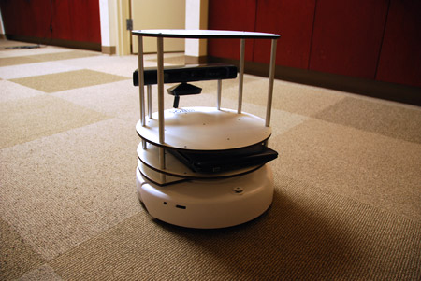

**Components:**

The components we need are already provided:

* iRobot (movement output)
* Netbook (coordinates input and output)
* Kinect (computer vision input)
* materials such as wood, 3-D printed plastic for the body

We do need a Kinect mount/clip, which Pragya has already selected and asked Luke to purchase

My reach goal for this project is to implement a robotic arm that can press an elevator button. To do this, I will need:

* 2 servo motors
* Arduino Uno
* 3D printed parts

I am pretty sure we will have all of these components readily available.

**Circuitry:**

Because we are not building circuitry, I will instead explain how the main components of Turtlebot will interact with one another. The Kinect is equipped with good computer vision and will be able to map out an area by “looking” at it. The Kinect will send this information to the Netbook, which will be running Robot Operating System (ROS). The Netbook will instruct the iRobot on how to move around. All of this will be operated from a VM running Ubuntu 64. The user will be able to see what the Kinect “sees” throughout the process, and give Turtlebot orders on where to navigate in real time.

**Timeline:**

Because we will generally meet on Fridays, setting a Wednesday deadline is impractical. I will set “Goals” for the week, and we can default to last week’s Goal as the current week’s Wednesday deadline material.

Week of 2/22:

Mon 2/23: pitch doc & design doc

Goal: set up workstation, do ROS tutorials, do readings

Week of 3/1:

Goal: assemble structures cohesively

Work on: testing kinect—working towards getting computer vision in the VM

Work on: moving irobot—working towards responding to user input

Week of 3/8:

Goal: get at least one of the components (Kinect, irobot) working

Reach Goal: begin working on mapping if Goal is met

Work on: continuing, debugging from previous week progress

Week of 3/15:

Before spring break, we would like to have ability to communicate between all components:

- irobot movement from user command

- vision in VM from Kinect

Week of 3/22:

Mon 4/23: Presentation part I

Goal: present on cohesive robot structures/functionality

Work on: mapping and navigation

Work on: object detection

3/29:

Goal: get map representation with Kinect

Work on: mapping and navigation

Work on: object detection

4/5:

Sat 4/11: NUCS at NEU!

Goal: have mapping, object detection, and navigation demo

4/12:

Fri 4/17: help Pragya at Sr Symposium

Goal: have Turtlebot make an appearance / delivery

Work on: build robotic arm

4/19:

Goal: get robotic arm responding to input

Work on: robotic arm

4/26:

4/7: Presentation part II

Goal: have Turtlebot make an appearance / delivery

Reach goal: have robotic arm able to push elevator button