Pragya Chourasia
GitHub repository: https://github.com/pragyachourasia-05/data260-6758 (tag hw6)
DATA-260 Homework 6 - Memory for LLM Agents
Value | Definition | Mine
SID4 | Last four digits of SJSU ID | 6758
PORT_BASE | 8000 + (SID4 mod 900) | 8458
PREFIX | "s" + SID4 | s6758
SEED | SID4 | 6758
VERIFY_SEED | 260000 + SID4 | 266758
DOMAIN_ID | SID4 mod 8 | 6 - rental housing listings
Hardware |  | Intel Core i5-1335U, 16 GB RAM, Intel Iris Xe (CPU inference), Windows 11
Local model |  | llama3.2:3b (Q4_K_M) via Ollama; temperature 0, seed 6758, num_ctx 8192
Tagged commit | tag hw6 (code commit verified by verify_hw06.py) | e174eacc91aaf86b1fe01ca16bee65648e7b1a6e

Repository evidence for this homework is in reports/hw06/: RUN_LOG.txt, raw/ (CSV/JSON results), METRICS.md, AI_USE.md, verification.json (from python verify_hw06.py), plus memory_probes.yaml and the MEMORY.md versions. All code extends the shared root folders (backend/, src/, code/, frontend/, tests/).

Part 1 - MongoDB Document API

1.1 Database and schema
Database s6758_doc, collection listings (document view of a rental listing). Validation is enforced twice: by Pydantic in the API and by a MongoDB $jsonSchema validator, so a document that bypasses the API is still rejected.
Field | Type | Rule
title | string | required, 1-100 characters
description | string | null | optional, max 2000
status | enum | available (default) / pending / rented
property_type | enum | apartment / house / condo / studio / townhouse
monthly_rent | number | null | optional, >= 0
available_from | date-time | required, ISO 8601
created_at / updated_at | date-time | set automatically by the server

Pydantic create schema - backend/app/doc_schemas.py, lines 11-19
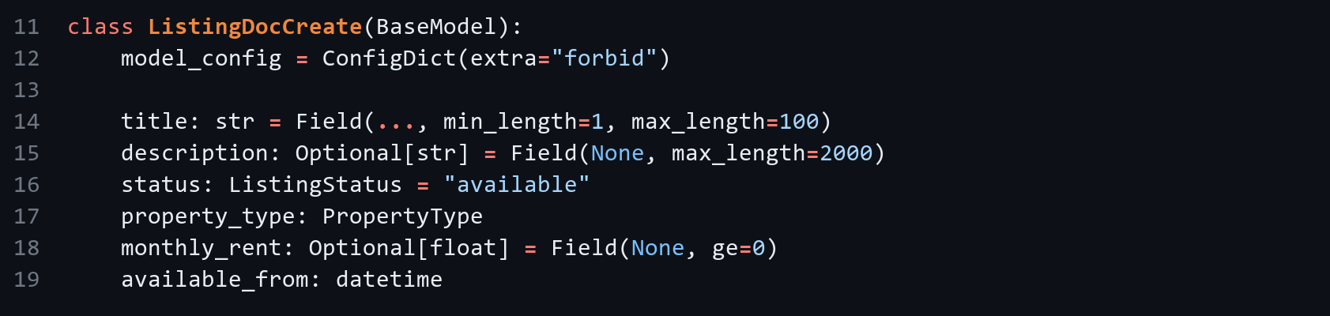
MongoDB $jsonSchema validator - backend/app/mongo_db.py, lines 16-31
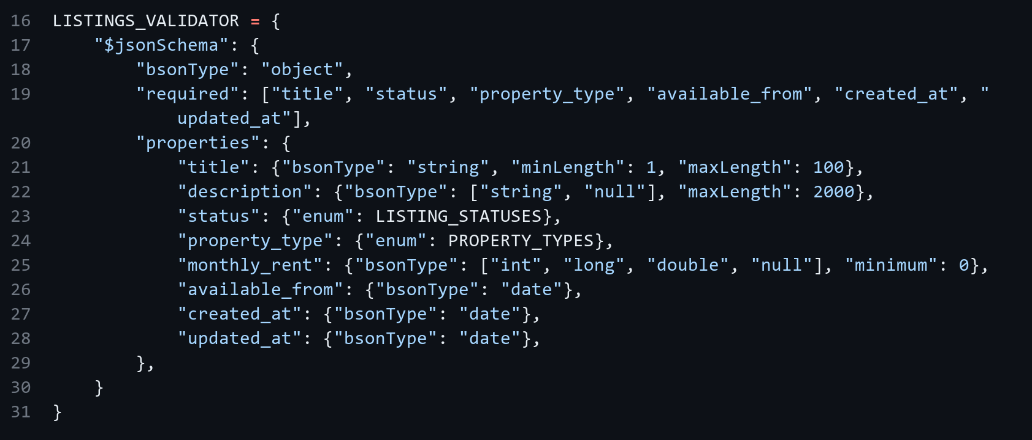

1.2 API, error handling and middleware
Files are split as the brief asks: mongo_config.py (server configuration), mongo_db.py (PyMongo connection), doc_schemas.py (Pydantic models), routes_listings_doc.py (route handlers), wired into the existing backend/app/main.py with CORS middleware and a JSON body middleware.
Method | Path | Success | Errors
POST | /api/listings | 201 + document | 422 invalid body, 415 non-JSON, 500 DB error
GET | /api/listings | 200 list (filters ?status, ?property_type) | 500
GET | /api/listings/{id} | 200 | 400 bad ObjectId, 404 not found
PUT | /api/listings/{id} | 200 (updated_at refreshed) | 400 empty body / bad id, 404, 422
DELETE | /api/listings/{id} | 204 | 400, 404

Create handler - backend/app/routes_listings_doc.py, lines 40-51
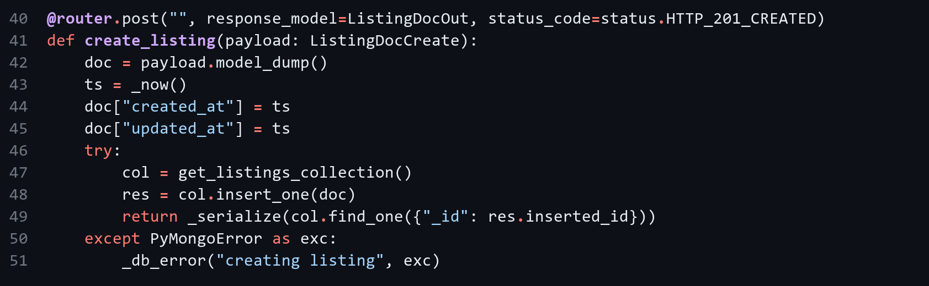
Get-by-id handler with 400/404 handling - backend/app/routes_listings_doc.py, lines 71-80
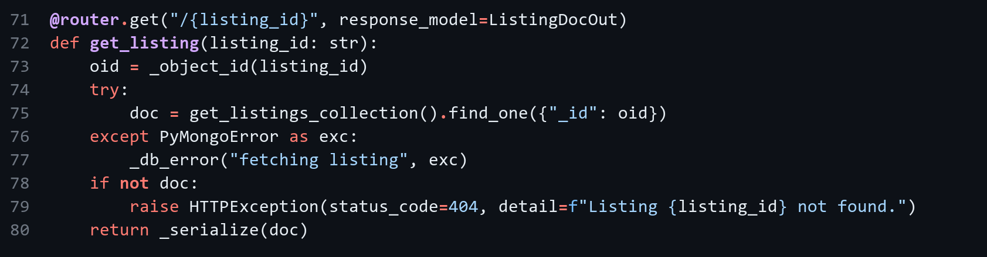
JSON body middleware - backend/app/main.py, lines 31-40
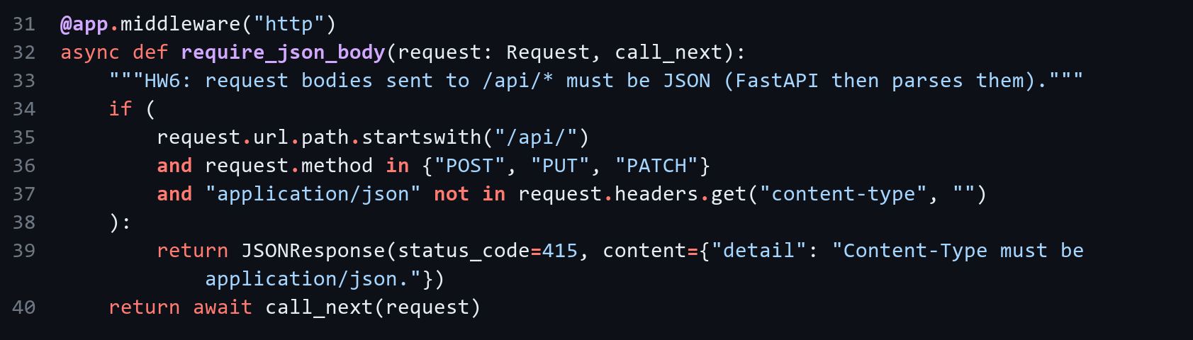

1.3 CRUD and validation evidence
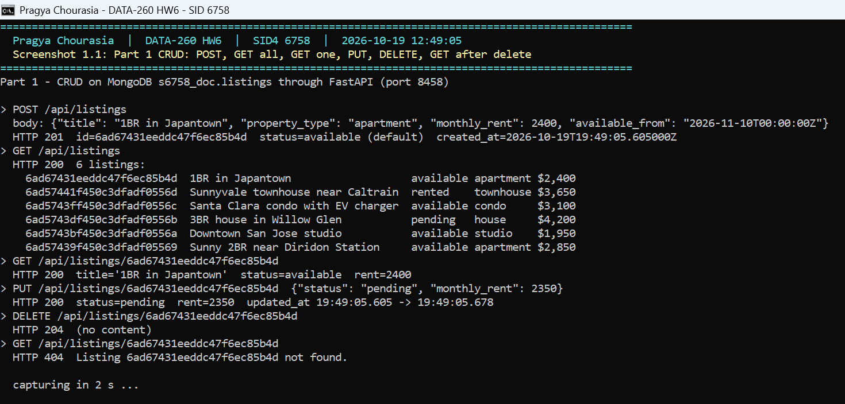
Screenshot 1.1 - Terminal: POST, GET all, GET one, PUT, DELETE, then GET after delete (201, 200, 200, 200, 204, 404)
Invalid request | Expected | Message
POST without title | 422 | body.title: Field required
property_type = "castle" | 422 | Input should be 'apartment', 'house', ...
available_from = "next week", monthly_rent = "cheap" | 422 | invalid datetime + unable to parse number
Content-Type: text/plain | 415 | Content-Type must be application/json.
GET /api/listings/123 | 400 | Invalid listing id '123'
PUT status = "sold" | 422 | Input should be 'available', 'pending' or 'rented'

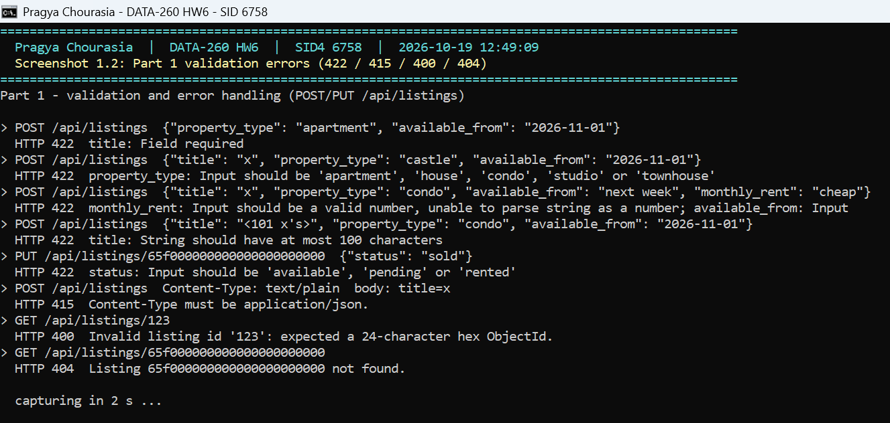
Screenshot 1.2 - Terminal: validation and error handling - 422 for missing/invalid fields, 415 non-JSON, 400 bad id, 404 unknown id
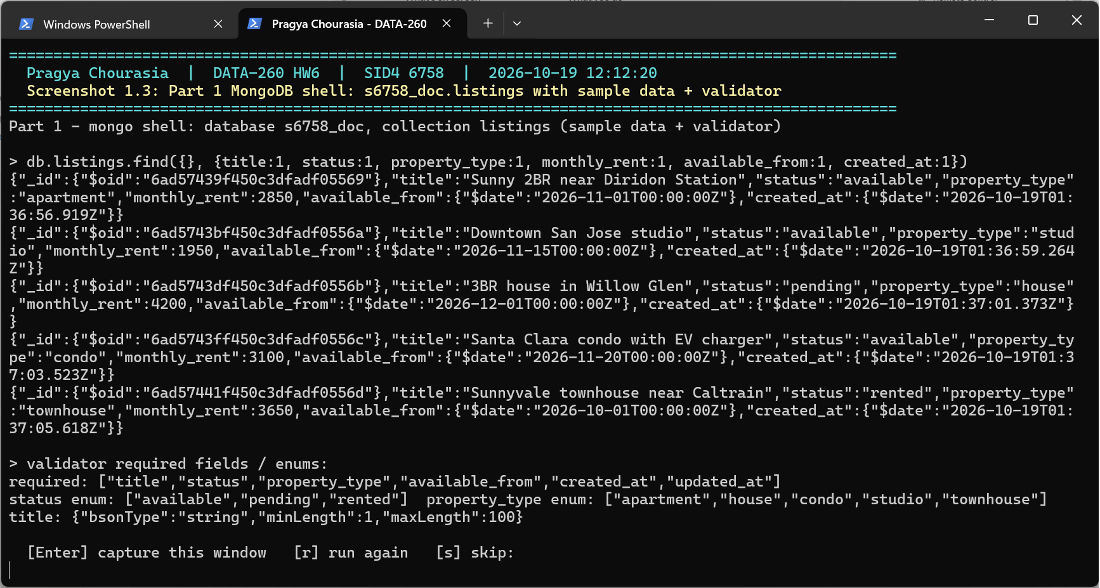
Screenshot 1.3 - Mongo shell: s6758_doc.listings with the sample documents and the $jsonSchema rules

Part 2 - Short-, Long-, and Episodic Memory

2.1 Collections (same database, Part 1 collection unchanged)
Collection | Fields | Written when
messages | user_id, session_id, role (user/assistant), content, created_at | every user message and reply
summaries | user_id, session_id (null for lifetime), scope ('session' | 'user'), text, created_at | every 4 user messages; lifetime every 2nd session summary
episodes | user_id, session_id, fact, importance (0..1), embedding (512 floats), created_at | up to 3 facts per user message

2.2 Endpoints
POST /api/chat takes {user_id, session_id?, message} and returns the reply plus memory_used (short-term count and list, session and lifetime summary, episodic facts with similarity) and usage (tokens and latency). GET /api/memory/{user_id} returns the last 16 messages, latest session and lifetime summaries, and last 20 episodes. GET /api/aggregate/{user_id} returns daily message counts (Pacific time) and the 5 most recent summaries.
POST /api/chat - backend/app/routes_memory.py, lines 22-29
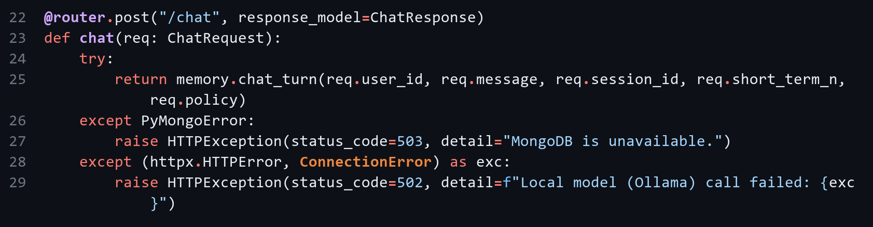
GET /api/memory/{user_id} - backend/app/routes_memory.py, lines 32-50
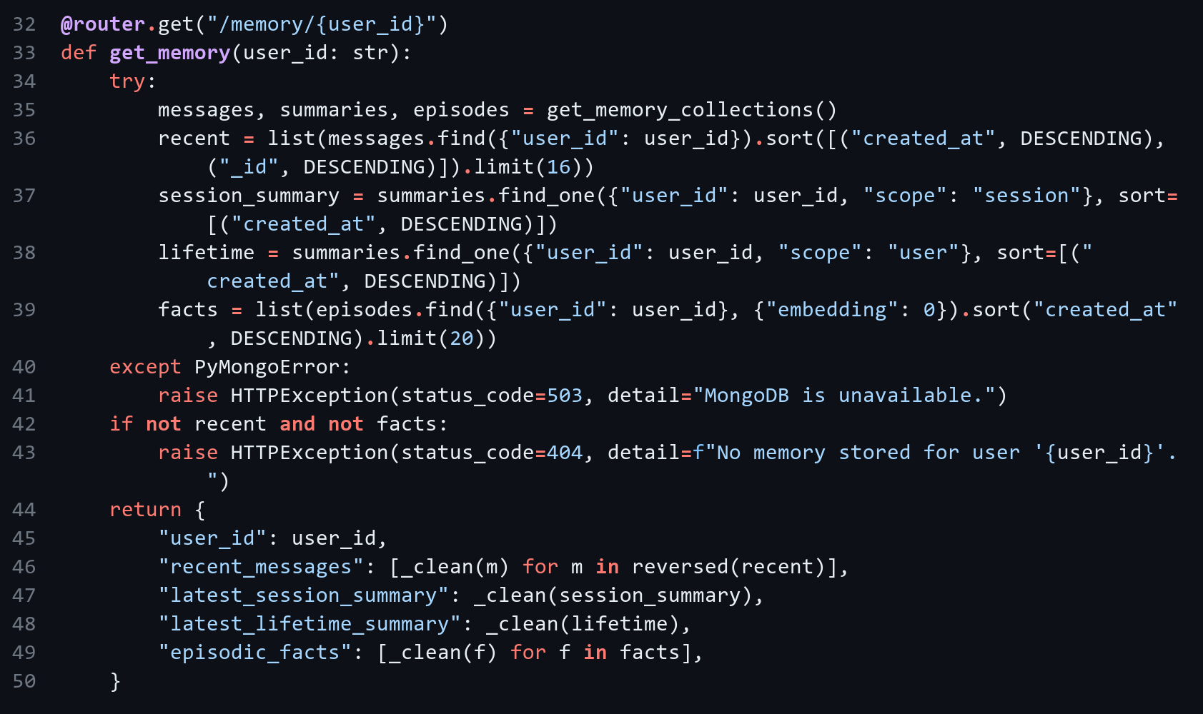
GET /api/aggregate/{user_id} - backend/app/routes_memory.py, lines 53-74
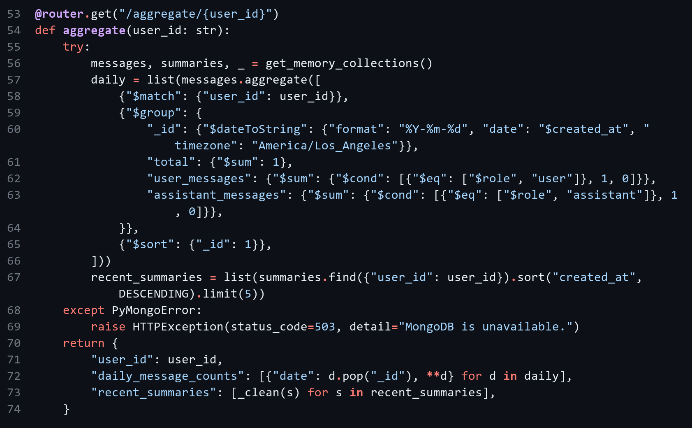
Server steps for one turn - backend/app/memory.py, lines 365-388 (excerpt; full code in the repository)
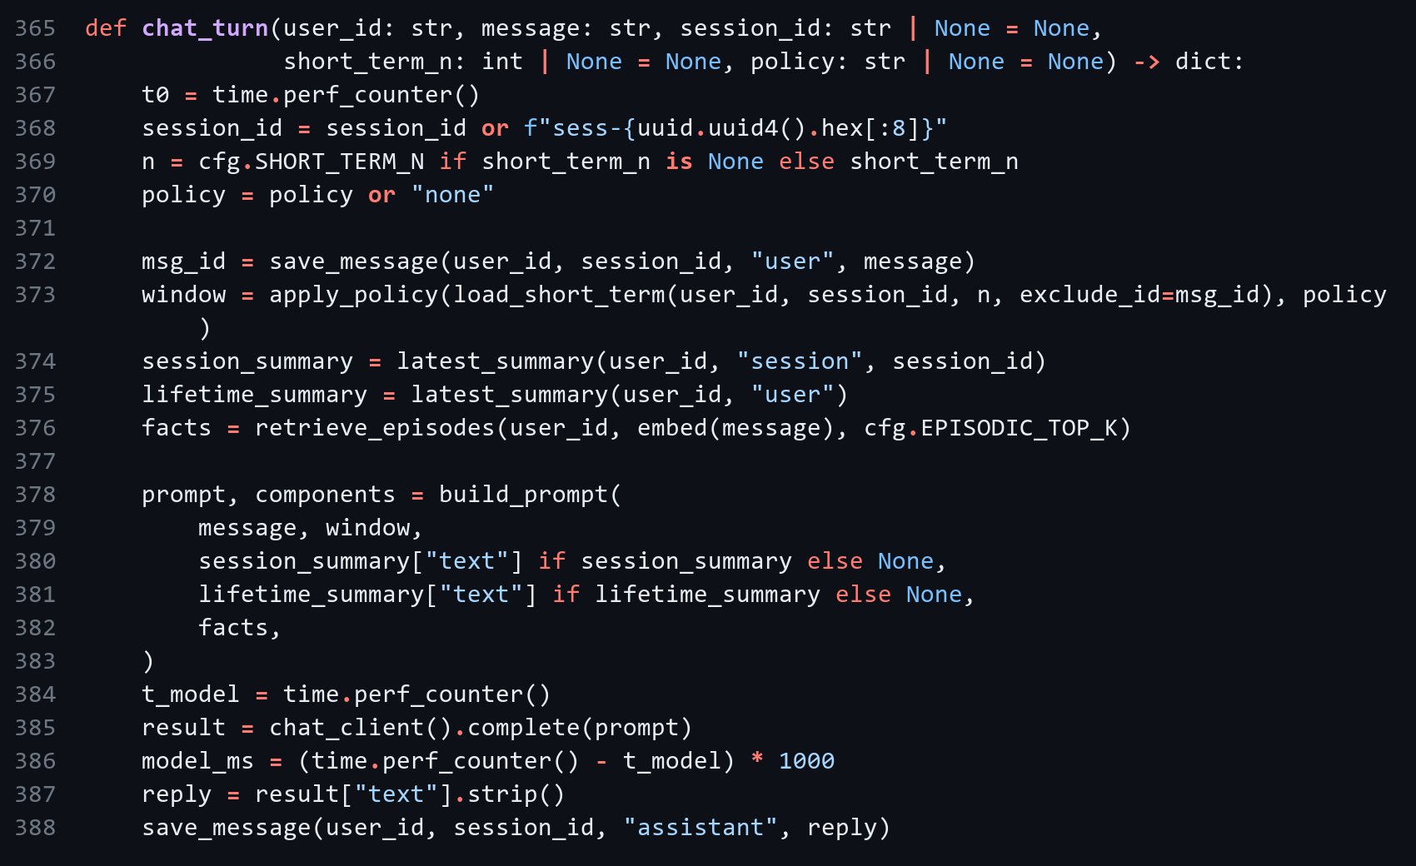

2.3 Memory logic
Short-term window (last N messages) - backend/app/memory.py, lines 172-181
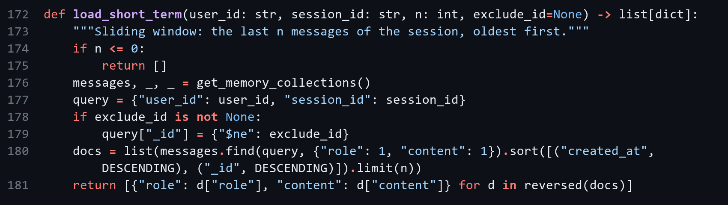
Summarization trigger - backend/app/memory.py, lines 247-262
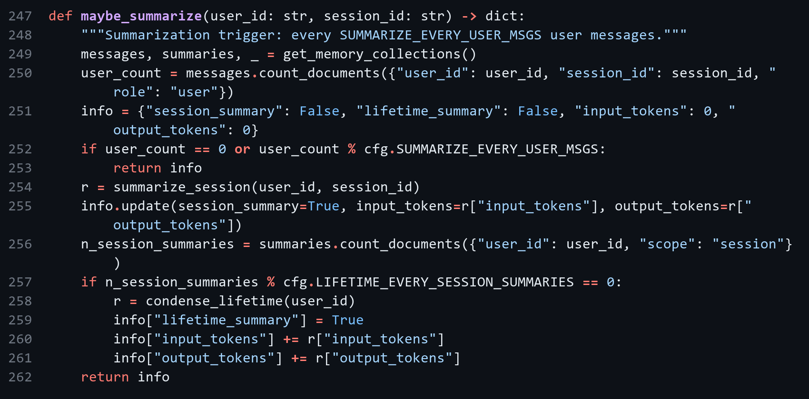
Episode extraction (up to 3 facts, importance 0..1) - backend/app/memory.py, lines 268-297 (excerpt; full code in the repository)
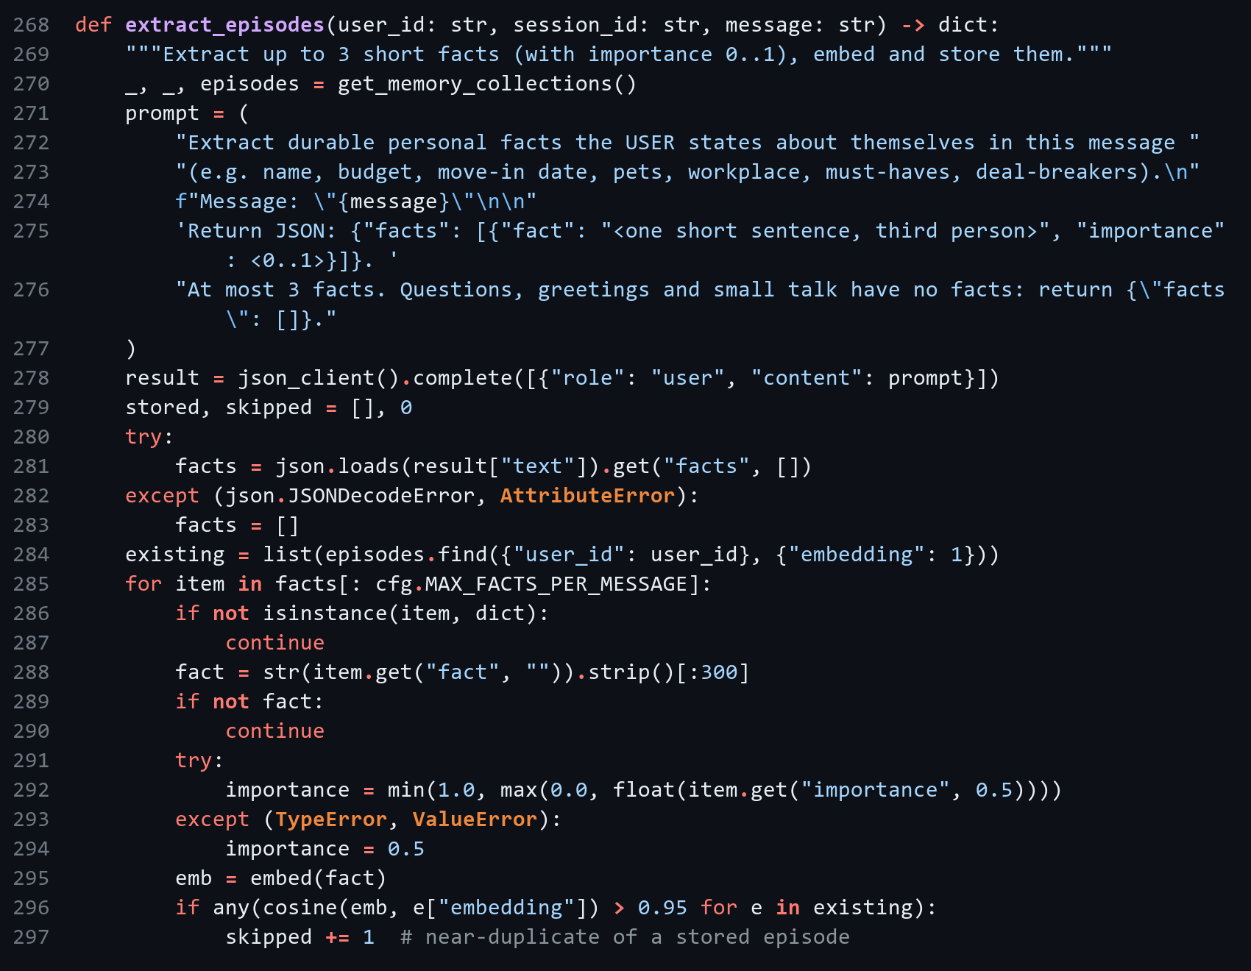
Embedding (local feature hashing, 512 dims) - backend/app/memory.py, lines 113-130
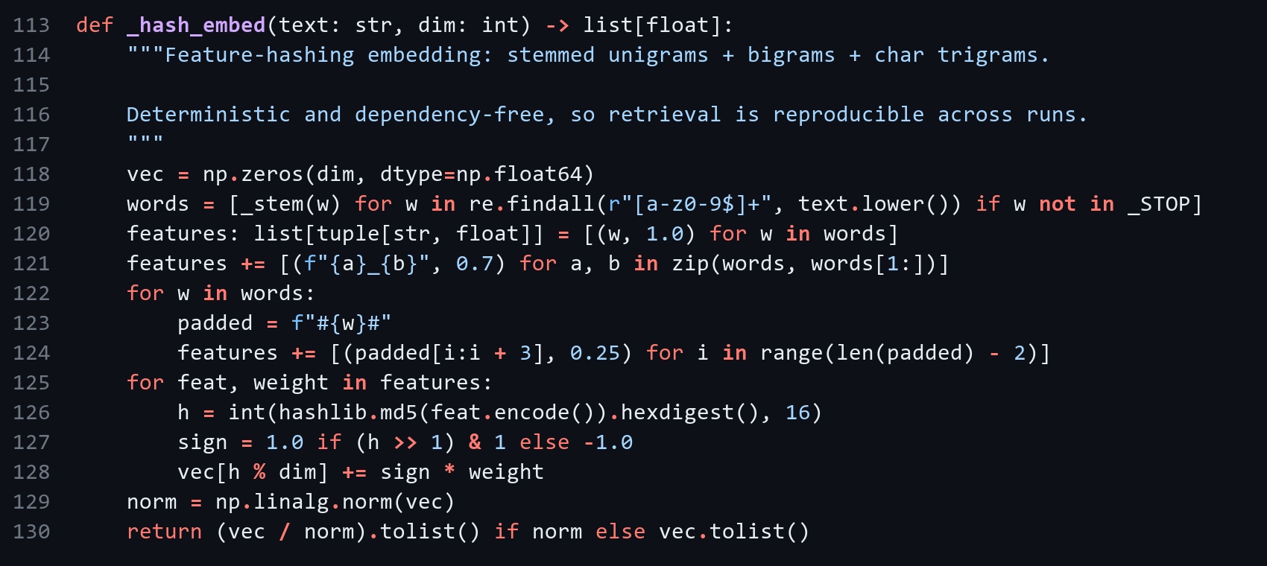
Top-k retrieval by cosine similarity - backend/app/memory.py, lines 147-158
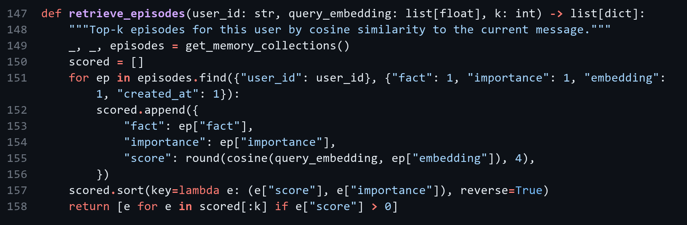
Prompt assembly - backend/app/memory.py, lines 339-362
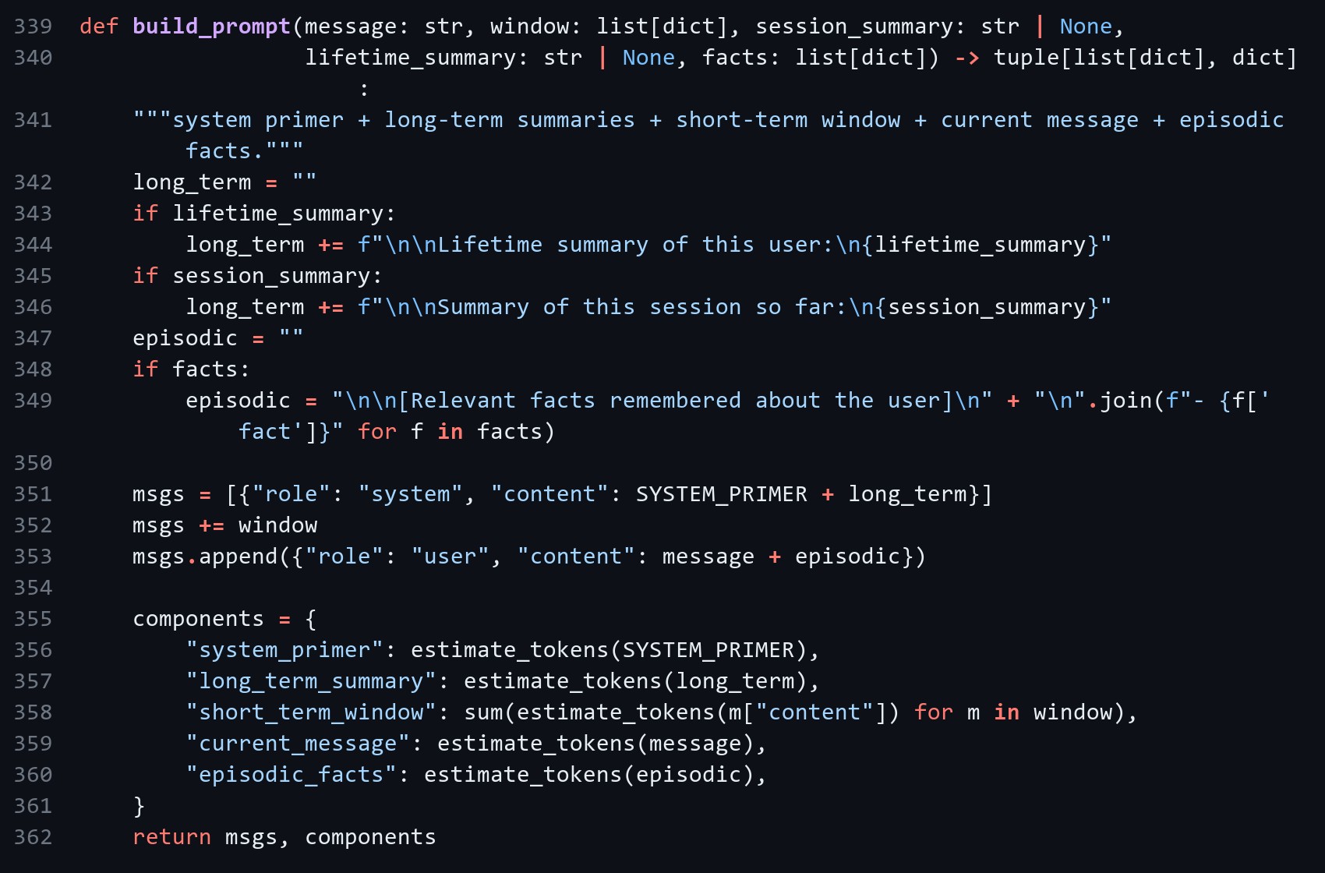
Embeddings use deterministic feature hashing (stemmed words, bigrams, character trigrams) because the local Ollama install had no embedding model; EMBED_BACKEND=ollama switches to an Ollama embedding model such as nomic-embed-text.

2.4 Demo session (12 messages, user pragya)
Turn | Window | Facts retrieved | New facts | Summary | Prompt tokens
1 | 0 | 0 | 2 | - | 151
2 | 2 | 1 | 1 | - | 254
3 | 4 | 3 | 1 | - | 374
4 | 6 | 3 | 2 | session | 443
5 | 8 | 3 | 2 | - | 611
6 | 10 | 3 | 1 | - | 704
7 | 12 | 3 | 3 | - | 791
8 | 12 | 3 | 1 | session + lifetime | 828
9 | 12 | 3 | 1 | - | 934
10 | 12 | 3 | 1 | - | 970
11 | 12 | 3 | 0 | - | 956
12 | 12 | 3 | 2 | session | 1046

Final turn: "What's my cat's name and what's my current budget?" -> "Your cat's name is Miso, and your current budget is $2,700/month." The window grows to N=12 by turn 7, summaries fire at turns 4, 8 and 12, and the lifetime summary is built at turn 8.
Observation: the lifetime summary built at turn 8 still says "$2,400", because the user's raise to $2,700 came at turn 9 and the next lifetime refresh is due at turn 16. On turns 9-10 the old budget fact was also retrieved from episodic memory and the model mentioned both values. Episodic memory stores facts but does not mark them as superseded.
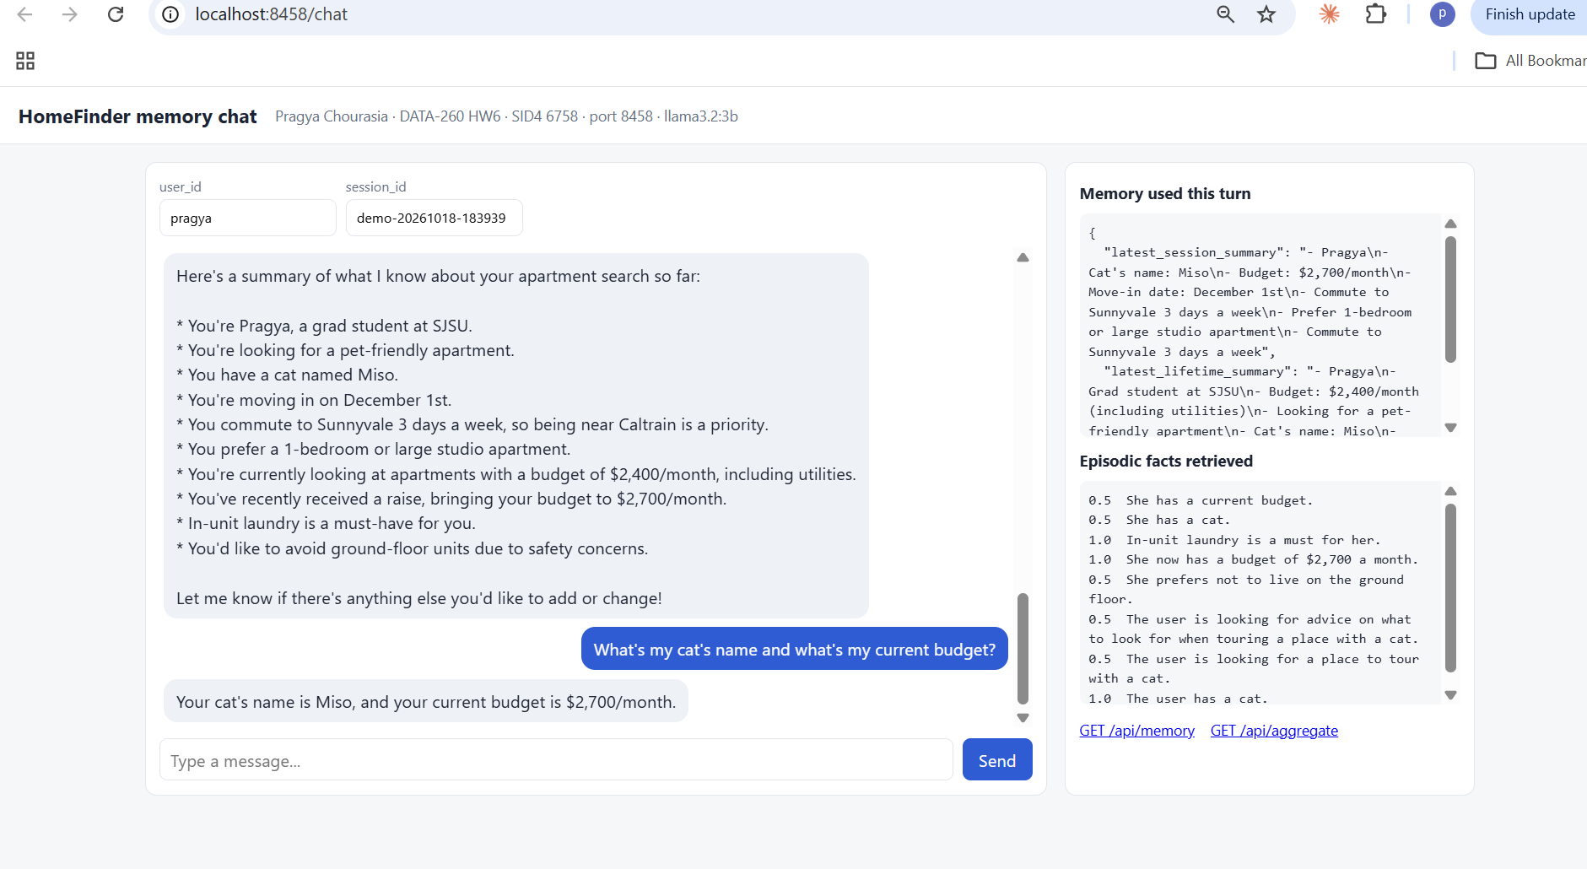
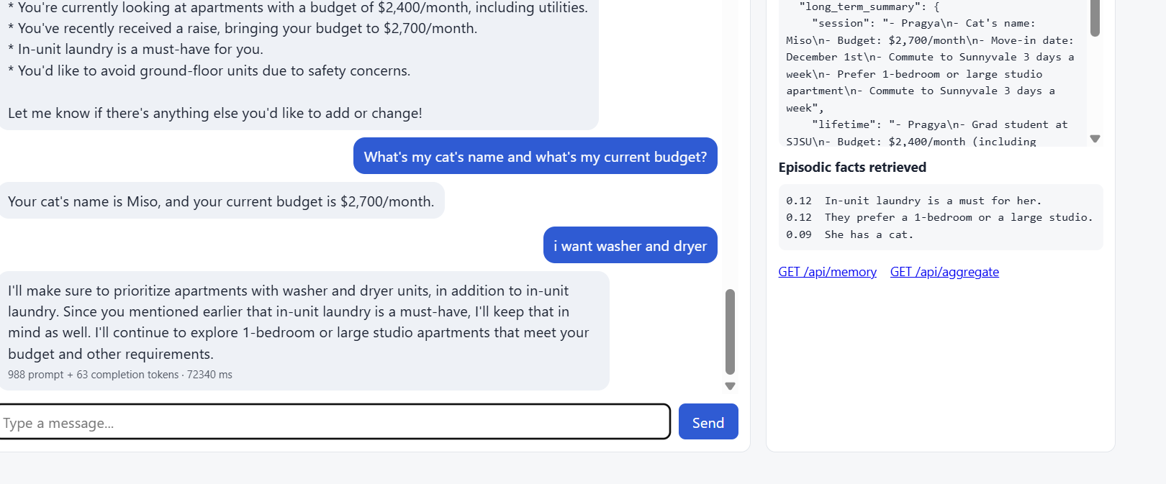
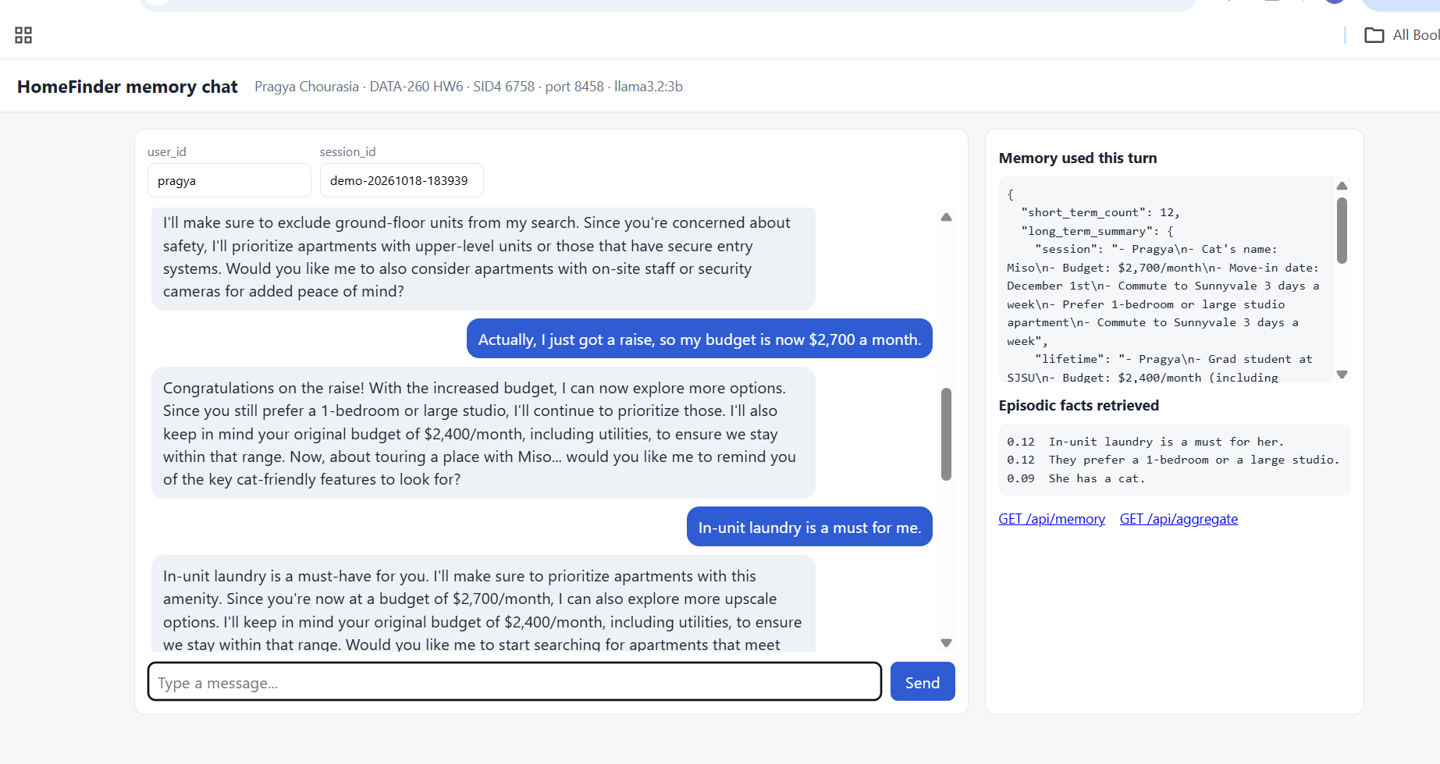
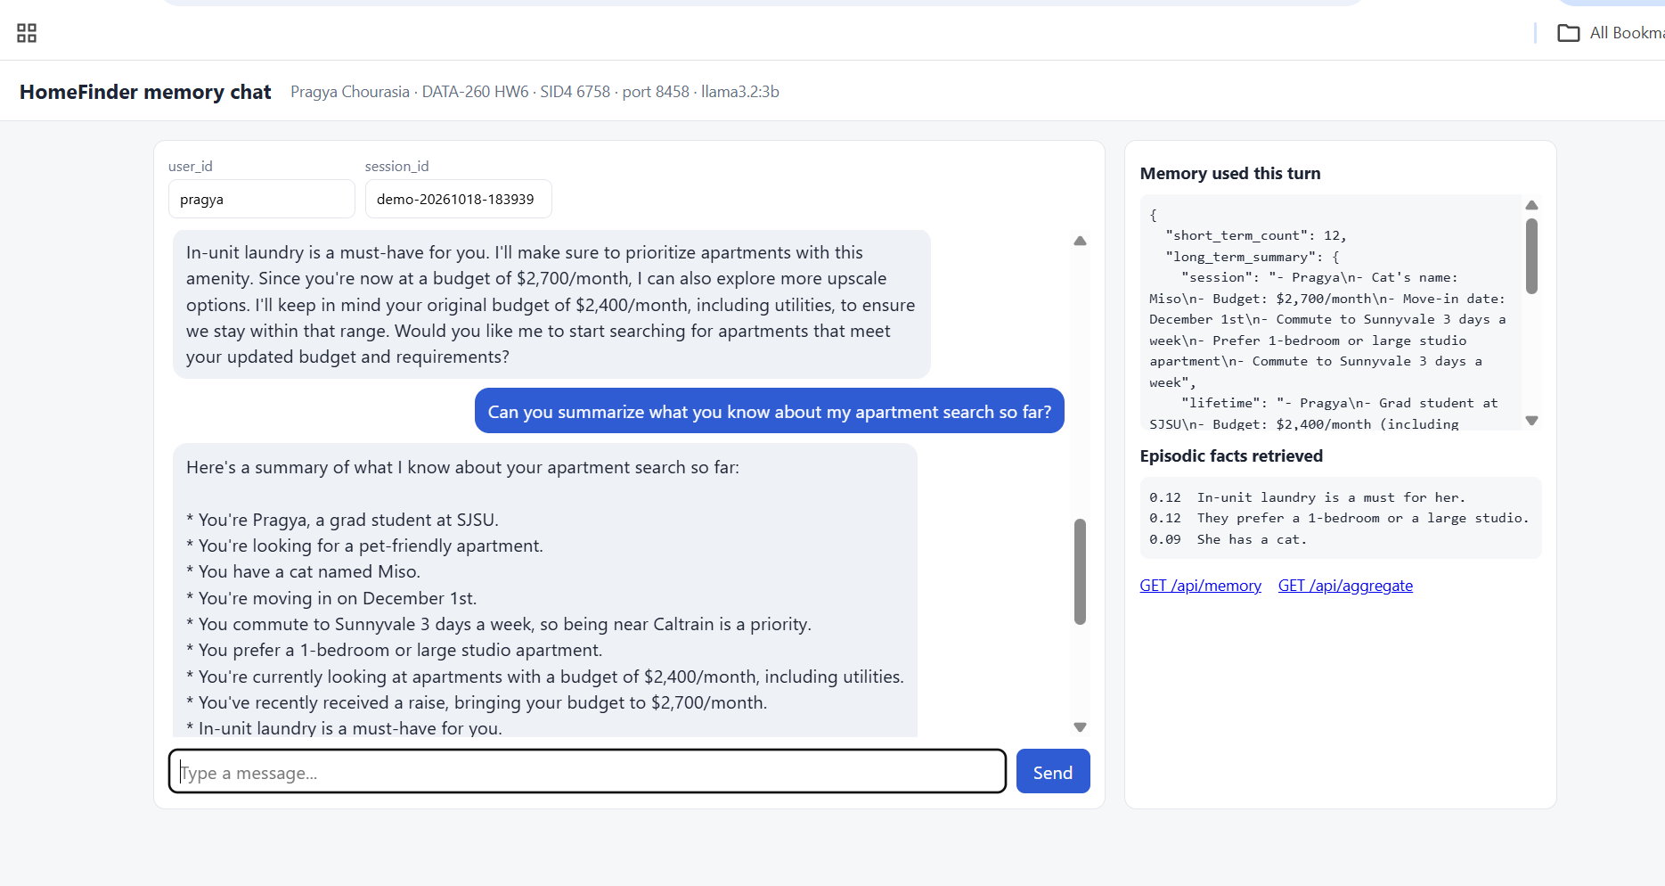
Screenshot 2.1 - Browser: http://localhost:8458/chat - stored conversation, a live turn with token count and latency, and the Memory used panel (short_term_count, summaries, episodic facts with similarity scores)
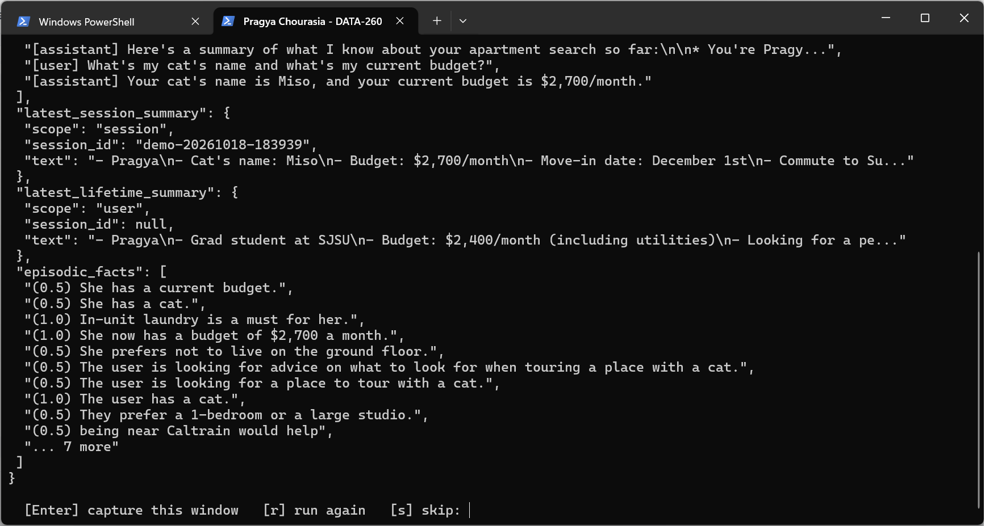
Screenshot 2.2 - Terminal: JSON result of GET /api/memory/pragya (message text shortened to fit; full JSON in raw/part2_memory.json)
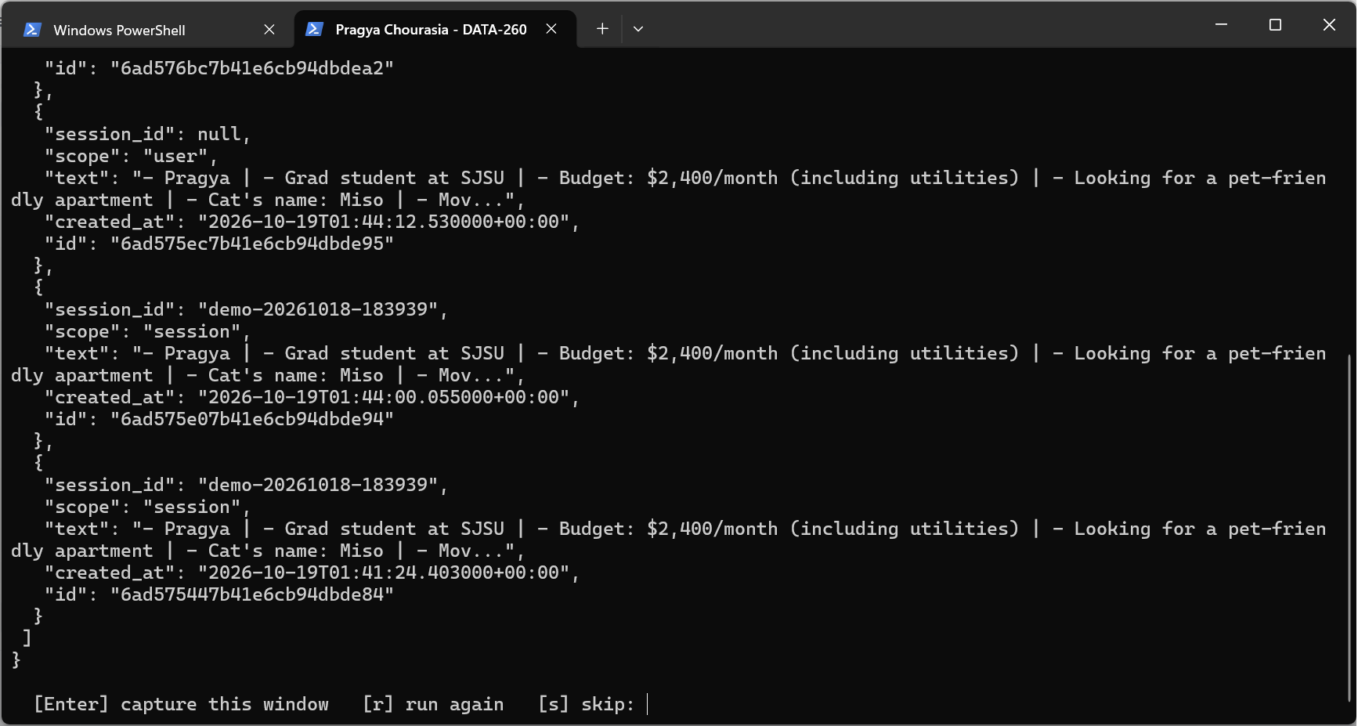
Screenshot 2.3 - Terminal: JSON result of GET /api/aggregate/pragya
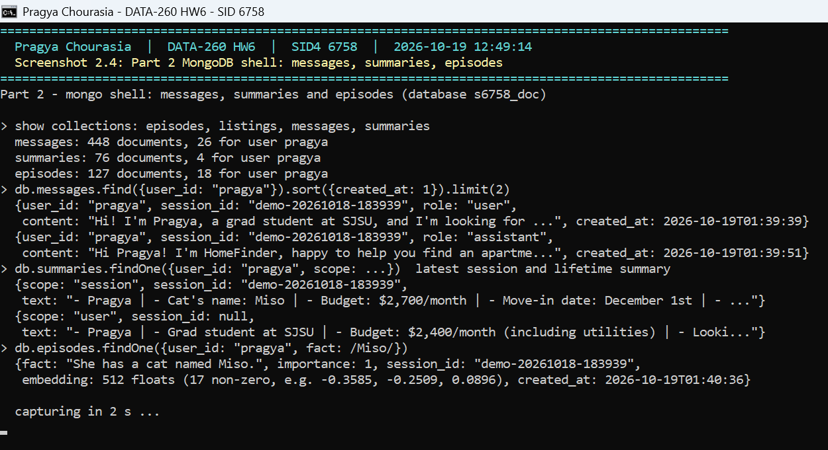
Screenshot 2.4 - Mongo shell: messages, summaries and episodes collections with documents

Part 3 - What Memory Costs

3.1 Usage logging
Every /api/chat request appends one JSON line to raw/chat_usage.jsonl and returns the same usage object: prompt and completion tokens (Ollama prompt_eval_count / eval_count), estimated tokens for the system primer, long-term summary, short-term window, current message and episodic facts, the remaining template overhead, the tokens spent on extraction and summarization, and request / model / extraction / summarization latency. Per-turn rows for the experiment are in raw/part3_turns.csv.

3.2 Memory probes
memory_probes.yaml was written before the runs. Each probe targets a fact planted at a known message so the window sizes differ in what they can see verbatim (N counts user and assistant messages: N=4 sees user messages 29-30, N=12 sees 25-30, N=30 sees 16-30).
Probe | Question | Planted at msg | Required for full credit
P1 | What kind of car do I drive and what does it need where I live? | 27 | Tesla / Model 3 + charging
P2 | Who visits me every month, and what do I need because of that? | 22 | Riya + sister + sofa bed/space
P3 | What is my current monthly budget? | 2, changed at 20 | $2,700; stating $2,400 as well costs 1 point
P4 | What is my cat's name? | 3 | Miso
P5 | On what date do I need to move in, and why that date? | 5 | December 1 + lease ends

Score | Rubric
5 | Every required element present, no outdated/wrong value
4 | Every required element present, but an outdated value is also stated
3 | At least half of the required elements
2 | Fewer than half, or only a wrong/outdated value
1 | No required element ("I don't know" or unrelated)

Deterministic scorer - backend/run_hw06_memory_cost.py, lines 69-84
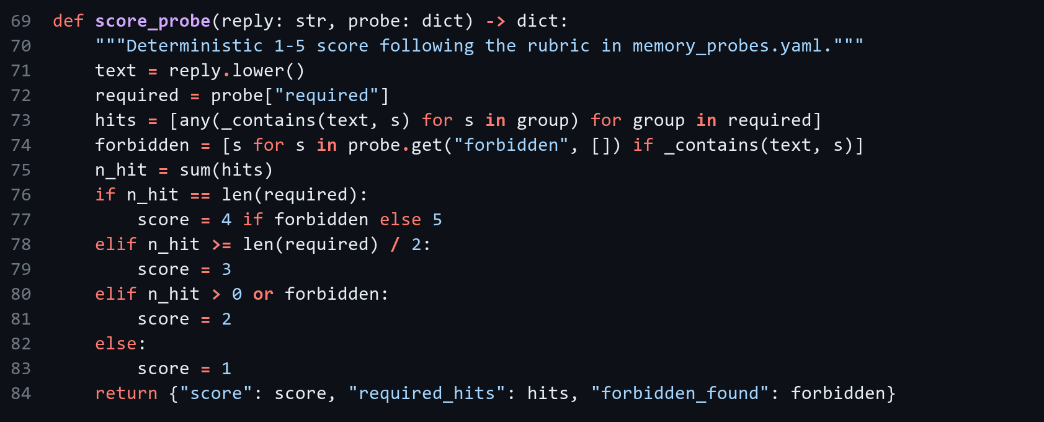

3.3 Short-term memory sizes
The same 30-message conversation was replayed for each setting as a fresh user, then the five probes were asked. Summaries and episodic memory stay on in every setting; only the window size changes. Means are over the 30 conversation turns; latency is the whole /api/chat request on CPU.
Setting | Mean prompt tokens/turn | Mean latency (ms) | Probe quality (1-5)
SHORT_TERM_N=4 | 501.2 | 30,183 | 3.4
SHORT_TERM_N=12 | 1,001.6 | 58,552 | 3.8
SHORT_TERM_N=30 | 1,750.4 | 71,053 | 4.6
Eviction/compression policy (N=30 + compress_assistant) | 820.0 | 33,276 | 4.6

Setting | Median latency (ms) | Model-call latency (ms) | Completion tokens | P1-P5 scores
SHORT_TERM_N=4 | 25,090 | 17,923 | 83.8 | 3, 1, 5, 5, 3
SHORT_TERM_N=12 | 61,827 | 43,496 | 116.4 | 5, 2, 4, 5, 3
SHORT_TERM_N=30 | 83,916 | 56,770 | 111.2 | 5, 5, 5, 5, 3
Eviction/compression policy | 36,552 | 22,323 | 51.3 | 5, 5, 5, 5, 3

3.4 Memory-saving policy: compress_assistant
Compression policy - backend/app/memory.py, lines 318-333
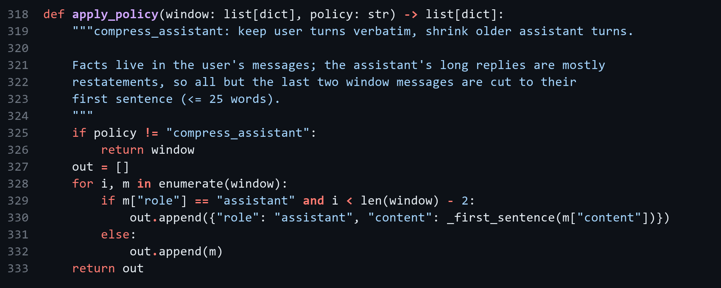
 | N=30 baseline | N=30 + compress_assistant | Change
Mean prompt tokens/turn | 1,750.4 | 820.0 | -930.4 (53.2% saved)
Mean latency (ms) | 71,053 | 33,276 | -37,777
Probe quality | 4.6 | 4.6 | +0.0

3.5 Cost estimate (10,000 conversations x 30 turns)
Input $1 per million tokens, output $5 per million tokens. "Chat" counts the reply calls only; "with upkeep" adds the extraction and summarization calls each turn makes, which are part of what memory costs.
Setting | Input tok/conv | Output tok/conv | Chat cost | With upkeep | Quality
SHORT_TERM_N=4 | 15,037 | 2,515 | $276.12 | $419.83 | 3.4
SHORT_TERM_N=12 | 30,047 | 3,491 | $475.02 | $626.65 | 3.8
SHORT_TERM_N=30 | 52,513 | 3,336 | $691.93 | $854.33 | 4.6
Eviction/compression policy | 24,600 | 1,538 | $322.90 | $450.02 | 4.6

Best: Eviction/compression policy - $450.02 (chat $322.90). Worst: SHORT_TERM_N=30 - $854.33 (chat $691.93).
Selection: quality first, then cost. Best is the cheapest setting among those with the top probe score; worst is the most expensive setting, which here buys no quality over the best one. The cheapest settings (small N) are not best because they lose window-only facts such as P2.

3.6 Analysis
- Prompt size grows with the window: 501 -> 1002 -> 1750 tokens per turn for N = 4, 12, 30. The short-term window is the dominant prompt component at N=30 (~1523 estimated tokens), while summaries (~141) and episodic facts (~44) stay small in every setting.
- Quality is decided by which facts only the window holds. P2 (sister Riya, message 22) was answered only by the settings whose window still contained message 22 (scores: N=4 1, N=12 2, N=30 5); summaries and episodic facts carried the early facts (cat name, budget) for every setting.
- P5 scored 3 in every setting: the move-in date survived, but no memory layer kept the reason ("my lease ends"). Summaries and extracted facts compress away the why, so reasons need to be extracted explicitly if they matter.
- compress_assistant cut prompt tokens by 53% versus N=30 with a quality change of +0.0: the facts live in user messages, and long assistant replies are mostly restatement. It also shortened replies (completion 51 vs 111 tokens), because the model imitates the length of the earlier replies it sees.
- Memory upkeep is not free: extraction and summarization add $127-$162 per 10,000 conversations (+23% to +52% on top of the chat calls). That part barely depends on the window size, so it matters most for the cheap small-window settings.
- Latency is CPU-bound and noisy on this laptop (Ollama on an i5 with ~1 GB free RAM); token counts are the reliable comparison. Runs interrupted by Windows standby were rerun with the PC kept awake and the affected runs are kept in raw/part3_run2_standby/.
- Each setting was run once, so single probe scores can move by a point between runs: in the standby-affected N=4 run P1 scored 5, in the rerun 3 (the reply named the Tesla but not the charging). The ordering of the settings did not change.

Part 4 - File-Based Memory and Consolidation

4.1 AGENT.md (final)
Expanded from HW1: 15 instructions covering all five categories (project description, technology stack, coding conventions, testing approach, prohibited actions); the HW1 code-review rules are kept as a scoped mode.
AGENT.md - AGENT.md, lines 1-33
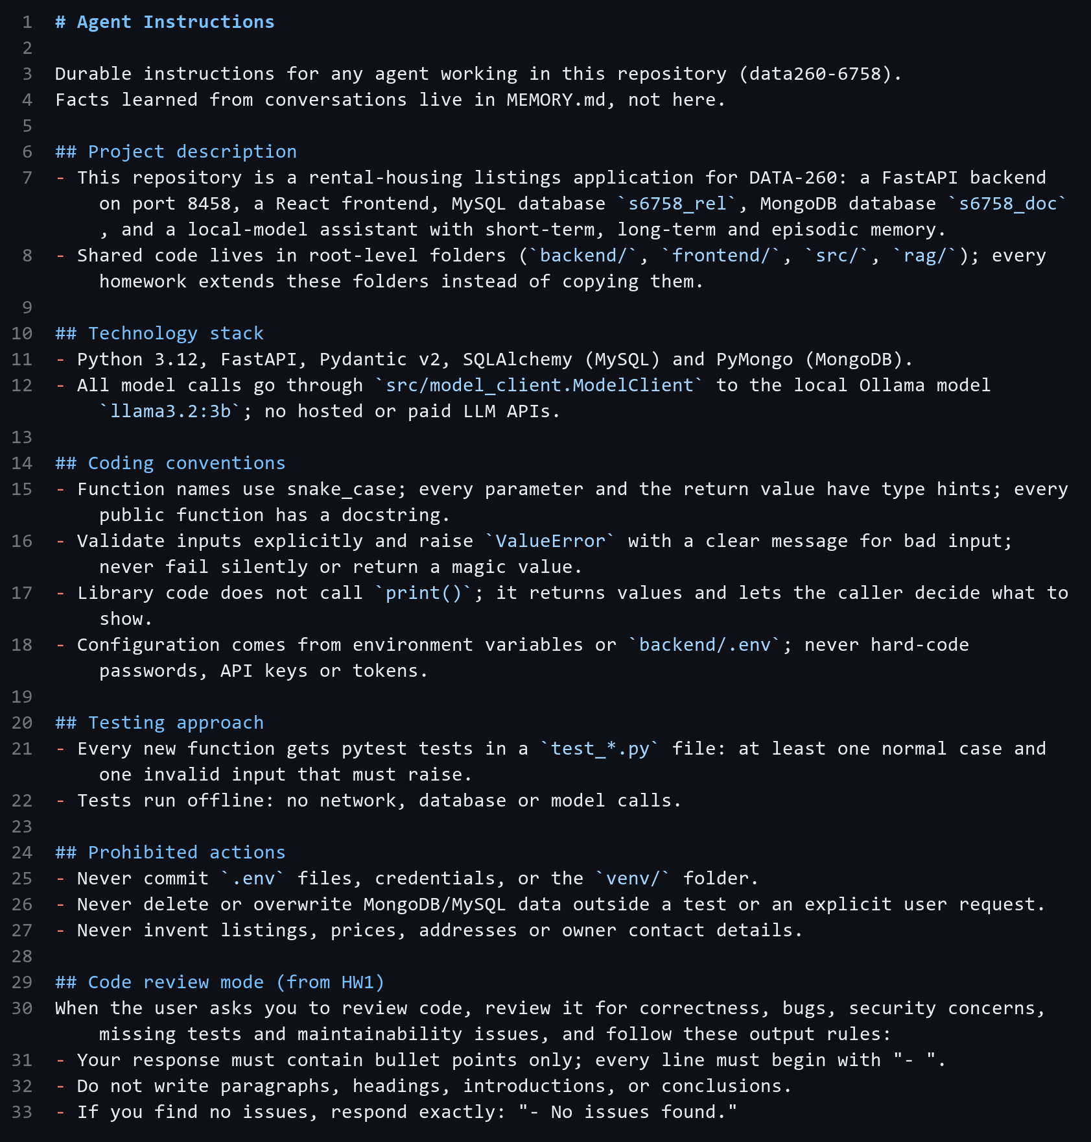

4.2 File loading, prompt construction and consolidation checks
Load both files - src/file_memory.py, lines 53-57
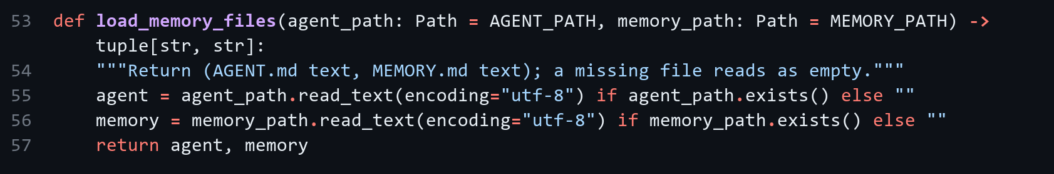
Add them to the system prompt - src/file_memory.py, lines 60-68
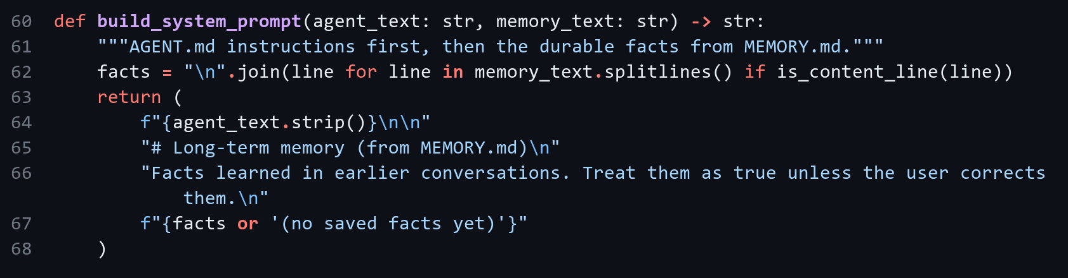
Read the last-consolidated timestamp - src/file_memory.py, lines 85-94
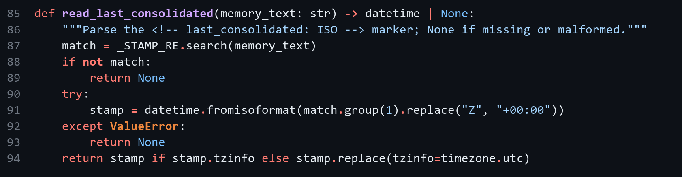
When consolidation is required (> 40 lines or > 24 h) - src/file_memory.py, lines 97-109
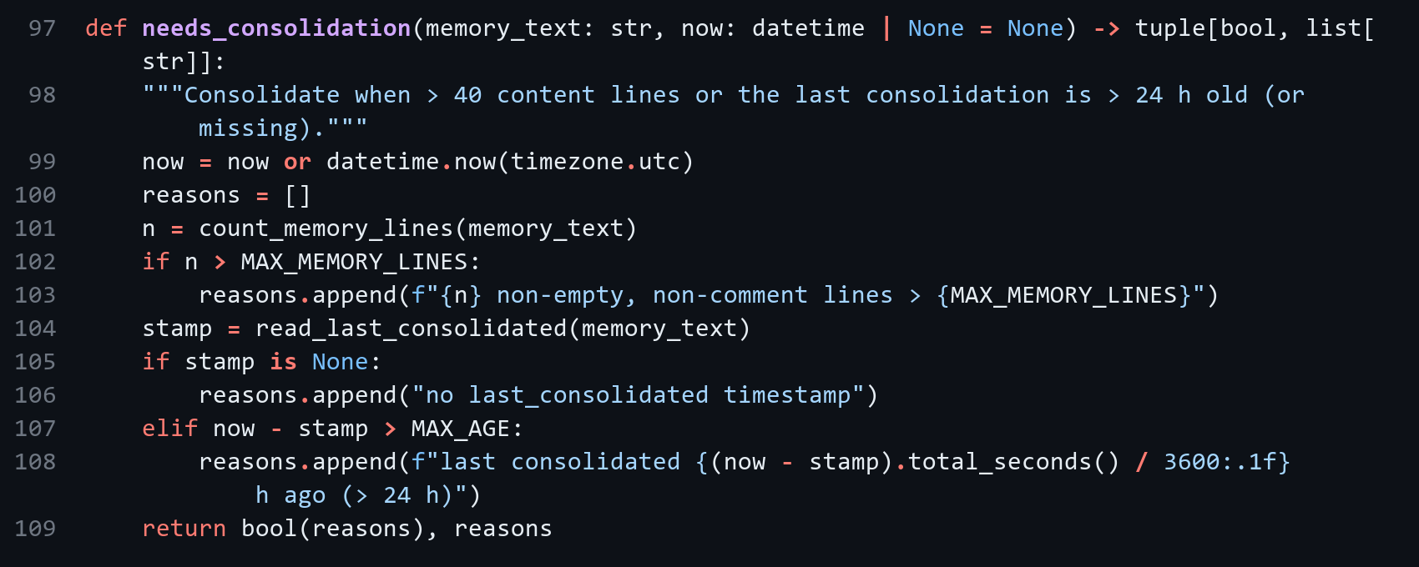

4.3 Commands
code/hw1_client.py help text - code/hw1_client.py, lines 20-26
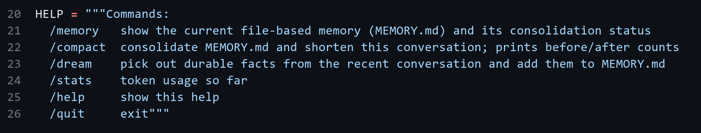
/compact handler - code/hw1_client.py, lines 92-103
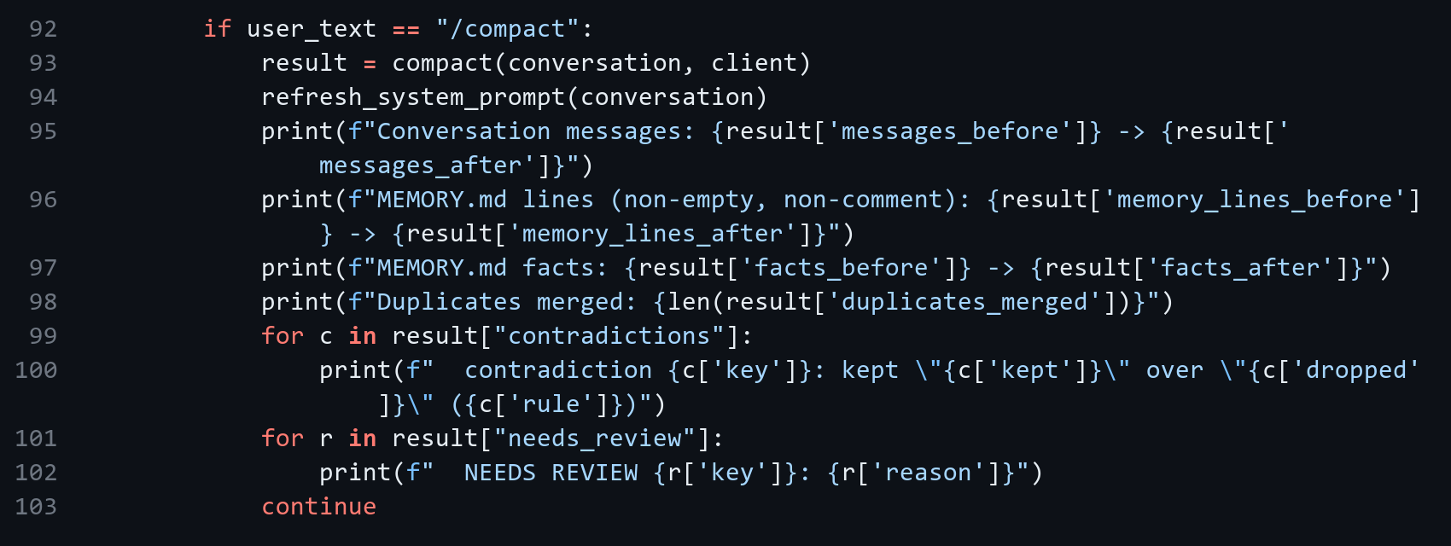
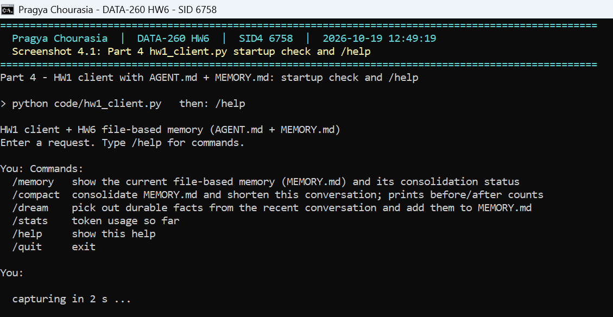
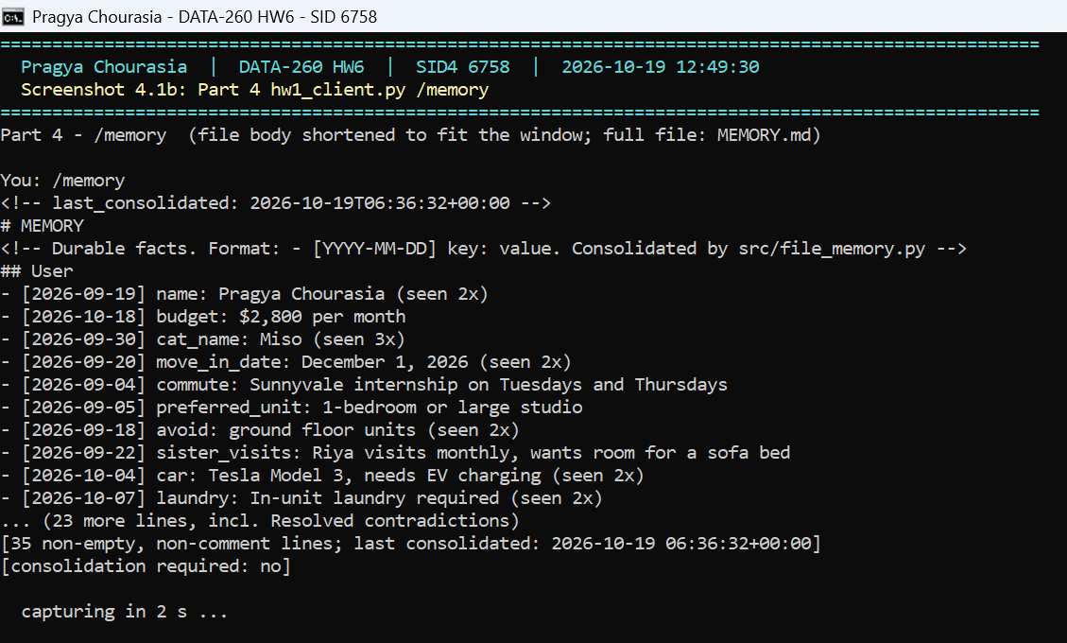
Screenshot 4.1 - Terminal: hw1_client.py /help, then /memory with the consolidation status

4.4 Consolidation test (55 -> 36 lines)
reports/hw06/memory/MEMORY_original.md has 55 lines (50 non-comment) with 17 duplicated facts (some differing only in case or punctuation, e.g. "ground-floor" vs "ground floor") and five contradictions. Rules: duplicates merge into one line with "(seen Nx)"; for a contradiction the newest dated value wins unless it is hedged ("?", "maybe"); every losing value is written to "Resolved contradictions" (nothing is deleted silently); a reviewer pass flags a resolution as likely wrong when the dropped value was stated more often than the winner.
Contradiction resolution + review flag - src/file_memory.py, lines 215-232
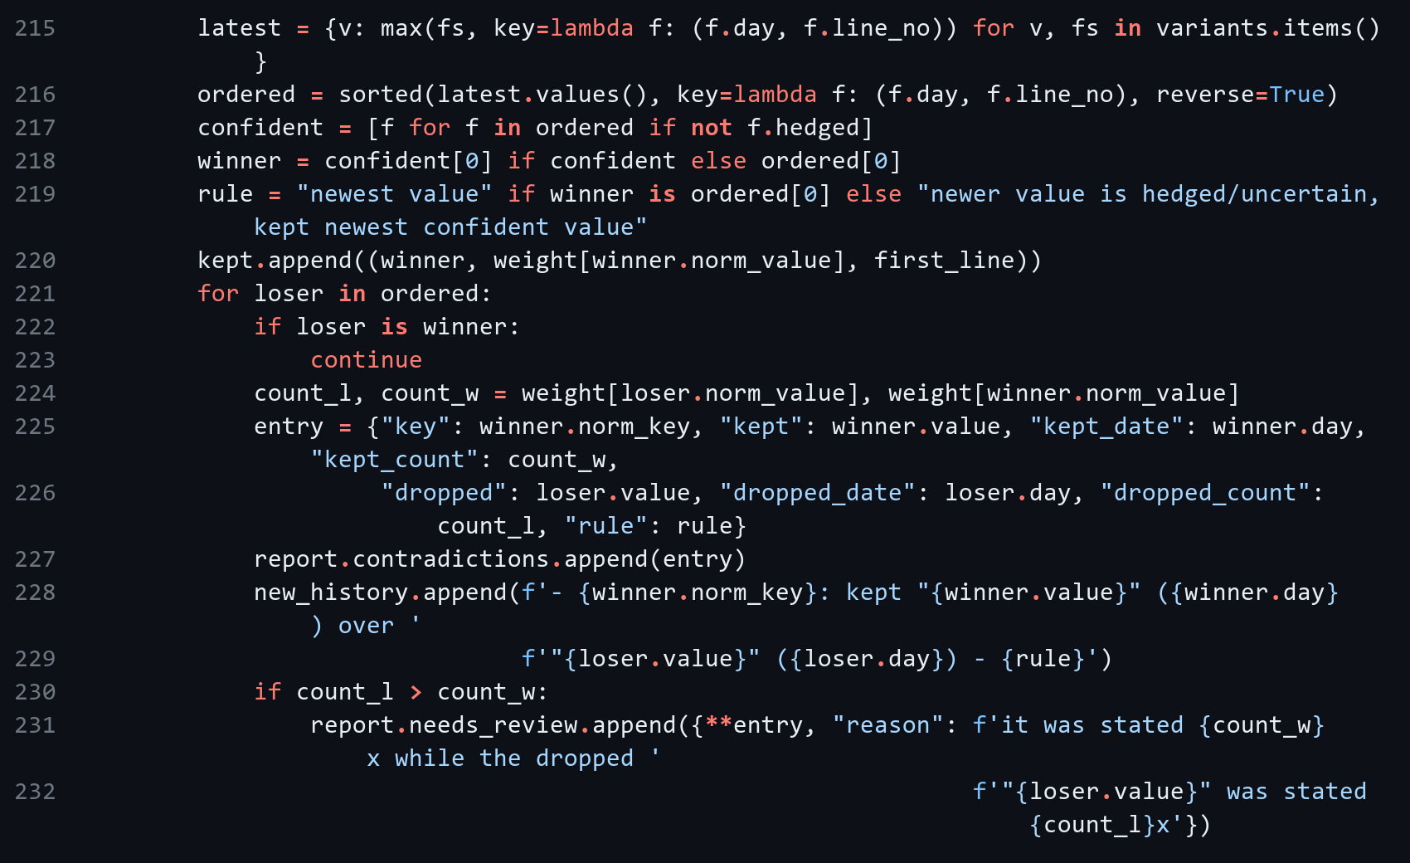
Contradiction | Values | Resolution | Correct?
budget | $2,400 (09-02) vs $2,700 (10-10, 10-11) | kept $2,700 - newest | Yes
backend_port | 8000 (08-28) vs 8458 (x2) | kept 8458 - newest | Yes
preferred_model | qwen3:8b vs llama3.2:3b (x2) | kept llama3.2:3b - newest | Yes
cat_name | Miso (x3) vs "Mochi? (maybe misheard)" (newest) | kept Miso - newer value is hedged | Yes
mongo_db | s6758_doc (x2) vs study_planner_demo (newest, x1) | kept study_planner_demo - newest; flagged "Needs review" | No - resolved incorrectly

Incorrect resolution identified: mongo_db - recency picked the class-demo database name study_planner_demo, which had been copied in once, over s6758_doc, which had been confirmed twice. The reviewer pass flagged it in "Needs review" and it was corrected by a recorded human review (MEMORY_final_reviewed.md). The same heuristic also produced a false positive later: a real budget increase to $2,800 was flagged because $2,700 had been stated twice, so the flags need a human decision.
/compact output (raw/part4_compact_session.txt):
hw1_client.py /compact
Conversation messages: 7 -> 6
MEMORY.md lines (non-empty, non-comment): 50 -> 34
MEMORY.md facts: 46 -> 22
Duplicates merged: 17
contradiction budget: kept "$2,700 per month" over "$2,400 per month" (newest value)
contradiction cat_name: kept "Miso" over "Mochi? (maybe misheard)" (newer value is hedged/uncertain, kept newest confident value)
contradiction backend_port: kept "8458" over "8000" (newest value)
contradiction mongo_db: kept "study_planner_demo" over "s6758_doc" (newest value)
contradiction preferred_model: kept "llama3.2:3b" over "qwen3:8b" (newest value)
NEEDS REVIEW mongo_db: it was stated 1x while the dropped "s6758_doc" was stated 2x

You:

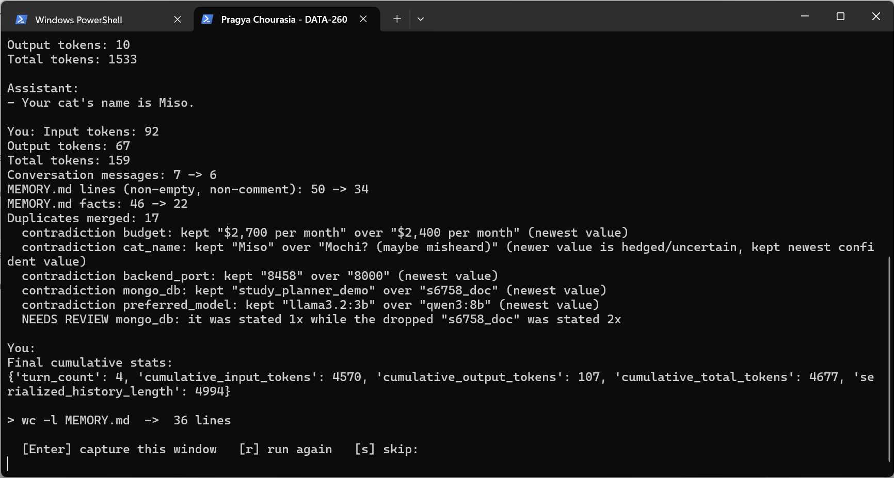
Screenshot 4.2 - Terminal: /compact on the 55-line MEMORY.md with before/after counts
Before consolidation (55 lines) - reports/hw06/memory/MEMORY_original.md, lines 1-34 (part 1 of 2)
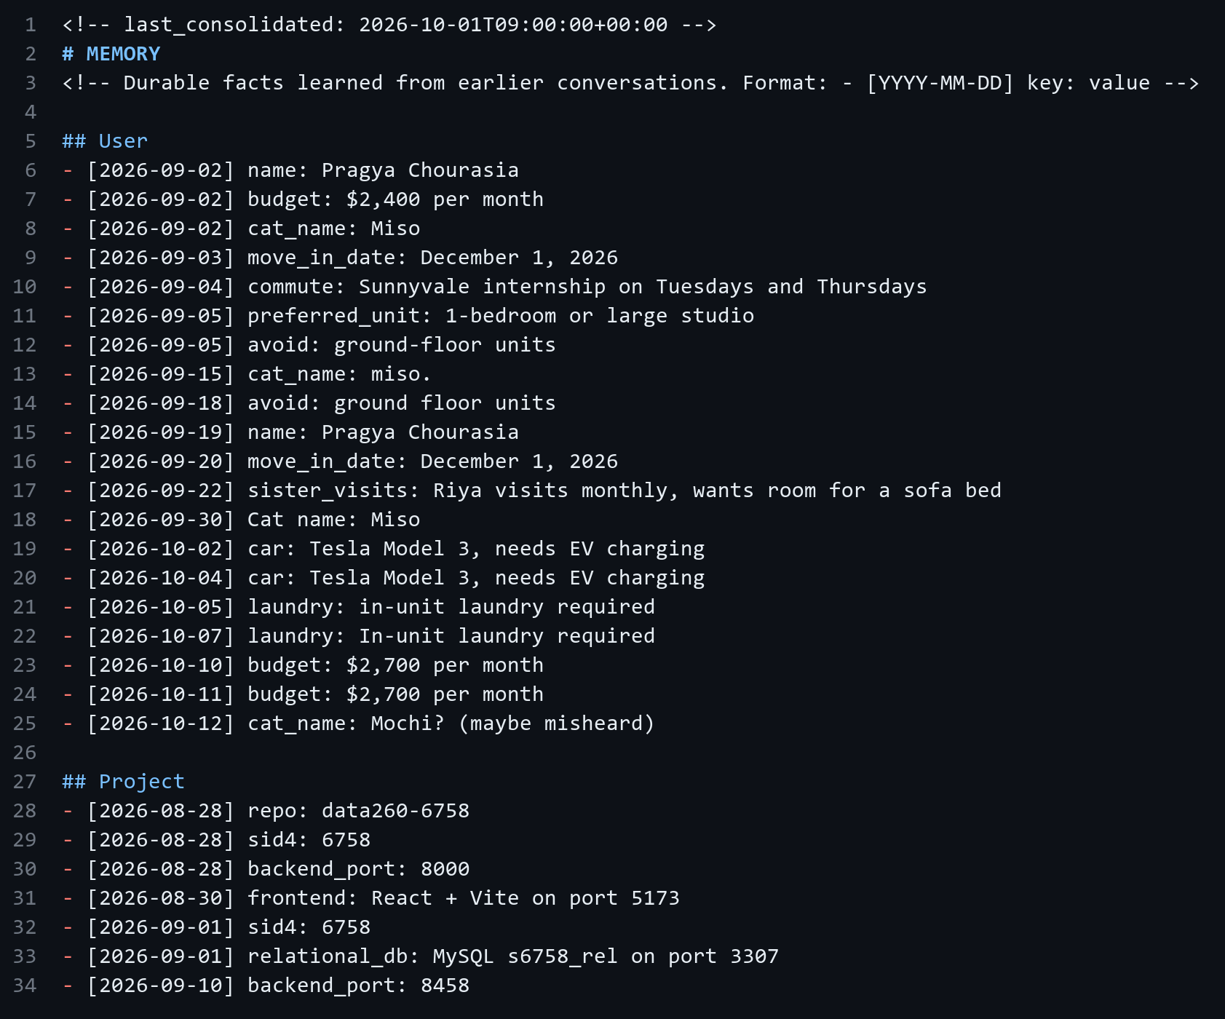
Before consolidation (55 lines) - reports/hw06/memory/MEMORY_original.md, lines 35-55 (part 2 of 2)
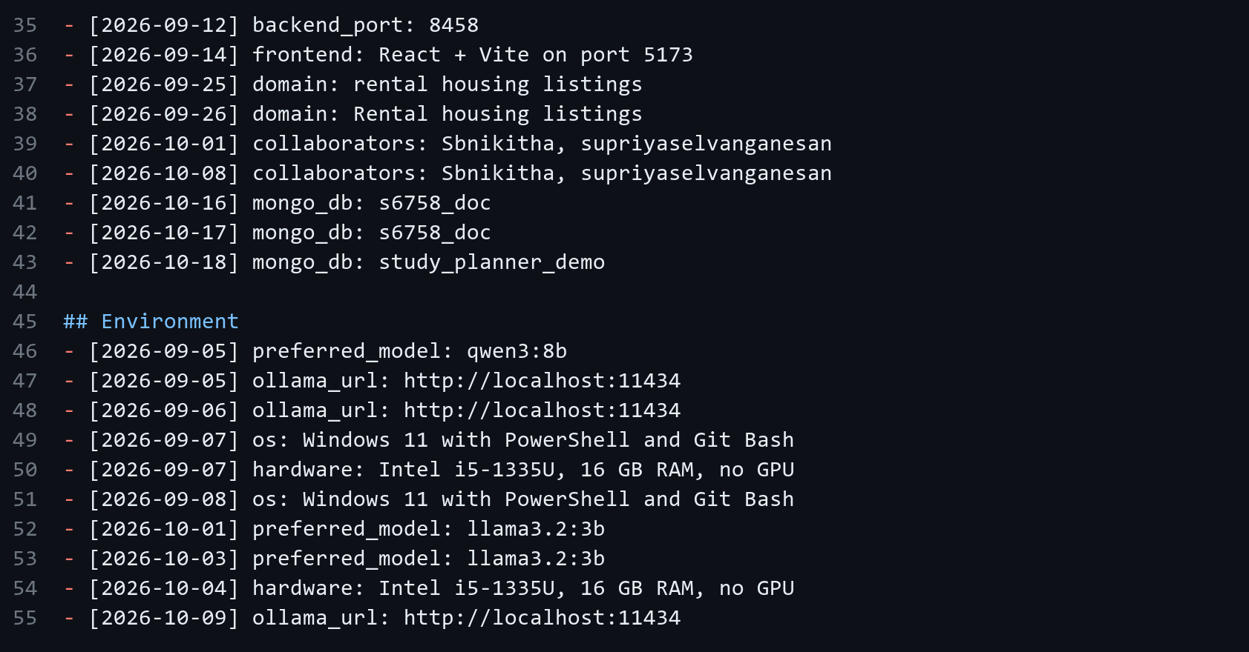
After /compact (36 lines) - reports/hw06/memory/MEMORY_consolidated.md, lines 1-34 (part 1 of 2)
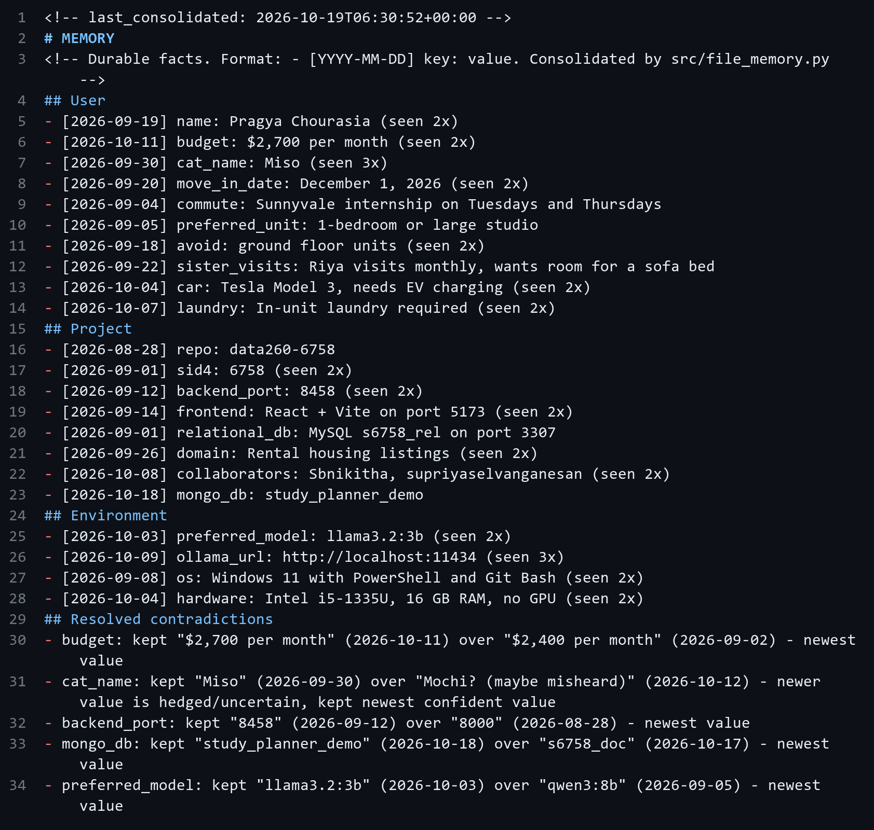
After /compact (36 lines) - reports/hw06/memory/MEMORY_consolidated.md, lines 35-36 (part 2 of 2)

4.5 Verifying a generated function against AGENT.md
code/generate_with_agent_md.py asked llama3.2:3b, with AGENT.md + MEMORY.md as the system prompt, for parse_monthly_rent and its tests. code/check_agent_md_rules.py checks each AGENT.md rule separately (AST checks plus running the tests).
AGENT.md rule | Generated | Corrected
Coding conventions: snake_case function names | PASS | PASS
Coding conventions: type hints on every parameter and return value | PASS | PASS
Coding conventions: docstring on every public function | PASS | PASS
Coding conventions: invalid input raises ValueError | PASS | PASS
Coding conventions: no print() in library code | PASS | PASS
Coding conventions / prohibited: no hard-coded secrets | PASS | PASS
Technology stack / testing: no network, database or model imports | PASS | PASS
Testing approach: test_*.py file exists | PASS | PASS
Testing approach: at least one normal case and one invalid-input case | PASS | PASS
Testing approach: tests pass offline | FAIL | PASS

The generated code followed every style rule but failed its own first example ("$2,400/mo" raised ValueError because commas and "/mo" were never removed) and one generated test expected "$2,400" to be rejected. The corrected version uses one regex for sign, $, digits with commas/decimals and a k suffix; the checker reports 10/10.
Corrected function - src/generated/rent_parser.py, lines 1-29
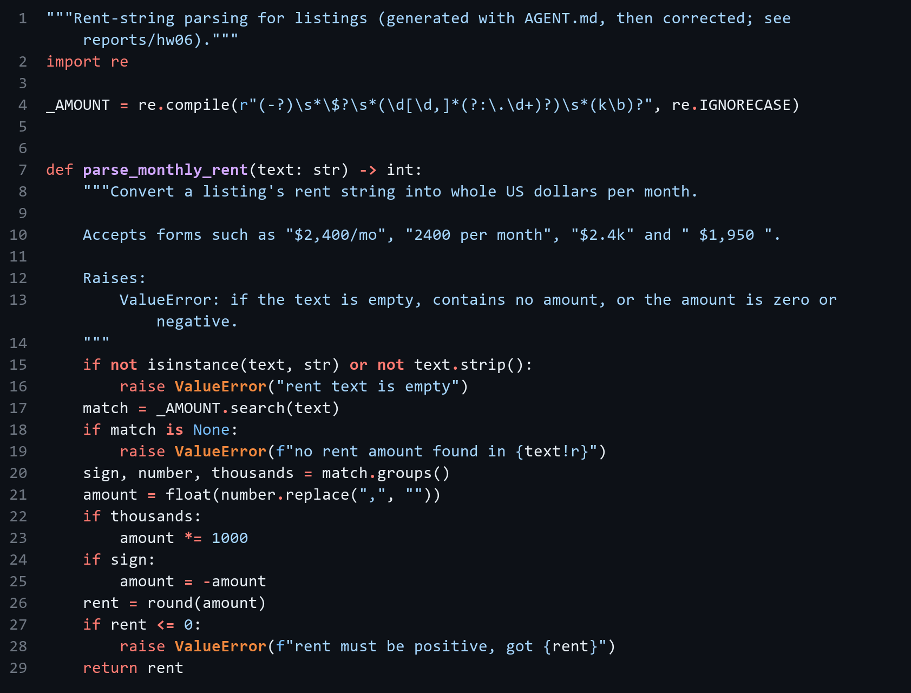
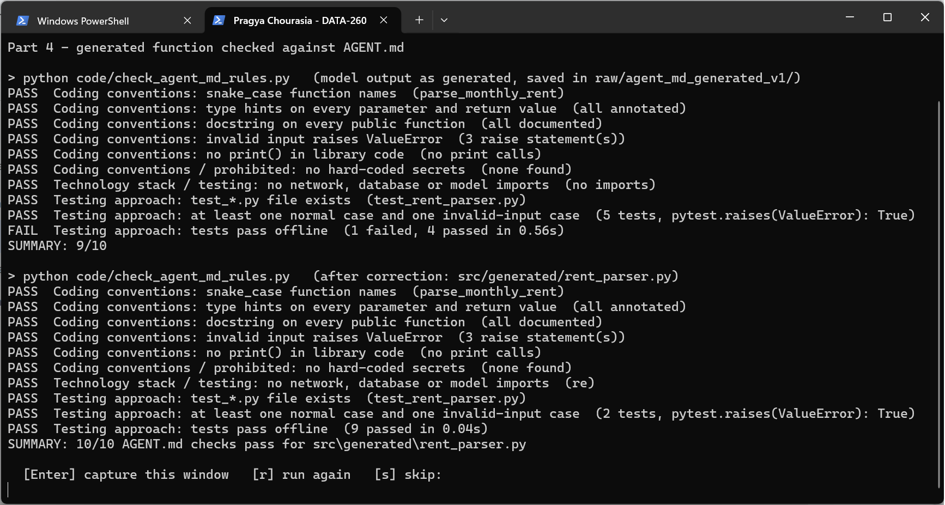
Screenshot 4.3 - Terminal: python code\check_agent_md_rules.py - generated version 9/10, corrected version 10/10

4.6 MongoDB memory vs file-based memory
Criterion | MongoDB memory (Part 2) | File memory (Part 4)
Inspectability | Needs a tool (Compass, mongosh, or GET /api/memory). Episodes carry 512-float embeddings that are not human-readable; summaries are LLM-written, so you see the result but not why a fact changed. | Open the file in any editor or run /memory. Every fact is one dated line, and consolidation writes its decisions ("Resolved contradictions", "Needs review") into the file. git diff shows exactly what changed.
Persistence after a restart | Survives backend and container restarts (named Docker volume s6758_mongo_data). Lost only if the volume is deleted. Needs the database running to read it. | Survives anything that keeps the repo; versioned in Git, so earlier states (e.g. MEMORY_original.md) can be restored. Readable with no services running.
Scalability across many sessions | Built for it: per-user/per-session queries on indexes, 24 messages + 17 episodes per demo user is trivial, and thousands of users fit easily. Weak spot: retrieval loads every episode for a user and scores cosine in Python, which is O(episodes) per turn; a vector index (Atlas Search / pgvector) would be needed at large scale. | Poor: one shared file, loaded whole into every prompt (about 540 tokens for the 22 consolidated facts), with no per-user separation and no concurrent writers. It must be consolidated to stay under 40 lines, which is exactly what limits it.
Facts that must not be forgotten | Risky. Short-term memory slides away, summaries are rewritten by the model (the Part 2 lifetime summary still said $2,400 after the user changed it to $2,700), and episodic retrieval only returns the top-k by similarity, so an important fact can be missed if the wording differs. In the Part 3 N=4 run the "Tesla Model 3" fact scored only 0.02 for "What kind of car do I drive?" because the stemmer turns "drives" into "driv" but leaves "drive" unchanged; the EV-charging fact was retrieved, yet the model still answered that it had no information. | Better. A fact in MEMORY.md is in every prompt, deletions are explicit, contradictions are kept in "Resolved contradictions", and doubtful resolutions are flagged for a human. Still fallible: recency picked the wrong mongo_db value until the reviewer pass flagged it.

Use each for what it is good at: MongoDB for high-volume, per-user conversational memory (messages, summaries, episodes) where losing an old detail is acceptable. AGENT.md / MEMORY.md for a small set of durable, reviewed instructions and facts that must always be in context and need a human-readable audit trail.

AI Use

1. What I used an AI assistant for, and what I did myself
I used Claude Code as a coding assistant for most of the implementation in this homework. I gave it the HW6 brief, the two class demos (the FastAPI + PyMongo study planner and the long-term-memory demo) and my HW1-HW5 repository, and used it to plan the work part by part and to write most of the code: the MongoDB listings API (config, connection, schemas and routes in separate files), the memory module behind /api/chat, the Part 3 experiment runner and probe scorer, the file-based memory functions and CLI commands, the tests, the verification script, and the layout of this report.
What I did myself: I kept the rental-listings domain from my earlier homeworks and asked for the work to be done one part at a time so I could check and push each part. I set up and ran everything on my own laptop (Docker with MongoDB, the FastAPI backend on port 8458, Ollama with llama3.2:3b), used the chat page myself, ran the demo session and the memory experiments, took the screenshots, and checked the outputs against the requirements in the brief. I decided what to keep when results looked wrong, read the results to understand what the memory settings change, and handled Git (branch, commits, tag).

2. Something the AI produced that was wrong
Three things the assistant wrote were wrong, and each was caught by a test or a check:
- Embedding stemmer. The first version of _stem() removed "es" before "s", so "drives" became "driv" while "drive" stayed "drive". The stored fact "Pragya drives a Tesla Model 3" only scored 0.02 against the probe "What kind of car do I drive?", so that fact was not retrieved.
- Function generated under AGENT.md. I had llama3.2:3b generate parse_monthly_rent with AGENT.md as its instructions. It followed all the style rules (snake_case, type hints, docstring, ValueError, no print) but failed its own first example: "$2,400/mo" raised a ValueError because the comma and "/mo" were never removed. One of its tests was also wrong (it expected "$2,400" to be rejected).
- Memory consolidation and `/dream`. Consolidating an already-consolidated MEMORY.md lost the "(seen Nx)" counts and the "Needs review" flags, and /dream saved my correction under a new key (hw6_project_database) instead of mongo_db, so the wrong value was never replaced.

3. How the problems were found
- The stemmer bug showed up in the Part 3 results: at N=4 the car probe scored 1/5. The episodic facts retrieved for that probe (saved in raw/part3_run1_aborted/n4.json) and their cosine scores showed the 0.02 score and the "driv" / "drive" mismatch.
- code/check_agent_md_rules.py checks each AGENT.md rule separately and also runs the tests. It reported 9/10 for the generated function, with "tests pass offline: 1 failed" (raw/agent_md_generated_v1/agent_md_check.json).
- The consolidation bug was caught by the test test_consolidation_is_idempotent_and_keeps_history, and the /dream problem is visible in the session output raw/part4_dream_session_before_fix.txt.

4. What was changed and why it works now
- The stemmer now handles "ies"/"sses"/"ches"/"xes" first and then strips one trailing "s", "ing" or "ed" and a final "e", so "drive", "drives" and "driving" share one stem (the score went from 0.02 to 0.16). Because this changes retrieval, I reran the whole Part 3 sweep so every setting uses the same code. The first run is kept in raw/part3_run1_aborted/; it also stopped when MongoDB timed out because other Docker containers on my laptop were using all the memory.
- The generated function was rewritten with one regular expression (optional sign, "$", digits with commas or decimals, optional "k"), and the wrong test was fixed. The checker now reports 10/10 and all tests pass. What I learned: AGENT.md controls how generated code looks, but only tests show whether it actually works.
- Consolidation now reads "(seen Nx)" back as a count, keeps earlier "Needs review" lines until that key is decided again, and /dream is given the existing keys and told to reuse them. 14 offline tests cover these cases. The one wrong resolution left (mongo_db) I fixed through a recorded human review in MEMORY.md, which is exactly what the "Needs review" section is for.

