Multi-Agent Data Collection Pipeline
Project Documentation

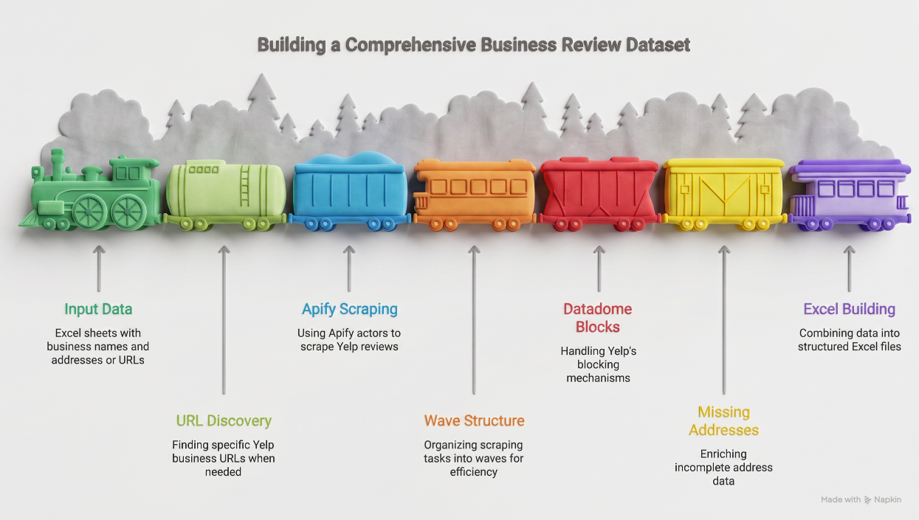
Figure 1. Multi-agent pipeline architecture
What This Project Does
This project collects public customer feedback data from online sources, cleans it, and delivers it as organized Excel files ready for analysis. The work uses a multi-agent pipeline, where several small programs (called agents) each do one job and pass their output to the next agent in the chain.
Instead of writing one giant script that does everything, the work is divided into specialized agents that run in parallel. This makes the whole system faster, more reliable, and easier to fix when something breaks.
Why Multi-Agent Design
A single script trying to do everything has three big problems:
- Speed. One script handles one URL at a time, which is slow.
- Fragility. If one URL fails, the whole script can stop.
- Debugging. When something goes wrong, you have to dig through hundreds of lines.
A multi-agent pipeline solves all three problems by splitting the work into focused pieces. Each agent has one clear job, runs independently, and can be restarted without losing work.

How the Pipeline Works
The pipeline has six main agents. Each one passes its results to the next.
1. Input Agent
Reads the source files (Excel sheets with business names, addresses, or URLs) and prepares a clean list of targets to process.
2. Discovery Agent
For each business, finds the correct page on the data source. This step is needed when the input only has names and addresses, not direct URLs. The agent uses a search engine to look up each location and saves the matching link.
3. Scraping Agents (Three in Parallel)
This is the core of the pipeline. Three agents run at the same time, each handling a different batch of pages. They work in waves, meaning all three agents start together, finish their batch, save progress, and then start the next wave. Running three agents in parallel makes the work three times faster than a single script.
4. Recovery Agent
When the data source blocks too many requests (which is common with bot protection systems), this agent steps in. It detects the block, switches to a fresh set of credentials, and retries the failed pages. This is what turns a 70 percent success rate into a 95 percent success rate.
5. Enrichment Agent
Sometimes the main source does not return every field. For example, the scraper might return reviews but not full street addresses. The enrichment agent fills these gaps by looking up the missing information from secondary sources, like official location directories or search engine results.
6. Output Agent
The final agent takes everything the others collected, removes duplicates, organizes the data into clean columns, and writes one or more Excel files. It also adds summary sheets so a non-technical user can quickly understand what is inside.
Tools Used and Why
Tool | What It Does | Why This One
Apify cloud platform | Runs the scraping agents in the cloud with rotating IP addresses | Local scrapers get blocked instantly by bot protection. Apify handles the proxies and browser fingerprinting automatically.
Python with asyncio | Coordinates the agents and runs them in parallel | Native support for running multiple tasks at once without complex threading code.
Playwright (headless browser) | Used by the Discovery and Enrichment agents to search for URLs and addresses | Mimics a real user browsing, so it can access pages that block simple HTTP requests.
pandas | Manipulates data, merges files, removes duplicates | Standard tool for tabular data in Python. Fast and well documented.
openpyxl | Writes formatted Excel files with multiple sheets, custom fonts, and colors | Gives full control over the final Excel output beyond what pandas alone provides.
The Wave Structure Explained
Each wave processes a small group of URLs. The structure looks like this:
Wave 1: Agent A (6 URLs) Agent B (6 URLs) Agent C (6 URLs) = 18 URLs done
Wave 2: Agent A (6 URLs) Agent B (6 URLs) Agent C (6 URLs) = 18 more URLs
Wave 3: ...
After every wave, progress is saved to a file. If the script crashes, gets killed, or is interrupted, the next run reads that file and continues from exactly where it stopped. No work is lost and no URL is processed twice.
This is one of the most important features of the pipeline. Long scraping jobs always face interruptions, so resumability is not optional.
Handling Failures and Blocks
Bot protection systems often block scrapers after a few hundred requests. When this happens, the pipeline does not give up. Instead:
- The Recovery Agent detects that recent waves are returning empty results.
- It pauses the run and signals that credentials need rotation.
- With a fresh set of credentials, the pipeline picks up where it left off.
- Each fresh rotation typically unlocks another batch of pages before the next block.
This rotation strategy is what allowed the project to reach high coverage even when individual scraping sessions kept getting blocked.
Output Format
The final output is a clean Excel workbook with multiple sheets:
- Summary sheet: Totals, date range, coverage percentage.
- Per-business sheet: One row per business with name, address, review count, average rating, and link.
- All-records sheet: Every individual record with all fields filled in.
- Failures sheet: Any URLs that could not be processed, with the reason listed.
The format is designed so that an analyst can open the file in Excel and start working immediately. No technical setup required.
Key Lessons From The Project
- Modular beats monolithic. Six small agents that each do one job are easier to build, test, and fix than one giant script.
- Save progress constantly. Anything that runs longer than five minutes should save state after every meaningful step.
- Plan for blocks, not just success. The happy path is the easy part. The recovery strategy is what makes a pipeline production ready.
- Use the right tool for each agent. A scraping agent needs a real browser. A merging agent only needs pandas. Picking the right tool for each step keeps the pipeline lightweight.
Future Scope
The current pipeline is a strong foundation, but several improvements can take it to the next level.
1. Self-Healing Agents
Right now the Recovery Agent waits for a human to provide fresh credentials. A future version can rotate credentials automatically by pulling from a managed pool, removing the need for manual restarts.
2. Smart Scheduling
Instead of running all waves back to back, the pipeline can learn the best times of day to scrape each source. Off-peak hours often have lighter bot protection and faster response times.
3. Real-Time Dashboard
A simple web dashboard showing live agent status, wave progress, success rates, and estimated time to completion would replace the need to read log files. This makes the system accessible to non-technical team members.
4. Cross-Source Enrichment
Right now the Enrichment Agent fills missing fields from one or two backup sources. A future version can pull from multiple sources in parallel (official locators, mapping services, business registries) and pick the most complete answer.
5. Quality Scoring
Add a final agent that scores each record for completeness and confidence. Records with all fields filled in get a higher score; records that relied on fallback sources get flagged for review.
6. Pipeline as a Service
Package the pipeline as a configurable tool where users only specify the source URL, target fields, and date range. The system handles the rest. This turns a custom project into a reusable internal product.
7. AI-Assisted Field Extraction
For unstructured text fields (like reviews), add a language model agent that can extract structured information such as sentiment, topics mentioned, complaints, and praise points. This adds analytical value on top of the raw data.
8. Automatic Schema Detection
The Input Agent currently expects a specific Excel format. A future version can detect column meanings automatically (which column has business names, which has addresses, etc.) using simple heuristics or a language model.
Each of these improvements builds on the existing multi-agent foundation without requiring a rewrite. That is the strength of modular design. New capabilities can be added by introducing new agents, not by rebuilding the whole system.

