**Outputs of Secant Method:**

**Output 1:**

1. **Solution**

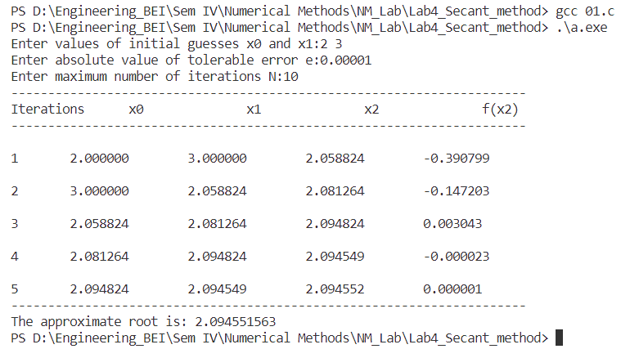

1. **Mathematical error case**

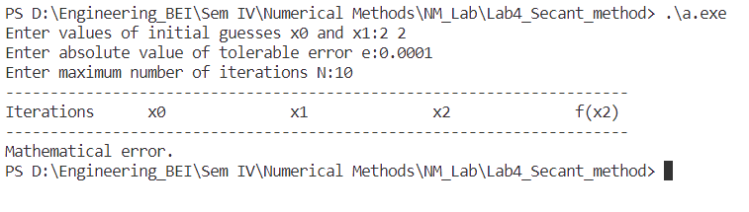

1. **Not convergent case**

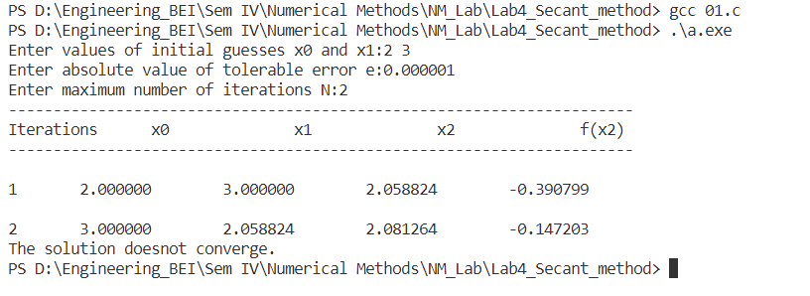

**Output 2:**

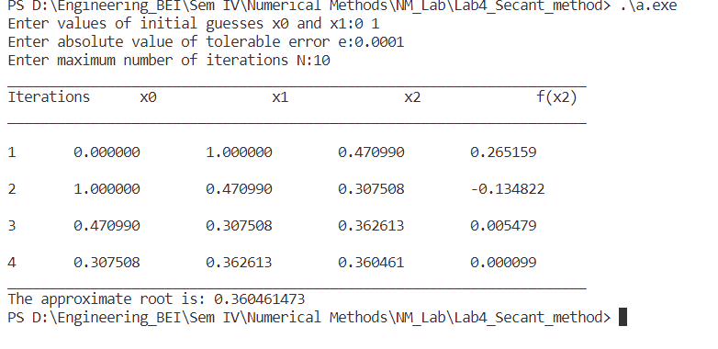

**Output 3:**

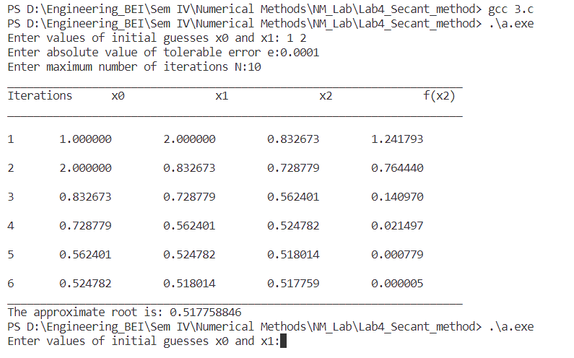

**Output 4:**

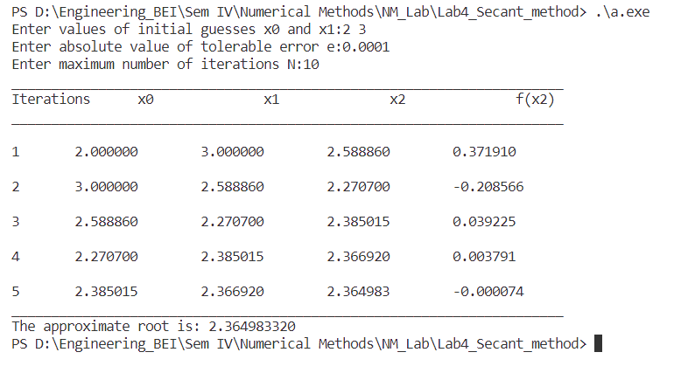

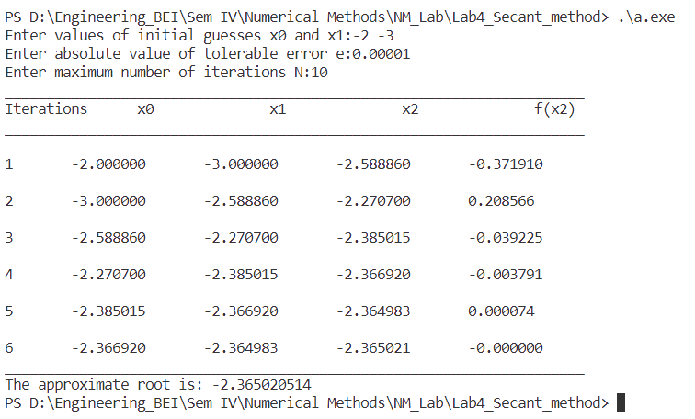

**Output 5:**

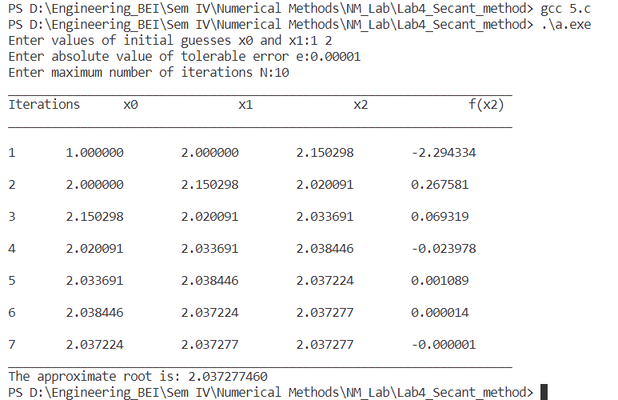

**Output of False Position Method:  
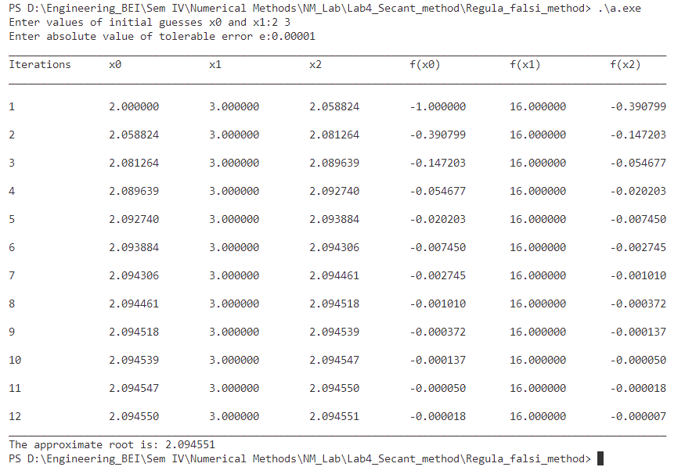**

**Output of Fixed Point Iteration Method:**

