**OUTPUT 1:**

**(0, 2), (1, 3), (2, 12), (5, 147). Estimate f(3) and f(7).**

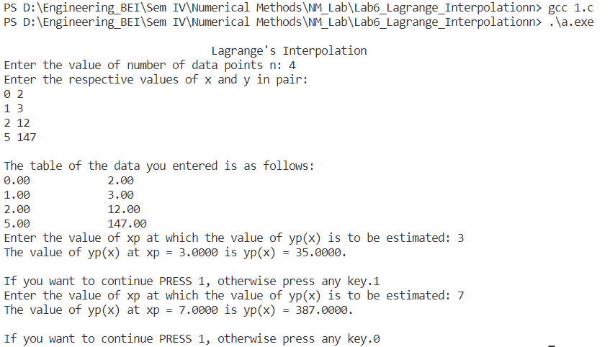

**OUTPUT 2:**

**(0, 18), (1, 10), (3, -18), (6, 90). Estimate f(2), f(4) and f(8).**