**Output 1:**

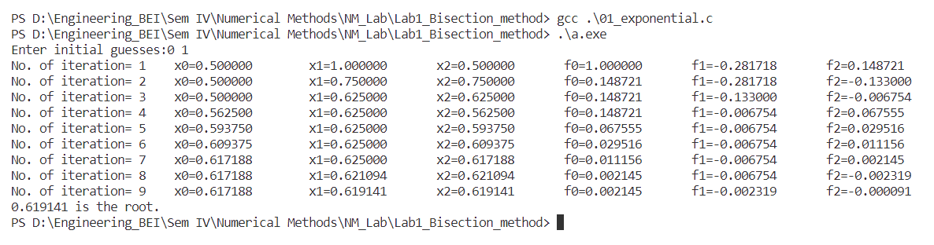

**Output 2:**

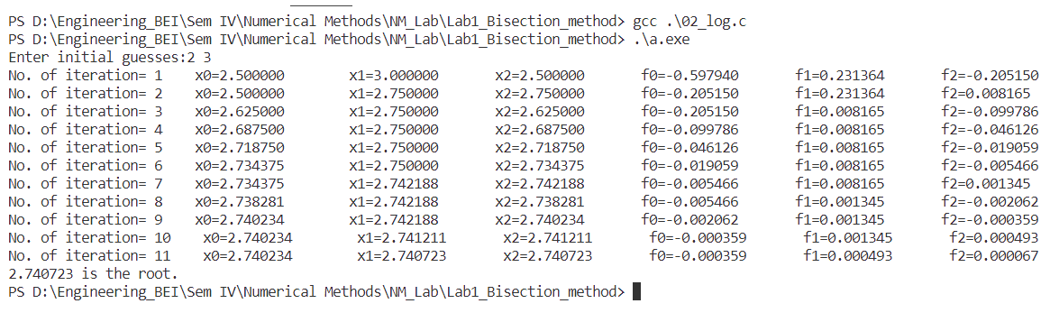

**Output 3:**

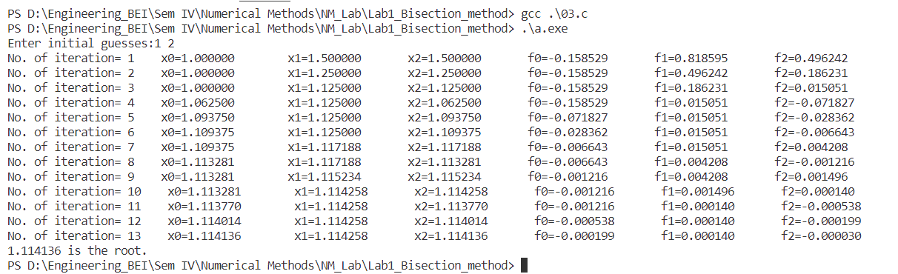

**Output 4:**

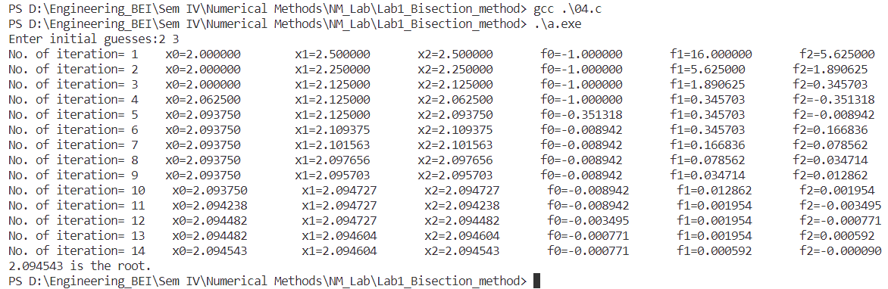

**Output 5:**

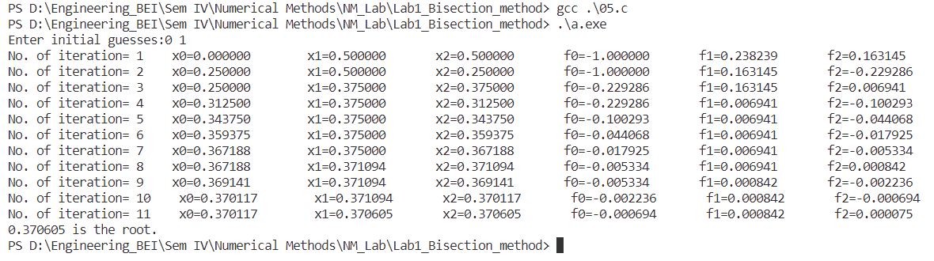

**Output 6:**

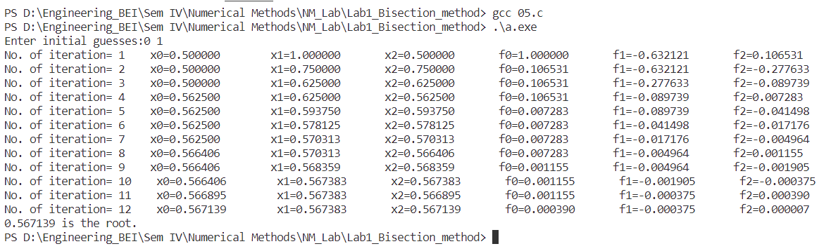

**Output 7:**

Bisection method is unable to find the output of the equation.

**Output 8: (of Source Code)**

