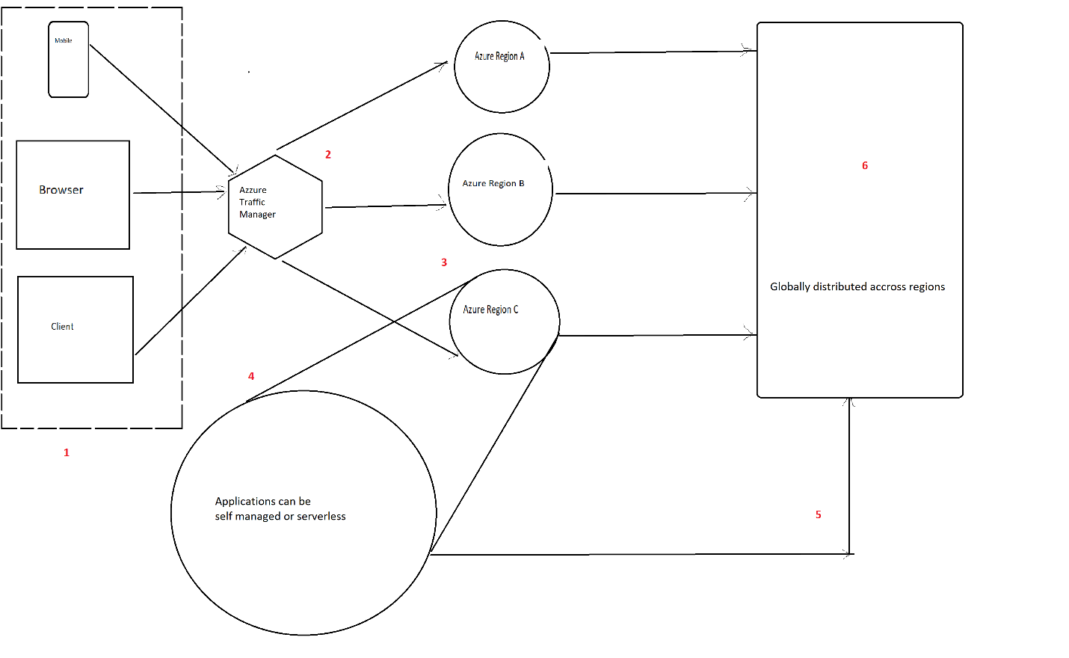

1. User access application through dedicated client(Virtual Machine)
2. Azure traffic manager will route users connection to best location based on the traffic across the multiple locations.

To improve the performance, we can deploy end points to two or more locations across globe.

1. Once landed, the application will handle the session and connect towards database.
2. This application can range from a simple static page up until a microservices-oriented application hosted in Kubernetes for instance.
3. Azure active directory takes care of the connection between Application and Cosmos DB through the keys
4. Azure cosmos DB is globally distributed

Implementation :

1. create Virtual network by giving subnet and IP address.
2. Create load balancer with zone redundant in Availability zone
3. Create VMs in different zones with load balancing option as Azure load balancer
4. Create NAT gateway and test the ip address
5. Create traffic manager profile and add the traffic manager end points
6. Create a azure cosmos db with core sql as option. Select with Geo Redundancy and multi region writes enabled.
7. Use the key values in the web application to be created further.
8. Now create a web app
9. Then publish the application in Azure app service
10. n **App Service**, enter your Web App name and the appropriate subscription, resource group, and hosting plan, then select **Create**