* Flatbed scanner are normally called desktop scanner.
* Drum scanner uses Photomultiplier tube technology.(PMT)
* Plasma monitor uses mixture of insert gases –neon and xenon.
* Laser printer- The major component of Laser printer is Photoreceptor, typically a revolving drum or cylinder.

Positive charged is given to drum by charged corona wire.

Toner is a fine powder composed of iron, plastic and carbon particle.

* SMPS rectifies AC – DC
* Motherboard-

slots :

1. Industry Standard Architecture (**ISA**)
2. Extended Industry Standard Architecture (EISA)
3. Peripheral Component Interconnect (PCI)
4. PCI Express (PCIe)
5. Accelerated Graphics Port (**AGP)**
6. RAM slot

Types of motherboard –

1. Full AT
2. Baby AT
3. ATX

Serial connectors: - USB (Universal Serial Bus)

Parallel connectors :- SCSI (Small Computer System Interface)

* BIOS is stored on flash memory chip on the motherboard.
* Memory Modules- Random access memory

1. SIMM (single in-line memory module) –{30 pin and 72 pin}
2. DIMM (dual in-line memory module) – {168 pin} [DDR 1, DDR 2, DDR 3]
3. SO-DIMM (small outline dual in-line memory module) – {72 pin}
4. RIMM ( Rambus In-line Memory Module) – (184 pin)

[Flavors – PC600

PC700

PC800 ]

* Processor –

1. CISC (Complex instruction set computing)
2. RISC (reduced instruction set computer)

* Memory

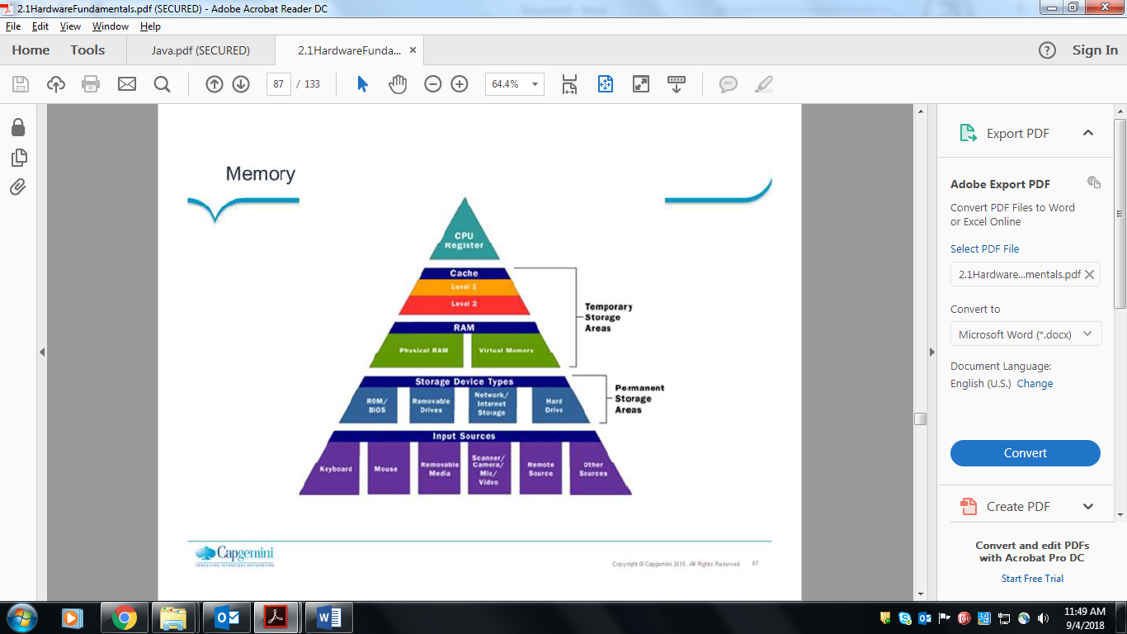

Sequential access memory (SAM) –

* Shift Register
* CCD (Charged Coupled Device)

Random Access Memory (RAM) –

* Flip-flop
* MOS RAM

Types of tapes -

* Linear Tape Open
* Digital Linear Tape

Types of hard disk interface –

* IDE
* SATA

SATA cables :

1. DATA connector
2. Power connector {Standard , slim line}
3. ESATA

* SCSI

1. Standard SCSI
2. Wide SCSI

SCSI connectors -

* 50 pin
* 68 pin
* 80 pin

SCSI types :

* SCSI 1
* SCSI 2
* SCSI 3