3 key points: (from<http://nwlc.org/resources/the-wage-gap-the-who-how-why-and-what-to-do/> )

* Mothers’ wages are affected by a lack of support for women’s disproportionate caregiving responsibilities.
* The high cost of childcare and a lack of paid leave make it less likely that women with caregiving responsibilities are able to stay in the workforce.
* This time out of work negatively impacts mothers’ wages, through policies like paid leave make it more likely that women will continue to work after having children, strengthening their connection to the workforce.

**1. What are the childcare options available and how are they used?**

**Child care options for children under 5 (US Census):**

Total children under 5 - 20,404,000

In regular childcare arrangement - 12,499,000

* Child care centers - all ages - at a facility - for all or part of the day
  + Day care - 2,726,000 - 13.4%
  + Nursery or preschool - 1,231,000 - 6%
* Family child care - providers care for children in their own homes
  + 1,554,000 - 7.6%
* Head start / Early head start - publicly funded care for low income families
  + 1,140,000 - 5.6%
* Nannies / In child's home
  + 750,000 - 3.7%
* Family
  + Mother - 723,000 - 3.5% (for time reference parent was working or in school)
  + Father - 3,623 - 17.8% (for time reference parent was working or in school)
  + Sibling - 520,000 - 2.6%
  + Grandparent - 4,834,000 - 23.7%
  + Other relative - 1,520,000 - 7.4%

**Other care options:**

* Drop in / Short term - care in places like gyms, offices, where parents drop kids for a short period of time
* Co-ops - not licensed or regulated, groups of parents that come together and care for children collectively by a variety of means
* Sick child care programs - care for children who are mildly ill
* 24 hour child care - for parents who are shift workers

1. **How does this vary with socio-economic class?**

see spreadsheet -<https://docs.google.com/spreadsheets/d/1AdcrHoc3vNO_ewwW3_9Ly3a4EgbdlSNcDNP-nADDXuM/edit?usp=sharing>

*Parents and the High Cost of Child Care: 2015 Report*

<http://usa.childcareaware.org/advocacy-public-policy/resources/reports-and-research/costofcare/>

In the United States, parents pay approximately 60 percent of child care costs for their children.

Over one-fifth of parents with children under age 13 work nonstandard schedules. (CENSUS data)

1. **How does this vary with family structure?**

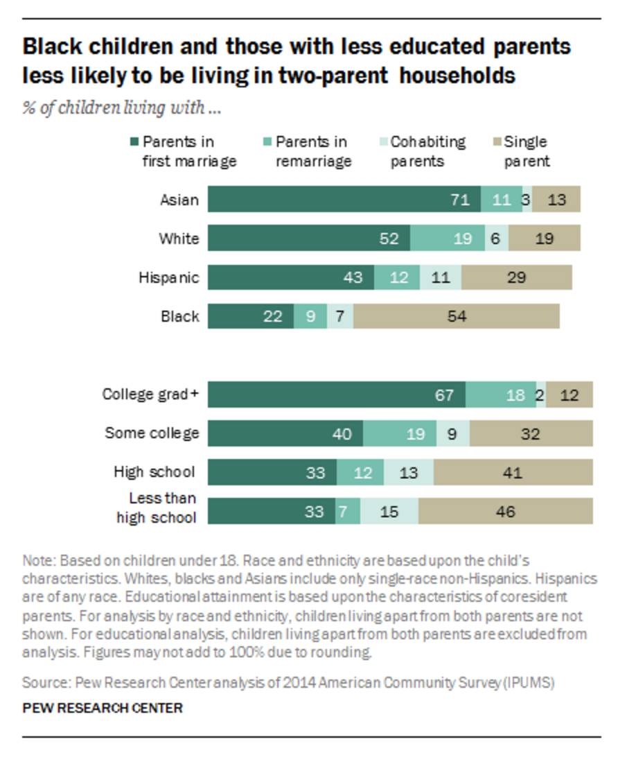

<http://www.pewsocialtrends.org/2015/12/17/1-the-american-family-today/>

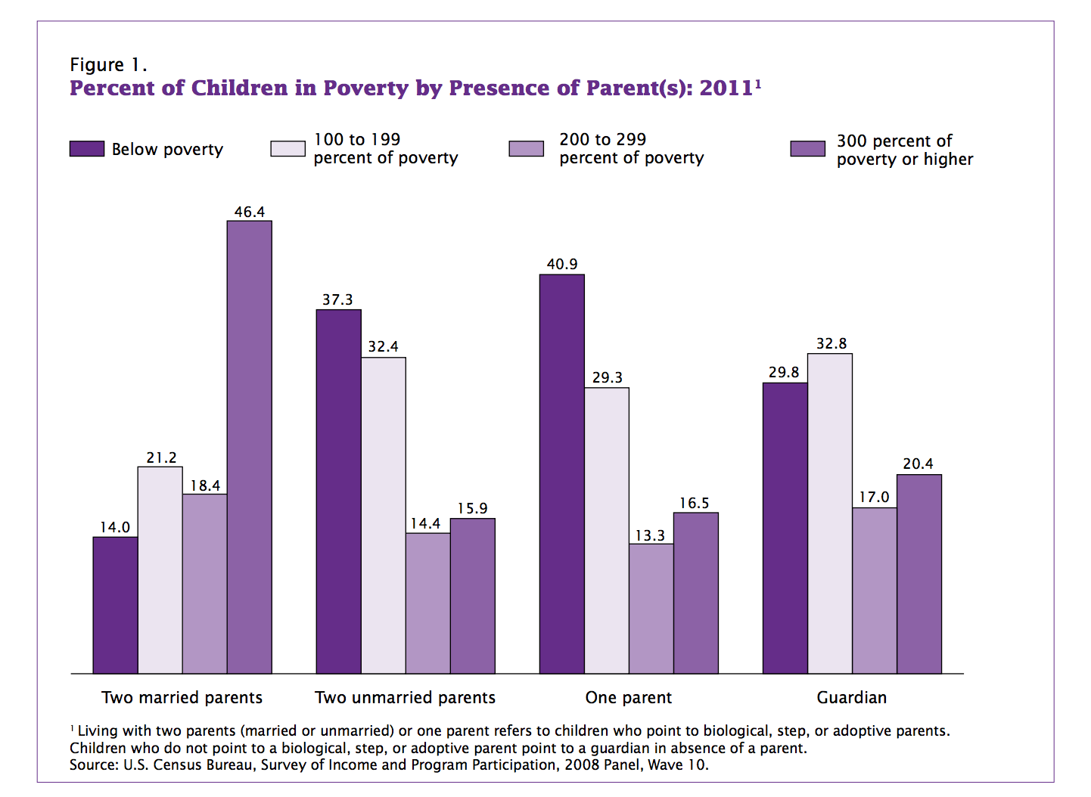

<https://www.census.gov/content/dam/Census/library/publications/2014/demo/p70-139.pdf>

In 2014, 21 percent of children (including nearly one in four children under age five) were living in households with incomes below the federal poverty line ($19,790 for a family of three). Nearly 64 percent of infants and toddlers receiving CCDBG funding live in families with household incomes below the federal poverty level. In 2014, almost 40 percent of black children and 32 percent of Hispanic children lived in poverty. (CENSUS data)

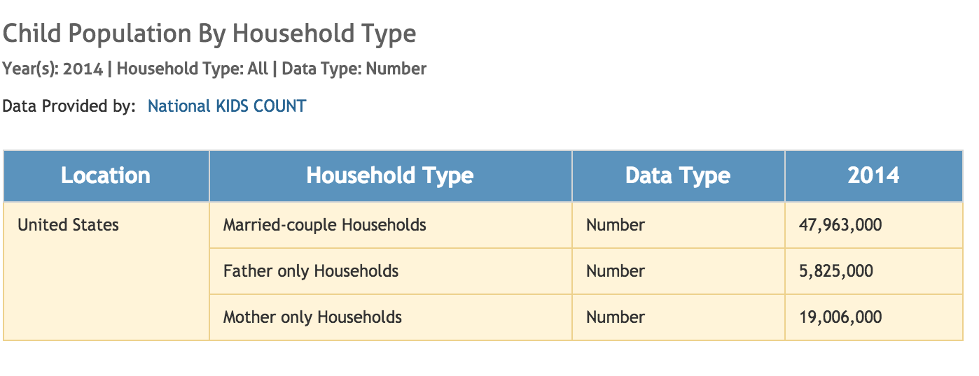

<http://datacenter.kidscount.org/data/tables/105-child-population-by-household-type?loc=1&loct=1#detailed/1/any/false/869/4290,4291,4292/427>

**How do working mothers make the choice about child care?**

Low income parents aren't considering multiple options when choosing care and 41% make the decision in one day. Most information and referrals come from informal sources (friends and family).

Mothers with less education put higher focus on safety and practical features (cost and location) than mothers with more education who put focus on quality of care. Working mothers also put more emphasis on practical features when making child care choices.

<http://www.acf.hhs.gov/sites/default/files/opre/child_care_decision_making_literature_review_pdf_version_v2.pdf>

DC Child care search tool: <http://childcareconnections.osse.dc.gov/providersearch.aspx>

The business case for child care:

Adjusted for inflation, U.S. businesses lose approximately $4.4 billion annually due to employee absenteeism as the result of child care breakdowns. (CENSUS Data)