

Indian Institute of Technology, Kanpur

Academic Semester: 2021-22 (I)

**ME634: Advanced Computational Fluid Dynamics**

Instructors: Prof. Anikesh Pal

**ASSIGNMENT 4**

**SOLVING FOR A LID-DRIVEN CAVITY USING RK3-CN**

Date: 14th April, 2021

**Pragya Patel**

**17807477**

Contents

Plots of u(j=j-midplane) at different time steps 3

Plots of w(j=j-midplane) and vorticity at steady-state 6

**Appendix (Formulation)**

**Input Values:**

CFL = 1.2; L = 1; Lx = 1; Ly = 1; Lz = 1;

N = 32; Nx = 32; Ny = 32; Nz = 32;

Re = 100; U = 1; (U at lid) nu = 0.01;

# Plots of u(j=j-midplane) at different time steps

Note: x and y axes show ith and kth nodes

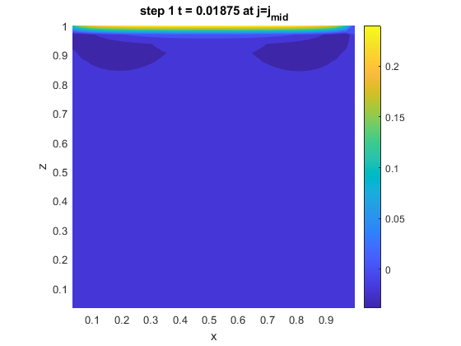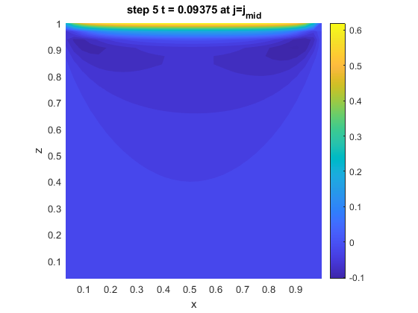

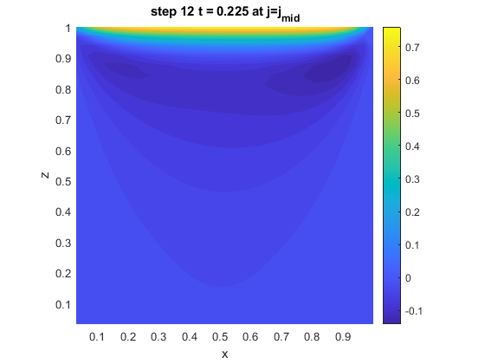

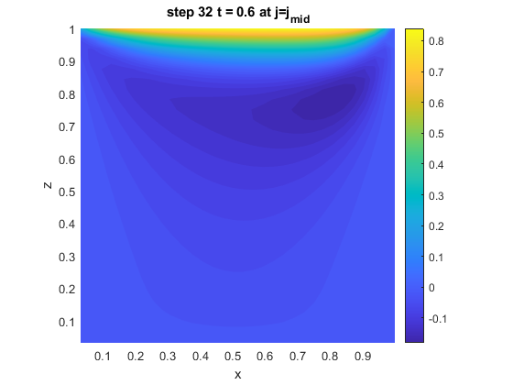

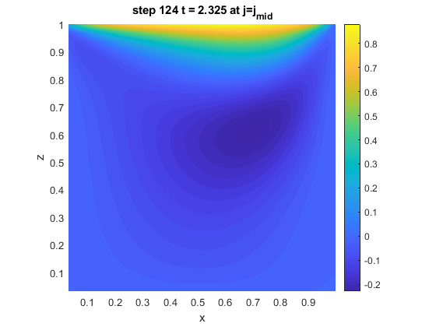

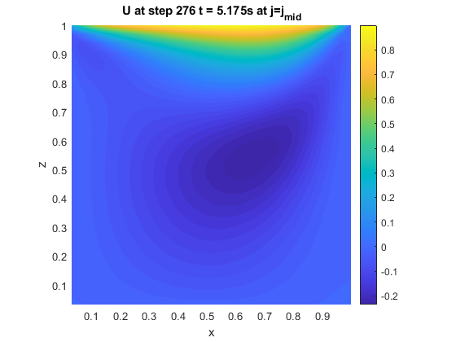

# Plots of w(j=j-midplane) and vorticity at steady-state

