**1. a) Write a LEX program to recognize valid *arithmetic expression.* Identifiers in the expression could be only integers and operators could be + and *. Count the identifiers & operators present and print them separately.**

%{

int id=0,d=0,op=0,plus=0,min=0,mul=0,dv=0,valid=1;

%}

%%

[0-9]+ {d++;}

[_a-zA-Z][0-9A-Za-z]* {id++;}

[+] {op++;plus++;}

[-] {op++;min++;}

[*] {op++;mul++;}

[/] {op++;dv++;}

\( {valid++;}

\) {valid--;}

. ;

[\n] {return 0;}

%%

int main()

{

printf("Enter Expression:\n");

yylex();

if(valid==1&&((d+id)==op+1||op==1))

{

printf("Valid Expression\n");

printf("No. of Identifiers:%d\n",id);

printf("No. of Digits:%d\n",d);

printf("No. of Operators:%d\n",op);

printf("Plus Operators(+):%d\n",plus);

printf("Minus Operators(-):%d\n",min);

printf("Multiplication Operators(*):%d\n",mul);

printf("Division Operators:%d\n",dv);

}

else

printf("Invalid Expression\n");

return 0;

}

OUTPUT:

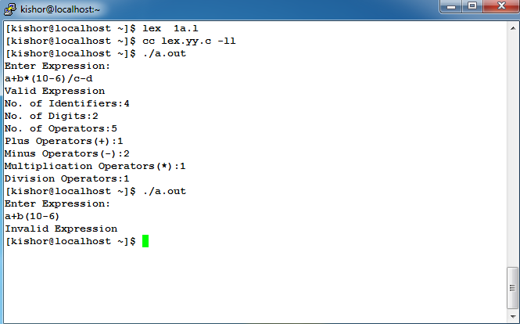

**1. b) Write YACC program to evaluate arithmetic expression involving operators: +, -, *, and /.*/**

**LEX PART :**

%{

#include"y.tab.h"

#include<math.h>

extern yylval;

%}

%%

[0-9]+ {yylval=atoi(yytext);return NUM;}

[+] {return '+';}

[-] {return '-';}

[*] {return '*';}

[/] {return '/';}

[\t]+ ;

[\n] {return 0;}

. {return yytext[0];}

%%

**YAAC PART** :

%{

#include<stdio.h>

#include<stdlib.h>

%}

%token NUM

%left '+''-'

%left '*''/'

%%

start: exp {printf("%d\n",$$);}

exp: exp'+'exp { $$ = $1+$3; }

|exp'-'exp { $$ = $1-$3; }

|exp'*'exp { $$ = $1*$3; }

|exp'/'exp

{

if($3==0)

{

yyerror();

exit(0);

}

else

{

$$ = $1/$3;

}

}

|'('exp')' { $$=$2; }

|NUM { $$=$1; }

;

%%

int main()

{

printf("Enter the Expression:\n");

yyparse();

return 0;

}

int yyerror()

{

printf("Invalid string\n");

exit(0);

}

**OUTPUT:**

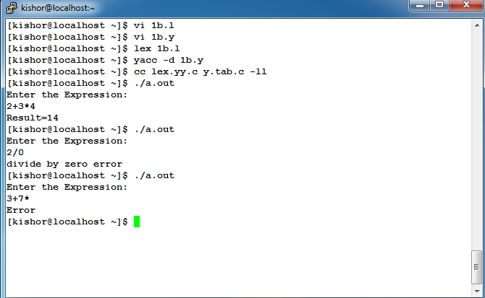

**2. Develop, Implement and Execute a program using YACC tool to recognize all strings ending with *b* preceded by *n a’s* using the grammar *an b* (note: input *n* value)**

**LEX PART :**

%{

#include "y.tab.h"

%}

%%

a {return A;}

b {return B;}

. {return yytext[0];}

[\n] {return 0;}

%%

**YACC PART :**

%{

#include<stdio.h>

#include<stdlib.h>

%}

%token A B

%%

S : A s1 B

s1 : A s1

|

;

%%

int main()

{

printf("Enter a string \n");

yyparse();

printf("valid expression\n");

}

int yyerror()

{

printf("Invalid string\n");

exit(0);

}

**OUTPUT:**

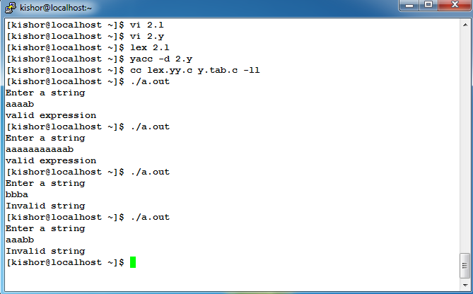

**3. Design, develop and implement YACC/C program to construct *Predictive / LL(1) Parsing Table* for the grammar rules: *A* ®*aBa , B* ®*bB |* e. Use this table to parse the sentence: *abba$***

#include<stdio.h>

#include<string.h>

#include<stdlib.h>

int num(char c)

{

switch(c)

{

case'A':return 0;

case'B':return 1;

case'a':return 0;

case'b':return 1;

case'@':return 2;

}

return 1;

}

int main()

{

Char m[2][3][10]={{"E\0","E\0","E\0"},{"E\0","E\0","E\0"}},ip[100],stack[100];

char first[3][10]={"a\0","b\0","@\0"},follow[3][10]={"$\0","a\0","a\0"},LHS[3][3]={"A\0","B\0","B\0"},RHS[3][4]={"aBa\0","bB\0","@\0"};

int size[2][3]={3,1,1,1,2,1},p,q,r,i,j,n,k,row,col;

printf("\nfirst={%c,%c,%c}",first[0][0],first[1][0],first[2][0]);

printf("\nfollow={%c,%c}\n\n\n",follow[0][0],follow[1][0]);

for(i=0;i<3;i++)

{

if(first[i][0]!='@')

strcpy(m[num(LHS[i][0])][num(first[i][0])],RHS[i]);

else

strcpy(m[num(LHS[i][0])][num(follow[i][0])],RHS[i]);

}

printf("Input the String:\n");

scanf("%s",ip);

strcat(ip,"$");

n=strlen(ip);

stack[0]='$';

stack[1]='A';

i=1;j=0;

printf("Parsing Table\n");

for(p=0;p<2;p++)

{

for(q=0;q<3;q++)

printf("%s\t",m[p][q]);

printf("\n");

}

printf("\nStack\tInput\n");

for(k=0;k<=i;k++)

printf("%c",stack[k]);

printf("\t");

for(k=j;k<=n;k++)

printf("%c",ip[k]);

printf("\n");

while((stack[i]!='$')&&(ip[j]!='$'))

{

if(stack[i]==ip[j])

{

i--;

j++;

for(k=0;k<=i;k++)

printf("%c",stack[k]);

printf("\t");

for(k=j;k<=n;k++)

printf("%c",ip[k]);

printf("\n");

}

switch(stack[i])

{

case 'A': row=0;break;

case 'B': row=1;break;

default:

if((stack[i]=='$')&&(ip[j]=='$'))

printf("Successful Parsing\n");

else

printf("Parsing Error\n");

exit(0);

}

switch(ip[j])

{

case 'a': col=0; break;

case 'b': col=1; break;

case 'c': col=2; break;

}

if(m[row][col][0]==ip[j])

{

for(k=size[row][col]-1;k>=0;k--)

{

stack[i]=m[row][col][k];

i++;

}

i--;

}

if(m[row][col][0]=='E')

{

if(i>0)

{

printf("Error\n");

exit(0);

}

}

if(m[row][col][0]=='@')

i--;

for(k=0;k<=i;k++)

printf("%c",stack[k]);

printf("\t");

for(k=j;k<=n;k++)

printf("%c",ip[k]);

printf("\n");

}

}

**OUTOUT:**

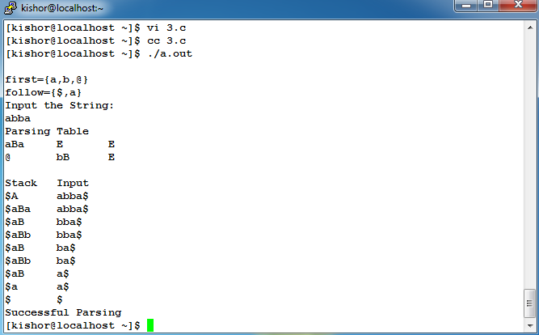

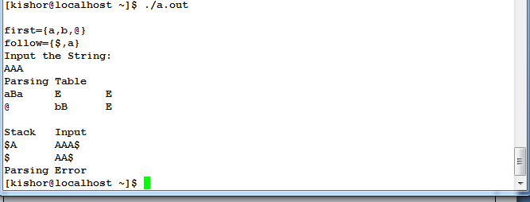

**4. Design, develop and implement YACC/C program to demonstrate *Shift Reduce Parsing* technique for the grammar rules: *E* ®*E+T | T, T* ®*T*F | F, F* ®*(E) | id* and parse the sentence: *id + id * id*.**

#include<stdio.h>

#include<string.h>

int k=0,z=0,i=0,j=0,c=0;

char a[16],ac[20],stk[15],act[10];

void check();

int main()

{

printf("Grammar: \n E->E+T|T \n T->T*F|F \n F->(E)|id\n");

printf("Enter the input string\n");

scanf("%s",a);

c=strlen(a);

strcpy(act,"SHIFT->");

printf("Stack \t Input \t\t Action\n");

printf("$\t %s$",a); //Initial contents of the input buffer

for(k=0,i=0;j<c;k++,i++,j++)

{

if(a[j]=='i' && a[j+1]=='d')

{

stk[i]=a[j];

stk[i+1]=a[j+1];

stk[i+2]='\0';

a[j]=' ';

a[j+1]=' ';

printf("\n$%s\t%s$\t%s id",stk,a,act);

check();

}

else

{

stk[i]=a[j];

stk[i+1]='\0';

a[j]=' ';

printf("\n$%s\t%s$\t%s symbol",stk,a,act);

check();

}

}printf("\n");

getchar();

}

void check()

{

strcpy(ac,"REDUCE");

for(z=0;z<c;z++)

if(stk[z]=='(' && stk[z+1]=='E'&& stk[z+2]==')')

{

stk[z]='F';

stk[z+1]='\0';

stk[z+2]='\0';

printf("\n$%s\t%s$\t%s by F->(E)",stk,a,ac);

i=i-2;

}

for(z=0;z<c;z++)

if(stk[z]=='i' && stk[z+1]=='d')

{

stk[z]='F';

stk[z+1]='\0';

printf("\n$%s\t%s$\t%s by F->id",stk,a,ac);

j++;

}

for(z=0;z<c;z++)

{

if(stk[z]=='T' && stk[z+1]=='*' && stk[z+2]=='F')

{

stk[z]='T';

stk[z+1]='\0';

stk[z+2]='\0';

printf("\n$%s\t%s$\t%s by T->T*F",stk,a,ac);

i=i-2;

}

else if(stk[z]=='F')

{

stk[z]='T';

printf("\n$%s\t%s$\t%s by T->F",stk,a,ac);

}

}

for(z=0;z<c;z++)

{

if(stk[z]=='E' && stk[z+1]=='+' && stk[z+2]=='T' && stk[z+3]=='*')

break;

if(stk[z]=='E' && stk[z+1]=='+' && stk[z+2]=='T')

if(a[j+1]=='*')

break;

else

{

stk[z]='E';

stk[z+1]='\0';

stk[z+2]='\0';

printf("\n$%s\t%s$\t%s by E->E+T",stk,a,ac);

i=i-2;

}

else if(stk[z]=='T')

{

if(stk[z+1]=='*'|| a[j+1]=='*')

break;

stk[z]='E';

printf("\n$%s\t%s$\t%s by E->T",stk,a,ac);

}

}

}

**OUTPUT:**

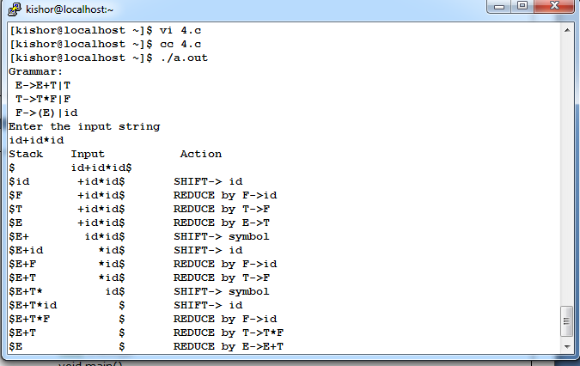

**5. Design, develop and implement a C/Java program to generate the machine code using *Triples* for the statement *A = -B * (C +D)* whose intermediate code in three-address form**

***T1 = -B***

***T2 = C + D***

***T3 = T1 + T2***

***A = T3***

#include<stdio.h>

#include<stdlib.h>

#include<string.h>

char op[2],arg1[5],arg2[5],result[5];

int count=0;

int main()

{

FILE *fp1,*fp2;

fp1=fopen("input.txt","r");

fp2=fopen("output.txt","w");

while(!feof(fp1) && count<4)

{

count ++;

fscanf(fp1,"%s%s%s%s",result,arg1,op,arg2);

if(strcmp(op,"+")==0)

{

fprintf(fp2,"\nMOV R0,%s",arg1);

fprintf(fp2,"\nADD R0,%s",arg2);

fprintf(fp2,"\nMOV %s,R0",result);

}

if(strcmp(op,"*")==0)

{

fprintf(fp2,"\nMOV R0,%s",arg1);

fprintf(fp2,"\nMUL R0,%s",arg2);

fprintf(fp2,"\nMOV %s,R0",result);

}

if(strcmp(op,"-")==0)

{

fprintf(fp2,"\nMOV R0,%s",arg1);

fprintf(fp2,"\nSUB R0,%s",arg2);

fprintf(fp2,"\nMOV %s,R0",result);

}

if(strcmp(op,"/")==0)

{

fprintf(fp2,"\nMOV R0,%s",arg1);

fprintf(fp2,"\nDIV R0,%s",arg2);

fprintf(fp2,"\nMOV %s,R0",result);

}

if(strcmp(op,"=")==0)

{

fprintf(fp2,"\nMOV R0,%s",arg1);

fprintf(fp2,"\nMOV %s,R0",result);

}

}

fclose(fp1);

fclose(fp2);

}

**OUTPUT:**

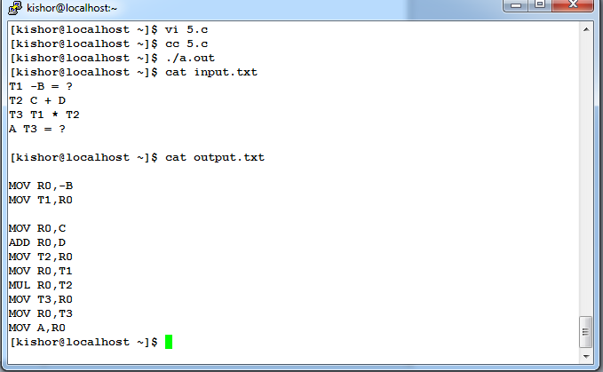

**6. a) Write a LEX program to eliminate *comment lines* in a *C* program and copy the resulting program into a separate file.**

%{

#include<stdio.h>

int com=0;

%}

%%

"/*"[^*]*.*"*/" {com++;}

\/\/[^\n]* com++;

%%

main(int argc,char *argv[])

{

if(argc!=3)

{

printf("\n\tUsage : %s <input file><output file>\n", argv[0]);

return;

}

yyin=fopen(argv[1], "r");

yyout=fopen(argv[2], "w");

yylex();

printf(" No of comment lines =%d\n",com);

}

**OUTPUT:**

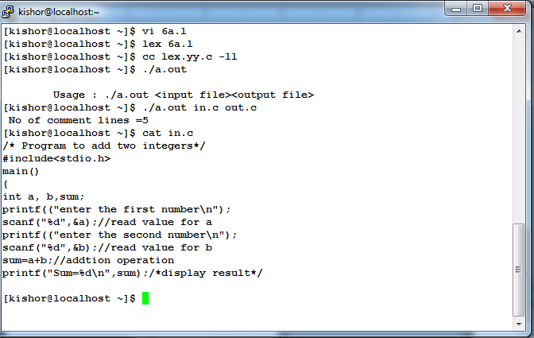

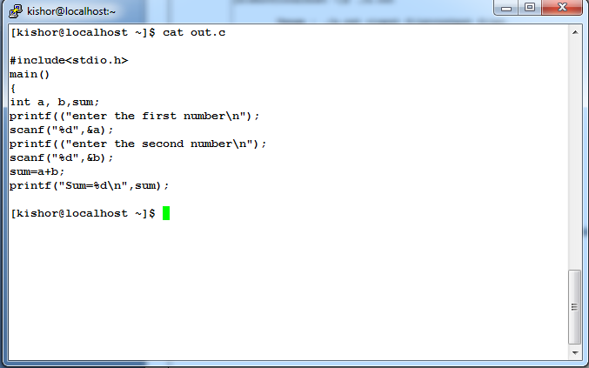

**6. b) Write YACC program to recognize valid *identifier, operators and keywords* in the given text (*C program*) file.**

**LEX PART :**

%{

#include <stdio.h>

#include "y.tab.h"

extern yylval;

%}

%%

[ \t] ;

[+|-|*|/|=|<|>] {printf("Operator is %s\n",yytext);return OP;}

[0-9]+ {yylval = atoi(yytext); printf("Number is %d\n",yylval); return DIG;}

int|char|bool|float|void|for|do|while|if|else|return|void|printf|scanf|”main()” {printf("Keyword is %s\n",yytext);return KEY;}

[a-zA-Z0-9]+ {printf("Identifier is %s\n",yytext);return ID;}

. ;

%%

**YACC PART :**

%{

#include<stdio.h>

#include<stdlib.h>

int id=0,dig=0,key=0,op=0;

%}

%token DIG ID KEY OP

%%

input:

DIG input{dig++;}

|ID input{id++;}

|KEY input{key++;}

|OP input{op++;}

|DIG {dig++;}

|ID {id++;}

|KEY {key++;}

|OP {op++;} ;

%%

FILE *yyin;

int main()

{

FILE *fp=fopen("6binput.c","r");

if(!fp)

{

printf("File not found\n");

return -1;

}

yyin=fp;

do{

yyparse();

}while(!feof(yyin));

printf("Numbers = %d\n Operators = %d\n Identifiers = %d\n Keywords = %d\n",dig,op,id,key);

}

int yyerror()

{

printf("Error \n");

exit(-1);

}

**OUTPUT:**

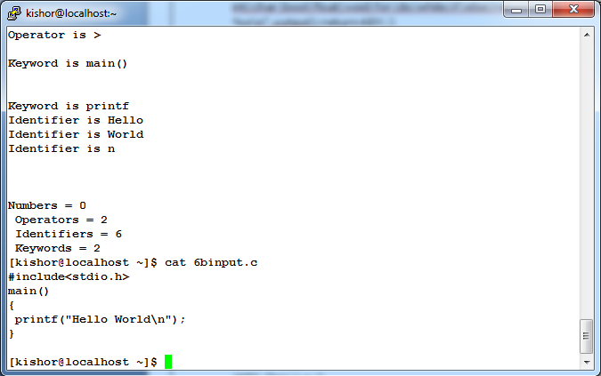

**7. Design, develop and implement a C/C++/Java program to simulate the working of Shortest remaining time first and Round Robin (RR) scheduling algorithms. Experiment with different quantum sizes for RR algorithm.**

#include<stdio.h>

#include<stdlib.h>

struct J

{

int id,bt,tat,wt,at,ft;

} job[100];

void scheduler(struct J job[],int n,int q,int c)

{

int burst[100],x,t=0,done=0,curr=0,diff=q,i=0;

float tat_sum=0,wt_sum=0;

for(i=0;i<n;i++)

burst[i]=job[i].bt;

if(c==0)

curr=-1;

while(done<n)

{

if(c==1)

{

for(x=0;x<n;x++)

{

if(job[curr].bt==0)

curr=x;

if(job[x].bt<job[curr].bt && job[x].bt>0 && job[x].at<=t)

curr=x;

}

diff=1;

}

else

{

while(1)

{

curr=(curr+1)%n;

if(job[curr].bt!=0)

break;

}

diff=(q<=job[curr].bt)?q:job[curr].bt;

}

job[curr].bt-=diff;

t+=diff;

if(job[curr].bt==0)

{

done++;

job[curr].ft=t;

}

}

if(c==1)

printf("SRJF Details are \n");

else

printf("RR Scheduling Details are \n");

for(i=0;i<n;i++)

{

job[i].bt=burst[i];

job[i].tat=job[i].ft-job[i].at;

job[i].wt=job[i].tat-job[i].bt;

tat_sum+=job[i].tat;

wt_sum+=job[i].wt;

}

printf("Job\tBT\tAT\tTAT\tWT\n");

for(i=0;i<n;i++)

printf("%d\t%d\t%d\t%d\t%d\n",i+1,job[i].bt,job[i].at,job[i].tat,job[i].wt);

printf("Avg TAT=%f\nAvg WT=%f\n",tat_sum/n,wt_sum/n);

}

void main()

{

int n,q,c,i;

printf("Enter the number of processes:\n");

scanf("%d",&n);

printf("Enter the arrival time and burst time\n");

for(i=0;i<n;i++)

{

printf("Job%d: ",i+1);

scanf("%d%d",&job[i].at,&job[i].bt);

}

while(1)

{

printf("1.RR\n2.SRJF\n3.Exit\n");

scanf("%d",&c);

switch(c)

{

case 1: printf("Enter time quantum: ");

scanf("%d",&q);

scheduler(job,n,q,0);

break;

case 2: scheduler(job,n,1,1);

break;

case 3: exit(0);

}

}

}

**OUTPUT:**

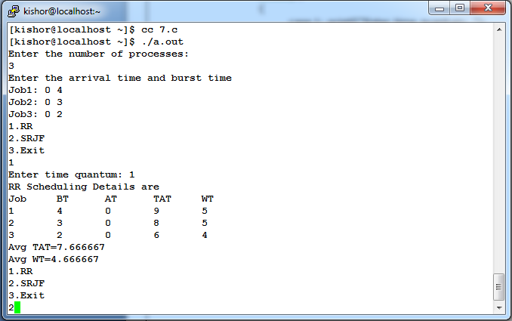

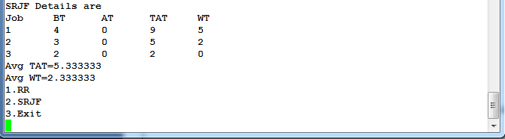

**8. Design, develop and implement a C/C++/Java program to implement Banker’s algorithm. Assume suitable input required to demonstrate the results**

#include<stdio.h>

#include<stdlib.h>

int alloc[10][10],max[10][10],need[10][10],avail[10],work[10],finish[10],request[10];

int p,r,j,i,k,v=0,req=0,pno;

int check(int i)

{

for(j=0;j<r;j++)

if(need[i][j]>work[j])

return 0;

return 1;

}

int main()

{

printf("Enter the number of processes and resources\n");

scanf("%d%d",&p,&r);

int seq[p];

printf("Enter the allocation matrix\n");

for(i=0;i<p;i++)

for(j=0;j<r;j++)

scanf("%d",&alloc[i][j]);

printf("Enter the maximum matrix\n");

for(i=0;i<p;i++)

for(j=0;j<r;j++)

scanf("%d",&max[i][j]);

for(i=0;i<p;i++)

for(j=0;j<r;j++)

need[i][j]=max[i][j]-alloc[i][j];

printf("Enter the available array\n");

for(i=0;i<r;i++)

{

scanf("%d",&avail[i]);

work[i]=avail[i];

}

L1:for(i=0;i<p;i++)

finish[i]=0;

while(v<p)

{

int allocated=0;

for(i=0;i<p;i++)

if(!finish[i]&&check(i))

{

for(k=0;k<r;k++)

work[k]=work[k]+alloc[i][k];

allocated=finish[i]=1;

seq[v]=i;

v++;

}

if(!allocated)

break;

}

for(i=0;i<p;i++)

if(finish[i]==0)

{

printf("Safe Sequence is not generated\n");

exit(0);

}

printf("Safe Sequence is: \n");

for(i=0;i<v;i++)

printf("%d\t",seq[i]);

printf("\n");

}

**OUTPUT:**

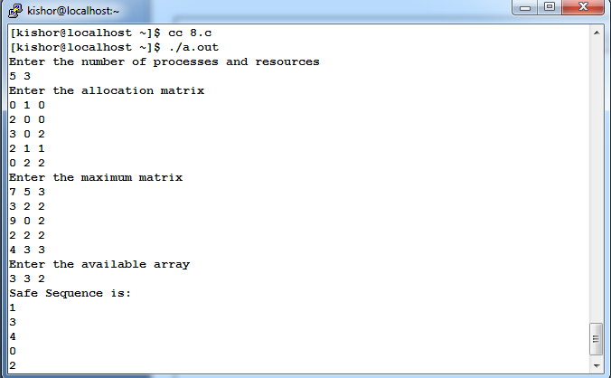

**9. Design, develop and implement a C/C++/Java program to implement page replacement algorithms LRU and FIFO. Assume suitable input required to demonstrate the results.**

#include<stdio.h>

#include<stdlib.h>

void FIFO(char s[],char F[],int l,int f)

{

int i,j=0,k,flag=0;

printf("PAGE\tFRAMES\tFAULTS");

for(i=0;i<l;i++)

{

for(k=0;k<f;k++)

if(F[k]==s[i])

flag=1;

printf("\n%c\t",s[i]);

if(flag==0)

{

F[j++]=s[i];

printf("%s",F);

printf("\tPage Fault");

}

else

{

flag=0;

printf("%s",F);

printf("\tPage Hit");

}

if(j==f)

j=0;

}

}

void lru(char s[],char F[],int l,int f)

{

int i,j=0,k,m,flag=0,top=0;

printf("\nPAGE\t FRAMES\t FAULTS");

for(i=0;i<l;i++)

{

for(k=0;k<f;k++)

if(F[k]==s[i])

flag=1;

printf("\n%c\t",s[i]);

if(j!=f && flag!=1)

{

F[top]=s[i];

if(++j!=f)

top++;

}

else

{

if(flag!=1)

{

for(k=0;k<top;k++)

F[k]=F[k+1];

F[top]=s[i];

}

else

{

for(m=k;m<top;m++)

F[m]=F[m+1];

F[top]=s[i];

}

}

printf("%s",F);

if(flag==0)

printf("\tPage Fault");

else

printf("\tPage Hit");

flag=0;

}

}

Int main()

{

int ch,i,l,f;

char F[10],s[25];

printf("Enter the no. of frames: ");

scanf("%d",&f);

F[f]='\0';

printf("Enter the length of the string: ");

scanf("%d",&l);

printf("Enter the string: ");

scanf("%s",s);

while(1)

{

printf("\nEnter:\n1:FIFO\n2:LRU\n3:EXIT\n");

scanf("%d",&ch);

switch(ch)

{

case 1: for(i=0;i<f;i++)

F[i]=-1;

FIFO(s,F,l,f);

break;

case 2: for(i=0;i<f;i++)

F[i]=-1;

lru(s,F,l,f);

break;

case 3: exit(0);

}

}

}

**OUTPUT:**

