Building a FastAPI for MNIST digit prediction

Prahalad A Vathsan, CH20B081

# Saving model from A05

The best model from the previous assignment which had the following metric was chosen

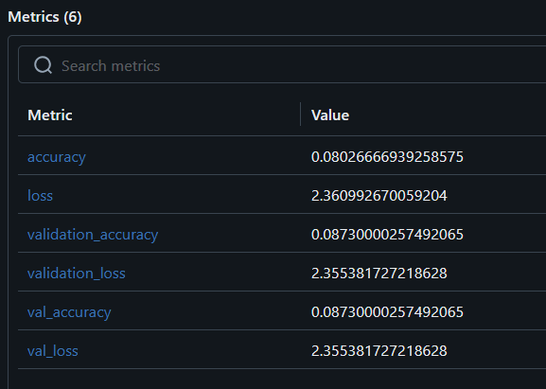

# Task 1

The web app was created and hosted:

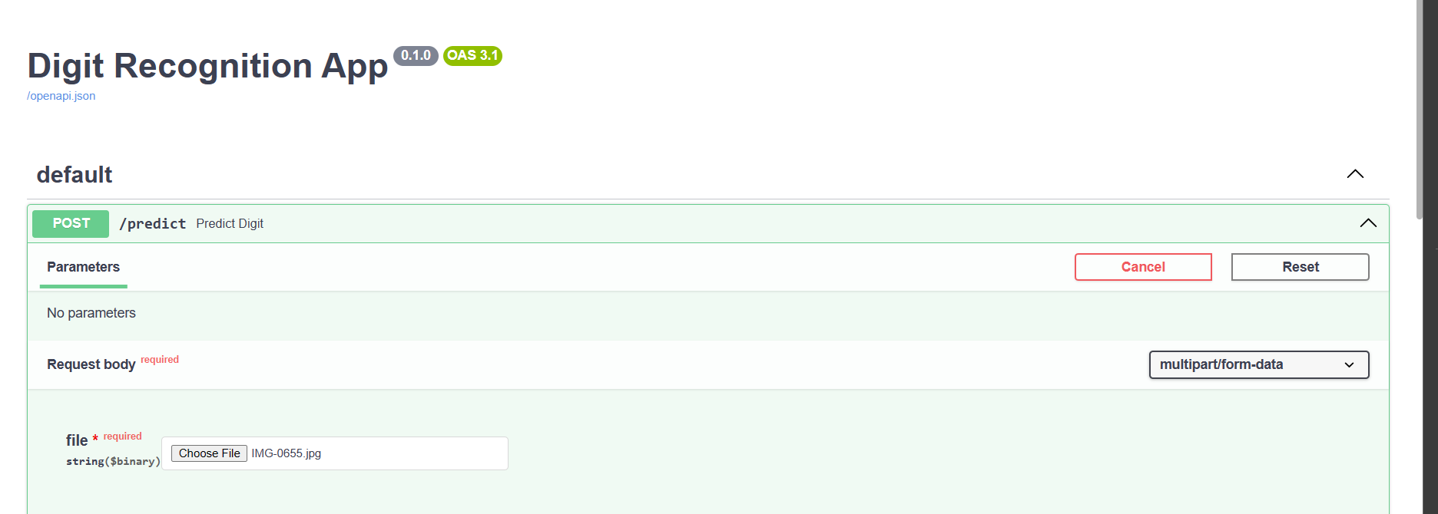

|  |  |
| --- | --- |
| Image | Prediction |
|  |  |
|  |  |
|  |  |
|  |  |

# Task 2

Handwritten digits were used as test data with following results:

|  |  |
| --- | --- |
| Image | Prediction |
|  |  |
|  |  |
|  |  |
|  |  |
|  |  |
|  |  |
|  |  |
|  |  |
|  |  |
|  |  |

# Inferences

The API was designed to be flexible by accepting the model path as a command line argument, which facilitated easy updates to the underlying model. The image processing function, `format_image`, was implemented to resize and normalize incoming images to a 28x28 grayscale format, ensuring consistency with the model's training data.

The model achieved an overall accuracy of 70% on the handdrawn images that were generated manually.

The observed accuracy indicates that while the model is fairly robust, there is room for improvement, especially in handling variations in digit style and quality inherent in user-generated images. The preprocessing step was vital, but might also be a point of enhancement to better adapt to diverse image qualities and styles.

The Github link for this assignment is: