1. Title: AgroBot Universal AI-Based Agricultural Assistant
2. Problem Statement:
Farmers often lack timely access to reliable information about crops, weather conditions, soil health, pest management, and market prices. Due to this lack of accessible and accurate guidance, many farmers face difficulties in making informed decisions related to crop selection, irrigation, fertilizer usage, and selling their produce at the right time. This often leads to reduced productivity, financial losses, and inefficient farming practices. Therefore, there is a need for an intelligent AI-based agricultural assistant that can provide farmers with accurate, real-time insights and recommendations to support better decision-making and improve overall agricultural productivity.
3. Outcomes:
- AI-Powered Farmer Assistance
Development of an intelligent system that provides farmers with instant guidance on crop selection, soil health, weather conditions, and pest control.
- Improved Decision Making
Farmers can make better farming decisions using real-time insights and data-driven recommendations.
- Better Crop Productivity
By following AI-based suggestions, farmers can improve crop yield and adopt more efficient farming practices.
- Market Awareness
The system helps farmers understand market prices and choose the right time to sell their produce.
- Accessible Agricultural Knowledge
The platform simplifies complex agricultural information and makes it easily accessible to farmers through a digital interface.
- Technology Adoption in Agriculture
Encourages the use of AI and digital tools in agriculture, supporting the movement toward smart and sustainable farming.
4. Technology:
- Python – Core programming language for backend development and AI integration.
- HTML, CSS, JavaScript – Used for designing the frontend user interface.
- Weather APIs – To fetch real-time weather data for agricultural decision-making.
- Gemini API (Google Generative AI) – For generating intelligent responses and agricultural guidance.
- SQLite / Database – For storing user data and application information.
- Environment Variables (.env) – Used to securely store API keys and configuration details.
- File Handling / Upload System – Used for managing uploaded images or files in the application.
- PyCharm – Used as the development environment.
- Git & GitHub – Used for version control and project management.
5. Modules to be Implemented:
1. User Authentication Module
- Secure login and registration system for farmers/users
- Session management for personalized experience
- Role-based access (Admin/User if needed)
2. Weather Forecast Module
- Provides real-time weather updates (temperature, humidity, rainfall)
- Location-based forecasting using APIs
- Helps farmers plan irrigation and harvesting
3. Crop Recommendation Module
- Suggests suitable crops based on:
  - Soil type
  - Weather conditions
  - Season
- Uses Machine Learning models for prediction

4. Plant Disease Detection Module
- Upload crop images for disease identification
- Uses CNN (Convolutional Neural Networks)
- Provides disease name and possible remedies
5. AI Chatbot Assistance Module
- Conversational assistant for farmer queries
- Answers questions about:
  - Farming techniques
  - Fertilizers
  - Pest control
- Can integrate with LLM APIs (like Gemini/OpenAI)
6. Soil Analysis Module
- Analyzes soil parameters (pH, nutrients, moisture)
- Suggests fertilizers and improvements
- Helps increase crop yield
7. Market Price Prediction Module
- Displays current market prices of crops
- Predicts future price trends using ML models
- Helps farmers decide the best time to sell
8. Dashboard & Visualization Module
- User-friendly dashboard showing:
  - Weather insights
  - Crop suggestions
  - Market trends
- Graphs and charts for better understanding
9. Location & Mapping Module
- Uses GPS/location input
- Displays region-specific data (weather, soil, crops)
- Map-based visualization
10. Notification & Alert Module
- Sends alerts for:
  - Weather changes
  - Disease risks
  - Market price updates
- Helps farmers take timely action
6. Architecture Diagram:
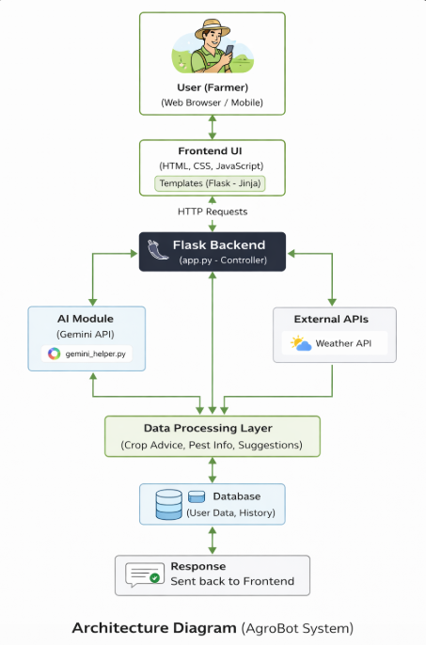

7.Database Scheme:
1. Users Table
Stores all registered farmer/admin details.
- id – INTEGER (Primary Key)
- username – TEXT
- email – TEXT
- password – TEXT (hashed)
- role – TEXT (admin/user)
- created_at – DATETIME
2. Queries / Chat Table
Stores user interactions with AgroBot (AI chat history).
- id – INTEGER (Primary Key)
- user_id – INTEGER (Foreign Key → Users.id)
- query – TEXT
- response – TEXT
- timestamp – DATETIME
3. Community Posts Table
(From community.html, chat_community.html)
- id – INTEGER (Primary Key)
- user_id – INTEGER (Foreign Key)
- content – TEXT
- created_at – DATETIME
4. Notifications Table
(From notifications.html)
- id – INTEGER (Primary Key)
- user_id – INTEGER (Foreign Key)
- message – TEXT
- status – TEXT (read/unread)
- created_at – DATETIME
5. Uploaded Files Table
(From uploads/ folder)
- id – INTEGER (Primary Key)
- user_id – INTEGER (Foreign Key)
- file_path – TEXT
- uploaded_at – DATETIME
Relationships
- One User → Many Queries
- One User → Many Community Posts
- One User → Many Notifications
- One User → Many Uploads
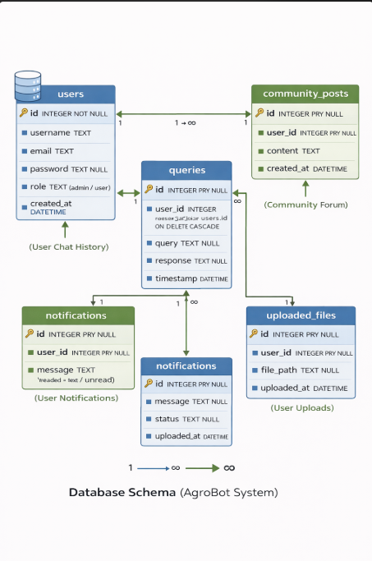
8. Feature Enhancement:
The AgroBot system can be further improved by incorporating advanced features to enhance usability, accuracy, and scalability. Some potential enhancements include:
1. Real-Time Market Price Integration:
Integrate APIs to provide farmers with live crop market prices, helping them make better selling decisions.
2. Multilingual Support:
Add support for regional languages to make the application usable for farmers from different regions.
3. Image-Based Disease Detection:
Allow users to upload crop images and use AI/ML models to detect plant diseases and suggest treatments.
4. Mobile Application Development:
Develop a mobile app version (Android/iOS) for better accessibility in rural areas.
5. Advanced Weather Forecasting:
Enhance weather predictions using more accurate APIs and provide alerts for extreme conditions.
6. Personalized Recommendations:
Use user data and history to provide customized farming suggestions.
7. Offline Mode:
Enable limited functionality without internet connectivity to support farmers in remote areas.
9. Conclusion:
The AgroBot system successfully demonstrates the application of artificial intelligence in agriculture by providing farmers with a smart, user-friendly platform for accessing important farming information. The system integrates AI-based assistance, weather insights, and structured data management to support better decision-making in areas such as crop planning, pest management, and general agricultural practices.
By leveraging modern web technologies and AI capabilities, AgroBot simplifies complex agricultural knowledge and makes it easily accessible to users. The inclusion of features such as chat-based interaction, community support, and personalized recommendations enhances the overall effectiveness of the system.
Overall, the project highlights the potential of AI-driven solutions in improving agricultural productivity, promoting digital transformation in farming, and empowering farmers with timely and reliable information. With further enhancements, AgroBot can evolve into a comprehensive and scalable solution for smart agriculture.
10. Outputs:
