Flutter Covid App Documentation

# Introduction

Since Flutter Food Delivery app is developed in [Flutter](https://flutter.dev/), you will need to have Flutter installed on your system.

The installation itself is very straightforward: <https://flutter.dev/docs/get-started/install>

# Compiling and running the app

1. Firstly, switch your flutter channel to master, as compiling for web will need you to be in beta channel. You can do this by typing “flutter channel beta” and then “flutter upgrade”.
2. Then run “flutter config --enable-web” to enable web support.
3. Open the “covid_connect” folder in your IDE of choice
4. Make sure that the Flutter SDK and DART SDK path are set, and Flutter and DART plugins are installed.
5. Type “flutter create .” into the terminal of your IDE to generate the Android iOS and web folders
6. Add your Google Maps API ([you can generate that from here](https://developers.google.com/maps/documentation/android-sdk/get-api-key)) key in the AndroidManifest.xml, AppDelegate.swift for iOS, index.html for web and enable Google Maps Javascript API.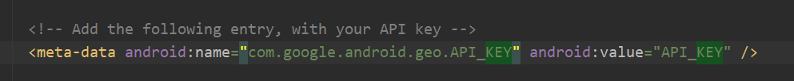
7. Type “flutter run” to run the app.
8. For web, run “flutter run -d chrome --web-port=8080 --web-hostname=127.0.0.1”.