Flutter App Documentation

# Introduction

Since this app is developed in [Flutter](https://flutter.dev/), you will need to have Flutter installed on your system.

The installation itself is very straightforward: <https://flutter.dev/docs/get-started/install>

# Backend

The Backend used for authentication and Database is [Firebase](https://firebase.google.com/).

1. Create a new Firebase project:

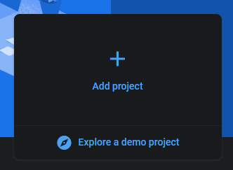

1. Enable Anonymous Authentication:

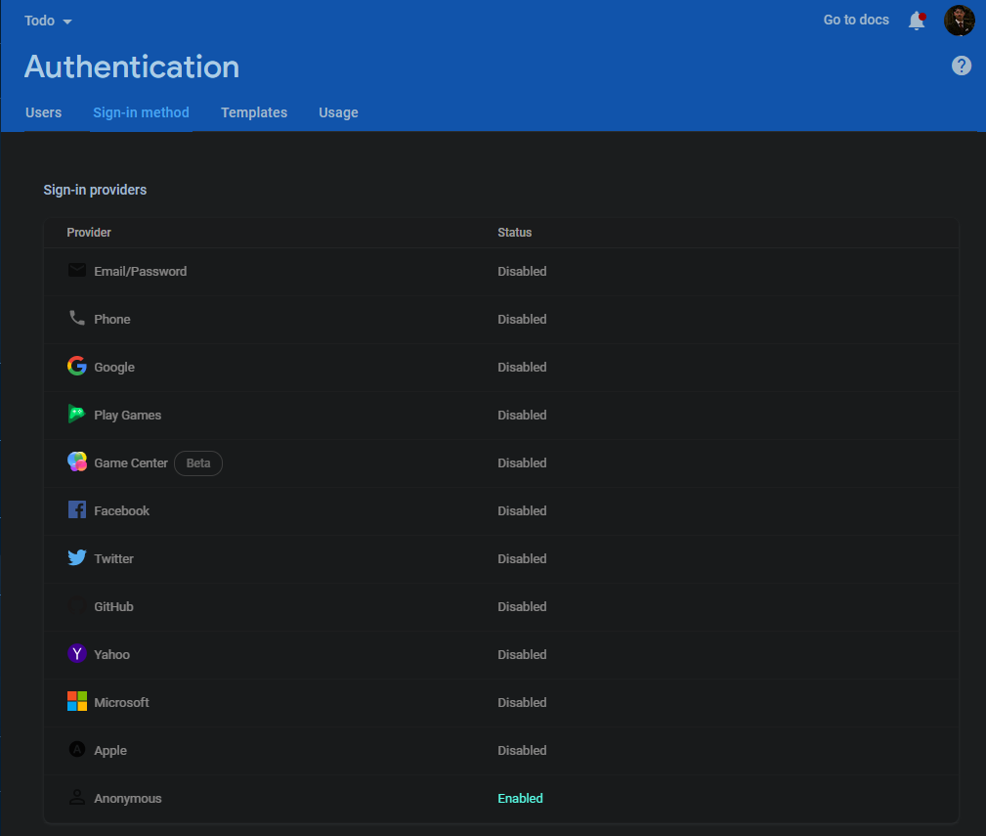

1. Start a new Cloud Firestore database:

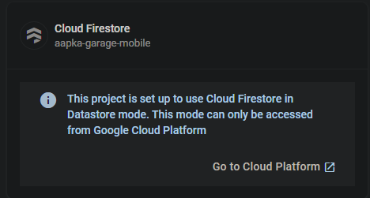

1. Link your Android and iOS apps to Firebase: https://firebase.google.com/docs/flutter/setup and download google-services.json and GoogleService-Info.plist
2. That’s it! Your backend is ready to roll.

# Compiling and running the app

1. Open the “todo” folder in your IDE of choice
2. Make sure that the Flutter SDK and DART SDK path are set, and Flutter and DART plugins are installed.
3. Type “flutter create .” into the terminal of your IDE to generate the Android and iOS folders
4. Paste the google-services.json and GoogleService-Info.plist files at the root of both these respective folders (as highlighted in 4th step of the previous topic).
5. Type “flutter run” to run the app.
6. Type “flutter build apk” and “flutter build ios” to generate builds for Android and iOS respectively.