### 1. *Login Page*

- *Fields:*

- Username (Text Field)

- Password (Password Field)

- *Actions:*

- *Submit (Button):* Validates credentials and redirects to Home Page if correct; otherwise, shows an error message.

- *Error Handling:*

- Displays an error message if the username or password is incorrect.

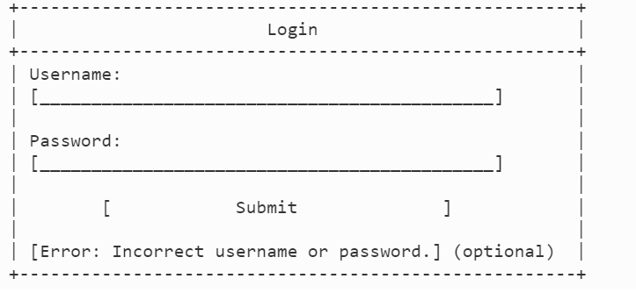

### 2. *Home Page (Dashboard)*

- *Components:*

- *Navigation Bar:* Links to Home, Create New Form, Reports, Log Out.

- *Table View:* Displays all open CC application forms.

- *Columns:*

- Serial No.

- Application ID

- Card Holder Name

- Application Form Status

- Age of Application Form

- Handled By Sales User

- *Actions:*

- *View/Edit Form:* Button to open the form details for viewing or editing.

- *Delete Application:* Button to delete a specific application. *This button should be enabled only for the Sales User who created the application.*

- *Create New Form:* Button to navigate to the Create/Edit CC Application Form page.

- *Download Report:* Button to export table data to an Excel report.

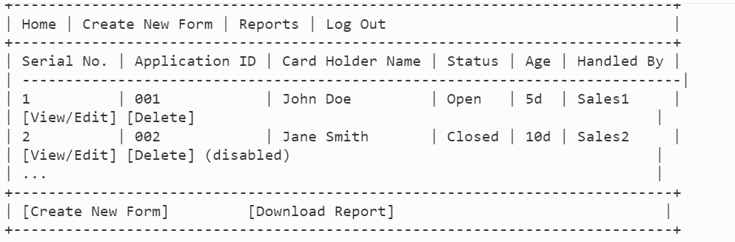

### 3. *Create/Edit CC Application Form Page*

- *Sections:*

- *Customer Details:*

- *Fields:* - *Is Customer New or Existing?* (Dropdown: New / Existing)

- If *Existing:*

- Bank Account Details (Fetched Automatically)

- If *New:*

- Full Name (Text Field)

- Date of Birth (Date Picker)

- Age (Auto-calculated from DOB)

- Address (Text Field)

- Contact Number (Text Field)

- Nominee (Text Field)

- Nominee Relationship (Dropdown)

- *Application Details:*

- *Fields:*

- Product (Dropdown: Silver, Gold, Platinum Card)

- ID Proof (Attachment: File Upload for Passport)

- Address Proof (Attachment: File Upload for Passport or Aadhar Card)

- Income Proof (Attachment: File Upload for Latest Payslip and PAN Number)

- Profile (Dropdown: New / Existing)

- *Actions:*

- *Submit:* Button to submit the form data.

- *Attach File:* Button to upload necessary documents.

- *Save:* Option to save the form as a draft.

- *Cancel:* Button to discard changes and return to the Home Page.

- *Error Handling:*

- Show error messages if mandatory fields are not filled.

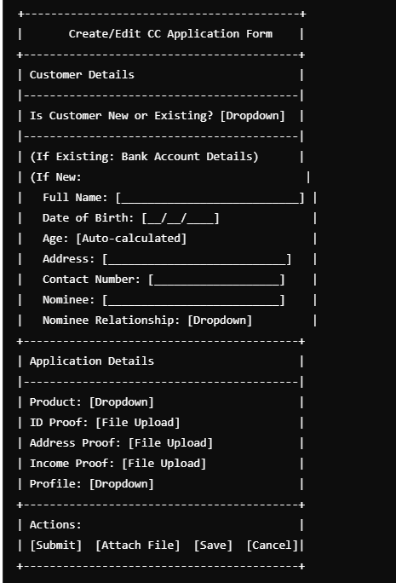

### 4. *Application Details Page*

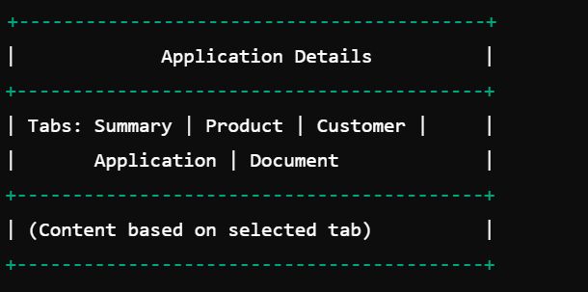

- *Tabs:*

- *Summary:* Displays overall details about the application.

- *Fields:* Application ID, Application Date, Approval Status, Staff Details

- *Product:* Displays requested and approved product details.

- *Fields:* Requested Product, Approved Product, Credit Score Check, Manual Approval Option

- *Customer:* Displays customer details.

- *Fields:* Name, Address, Email, Contact Number, Date of Birth, Age, Nominee Details, etc.

- *Application:* Reflects application status and related actions.

- *Fields:* Application Status, Actions (Edit, Delete)

- *Document:* Manages customer documents.

- *Fields:* ID Proof, Address Proof, Income Proof

- *Actions:* View/Download documents

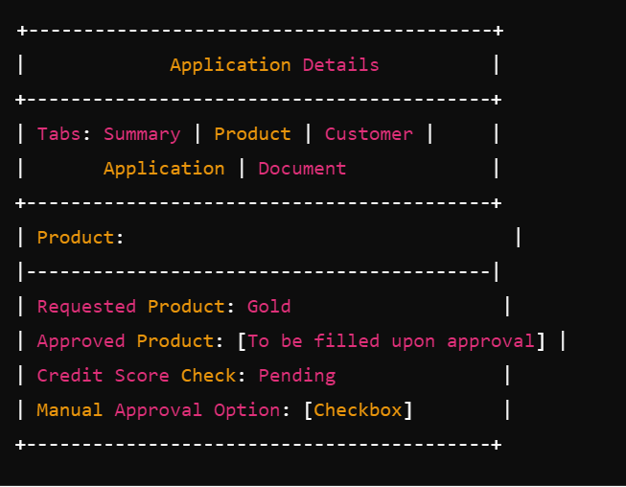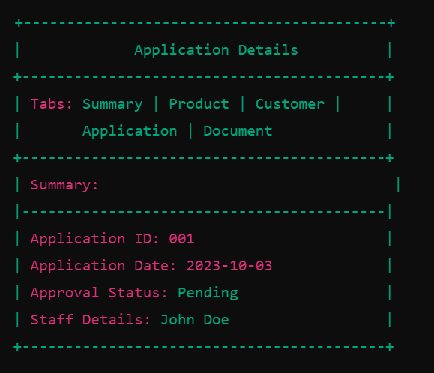

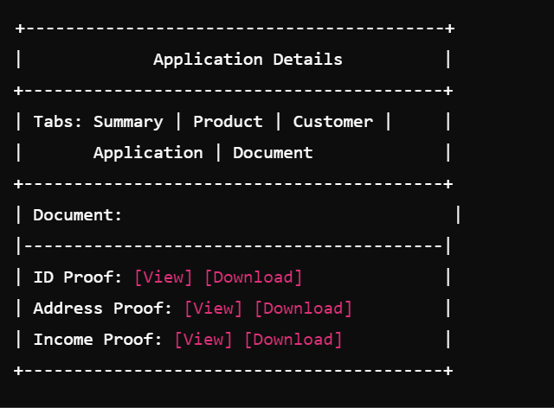

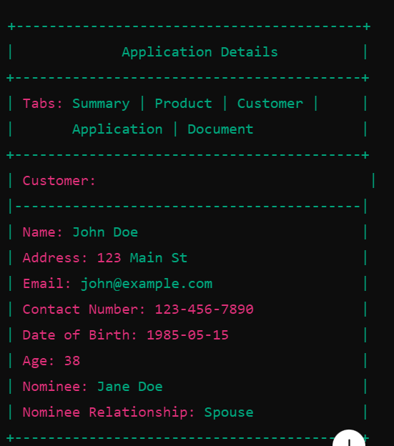

### 5. *Flow of Pages*

1. *Login Page* → User enters credentials → *Home Page*.

2. *Home Page*:

- Selects "Create New Form" → *Create/Edit CC Application Form Page*.

- Clicks on an application from the table → *Application Details Page*.

- Clicks "Delete Application" (enabled only if created by the logged-in Sales User) → Confirmation prompt before deletion.

3. *Create/Edit CC Application Form Page*:

- User specifies if the customer is New or Existing.

- If New, user fills in all mandatory customer details.

- User fills in application details and submits the form.

4. *Application Details Page*:

- Navigation between tabs (Summary, Product, Customer, Application, Document).

- Option to "Accept Offer" or "Request Approval" triggers back-end processes (e.g., Bureau Credit Checks, notifying the Transaction Processing System).

5. *Home Page*:

- Option to download Excel report.

### 6. *Detailed Inputs and Attributes for Each Page*

- *Login Page:*

- Username: Required

- Password: Required

- Submit Button: Triggers login validation

- *Home Page:*

- Table Columns (Serial No., Application ID, etc.): Display data fetched from the database

- View/Edit Form Button: Opens application form in editable mode

- Delete Application Button: Deletes the application (enabled only for the creator of the application)

- Create New Form Button: Opens a new form for data input

- *Create/Edit CC Application Form Page:*

- Customer Section:

- Is Customer New or Existing: Required

- For New Customers: Full Name, DOB, Address, Contact Number, Nominee Details: Required

- Application Section:

- Product, ID Proof, Address Proof, Income Proof, Profile: Required fields

- Attach File Buttons: For uploading required documents

- Submit Button: Submits form data to back-end for processing

- Save Button: Saves form as a draft

- *Application Details Page:*

- Summary Tab: Displays general application information

- Product Tab: Displays requested and approved product details

- Customer Tab: Displays customer contact and identification details

- Application Tab: Reflects the current state of the application

- Document Tab: Manages uploaded documents with view/download options

### 7. *Connections and Flow*

- *Login Validation*: Login Page validates against user database.

- *Dashboard Data*: Home Page fetches open applications from the server.

- *Form Submission*: Create/Edit Form Page submits data to the back-end, triggering document management and credit checks.

- *Application Details*: Application Details Page fetches and displays data based on user actions (e.g., viewing an application).

- *Notifications*: System sends notifications to different systems (e.g., Mail Manager, PrintShop) based on form actions.