Name : Rahul Priyadarshi
SJSU ID : 008091837
SJSU CMPE297 Assignment2 solutions

I. First deployment to Cloud Foundry (2 points)

Ans: Have developed and deployed Hello World program on CloudFoundry using Ruby and Node.js.

- Url for Hello World ruby app on Cloud Foundry is
http://hello-rahul.cloudfoundry.com/

The code Hello.rb is checked into GitHub.

Below is the screen shot for the GitHub deployment.

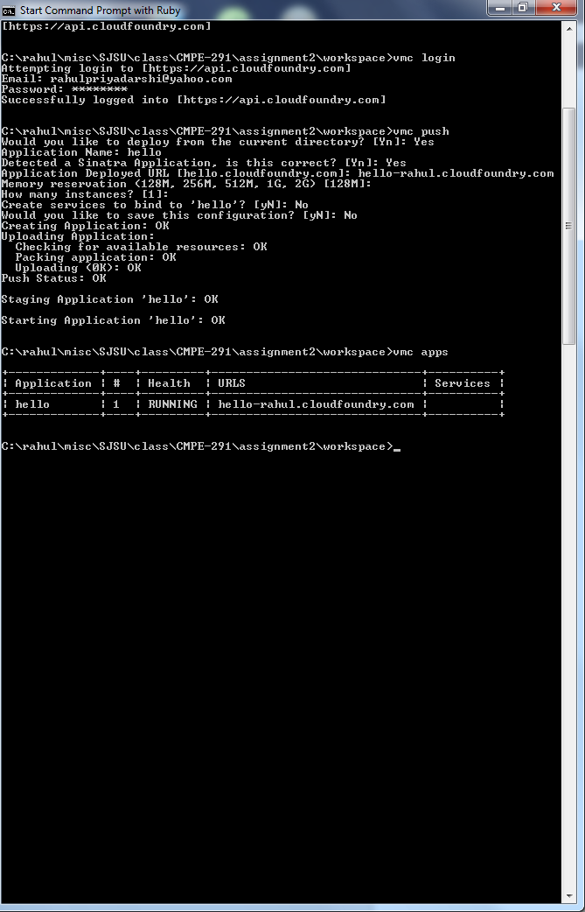
Below is the screen shot for the results from cloud foundry.
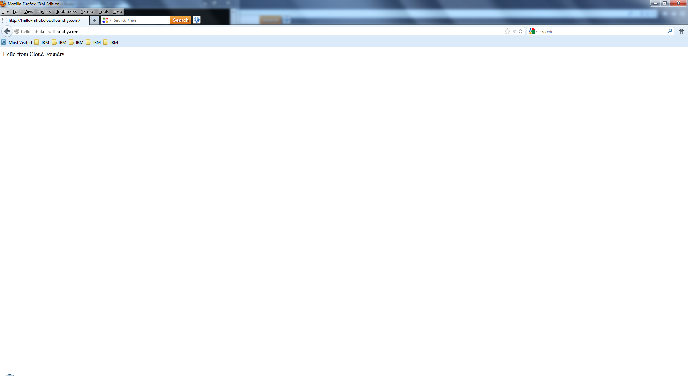

- Url for Hello World Node.js app is as follows….
http://rahuljs-node.cloudfoundry.com/

The code app.js is checked into GitHub. It can be found in Nodejs/hello-node

Screen shot for the Cloud Foundry deployed is below.

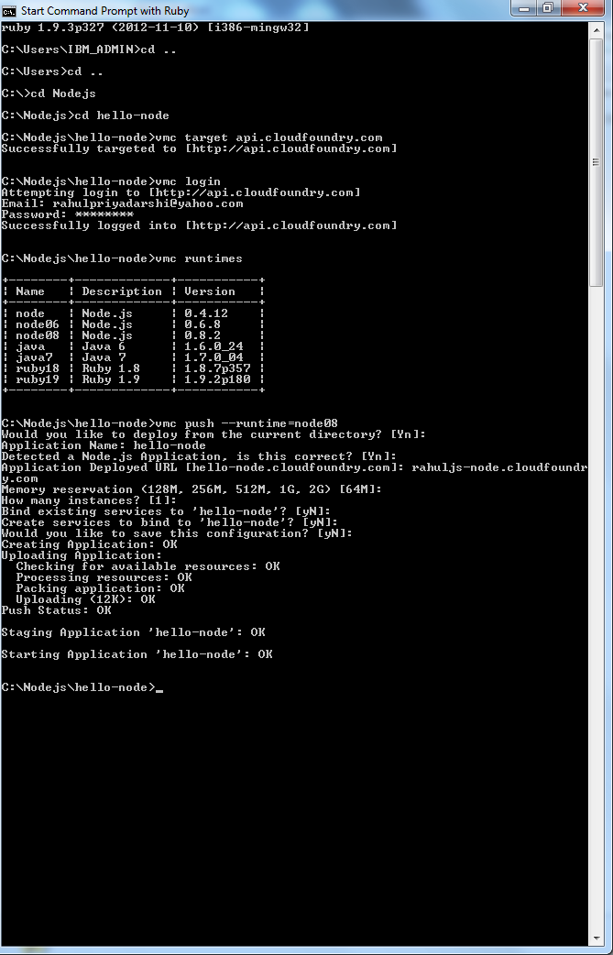
Screen shot for the out put is pasted below.
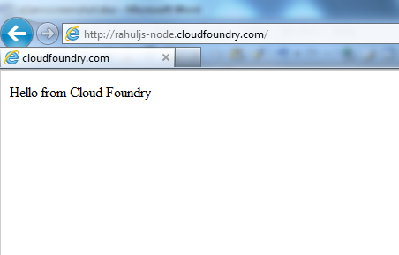

- Url for Hello World Node.js app is as follows….
http://cmpe297-assign2-rahul.cloudfoundry.com/

The code app.js is checked into GitHub. . It can be found in Nodejs/hello-node.

Screen shot for the Cloud Foundry deployed is below.

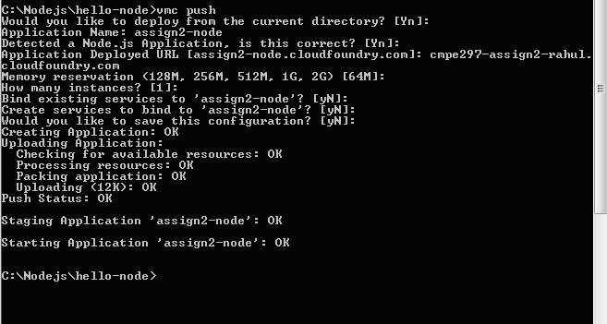

Screen shot for output is pasted below.
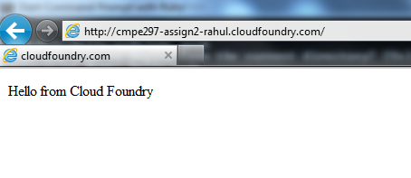

Updated the app using vmc update:

Screen shot for update to Cloud Foundry is below
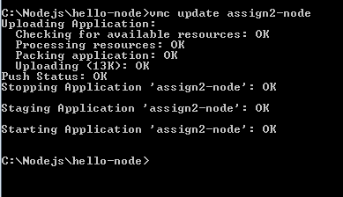

Screen shot for output is pasted below.
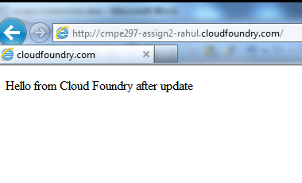

What is the command to scale the application instances up or down?
Ans:
vmc instances <appname> <num|delta>
Scale the application instances up or down.

II. Persisting data into MongoDB
Ans: Have implemented this in two different ways.

Persisting data in mongodb example 1:
Url for Node.js app is as follows….
http://cmpe297-assign2-rahulmongo1.cloudfoundry.com and
http://cmpe297-assign2-rahulmongo1.cloudfoundry.com/history
The code app.js is checked into GitHub. . It can be found in Nodejs/mongo-node.

Below is the screen shot for the deployment of app.js in cloud foundry.
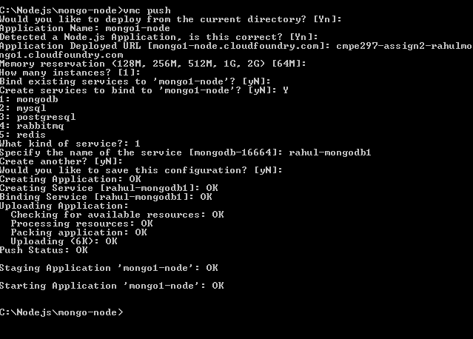

Below is the screen shot of the result when recording the ip address:
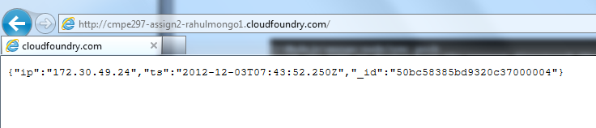

Below is the screen shot of the result when displaying the ip addresses recorded earlier:
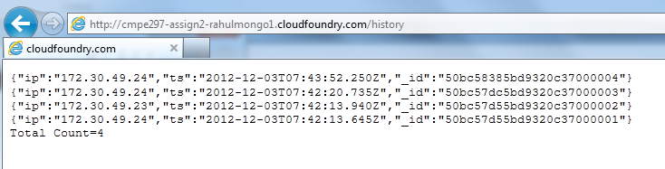

Persisting data in mongodb example 2:

Url for Node.js app is as follows….
http://cmpe297-assign2-rahulmongo2.cloudfoundry.com
The code app.js is checked into GitHub.
It can be found in Nodejs/mongo-aggregate.

Below is the screen shot for the deployment of app.js in cloud foundry.
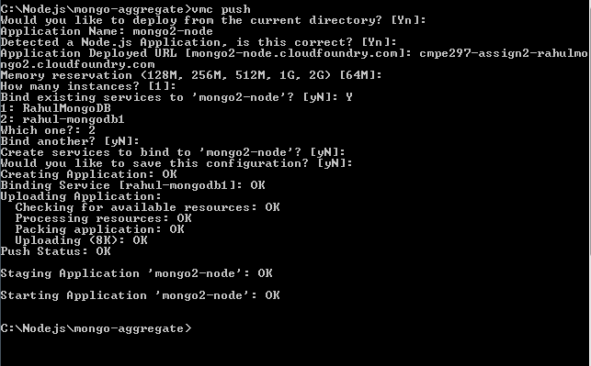

Note:The output of this example is pasted below and also documented in out-example2.txt. This has also been uploaded to GitHub. In Nodejs/mongo-aggregate/out-example2.txt has been generated by running “node app.js” locally…….
[{"_id":"2012-12-03T07:56:34.773Z","count":1},{"_id":"2012-12-01T06:55:05.072Z","count":1},{"_id":"2012-12-01T06:18:02.398Z","count":1},{"_id":"2012-12-01T06:22:27.507Z","count":1},{"_id":"2012-11-22T00:26:00.666Z","count":1},{"_id":"2012-12-01T06:20:44.506Z","count":1},{"_id":"2012-12-01T06:16:23.959Z","count":1},{"_id":"2012-12-01T06:23:56.571Z","count":1},{"_id":"2012-11-22T00:25:58.362Z","count":1},{"_id":"2012-12-01T06:13:23.989Z","count":1},{"_id":"2012-11-22T00:36:05.927Z","count":1},{"_id":"2012-12-01T05:53:18.415Z","count":1},{"_id":"2012-11-22T00:25:52.474Z","count":1},{"_id":"2012-12-01T04:23:10.887Z","count":1},{"_id":"2012-11-22T03:49:21.281Z","count":1},{"_id":"2012-11-23T04:38:34.823Z","count":1},{"_id":"2012-11-23T04:58:12.487Z","count":1},{"_id":"2012-11-22T05:23:22.527Z","count":1},{"_id":"2012-12-01T06:05:39.069Z","count":1},{"_id":"2012-12-01T04:12:04.122Z","count":1},{"_id":"2012-11-23T04:57:15.727Z","count":1},{"_id":"2012-11-23T04:39:57.652Z","count":1},{"_id":"2012-11-22T02:31:42.891Z","count":1},{"_id":"2012-11-23T04:55:35.913Z","count":1},{"_id":"2012-11-22T00:23:39.903Z","count":1},{"_id":"2012-12-01T04:35:25.727Z","count":1},{"_id":"2012-11-22T00:23:38.069Z","count":1},{"_id":"2012-11-22T00:36:08.754Z","count":1},{"_id":"2012-11-22T00:24:10.088Z","count":1},{"_id":"2012-11-23T04:40:36.472Z","count":1}]

III Extra Credit
Ans: Have coded the extra credit part. Have uploaded the same in Cloud Foundry and also uploaded code to Git Hub.

Url for Node.js app is as follows….
http://cmpe297-assign2-rahulmongo3.cloudfoundry.com
The code app.js is checked into GitHub.
It can be found in Nodejs/ mogo-mapreduce.

Below is the screen shot for the deployment of app.js in cloud foundry.

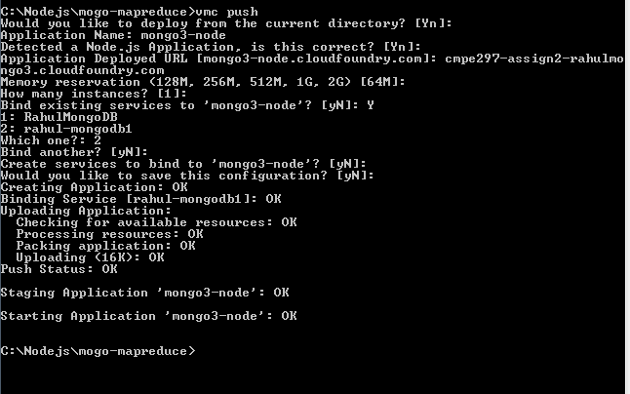

Note:The output of this example is pasted in screen shot below. Also documented in out-mapreduce.txt. This has also been checked in to GitHub in Nodejs/ mogo-mapreduce /out-mapreduce.txt has been generated by running “node app.js” locally…….

