**DNA and RNA Damage Assay and Library Construction of New Ammonium Bisulfite Recipe for Ultramild BS-Seq**

**Yushuai Liu**

**9/23/2024**

**Background**

Since Tanner has been focusing on finishing UMBS work, I will do more optimizations for lower temperature. In this batch, we will test two different methods and different temperatures from 25 o 55 C while keeping the recipe the same. Method Aismixing protect buffer and sample first, then adding BS reagent to conducting BS treatment. Method B is mixing BS reagent and protect buffer first, then add sample DNA sample. To test the conversion efficiency under different treatment conditions, I will build UMBS-seq libraries using selected DNA and RNA samples with less damage.

**Design**

1. Treatment conditions:

Take 2 ng ligated lambda DNA each to do the following BS treatment:

|  |  |  |  |
| --- | --- | --- | --- |
| **Sample ID** | **Recipe** | **Temp (C)** | **Time** |
| ST | Denaturation but without BS treatment |  |  |
| 1 | BS China + protect buffer | 55 | 60 mins |
| 2 | BS China + protect buffer | 50 | 90 mins |
| 3 | BS China + protect buffer | 50 | 120 mins |
| 4 | BS China + protect buffer | 45 | 4 hrs |
| 5 | BS China + protect buffer | 45 | 8 hrs |
| 6 | BS China + protect buffer | 40 | 8 hrs |
| 7 | BS China + protect buffer | 37 | 8 hrs |
| 8 | BS China + protect buffer | 40 | 16 hrs |
| 9 | BS China + protect buffer | 37 | 16 hrs |
| 10 | BS China + protect buffer | 30 | 16 hrs |
| 11 | BS China + protect buffer | 25 | 16 hrs |

**Materials**

|  |  |
| --- | --- |
| Lambda DNA | Tanner’s Box in -20 C freezer, 90 ng/uL |
| Protection Buffer | Yushuai’s Box in 4 C freezer |
| Kit- EZ RNA Methylation Kit | Shelf above the bench |
| Kit-EZ DNA Methylation-Gold kit | Shelf above the bench |
| New Bisulfite reagent | In cabinet under fume hood |
| [NEBNext UltraShear](https://www.neb.com/en-us/products/m7634nebnext-ultrashear) | #E6655, Tanner’s Box in -20 C freezer |
| [Zymo Methylated pUC19 DNA Set](https://www.zymoresearch.com/products/methylated-non-methylated-puc19-dna-set) | D5017, Tanner’s Box in -20 C freezer |
| [KAPA Evo Prep Kit](chrome-extension://efaidnbmnnnibpcajpcglclefindmkaj/https:/elabdoc-prod.roche.com/eLD/api/downloads/580531d2-d903-ef11-2591-005056a71a5d?countryIsoCode=XG) | Tanner’s Box in -20 C freezer |

**Recipe Preparation**

**1. New Recipe**

**New BS reagent** (37.5 uL) **+ protect buffer** (7.5 uL)

**How to make the recipe:**

**method A-** Mix protect buffer and DNA sample first, then add BS reagent

**method B-** Mix BS reagent and DNA protect buffer first, then add DNA sample

**DNA Damage Assay – prepare ligated DNA (2 Samples)**

*Remove beads to warm them

Prepare 500 ng Lambda: Take **5.6 µl** Lambda DNA (90 ng/µl)

Prepare 10 ng PUC19 plasmid DNA: Take **10 µl** plasmid DNA (10 ng/µl)

1. **Enzymatic Fragmentation -** with NEBNext UltraShear (2 Samples)

**For each sample, start with:**

|  |  |  |
| --- | --- | --- |
| **Component** | **Total Volume for two samples (ul)** | **Volume per sample (ul)** |
| Sterile Water | 10.4 | 18.2 |
| Methylated pUC19 plasmid (1 ng/ul 🡪 10 ng, ~2%) | 10 | 5 |
| Lambda (500 ng) | 5.6 | 2.8 |
| UltraShear Reaction Buffer (white) | 14 | 14 |
| NEBNext UltraShear (white) | 4 | 4 |
| **Total volume** | **44** | **44** |

Assemble each fragmentation reaction **on ice** by adding the components in the above order, incubate in a thermocycler **with lid at 75C**

|  |  |  |
| --- | --- | --- |
| **Step** | **Temp** | **Time** |
| Fragmentation | 37°C | **30 min** |
| Additional Incubation | 65°C | 15 min |
| HOLD | 4°C | ∞ |

Consolidate 2 samples into 1 samples of equal volume (88 µl)

1. **AmPure Beads Clean-Up**
   1. *Warm beads to RT before use!*
      1. 1.0x beads ratio – 88 µl for each sample (after combining!)
      2. Elute with 36 µl water to get 35 µl

**AmPure Beads Purification Procedure**

* 1. Vortex beads to resuspend
  2. Add **X** µl beads to sample (pipette up and down to mix)
  3. Incubate for up to 5 minutes at RT
  4. Place on magnet and discard supernatant once clear
  5. Add 200 µl of fresh 80% ethanol
  6. Incubate at RT for 30 seconds and remove and discard supernatant
  7. Wash again with 200 µl 80% EtOH
  8. Air dry the beads for 5 minutes (DO NOT OVER DRY)
  9. Elute with **X** µl RNA H2O by incubating at RT for 2 min
  10. Place on magnet and take **X** µl of supernatant to next step

1. **End Prep and A-Tailing**

To 35 µl of fragmentated DNA (500 ng) and then add:

|  |  |
| --- | --- |
| **Reagent** | **Volume per sample (ul)** |
| ~~164bp 5mC dsDNA (1ng/ul 🡪 5 ng, ~1.0%)~~ | ~~5 µl~~ |
| KAPA End Repair and A-Tailing Ready Mix | 25 µl |

Sample final volume: **60 µl**

Incubate at: **Pre-cool the block to 4C, add sample, then incubate at** **35 C for 30 min followed by 65 C for 30 min (Lid @ 80C)**

1. **Adaptor Ligation**
   1. To 60 µl of end repaired DNA (500 ng)

|  |  |
| --- | --- |
| **Reagent** | **Volume per sample (ul)** |
| NEBNext *Methylated* Adaptor (No Dilution)  - *NOT the adaptor included in kit* | 5 µl |
| KAPA Ligation ReadyMix | 10 µl |

Sample final volume: **75 µl**

Incubate at: **Pre-cool block to 4 C, add sample, then incubate at 20 C for 15 minutes with lid at 50 C**

* 1. To **75 µL of sample**, add:

|  |  |
| --- | --- |
| **Reagent** | **Volume per sample (ul)** |
| USER Enzyme | 3.0 |

Sample final volume: **78**

Incubate at: **37 °C for 15 mins** **with lid at 50 °C**

1. **AmPure Beads Purification** 
   1. *Warm beads to RT before use! (~30 min)*
      1. 0.8x beads ratio – 62.4 µl.

Elute with 251 µl RNA water to collect 250 µl (~2 ng/µl)

Take out 30 uL ligated DNA to do KOH denaturation for this batch of experiment, and store the rest in -80 C freezer. For example, add 5 uL 20 M KOH to 195 uL H2O, get 0.5 M KOH, then take out 45 uL 0.5 M KOH and mix with 15 uL sample and 15 uL H2O, that is 75 uL (final concentration of KOH is 0.3 M). Then 42 C for 20 mins, after the reaction is done, place on ice, take out 5 uL denatured DNA to do BS treatment.

**BS Treatment – 22 Samples**

Method A:

1. Transfer 7.5 ul protect buffer to the empty 200 ul PCR tube.

2. Add 5 ul denatured DNA to DNA protect buffer, pipette, vortex and quickly spin down.

3. Add 37.5 uL BS reagent to the mix in step 2, pipette, vortex and quickly spin down. The liquid is clear.

4. Incubate the reactions at different temperatures and times based on the table in the design part.

5. After the reaction is done, add 100 uL RNA H2O required in desulphonation procedures and place on ice. Make sure there is no precipitation.

Method B:

1. Transfer 7.5 ul protect buffer to the empty 200 ul PCR tube.

2. Add 37.5 ul BS reagent to protect buffer, pipette, vortex and quickly spin down. The liquid is not clear now, like milk.

3. Add 5 uL denatured DNA to the mix in step 2, pipette, vortex and quickly spin down. The liquid is clear now.

4. Incubate the reactions at different temperatures and times based on the table in the design part.

5. After the reaction is done, add 100 uL RNA H2O required in desulphonation procedures and place on ice. Make sure there is no precipitation.

**Desulphonation (22 Samples) - EZ DNA Methylation Gold-Kit**

* 1. For each sample🡪50 ul, add 100 µL H2O.
  2. M-Binding Buffer – 600 µL 🡪 Centrifuge 16,000 xg for 30s
  3. M-Wash Buffer – 100 µL 🡪 Centrifuge 16,000 xg for 30s
  4. M-Desulphonation Buffer – 200 µL on column
  5. Incubate at Rm Temp for 15 mins 🡪 Centrifuge 16,000 xg for 30s
  6. M-Wash Buffer – 200 µL 🡪 Centrifuge 16,000 xg for 30s
  7. Repeat washing for another 3 times
  8. Discard 🡪 Centrifuge 16,000 xg for 2 mins

Elute with H2O – 21 µL 🡪 Centrifuge 16,000 xg for 1min, get 20 uL in total.

**qPCR – all 23 samples**

|  |  |  |
| --- | --- | --- |
| **Reagent** | **Volume per sample (ul)** | **Volume per 23.8 samples (ul)** |
| KAPA HiFi Hotstart Uracil+ 2X Ready Mix | 10 | 238 |
| Universal primer | 1 | 23.8 |
| Mixed Index primer | 1 | 23.8 |
| H2O | 6 | 142.8 |
| SYBR Green | 1 | 23.8 |
| **Final volume** | **19** |  |

To **1 ul** of all 23 samples, add:

Sample final volume**: 20 ul** 🡪

|  |  |
| --- | --- |
| Pre-incubation | 95 C; 600 s |
| X40 | 95 C; 20 s |
| 60 C; 20 s |
| 72 C; 20 s |
| Melting curves | 95 C; 10 s |
| 65 C; 60 s |
| 97 C; 1 s |

After you got qPCR data, let’s discuss what libraries should proceed to PCR to build libraries for sequencing.

**DNA Sample information and qPCR results**

**How to make the recipe:**

**method A-** Mix DNA protect buffer and DNA first, then add BS reagent

**method B-** Mix BS reagent and DNA protect buffer first, then add DNA

|  |  |  |  |  |  |
| --- | --- | --- | --- | --- | --- |
| **Sample ID** | **Recipe** | **Temp (C)** | **Time** | **How to make the recipe** | **qPCR** |
| ST | Denaturation but without BS treatment |  |  |  | 8.5 |
| A-1 | BS China + DNA protect buffer | 55 | 60 mins | Method A | 12 |
| A-2 | BS China + DNA protect buffer | 50 | 90 mins | Method A | 12 |
| A-3 | BS China + DNA protect buffer | 50 | 120 mins | Method A | 12.5 |
| A-4 | BS China + DNA protect buffer | 45 | 4 hrs | Method A | 12 |
| A-5 | BS China+ DNA protect buffer | 45 | 8 hrs | Method A | 13.7 |
| A-6 | BS China + DNA protect buffer | 40 | 8 hrs | Method A | 13 |
| A-7 | BS China+ DNA protect buffer | 37 | 8 hrs | Method A | 12.6 |
| A-8 | BS China + DNA protect buffer | 40 | 16 hrs | Method A | 13.7 |
| A-9 | BS China + DNA protect buffer | 37 | 16 hrs | Method A | 13.8 |
| A-10 | BS China + DNA protect buffer | 30 | 16 hrs | Method A | 12.8 |
| A-11 | BS China + DNA protect buffer | 25 | 16 hrs | Method A | 12.1 |
| B-1 | BS China + DNA protect buffer | 55 | 60 mins | Method B | 11.3 |
| B-2 | BS China + DNA protect buffer | 50 | 90 mins | Method B | 11.4 |
| B-3 | BS China + DNA protect buffer | 50 | 120 mins | Method B | 11.2 |
| B-4 | BS China + DNA protect buffer | 45 | 4 hrs | Method B | 12.3 |
| B-5 | BS China + DNA protect buffer | 45 | 8 hrs | Method B | 13 |
| B-6 | BS China + DNA protect buffer | 40 | 8 hrs | Method B | 13.4 |
| B-7 | BS China + DNA protect buffer | 37 | 8 hrs | Method B | 11.9 |
| B-8 | BS China + DNA protect buffer | 40 | 16 hrs | Method B | 13.2 |
| B-9 | BS China + DNA protect buffer | 37 | 16 hrs | Method B | 12.6 |
| B-10 | BS China + DNA protect buffer | 30 | 16 hrs | Method B | 12.2 |
| B-11 | BS China + DNA protect buffer | 25 | 16 hrs | Method B | 11.5 |

Based on the qPCR results, we chose ST, A-1, A-2, A-3, A-4, B-1, B-2, B-3, B-4, B-7, B-8, B-9, B-10 and B-11 to build UMBS-seq libraries since the Ct values are relatively smaller suggesting lower DNA damage.

**PCR – 14 samples for DNA assay**

|  |  |  |
| --- | --- | --- |
| **Reagent** | **Volume per sample (ul)** | **Volume per 14.6 samples (ul)** |
| KAPA Hifi U+ 2X Master Mix | 12.5 |  |
| Universal primer | 0.625 |  |
| Index primer | 0.625 |  |
| H2O | 2.25 |  |
| **Final volume** | **16** |  |

**To 9 uL sample, add:**

Sample final total volume: **25 ul** 🡪

|  |  |
| --- | --- |
|  | 98 C; 45 s |
| x cycles  (Calculate based on the qPCR Ct value) | 98C; 15 s |
| 60 C; 30 s |
| 72 C; 30 s |
|  | 72 C; 1 min |
|  | 4C |

**AmPure beads purification**

* 1. 0.6x beads ratio – 15 µL
  2. Elute with H2O – 12.5 µL
* 10 µL libraries
* 1 µL QC
* 1 µL Qubit

**Library information – samples are from DNA damage assay (14 samples)**

|  |  |  |  |  |  |  |  |  |  |
| --- | --- | --- | --- | --- | --- | --- | --- | --- | --- |
| ID | Content | qPCR | PCR  9 uL  sample | Index# | Kit | Qubit (ng/ul) | QC  (ng/ul) | Dilution fold for QC | i7 |
| ST | 2 ng ligated DNA, Denaturation but without BS treatment | 10.4 | 9 | 1 | NEBNext  Set # 1 and 2 | 5.02 | 1.43 | 5 | ATCACG |
| A-1 | 2 ng ligated DNA, BS + protect buffer, 55C 60 mins, method A | 12.1 | 12 | 2 | 7.46 | 1.91 | 5 | CGATGT |
| A-2 | 2 ng ligated DNA, BS + protect buffer, 50C 90 mins, method A | 15.1 | 12 | 4 | 8.58 | 2.12 | 5 | TGACCA |
| A-3 | 2 ng ligated DNA, BS + protect buffer, 50C 120 mins, method A | 8.6 | 13 | 5 |  | 8.34 | 2.18 | 5 | ACAGTG |
| A-4 | 2 ng ligated DNA, BS + protect buffer, 45C 4 hrs, method A | 12 | 12 | 6 |  | 8.26 | 2.18 | 5 | GCCAAT |
| B-1 | 2 ng ligated DNA, BS + protect buffer, 55C 60 mins, method B | 15.3 | 12 | 7 |  | 13.3 | 3.41 | 5 | CAGATC |
| B-2 | 2 ng ligated DNA, BS + protect buffer, 50C 90 mins, method B | 9 | 12 | 8 |  | 12.3 | 2.73 | 5 | ACTTGA |
| B-3 | 2 ng ligated DNA, BS + protect buffer, 50C 120 mins, method B | 12.2 | 12 | 9 |  | 14.7 | 3.83 | 5 | GATCAG |
| B-4 | 2 ng ligated DNA, BS + protect buffer, 45C 4 hrs, method B | 15.6 | 12 | 10 |  | 7.64 | 1.83 | 5 | TAGCTT |
| B-7 | 2 ng ligated DNA, BS + protect buffer, 37C 8 hrs, method B | 9.7 | 12 | 11 |  | 8.5 | 2.09 | 5 | GGCTAC |
| B-8 | 2 ng ligated DNA, BS + protect buffer, 40C 16 hrs, method B | 12 | 13 | 12 |  | 6.12 | 1.47 | 5 | CTTGTA |
| B-9 | 2 ng ligated DNA, BS + protect buffer, 37C 16 hrs, method B | 17 | 13 | 13 |  | 9.6 | 2.87 | 5 | AGTCAA |
| B-10 | 2 ng ligated DNA, BS + protect buffer, 30C 16 hrs, method B | 8.7 | 12 | 14 |  | 9.28 | 2.57 | 5 | AGTTCC |
| B-11 | 2 ng ligated DNA, BS + protect buffer, 25C 16 hrs, method B | 15.6 | 12 | 15 |  | 8.38 | 1.99 | 5 | ATGTCA |

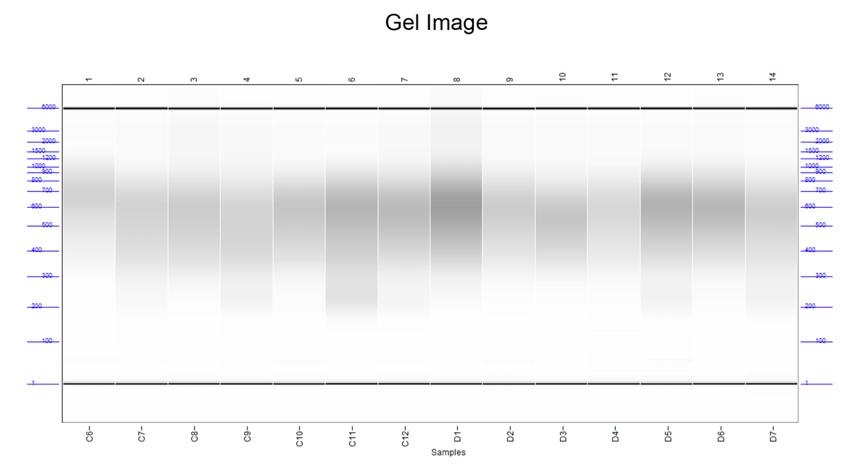

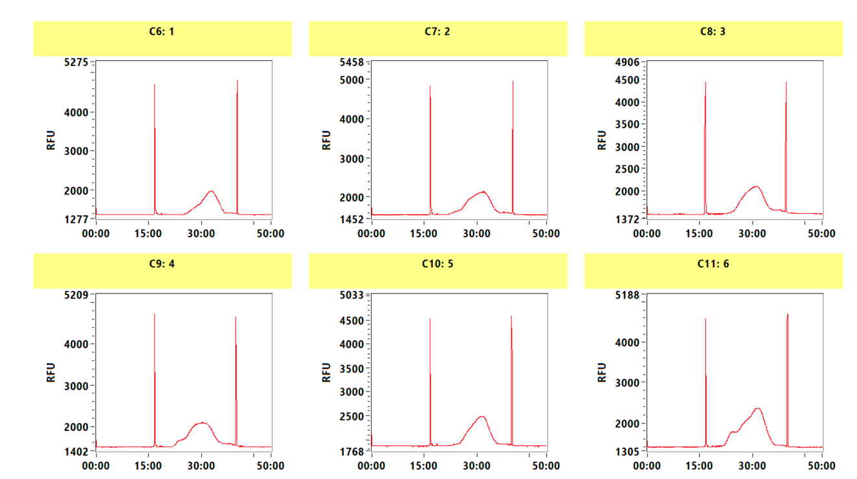

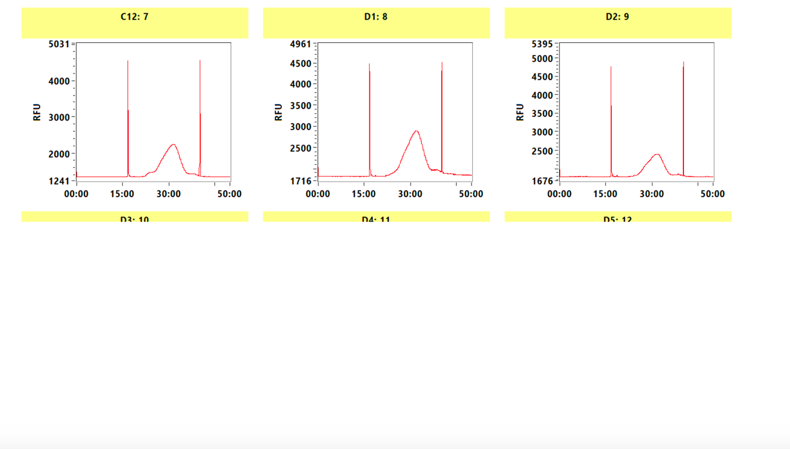

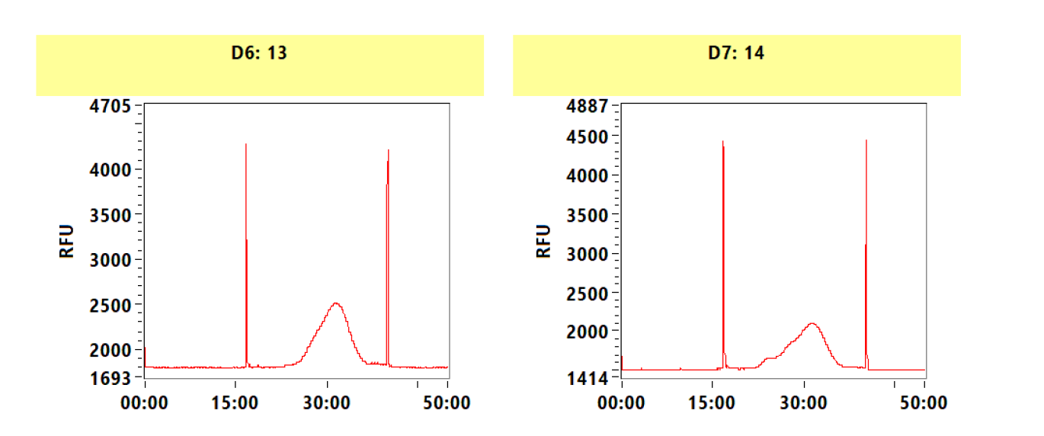

**Discussion**

Based on the qPCR results, we confirmed the trend that lower temperature (from 55°C and 37°C to 25°C) and longer treatment time (from 1 hrs to 16hrs) can cause less DNA damage.

To test the conversion efficiency under different treatment conditions, I built 14 UMBS-seq libraries using selected DNA samples with less damage. Now we are waiting for the sequencing data analysis.

Based on the QC results, 50 C for 90 min or 120 min gave the most library yields and the longest inserts, suggesting lower DNA damage.