JANKE LLP
Sample Social Media Posts

Two developed examples showing how the approved black, white and Prairie Gold system can work in practice.
 | 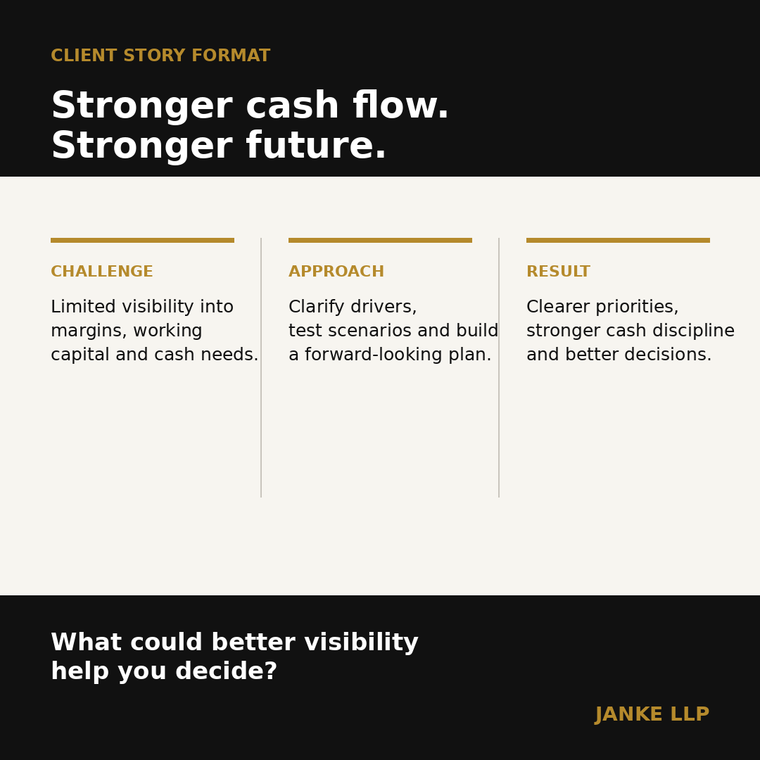
Concept mockups for review. Final production graphics should use the approved Janke LLP logo files, final photography, and the current brand standards.

Sample 1: Clarity Before the Next Decision
Content category | Advisory insight / brand awareness
Primary audience | Owner-managed and family businesses in Saskatchewan
Communication objective | Show how Janke LLP helps clients move from uncertainty to clear action
Recommended format | LinkedIn single-image post; adaptable to Facebook and Instagram
Final caption
Smart decisions start with the right information.
When the numbers are changing, the real question is not simply what happened. It is what the information means for the next decision.
Janke LLP helps business owners turn financial information into practical direction — whether the priority is improving cash flow, planning for growth, preparing for succession or making a major investment.
What does better look like for your business? Start the conversation.
On-graphic copy
Clarity today.
Confidence tomorrow.
Grounded advice. Grow better.
Visual direction
Use a clean, minimal composition featuring either a real Saskatchewan business environment, a prairie detail, or a typography-led treatment. Black and white should carry the design. Prairie Gold may be used for one headline line, a rule, a small marker, or a single point of emphasis. Keep generous negative space. Avoid teal, sage, navy, gradients, and decorative colour blocks. The Janke LLP logo appears independently; the supporting line is never attached to the logo.
Accessibility alt text
A black Janke LLP graphic with the headline 'Clarity today. Confidence tomorrow.' and the supporting line 'Grounded advice. Grow better.', using white text with restrained Prairie Gold emphasis.
Hashtags
#BusinessAdvisory #SaskatchewanBusiness #BusinessPlanning #JankeLLP

Sample 1: Channel Adaptation and Release Checks
Channel adaptation notes
LinkedIn: publish the full caption. Facebook: retain the full message but place the question earlier. Instagram: shorten the middle paragraph and place the call to action before the hashtags. Avoid copying the same opening line across channels when posting simultaneously.
Pre-publication checks
- Confirm technical accuracy and any referenced deadlines.
- Confirm the visual uses approved logo files, Gilroy/Arial typography, and the black/white/Prairie Gold palette.
- Confirm image rights and client consent where applicable.
- Review all links, tags, alt text and mobile cropping before release.
- Check that Prairie Gold remains an accent rather than the dominant field colour.
Brand application note
The social system may be more expressive than formal documents, but it should still feel simple, premium and direct. Start with black and white. Add Prairie Gold only where it improves hierarchy or recognition.

Sample 2: Stronger Cash Flow. Stronger Future.
Content category | Anonymized client outcome / advisory education
Primary audience | Established privately held businesses experiencing growth or margin pressure
Communication objective | Demonstrate Janke LLP's practical advisory process without making unsupported performance claims
Recommended format | LinkedIn single-image post; adaptable to Facebook and Instagram
Final caption
A growing business can still feel short of cash.
In this anonymized example, an owner-managed company had strong demand but limited visibility into margins, working capital and the cash required to support growth.
We worked with the owners to clarify the drivers, test practical scenarios and build a forward-looking plan. The result was not a single dramatic fix. It was a better decision process: clearer priorities, stronger cash discipline and greater confidence about where to invest next.
The details differ for every business. The value of clarity does not. What could better visibility help you decide?
On-graphic copy
Stronger cash flow.
Stronger future.
Challenge | Approach | Result
Visual direction
Create a three-part visual with simple headings: Challenge, Approach and Result. Use a black foundation with white typography and Prairie Gold for the three labels, dividers, or a small result marker. A genuine business image may be included only where proper consent exists. Keep result language qualitative unless verified figures are approved. Avoid fabricated testimonial quotations and avoid the former teal/sage/navy system.
Accessibility alt text
A Janke LLP client-story graphic titled 'Stronger cash flow. Stronger future.' It summarizes an anonymized business challenge, Janke LLP's planning approach and the resulting improvement in clarity and cash discipline, using black, white and Prairie Gold.
Hashtags
#CashFlow #BusinessGrowth #Advisory #OwnerManagedBusiness #JankeLLP

Sample 2: Channel Adaptation and Release Checks
Channel adaptation notes
LinkedIn: retain the anonymized case-study framing and full context. Facebook: shorten to three compact paragraphs. Instagram: use a three-slide carousel — Challenge, Approach and Result — with the full disclaimer and context in the caption. Do not use a fabricated testimonial quotation.
Pre-publication checks
- Confirm the example is genuinely anonymized and cannot reasonably identify a client without permission.
- Confirm technical accuracy and any referenced performance statements.
- Confirm the visual uses approved logo files, Gilroy/Arial typography, and the black/white/Prairie Gold palette.
- Confirm image rights and client consent where applicable.
- Review all links, tags, alt text and mobile cropping before release.
Brand application note
For case-study-style social content, use Prairie Gold to organize the story rather than decorate it. Gold works best for labels, rules, icons, or a single key phrase; the overall impression should remain predominantly black and white.

