F-Test
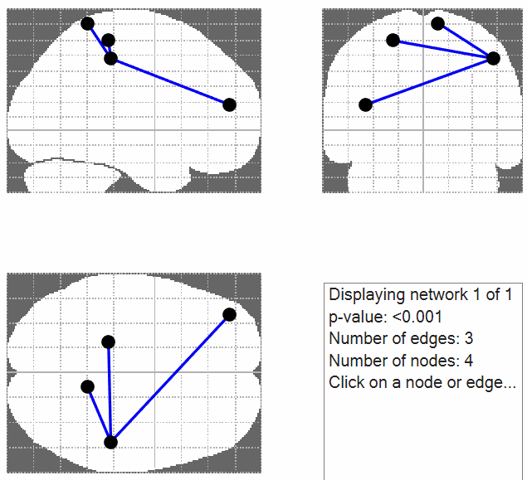
Node 22: (-20, -30, 60)
- Part of the left somatosensory cortex, more ventral and medial.
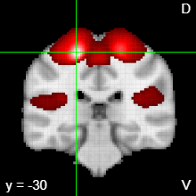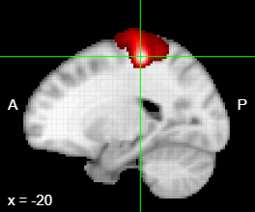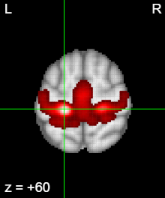
- Connectivity difference with node 41 (47, -30, 49)
- Left Primary Motor (4)
- Investigation of the Neural Control of Cough and Cough Suppression in Humans Using Functional Brain Imaging (Mazzone et al., 2011)
Node 41 (47, -30, 49)
- Part of the right parietal lobe, more anterior and distal
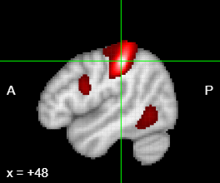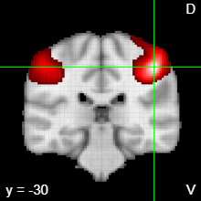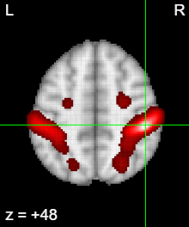
- Right primary sensory (1)
- This is the hub in my network
- Neural Circuits Underlying Imitation Learning of Hand Actions: An Event-Related fMRI Study (Buccino et al., 2004)

