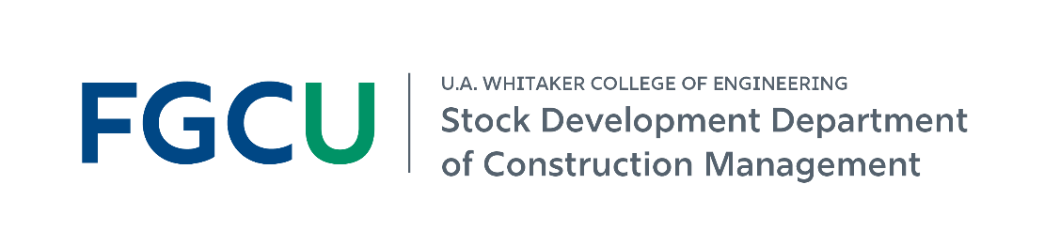
Construction Management at FGCU
Industry Partner Brief | Fall 2026
Established Summer 2019 • ACCE-accredited BSCM • 12 full-time + 11 adjunct faculty and staff
A fast-growing, industry-connected program focused on career-ready learning and regional workforce needs.
At a glance
475  BSCM students currently enrolled | 69  graduates last academic year | $73K  average starting salary*
95%  placement within 6 months** | 84  for-credit CM internships last academic year | 60  industry guest lectures last academic year
*Self-reported by graduates in the AY 2025-26 senior exit survey. **CM-related employment or graduate school within six months of graduation.
Program growth
Fall enrollment grew from 44 students in 2019 to 475 students in Fall 2026.
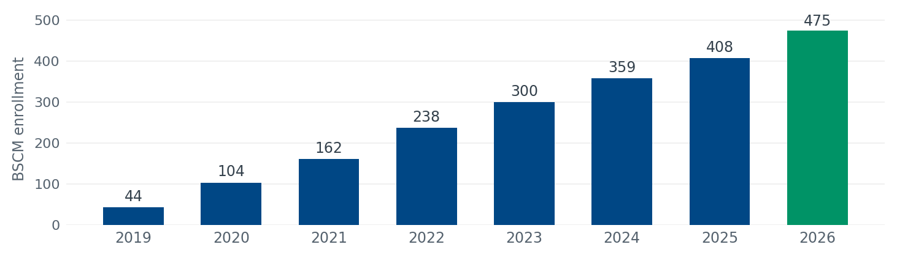
2026 student profile
88 freshmen | 16% women | 47% minorities | 49% from SWFL’s 5-county region

97% | of internship employers rated CM student performance Outstanding or Very Good (71% Outstanding, 26% Very Good, 3% Average; AY 2025-26, n = 86).

Industry partnership is built into the program
Our 2026-2031 priorities emphasize career-ready students, meaningful industry engagement, and continuous improvement informed by practice.
1 | Build the talent pipeline  • Strengthen internship placement coordination and tracking  • Connect employers with students through resume reviews, mock interviews, and employer panels  • Expand student participation in ASC, ABC, and other industry competitions  • Increase faculty-mentored undergraduate research and applied learning opportunities

2 | Bring industry into student learning  • Offer structured guest lectures and practitioner panels  • Host jobsite tours, trade demonstrations, and equipment showcases  • Engage with student organizations and competition teams  • Participate in advisory activities that help keep curriculum aligned with practice

3 | Collaborate with faculty and the program  • Host a Faculty Summer Industry Residency  • Collaborate on applied research aligned with industry needs  • Support faculty exposure to emerging technology and current practice  • Help inform continuous curriculum improvement

Ways your company can engage
Build your talent pipeline  Host for-credit CM internships and connect with students as they prepare for full-time employment. | Bring your expertise into learning  Offer a guest lecture, trade demonstration, equipment showcase, practitioner panel, or site tour.
Support career readiness  Join resume reviews, mock interviews, employer panels, or recruiting conversations. | Engage student organizations  Connect with the ABC Student Chapter, Women in Construction Club, and competition teams.
Partner with faculty  Host a Faculty Summer Industry Residency or collaborate on applied research tied to industry needs. | Invest in student success  Support scholarships or sponsored student competition teams; $21,000 in department scholarships was awarded in AY 2025-26.
Workforce learning beyond the BSCM
Certificate program  Introduction to Construction Management | Certificate program  Essentials of Construction Blueprint Reading | Graduate study  M.S. in Civil Engineering with a Construction Management concentration
Industry partnership conversation: How could your company connect with FGCU students this year - through internships, recruiting, guest lectures, site tours, student organizations, or faculty collaboration?
Data reflect AY 2025-26 and Fall 2026 enrollment figures, unless otherwise noted.

