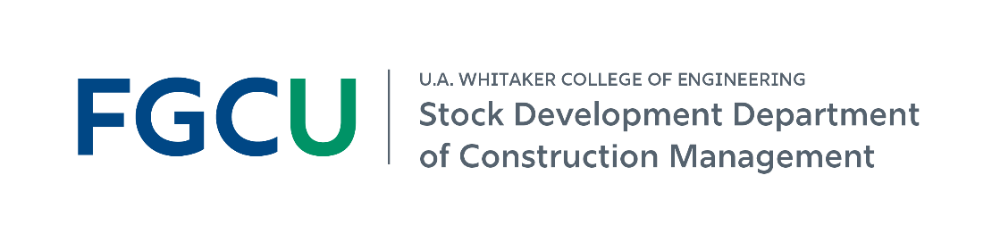
Construction Management at FGCU
B.S. in Construction Management | Prospective Student & Family Guide | Fall 2026
ACCE-accredited BSCM • Hands-on learning • Strong industry connections
Construction managers help coordinate projects from start to finish - including people, schedules, budgets, materials, and project delivery.
Career outcomes and real-world experience
95%  placement within 6 months** | $73K  average starting salary* | 84  for-credit CM internships last academic year
60  industry guest lectures last academic year | 69  graduates last academic year | 475  BSCM students currently enrolled
*Self-reported by graduates in the AY 2025-26 senior exit survey. **CM-related employment or graduate school within six months of graduation.
A fast-growing program
Fall enrollment grew from 44 students in 2019 to 475 students in Fall 2026.
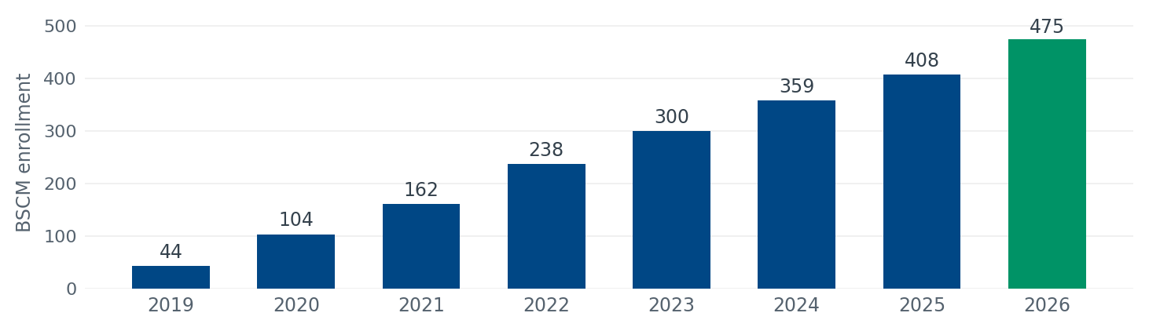
Join a growing student community
88 freshmen | 16% women | 47% minorities | 49% from SWFL’s 5-county region
97% | of internship employers rated CM student performance Outstanding or Very Good (71% Outstanding, 26% Very Good, 3% Average; AY 2025-26, n = 86).

What will your FGCU Construction Management experience look like?
The BSCM blends classroom learning with industry experience so you can build technical, management, leadership, and problem-solving skills for construction careers.
1 | Learn by doing  • Complete a for-credit construction management internship.  • Visit jobsites and learn through trade demonstrations and equipment showcases.  • Earn the 30-hour OSHA card as part of the program.

2 | Learn with industry  • Meet industry professionals through guest lectures, practitioner panels, and employer events.  • Work on senior capstone experiences supported and mentored by industry partners.  • Learn in a program whose curriculum is regularly informed by construction industry advisors.

3 | Get involved and build your network  • Join the Associated Builders and Contractors (ABC) Student Chapter or Women in Construction Club.  • Participate in construction competitions and career-readiness activities.  • Explore undergraduate research, including areas such as BIM and AI in construction.

Where can a Construction Management degree take you?
Estimator | Project Engineer | Assistant Project Manager | Assistant Superintendent
What you will learn to manage
Safety & quality  Plan for safe work and understand quality assurance and control. | Cost & accounting  Create estimates and understand construction accounting and cost control. | Scheduling & project control  Create schedules and understand project control processes.
Methods, materials & equipment  Analyze how projects are built and what resources are used. | Technology  Apply electronic-based technology to manage the construction process. | Contracts & delivery  Understand project delivery, roles, responsibilities, and legal implications.
More opportunities at FGCU
Scholarship support  $21,000 in department scholarships was awarded to students in AY 2025-26. | Start learning early  Construction Management courses are offered throughout all four years of the program. | Continue to graduate study  FGCU offers an M.S. in Civil Engineering with a Construction Management concentration.
Take the next step
Visit Holmes Hall. Meet our students and faculty. Ask about internships, student organizations, competitions, research, and careers.  Explore the BSCM: https://www.fgcu.edu/eng/constructionmanagement/constructionmanagement-bs |   Scan to learn more
Data reflect AY 2025-26 and Fall 2026 figures unless otherwise noted.

