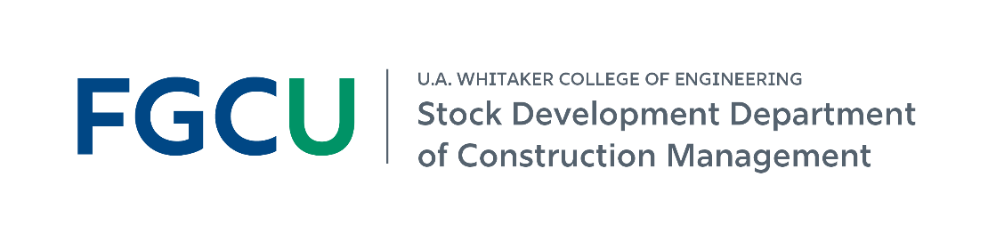
Build Your Future in Construction Management at FGCU
B.S. in Construction Management | Prospective Student & Family Guide | Fall 2026
ACCE-accredited BSCM • Hands-on learning • Strong industry connections
Construction managers help coordinate projects from start to finish - including people, schedules, budgets, materials, and project delivery.
Career outcomes and real-world experience
95%  placement within 6 months** | $73K  average starting salary* | 84  for-credit CM internships last academic year
60  industry guest lectures last academic year | 69  graduates last academic year | 475  BSCM students currently enrolled
*Self-reported by graduates in the AY 2025-26 senior exit survey. **CM-related employment or graduate school within six months of graduation.
A fast-growing program
Fall enrollment grew from 44 students in 2019 to 475 students in Fall 2026.
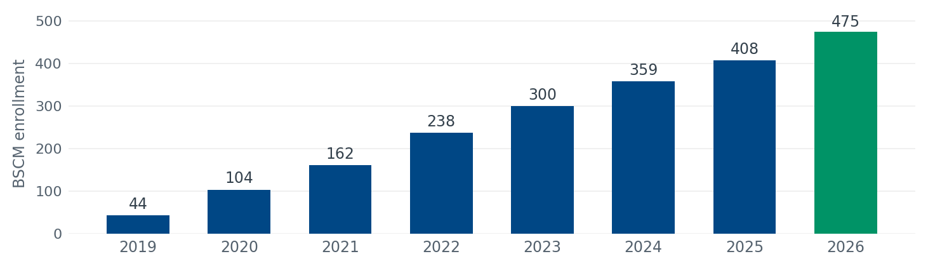
Join a growing student community
88 freshmen | 16% women | 47% minorities | 49% from SWFL’s 5-county region
97% | of internship employers rated CM student performance Outstanding or Very Good (71% Outstanding, 26% Very Good, 3% Average; AY 2025-26, n = 86).

What will your FGCU Construction Management experience look like?
The BSCM blends classroom learning with industry experience so you can build technical, management, leadership, and problem-solving skills for construction careers.
1 | Learn by doing  • Complete a for-credit construction management internship.  • Visit jobsites and learn through trade demonstrations and equipment showcases.  • Earn the 30-hour OSHA card as part of the program.

2 | Learn with industry  • Meet industry professionals through guest lectures, practitioner panels, and employer events.  • Work on senior capstone experiences supported and mentored by industry partners.  • Learn in a program whose curriculum is regularly informed by construction industry advisors.

3 | Get involved and build your network  • Join the Associated Builders and Contractors (ABC) Student Chapter or Women in Construction Club.  • Participate in construction competitions and career-readiness activities.  • Explore undergraduate research, including areas such as BIM and AI in construction.

Where can a Construction Management degree take you?
Estimator | Project Engineer | Assistant Project Manager | Assistant Superintendent
What you will learn to manage
Safety & quality  Plan for safe work and understand quality assurance and control. | Cost & accounting  Create estimates and understand construction accounting and cost control. | Scheduling & project control  Create schedules and understand project control processes.
Methods, materials & equipment  Analyze how projects are built and what resources are used. | Technology  Apply electronic-based technology to manage the construction process. | Contracts & delivery  Understand project delivery, roles, responsibilities, and legal implications.
More opportunities at FGCU
Scholarship support  $21,000 in department scholarships was awarded to students in AY 2025-26. | Start learning early  Construction Management courses are offered throughout all four years of the program. | Continue to graduate study  FGCU offers an M.S. in Civil Engineering with a Construction Management concentration.
Take the next step and connect with us
Visit Holmes Hall. Meet our students and faculty.  Ask about internships, student organizations, competitions, research, and careers.  Explore the BSCM: fgcu.edu/eng/constructionmanagement/constructionmanagement-bs | LinkedIn    Connect | Instagram    Follow | Facebook    Follow
Data reflect AY 2025-26 and Fall 2026 figures unless otherwise noted.

