PRODUCT ORDER PROCESSING SYSTEM

Software Requirements Specification

Submitted By:

Anjali Rani
Ashu
Rahul Sharma
Pravesh Sharma
Prajwal Sharma
Vidhi Choudhary

Revision History

Date (dd/mm/yyyy) | Description
26-Aug-2019 | The purpose of this project is to automate order, inventory, and payment.

Table of Contents

- Scope (of the project)
- Functional Requirements Non Functional requirements
- Use Case Diagram
- Usage Scenarios
- Adopted Methodology
- Work Plan (Use MS Project to create Schedule/Work Plan)

SRS Document

- Scope of Project:

This project will consist of creating the tool for automated Order, Purchase, Sale, Payment, and Receipt. This project will fulfill the requirement of inventory and ledger system. It will generate the reports about inventory and ledger to control inventory flow and party ledger. It will enable party to setup order, and administrator module will enable to approve or reject the request, and maintain various lists of shop category.
The main goal of Order Management System is to ensure consistent availability of supplies for consumers. Thus, Order Management System is directed toward owners of small to large stores and stock managers who are responsible of maintaining sufficient goods on hand in a retail or manufacturing business. It can scale from a single computer running both client and server software up to multiple stores and warehouses

- Functional Requirements:

The structure of the system can be divided into three main logical components. The first component must provide some form of Inventory management, allowing the Store/Shop to control what can be ordered by customers. The second component is the Ordering system and provides the functionality for customers to place their order and supply all necessary details. The third and final logical component is the order retrieval system. Used by the Store/Shop to keep track of all orders which have been placed, this component takes care of retrieving and displaying order information, as well as updating orders which have already been processed.

Ordering System
Customer
Database
Ordering Retrieval
Store/Shop Employee

Inventory Management

Store/Shop Employee

As can be seen in the above system model diagramed, each of the three system components essentially provides a layer of isolation between the end user and the database. The motivation behind this isolation is twofold. Firstly, allowing the end user to interact with the system through a rich interface provide a much more enjoyable user experience, particularly for the non-technical users which will account for the majority of the system’s users. In addition, this isolation layer also protects the integrity of the database by preventing users from taking any action outside those which the system is designed to handle. Because of this design pattern, it is essential to enumerate exactly which functions a user will be presented and these functions are outlined below, grouped by component.

The Ordering System
Users of the ordering system, namely Store/Shop customers, must be provided the following functionality:
- Create an account.
- Manage their account.
- Log in to the system.
- Navigate the Store/Shop’s Inventory.
- Select a product from the Inventory.
- Customize options for a selected product.
- Add a product to their current order.
- Review their current order.
- Remove a product/remove all products from their current order.
- Provide delivery and payment details.
- Place an order.
- Receive confirmation in the form of an order number.

As the goal of the system is to make the process of placing an order as simple as possible for the customer, the functionality provided through the ordering system is restricted to that which most pertinent to accomplish the desired task. All of the functions outlined above, with the exceptions of account creation and management, will be used every time a customer places an order.

Inventory Management System
The Inventory management system will be available only to Store/Shop employees and will, as the name suggests, allow them to manage the Inventory that is displayed to users of the ordering system. The functions afforded by the Inventory management system provide user with the ability to, using a graphical interface:
- Add a new/update/delete supplier to/from the Inventory.
- Add a new/update/delete product category to/from the Inventory.
- Add a new/update/delete product to/from the Inventory.
- Add a new/update/delete option for a given product.
- Update price for a given product.
- Update default options for a given product.
- Update additional information (description, photo, etc.) for a given product.

It is anticipated that the functionality provided by this component will be one of the first things noted by the Store/Shop user, as they will have to go through it to configure their Inventory, etc. before beginning to actually take orders. Once everything is initially configured, however, this component will likely be the least used, as Inventory updates generally do not occur with great frequency.

Order Retrieval System
Of the three components, the order retrieval system is functionally the simplest. Like the Inventory management system, it is designed to be used only by Store/Shop employees, and provides the following functions:
- Retrieve new orders from the database.
- Display the orders in an easily readable, graphical way.
- Mark an order as having been processed and remove it from the active order list.

Non Functional Requirements:

The software or tools that used in order management system are Visual Studio 2013 C# (Dot Net), Dot Net Framework 4.5.1, MS SQL Server 2008, and Crystal Reports 2013.
All of the application data is stored in a SQL database, and therefore a SQL server must also be installed on the host computer. For desktop application SQL connectivity should be installed on client computer but not need for web interface on client side.
The server hardware can be any computer capable of running both the web and database servers and handling the expected traffic. For an online shop that is not expecting to see much web traffic, or possibly doing only a limited test run, an average personal computer may be appropriate. Once the site starts generating more hits, though, it will likely be necessary to upgrade to a dedicated host to ensure proper performance.
As mentioned in the system model, at the heart of the entire system is the database. In fact, the system could be completely operational using nothing but the database and an appropriate shell utility, assuming that all users are well-versed in SQL and enjoy using it to order. While this would be a bit extreme, it does illustrate the point that the one part of the system which will stay relatively constant is the database. On the other hand, it is very probable that the other components will continue to evolve with time.
It will compatible for both 64 bit and 32 bit machine but at least P4 with 1 GB RAM. The security of the system will be tight, and anyone can login with id and password having related permission. All users will have their own rights and will maintain complete log sheet of every user and every process done by that user.

- Use Case Diagram(s) (For Customer ,Visitor and Administrator):

Login

Browse Category
Manage Customer Database

Add/Remove item
From Cart
View/Delete Guest
book entries

Add/Remove/Update item Category

Payment
Administrator

By Credit
Card
Customer
By Check
Shopping Order

LogOut

Visit Site
View Account Detail

Visitor
Create New Account
Cancel Order before Shipping

- Usage Scenarios:

Each of the system components will have their own unique interface. These are described below.

Ordering System
Users of the ordering system will interact with the application through a series of simple forms. Each category of product has its own form associated with it which presents a drop down Inventory for choosing which specific product from the category should be added to the order, and a series of check boxes and radio buttons for selecting which options are to be included. Adding a product to the order is accomplished by a single button click. Users select which category of product they would like to order, and therefore which form should be displayed, by navigating an Inventory bar, an approach which should be familiar to most users. Entering delivery and payment deals is done in a similar manner. The user is presented with a form and must complete the required fields, which include both drop down and text boxes, before checking out and receiving a confirmation number. One thing worth noting here is that whenever possible drop down boxes and buttons were used over freeform input in order to both simplify the ordering process and reduce the possibility of and SQL injection attempt.

Inventory Management System
User interaction with the Inventory management system is similar to that with the ordering system. Users navigate a tree structure to find the supplier, category, or specific product that they would like to modify and after making their selection they are presented with a form which displays all of the current fields and values associated with that product, all of which can be modified or removed. The form also presents buttons which allow the addition of new fields and values. Unlike the ordering system, however, most of the input here will be freeform, specifically in the form of text boxes, since there is no finite set of fields which could be added. This does not raise a major concern though, as input sanitation will be performed, and the user, who is assumed to be a Store/Shop employee, is less likely to be malicious than a web user.

Order Retrieval System
User interaction with the order retrieval will be very simple. The application will automatically fetch new orders from the database at regular intervals and display the order numbers, along with delivery time, in a panel on the left hand side of the application. To view the details of an order, the user must simply click on that order number, which will populate the right-hand panel with the details, displayed in an easy to read and navigate tree structure. This structure can intuitively be expanded and collapsed to display only the desired information. Finally, once and order is processed, the user clicks a single button, labeled “Processed”, to remove it from the list of active orders.
- Adopted Methodology:

This system will use both waterfall and spiral models

- Waterfall Model:
In this approach, we see that processes flows in a downward fashion from requirement phase to accepting phase which meets to client satisfaction. Requirements phase collects software specifications, functional and non-functional requirements in SRS (software requirement specification). Analysis phase analyzes cases and work plan on the basis of software requirement phase that covers use case scenarios up to methodology and work plan. Design phase goes through with flow charts, algorithms and GUI on the basis of analysis phase. Coding phase generates the actual logic of the application and provide functionality to the system.
The system logic is tested if it is working as it is as in designing phase. Finally, client acceptance phase verify if application meets to the client’s requirement.

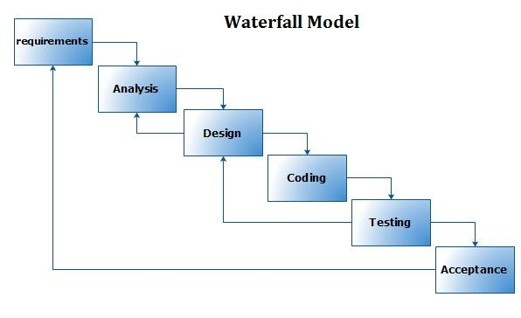

- Spiral Model:
Spiral model overcomes the cons of waterfall model by adding risk analysis to its phase and these phases are iteratively followed by one after another in order to avoid maximum risk during software development. By Iteratively followed means that task move through four processes many times until quality ensured.

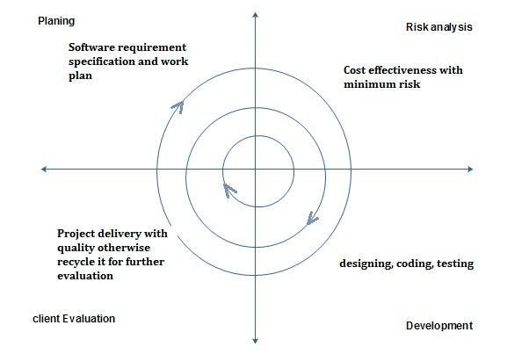

- Combination of waterfall and spiral model:
Combination of both waterfall and spiral model is called hybrid approach of system development that maximize the quality of system and minimize the disadvantages and risk.
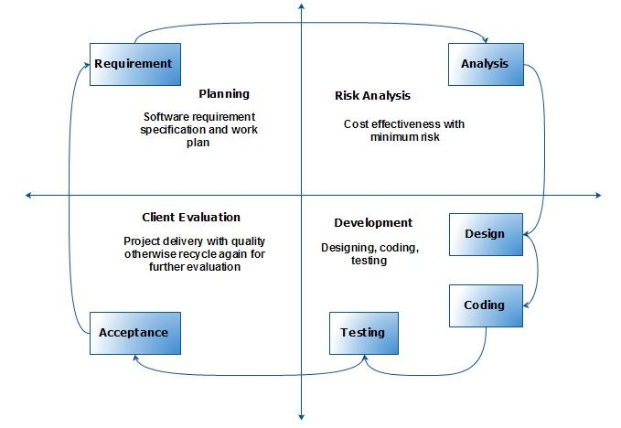

- Work Plan (Use MS Project to create Schedule/Work Plan)

Days
