AI-Powered Customer Churn Prediction
& Retention Analytics
AICTE | IBM SkillsBuild Data Analytics with AI Internship 2026

Student: Priyanshu Raj

Dataset: Telco Customer Churn
Source: IBM Sample Data, distributed via Kaggle
URL: https://www.kaggle.com/datasets/blastchar/telco-customer-churn

Run command:
python -m streamlit run PriyanshuRaj_CustomerChurnAnalytics.py

1. Executive Summary
This report documents the AI-Powered Customer Churn Prediction & Retention Analytics project, developed for the AICTE | IBM SkillsBuild Data Analytics with AI Internship 2026 by student Priyanshu Raj. The project analyses the IBM Telco Customer Churn dataset (7,043 customers, 21 features) to understand churn patterns and build predictive models.
The overall churn rate is 26.54% (1,869 churned out of 7,043 customers). Three scikit-learn classifiers were trained and evaluated on a held-out test set (20%). Logistic Regression achieved the highest ROC-AUC among the evaluated models (84.18%), followed by Gradient Boosting (83.85%) and Random Forest (82.22%). An interactive 8-page Streamlit dashboard delivers churn analysis, prediction, feature importance, and automated AI-based insights.
Metric | Value
Total Customers | 7,043
Churned Customers | 1,869 (26.54%)
Retained Customers | 5,174 (73.46%)
Best Model | Logistic Regression
Best ROC-AUC | 84.18%
Best F1-Score | 60.61%
Best Accuracy | 80.62%

2. Problem Statement
"Can customer account, service, billing, and usage characteristics be analysed to understand churn patterns and build a machine-learning model that predicts whether a customer is likely to churn?"
Customer churn — the loss of customers to competitors or cancellation — represents a significant business challenge. Acquiring new customers costs substantially more than retaining existing ones. This project addresses the churn prediction problem through a combination of exploratory data analysis, feature engineering, supervised machine learning, and model interpretability, delivered through an interactive dashboard.

3. Objectives
- Inspect and clean the Telco Customer Churn dataset without modifying the raw file.
- Perform comprehensive EDA to identify patterns associated with churn.
- Engineer meaningful derived features to improve model performance.
- Calculate dynamic KPIs (churn rate, average tenure, charges, etc.).
- Train and evaluate Logistic Regression, Random Forest, and Gradient Boosting classifiers.
- Interpret model behaviour via feature importance (coefficients and built-in importances).
- Generate automated AI-based analytical insights derived entirely from computed results.
- Deliver an interactive Streamlit dashboard with 8 pages, sidebar filters, and a prediction form.

4. Dataset Overview
Property | Value
Dataset Name | WA_Fn-UseC_-Telco-Customer-Churn.csv
Source | IBM Sample Data, distributed via Kaggle
URL | https://www.kaggle.com/datasets/blastchar/telco-customer-churn
Rows | 7,043
Columns | 21
Target Column | Churn (Yes / No)
Dataset Grain | One row = one unique telecom customer account
Class Balance | No (Retained): 73.46% | Yes (Churned): 26.54%

5. Data Dictionary
Column | Type | Description | Example Values | Role
customerID | str | Unique customer ID | 7590-VHVEG | Identifier — dropped before ML
gender | str | Customer gender | Male, Female | Feature
SeniorCitizen | int → str | Senior citizen (0/1 → No/Yes after cleaning) | 0, 1 | Feature
Partner | str | Has a partner | Yes, No | Feature
Dependents | str | Has dependents | Yes, No | Feature
tenure | int64 | Months with company (range: 0–72) | 1, 34, 72 | Key Feature
PhoneService | str | Has phone service | Yes, No | Feature
MultipleLines | str | Multiple phone lines | Yes, No, No phone service | Feature
InternetService | str | Internet service type | DSL, Fiber optic, No | Key Feature
OnlineSecurity | str | Online security add-on | Yes, No, No internet service | Feature
OnlineBackup | str | Online backup add-on | Yes, No, No internet service | Feature
DeviceProtection | str | Device protection add-on | Yes, No, No internet service | Feature
TechSupport | str | Tech support add-on | Yes, No, No internet service | Feature
StreamingTV | str | Streaming TV add-on | Yes, No, No internet service | Feature
StreamingMovies | str | Streaming movies add-on | Yes, No, No internet service | Feature
Contract | str | Contract term type | Month-to-month, One year, Two year | Key Feature
PaperlessBilling | str | Uses paperless billing | Yes, No | Feature
PaymentMethod | str | Payment method (4 types) | Electronic check, … | Key Feature
MonthlyCharges | float64 | Monthly bill in USD (18.25–118.75) | 29.85, 70.35 | Key Feature
TotalCharges | str → float64 | Total billed to date; 11 blanks (tenure=0) | 29.85, 1889.50 | Feature
Churn | str | TARGET: did customer churn? | Yes=26.54%, No=73.46% | Target Variable

6. Data Quality Assessment
Issue | Detail | Rows Affected
No true null (NaN) values | pandas isnull().sum() = 0 | 0
TotalCharges stored as string | Loaded as str dtype due to blank entries | 7,043
Blank TotalCharges entries | 11 rows with tenure=0 have empty TotalCharges strings | 11
SeniorCitizen as integer 0/1 | Other binary columns use Yes/No strings | 7,043
customerID — identifier only | No predictive value; must be dropped before ML | 7,043
Duplicate rows (raw, exact) | 0 exact duplicates in the raw file | 0
Feature-level duplicates post-drop | 22 rows share identical feature values — real customers | 22

7. Data Cleaning
All cleaning was performed on a copy of the raw file. The original CSV was never modified.
Step | Problem | Method | Result
1 | Whitespace in string columns | str.strip() on all object columns | Silent category mismatches prevented
2 | TotalCharges as str with 11 blanks | pd.to_numeric(errors='coerce'); NaN filled with 0.0 | TotalCharges now float64; 11 blanks = 0.0
3 | SeniorCitizen as int 0/1 | Map {0:'No', 1:'Yes'} | Consistent Yes/No encoding
4 | customerID — unique identifier | Drop column | Prevents data leakage; removed from processed dataset

Post-cleaning: 7,043 rows | 20 columns | 0 null values | TotalCharges = float64 | SeniorCitizen = Yes/No strings

8. Feature Engineering
Six new features were derived from existing columns. Each is justified below.
Feature | Formula / Logic | Purpose | Used In
TenureGroup | Bins: 0-12, 13-24, 25-48, 49-72 months | Segment customers by lifecycle stage | EDA
ChargeBand | Bins: Low(<35), Medium(35-65), High(65-90), Very High(>90) | Segment customers by billing tier | EDA
ServiceCount | Count of 6 internet add-on subscriptions = Yes | Capture service adoption breadth | ML + EDA
HasPhone | 1 if PhoneService=Yes, else 0 | Binary internet/phone flag for model | ML
HasInternet | 1 if InternetService != 'No', else 0 | Binary internet flag for model | ML
ChargePerTenure | TotalCharges / tenure (or MonthlyCharges if tenure=0) | Average monthly spend over customer lifetime | ML

9. Exploratory Data Analysis

9.1 Churn Target Distribution
Total customers: 7,043 | Churned: 1,869 (26.54%) | Retained: 5,174 (73.46%). The dataset is moderately imbalanced (~73/27). Stratified splitting and ROC-AUC as the primary evaluation metric were used to address class imbalance.
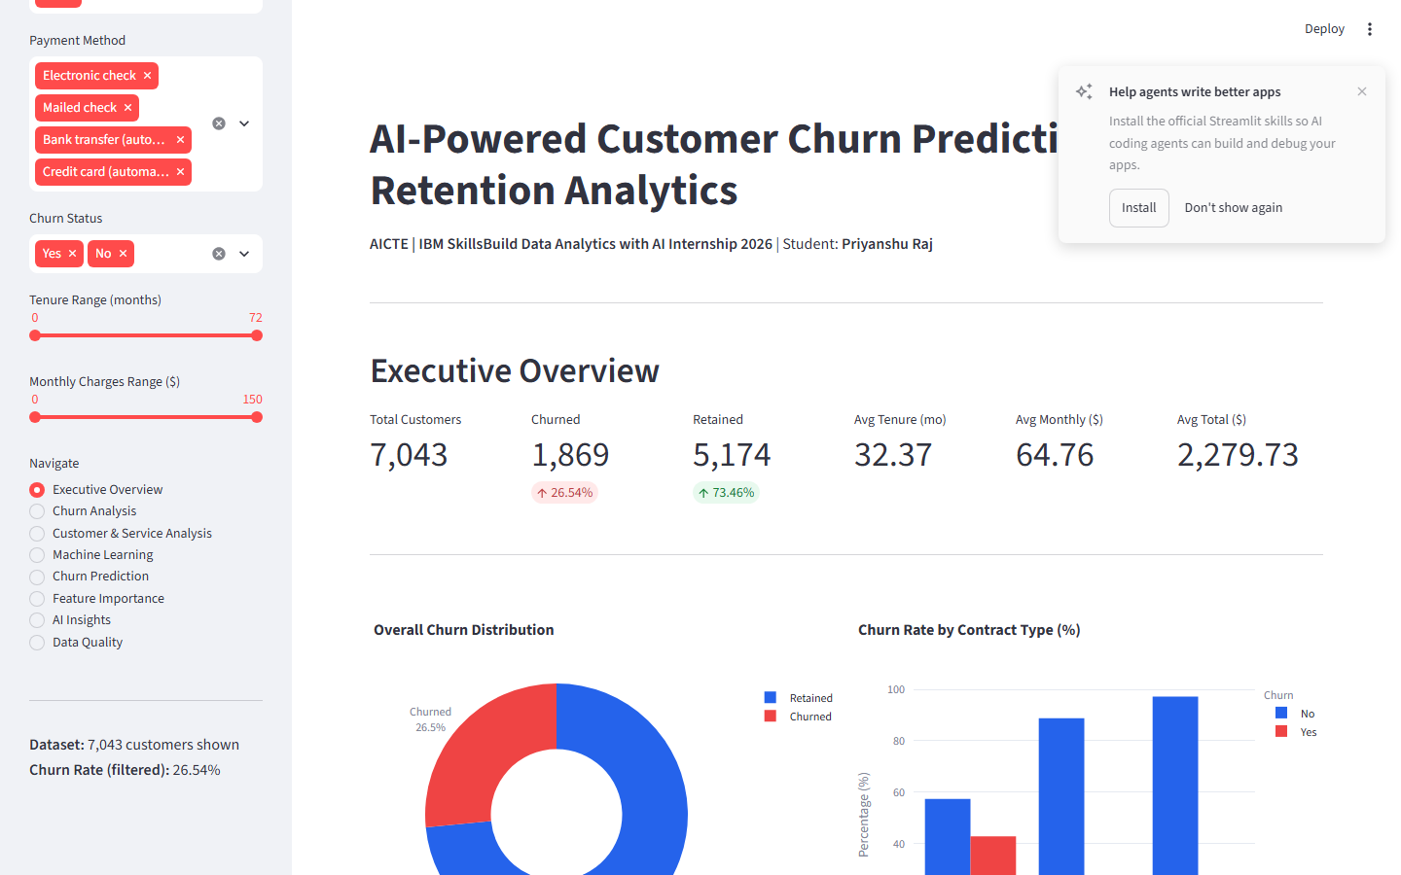
Figure 1 — Executive Overview: Churn distribution, contract analysis, tenure group, monthly charges

9.2 Churn by Contract Type
Month-to-month contracts show the highest observed churn rate (42.71%), compared with One-year (11.27%) and Two-year (2.83%) contracts. This is the strongest single-variable association observed in the dataset.
Contract Type | Observed Churn Rate (%)
Month-to-month | 42.71
One year | 11.27
Two year | 2.83

9.3 Churn by Tenure Group
Tenure Group | Observed Churn Rate (%)
0-12 mo | 47.44
13-24 mo | 28.71
25-48 mo | 20.39
49-72 mo | 9.51

The 0-12 month group shows the highest observed churn rate (47.44%). Churn declines consistently with tenure, with long-tenure customers (49-72 mo) showing only 9.51% observed churn.

9.4 Churn by Internet Service
Internet Service | Observed Churn Rate (%)
DSL | 18.96
Fiber optic | 41.89
No | 7.40

Fiber optic customers show a notably higher observed churn rate (41.89%) compared with DSL (18.96%) and no internet (7.40%). This association may warrant further investigation.

9.5 Churn by Payment Method
Payment Method | Observed Churn Rate (%)
Bank transfer (automatic) | 16.71
Credit card (automatic) | 15.24
Electronic check | 45.29
Mailed check | 19.11

9.6 Churn by Demographics
Variable | Value | Observed Churn Rate (%)
SeniorCitizen | Yes | 41.68
SeniorCitizen | No | 23.61
Partner | No | 32.96
Partner | Yes | 19.66
Dependents | No | 31.28
Dependents | Yes | 15.45

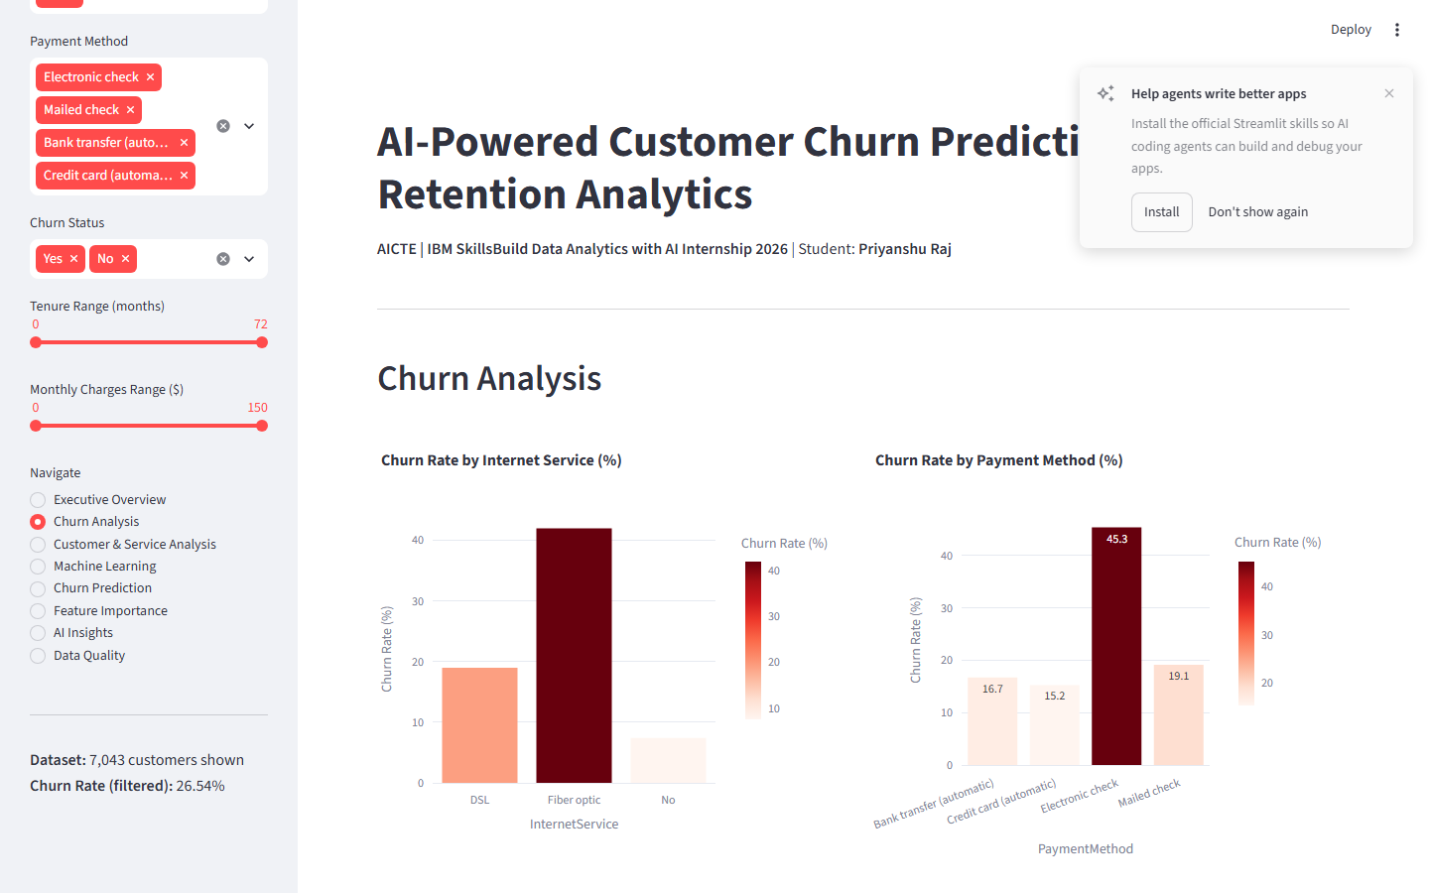
Figure 2 — Churn Analysis page: Churn by internet service, payment method, senior citizen, paperless billing
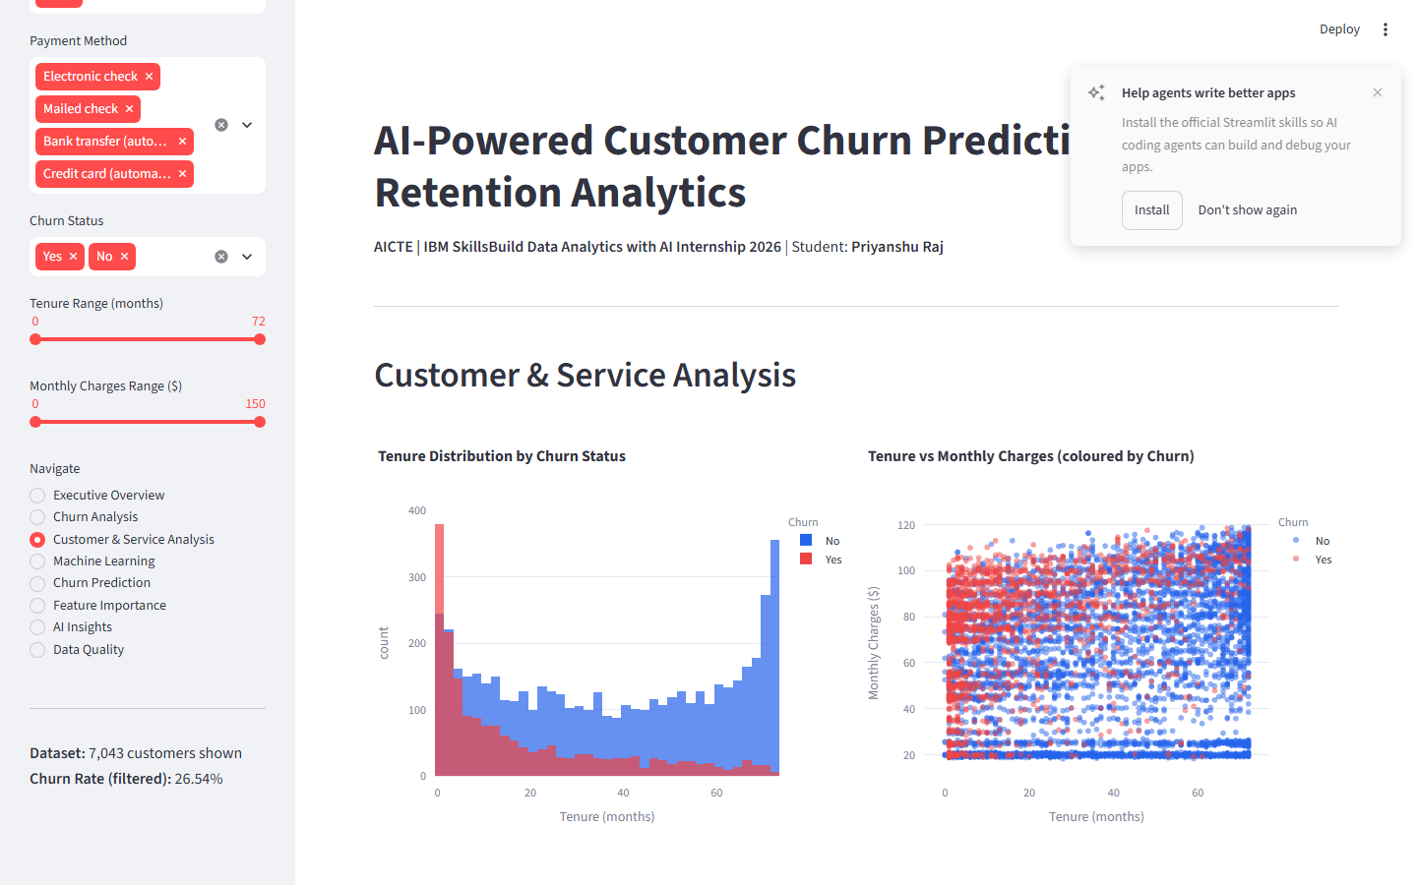
Figure 3 — Customer & Service Analysis: Tenure distribution, charges, service subscription count

10. KPI Analysis
All KPIs are dynamically computed from the cleaned dataset at runtime.
KPI | Actual Computed Value
Total Customers | 7,043
Churned Customers | 1,869
Retained Customers | 5,174
Churn Rate | 26.54%
Retention Rate | 73.46%
Average Tenure (all customers) | 32.37 months
Average Tenure (churned) | 17.98 months
Average Tenure (retained) | 37.57 months
Average Monthly Charges (all) | $64.76
Average Monthly Charges (churned) | $74.44
Average Monthly Charges (retained) | $61.27
Average Total Charges (all) | $2,279.73
Average Total Charges (churned) | $1,531.80
Average Total Charges (retained) | $2,549.91

11. Machine Learning Methodology

11.1 Feature Set
Total features used for training: 23 (7 numeric, 16 categorical). customerID was excluded (identifier). TenureGroup and ChargeBand were excluded (categorical bins redundant with their numeric sources in tree models).
Type | Features
Numeric (7) | tenure, MonthlyCharges, TotalCharges, ServiceCount, HasPhone, HasInternet, ChargePerTenure
Categorical (16) | gender, SeniorCitizen, Partner, Dependents, PhoneService, MultipleLines, InternetService, OnlineSecurity, OnlineBackup, DeviceProtection, TechSupport, StreamingTV, StreamingMovies, Contract, PaperlessBilling, PaymentMethod

11.2 Preprocessing Pipeline
- StandardScaler applied to all 7 numeric features (zero mean, unit variance).
- OneHotEncoder(handle_unknown='ignore') applied to all 16 categorical features.
- Both transformers wrapped in a single ColumnTransformer.
- ColumnTransformer embedded in a sklearn Pipeline with each classifier — prevents data leakage between train and test.
- The same Pipeline object is used for both training and all predictions.

11.3 Train / Test Split
Parameter | Value
Split ratio | 80% train / 20% test
Stratification | Yes — on target (Churn) to preserve 26.54% / 73.46% ratio
Random state | 42 (fixed for full reproducibility)
Training samples | 5,634
Test samples | 1,409

11.4 Models Trained
Model | Key Hyperparameters
Logistic Regression | max_iter=1000, random_state=42, C=1.0 (default)
Random Forest | n_estimators=200, random_state=42 (all other defaults)
Gradient Boosting | n_estimators=200, random_state=42 (all other defaults)

12. Model Evaluation
ROC-AUC was selected as the primary evaluation metric because: (1) the dataset is class-imbalanced (26.54% churn); (2) raw accuracy is misleading under imbalance; (3) ROC-AUC measures the model's ability to rank churn risk regardless of threshold.

12.1 Model Comparison (actual computed, held-out test set)
Model | Accuracy % | Precision % | Recall % | F1 % | ROC-AUC %
Logistic Regression | 80.62 | 65.83 | 56.15 | 60.61 | 84.18 ★
Random Forest | 78.64 | 62.54 | 48.66 | 54.74 | 82.22
Gradient Boosting | 79.35 | 64.26 | 50.0 | 56.24 | 83.85

★ Best model by ROC-AUC

12.2 Confusion Matrices (Logistic Regression — best model)
 | Predicted: No Churn | Predicted: Churn
Actual: No Churn | TN = 926 | FP = 109
Actual: Churn | FN = 164 | TP = 210

12.3 All Confusion Matrices
Logistic Regression
 | Pred: No Churn | Pred: Churn
True: No Churn | TN=926 | FP=109
True: Churn | FN=164 | TP=210

Random Forest
 | Pred: No Churn | Pred: Churn
True: No Churn | TN=926 | FP=109
True: Churn | FN=192 | TP=182

Gradient Boosting
 | Pred: No Churn | Pred: Churn
True: No Churn | TN=931 | FP=104
True: Churn | FN=187 | TP=187

12.4 Classification Reports
Logistic Regression
precision recall f1-score support
No Churn 0.85 0.89 0.87 1035
Churn 0.66 0.56 0.61 374
accuracy 0.81 1409
macro avg 0.75 0.73 0.74 1409
weighted avg 0.80 0.81 0.80 1409
Random Forest
precision recall f1-score support
No Churn 0.83 0.89 0.86 1035
Churn 0.63 0.49 0.55 374
accuracy 0.79 1409
macro avg 0.73 0.69 0.70 1409
weighted avg 0.77 0.79 0.78 1409
Gradient Boosting
precision recall f1-score support
No Churn 0.83 0.90 0.86 1035
Churn 0.64 0.50 0.56 374
accuracy 0.79 1409
macro avg 0.74 0.70 0.71 1409
weighted avg 0.78 0.79 0.78 1409
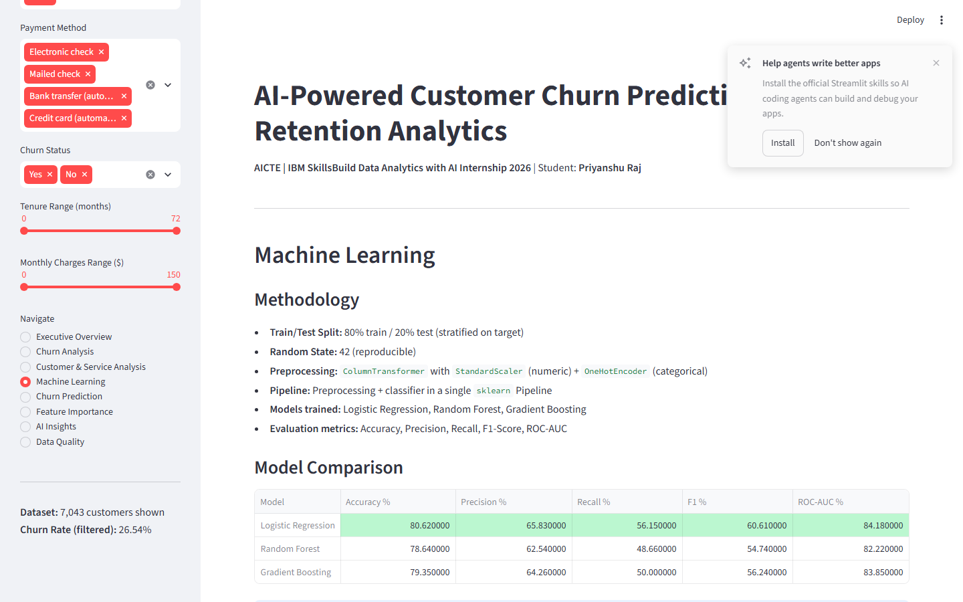
Figure 4 — Machine Learning page: Model comparison table and ROC curves

13. Feature Importance & Interpretability
Feature importance indicates each feature's predictive contribution to a given model. For Logistic Regression, absolute values of standardised coefficients are used. For Random Forest and Gradient Boosting, built-in feature_importances_ (mean decrease in impurity) are used. IMPORTANT: Feature importance reflects statistical association within the model — it does NOT establish causal relationships.

13.1 Logistic Regression — Top 10 Features
Feature | Importance Score
tenure | 1.228939
Contract_Two year | 0.748980
MonthlyCharges | 0.720614
InternetService_DSL | 0.712671
InternetService_Fiber optic | 0.647342
Contract_Month-to-month | 0.592746
TotalCharges | 0.501642
HasInternet | 0.342304
PaperlessBilling_No | 0.317011
MultipleLines_No | 0.304906

13.2 Random Forest — Top 10 Features
Feature | Importance Score
TotalCharges | 0.131792
tenure | 0.117412
ChargePerTenure | 0.110339
MonthlyCharges | 0.108593
Contract_Month-to-month | 0.058853
OnlineSecurity_No | 0.030611
PaymentMethod_Electronic check | 0.026412
ServiceCount | 0.025031
TechSupport_No | 0.023132
InternetService_Fiber optic | 0.022305

13.3 Gradient Boosting — Top 10 Features
Feature | Importance Score
Contract_Month-to-month | 0.337064
tenure | 0.123827
TotalCharges | 0.109564
InternetService_Fiber optic | 0.077634
ChargePerTenure | 0.074048
MonthlyCharges | 0.066425
OnlineSecurity_No | 0.062664
PaymentMethod_Electronic check | 0.038053
TechSupport_No | 0.034660
PaperlessBilling_Yes | 0.009853

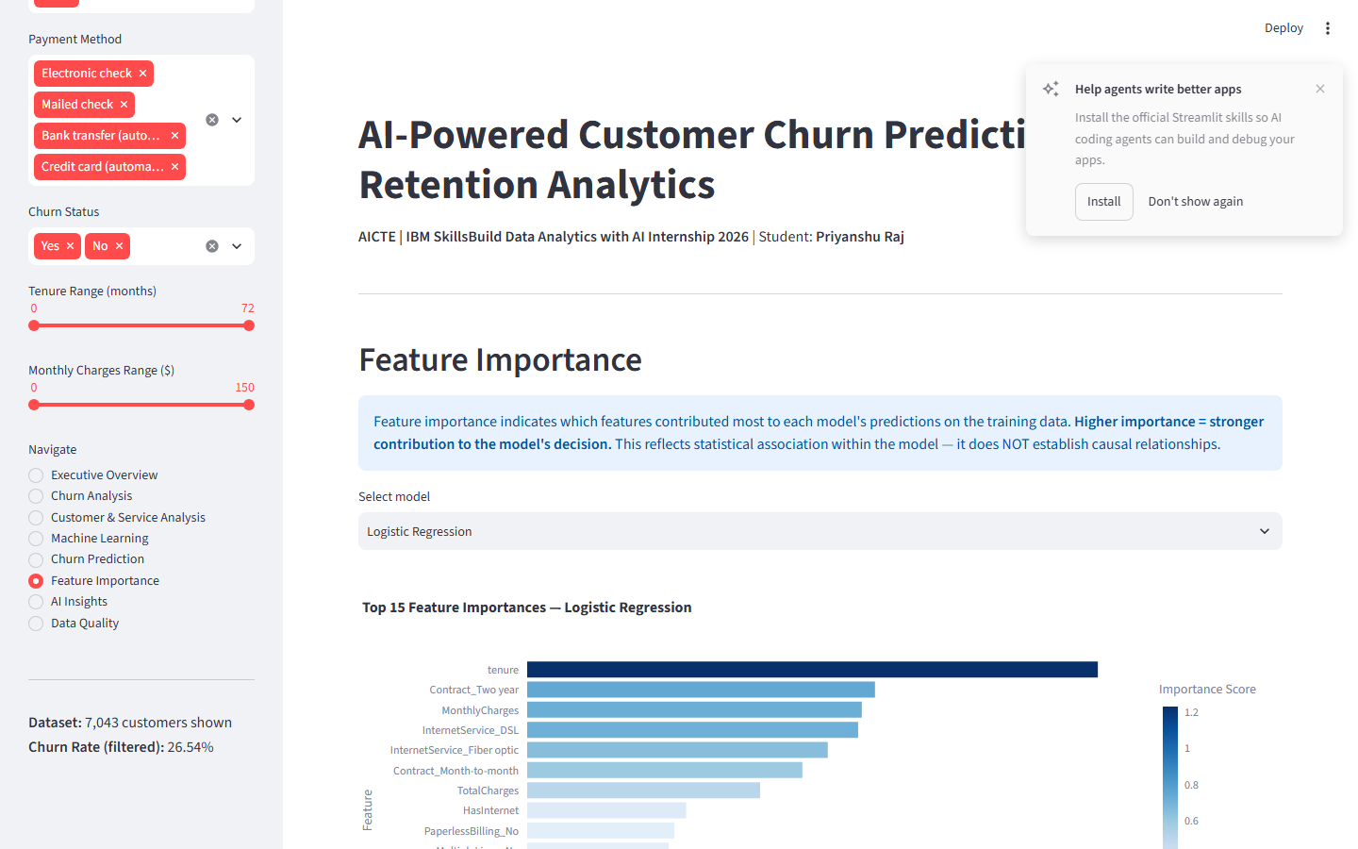
Figure 5 — Feature Importance page: Top 15 features with importance scores

14. Churn Prediction
The Streamlit dashboard includes an interactive Churn Prediction page. Users input customer characteristics through a form. The trained pipeline applies the same preprocessing used during training and outputs:
- Predicted Churn Class: Yes (Likely to Churn) or No (Likely to Stay)
- Model-predicted churn probability (%)
- A probability gauge chart (green 0-30%, yellow 30-60%, red 60-100%)
Disclaimer displayed to users: 'Predictions are probabilistic estimates based on patterns learned from training data. They are NOT guaranteed outcomes. Always combine model outputs with domain knowledge before making business decisions.'
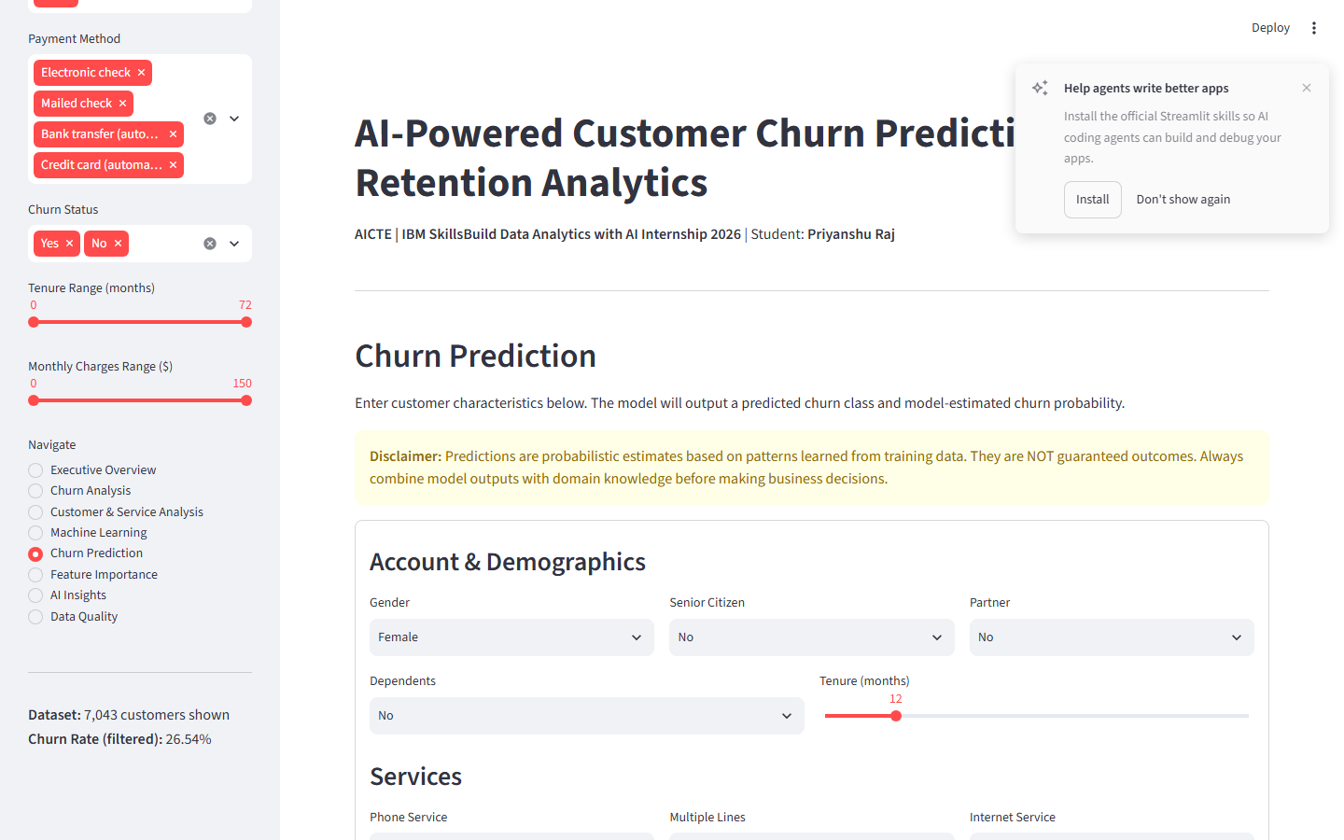
Figure 6 — Churn Prediction page: Interactive input form with probability gauge

15. AI-Based Analytical Insights
Automated insights are generated programmatically from actual computed values (churn rates, KPIs, model metrics, segment comparisons). No external AI API or LLM is used. All statements use associative language ('associated with', 'observed higher churn', 'the model identified') to avoid causal claims.
Example insights generated at runtime:
- Customers on 'Month-to-month' contracts show a churn rate of 42.7%, compared with 2.8% for 'Two year' contracts.
- Churned customers have an average tenure of 17.98 months, compared with 37.57 months for retained customers.
- Churned customers have an average monthly charge of $74.44, compared with $61.27 for retained customers.
- Logistic Regression achieved the highest ROC-AUC of 84.18% on the held-out test set.
- Fiber optic internet customers show an observed churn rate of 41.9%, higher than DSL (19.0%).
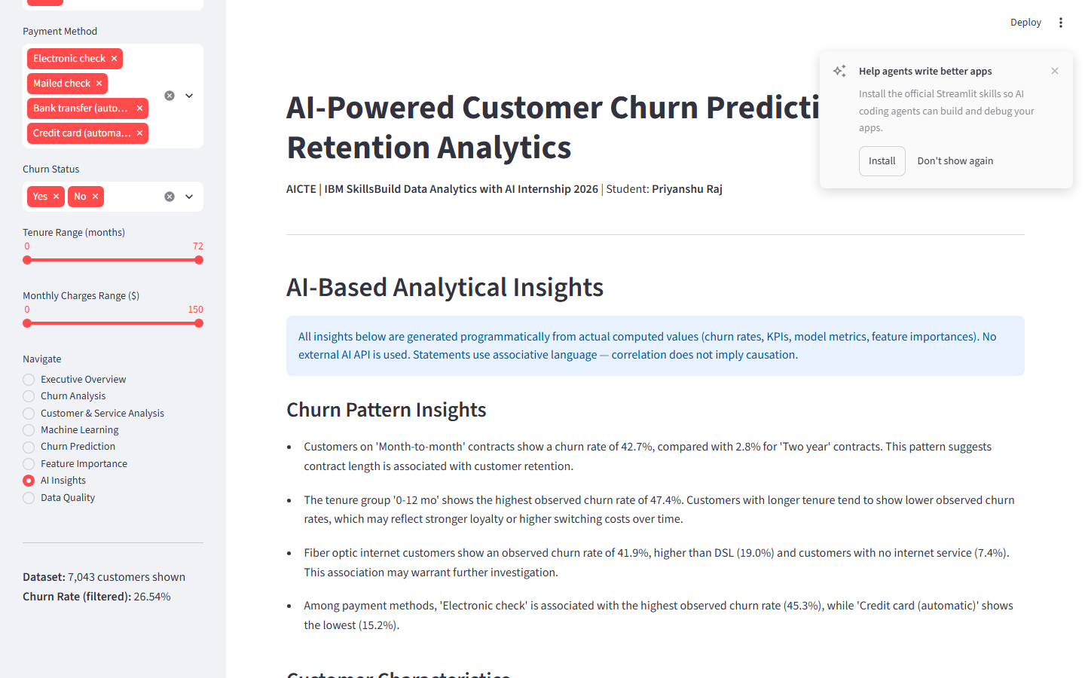
Figure 7 — AI Insights page: Automated analytical insights by category

16. Streamlit Dashboard
Run command: python -m streamlit run PriyanshuRaj_CustomerChurnAnalytics.py
URL: http://localhost:8501
Viewport: 1440×900 (tested)
The dashboard has 8 pages navigable via a sidebar radio selector. Sidebar filters (Contract, Internet Service, Payment Method, Churn Status, Tenure Range, Monthly Charges Range) update KPIs and charts dynamically on all analysis pages.
Page | Key Content
1. Executive Overview | 6 KPI cards, churn donut, contract/tenure charts, key observations
2. Churn Analysis | Churn by internet, payment, senior citizen, paperless billing, service table
3. Customer & Service Analysis | Tenure histogram, scatter plot, charges by tenure group, service count
4. Machine Learning | Model comparison table, confusion matrices, ROC curves, classification report
5. Churn Prediction | Interactive input form, predicted class, probability gauge, disclaimer
6. Feature Importance | Top-15 features per model, model selector, full importance table
7. AI Insights | 4 insight categories generated from actual computed values
8. Data Quality | Before/after cleaning KPIs, cleaning steps, target distribution, raw data sample

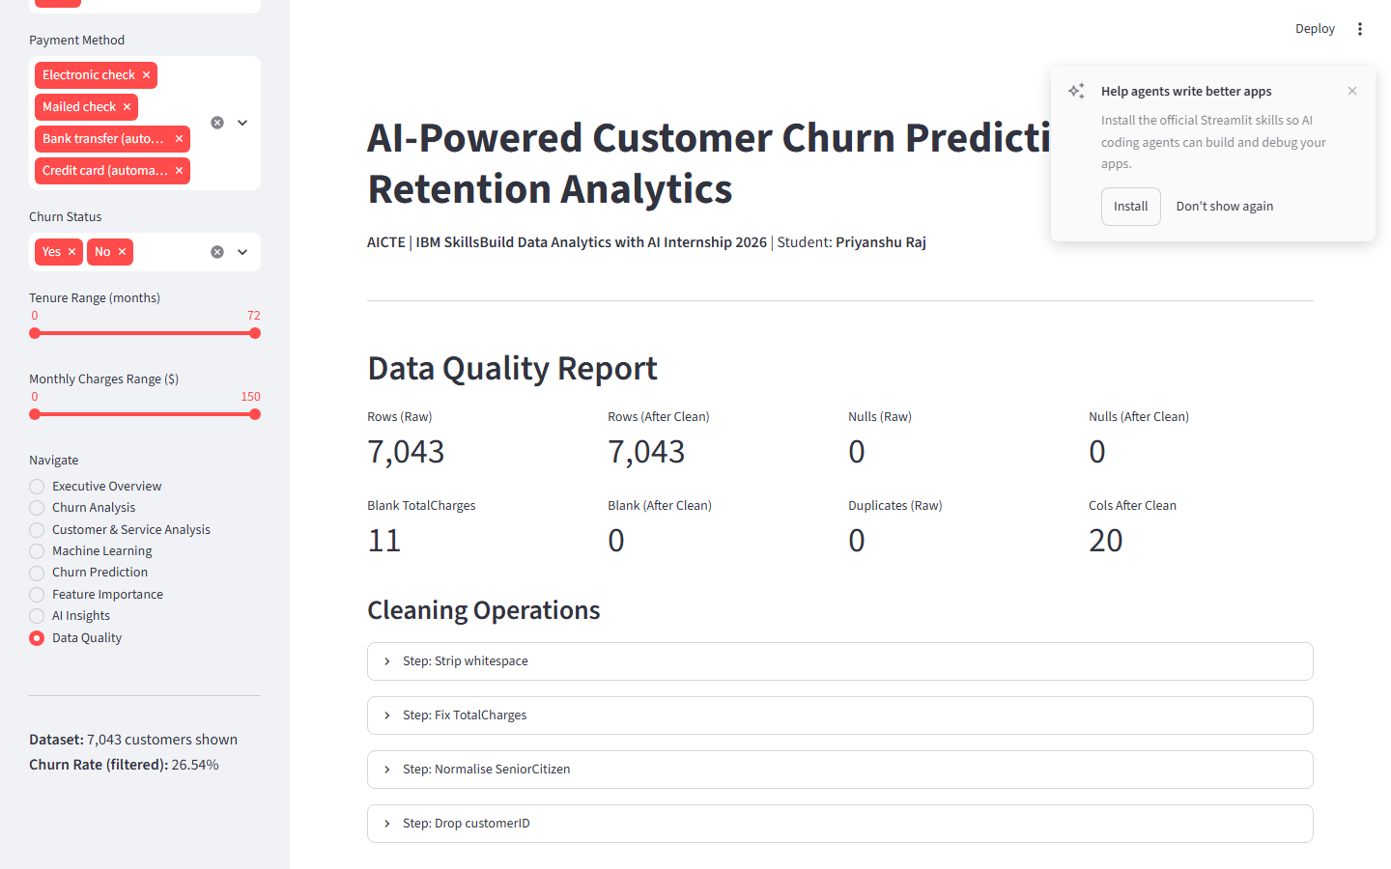
Figure 8 — Data Quality page: Cleaning summary and target distribution

17. Key Findings
- Overall churn rate: 26.54% (1,869 out of 7,043 customers).
- Month-to-month contract customers show the highest observed churn rate (42.71%), vs 2.83% for two-year contracts.
- Tenure 0-12 months is associated with the highest observed churn (47.44%). Average tenure: churned = 17.98 mo, retained = 37.57 mo.
- Churned customers have a higher average monthly charge ($74.44) vs retained ($61.27), a difference of $13.17.
- Fiber optic internet is associated with 41.89% observed churn, vs 18.96% for DSL.
- Electronic check payment is associated with 45.29% observed churn, the highest of all payment methods.
- Senior citizens show a higher observed churn rate (41.68%) than non-seniors (23.61%).
- Best model: Logistic Regression — ROC-AUC 84.18%, F1 60.61%, Accuracy 80.62%.
- Across all models, Contract_Month-to-month, tenure, and MonthlyCharges consistently rank among the top features.

18. Business Insights & Recommendations
All recommendations are based on observed associations. Correlation does not imply causation. Business decisions should incorporate domain knowledge and controlled experiments.
Finding | Evidence | Possible Action
Short-tenure customers show higher observed churn | 0-12 mo group: 47.4% churn rate | Early engagement and onboarding programs may be worth evaluating
Month-to-month contracts associated with higher churn | 42.7% vs 2.8% for two-year | Incentives to upgrade to annual/two-year contracts
Electronic check associated with higher churn | 45.3% vs ~15-17% for automatic methods | Encourage migration to automatic payment methods
Fiber optic customers show higher observed churn | 41.9% vs 19.0% for DSL | Investigate service quality and pricing for fibre tier
Customers without add-on services show higher churn | Lower ServiceCount associated with higher churn | Evaluate value proposition of security/support bundles

19. Technical Architecture
Component | Technology | Purpose
Language | Python 3.10+ | Core development language
Data Processing | pandas 2.0+, numpy 1.24+ | Loading, cleaning, feature engineering
Machine Learning | scikit-learn 1.3+ | Preprocessing pipeline, models, evaluation
Visualisation | Plotly 5.18+ | Interactive charts in dashboard
Dashboard Framework | Streamlit 1.32+ | Web app and user interface
Report Generation | python-docx 1.1+ | This DOCX report
Path Management | pathlib (stdlib) | Cross-platform relative paths
Reproducibility | random_state=42 | Fixed seed for all models
Screenshot Capture | Playwright 1.63+ | Automated headless browser capture

No external APIs, paid services, or hardcoded local paths are used. The project is fully self-contained and GitHub-compatible.

20. Project Workflow
- 1. Raw CSV loaded → data quality inspection
- 2. Cleaning: whitespace strip, TotalCharges cast, SeniorCitizen normalised, customerID dropped
- 3. Processed CSV saved to data/processed/
- 4. Feature engineering: 6 derived features added
- 5. KPI calculation: 14 dynamic KPIs computed
- 6. EDA: segment churn rates computed for all key variables
- 7. ML preprocessing: ColumnTransformer (StandardScaler + OneHotEncoder)
- 8. Train/test split: 80/20, stratified, random_state=42
- 9. Three classifiers trained: Logistic Regression, Random Forest, Gradient Boosting
- 10. Evaluation: Accuracy, Precision, Recall, F1, ROC-AUC, Confusion Matrix, ROC Curve
- 11. Feature importance extracted for all three models
- 12. AI-based insights generated from actual computed values
- 13. Streamlit dashboard served at localhost:8501
- 14. Churn prediction: interactive form with same pipeline as training

21. Limitations
- The dataset is a single snapshot in time; no temporal sequence is modelled.
- Observed associations do not imply causation. All EDA findings use associative language.
- Model performance is bounded by the features available in the dataset. External factors (competitor pricing, service quality, network outages) are not captured.
- Predictions are probabilistic estimates and should not be the sole basis for retention decisions.
- Class imbalance (26.54% churn) means recall for churned customers is lower than overall accuracy suggests.
- Feature importance from tree models reflects training-data patterns and may not generalise to new data distributions.

22. Future Scope
- Incorporate SHAP (SHapley Additive exPlanations) for per-prediction explainability.
- Experiment with XGBoost and LightGBM classifiers.
- Add time-series churn modelling if longitudinal customer data becomes available.
- Implement SMOTE or class-weighting to improve recall on the minority class.
- Deploy as a cloud-hosted Streamlit app (e.g., Streamlit Community Cloud).
- Add automated model retraining triggers when data distribution drifts.
- Integrate a customer segmentation layer (e.g., k-means) for targeted retention campaigns.

23. Conclusion
This project successfully demonstrates the application of data analytics and machine learning to the customer churn prediction problem using the IBM Telco dataset. The overall churn rate of 26.54% (1,869 customers) represents a meaningful retention challenge. Through rigorous EDA, systematic feature engineering, and evaluation of three classifiers, Logistic Regression achieved the highest ROC-AUC among the evaluated models (84.18% on the held-out test set). Month-to-month contracts, short tenure, Fiber optic internet, and electronic check payment were consistently associated with higher observed churn across EDA and model interpretability analysis. The interactive Streamlit dashboard makes these findings accessible and actionable, while the automated AI-based insights layer provides clear, evidence-backed summaries. All findings are grounded in actual computed values — no statistics were invented.

24. How to Run the Project
Step | Action
1 | Download dataset from https://www.kaggle.com/datasets/blastchar/telco-customer-churn
2 | Place CSV at: PriyanshuRaj_CustomerChurnAnalytics/data/raw/WA_Fn-UseC_-Telco-Customer-Churn.csv
3 | Install dependencies: pip install -r requirements.txt
4 | Run dashboard: python -m streamlit run PriyanshuRaj_CustomerChurnAnalytics.py
5 | Open browser at: http://localhost:8501
6 | Processed data and ML models are generated automatically on first run (cached)

25. References
[1] IBM Telco Customer Churn dataset. Kaggle. https://www.kaggle.com/datasets/blastchar/telco-customer-churn
[2] Pedregosa et al. scikit-learn: Machine Learning in Python. JMLR 12, pp. 2825-2830, 2011.
[3] Streamlit documentation. https://docs.streamlit.io
[4] Plotly Python graphing library. https://plotly.com/python
[5] python-docx documentation. https://python-docx.readthedocs.io
[6] AICTE | IBM SkillsBuild Data Analytics with AI Internship 2026.

