Report: Optimising NYC Taxi Operations

Include your visualisations, analysis, results, insights, and outcomes. Explain your methodology and approach to the tasks. Add your conclusions to the sections.

## Data Preparation

* 1. Loading the dataset
     1. **Sample the data and combine the files**  
        - Loaded the dataset of NYC taxi which is in Parquet format
* Then I sampled the dataset based on the sampling frequency which I

Have taken 0.007 after doing the sampling total records are between 2.5lakhs to 3 lakhs record

* After sampling it I have saved the final dataset in Parquet format
* Then load that sampled dataset for the analysis.

## Data Cleaning

### Fixing Columns

* + 1. **Fix the index**  
       - I cleaned the loaded sampled dataset by fixing the index by running reset_index of pandas dataframe.
* Then I analysed what all columns are having Nan values .
* After analysing the nan values I try to impute the nan values with appropriate values by taking median of the column   
  + 1. **Combine the two airport_fee columns**- In the dataset I had two columns of airport_fee and Airport_fee which I tried to combine, I combined is using combined_first function available in pandas

### Handling Missing Values

* + 1. **Find the proportion of missing values in each column**
* In the dataset I find the proportion of missing values by taking the sum and dividing by its length and multiplying it with 100 to get the percentage of proportion.

* + 1. **Handling missing values in passenger_count**

- Handles the missing values in passenger_count by imputing the median of the passenger_count.

* + 1. **Handle missing values in RatecodeID**  
       - Handled the RatecodeID with imputing median values of the column
    2. **Impute NaN in congestion_surcharge**- Imputed the congestion_surcharge with median values of the column

### Handling Outliers and Standardising Values

* + 1. **Check outliers in payment type, trip distance and tip amount columns**- I handled the outliers in passenger_count by removing the passenger count with more than 7 passengers because the count of passenger for 7 and above is very small.
* Handled the outliers for trip_distance and fare_amount where trip_amount should not be zero and fare_amount should not be more than 300.
* Also filtered out the data based on trip_distance and fare_amount is not zero also the pickup and drop is not the same .
* Filtered out trip_distance more than 250 and also if the payment type is 0
* Filtered out where passenger count is 0 and fare amount is more than 0
* Filtered out where toll amount is more than 0 and trip distance is 0.
* Also filtered out where total amount is less than 0

## Exploratory Data Analysis

### General EDA: Finding Patterns and Trends

1. I have categorised
2. * `VendorID`:Numerical
3. * `tpep_pickup_datetime`:Categorical
4. * `tpep_dropoff_datetime`:Categorical
5. * `passenger_count`:Numerical
6. * `trip_distance`:Numerical
7. * `RatecodeID`:Categorical
8. * `PULocationID`:Numerical
9. * `DOLocationID`:Numerical
10. * `payment_type`:Categorical
11. * `pickup_hour`:Numerical
12. * `trip_duration`:Numerical
13. The following monetary parameters belong in the same category, is it categorical or numerical?
14. * `fare_amount`:Numerical
15. * `extra`:Numerical
16. * `mta_tax`:Numerical
17. * `tip_amount`:Numerical
18. * `tolls_amount`:Numerical
19. * `improvement_surcharge`:Numerical
20. * `total_amount`:Numerical
21. * `congestion_surcharge`:Numerical
22. * `airport_fee`:Numerical
    * 1. **Analyse the distribution of taxi pickups by hours, days of the week, and monthsA graph of a taxi pickup

         AI-generated content may be incorrect.**
      2. **A line graph with blue dots

         AI-generated content may be incorrect.**
      3. **A graph of blue bars

         AI-generated content may be incorrect.**
      4. **A graph with blue lines and text

         AI-generated content may be incorrect.**
      5. **A graph of blue vertical lines

         AI-generated content may be incorrect.**
      6. **A graph with blue lines and numbers

         AI-generated content may be incorrect.**
      7. **Filter out the zero/negative values in fares, distance and tips  
         -** I filtered out zero and negative values for fares,distance and trips
      8. **Analyse the monthly revenue trends**A graph with blue lines and dots

         AI-generated content may be incorrect.

monthly_pickup total_amount

0 January 447053.59

1 February 427286.82

2 March 510144.45

3 April 491536.07

4 May 542807.50

5 June 511631.66

6 July 425437.44

7 August 416532.96

8 September 440402.75

9 October 553688.52

10 November 511470.62

11 December 496220.52

**Find the proportion of each quarter’s revenue in the yearly revenue**quater total_amount proportion

1 1384484.86 23.98%

2 1545975.23 26.77%

3 1282373.15 22.21%

4 1561379.66 27.04%

* + 1. **Analyse and visualise the relationship between distance and fare amount  
       A graph with blue dots

       AI-generated content may be incorrect.**
    2. **Analyse the relationship between fare/tips and trips/passengers  
       A graph with blue dots

       AI-generated content may be incorrect.**A graph of blue dots

       AI-generated content may be incorrect.A graph of a passenger count

       AI-generated content may be incorrect.
    3. **Analyse the distribution of different payment types  
       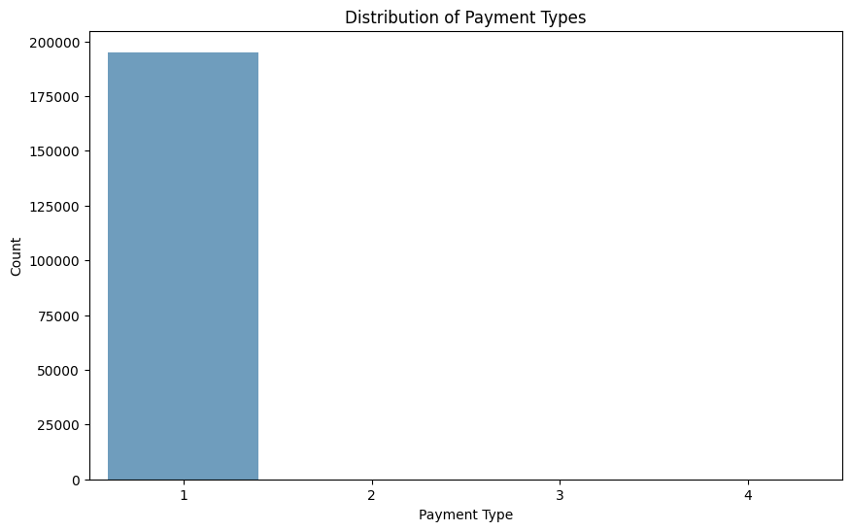**
    4. **Load the taxi zones shapefile and display it  
       A map of the united states

       AI-generated content may be incorrect.**
    5. **Merge the zone data with trips data**- Yes I have merged the trips data with zone data
    6. **Find the number of trips for each zone/location ID**
    7. 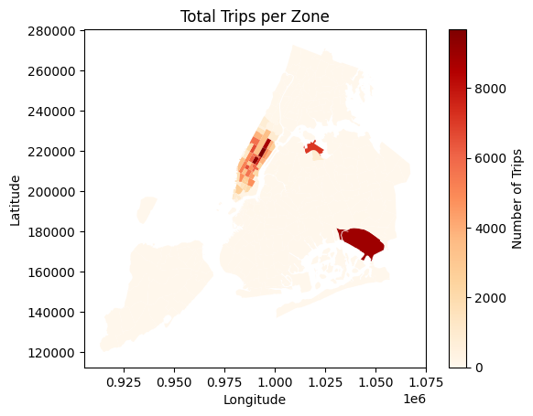
    8. **Add the number of trips for each zone to the zones dataframe  
       -** Yes I have added trips for each zone to the zones dataframe in the notebook
    9. **Plot a map of the zones showing number of trips  
         
       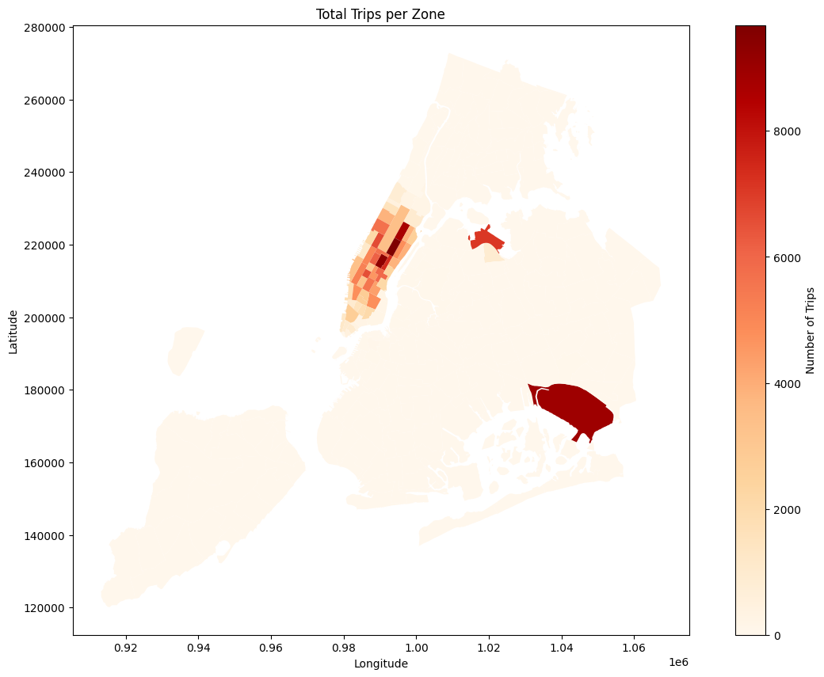**

**Conclude with results**## Findings from General analysis

1. Busiest Hours & Days

Analysis of the hourly trends shows that taxi pickups peak during rush hours (typically early morning and late afternoon/evening). Weekdays tend to have higher volumes compared to weekends, indicating commuter patterns dominate.

2. Monthly & Quarterly Trends in Revenue

The financial analysis reveals that revenue exhibits seasonal patterns with noticeable peaks in specific months. Quarterly aggregation shows varied revenue proportions with some quarters driving a higher share of the total revenue, likely reflecting seasonal tourism or commuter fluctuations.

3. Fare Dependence on Trip Attributes

- Trip Distance & Duration: There is a clear positive relationship where longer distances and durations result in higher fares.

- Passenger Count: While the fare generally scales with distance, trips with higher passenger counts may indicate shared rides or peak-time dynamics influencing pricing.

4. Tip Amount and Trip Distance

The correlation analysis suggests that longer trips tend to garner higher tip amounts. This could reflect both a higher base fare and the tendency for passengers to tip more on longer journeys.

5. Busiest Zones

The geographical analysis using the choropleth map of taxi zones (sorted by total trips) identifies key pickup areas with the highest trip density. These zones are typically located in commercial or transit hubs, highlighting urban centers of activity.



### Detailed EDA: Insights and Strategies

* + 1. **Identify slow routes by comparing average speeds on different routes**

1. PULocationID DOLocationID pickup_hours avg_duration avg_distance speed_mph
2. 34779 209 232 13 1431.883333 1.040000 0.043579
3. 30771 164 100 21 698.833333 0.790000 0.067827
4. 28547 162 114 11 1398.033333 2.910000 0.124890
5. 41206 234 256 18 1425.250000 3.220000 0.135555
6. 29612 163 87 15 38.550000 0.090000 0.140078
7. 12889 113 181 19 35.250000 0.090000 0.153191
8. 35950 229 41 17 1428.083333 4.160000 0.174780
9. 36347 229 145 16 703.366667 2.390000 0.203877
10. 12960 113 224 16 477.138889 1.866667 0.234732
11. 11726 107 148 20 411.676190 1.655714 0.241313

* + 1. **Calculate the hourly number of trips and identify the busy hours  
       A graph of a taxi trip

       AI-generated content may be incorrect.**
    2. **Scale up the number of trips from above to find the actual number of trips  
       A graph of blue bars

       AI-generated content may be incorrect.**

5 Busiest Hours and their estimated actual trip counts:

pickup_hours actual_trips

18 18 2.028571e+06

17 17 1.915000e+06

19 19 1.822000e+06

16 16 1.700000e+06

15 15 1.687286e+06

* + 2. **Compare hourly traffic on weekdays and weekends  
       A graph with lines and dots

       AI-generated content may be incorrect.**

**Identify the top 10 zones with high hourly pickups and drops**Top 10 Pickup Zones with the Highest Hourly Pickups:

zone total_pickups_hourly pickup_hours

1193 Midtown Center 821 18

1192 Midtown Center 818 17

1194 Midtown Center 695 19

1731 Upper East Side South 688 17

1730 Upper East Side South 666 16

1217 Midtown East 663 18

859 JFK Airport 659 22

1191 Midtown Center 656 16

1729 Upper East Side South 654 15

1732 Upper East Side South 649 18

----------------------------------------------

Top 10 Dropoff Zones with the Highest Hourly Dropoffs:

zone total_dropoff_hourly dropoff_hours

41386 Upper East Side South 131 15

41387 Upper East Side South 131 16

41388 Upper East Side South 121 17

41385 Upper East Side South 119 14

42277 Upper East Side North 116 15

41389 Upper East Side South 105 18

42273 Upper East Side North 105 11

42274 Upper East Side North 105 12

42280 Upper East Side North 103 18

41390 Upper East Side South 97 19



**Find the ratio of pickups and dropoffs in each zone**10 Highest Pickup/Dropoff Ratios:

zone pickup_dropoff_ratio

64 East Elmhurst 15.423729

119 JFK Airport 5.018100

125 LaGuardia Airport 2.921423

195 South Jamaica 1.571429

169 Penn Station/Madison Sq West 1.564966

40 Central Park 1.435289

229 West Village 1.388493

102 Greenwich Village South 1.358012

147 Midtown East 1.306399

92 Garment District 1.233844

------------------------------------

10 Lowest Pickup/Dropoff Ratios:

zone pickup_dropoff_ratio

0 Newark Airport 0.001912

205 Stuyvesant Heights 0.007246

223 Washington Heights North 0.009709

85 Flushing 0.013514

55 Crown Heights North 0.014981

200 Spuyten Duyvil/Kingsbridge 0.015385

34 Bushwick South 0.016854

245 NaN 0.019469

183 Roosevelt Island 0.019608

82 Flatbush/Ditmas Park 0.022388



**Identify the top zones with high traffic during night hours**Top 10 Pickup Zones during Night Hours:

PULocationID zone total_pickups

30 79 East Village 1673

104 249 West Village 1471

52 132 JFK Airport 1230

62 148 Lower East Side 1110

19 48 Clinton East 998

46 114 Greenwich Village South 962

93 230 Times Sq/Theatre District 812

54 138 LaGuardia Airport 690

78 186 Penn Station/Madison Sq West 653

43 107 Gramercy 631

---------------------------------------------------

Top 10 Dropoff Zones during Night Hours:

DOLocationID zone total_dropoffs

1269 107 East Village 102

2407 170 East Village 92

942 79 Lower East Side 87

966 79 West Village 85

1992 148 East Village 72

3534 249 East Village 70

764 68 Clinton East 66

557 48 West Chelsea/Hudson Yards 61

558 48 West Village 61

1148 90 West Village 59

**Find the revenue share for nighttime and daytime hours**Revenue Share for Night Hours and Day Hours:

time_period

day 4988026.29

night 642796.62

Revenue Share Percentage for Night Hours and Day Hours:

time_period

day 88.584322

night 11.415678

**For the different passenger counts, find the average fare per mile per passenger**Average fare per mile per passenger :

passenger_count fare_per_mile_per_passenger

0 1.0 8.029516

1 2.0 3.954178

2 3.0 2.517986

3 4.0 2.127939

4 5.0 1.482459

5 6.0 1.252962

* + 2. **Find the average fare per mile by hours of the day and by days of the week  
       Average fare per mile by day of the week:**
    3. **weekly_pickups fare_per_mile**
    4. **0 Sunday 7.634169**
    5. **1 Monday 7.512544**
    6. **2 Tuesday 8.004686**
    7. **3 Wednesday 8.069043**
    8. **4 Thursday 9.162476**
    9. **5 Friday 7.688428**
    10. **6 Saturday 7.614438**
    11. **Average fare per mile by time of the day:**
    12. **pickup_hours fare_per_mile**
    13. **0 0 6.410022**
    14. **1 1 6.806930**
    15. **2 2 7.142064**
    16. **3 3 6.205389**
    17. **4 4 6.107607**
    18. **5 5 5.590001**
    19. **6 6 6.897585**
    20. **7 7 6.839061**
    21. **8 8 7.973451**
    22. **9 9 7.790945**
    23. **10 10 8.565540**
    24. **11 11 8.352754**
    25. **12 12 8.555171**
    26. **13 13 8.178640**
    27. **14 14 9.241011**
    28. **15 15 8.959870**
    29. **16 16 9.172986**
    30. **17 17 8.490833**
    31. **18 18 8.114363**
    32. **19 19 9.115031**
    33. **20 20 7.087510**
    34. **21 21 6.822607**
    35. **22 22 7.020540**
    36. **23 23 6.560356**

**Analyse the average fare per mile for the different vendors**Average fare per mile for different vendors:

VendorID fare_per_mile

1 7.642379

2 8.102140

**Compare the fare rates of different vendors in a distance-tiered fashion**Average fare per mile for different vendors and distance tiers:

VendorID tiered_fashion fare_per_mile

1 2 to 5 miles 6.345860

1 more than 5 miles 8.156006

2 2 to 5 miles 6.534969

2 more than 5 miles 8.757770

* + 1. **Analyse the tip percentages  
       Average tip percentage based on distance:**
    2. **trip_distance tip_percentage**
    3. **0 0.01 75.062222**
    4. **1 0.02 17.934000**
    5. **2 0.03 37.306667**
    6. **3 0.04 25.751667**
    7. **4 0.05 73.426667**
    8. **... ... ...**
    9. **2716 60.67 16.860000**
    10. **2717 65.05 22.280000**
    11. **2718 67.51 20.500000**
    12. **2719 104.30 11.720000**
    13. **2720 187.35 0.080000**
    14. **[2721 rows x 2 columns]**
    15. **Average tip percentage based on passenger count:**
    16. **passenger_count tip_percentage**
    17. **0 1.0 25.891362**
    18. **1 2.0 25.483622**
    19. **2 3.0 25.666646**
    20. **3 4.0 25.829728**
    21. **4 5.0 25.852152**
    22. **5 6.0 25.700622**
    23. **Average tip percentage based on pickup time:**
    24. **pickup_hours tip_percentage**
    25. **0 0 25.391060**
    26. **1 1 26.286398**
    27. **2 2 26.014264**
    28. **3 3 26.636555**
    29. **4 4 25.893870**
    30. **5 5 25.317863**
    31. **6 6 24.910584**
    32. **7 7 24.770510**
    33. **8 8 24.882686**
    34. **9 9 24.938298**
    35. **10 10 25.278629**
    36. **11 11 25.109475**
    37. **12 12 25.185854**
    38. **13 13 25.183672**
    39. **14 14 24.988196**
    40. **15 15 24.528688**
    41. **16 16 27.001827**
    42. **17 17 26.902625**
    43. **18 18 27.156691**
    44. **19 19 27.238032**
    45. **20 20 26.101260**
    46. **21 21 25.991379**
    47. **22 22 26.083435**
    48. **23 23 25.430046**

1. Metric Low Tip (<10%) High Tip (>25%)
2. 0 Avg Fare ($) 26.277822 14.780328
3. 1 Avg Trip Distance (miles) 4.916720 2.386226
4. 2 Avg Trip Duration (mins) 22.969075 12.976810
5. 3 Avg Total Amount ($) 33.640694 24.974812

* + 1. **Analyse the trends in passenger count  
       A graph with blue lines

       AI-generated content may be incorrect.**

**Analyse the variation of passenger counts across zones  
  
**Average passenger count across zones:

zone passenger_count

0 Alphabet City 1.403315

1 Arrochar/Fort Wadsworth 3.000000

2 Astoria 1.206897

3 Auburndale 1.000000

4 Baisley Park 1.522727

.. ... ...

141 Williamsburg (South Side) 1.236842

142 Woodside 1.250000

143 World Trade Center 1.459959

144 Yorkville East 1.315315

145 Yorkville West 1.352861

* + 1. **Analyse the pickup/dropoff zones or times when extra charges are applied more frequently.  
         
       A green and red graph

       AI-generated content may be incorrect.**
    2. **A graph with blue lines

       AI-generated content may be incorrect.**

## Conclusions

### Final Insights and Recommendations

**Recommendations to optimize routing and dispatching based on demand patterns and operational inefficiencies.**  
**### Recommendations for Optimizing Routing and Dispatching**

Based on the demand patterns and operational inefficiencies identified through the EDA, here are some recommendations to optimize routing and dispatching:

1. **\*\*Dynamic Dispatching Based on Real-Time Demand:\*\***

* Implement a real-time dispatching system that adjusts taxi allocation based on current demand patterns.

* Use machine learning models to predict demand in different zones at different times of the day, and proactively dispatch taxis to those areas.

2. **\*\*Optimized Routing Based on Traffic Conditions:\*\***

* Integrate real-time traffic data into the routing system to avoid congested areas and reduce trip durations.

* Use algorithms that consider both distance and estimated travel time to suggest the most efficient routes.

3. **\*\*Incentivize Drivers to Serve High-Demand Zones:\*\***

* Offer bonuses or incentives to drivers who pick up passengers in zones with high pickup/dropoff ratios or during peak hours.

* Use a dynamic pricing model to encourage drivers to serve areas with high demand and limited supply.

4. **\*\*Reduce Idle Time:\*\***

* Use predictive models to identify areas where taxis are likely to be idle and dispatch them to nearby high-demand zones.

* Implement a system that alerts drivers when they are in an area with low demand and suggests alternative locations.

5. **\*\*Optimize Airport Dispatching:\*\***

* Use real-time flight arrival data to predict demand at airports and dispatch taxis accordingly.

* Implement a virtual queueing system to manage taxi dispatch at airports and reduce wait times for both passengers and drivers.

6. **\*\*Improve Route Planning:\*\***

* Use historical trip data to identify common routes and optimize them for efficiency.

* Consider factors such as traffic patterns, road closures, and construction when planning routes.

7. **\*\*Dynamic Pricing Strategies:\*\***

* Implement surge pricing during peak hours and in high-demand zones to balance supply and demand.

* Offer discounts or promotions during off-peak hours to incentivize ridership.

8. **\*\*Data-Driven Decision Making:\*\***

* Continuously monitor key performance indicators (KPIs) such as trip duration, idle time, and customer satisfaction to identify areas for improvement.

* Use A/B testing to evaluate the effectiveness of different routing and dispatching strategies.

By implementing these recommendations, you can optimize routing and dispatching, reduce operational inefficiencies, and improve customer satisfaction. This data-driven approach ensures that your taxi fleet is well-positioned to meet the dynamic demands of New York City's transportation landscape.

* + 1. **Suggestions on strategically positioning cabs across different zones to make best use of insights uncovered by analysing trip trends across time, days and months.**

1. **### Strategic Cab Positioning Based on Trip Trends**
2. To strategically position cabs across different zones, consider the following recommendations based on the insights from your trip trend analysis:
3. 1. **\*\*Identify High-Demand Zones:\*\***
4. * Focus on commercial hubs (e.g., Midtown, Financial District) and transit centers (e.g., airports, train stations) as primary deployment zones.
5. * Use historical data to identify zones with consistently high pickup counts.
6. 2. **\*\*Align with Temporal Trends:\*\***
7. * **\*\*Hourly Patterns:\*\***
8. * Increase cab availability during rush hours (7-9 AM and 5-7 PM) in zones with high commuter traffic.
9. * Adjust fleet size based on hourly trends, reducing the number of cabs during off-peak hours to minimize idle time.
10. * **\*\*Daily Patterns:\*\***
11. * Deploy more cabs on weekdays to accommodate higher commuter traffic.
12. * Adjust strategies for weekends, considering different peak times and demand patterns.
13. * **\*\*Monthly Trends:\*\***
14. * Increase cab availability during months with higher ridership, such as tourist season or months with major events.
15. 3. **\*\*Optimize Based on Pickup/Dropoff Ratios:\*\***
16. * Identify zones with high pickup/dropoff ratios to strategically position cabs where demand exceeds supply.
17. * Use a dynamic dispatching system to allocate cabs to zones with imbalanced pickup and dropoff activity.
18. 4. **\*\*Consider Trip Characteristics:\*\***
19. * Optimize routes to avoid slow zones and reduce trip durations, especially during peak hours.
20. * Use predictive models to anticipate demand based on factors such as weather, events, and holidays.
21. 5. **\*\*Implement Dynamic Dispatching:\*\***
22. * Use a real-time dispatching system that adjusts cab allocation based on current demand patterns.
23. * Use machine learning models to predict demand in different zones at different times of the day, and proactively dispatch cabs to those areas.
24. 6. **\*\*Incentivize Drivers:\*\***
25. * Offer bonuses or incentives to drivers who pick up passengers in zones with high pickup/dropoff ratios or during peak hours.
26. * Use a dynamic pricing model to encourage drivers to serve areas with high demand and limited supply.
27. 7. **\*\*Monitor and Adjust:\*\***
28. * Continuously monitor key performance indicators (KPIs) such as trip duration, idle time, and customer satisfaction to identify areas for improvement.
29. * Use A/B testing to evaluate the effectiveness of different cab positioning strategies.
30. By implementing these recommendations, you can strategically position cabs across different zones to make the best use of insights uncovered by analyzing trip trends across time, days, and months. This data-driven approach ensures that your taxi fleet is well-positioned to meet the dynamic demands of New York City's transportation landscape.
    * 1. **Propose data-driven adjustments to the pricing strategy to maximize revenue while maintaining competitive rates with other vendors.**
31. **### Data-Driven Adjustments to Pricing Strategy**
32. Based on the analysis of tip percentages, distances, passenger counts, and pickup times, here are some data-driven adjustments to the pricing strategy to maximize revenue while maintaining competitive rates:
33. 1. **\*\*Distance-Based Pricing:\*\***
34. * **\*\*Insight:\*\*** Average tip percentage varies with trip distance.
35. * **\*\*Adjustment:\*\*** Implement a dynamic pricing model that adjusts the base fare based on trip distance. For example, increase the base fare for longer trips, as they tend to yield higher tip percentages.
36. 2. **\*\*Passenger Count-Based Pricing:\*\***
37. * **\*\*Insight:\*\*** Average tip percentage varies with passenger count.
38. * **\*\*Adjustment:\*\*** Consider implementing a surcharge for trips with higher passenger counts, as they may indicate shared rides or peak-time dynamics influencing pricing.
39. 3. **\*\*Time-Based Pricing:\*\***
40. * **\*\*Insight:\*\*** Average tip percentage varies with pickup time.
41. * **\*\*Adjustment:\*\*** Implement surge pricing during peak hours (e.g., rush hours, weekends) when demand is high and supply is limited. Offer discounts or promotions during off-peak hours to incentivize ridership.
42. 4. **\*\*Dynamic Pricing Model:\*\***
43. * **\*\*Insight:\*\*** Demand and tip percentages vary based on multiple factors.
44. * **\*\*Adjustment:\*\*** Implement a dynamic pricing model that considers all relevant factors (distance, passenger count, pickup time, location, etc.) to optimize pricing in real-time.
45. 5. **\*\*Competitive Pricing:\*\***
46. * **\*\*Insight:\*\*** Maintaining competitive rates is crucial for attracting customers.
47. * **\*\*Adjustment:\*\*** Continuously monitor competitor pricing and adjust your rates accordingly. Offer discounts or promotions to match or beat competitor prices.
48. 6. **\*\*Incentivize Drivers:\*\***
49. * **\*\*Insight:\*\*** Higher tip percentages can incentivize drivers to provide better service.
50. * **\*\*Adjustment:\*\*** Implement a system that rewards drivers with higher tip percentages, such as bonuses or incentives for maintaining high customer satisfaction ratings.
51. 7. **\*\*Transparency:\*\***
52. * **\*\*Insight:\*\*** Customers appreciate transparency in pricing.
53. * **\*\*Adjustment:\*\*** Clearly communicate pricing policies and any surcharges or discounts to customers before they book a ride.
54. 8. **\*\*A/B Testing:\*\***
55. * **\*\*Insight:\*\*** Different pricing strategies may work better in different situations.
56. * **\*\*Adjustment:\*\*** Use A/B testing to evaluate the effectiveness of different pricing strategies and continuously optimize your pricing model.
57. By implementing these data-driven adjustments to the pricing strategy, you can maximize revenue while maintaining competitive rates and improving customer satisfaction. This approach ensures that your taxi service is well-positioned to meet the dynamic demands of New York City's transportation landscape.