TCIE-I WIREFRAME-FIGMA DESIGN Submission
PROJECT NAME :- Placement Prep
- Project Introduction:-
Project Description
Placement Prep is an AI-powered placement preparation platform designed to help students become job-ready through structured practice and personalised feedback. The system allows students to complete onboarding, upload and analyse their resume using AI, practise aptitude and reasoning tests, solve coding problems in an online code editor, take AI-driven mock interviews, and track their placement readiness and skill gaps. An administrative panel allows administrators to manage users, companies, question banks, AI prompts, and system analytics, while faculty members can monitor student performance and export reports.
Objectives
- Provide a single platform for complete placement preparation.
- Analyse resumes with AI and provide ATS score, extracted skills, and improvement suggestions.
- Offer aptitude, reasoning, and coding practice with instant results and explanations.
- Conduct AI-based mock interviews with feedback on performance.
- Calculate the placement readiness score and identify skill gaps with a learning roadmap.
- Help faculty and administrators monitor students and manage content.
STUDENT ONBOARDING MODULE
PAGE 1 — ACADEMIC BACKGROUND
Screen Name: Onboarding – Academic Background
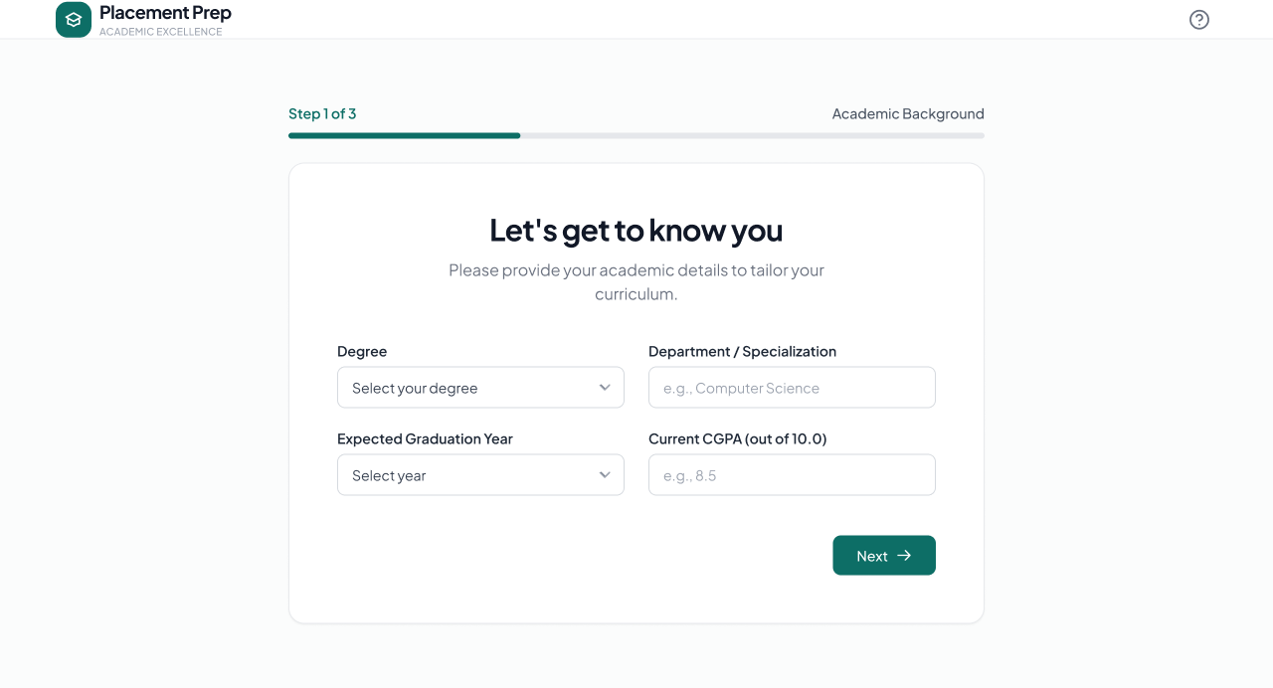
Description
The Academic Background page is the first step of student onboarding. It collects the student's degree, department, expected graduation year, and current CGPA so that the platform can tailor the preparation curriculum.
Features
- Step 1 of 3 Progress Indicator
- Degree
- Department / Specialization
- Expected Graduation Year
- Current CGPA (out of 10.0)
- Next
- Help
Navigation
Academic Background → Next → Target Companies
PAGE 2 — TARGET COMPANIES
Screen Name: Onboarding – Target Companies
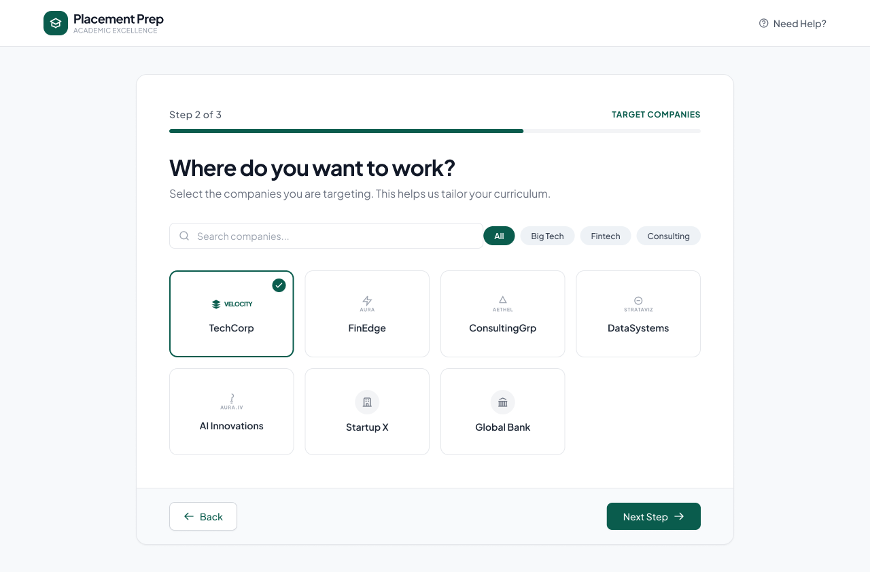
Description
The Target Companies page allows students to select the companies they want to work for. This helps the platform tailor the curriculum and preparation according to the chosen companies.
Features
- Step 2 of 3 Progress Indicator
- Search Companies
- Category Filters (All, Big Tech, Fintech, Consulting)
- Company Selection Cards
- Selected Company Indicator
- Back
- Next Step
- Need Help
Navigation
Academic Background → Target Companies → Skill Assessment
Target Companies → Back → Academic Background
PAGE 3 — SKILL ASSESSMENT
Screen Name: Onboarding – Skill Assessment
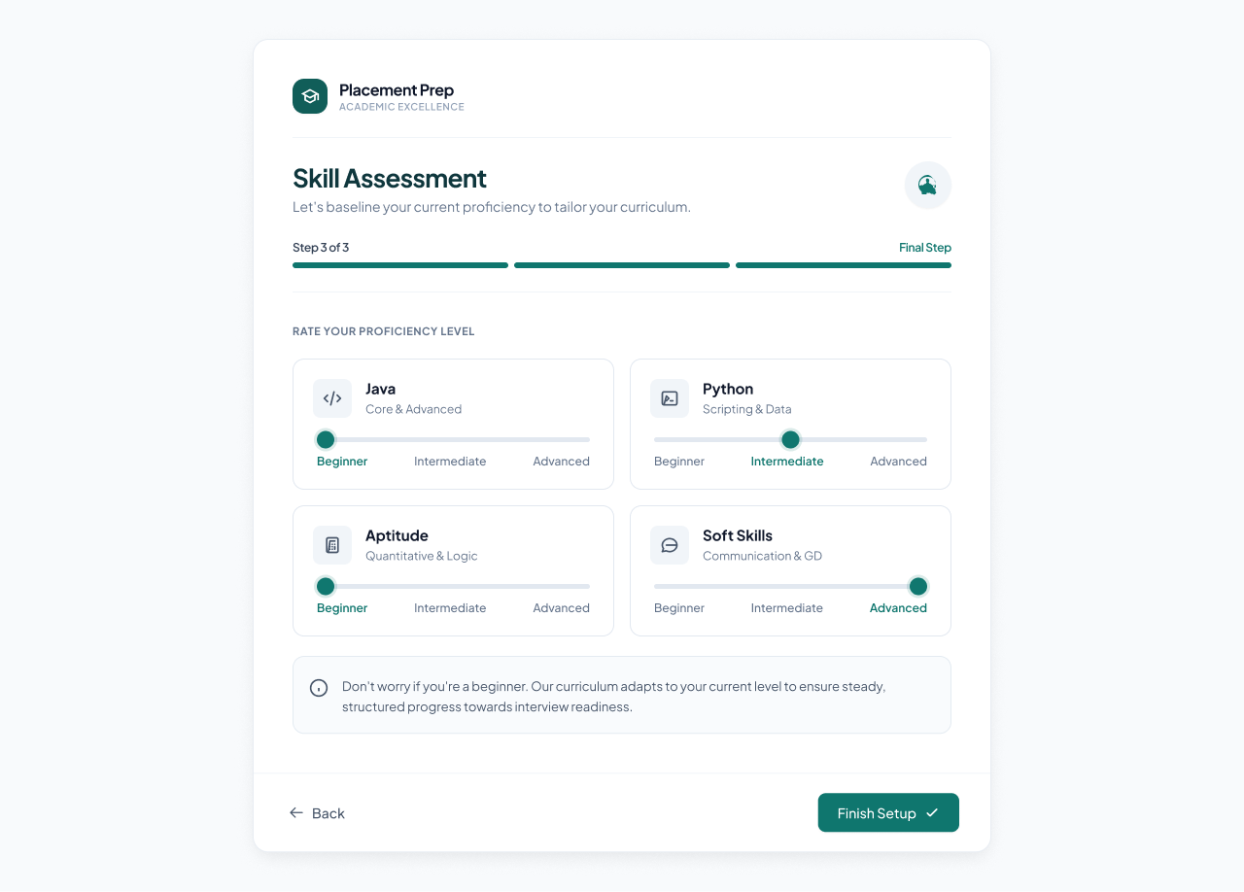
Description
The Skill Assessment page is the final onboarding step. Students rate their current proficiency level in key areas so that the platform can baseline their skills and adapt the curriculum to their level.
Features
- Step 3 of 3 Progress Indicator (Final Step)
- Java Proficiency (Core & Advanced)
- Python Proficiency (Scripting & Data)
- Aptitude Proficiency (Quantitative & Logic)
- Soft Skills Proficiency (Communication & GD)
- Proficiency Sliders (Beginner / Intermediate / Advanced)
- Adaptive Curriculum Information Note
- Back
- Finish Setup
Navigation
Target Companies → Skill Assessment → Finish Setup → Student Dashboard
Skill Assessment → Back → Target Companies
STUDENT DASHBOARD & PREPARATION MODULES
PAGE 4 — STUDENT DASHBOARD
Screen Name: Student Home Dashboard
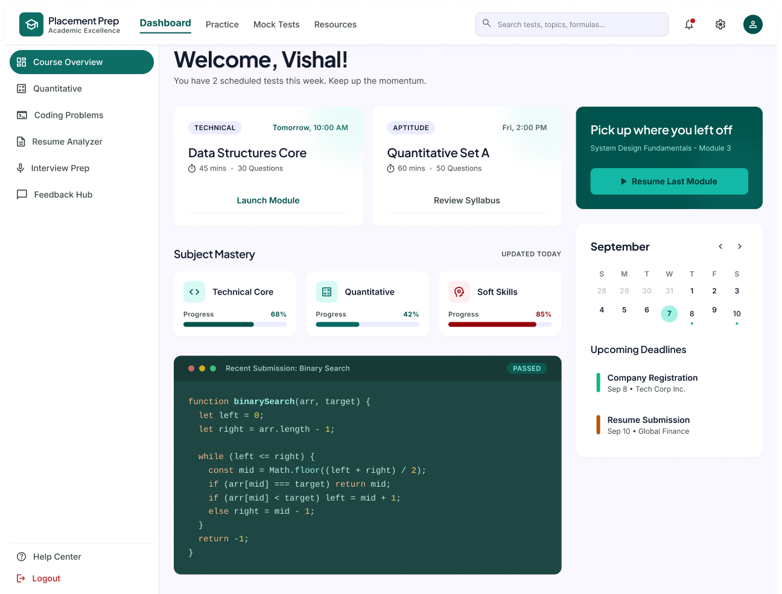
Description
The Student Dashboard is the main landing page for students after login. It gives an overview of scheduled tests, subject mastery, recent coding submissions, upcoming deadlines, and quick access to all preparation modules.
Features
- Welcome Message with Scheduled Tests Summary
- Scheduled Tests (Data Structures Core, Quantitative Set A)
- Launch Module / Review Syllabus
- Resume Last Module
- Subject Mastery Progress (Technical Core, Quantitative, Soft Skills)
- Recent Submission Preview (Binary Search – Passed)
- Monthly Calendar
- Upcoming Deadlines
- Global Search
- Notifications and Settings
- Profile Access
Navigation
Dashboard → Practice / Mock Tests / Resources
Dashboard → Quantitative / Coding Problems / Resume Analyzer / Interview Prep / Feedback Hub
PAGE 5 — RESUME UPLOAD
Screen Name: Upload Your Resume
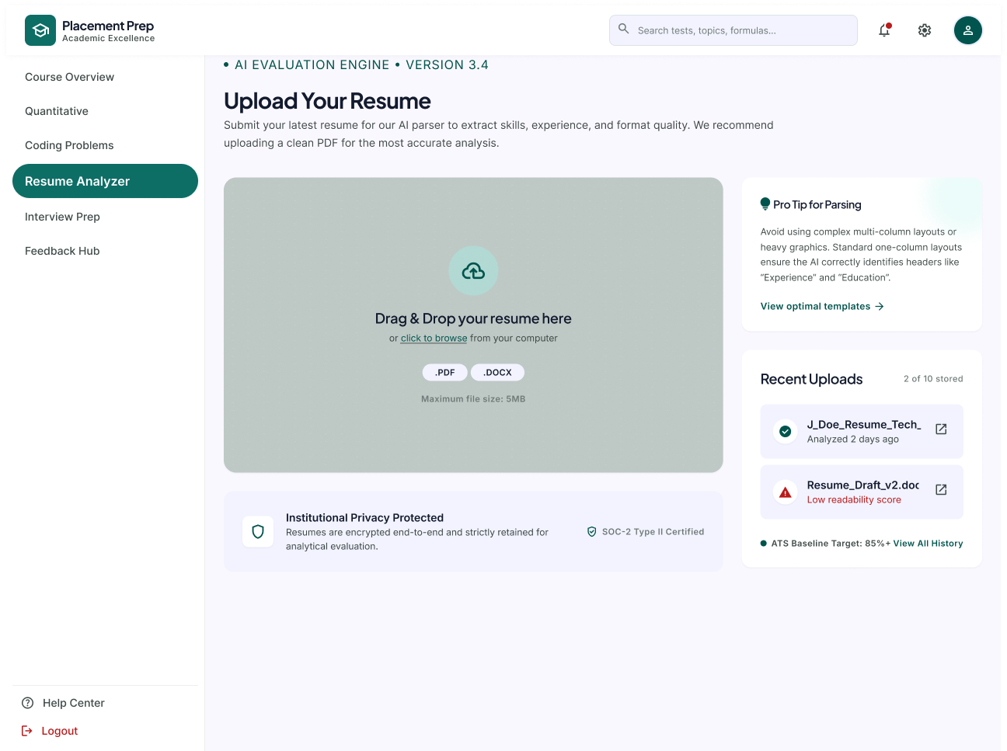
Description
The Resume Upload page allows students to upload their latest resume so that the AI parser can extract skills, experience, and format quality. PDF and DOCX files are supported.
Features
- Drag & Drop Upload Area
- Click to Browse
- Supported Formats (.PDF, .DOCX)
- Maximum File Size (5MB)
- Pro Tip for Parsing
- View Optimal Templates
- Recent Uploads (with analysis status)
- ATS Baseline Target and View All History
- Institutional Privacy Protection Notice
Navigation
Resume Analyzer → Upload Resume → Resume Viewer
Upload Resume → Recent Uploads → Open Resume
PAGE 6 — RESUME VIEWER
Screen Name: Resume Viewer
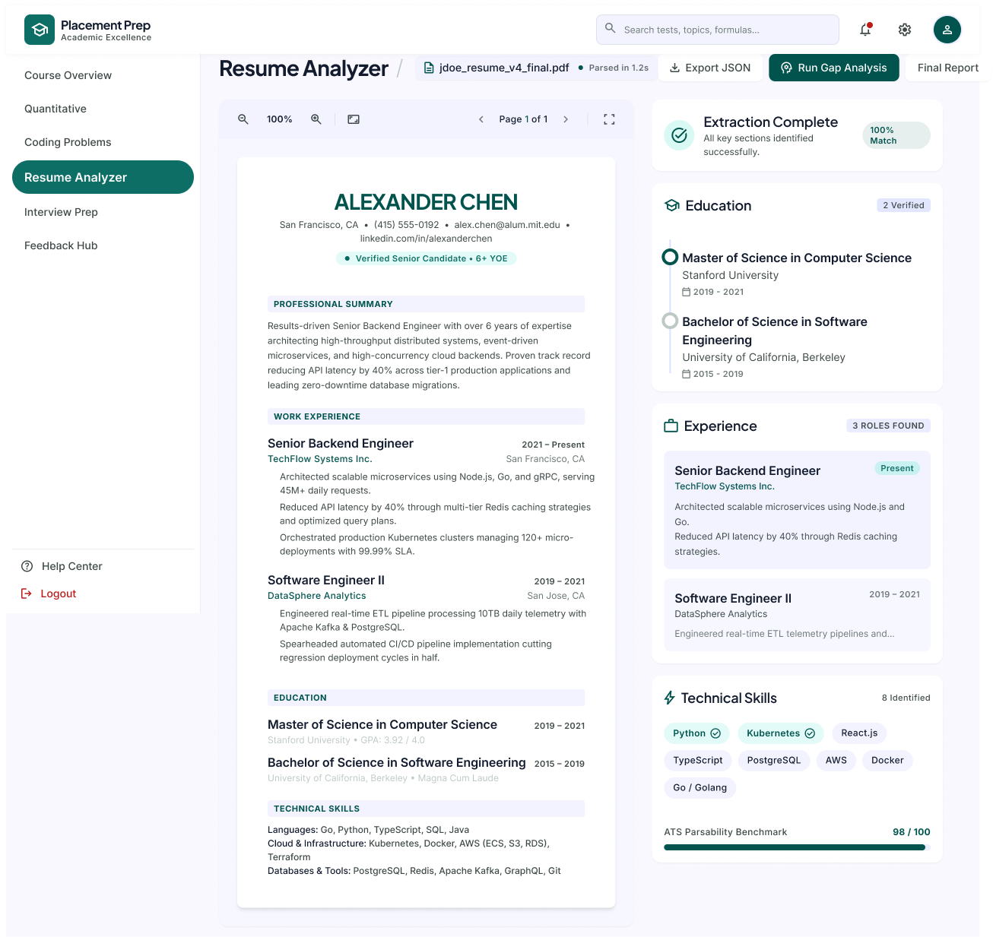
Description
The Resume Viewer page displays the uploaded resume alongside the information extracted by the AI parser, including education, experience, and technical skills.
Features
- Uploaded File Name and Parsed Status
- Export JSON
- Run Gap Analysis
- Final Report
- Resume Preview (Zoom, Page Navigation, Full Screen)
- Extraction Complete Status
- Education Details
- Experience Details
- Technical Skills
- ATS Parsability Benchmark
Navigation
Resume Upload → Resume Viewer
Resume Viewer → Run Gap Analysis → Skill Gap Analysis
Resume Viewer → Final Report → AI Resume Analysis
PAGE 7 — AI RESUME ANALYSIS
Screen Name: Resume Analysis Report
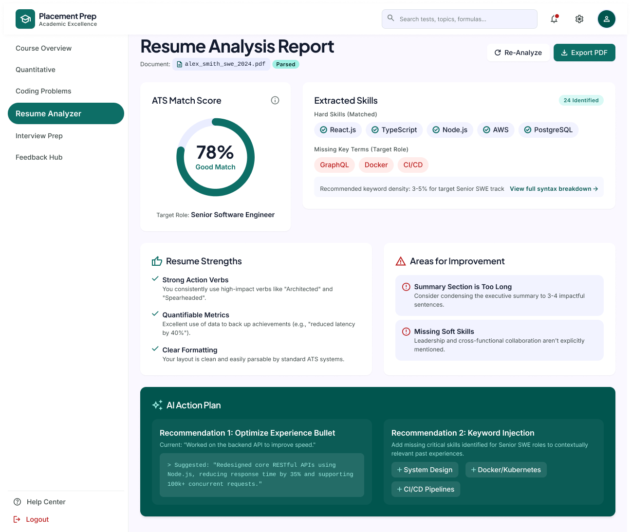
Description
The AI Resume Analysis page presents the AI-generated evaluation of the student's resume, including the ATS match score, extracted skills, strengths, areas for improvement, and an action plan to improve the resume.
Features
- Document Name and Parsed Status
- Re-Analyze
- Export PDF
- ATS Match Score
- Target Role
- Extracted Skills (Matched Hard Skills)
- Missing Key Terms for Target Role
- Keyword Density Recommendation
- Resume Strengths
- Areas for Improvement
- AI Action Plan (Optimize Experience Bullet, Keyword Injection)
Navigation
Resume Viewer → AI Resume Analysis
AI Resume Analysis → Re-Analyze / Export PDF
PAGE 8 — APTITUDE PRACTICE
Screen Name: Aptitude Practice
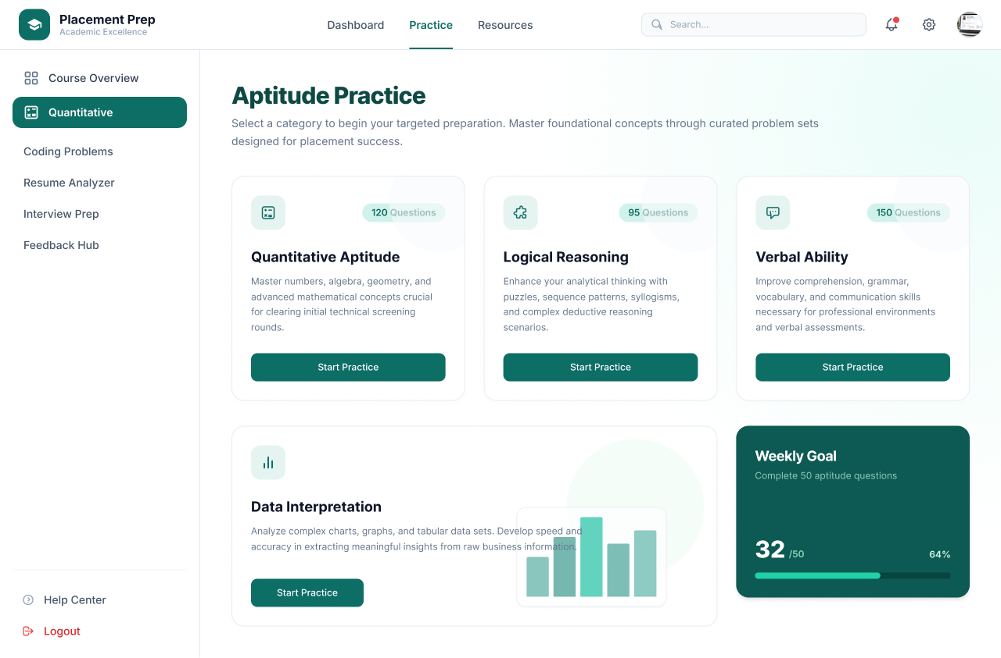
Description
The Aptitude Practice page allows students to select an aptitude category and begin targeted preparation through curated problem sets designed for placement tests.
Features
- Quantitative Aptitude
- Logical Reasoning
- Verbal Ability
- Data Interpretation
- Number of Questions per Category
- Start Practice
- Weekly Goal Progress
Navigation
Dashboard → Quantitative → Aptitude Practice
Aptitude Practice → Start Practice → Test Results
PAGE 9 — TEST RESULTS
Screen Name: Quantitative Aptitude Set A – Result
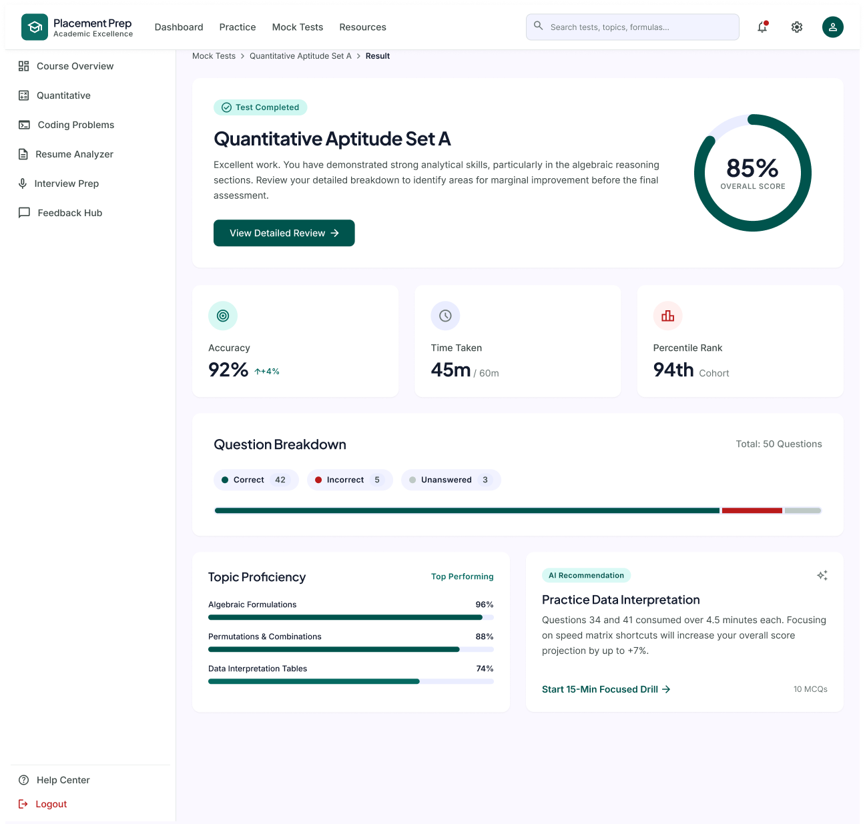
Description
The Test Results page shows the summary of a completed aptitude test, including the overall score, accuracy, time taken, percentile rank, question breakdown, topic proficiency, and an AI recommendation for improvement.
Features
- Test Completed Status
- Overall Score
- View Detailed Review
- Accuracy
- Time Taken
- Percentile Rank
- Question Breakdown (Correct, Incorrect, Unanswered)
- Topic Proficiency
- AI Recommendation
- Start 15-Min Focused Drill
Navigation
Mock Tests → Test Result
Test Results → View Detailed Review → Test Review
Test Results → Start 15-Min Focused Drill
PAGE 10 — TEST REVIEW
Screen Name: Quantitative Aptitude Review
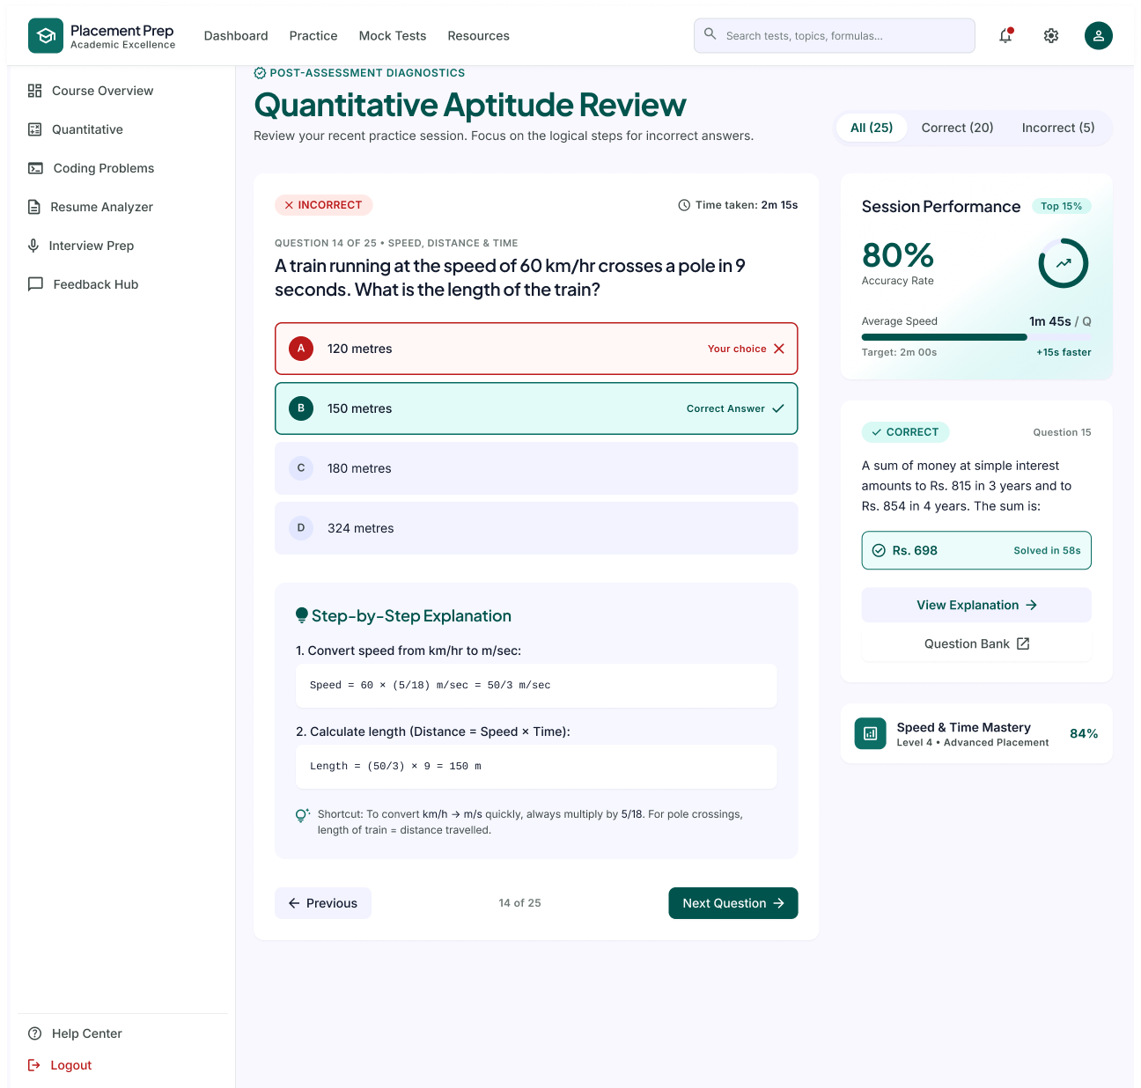
Description
The Test Review page allows students to review their aptitude test question by question, compare their answer with the correct answer, and understand the solution through step-by-step explanations.
Features
- Question Filters (All, Correct, Incorrect)
- Question Number and Topic
- Answer Options with Your Choice and Correct Answer
- Time Taken per Question
- Step-by-Step Explanation
- Shortcut Tip
- Previous / Next Question
- Session Performance (Accuracy Rate, Average Speed)
- Next Question Summary with View Explanation
- Question Bank Link
- Topic Mastery Indicator
Navigation
Test Results → View Detailed Review → Test Review
Test Review → Previous / Next Question
Test Review → Question Bank
PAGE 11 — SELECT INTERVIEW MODE
Screen Name: Select Interview Mode
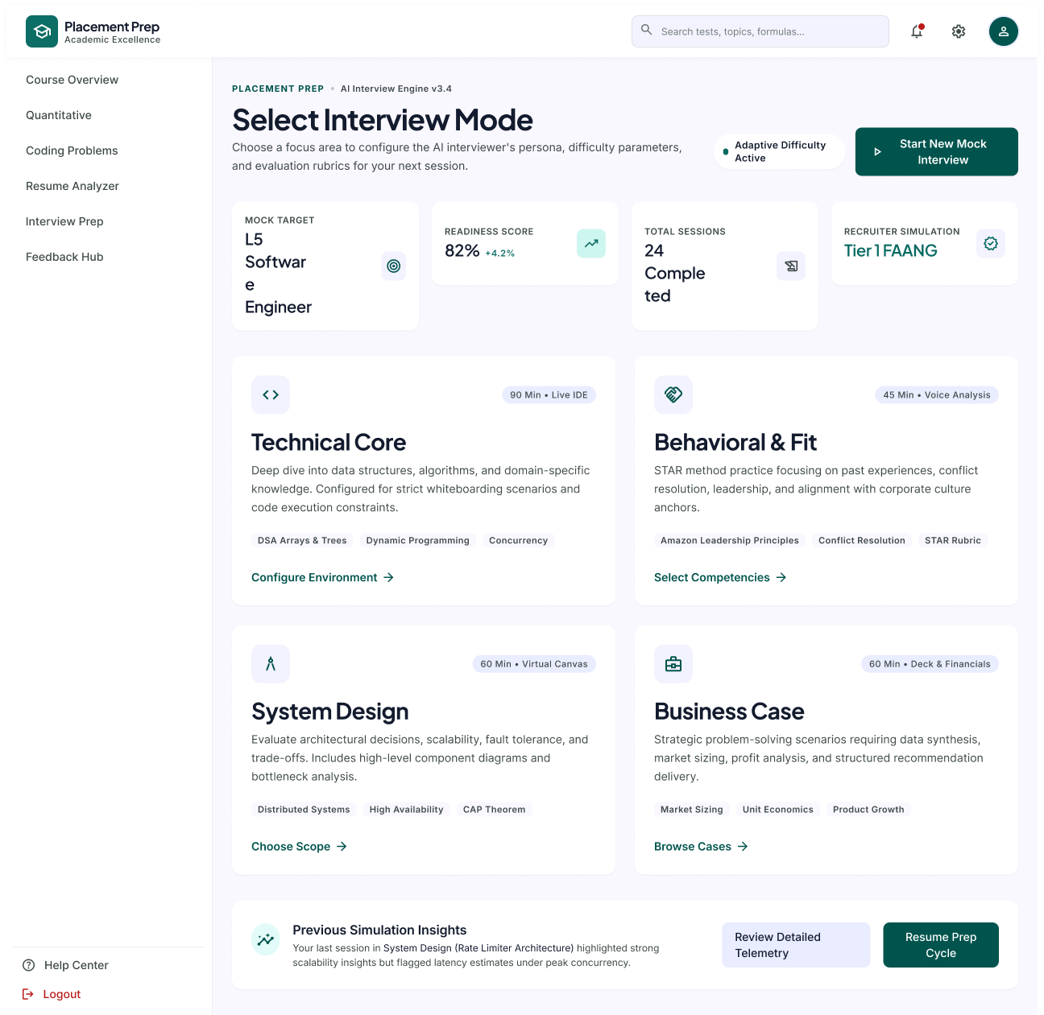
Description
The Select Interview Mode page allows students to choose a focus area for their AI mock interview. Each mode configures the interviewer's persona, difficulty, and evaluation rubric for the session.
Features
- AI Interview Engine Version and Adaptive Difficulty Status
- Start New Mock Interview
- Mock Target
- Readiness Score
- Total Sessions Completed
- Recruiter Simulation
- Technical Core Mode (Configure Environment)
- Behavioral & Fit Mode (Select Competencies)
- System Design Mode (Choose Scope)
- Business Case Mode (Browse Cases)
- Previous Simulation Insights
- Review Detailed Telemetry
- Resume Prep Cycle
Navigation
Dashboard → Interview Prep → Select Interview Mode
Select Interview Mode → Start New Mock Interview → Live Interview
Select Interview Mode → Configure Environment / Select Competencies / Choose Scope / Browse Cases
PAGE 12 — LIVE INTERVIEW
Screen Name: Live Interview Session
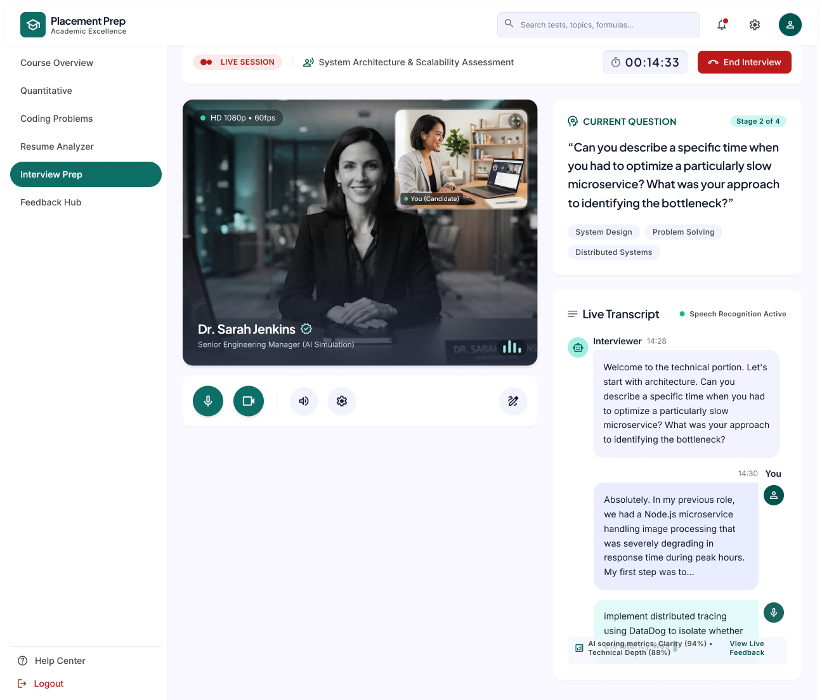
Description
The Live Interview page is the active AI mock interview room. The student answers questions from an AI interviewer over video while a live transcript, the current question, and real-time AI scoring metrics are shown alongside.
Features
- Live Session Indicator and Session Title (System Architecture & Scalability Assessment)
- Session Timer
- End Interview
- Interviewer Video Feed (HD 1080p, 60fps) with AI Interviewer Name and Role
- Candidate Self-View (You)
- Microphone, Camera, Speaker and Settings Controls
- Annotation / Notes Tool
- Current Question with Stage Indicator (Stage 2 of 4)
- Question Topic Tags (System Design, Problem Solving, Distributed Systems)
- Live Transcript (Interviewer and Candidate)
- Speech Recognition Active Status
- AI Scoring Metrics (Clarity, Technical Depth)
- View Live Feedback
Navigation
Select Interview Mode → Start New Mock Interview → Live Interview
Live Interview → End Interview → Feedback Hub
Live Interview → View Live Feedback
PAGE 13 — FEEDBACK HUB
Screen Name: Feedback Hub
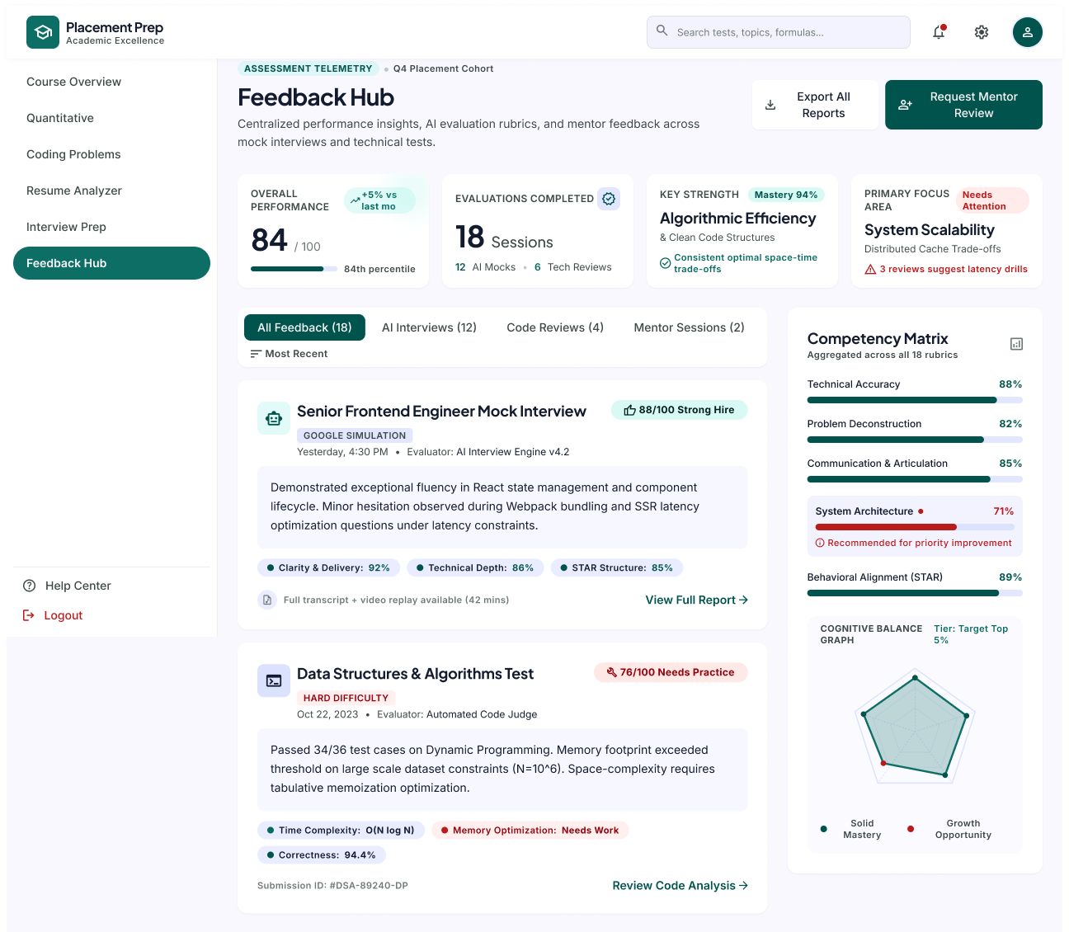
Description
The Feedback Hub centralises performance insights, AI evaluation rubrics, and mentor feedback across mock interviews and technical tests. Students can see overall performance, filter feedback by type, and identify strengths and areas that need improvement.
Features
- Assessment Telemetry Header (Q4 Placement Cohort)
- Export All Reports
- Request Mentor Review
- Overall Performance Score with Percentile and Monthly Change
- Evaluations Completed (AI Mocks and Tech Reviews)
- Key Strength Card (Algorithmic Efficiency)
- Primary Focus Area Card (System Scalability)
- Feedback Filter Tabs (All Feedback, AI Interviews, Code Reviews, Mentor Sessions)
- Sort by Most Recent
- AI Interview Feedback Card with Score, Rating and Sub-Scores (Clarity & Delivery, Technical Depth, STAR Structure)
- Full Transcript and Video Replay Availability
- View Full Report
- Code Test Feedback Card with Difficulty, Score and Metrics (Time Complexity, Memory Optimization, Correctness)
- Submission ID and Review Code Analysis
- Competency Matrix (Technical Accuracy, Problem Deconstruction, Communication, System Architecture, Behavioral Alignment)
- Priority Improvement Highlight
- Cognitive Balance Graph (Solid Mastery vs Growth Opportunity)
Navigation
Dashboard → Feedback Hub
Live Interview → End Interview → Feedback Hub
Feedback Hub → View Full Report → Interview Feedback Report
Feedback Hub → Request Mentor Review / Export All Reports
PAGE 14 — INTERVIEW FEEDBACK REPORT
Screen Name: Interview Feedback – Session Details
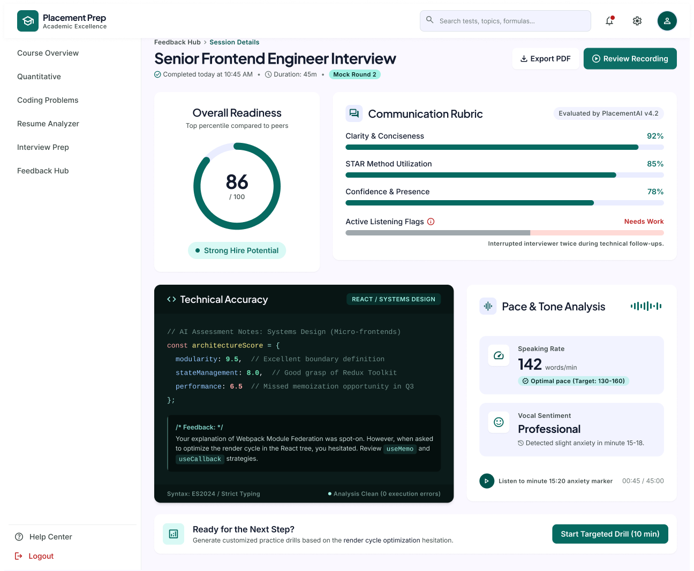
Description
The Interview Feedback Report page shows the detailed evaluation of a completed mock interview session, including the overall readiness score, communication rubric, technical accuracy notes, pace and tone analysis, and a targeted drill recommendation.
Features
- Breadcrumb (Feedback Hub › Session Details)
- Session Title, Completion Time, Duration and Mock Round Tag
- Export PDF
- Review Recording
- Overall Readiness Score with Strong Hire Potential Rating
- Communication Rubric (Clarity & Conciseness, STAR Method Utilization, Confidence & Presence, Active Listening Flags)
- Technical Accuracy Panel with AI Assessment Notes and Feedback
- Pace & Tone Analysis (Speaking Rate, Vocal Sentiment)
- Anxiety Marker Audio Playback
- Ready for the Next Step? Recommendation
- Start Targeted Drill (10 min)
Navigation
Feedback Hub → View Full Report → Interview Feedback Report
Interview Feedback Report → Export PDF / Review Recording
Interview Feedback Report → Start Targeted Drill
Interview Feedback Report → Feedback Hub
PAGE 15 — CODING PROBLEM DIRECTORY
Screen Name: Coding Problem Directory
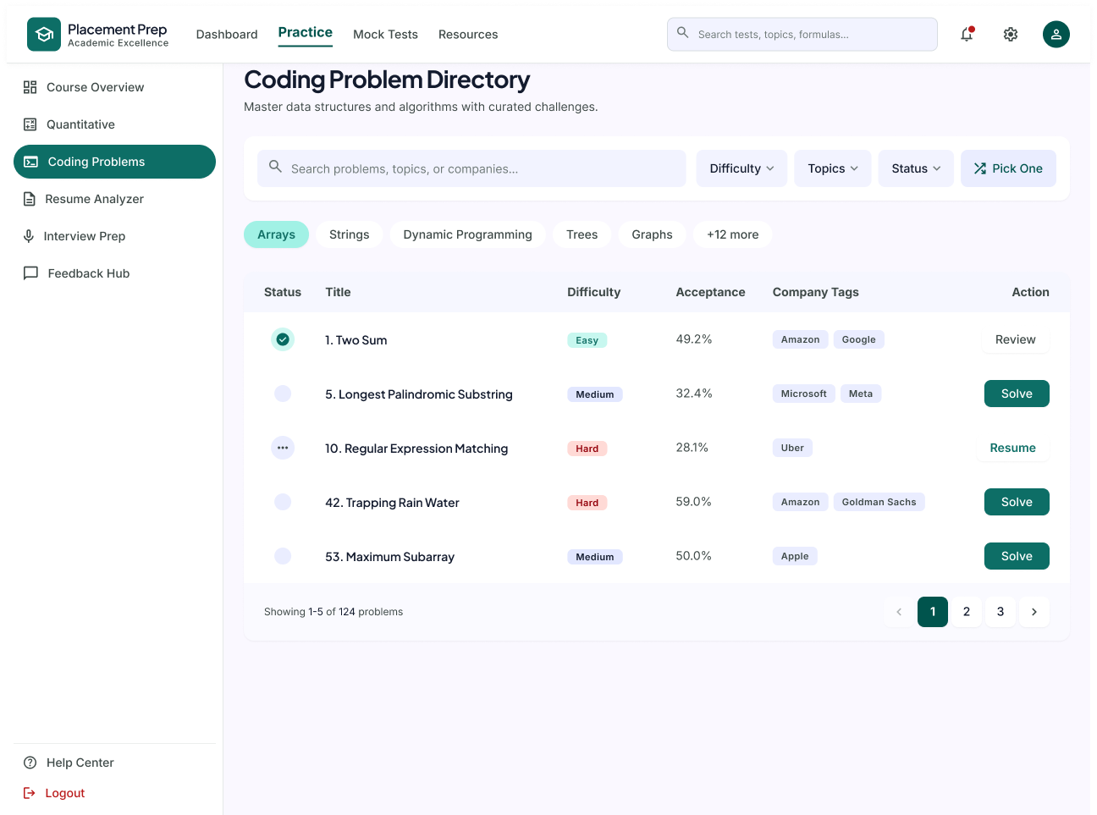
Description
The Coding Problem Directory page lists curated coding challenges that students can search, filter, and solve to master data structures and algorithms.
Features
- Search Problems, Topics, or Companies
- Difficulty Filter
- Topics Filter
- Status Filter
- Pick One
- Topic Chips (Arrays, Strings, Dynamic Programming, Trees, Graphs)
- Problem Status
- Problem Title
- Difficulty Level
- Acceptance Rate
- Company Tags
- Review / Solve / Resume Action
- Pagination
Navigation
Dashboard → Coding Problems → Problem Directory
Problem Directory → Solve / Resume / Review → Problem Details
PAGE 16 — PROBLEM DETAILS
Screen Name: Problem Details
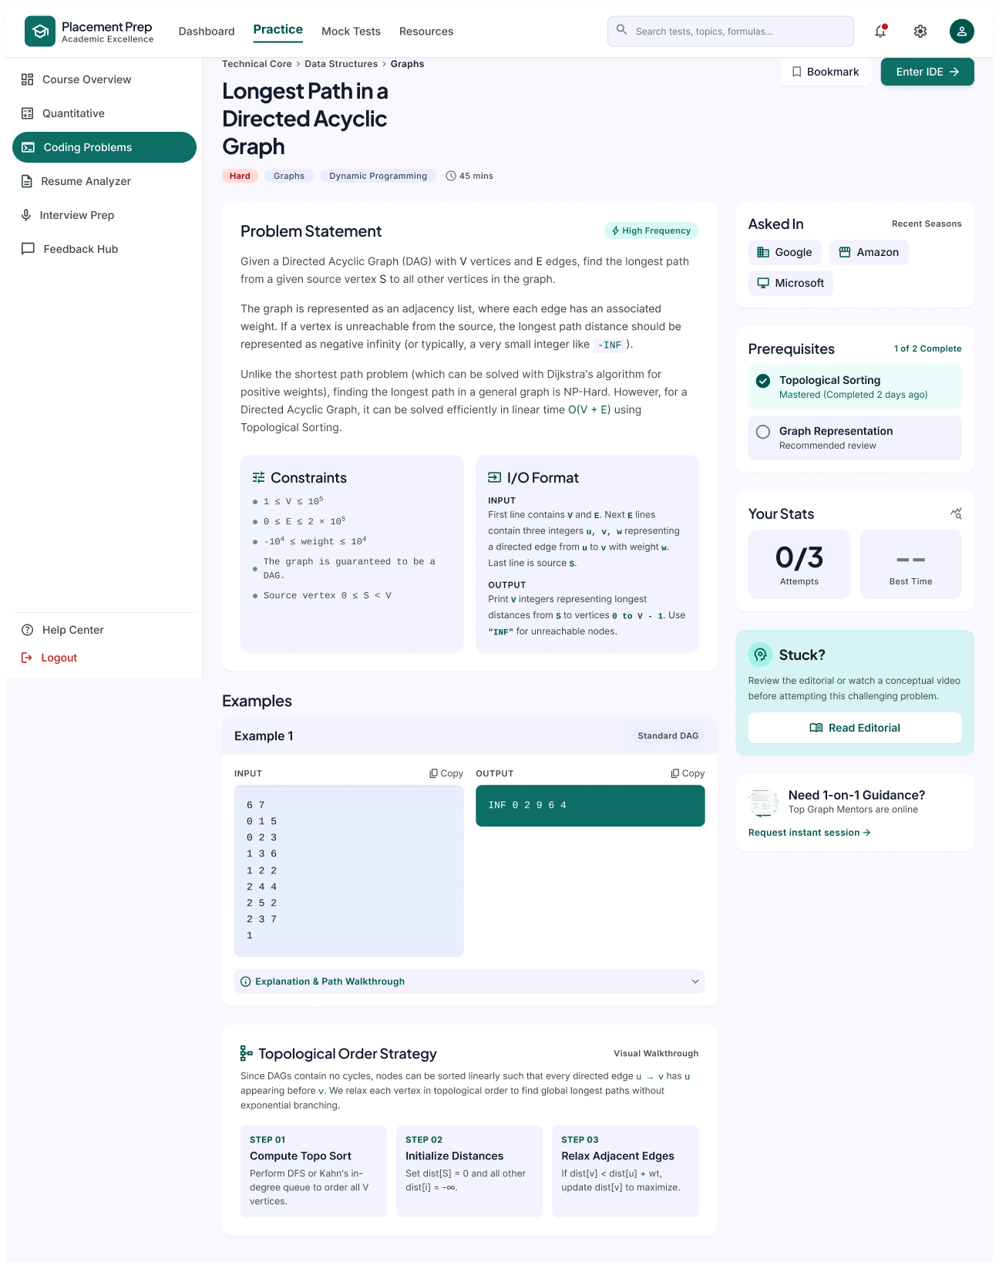
Description
The Problem Details page presents the complete description of a selected coding problem, including the problem statement, constraints, input/output format, examples, and a step-by-step strategy, before the student enters the code editor.
Features
- Problem Title, Difficulty, Topics, and Time Estimate
- Bookmark
- Enter IDE
- Problem Statement
- Constraints
- Input / Output Format
- Examples with Copy Option
- Explanation & Path Walkthrough
- Topological Order Strategy (Step-by-Step Walkthrough)
- Asked In (Company Tags)
- Prerequisites
- Your Stats (Attempts, Best Time)
- Read Editorial
- Request Instant Session
Navigation
Coding Problems → Problem Details
Problem Details → Enter IDE → Code Editor
PAGE 17 — CODE EDITOR
Screen Name: Code Editor
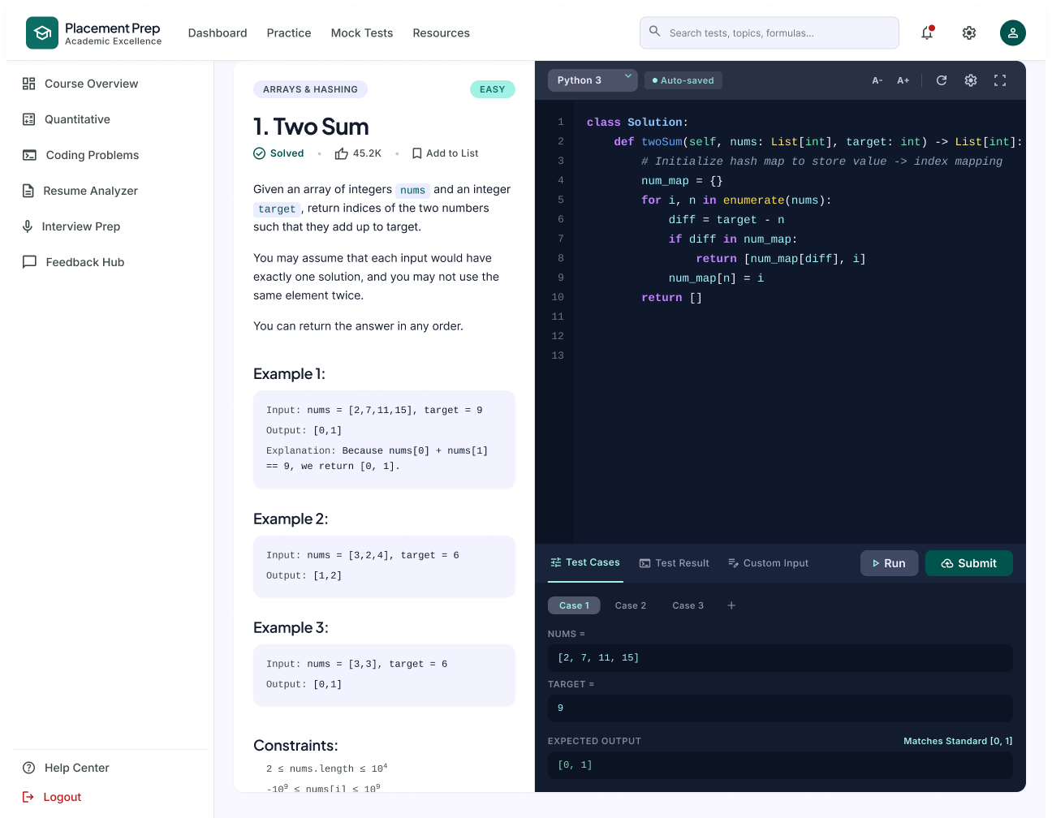
Description
The Code Editor page provides an online coding environment where students can read the problem, write their solution, run it against test cases, and submit it for evaluation.
Features
- Problem Title, Topic, Difficulty, and Solved Status
- Problem Statement with Examples and Constraints
- Language Selection
- Auto-Saved Indicator
- Font Size Controls
- Reset Code
- Editor Settings
- Full Screen Mode
- Code Editor
- Test Cases (Case 1, Case 2, Case 3, Add Case)
- Test Result
- Custom Input
- Run
- Submit
Navigation
Problem Details → Enter IDE → Code Editor
Code Editor → Run → Test Result
Code Editor → Submit
PAGE 18 — SKILL GAP ANALYSIS
Screen Name: Skill Gap Analysis
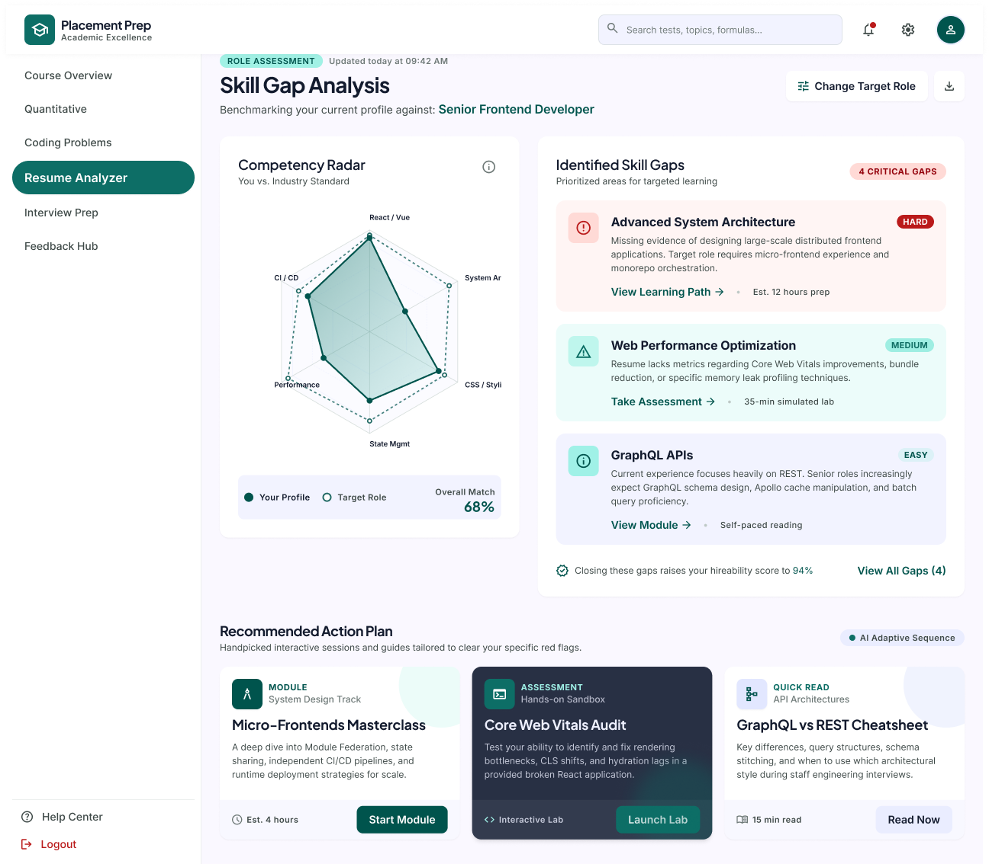
Description
The Skill Gap Analysis page compares the student's current profile with the requirements of a target role. It highlights the missing skills, shows the overall match, and recommends an action plan to close the gaps.
Features
- Role Assessment Status and Last Updated Time
- Target Role Benchmark
- Change Target Role
- Download Report
- Competency Radar (Your Profile vs Target Role)
- Overall Match Percentage
- Identified Skill Gaps (Hard, Medium, Easy)
- View Learning Path
- Take Assessment
- View Module
- Hireability Score Improvement
- View All Gaps
- Recommended Action Plan (Module, Assessment, Quick Read)
Navigation
Resume Viewer → Run Gap Analysis → Skill Gap Analysis
Skill Gap Analysis → Start Module / Launch Lab / Read Now
PAGE 19 — HELP CENTER
Screen Name: Help Center
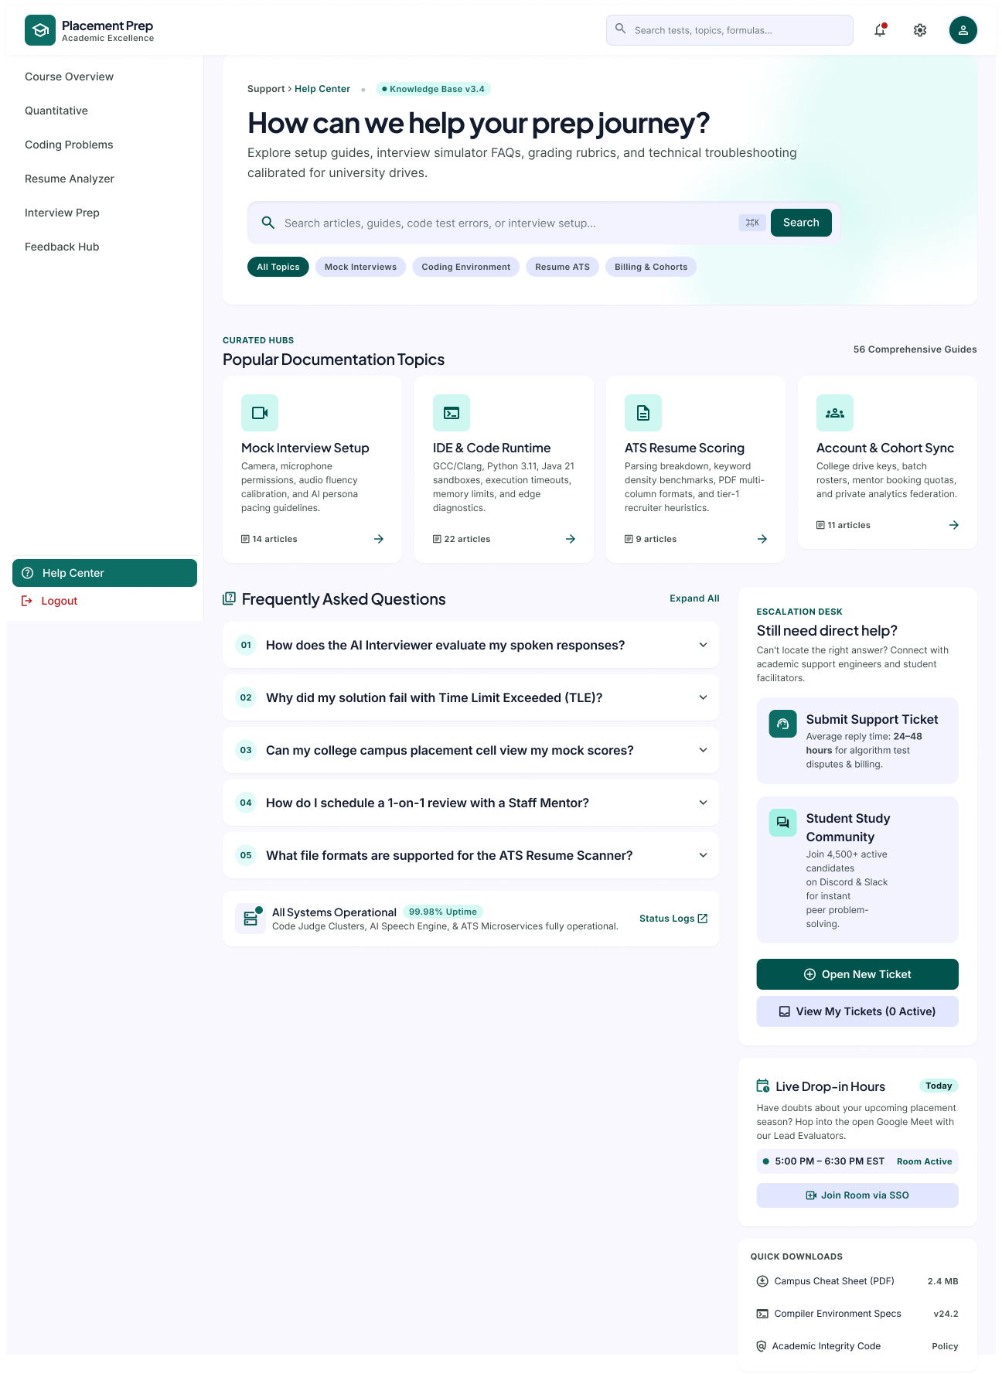
Description
The Help Center is the support area of the platform. It lets students search documentation, read frequently asked questions, raise support tickets, and join live drop-in sessions for help during their placement preparation.
Features
- Breadcrumb and Knowledge Base Version
- Search Articles, Guides, Code Test Errors or Interview Setup
- Topic Filters (All Topics, Mock Interviews, Coding Environment, Resume ATS, Billing & Cohorts)
- Popular Documentation Topics (Mock Interview Setup, IDE & Code Runtime, ATS Resume Scoring, Account & Cohort Sync)
- Article Count per Topic
- Frequently Asked Questions with Expand All
- Escalation Desk (Submit Support Ticket, Student Study Community)
- Open New Ticket
- View My Tickets
- Live Drop-in Hours with Join Room via SSO
- System Status Indicator with Status Logs
- Quick Downloads (Campus Cheat Sheet, Compiler Environment Specs, Academic Integrity Code)
Navigation
Sidebar → Help Center
Help Center → Open New Ticket / View My Tickets
Help Center → Join Room via SSO
Help Center → Status Logs / Quick Downloads
FACULTY DASHBOARD MODULE
PAGE 20 — FACULTY DASHBOARD — BATCH READINESS OVERVIEW
Screen Name: Faculty Dashboard – Overview
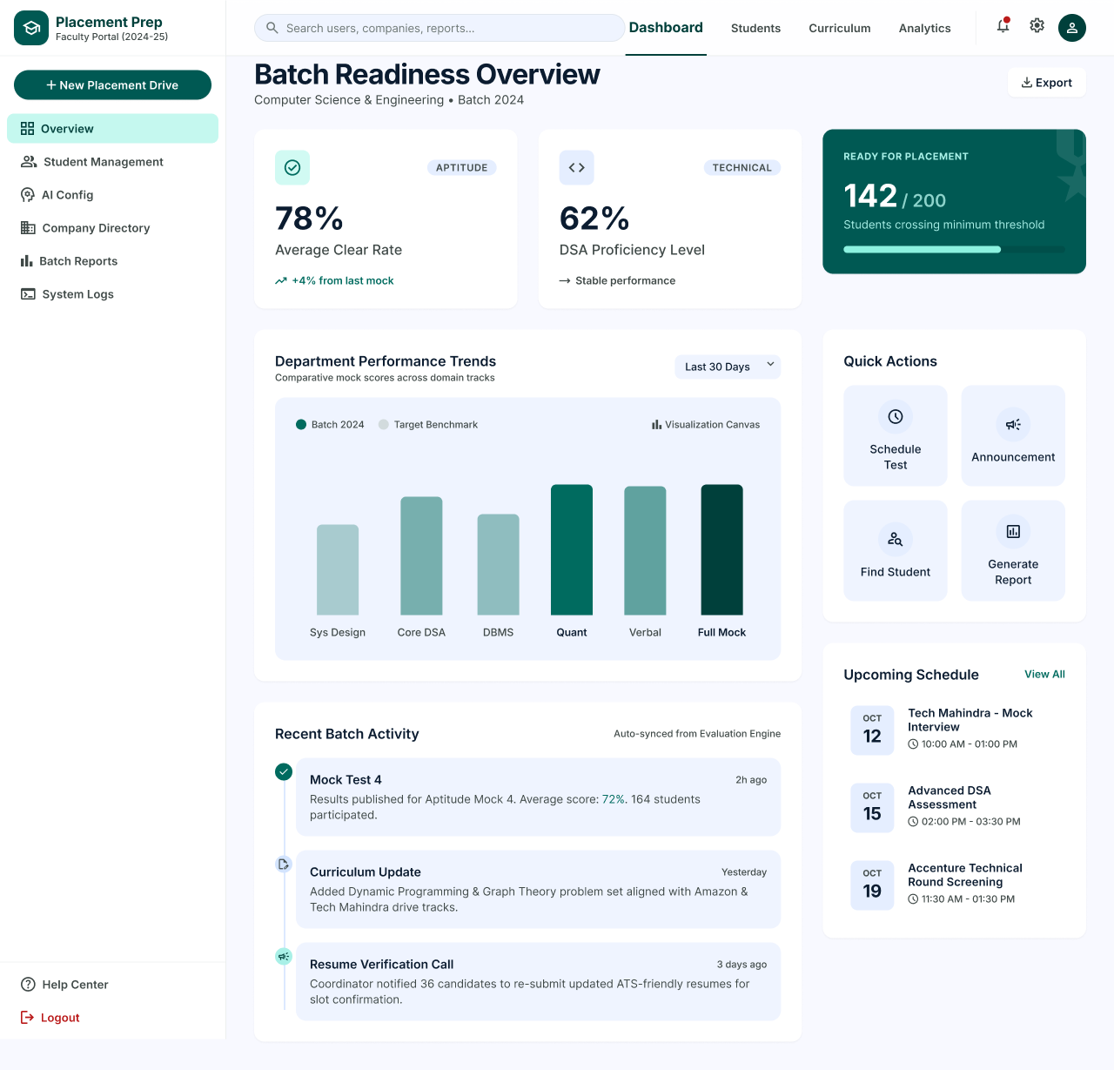
Description
The Faculty Dashboard is the landing page for faculty members and placement coordinators after login. It gives a batch-level overview of aptitude and technical readiness, the number of students ready for placement, department performance trends, recent batch activity and upcoming schedules, along with quick actions for common tasks.
Features
- Faculty Portal Header (Academic Year 2024-25) with Global Search
- Top Navigation (Dashboard, Students, Curriculum, Analytics)
- Notifications, Settings and Profile Access
- New Placement Drive
- Sidebar Menu (Overview, Student Management, AI Config, Company Directory, Batch Reports, System Logs)
- Batch Readiness Overview (Computer Science & Engineering, Batch 2024)
- Export
- Aptitude Summary (78% Average Clear Rate, +4% from last mock)
- Technical Summary (62% DSA Proficiency Level, Stable Performance)
- Ready for Placement (142 / 200 Students Crossing Minimum Threshold)
- Department Performance Trends Chart (Batch 2024 vs Target Benchmark, Last 30 Days Filter)
- Quick Actions (Schedule Test, Announcement, Find Student, Generate Report)
- Upcoming Schedule with View All
- Recent Batch Activity (Mock Test 4, Curriculum Update, Resume Verification Call)
- Help Center and Logout
Navigation
Login → Faculty Dashboard (Overview)
Overview → Student Management / AI Config / Company Directory / Batch Reports / System Logs
Overview → Quick Actions → Find Student → Student Management
Overview → Quick Actions → Generate Report → Report Builder
Overview → Top Navigation → Students / Curriculum / Analytics
PAGE 21 — STUDENT MANAGEMENT
Screen Name: Student Management
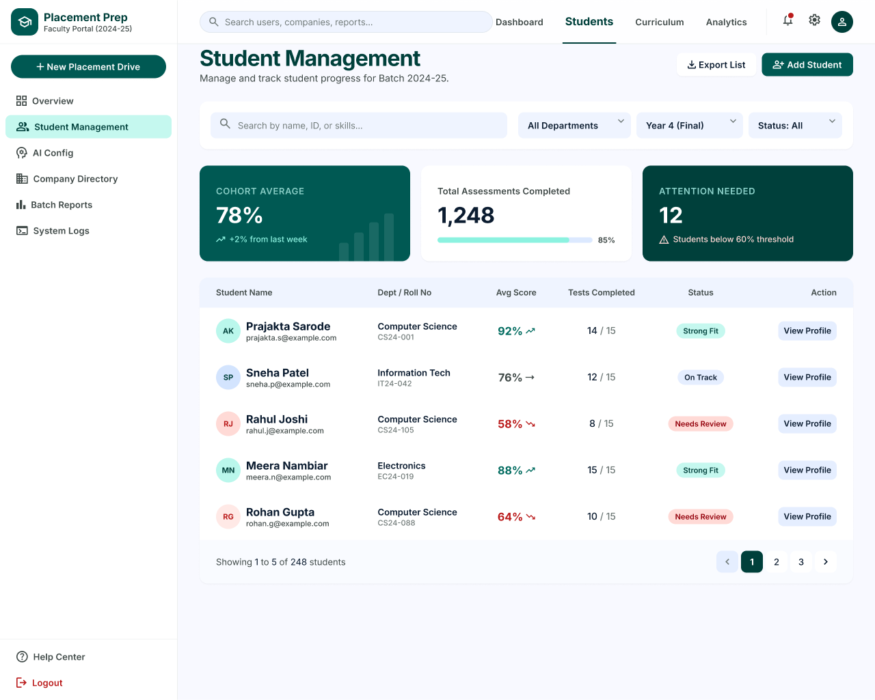
Description
The Student Management page lets faculty manage and track student progress for the batch. Faculty can search and filter students, view cohort-level statistics, identify students who need attention, and open an individual student profile.
Features
- Page Title and Batch Description (Batch 2024-25)
- Export List
- Add Student
- Search by Name, ID or Skills
- Filters (All Departments, Year 4 (Final), Status: All)
- Cohort Average (78%, +2% from last week)
- Total Assessments Completed (1,248)
- Attention Needed (12 Students below 60% Threshold)
- Student Table (Student Name, Dept / Roll No, Avg Score, Tests Completed, Status, Action)
- Performance Trend Indicators
- Status Badges (Strong Fit, On Track, Needs Review)
- View Profile
- Pagination (Showing 1 to 5 of 248 Students)
Navigation
Overview → Student Management
Student Management → View Profile → Student Profile
Student Management → Add Student / Export List
PAGE 22 — STUDENT PROFILE
Screen Name: Student Profile
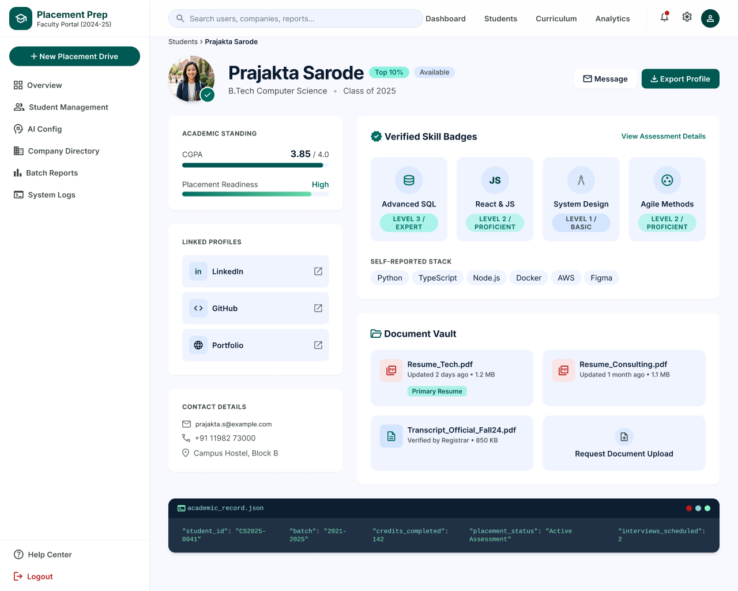
Description
The Student Profile page shows the complete profile of an individual student, including academic standing, placement readiness, verified skill badges, linked profiles, contact details and uploaded documents, so faculty can review a student before shortlisting or mentoring.
Features
- Breadcrumb (Students › Student Name)
- Student Photo, Name, Top 10% and Available Badges
- Degree and Class Year (B.Tech Computer Science, Class of 2025)
- Message
- Export Profile
- Academic Standing (CGPA and Placement Readiness)
- Linked Profiles (LinkedIn, GitHub, Portfolio)
- Contact Details (Email, Phone, Campus Address)
- Verified Skill Badges (Advanced SQL, React & JS, System Design, Agile Methods)
- View Assessment Details
- Self-Reported Stack
- Document Vault (Resume_Tech.pdf, Resume_Consulting.pdf, Transcript_Official_Fall24.pdf)
- Primary Resume Tag
- Request Document Upload
- Academic Record Summary (Student ID, Batch, Credits Completed, Placement Status, Interviews Scheduled)
Navigation
Student Management → View Profile → Student Profile
Student Profile → View Assessment Details → Student Performance Details
Student Profile → Message / Export Profile
PAGE 23 — STUDENT PERFORMANCE DETAILS
Screen Name: Student Performance Details
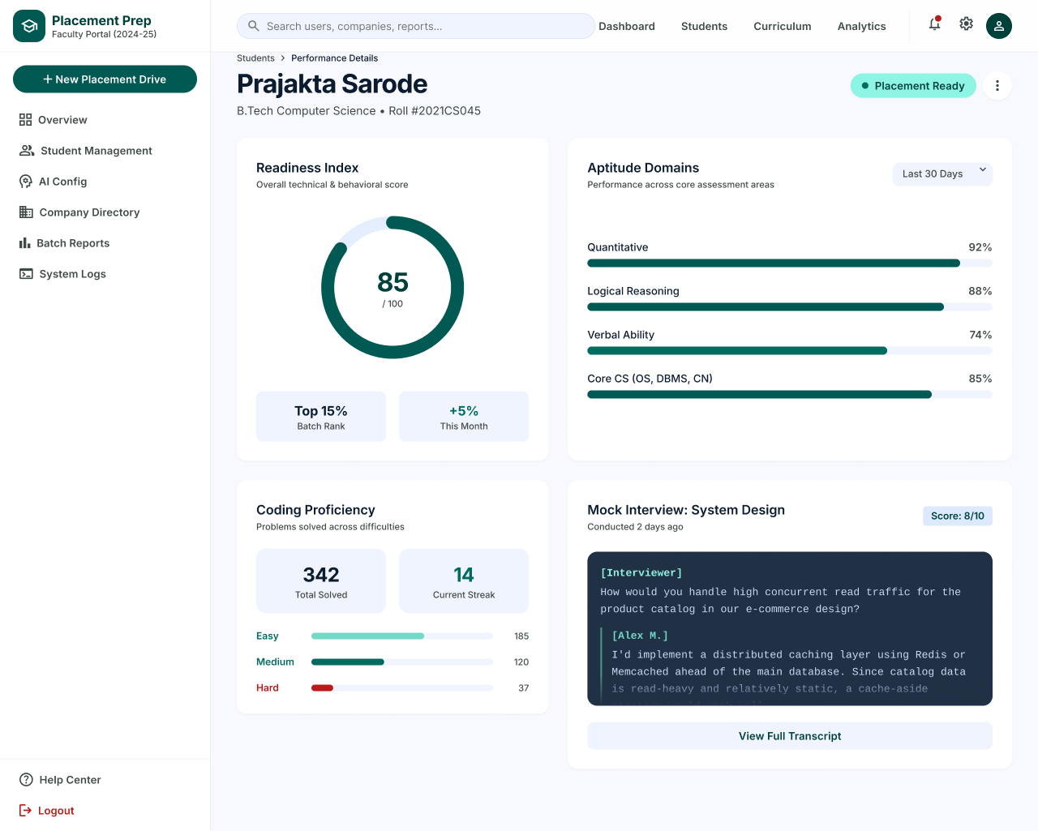
Description
The Student Performance Details page presents a detailed performance report for one student, covering the overall readiness index, aptitude domain scores, coding proficiency and the latest mock interview result.
Features
- Breadcrumb (Students › Performance Details)
- Student Name, Degree and Roll Number
- Placement Ready Status Badge
- More Options Menu
- Readiness Index (85 / 100)
- Batch Rank (Top 15%) and Monthly Change (+5%)
- Aptitude Domains (Quantitative, Logical Reasoning, Verbal Ability, Core CS)
- Time Period Filter (Last 30 Days)
- Coding Proficiency (Total Solved, Current Streak)
- Problems Solved by Difficulty (Easy, Medium, Hard)
- Mock Interview: System Design with Score and Conducted Date
- Transcript Preview
- View Full Transcript
Navigation
Student Profile → View Assessment Details → Student Performance Details
Student Performance Details → View Full Transcript
Student Performance Details → Students (Breadcrumb)
PAGE 24 — CURRICULUM MANAGEMENT
Screen Name: Curriculum Management
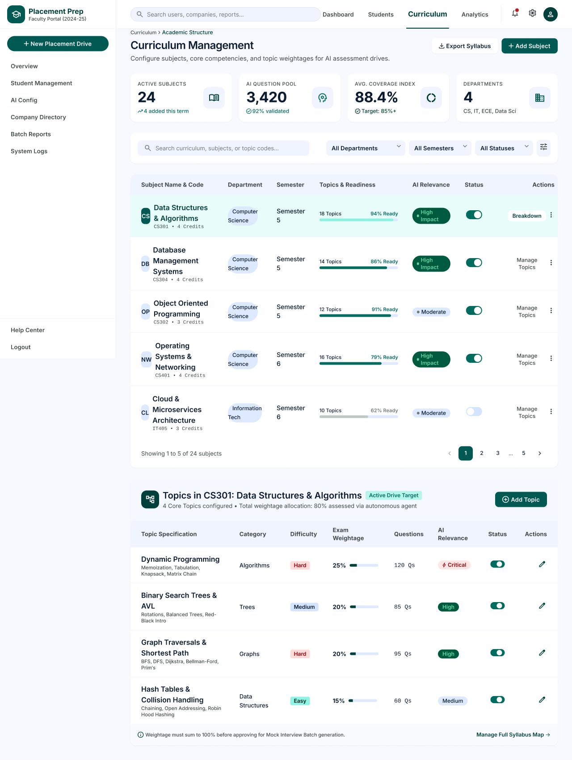
Description
The Curriculum Management page allows faculty to configure subjects, core competencies and topic weightages that drive AI assessments. Faculty can view coverage statistics, enable or disable subjects, and manage the topics of each subject.
Features
- Breadcrumb (Curriculum › Academic Structure)
- Export Syllabus
- Add Subject
- Active Subjects (24, 4 added this term)
- AI Question Pool (3,420, 92% validated)
- Average Coverage Index (88.4%, Target 85%+)
- Departments (4: CS, IT, ECE, Data Sci)
- Search Curriculum, Subjects or Topic Codes
- Filters (All Departments, All Semesters, All Statuses)
- Subject Table (Subject Name & Code, Department, Semester, Topics & Readiness, AI Relevance, Status, Actions)
- Status Toggle
- Breakdown / Manage Topics
- Pagination (Showing 1 to 5 of 24 Subjects)
- Topics Panel for Selected Subject (Active Drive Target)
- Add Topic
- Topic Table (Topic Specification, Category, Difficulty, Exam Weightage, Questions, AI Relevance, Status, Actions)
- Weightage Note (must sum to 100% before approving Mock Interview Batch generation)
- Manage Full Syllabus Map
Navigation
Top Navigation → Curriculum → Curriculum Management
Curriculum Management → Breakdown / Manage Topics → Topics Panel
Curriculum Management → Add Subject / Add Topic / Export Syllabus
PAGE 25 — PERFORMANCE ANALYTICS
Screen Name: Performance Analytics
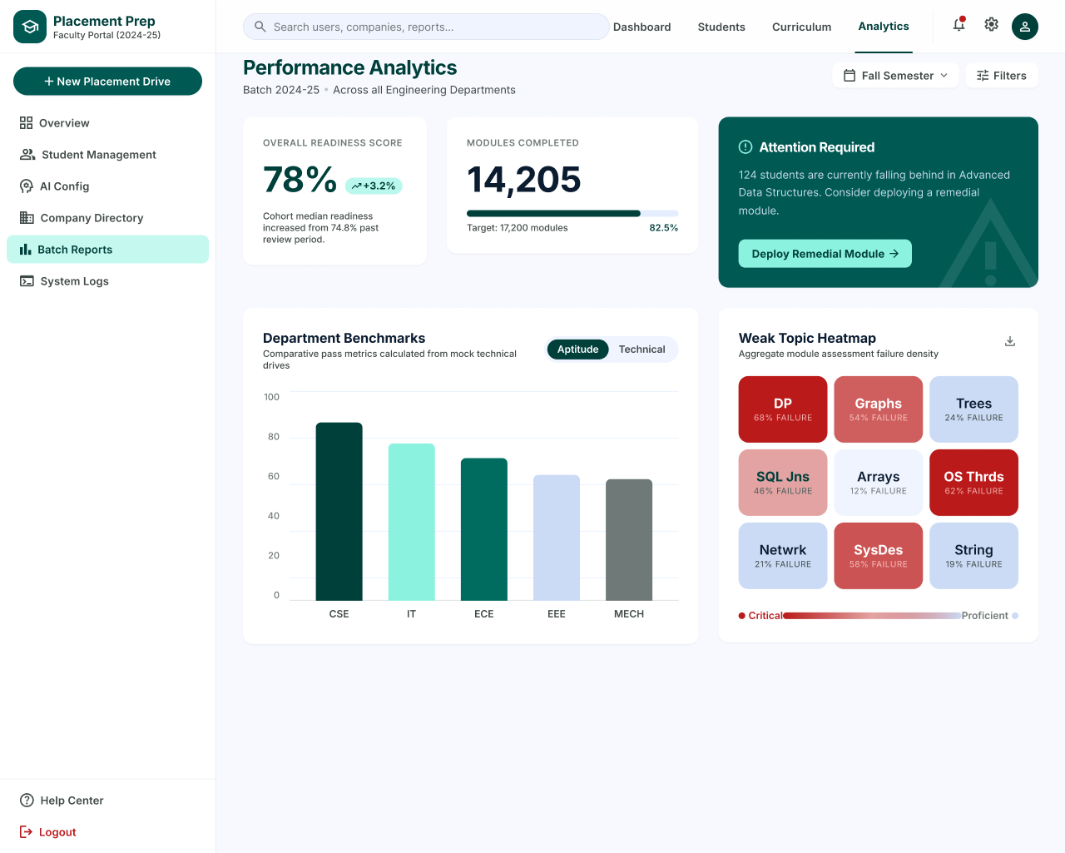
Description
The Performance Analytics page gives faculty a batch-wide view of placement readiness across all engineering departments. It highlights overall readiness, module completion, department benchmarks and the weakest topics, and lets faculty act on students who are falling behind.
Features
- Page Title and Batch Description (Batch 2024-25, All Engineering Departments)
- Semester Filter (Fall Semester)
- Filters
- Overall Readiness Score (78%, +3.2%)
- Modules Completed (14,205 against a Target of 17,200)
- Attention Required Alert
- Deploy Remedial Module
- Department Benchmarks Bar Chart (CSE, IT, ECE, EEE, MECH)
- Aptitude / Technical Toggle
- Weak Topic Heatmap (DP, Graphs, Trees, SQL Joins, Arrays, OS Threads, Network, System Design, String)
- Failure Percentage per Topic
- Critical to Proficient Colour Legend
- Download Heatmap
Navigation
Top Navigation → Analytics → Performance Analytics
Sidebar → Batch Reports → Performance Analytics
Performance Analytics → Deploy Remedial Module
Performance Analytics → Filters / Semester Filter
PAGE 26 — TEST & INTERVIEW REPORTS
Screen Name: Test & Interview Reports
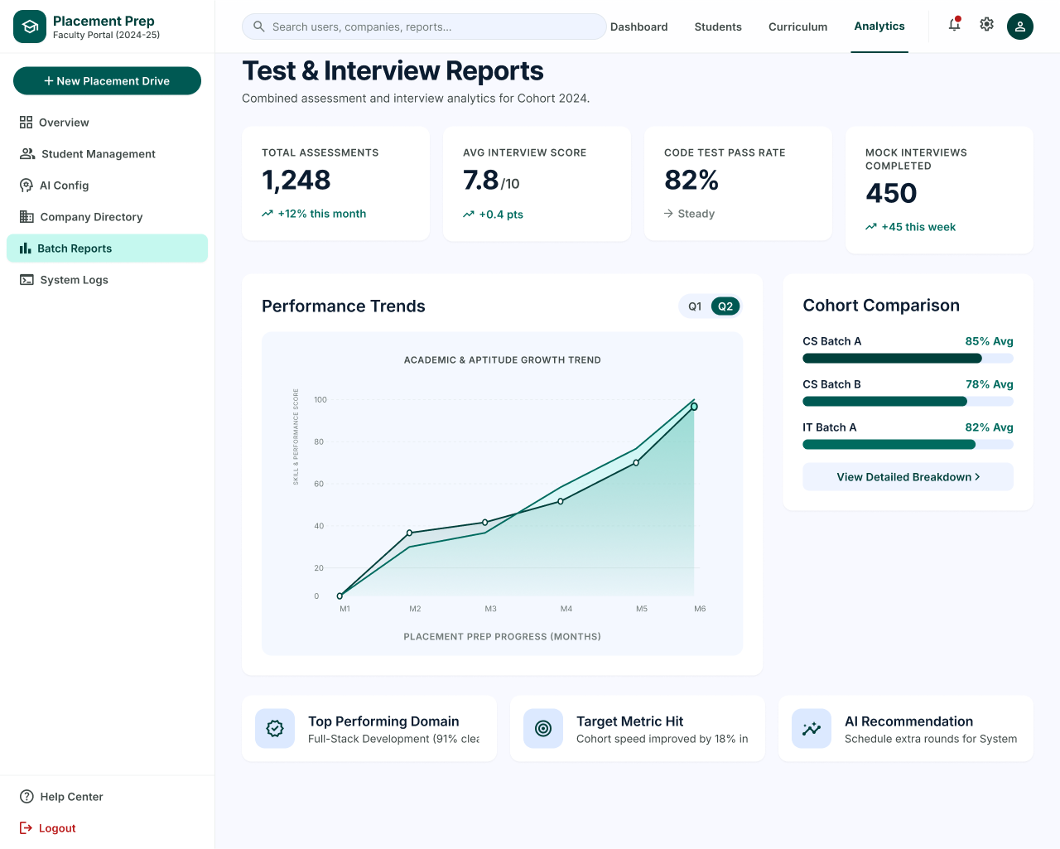
Description
The Test & Interview Reports page combines assessment and interview analytics for the cohort. It shows key totals, performance trends over time, a comparison between batches and short insights generated from the data.
Features
- Page Title and Description (Cohort 2024)
- Total Assessments (1,248, +12% this month)
- Average Interview Score (7.8 / 10, +0.4 pts)
- Code Test Pass Rate (82%, Steady)
- Mock Interviews Completed (450, +45 this week)
- Performance Trends Line Chart (Academic & Aptitude Growth Trend, M1 to M6)
- Quarter Toggle (Q1, Q2)
- Cohort Comparison (CS Batch A, CS Batch B, IT Batch A)
- View Detailed Breakdown
- Insight Cards (Top Performing Domain, Target Metric Hit, AI Recommendation)
Navigation
Sidebar → Batch Reports → Test & Interview Reports
Test & Interview Reports → View Detailed Breakdown → Placement Readiness Matrix
Test & Interview Reports → Q1 / Q2 Toggle
PAGE 27 — PLACEMENT READINESS MATRIX
Screen Name: Placement Readiness Matrix
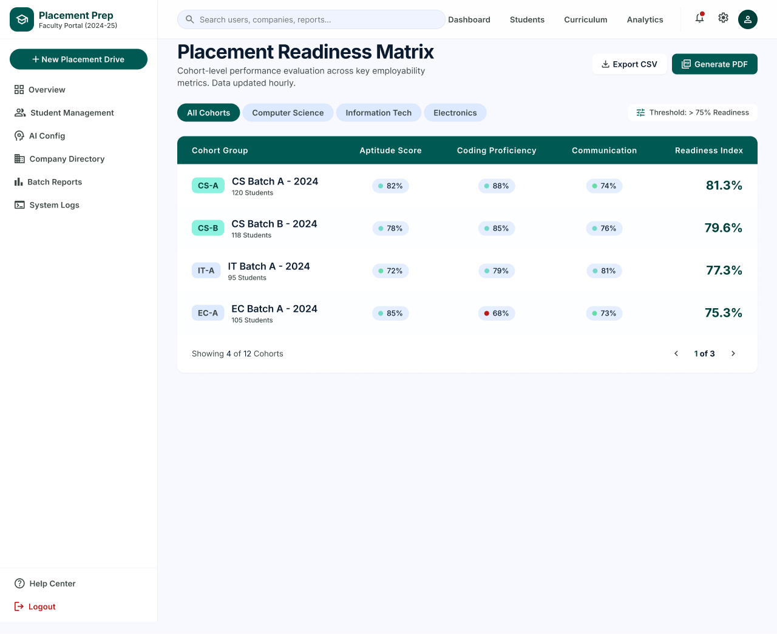
Description
The Placement Readiness Matrix presents a cohort-level evaluation of key employability metrics. Faculty can compare cohorts by aptitude, coding proficiency and communication, see the overall readiness index of each cohort, and export the data.
Features
- Page Title and Description (Data Updated Hourly)
- Export CSV
- Generate PDF
- Cohort Filters (All Cohorts, Computer Science, Information Tech, Electronics)
- Readiness Threshold (> 75% Readiness)
- Matrix Table (Cohort Group, Aptitude Score, Coding Proficiency, Communication, Readiness Index)
- Cohort Tags and Student Counts (CS-A, CS-B, IT-A, EC-A)
- Low Score Indicator (Coding Proficiency below threshold)
- Pagination (Showing 4 of 12 Cohorts)
Navigation
Test & Interview Reports → View Detailed Breakdown → Placement Readiness Matrix
Placement Readiness Matrix → Export CSV / Generate PDF
Placement Readiness Matrix → Cohort Filters
PAGE 28 — REPORT BUILDER
Screen Name: Report Builder
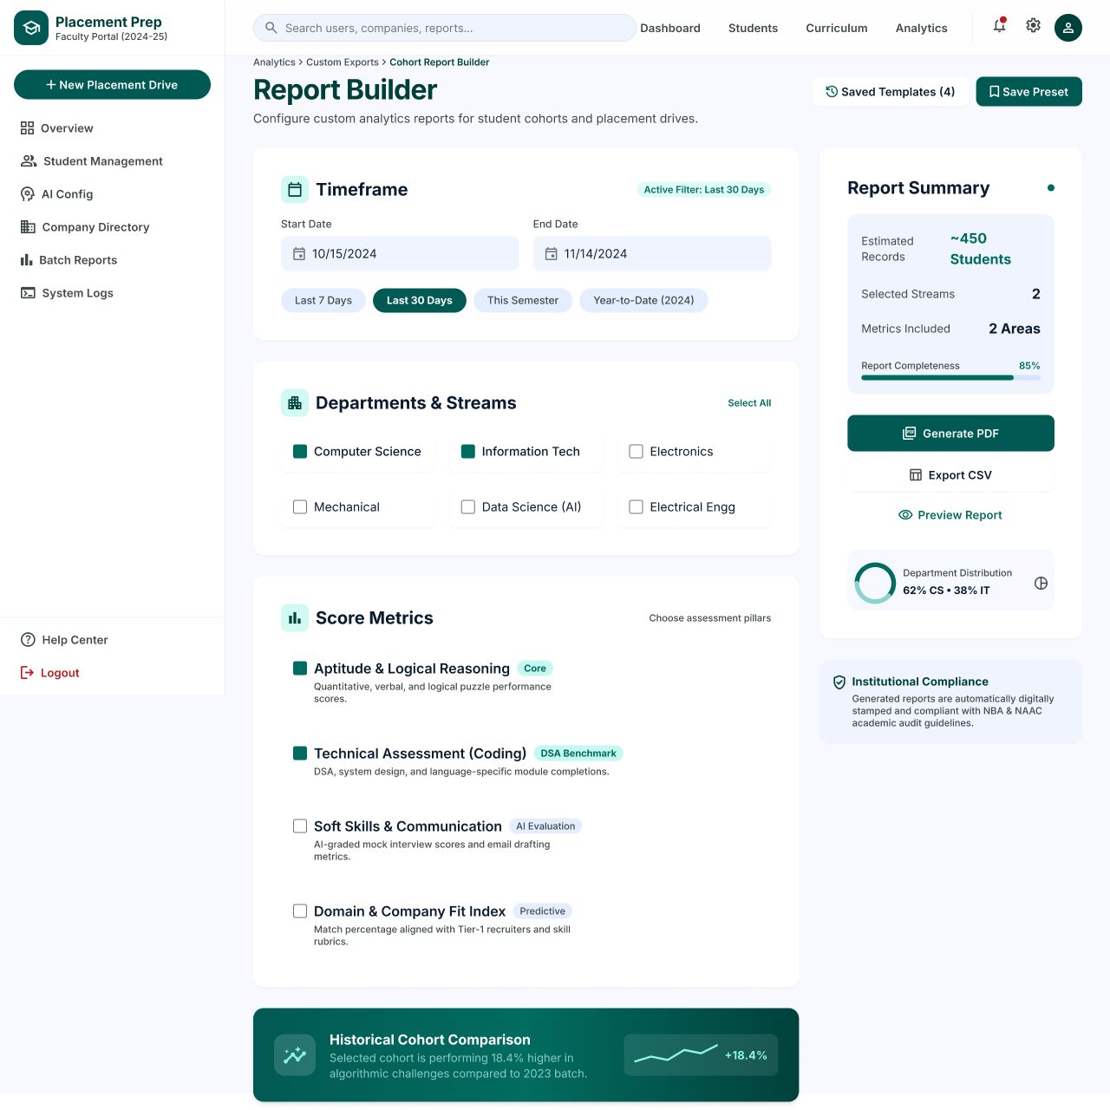
Description
The Report Builder page allows faculty to configure custom analytics reports for student cohorts and placement drives. Faculty choose the timeframe, departments and score metrics, review a live summary, and then generate the report as a PDF or CSV.
Features
- Breadcrumb (Analytics › Custom Exports › Cohort Report Builder)
- Saved Templates (4)
- Save Preset
- Timeframe (Start Date, End Date)
- Quick Ranges (Last 7 Days, Last 30 Days, This Semester, Year-to-Date)
- Active Filter Indicator
- Departments & Streams with Select All (Computer Science, Information Tech, Electronics, Mechanical, Data Science (AI), Electrical Engg)
- Score Metrics (Aptitude & Logical Reasoning, Technical Assessment (Coding), Soft Skills & Communication, Domain & Company Fit Index)
- Report Summary (Estimated Records, Selected Streams, Metrics Included, Report Completeness)
- Generate PDF
- Export CSV
- Preview Report
- Department Distribution
- Institutional Compliance Note (NBA & NAAC)
- Historical Cohort Comparison
Navigation
Overview → Quick Actions → Generate Report → Report Builder
Report Builder → Generate PDF / Export CSV / Preview Report
Report Builder → Saved Templates / Save Preset
PAGE 29 — AI PROMPT CONFIGURATION
Screen Name: AI Prompt Configuration
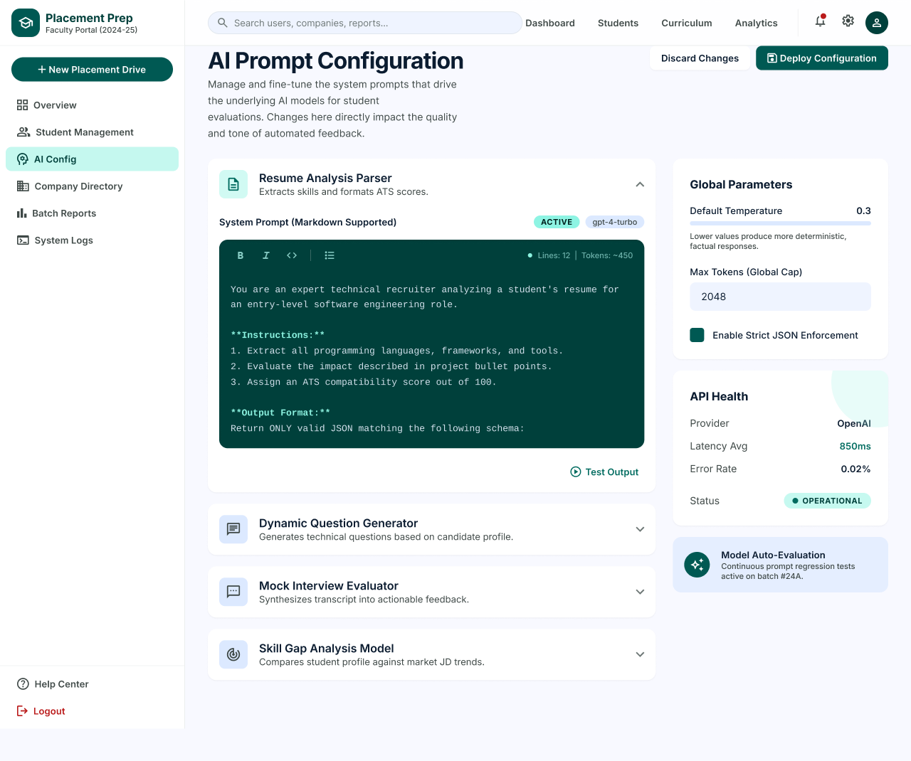
Description
The AI Prompt Configuration page allows faculty to manage and fine-tune the system prompts that drive the AI models used for student evaluations. Changes made here directly affect the quality and tone of automated feedback.
Features
- Page Title and Description
- Discard Changes
- Deploy Configuration
- Prompt Modules (Resume Analysis Parser, Dynamic Question Generator, Mock Interview Evaluator, Skill Gap Analysis Model)
- Expandable Module Panels
- System Prompt Editor with Markdown Support
- Editor Toolbar (Bold, Italic, Code, List)
- Active Status and Model Tag (gpt-4-turbo)
- Line and Token Count
- Test Output
- Global Parameters (Default Temperature, Max Tokens, Strict JSON Enforcement)
- API Health (Provider, Latency Average, Error Rate, Status)
- Model Auto-Evaluation Notice
Navigation
Sidebar → AI Config → AI Prompt Configuration
AI Prompt Configuration → Test Output
AI Prompt Configuration → Deploy Configuration / Discard Changes
PAGE 30 — COMPANY DIRECTORY
Screen Name: Company Directory
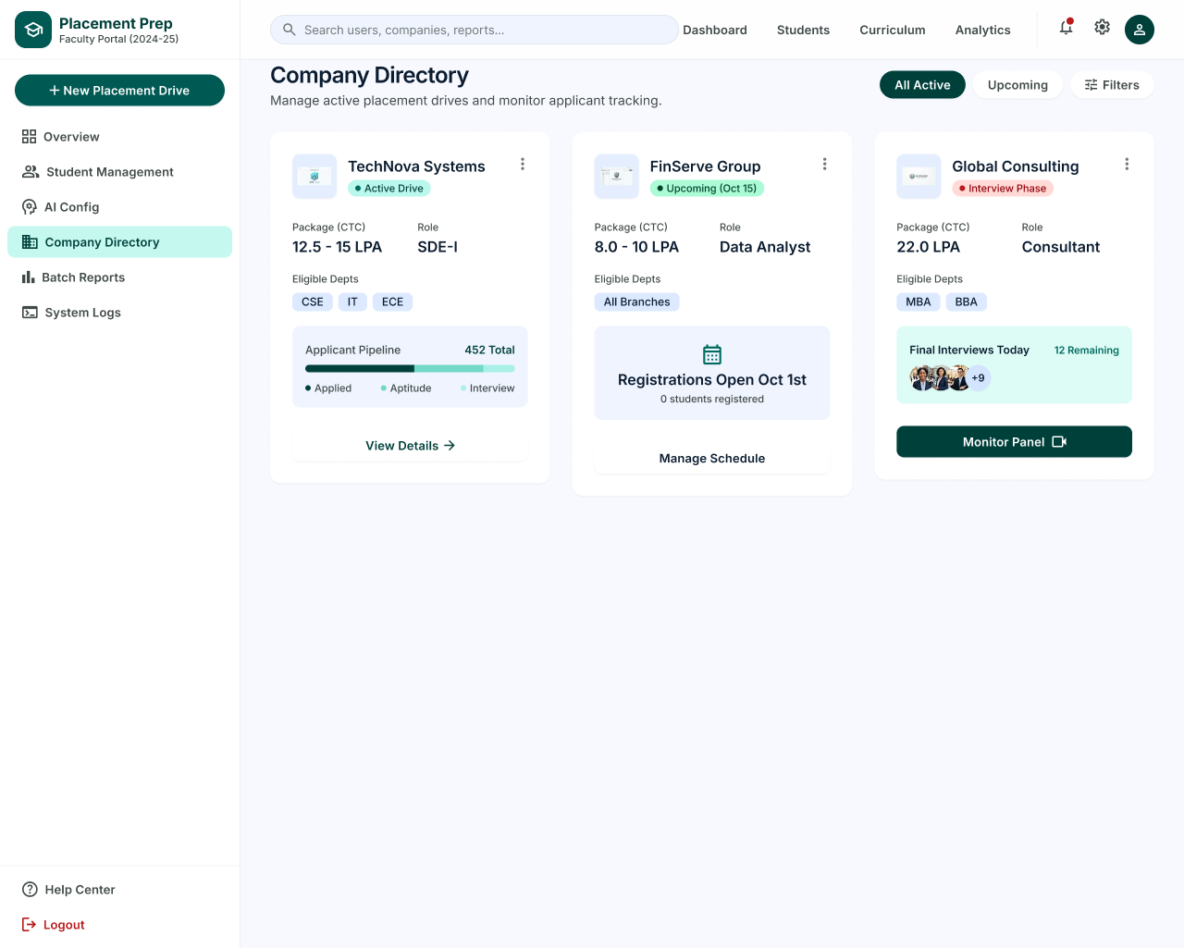
Description
The Company Directory page allows faculty to manage active placement drives and monitor applicant tracking for each visiting company.
Features
- Page Title and Description
- Drive Filters (All Active, Upcoming, Filters)
- Company Cards (TechNova Systems, FinServe Group, Global Consulting)
- Drive Status Badges (Active Drive, Upcoming, Interview Phase)
- Package (CTC) and Role
- Eligible Departments
- Applicant Pipeline (Applied, Aptitude, Interview) with Total Count
- View Details
- Registration Status for Upcoming Drive
- Manage Schedule
- Final Interviews Today with Remaining Count
- Monitor Panel
- Card Options Menu
Navigation
Sidebar → Company Directory
Company Directory → View Details
Company Directory → Manage Schedule
Company Directory → Monitor Panel
PAGE 31 — SYSTEM LOGS
Screen Name: System Logs
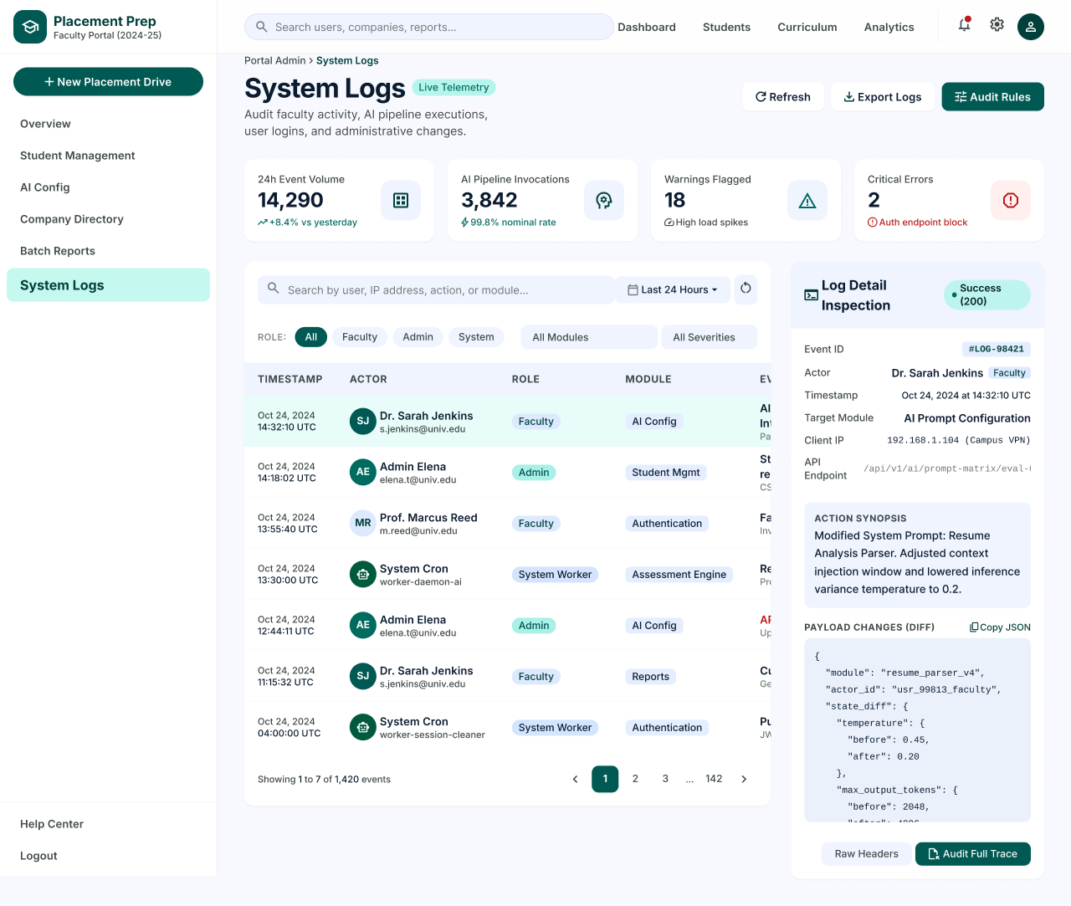
Description
The System Logs page lets faculty and administrators audit faculty activity, AI pipeline executions, user logins and administrative changes. A detail panel allows a single log event to be inspected in depth.
Features
- Breadcrumb (Portal Admin › System Logs) and Live Telemetry Tag
- Refresh
- Export Logs
- Audit Rules
- 24h Event Volume (14,290)
- AI Pipeline Invocations (3,842)
- Warnings Flagged (18)
- Critical Errors (2)
- Search by User, IP Address, Action or Module
- Time Filter (Last 24 Hours)
- Role Filters (All, Faculty, Admin, System)
- Module and Severity Filters
- Log Table (Timestamp, Actor, Role, Module, Event)
- Pagination (Showing 1 to 7 of 1,420 Events)
- Log Detail Inspection Panel (Event ID, Actor, Timestamp, Target Module, Client IP, API Endpoint)
- Action Synopsis
- Payload Changes (Diff) with Copy JSON
- Raw Headers
- Audit Full Trace
Navigation
Sidebar → System Logs
System Logs → Select Log Entry → Log Detail Inspection
System Logs → Export Logs / Audit Rules / Refresh
Log Detail Inspection → Raw Headers / Audit Full Trace
PAGE 32 — FACULTY HELP CENTER & DOCUMENTATION
Screen Name: Help Center & Documentation
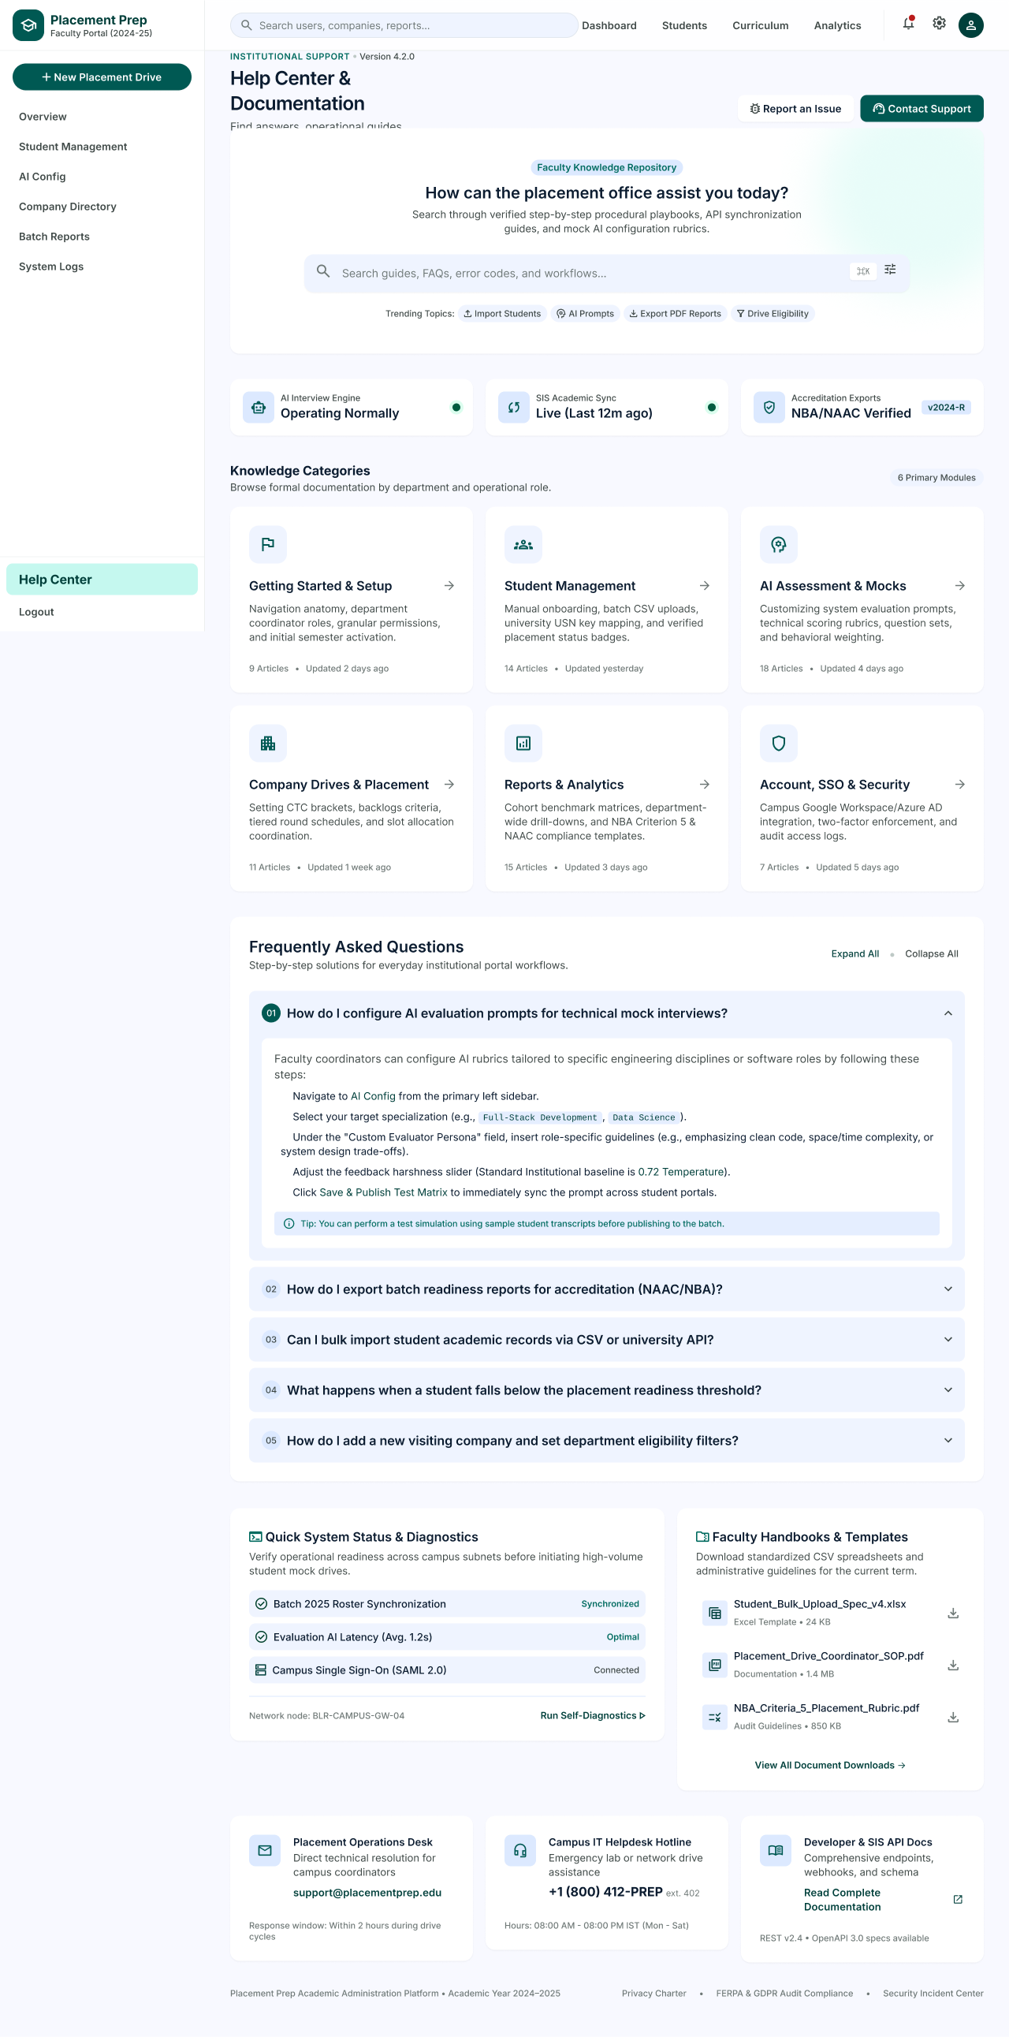
Description
The Faculty Help Center & Documentation page provides procedural guides, FAQs, system status and support contacts for placement office staff, so that coordinators can resolve common portal workflows without raising a request.
Features
- Institutional Support Header (Version 4.2.0)
- Report an Issue
- Contact Support
- Faculty Knowledge Repository Search with Trending Topics (Import Students, AI Prompts, Export PDF Reports, Drive Eligibility)
- System Status Cards (AI Interview Engine, SIS Academic Sync, Accreditation Exports)
- Knowledge Categories (Getting Started & Setup, Student Management, AI Assessment & Mocks, Company Drives & Placement, Reports & Analytics, Account, SSO & Security)
- Article Count and Last Updated Time per Category
- Frequently Asked Questions with Expand All / Collapse All
- Step-by-Step FAQ Answer with Tip
- Quick System Status & Diagnostics with Run Self-Diagnostics
- Faculty Handbooks & Templates (Downloads)
- View All Document Downloads
- Support Contacts (Placement Operations Desk, Campus IT Helpdesk Hotline, Developer & SIS API Docs)
- Footer Links (Privacy Charter, FERPA & GDPR Audit Compliance, Security Incident Center)
Navigation
Sidebar → Help Center
Help Center → Knowledge Categories / FAQs
Help Center → Report an Issue / Contact Support
Help Center → Run Self-Diagnostics / Document Downloads
PAGE 33 — EDIT PROFILE SETTINGS
Screen Name: Profile Settings – Edit Profile
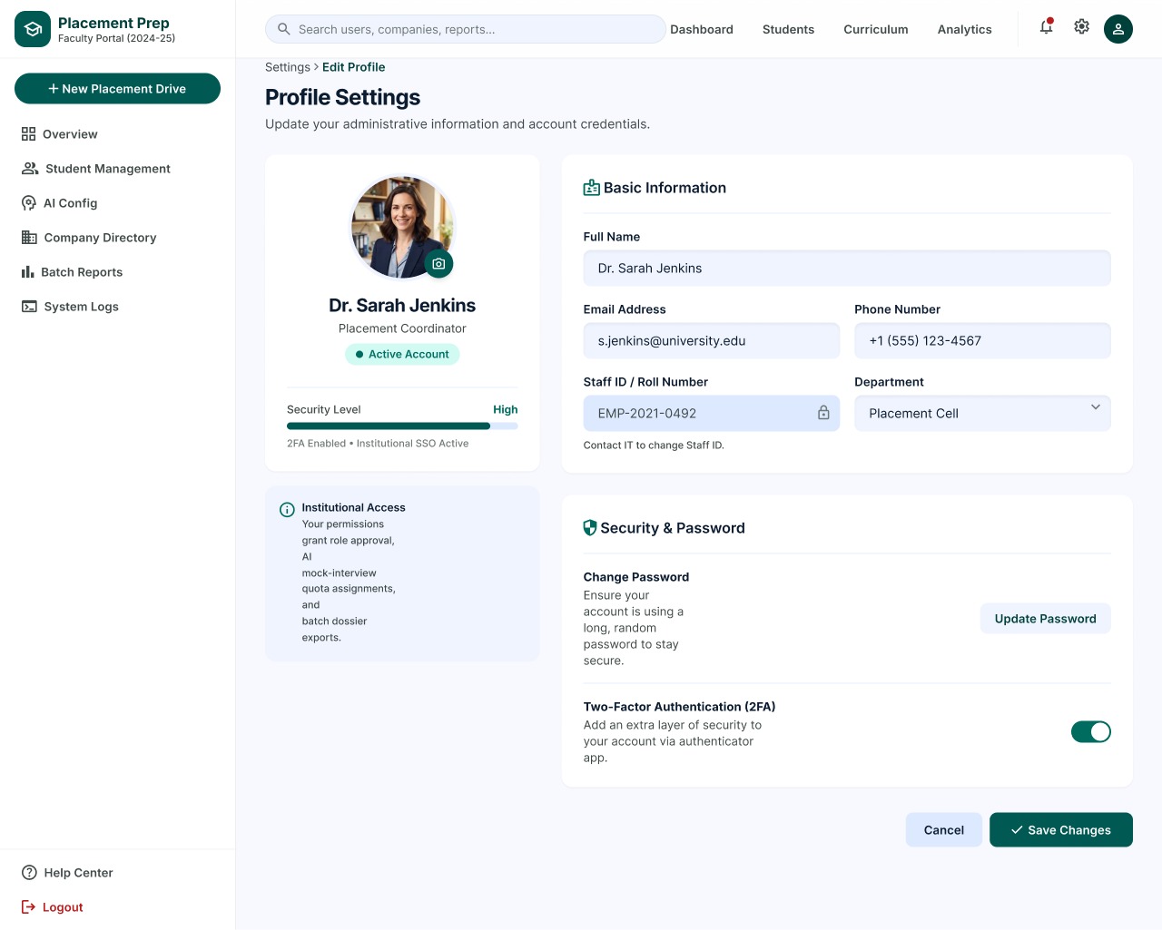
Description
The Profile Settings page allows faculty members to update their administrative information and account credentials, including password and two-factor authentication.
Features
- Breadcrumb (Settings › Edit Profile)
- Profile Photo with Change Option
- Name, Role and Active Account Status
- Security Level Indicator (2FA Enabled, Institutional SSO Active)
- Institutional Access Information
- Basic Information (Full Name, Email Address, Phone Number)
- Staff ID / Roll Number (Read-Only)
- Department
- Change Password with Update Password
- Two-Factor Authentication (2FA) Toggle
- Cancel
- Save Changes
Navigation
Profile Icon → Edit Profile → Profile Settings
Profile Settings → Update Password
Profile Settings → Save Changes / Cancel
ADMIN PANEL MODULE
PAGE 34 — PLATFORM OVERVIEW
Screen Name: Platform Overview
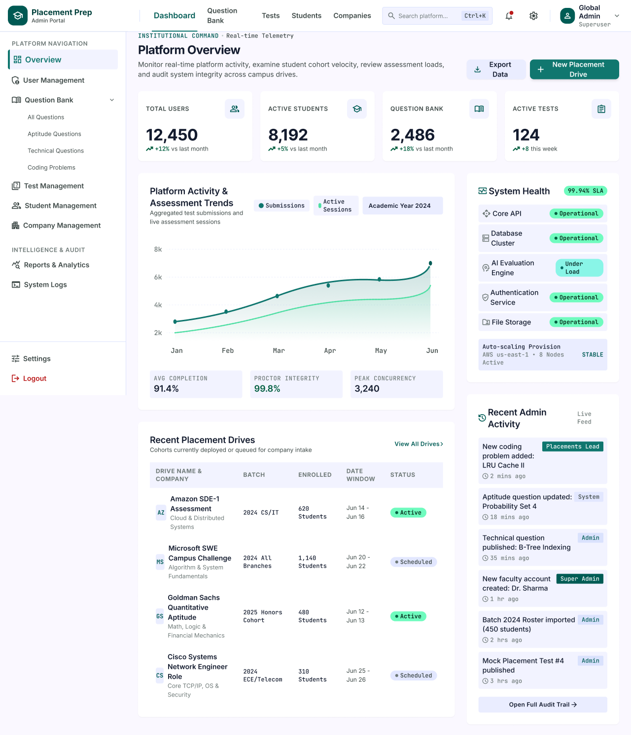
Description
The Platform Overview is the landing page of the Admin Portal for superusers. It lets administrators monitor real-time platform activity, examine student cohort velocity, review assessment loads and audit system integrity across campus drives.
Features
- Top Navigation (Dashboard, Question Bank, Tests, Students, Companies)
- Global Search (Ctrl+K), Notifications, Settings and Profile (Global Admin, Superuser)
- Sidebar Menu (Overview, User Management, Question Bank, Test Management, Student Management, Company Management, Reports & Analytics, System Logs)
- Question Bank Sub-Menu (All Questions, Aptitude Questions, Technical Questions, Coding Problems)
- Institutional Command Header with Real-time Telemetry
- Export Data
- New Placement Drive
- Summary Cards (Total Users 12,450, Active Students 8,192, Question Bank 2,486, Active Tests 124)
- Platform Activity & Assessment Trends Chart (Submissions, Active Sessions)
- Average Completion, Proctor Integrity and Peak Concurrency Metrics
- System Health (Core API, Database Cluster, AI Evaluation Engine, Authentication Service, File Storage) with SLA Indicator
- Auto-Scaling Provision Status
- Recent Placement Drives Table with View All Drives
- Recent Admin Activity Live Feed
- Open Full Audit Trail
- Settings and Logout
Navigation
Login → Platform Overview
Platform Overview → New Placement Drive / Export Data
Platform Overview → View All Drives → Placement Drive Management
Platform Overview → Open Full Audit Trail → System Logs
Platform Overview → Sidebar → User Management / Question Bank / Test Management / Student Management / Company Management / Reports & Analytics
PAGE 35 — USER MANAGEMENT
Screen Name: User Management
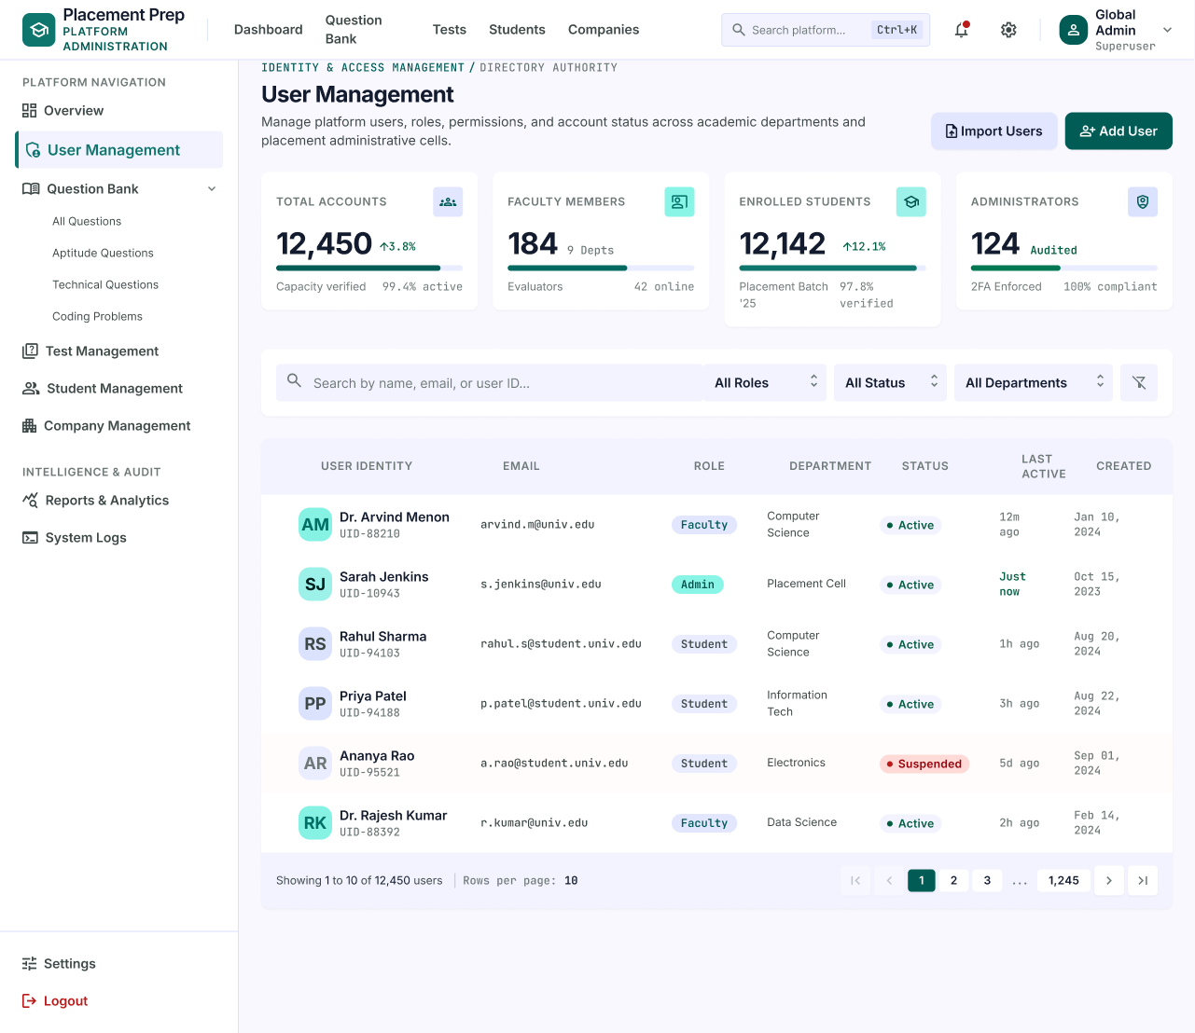
Description
The User Management page allows administrators to manage platform users, roles, permissions and account status across academic departments and placement administrative cells.
Features
- Identity & Access Management Header
- Import Users
- Add User
- Summary Cards (Total Accounts, Faculty Members, Enrolled Students, Administrators)
- Search by Name, Email or User ID
- Filters (All Roles, All Status, All Departments)
- Clear Filters
- User Table (User Identity, Email, Role, Department, Status, Last Active, Created)
- Role Badges (Faculty, Admin, Student)
- Status Badges (Active, Suspended)
- Pagination with Rows per Page (Showing 1 to 10 of 12,450 users)
Navigation
Platform Overview → Sidebar → User Management
User Management → Import Users / Add User
User Management → Search / Filters
PAGE 36 — CENTRAL QUESTION BANK
Screen Name: Central Question Bank
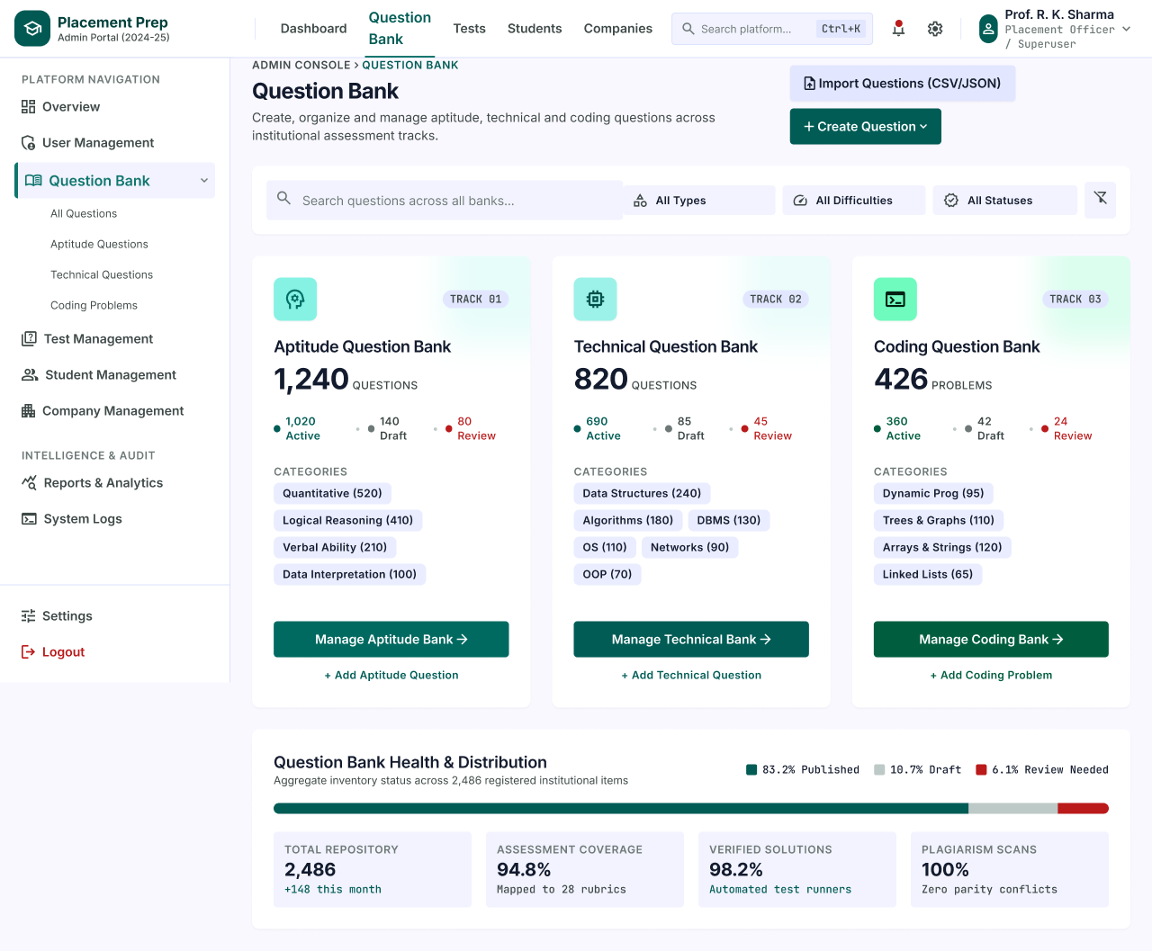
Description
The Central Question Bank page gives administrators a single view of all question banks used for placement assessments. It shows the size and status of the Aptitude, Technical and Coding banks and provides quick access to manage or add questions.
Features
- Breadcrumb (Admin Console › Question Bank)
- Import Questions (CSV/JSON)
- Create Question
- Search Questions across All Banks
- Filters (All Types, All Difficulties, All Statuses)
- Aptitude Question Bank (1,240 Questions; Active, Draft, Review Counts)
- Aptitude Categories (Quantitative, Logical Reasoning, Verbal Ability, Data Interpretation)
- Technical Question Bank (820 Questions; Active, Draft, Review Counts)
- Technical Categories (Data Structures, Algorithms, DBMS, OS, Networks, OOP)
- Coding Question Bank (426 Problems; Active, Draft, Review Counts)
- Coding Categories (Dynamic Prog, Trees & Graphs, Arrays & Strings, Linked Lists)
- Manage Aptitude / Technical / Coding Bank
- Add Aptitude Question / Add Technical Question / Add Coding Problem
- Question Bank Health & Distribution (Published, Draft, Review Needed)
- Repository Metrics (Total Repository, Assessment Coverage, Verified Solutions, Plagiarism Scans)
Navigation
Platform Overview → Sidebar → Question Bank → Central Question Bank
Central Question Bank → Manage Aptitude Bank / Manage Technical Bank / Manage Coding Bank
Central Question Bank → Create Question / Import Questions
Central Question Bank → Create Assessment → Select Questions
PAGE 37 — QUESTION BANK
Screen Name: Question Bank
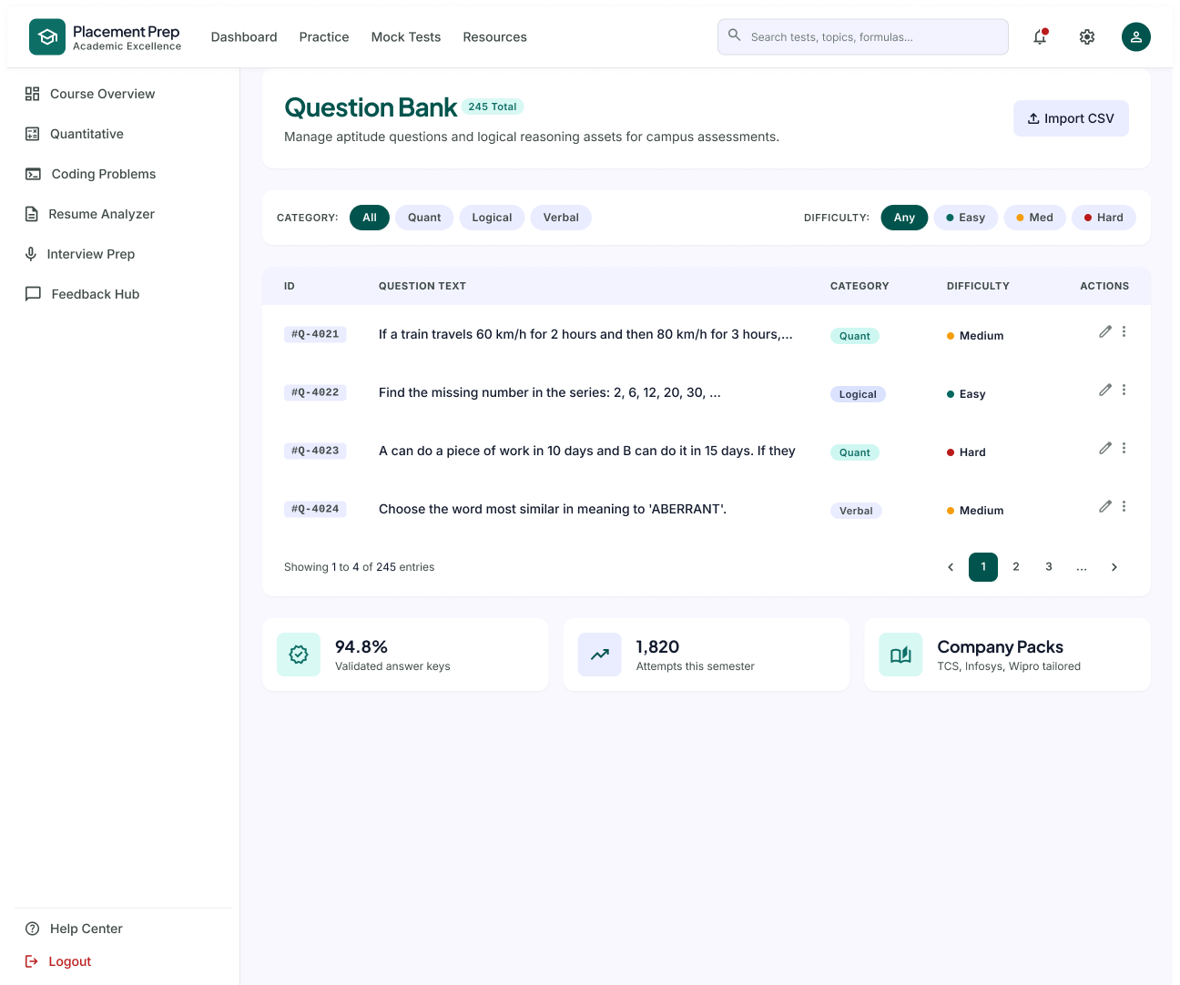
Description
The Question Bank page allows administrators to manage aptitude questions and logical reasoning assets used for campus assessments. Questions can be filtered by category and difficulty, edited, or imported in bulk.
Features
- Total Question Count
- Import CSV
- Category Filter (All, Quant, Logical, Verbal)
- Difficulty Filter (Any, Easy, Medium, Hard)
- Question ID
- Question Text
- Category
- Difficulty
- Edit and More Actions
- Pagination
- Validated Answer Keys
- Attempts This Semester
- Company Packs
Navigation
Dashboard → Question Bank
Question Bank → Import CSV / Edit Question
Central Question Bank → Manage Aptitude Bank → Question Bank
PAGE 38 — TEST MANAGEMENT
Screen Name: Test Management
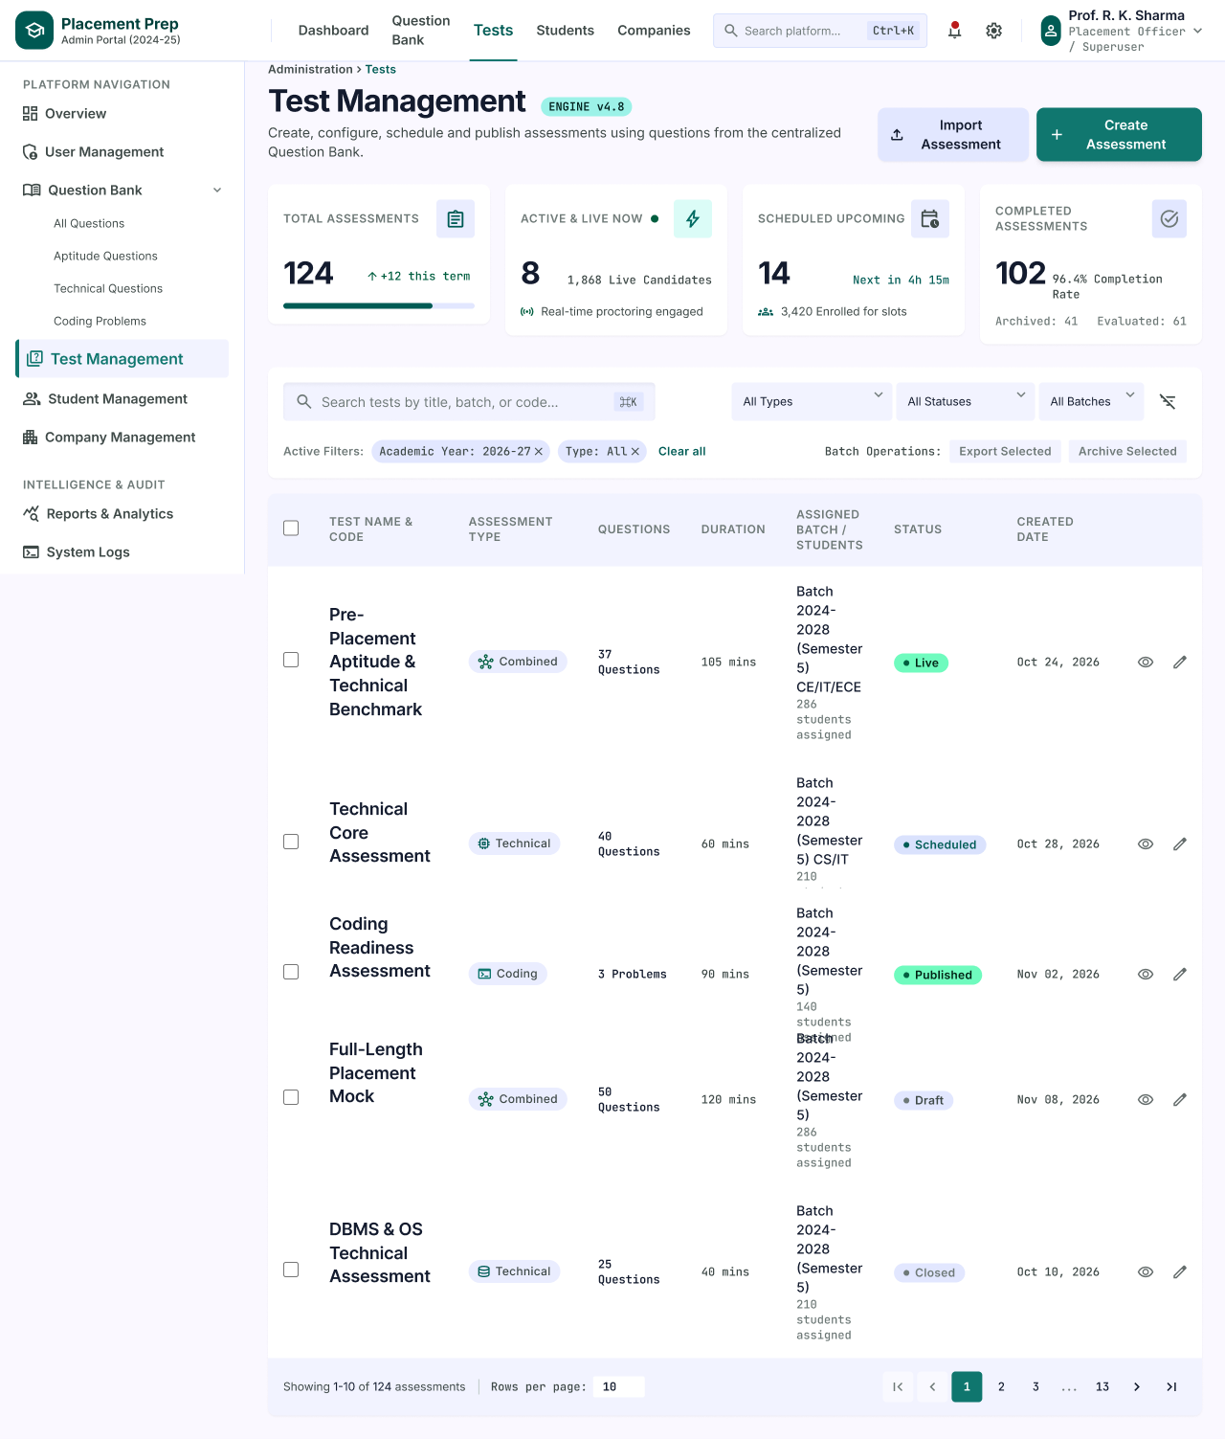
Description
The Test Management page lets administrators create, configure, schedule and publish assessments using questions from the centralized Question Bank. It lists all assessments with their type, duration, assigned batches and current status.
Features
- Breadcrumb (Administration › Tests) and Engine Version
- Import Assessment
- Create Assessment
- Summary Cards (Total Assessments, Active & Live Now, Scheduled Upcoming, Completed Assessments)
- Live Candidate Count with Real-time Proctoring Status
- Search Tests by Title, Batch or Code
- Filters (All Types, All Statuses, All Batches)
- Active Filter Chips with Clear All
- Batch Operations (Export Selected, Archive Selected)
- Assessment Table (Test Name & Code, Assessment Type, Questions, Duration, Assigned Batch / Students, Status, Created Date)
- Status Badges (Live, Scheduled, Published, Draft, Closed)
- View and Edit Actions
- Pagination with Rows per Page (Showing 1-10 of 124 assessments)
Navigation
Platform Overview → Sidebar → Test Management
Test Management → Create Assessment → Create Assessment
Test Management → View → Test Details
Test Management → Edit / Import Assessment
PAGE 39 — CREATE ASSESSMENT
Screen Name: Create Assessment
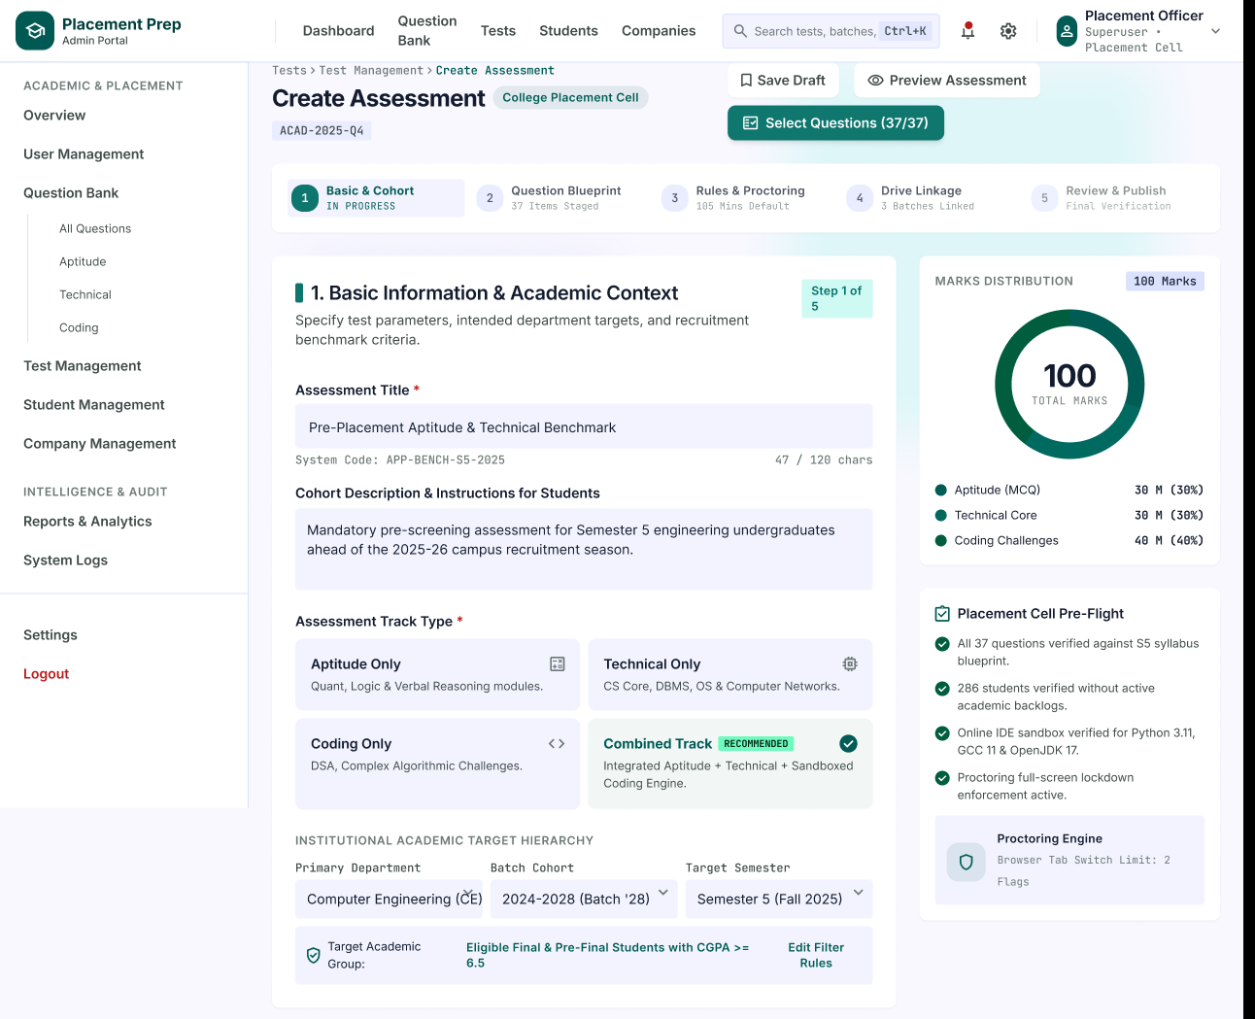
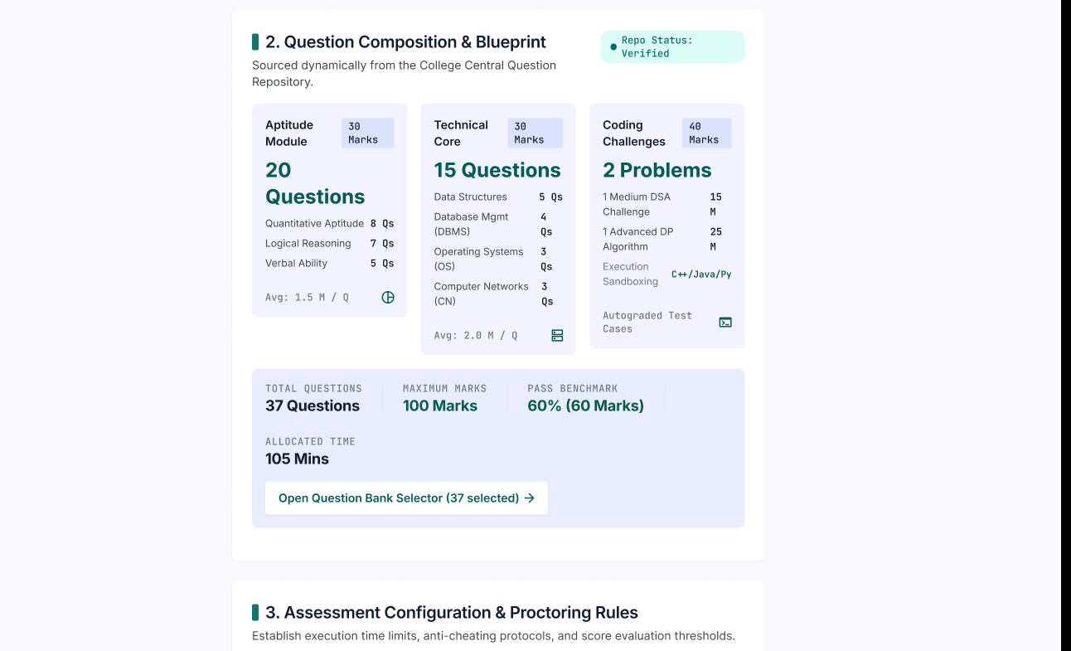
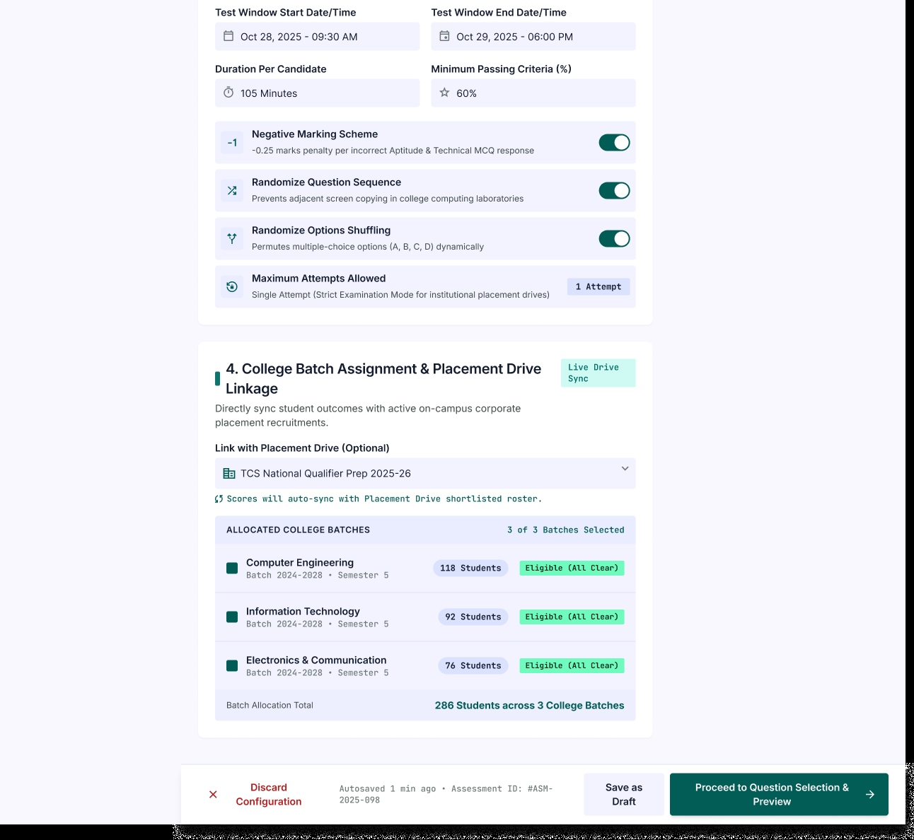
Description
The Create Assessment page is a step-by-step form for setting up a new placement assessment. Administrators define the basic information, question blueprint, proctoring rules and batch or drive linkage, while a side panel shows marks distribution and pre-flight checks.
Features
- Breadcrumb (Tests › Test Management › Create Assessment)
- Save Draft
- Preview Assessment
- Select Questions (37/37)
- Five-Step Progress Indicator (Basic & Cohort, Question Blueprint, Rules & Proctoring, Drive Linkage, Review & Publish)
- Basic Information (Assessment Title, System Code, Cohort Description & Instructions)
- Assessment Track Type (Aptitude Only, Technical Only, Coding Only, Combined Track)
- Institutional Academic Target Hierarchy (Primary Department, Batch Cohort, Target Semester)
- Target Academic Group with Edit Filter Rules
- Question Composition & Blueprint (Aptitude Module, Technical Core, Coding Challenges)
- Totals (Total Questions, Maximum Marks, Pass Benchmark, Allocated Time)
- Open Question Bank Selector
- Assessment Configuration & Proctoring Rules (Test Window Start/End, Duration, Minimum Passing Criteria)
- Negative Marking, Randomize Question Sequence, Randomize Options Shuffling, Maximum Attempts
- College Batch Assignment & Placement Drive Linkage
- Allocated College Batches with Eligibility Status
- Marks Distribution Chart
- Placement Cell Pre-Flight Checklist
- Proctoring Engine Summary
- Discard Configuration, Save as Draft, Proceed to Question Selection & Preview
Navigation
Test Management → Create Assessment → Create Assessment
Create Assessment → Select Questions / Proceed to Question Selection & Preview → Question Selection
Create Assessment → Save Draft / Preview Assessment
Create Assessment → Discard Configuration → Test Management
PAGE 40 — QUESTION SELECTION
Screen Name: Question Selection
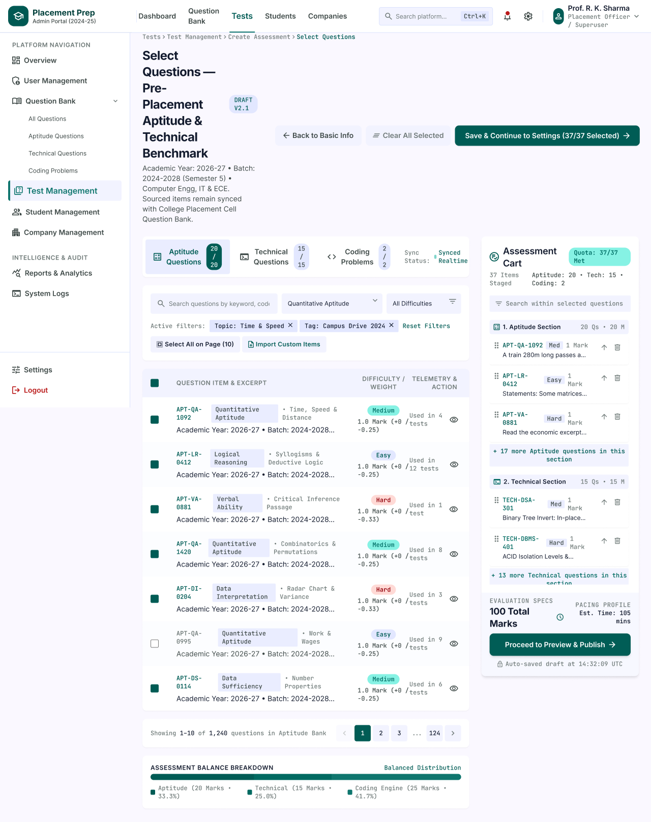
Description
The Question Selection page lets administrators choose the questions for an assessment from the Question Bank. Questions are filtered by category, topic and difficulty and added to an assessment cart that tracks the quota for each section.
Features
- Breadcrumb (Tests › Test Management › Create Assessment › Select Questions)
- Assessment Title with Draft Version
- Back to Basic Info
- Clear All Selected
- Save & Continue to Settings (37/37 Selected)
- Section Tabs (Aptitude Questions, Technical Questions, Coding Problems) with Selected Counts
- Bank Sync Status
- Search by Keyword or Code
- Topic and Difficulty Filters
- Active Filter Chips with Reset Filters
- Select All on Page
- Import Custom Items
- Question Table (Question ID and Excerpt, Category and Topic, Difficulty, Marks and Negative Marking, Usage Count)
- Question Preview
- Pagination (Showing 1-10 of 1,240 questions)
- Assessment Balance Breakdown (Aptitude, Technical, Coding)
- Assessment Cart with Quota Status
- Cart Sections with Reorder and Remove Actions
- Search within Selected Questions
- Evaluation Specs (Total Marks, Estimated Time)
- Proceed to Preview & Publish
- Auto-Saved Draft Time
Navigation
Create Assessment → Proceed to Question Selection & Preview → Question Selection
Question Selection → Back to Basic Info → Create Assessment
Question Selection → Save & Continue to Settings
Question Selection → Proceed to Preview & Publish → Assessment Preview & Publish
PAGE 41 — ASSESSMENT PREVIEW & PUBLISH
Screen Name: Assessment Preview and Publish
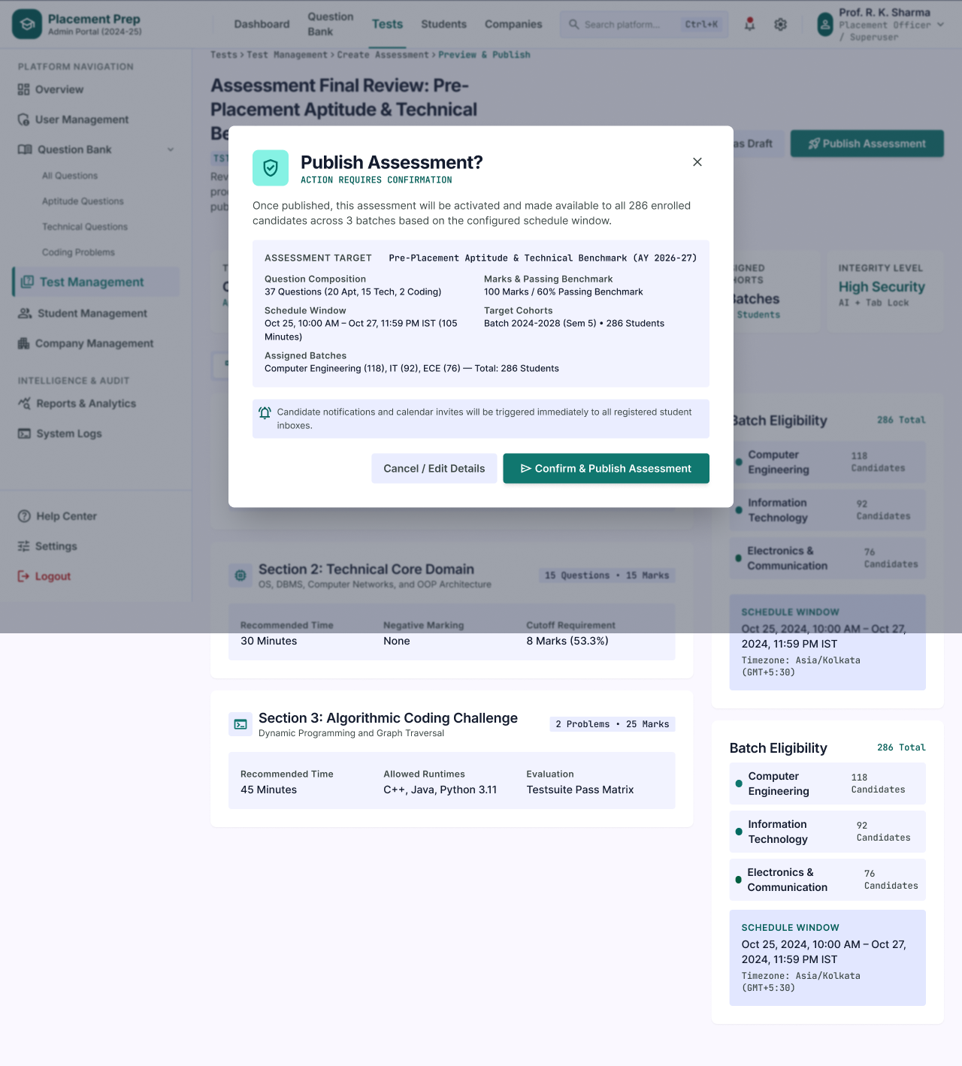
Description
The Assessment Preview & Publish page is the final review step before an assessment goes live. A confirmation dialog summarises the assessment and asks the administrator to confirm before it is published to all assigned candidates.
Features
- Breadcrumb (Tests › Test Management › Create Assessment › Preview & Publish)
- Assessment Final Review Header
- Save as Draft
- Publish Assessment
- Publish Assessment Confirmation Dialog
- Assessment Target Summary
- Question Composition (Aptitude, Technical, Coding)
- Marks & Passing Benchmark
- Schedule Window
- Target Cohorts
- Assigned Batches (Computer Engineering, IT, ECE) with Total Students
- Candidate Notification and Calendar Invite Notice
- Cancel / Edit Details
- Confirm & Publish Assessment
- Review Sections (Technical Core Domain, Algorithmic Coding Challenge)
- Integrity Level
- Batch Eligibility
- Schedule Window and Timezone
Navigation
Question Selection → Proceed to Preview & Publish → Assessment Preview & Publish
Assessment Preview & Publish → Confirm & Publish Assessment → Test Management
Assessment Preview & Publish → Cancel / Edit Details → Create Assessment
Assessment Preview & Publish → Save as Draft
PAGE 42 — TEST DETAILS
Screen Name: Test Details
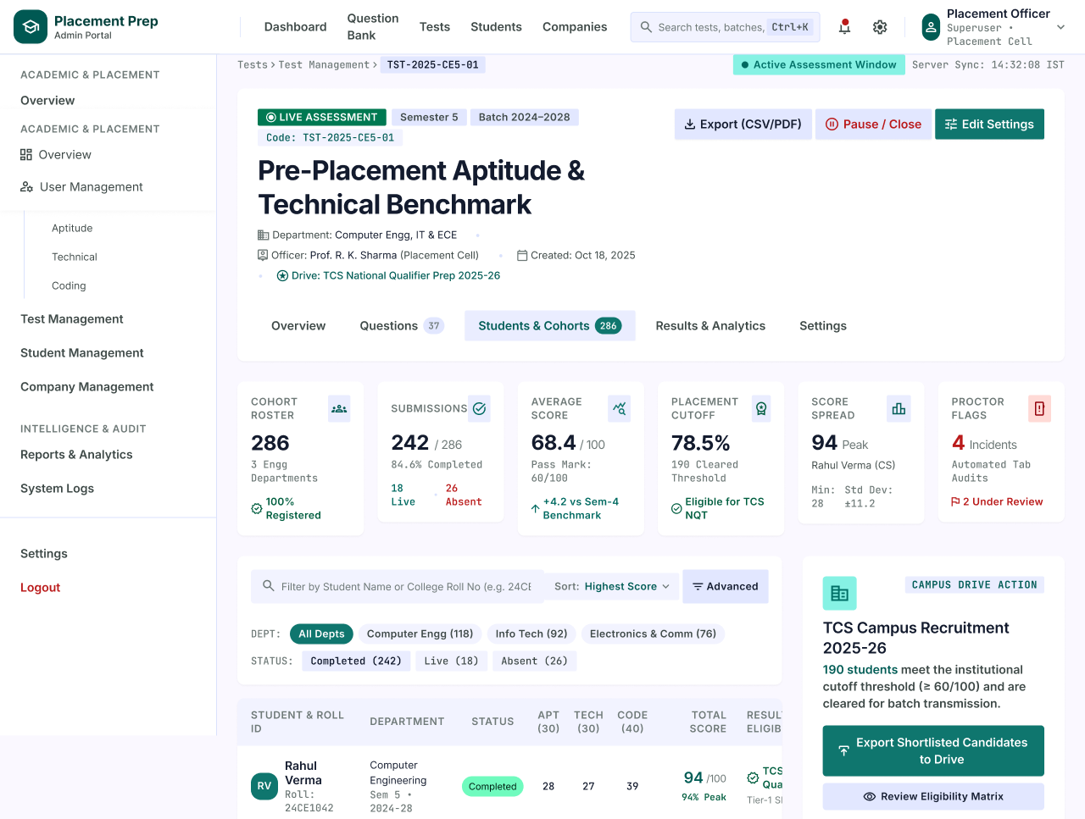
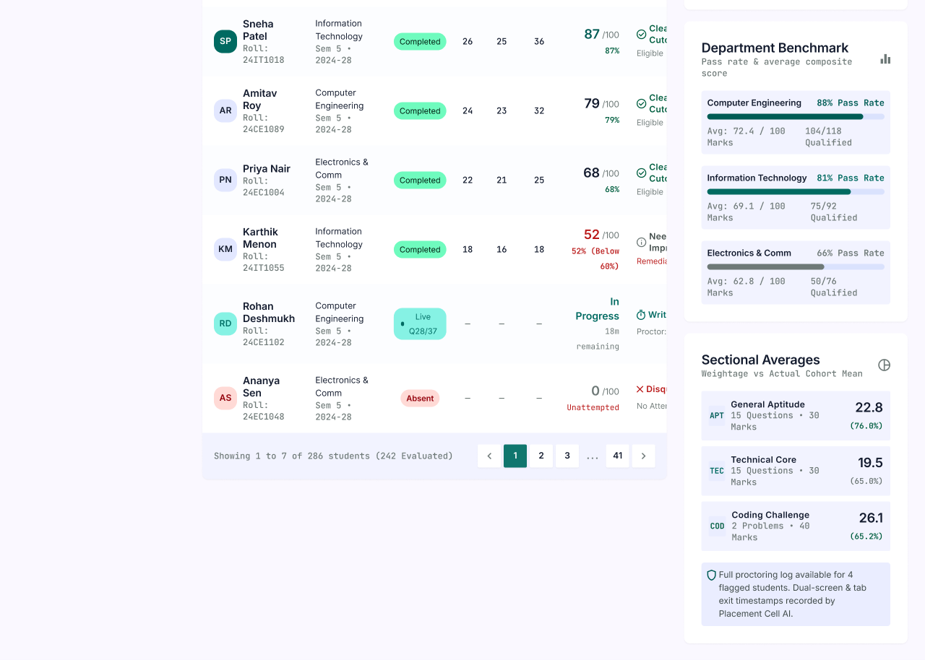
Description
The Test Details page shows the full status of a single assessment. Administrators can see submissions, scores, proctoring flags and student results, review department benchmarks, and export shortlisted candidates to a campus drive.
Features
- Breadcrumb (Tests › Test Management › Test Code)
- Active Assessment Window and Server Sync Time
- Live Assessment, Semester and Batch Tags
- Assessment Title and Code
- Export (CSV/PDF)
- Pause / Close
- Edit Settings
- Assessment Details (Department, Officer, Created Date, Linked Drive)
- Tabs (Overview, Questions, Students & Cohorts, Results & Analytics, Settings)
- Summary Cards (Cohort Roster, Submissions, Average Score, Placement Cutoff, Score Spread, Proctor Flags)
- Filter by Student Name or Roll Number
- Sort (Highest Score) and Advanced Filters
- Department Filters (All Depts, Computer Engg, Info Tech, Electronics & Comm)
- Status Filters (Completed, Live, Absent)
- Student Results Table (Student & Roll ID, Department, Status, Aptitude, Technical, Coding, Total Score, Result / Eligibility)
- Pagination (Showing 1 to 7 of 286 students)
- Campus Drive Action (Export Shortlisted Candidates to Drive, Review Eligibility Matrix)
- Department Benchmark (Pass Rate and Qualified Count)
- Sectional Averages (General Aptitude, Technical Core, Coding Challenge)
- Proctoring Log Notice
Navigation
Test Management → View → Test Details
Test Details → Export (CSV/PDF) / Pause / Close / Edit Settings
Test Details → Export Shortlisted Candidates to Drive → Placement Drive Details
Test Details → Students & Cohorts → Student Details
PAGE 43 — STUDENT MANAGEMENT (ADMIN)
Screen Name: Student Management
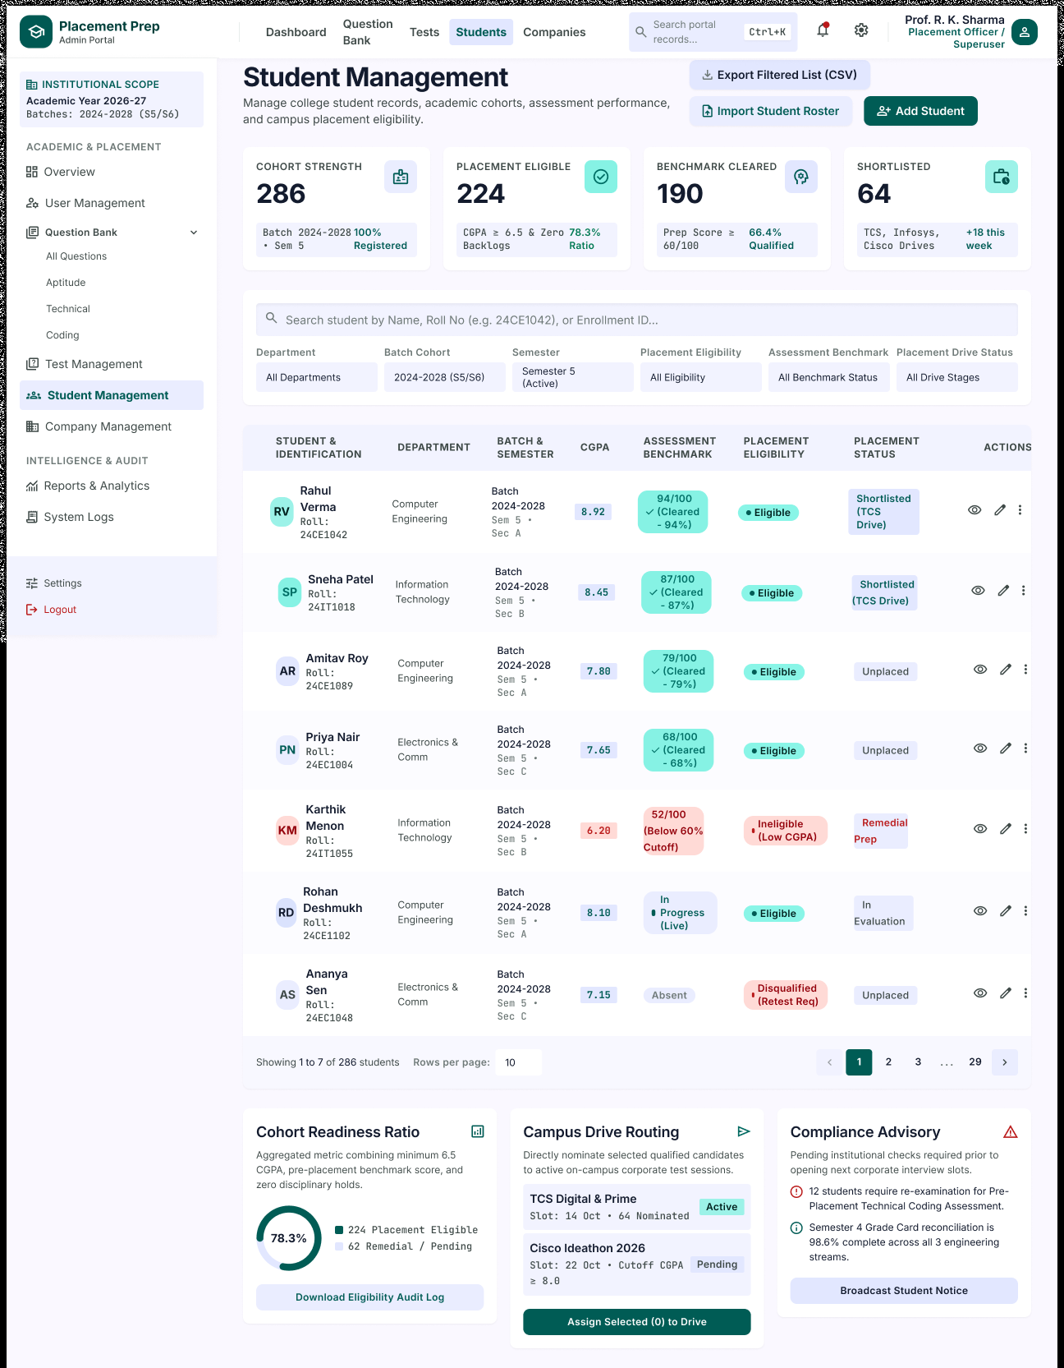
Description
The Student Management page in the Admin Portal lets administrators manage college student records, academic cohorts, assessment performance and campus placement eligibility.
Features
- Institutional Scope Panel (Academic Year and Batches)
- Export Filtered List (CSV)
- Import Student Roster
- Add Student
- Summary Cards (Cohort Strength, Placement Eligible, Benchmark Cleared, Shortlisted)
- Search by Name, Roll Number or Enrollment ID
- Filters (Department, Batch Cohort, Semester, Placement Eligibility, Assessment Benchmark, Placement Drive Status)
- Student Table (Student & Identification, Department, Batch & Semester, CGPA, Assessment Benchmark, Placement Eligibility, Placement Status, Actions)
- Eligibility and Placement Status Badges
- View, Edit and More Actions
- Pagination with Rows per Page (Showing 1 to 7 of 286 students)
- Cohort Readiness Ratio with Download Eligibility Audit Log
- Campus Drive Routing with Assign Selected to Drive
- Compliance Advisory with Broadcast Student Notice
Navigation
Platform Overview → Sidebar → Student Management
Student Management → View → Student Details
Student Management → Add Student / Import Student Roster / Export Filtered List
Student Management → Assign Selected to Drive
PAGE 44 — STUDENT DETAILS
Screen Name: Student Details
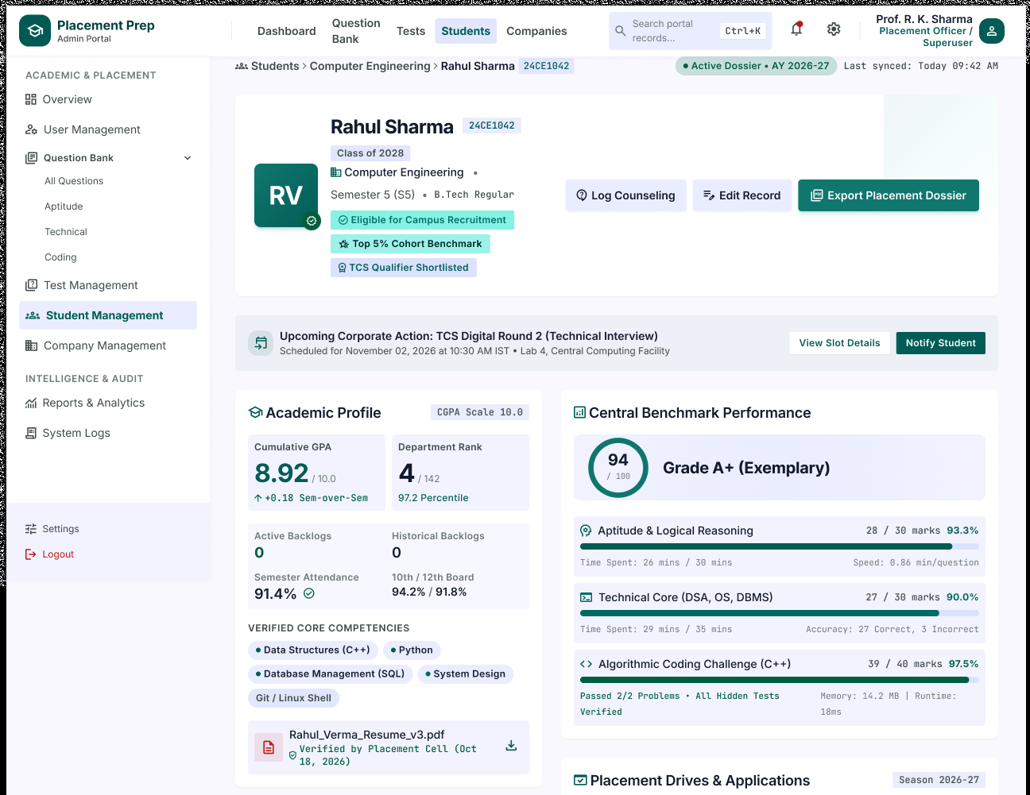
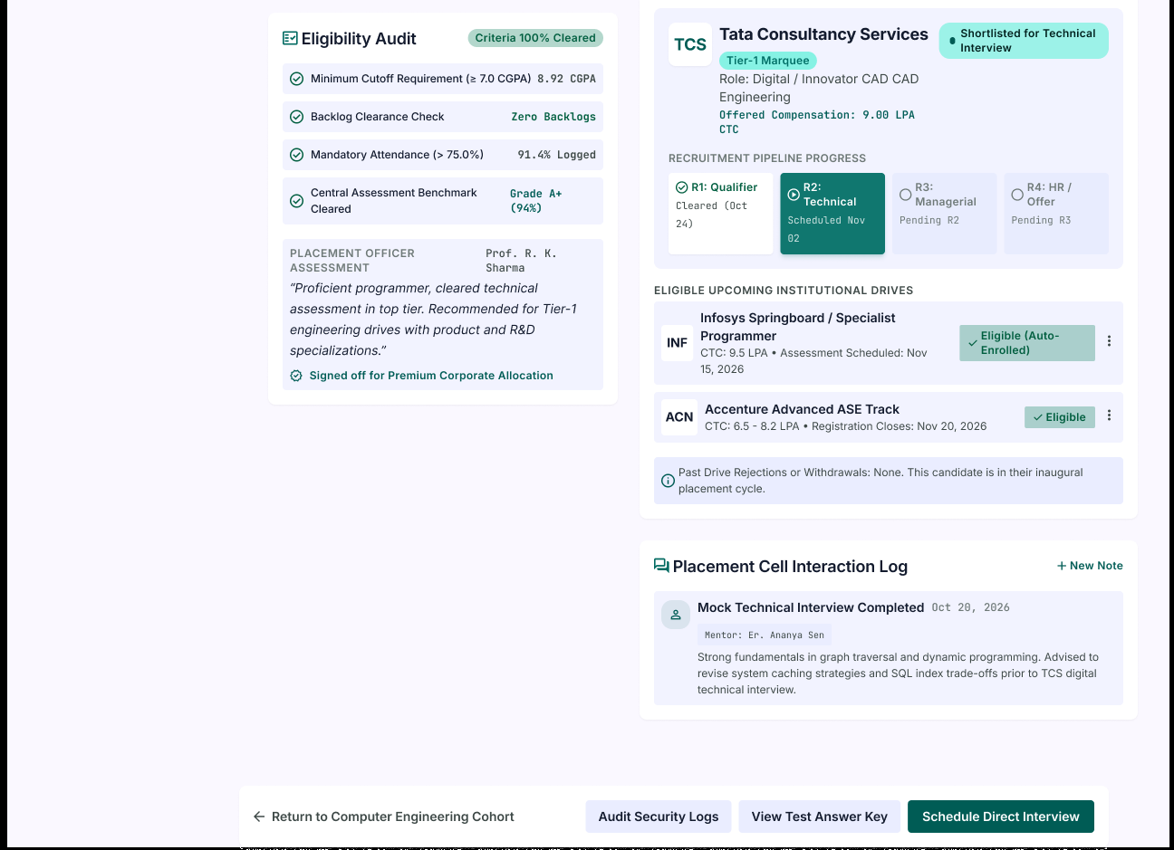
Description
The Student Details page shows the complete placement dossier of one student, including academic profile, eligibility audit, central benchmark performance, drive applications and the placement cell interaction log.
Features
- Breadcrumb (Students › Department › Student Name and Roll Number)
- Active Dossier Status and Last Synced Time
- Student Header (Name, Class, Department, Semester, Programme)
- Status Badges (Eligible for Campus Recruitment, Top 5% Cohort Benchmark, TCS Qualifier Shortlisted)
- Log Counseling
- Edit Record
- Export Placement Dossier
- Upcoming Corporate Action Banner with View Slot Details and Notify Student
- Academic Profile (Cumulative GPA, Department Rank, Backlogs, Attendance, 10th / 12th Marks)
- Verified Core Competencies
- Verified Resume Download
- Eligibility Audit (Minimum Cutoff, Backlog Clearance, Attendance, Benchmark Cleared)
- Placement Officer Assessment
- Central Benchmark Performance (Overall Grade, Aptitude, Technical Core, Coding Challenge)
- Placement Drives & Applications with Recruitment Pipeline Progress
- Eligible Upcoming Institutional Drives
- Past Drive Rejections Notice
- Placement Cell Interaction Log with New Note
- Return to Cohort, Audit Security Logs, View Test Answer Key, Schedule Direct Interview
Navigation
Student Management → View → Student Details
Student Details → Log Counseling / Edit Record / Export Placement Dossier
Student Details → View Slot Details / Notify Student
Student Details → View Test Answer Key / Audit Security Logs / Schedule Direct Interview
Student Details → Return to Cohort → Student Management
PAGE 45 — COMPANY MANAGEMENT
Screen Name: Company Management
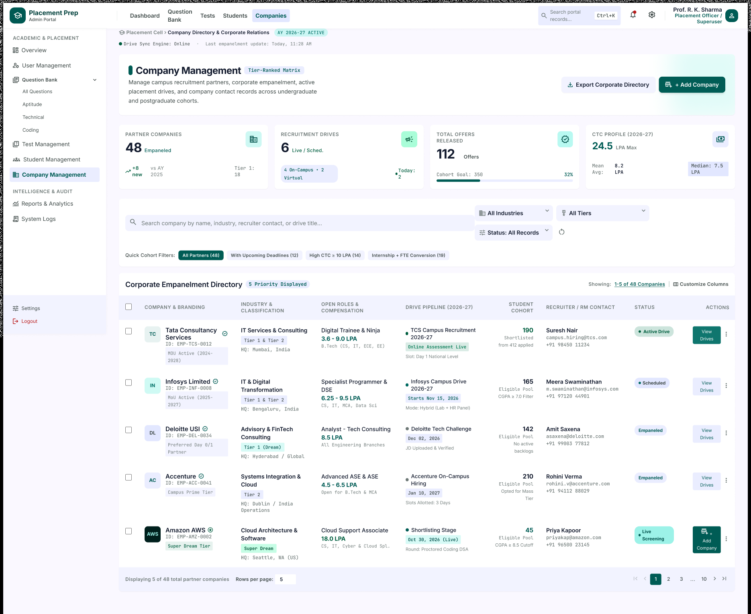
Description
The Company Management page lets administrators manage campus recruitment partners, corporate empanelment, active placement drives and company contact records across undergraduate and postgraduate cohorts.
Features
- Breadcrumb (Placement Cell › Company Directory & Corporate Relations) with Academic Year Tag
- Drive Sync Engine Status and Last Empanelment Update
- Tier-Ranked Matrix Tag
- Export Corporate Directory
- Add Company
- Summary Cards (Partner Companies, Recruitment Drives, Total Offers Released, CTC Profile)
- Search by Company, Industry, Recruiter Contact or Drive Title
- Filters (All Industries, All Tiers, Status: All Records)
- Quick Cohort Filters (All Partners, With Upcoming Deadlines, High CTC, Internship + FTE Conversion)
- Corporate Empanelment Directory with Customize Columns
- Directory Table (Company & Branding, Industry & Classification, Open Roles & Compensation, Drive Pipeline, Student Cohort, Recruiter / RM Contact, Status, Actions)
- Tier Tags and MoU Status
- View Drives and More Actions
- Pagination with Rows per Page (Displaying 5 of 48 partner companies)
Navigation
Platform Overview → Sidebar → Company Management
Company Management → View Drives → Placement Drive Management
Company Management → Add Company / Export Corporate Directory
Company Management → Search / Filters
PAGE 46 — PLACEMENT DRIVE MANAGEMENT
Screen Name: Placement Drive Management
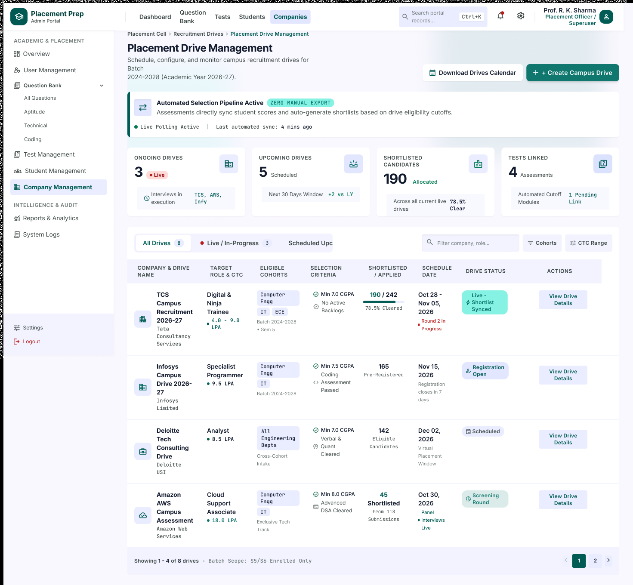
Description
The Placement Drive Management page lets administrators schedule, configure and monitor campus recruitment drives. Assessment scores are synced automatically to generate shortlists based on each drive's eligibility cutoffs.
Features
- Breadcrumb (Placement Cell › Recruitment Drives › Placement Drive Management)
- Download Drives Calendar
- Create Campus Drive
- Automated Selection Pipeline Notice (Live Polling and Last Sync)
- Summary Cards (Ongoing Drives, Upcoming Drives, Shortlisted Candidates, Tests Linked)
- Drive Tabs (All Drives, Live / In-Progress, Scheduled / Upcoming)
- Filter by Company or Role
- Cohorts and CTC Range Filters
- Drive Table (Company & Drive Name, Target Role & CTC, Eligible Cohorts, Selection Criteria, Shortlisted / Applied, Schedule Date, Drive Status, Actions)
- Drive Status Badges (Live, Registration Open, Scheduled, Screening Round)
- View Drive Details
- Pagination (Showing 1-4 of 8 drives) with Batch Scope Note
Navigation
Platform Overview → View All Drives → Placement Drive Management
Company Management → View Drives → Placement Drive Management
Placement Drive Management → View Drive Details → Placement Drive Details
Placement Drive Management → Create Campus Drive / Download Drives Calendar
PAGE 47 — PLACEMENT DRIVE DETAILS
Screen Name: Placement Drive Details
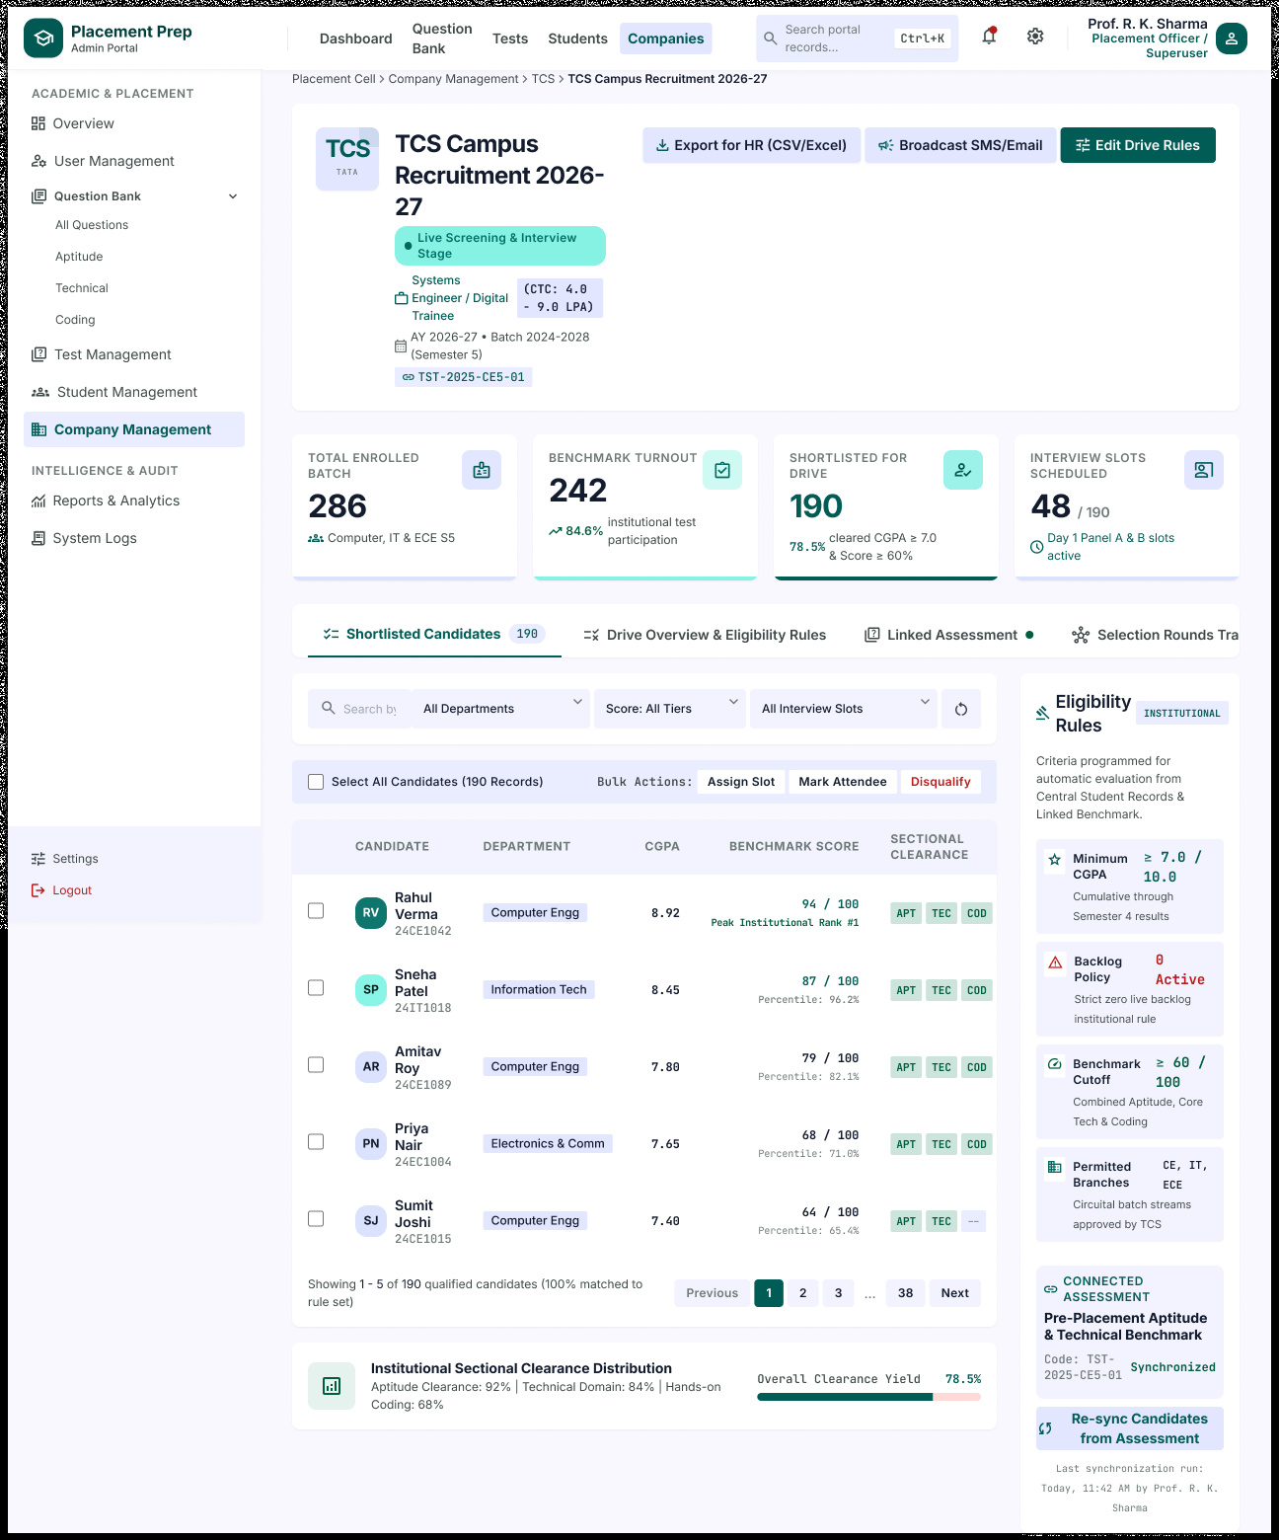
Description
The Placement Drive Details page shows the complete status of one recruitment drive. Administrators can review shortlisted candidates, eligibility rules, the linked assessment and interview slots, and take bulk actions on candidates.
Features
- Breadcrumb (Placement Cell › Company Management › Company › Drive Name)
- Company Logo, Drive Title and Stage Tag
- Role, CTC Range, Academic Year and Linked Test Code
- Export for HR (CSV/Excel)
- Broadcast SMS/Email
- Edit Drive Rules
- Summary Cards (Total Enrolled Batch, Benchmark Turnout, Shortlisted for Drive, Interview Slots Scheduled)
- Tabs (Shortlisted Candidates, Drive Overview & Eligibility Rules, Linked Assessment, Selection Rounds Tracking)
- Search and Filters (Department, Score Tier, Interview Slots)
- Select All Candidates with Bulk Actions (Assign Slot, Mark Attendee, Disqualify)
- Candidate Table (Candidate, Department, CGPA, Benchmark Score, Sectional Clearance)
- Pagination (Showing 1 - 5 of 190 qualified candidates)
- Institutional Sectional Clearance Distribution and Overall Clearance Yield
- Eligibility Rules (Minimum CGPA, Backlog Policy, Benchmark Cutoff, Permitted Branches)
- Connected Assessment with Synchronization Status
- Re-sync Candidates from Assessment
- Last Synchronization Run
Navigation
Placement Drive Management → View Drive Details → Placement Drive Details
Placement Drive Details → Linked Assessment → Test Details
Placement Drive Details → Export for HR / Broadcast SMS/Email / Edit Drive Rules
Placement Drive Details → Assign Slot / Mark Attendee / Disqualify
Placement Drive Details → Re-sync Candidates from Assessment
PAGE 48 — REPORTS & ANALYTICS (ADMIN)
Screen Name: Reports & Analytics
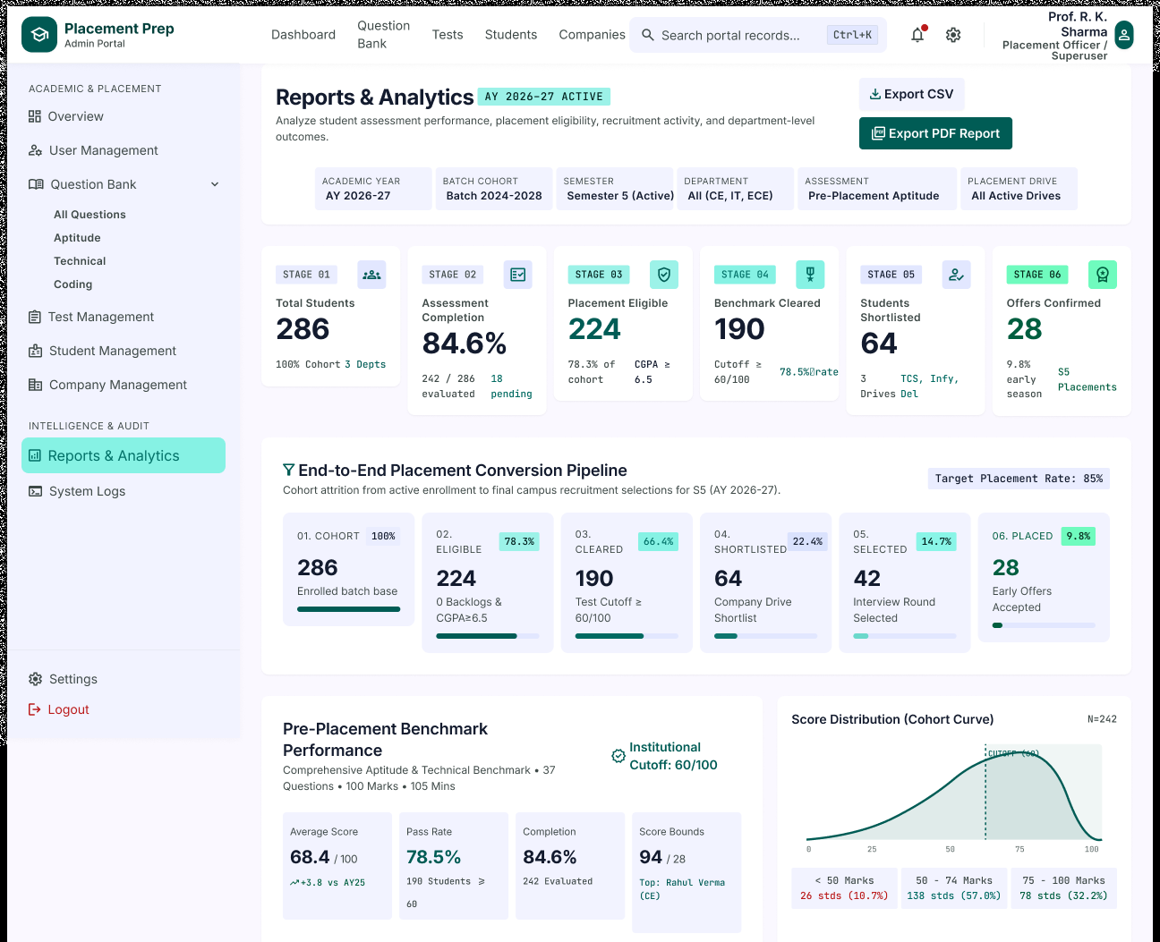
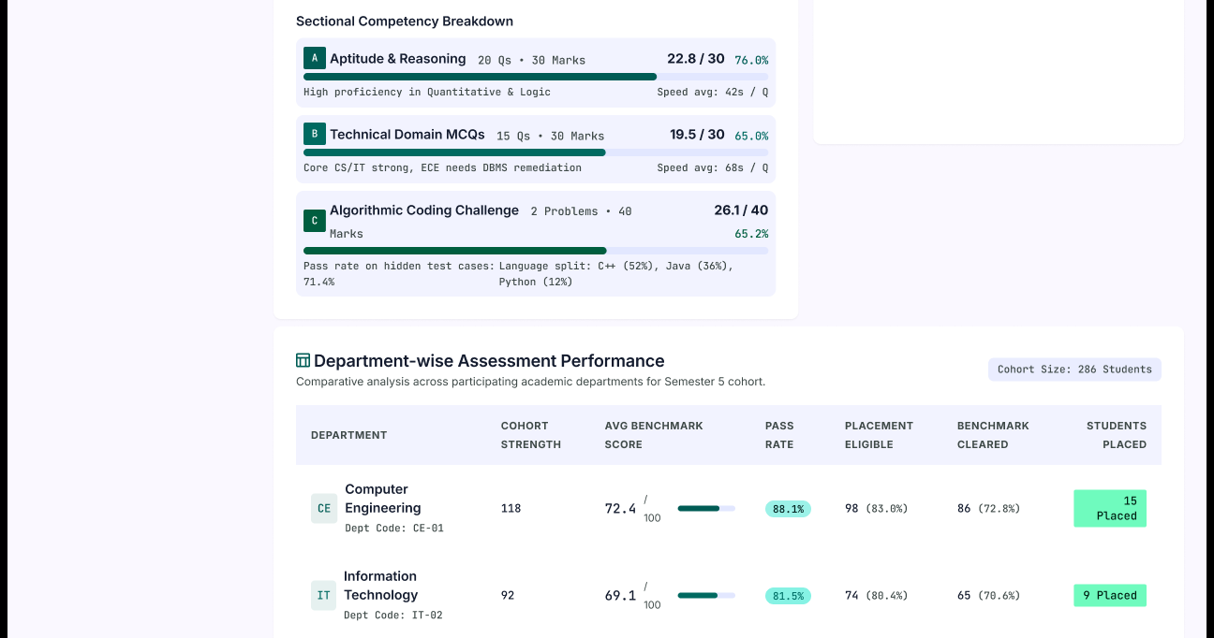
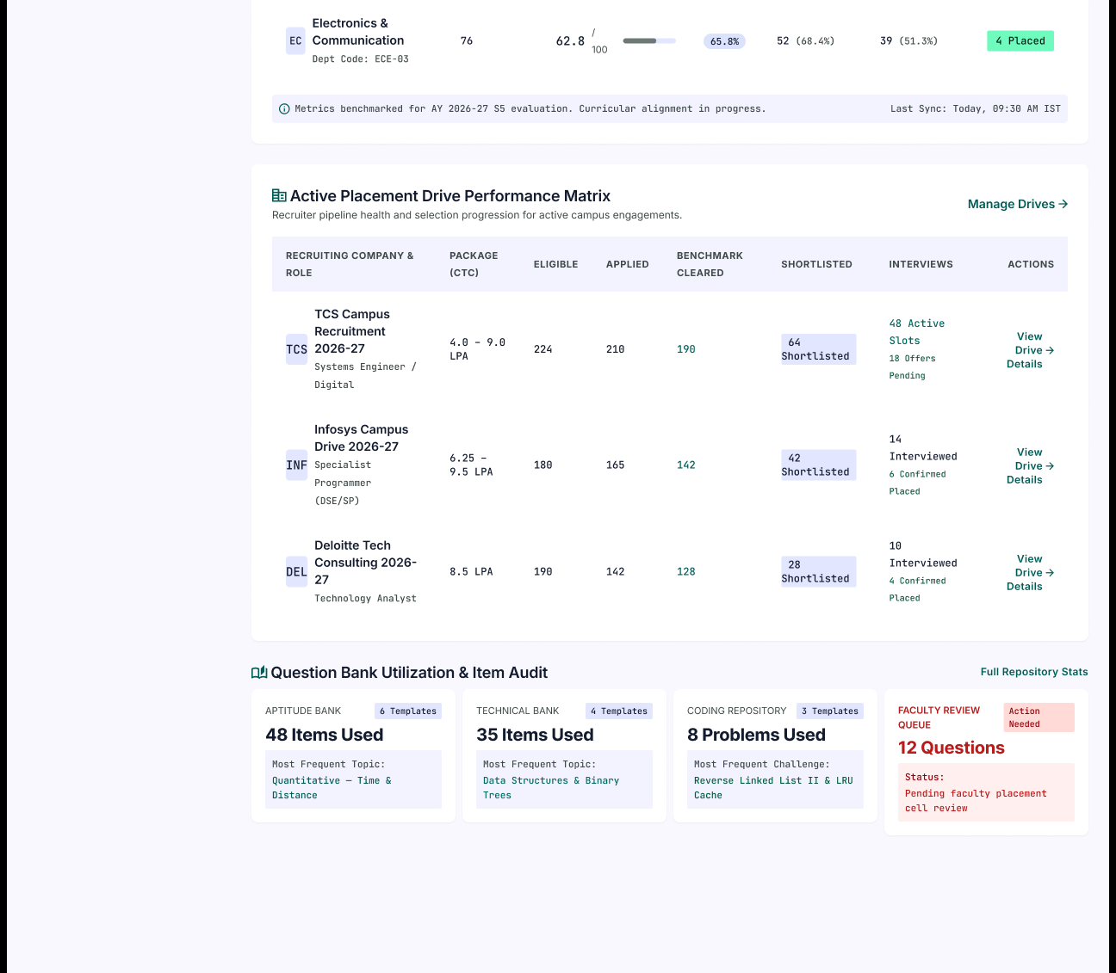
Description
The Reports & Analytics page lets administrators analyse student assessment performance, placement eligibility, recruitment activity and department-level outcomes through a full placement conversion pipeline.
Features
- Title with Academic Year Tag
- Export CSV
- Export PDF Report
- Report Filters (Academic Year, Batch Cohort, Semester, Department, Assessment, Placement Drive)
- Stage Summary Cards (Total Students, Assessment Completion, Placement Eligible, Benchmark Cleared, Students Shortlisted, Offers Confirmed)
- End-to-End Placement Conversion Pipeline with Target Placement Rate
- Pre-Placement Benchmark Performance (Average Score, Pass Rate, Completion, Score Bounds)
- Institutional Cutoff Indicator
- Score Distribution Cohort Curve with Score Bands
- Sectional Competency Breakdown (Aptitude & Reasoning, Technical Domain MCQs, Algorithmic Coding Challenge)
- Department-wise Assessment Performance Table
- Active Placement Drive Performance Matrix with Manage Drives
- Question Bank Utilization & Item Audit (Aptitude, Technical, Coding)
- Faculty Review Queue
- Full Repository Stats
Navigation
Platform Overview → Sidebar → Reports & Analytics
Reports & Analytics → Export CSV / Export PDF Report
Reports & Analytics → Manage Drives → Placement Drive Management
Reports & Analytics → Full Repository Stats → Central Question Bank
PAGE 49 — SYSTEM LOGS (ADMIN)
Screen Name: System Logs
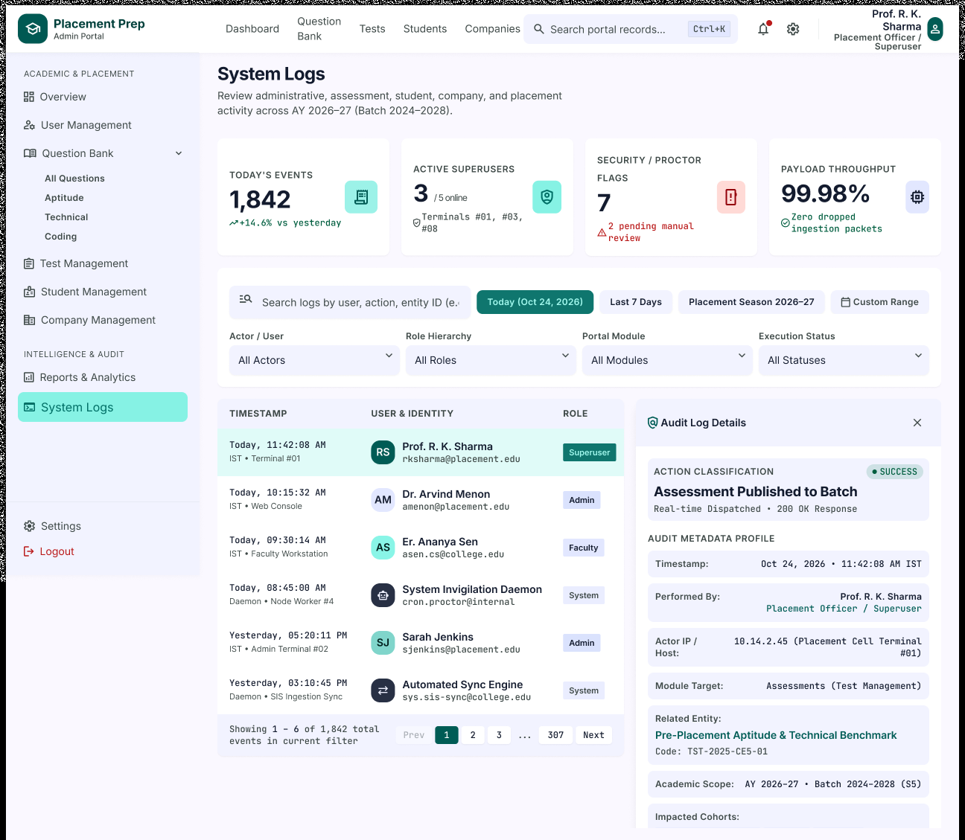
Description
The System Logs page lets administrators review administrative, assessment, student, company and placement activity across the academic year. Selecting a log entry opens a detailed audit panel.
Features
- Page Title and Description
- Summary Cards (Today's Events, Active Superusers, Security / Proctor Flags, Payload Throughput)
- Search Logs by User, Action or Entity ID
- Time Filters (Today, Last 7 Days, Placement Season, Custom Range)
- Filters (Actor / User, Role Hierarchy, Portal Module, Execution Status)
- Log Table (Timestamp, User & Identity, Role)
- Role Badges (Superuser, Admin, Faculty, System)
- Pagination (Showing 1 - 6 of 1,842 events)
- Audit Log Details Panel with Close Option
- Action Classification and Result Status
- Audit Metadata Profile (Timestamp, Performed By, Actor IP / Host, Module Target, Related Entity, Academic Scope, Impacted Cohorts)
Navigation
Platform Overview → Open Full Audit Trail → System Logs
Platform Overview → Sidebar → System Logs
System Logs → Select Log Entry → Audit Log Details
System Logs → Search / Filters / Time Filters
PAGE 50 — ADMIN SETTINGS
Screen Name: Admin Settings
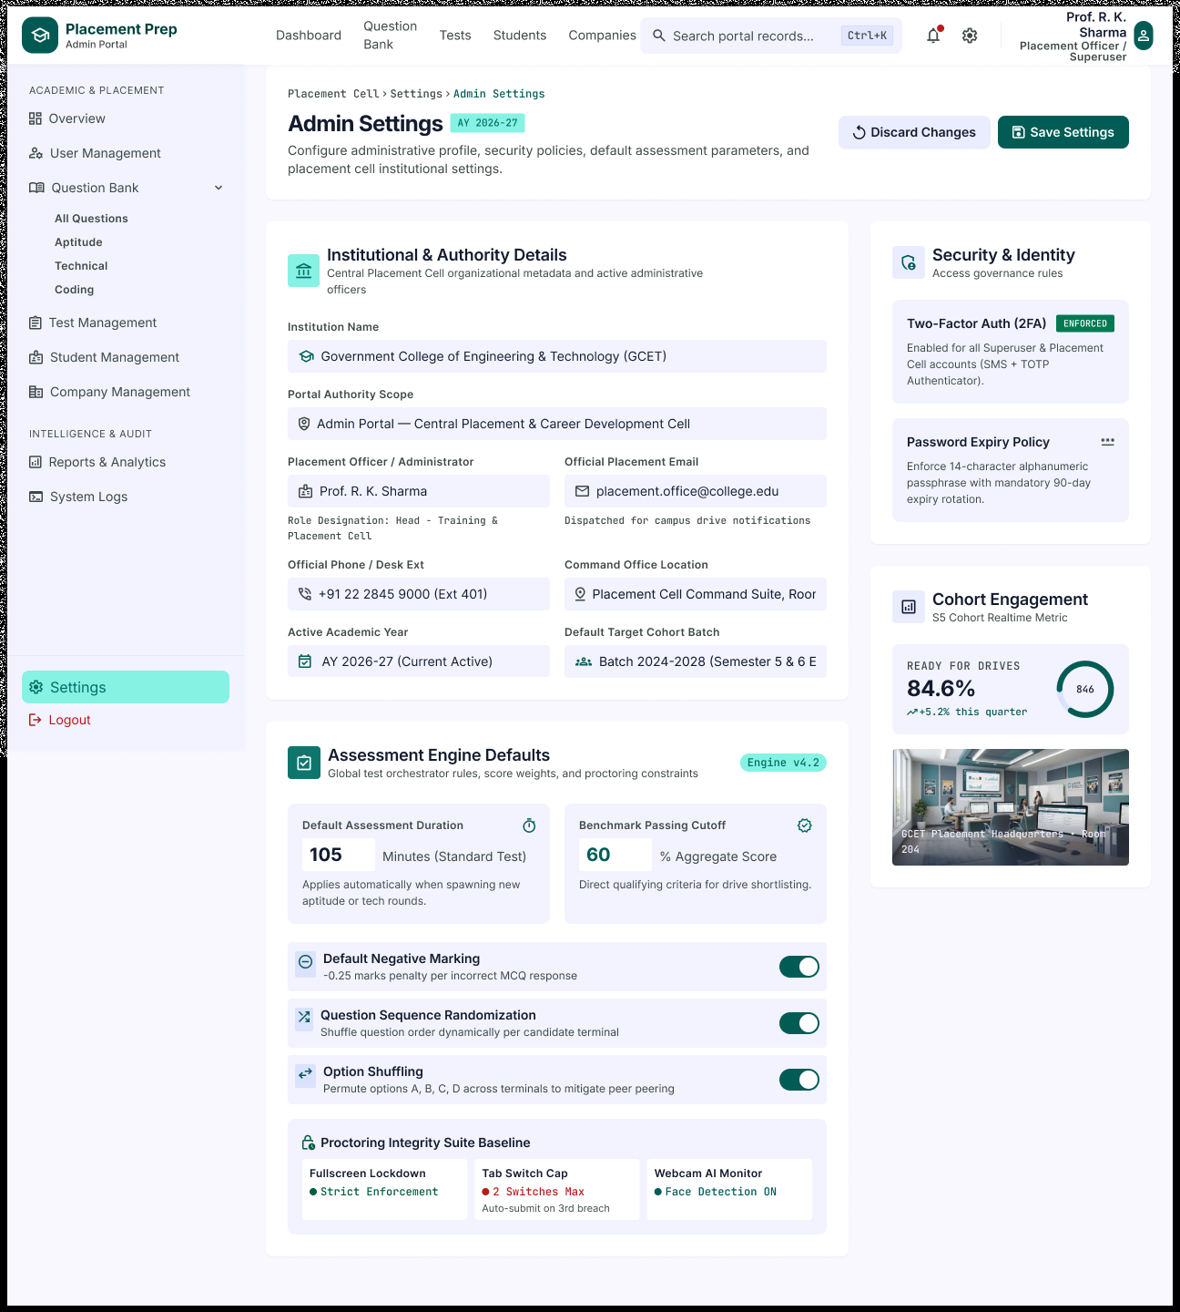
Description
The Admin Settings page lets administrators configure the administrative profile, security policies, default assessment parameters and institutional settings of the placement cell.
Features
- Breadcrumb (Placement Cell › Settings › Admin Settings) with Academic Year Tag
- Discard Changes
- Save Settings
- Institutional & Authority Details (Institution Name, Portal Authority Scope, Placement Officer, Official Email, Official Phone, Command Office Location, Active Academic Year, Default Target Cohort Batch)
- Assessment Engine Defaults (Default Assessment Duration, Benchmark Passing Cutoff)
- Default Negative Marking Toggle
- Question Sequence Randomization Toggle
- Option Shuffling Toggle
- Proctoring Integrity Suite Baseline (Fullscreen Lockdown, Tab Switch Cap, Webcam AI Monitor)
- Security & Identity (Two-Factor Authentication, Password Expiry Policy)
- Cohort Engagement Summary (Ready for Drives)
- Placement Cell Headquarters Image
Navigation
Platform Overview → Sidebar → Settings
Settings Icon (Top Bar) → Admin Settings
Admin Settings → Save Settings / Discard Changes
AUTHENTICATION & ACCOUNT MODULE
PAGE 51 — LANDING PAGE
Screen Name: Landing Page
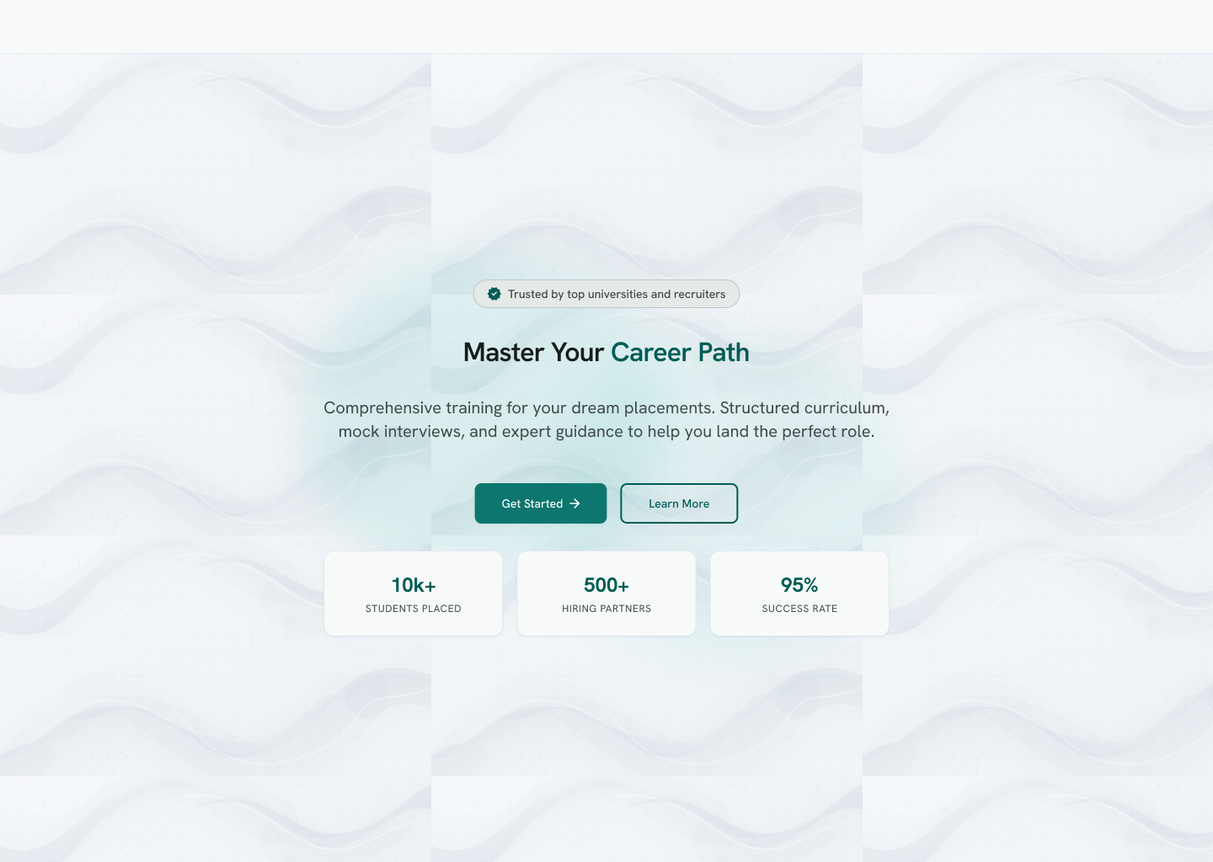
Description
The Landing Page is the public entry point of the Placement Prep platform. It introduces the platform, shows key placement statistics and lets visitors start registration or learn more about the platform.
Features
- Trusted by Top Universities and Recruiters Badge
- Headline (Master Your Career Path) and Supporting Description
- Get Started
- Learn More
- Platform Statistics (10k+ Students Placed, 500+ Hiring Partners, 95% Success Rate)
Navigation
Landing Page → Get Started → Select Your Role
Landing Page → Learn More
PAGE 52 — SELECT YOUR ROLE
Screen Name: Select Your Role (Choose Your Path)
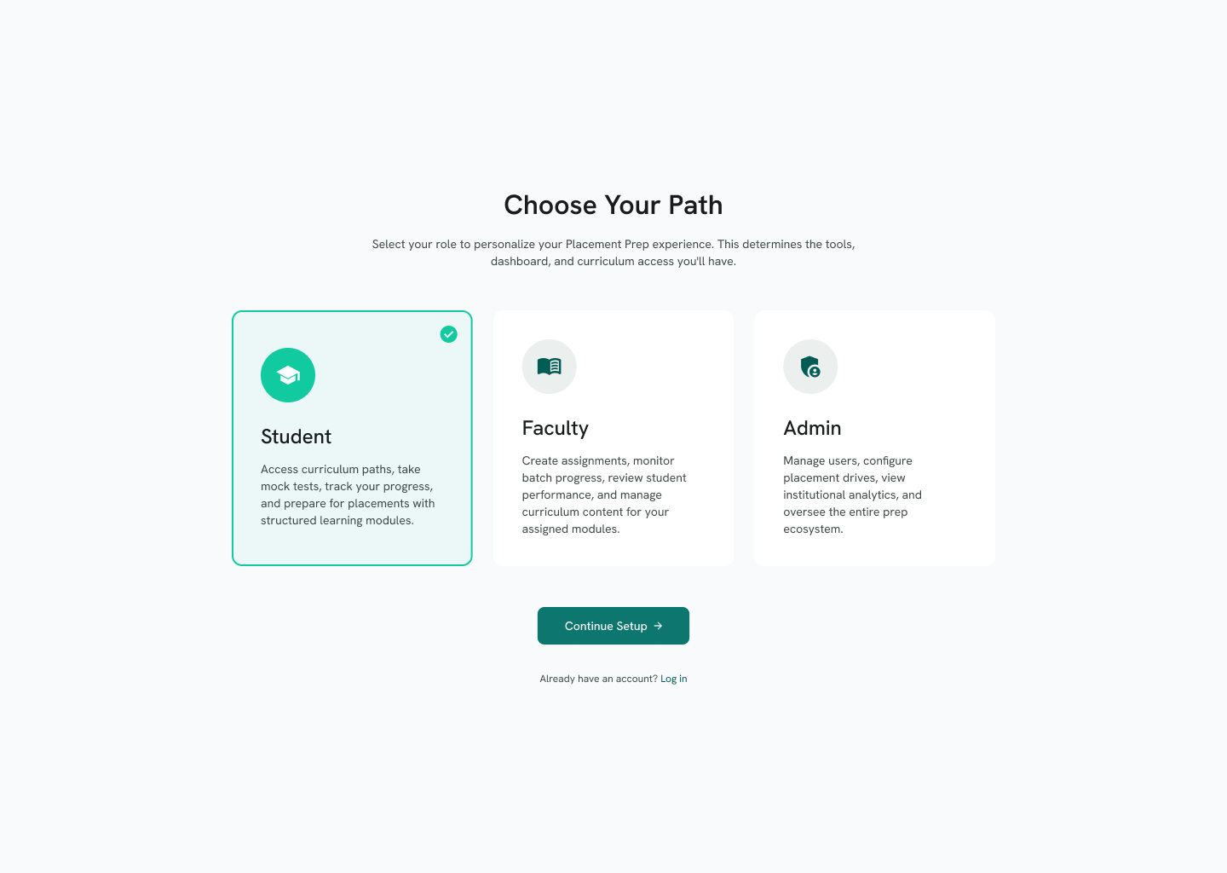
Description
The Select Your Role page lets a new user choose how they will use the platform. The selected role decides the tools, dashboard and curriculum access the user will get.
Features
- Choose Your Path Heading and Description
- Role Cards (Student, Faculty, Admin) with Role Descriptions
- Selected Role Indicator
- Continue Setup
- Already have an account? Log in
Navigation
Landing Page → Get Started → Select Your Role
Select Your Role → Continue Setup → Register
Select Your Role → Log in → Login
PAGE 53 — REGISTER
Screen Name: Register – Create an Account
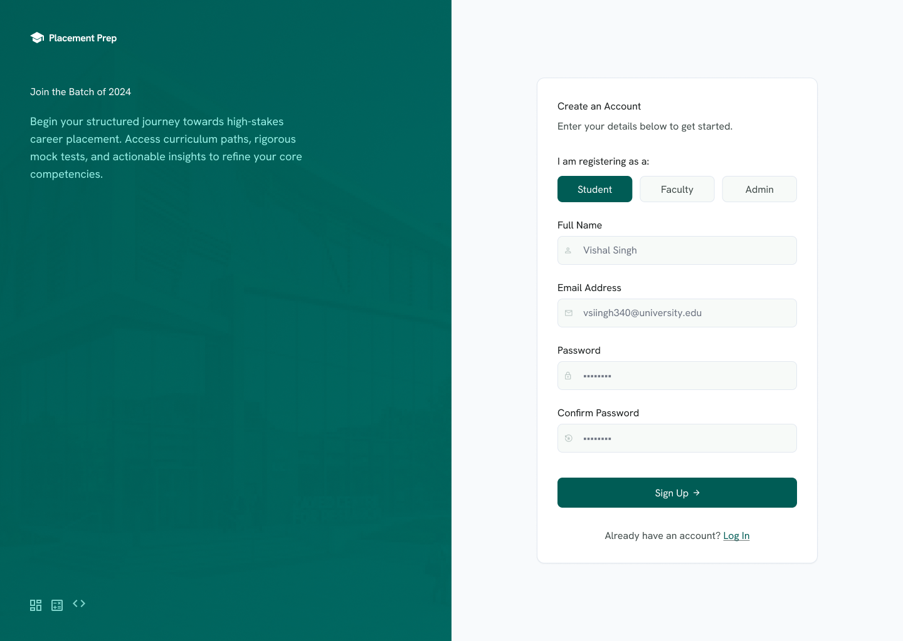
Description
The Register page lets a new user create a Placement Prep account by choosing a role and entering basic details.
Features
- Placement Prep Branding and Batch Introduction Panel
- Create an Account Heading and Description
- Role Selector (Student, Faculty, Admin)
- Full Name
- Email Address
- Password
- Confirm Password
- Sign Up
- Already have an account? Log In
Navigation
Select Your Role → Continue Setup → Register
Register → Sign Up → Verify Email
Register → Log In → Login
PAGE 54 — VERIFY EMAIL (OTP)
Screen Name: Verify OTP – Verify Your Email
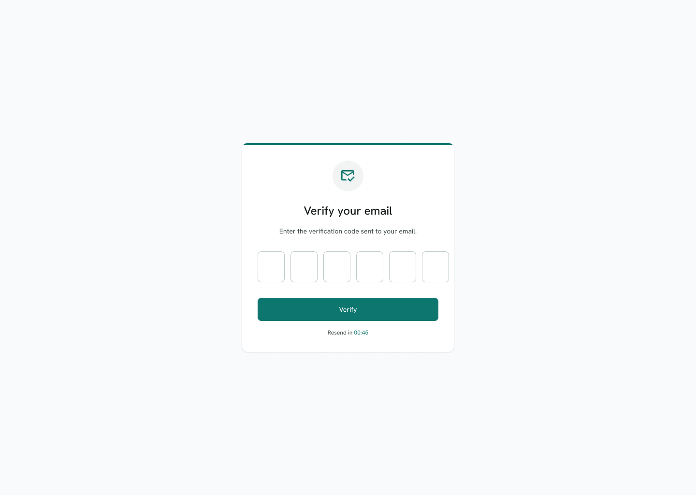
Description
The Verify Email page confirms the user's email address by asking for the verification code sent to it.
Features
- Verify Your Email Heading and Instruction
- Six-Digit Verification Code Input
- Verify
- Resend Code Countdown Timer
Navigation
Register → Sign Up → Verify Email
Verify Email → Verify → Student Onboarding (for Student role)
Verify Email → Resend Code
PAGE 55 — LOGIN
Screen Name: Login
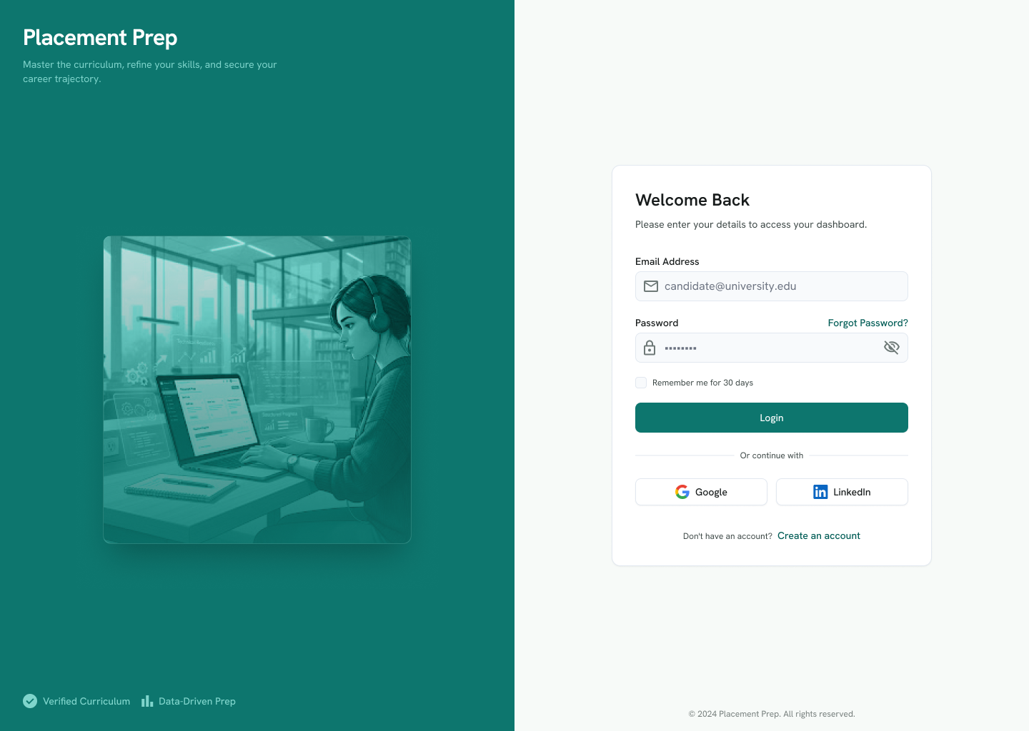
Description
The Login page lets registered users sign in to access their dashboard, using an email and password or a Google or LinkedIn account.
Features
- Placement Prep Branding Panel with Tagline and Highlights (Verified Curriculum, Data-Driven Prep)
- Welcome Back Heading and Description
- Email Address
- Password with Show / Hide Option
- Forgot Password?
- Remember Me for 30 Days
- Login
- Continue with Google
- Continue with LinkedIn
- Don't have an account? Create an account
Navigation
Login → Login → Dashboard (Student / Faculty / Admin, based on role)
Login → Forgot Password? → Forgot Password
Login → Create an account → Select Your Role
Login → Google / LinkedIn
PAGE 56 — FORGOT PASSWORD
Screen Name: Forgot Password
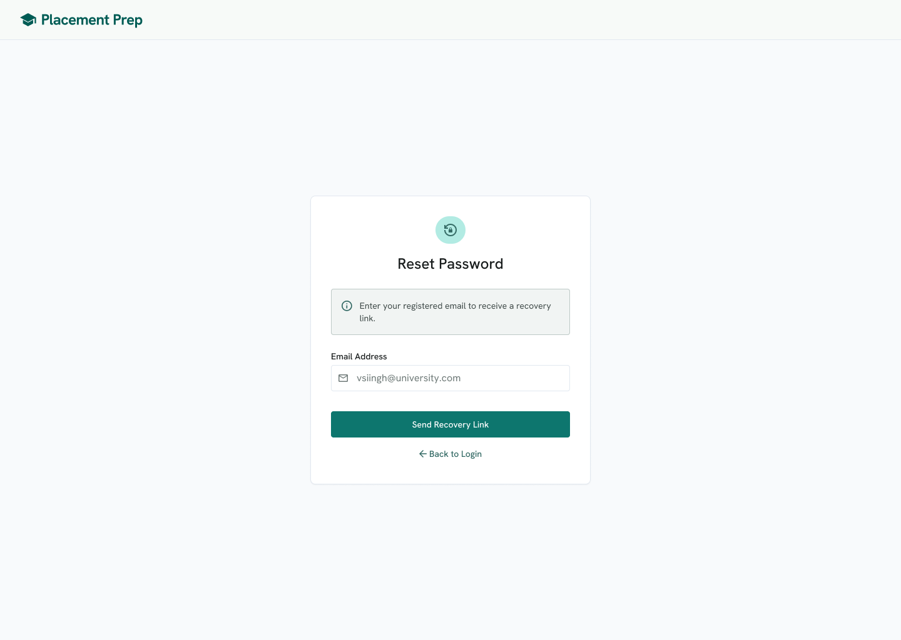
Description
The Forgot Password page lets a user who cannot sign in request a password recovery link by entering their registered email address.
Features
- Placement Prep Header
- Reset Password Heading
- Recovery Information Message
- Email Address
- Send Recovery Link
- Back to Login
Navigation
Login → Forgot Password? → Forgot Password
Forgot Password → Send Recovery Link → Reset Password
Forgot Password → Back to Login → Login
PAGE 57 — RESET PASSWORD
Screen Name: Reset Password
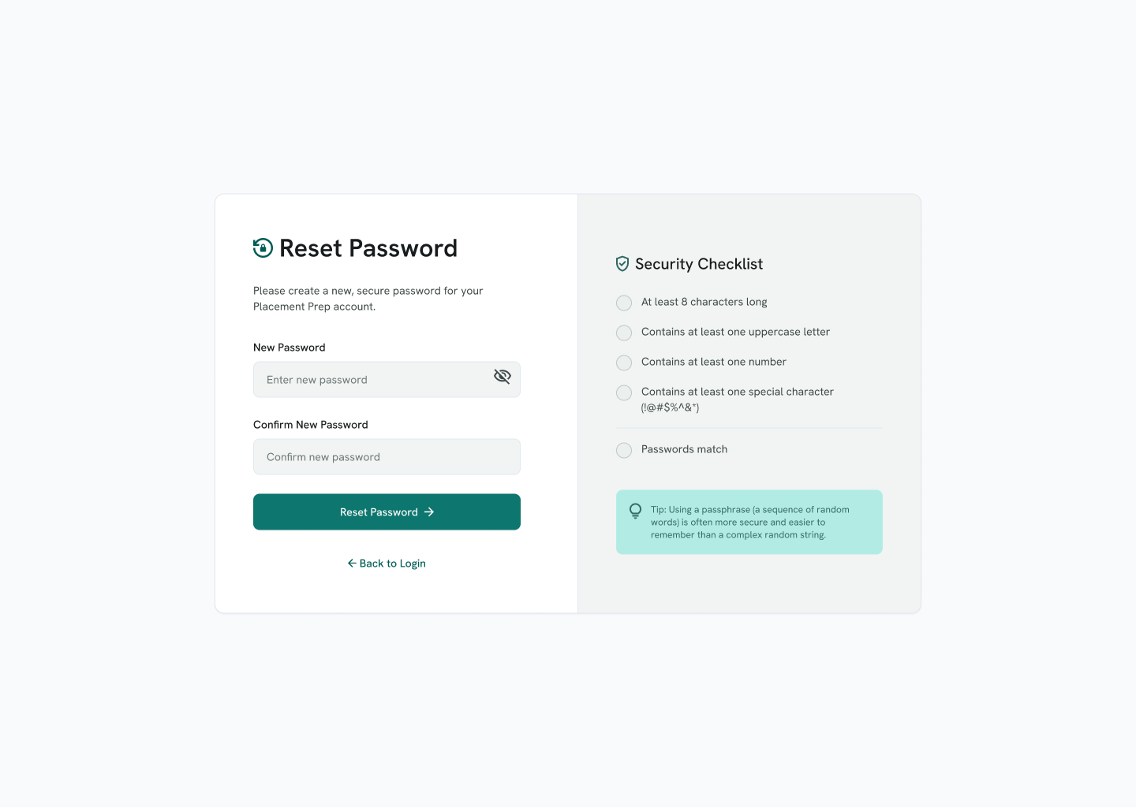
Description
The Reset Password page lets a user set a new password. A security checklist shows the password rules and updates as the user types.
Features
- Reset Password Heading and Instruction
- New Password with Show / Hide Option
- Confirm New Password
- Reset Password
- Back to Login
- Security Checklist (8 Characters, Uppercase Letter, Number, Special Character, Passwords Match)
- Password Tip
Navigation
Forgot Password → Send Recovery Link → Reset Password
Reset Password → Reset Password → Login
Reset Password → Back to Login → Login
PAGE 58 — ACCOUNT SETTINGS
Screen Name: Settings – Account Preferences
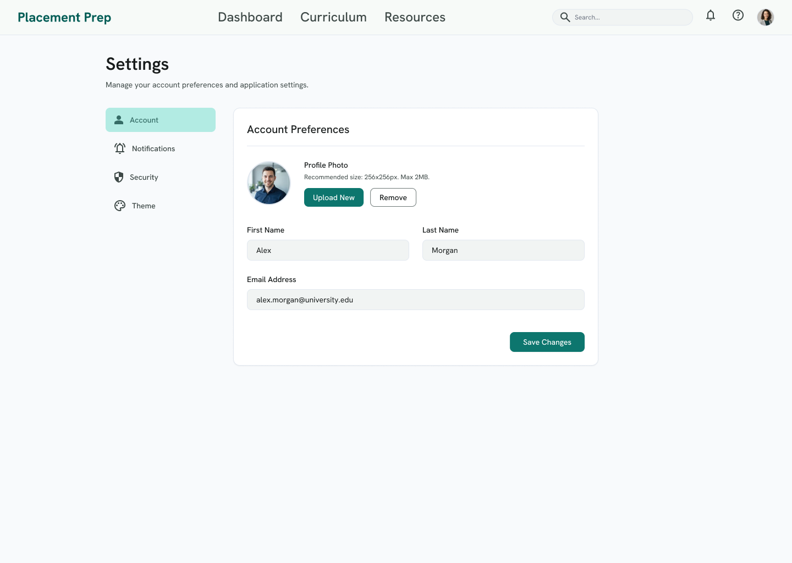
Description
The Settings page lets a signed-in user manage account preferences and application settings, starting with profile photo and basic account details.
Features
- Top Navigation (Dashboard, Curriculum, Resources), Search, Notifications, Help and Profile
- Settings Heading and Description
- Settings Menu (Account, Notifications, Security, Theme)
- Account Preferences
- Profile Photo with Upload New and Remove
- First Name
- Last Name
- Email Address
- Save Changes
Navigation
Profile Icon → Settings → Account Preferences
Settings → Notifications / Security / Theme
Settings → Save Changes

