Healthcare Analytics Dashboard using SQL & Power BI
Project Report

1. Project Overview
This project develops an end-to-end Healthcare Analytics solution using MySQL and Power BI. It analyzes patient, doctor, appointment, billing, department, and medication data to provide operational, financial, and clinical insights for hospital management.

2. Business Problem
Hospitals generate large amounts of operational and financial data. Without centralized reporting, management cannot easily monitor patient flow, doctor performance, appointment efficiency, revenue, or medication trends. This project addresses these challenges through interactive dashboards.

3. Objectives
• Build an end-to-end analytics solution.
• Clean and validate healthcare data.
• Perform SQL-based exploratory analysis.
• Develop KPIs.
• Create interactive Power BI dashboards.
• Support data-driven decision making.

4. Dataset
Six tables: Patients Table, Doctors Table, Departments Table, Appointments Table, Bills Table, and Medications Table.
Table Names With Each Column Names
- patients: patient_id, first_name, last_name, gender, date_of_birth, phone, email, address, city, blood_group.
- doctors: doctor_id, first_name, last_name, gender, specialization, department_id, city, experience_years, phone, email, joining_date, consultation_fee.
- departments: department_id, department_name, city, location_floor, phone_extension, total_staff, budget_allocation, established_year, shift_timing, head_doctor_id.
- appointments: appointment_id, patient_id, doctor_id, department_id, appointment_date, appointment_time, purpose, diagnosis, status, follow_up_required, follow_up_date, created_at.
- bills: bill_id, appointment_id, patient_id, doctor_id, total_amount, discount, insurance_amount, net_amount, payment_mode, payment_status, billing_date, due_date, insurance_claim.
- medications: medication_id, appointment_id, patient_id, doctor_id, generic_name, brand_name, dosage, frequency, start_date, end_date, notes, status, prescribed_date. this is my all tables and columns name so give me full sql project with powerbi dashboard

5. Workflow
Business Understanding → Database Understanding → SQL Data Cleaning → EDA → KPI Development → Dashboard SQL Queries → Power BI Data Modeling → DAX Measures → Dashboard Design → Business Insights.

6. Data Cleaning
Validated duplicates, null values, invalid genders, blood groups, dates, appointment status, payment status, billing calculations, medication status, and data consistency.

7. Exploratory Data Analysis
- Patient demographics,
- doctor specialization,
- appointment trends,
- department performance,
- revenue analysis,
- payment analysis,
- insurance claims,
- medication analysis,
- and diagnosis trends.

8. KPIs
1. Total Patients
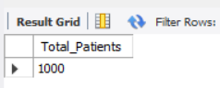
2. Total Doctors
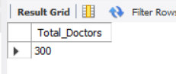
3. Total Appointments
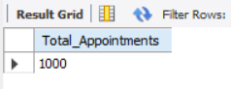
4. Appointment Completion Rate
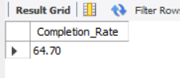
5. Total Revenue
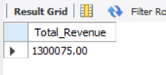
6. Average Bill Amount
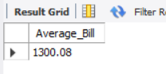
7. Follow-up Appointments
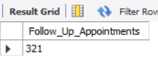
8. Active Medications
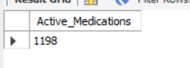

9. Dashboard 1 - Hospital Overview
Shows executive summary with KPIs, monthly revenue, appointment status, department performance, patients by city, and payment mode.

10. Dashboard 2 - Patient & Doctor Analytics
Shows executive summary with KPIs ,Analyzes patient demographics, doctor specialization, experience, appointments, and revenue.

11. Dashboard 3 - Financial & Medication Analytics
Shows executive summary with KPIs ,Analyzes billing, revenue, insurance claims, medication status, prescriptions, and diagnoses.

12. Business Insights
- Identify high-performing departments,
- monitor appointment completion,
- analyze patient demographics, evaluate doctor workload,
- optimize billing, and monitor medication usage.

13. Recommendations
- Improve staffing in busy departments,
- reduce appointment cancellations,
- monitor follow-ups,
- optimize pharmacy inventory,
- and strengthen revenue monitoring.

14. Skills Demonstrated
SQL, MySQL, Data Cleaning, EDA, Joins, CTEs, Window Functions, Power BI, DAX, Data Modeling, Dashboard Design, Business Intelligence.

15. Conclusion
The project demonstrates an end-to-end healthcare analytics solution that transforms raw hospital data into actionable insights using SQL and Power BI.

