**Analyzing around 4,000 past projects on Kickstarter to discover what elements aid in a successful project.**

**Conclusions:**

Based on our analysis, it is clear that all the successful projects are fully funded. Although data is positively skewed, 88% of the successful projects are funded 100-200% of their initial funding goal.

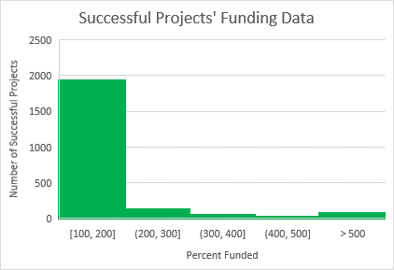

It is evident that, projects with $50,000 or more as their initial funding goal have lesser chance at being successful and also are more susceptible to failure and cancellation. Only 19% of the projects in that goal range have been successful compared to the average of 62% in all other goal ranges less than $50,000.

In the line graph below, it can be seen that the greatest number of successful projects are launched in May and although not dramatically, the number does go down considerably from June with its lowest in December.

Largest number of overall, and successful, projects are from Theater category, Plays being the most popular sub-category of all. Though, Music has the second largest number of successful projects, it has relatively a better chance at being successful (of the total Music projects 77% are successful compared to 60% in Theater category).

**Limitations:**

* The study sample is not representative of all countries therefore the analysis cannot be generalized for countries other than US.
* Some of the data in the sample is highly skewed. Outliers could contain valuable information. Using statistical tests was out of scope for this project but it could have been important to analyze why are these outliers occurring, where and what their meaning might be; Rather than ignoring the outliers, regardless of their significance.
* Over 300,000 projects are launched on Kickstarter. For the confidence level of 95% our sample size of 4000 is not statistically significant.

**Some of the possible tables/graphs we could create:**

* We could create a relative frequency table showing proportion of successful, failed, cancelled and live projects in the given sample.

|  |  |  |
| --- | --- | --- |
| **State** | **Number of projects** | **Percent of total** |
| successful | 2185 | 53% |
| failed | 1530 | 37% |
| canceled | 349 | 8% |
| live | 50 | 1% |
| **Total** | 4114 |  |

* We could create a scatter plot to investigate (negative) correlation between Goal amount more than $50,000 and backers count or pledged amount or percent funded.
* We could also make column charts to analyze impact of project being staff picked and having a Spotlight feature on its success.

(All successful projects had spotlight feature and none of the failed or canceled projects used one. It could suggest that spotlight has a significant impact on the success of the project however this will need further investigation.

Staff picked column chart may indicate that 87% of the projects that are staff picked are successful. However, it also suggests that78% of the total successful projects are successful despite not being staff picked. Hence, it could be worth being staff picked but its not a deciding factor for the project to do well.)