DATA ANALYSIS AND VISUALIZATION FOR LOGISTICS PERFORMANCE
Week 3 Task – Logistics Data Analyst Intern
Project: Last-Mile Delivery Performance Analysis and Route Optimization

Intern | Prajakta Nandkumar Nalawade
Internship | Logistics Data Analyst Intern
Task | Week 3 – Advanced Data Analysis and Visualization
Primary Dataset | routes_performance.xlsx
Source | Mendeley Data – Last-mile delivery route deviations dataset: planned vs. actual routes
Tools | Python, Pandas, NumPy, Matplotlib, Seaborn

Prepared for YuvaIntern Internship Submission

1. Objective
The objective of this task is to perform Exploratory Data Analysis (EDA) on logistics route data using Python and to present meaningful findings through visualizations. The analysis focuses on understanding planned and actual route distances, route-sequence changes, arrival-time behaviour, time-window performance, and day-wise logistics patterns. The purpose is to convert raw logistics data into understandable information that can support operational decision-making.

2. Dataset Overview
2.1 Dataset Source
The project uses the publicly available Mendeley Data dataset titled “Last-mile delivery route deviations dataset: planned vs. actual routes”. The downloaded file used for the analysis is routes_performance.xlsx.
2.2 Business Scenario
A logistics company uses route-planning software to create planned delivery sequences for vehicles and drivers. During actual operations, drivers may follow a different stop sequence or travel a different distance. The company wants to analyse route performance and identify areas that require operational review.

2.3 Dataset Characteristics
Characteristic | Observed value
Rows | 249,231 data rows
Columns | 16 source columns
Unique Route IDs | 19,647
Unique Driver IDs | 400
Unique Stop IDs | 13,125
Unique Address IDs | 10,864
Week IDs | 32 distinct values (0–31)
Country | 2 coded values (0 and 1)
Day of Week | Monday through Sunday
Delivery | 2 coded values (0 and 1)
Depot | 2 coded values (0 and 1)

2.4 Source Columns and Their Analytical Role
Variable | Meaning / Role
Route ID | Route-wise grouping
Driver ID | Driver-wise grouping when required.
Stop ID | Stop identification
Address ID
  Location identification
Week ID | Week-wise comparison
Country | Categorical comparison
Day of Week
  Day-wise analysis
IndexP | Planned stop sequence
IndexA | Actual stop sequence
Arrived Time
  Arrival-time analysis
Earliest Time
  Time-window analysis
Latest Time | Time-window analysis.
DistanceP | Planned distance analysis
DistanceA | Actual distance analysis
Depot
  Depot-related grouping
Delivery
  Delivery-related descriptive analysis

For exploratory data analysis, the main numerical and operational variables selected are DistanceP, DistanceA, IndexP, IndexA, Arrived Time, Earliest Time, Latest Time, and Day of Week. Identifier fields such as Route ID, Driver ID, Stop ID, and Address ID are retained for grouping and reference rather than numerical calculations.

3. EDA Methodology
Exploratory Data Analysis is performed to understand the structure, distribution, central tendency, relationships, and operational patterns present in the logistics dataset. The analysis begins with descriptive statistics and then proceeds to distribution analysis, correlation analysis, planned-versus-actual comparison, day-wise analysis, and route-sequence analysis.
3.1 EDA Workflow
Load Dataset
↓
Inspect Dataset
↓
Descriptive Statistics
↓
Central Tendency Analysis
↓
Distribution Analysis
↓
Correlation Analysis
↓
Planned vs Actual Analysis
↓
Day-wise Analysis
↓
Route Sequence Analysis
↓
Time-window Analysis
↓
Analytical Insights

3.2 Python Code
import pandas as pd
import numpy as np
import matplotlib.pyplot as plt
import seaborn as sns

# Load logistics dataset
df = pd.read_excel("routes_performance.xlsx")

# Display first five rows
print(df.head())
# Check dataset size
print("Dataset Shape:", df.shape)
# Check column names
print("Columns:")
print(df.columns.tolist())

# Check data types and non-null values
print(df.info())
# Generate descriptive statistics
print(df.describe())

4. Central Tendency Analysis
Central tendency measures are used to identify the typical or central values of numerical logistics variables. In this analysis, Mean, Median, and Mode are calculated for selected variables including planned distance, actual distance, arrival time, and planned and actual stop-sequence positions. Mean represents the average value, Median represents the middle value of the observations, and Mode represents the most frequently occurring value. Using all three measures helps provide a more complete understanding of the dataset, especially when the data contains extreme values or skewed distributions.

4.1 Python code
import pandas as pd
# dataset
df = pd.read_excel("routes_performance.xlsx")
# Variables for central tendency
columns = [
"DistanceP",
"DistanceA",
"Arrived Time",
"IndexP",
"IndexA"
]
# Calculate Mean
mean_values = df[columns].mean()
# Calculate Median
median_values = df[columns].median()
# Calculate Mode
mode_values = df[columns].mode().iloc[0]

# Create summary table
central_tendency = pd.DataFrame({
"Mean": mean_values,
"Median": median_values,
"Mode": mode_values
})
print(central_tendency)

4.2 Result
Variable | Mean | Median | Mode
DistanceP | 5.057804 | 0.936215 | 0.0
DistanceA | 4.982086 | 0.912488 | 0.0
Arrived Time | 1242.425667 | 391.872000 | 0.0
IndexP | 7.064165 | 6.000000 | 0.0
IndexA | 7.064165 | 6.000000 | 0.0

4.3 Interpretation
The mean provides the average value of each numerical variable, while the median represents the middle observation. Comparing the mean and median helps identify whether the data is influenced by extreme values. The mode shows the value that occurs most frequently. For route-sequence variables such as IndexP and IndexA, the mode can help identify the most common sequence position.

5. Distribution Analysis
5.1 Graph 1 – Histogram of Actual Distance
The histogram is used to understand how actual route-distance values are distributed and where most observations are concentrated.
Python code
import pandas as pd
import matplotlib.pyplot as plt

# Load dataset
df = pd.read_excel("routes_performance.xlsx")

# Create histogram
plt.hist(df["DistanceA"], bins=30)

plt.xlabel("Actual Distance")
plt.ylabel("Number of Records")
plt.title("Distribution of Actual Distance")

plt.show()
Graph Output
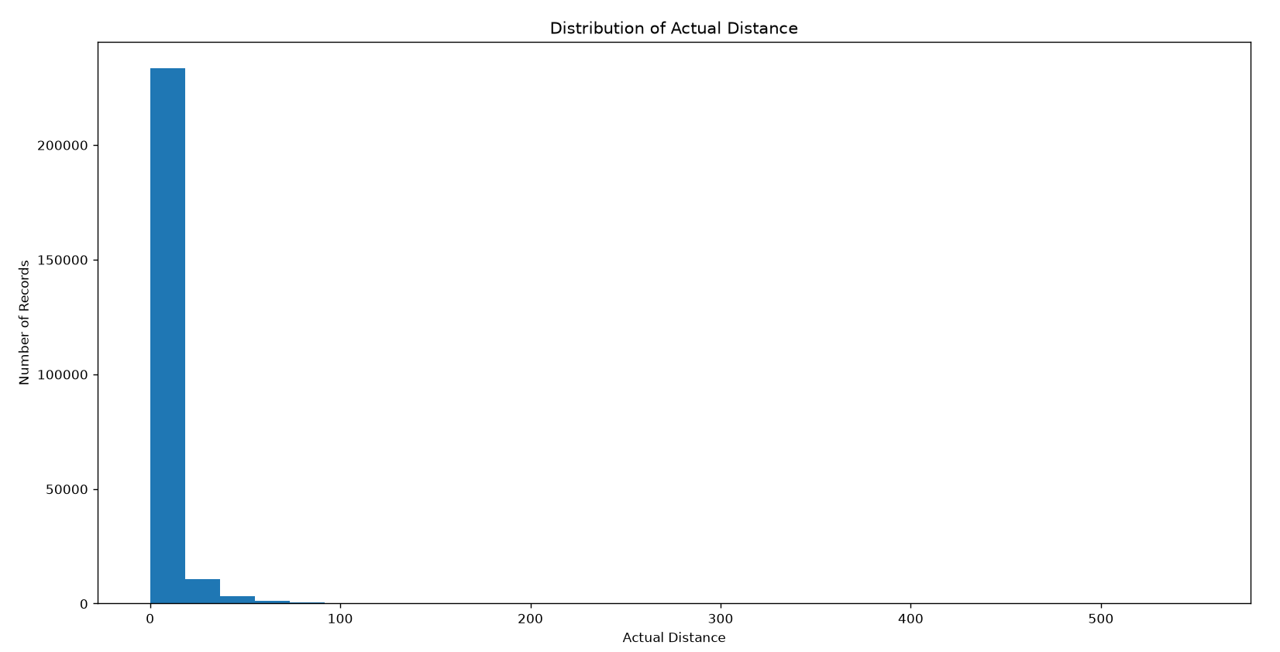

Interpretation
The histogram shows that most actual route-distance observations are concentrated at lower distance values. As the actual distance increases, the number of records decreases significantly. The distribution has a long right tail, indicating the presence of a smaller number of high-distance observations. Therefore, the DistanceA variable is positively skewed, and some observations may require further investigation.

5.2 Graph 2 – Planned vs Actual Distance Boxplot
The boxplot is used to compare the median, spread, and extreme observations of planned and actual distance values. It helps identify differences in the distribution of planned and actual route distances and highlights unusually high observations.
Python Code
import pandas as pd
import matplotlib.pyplot as plt
# Load dataset
df = pd.read_excel("routes_performance.xlsx")
# Create boxplot
plt.boxplot(
[
df["DistanceP"],
df["DistanceA"]
],
labels=["Planned Distance", "Actual Distance"],
showfliers=True
)
plt.ylabel("Distance")
plt.title("Planned vs Actual Distance Distribution")
plt.show()

Graph Output
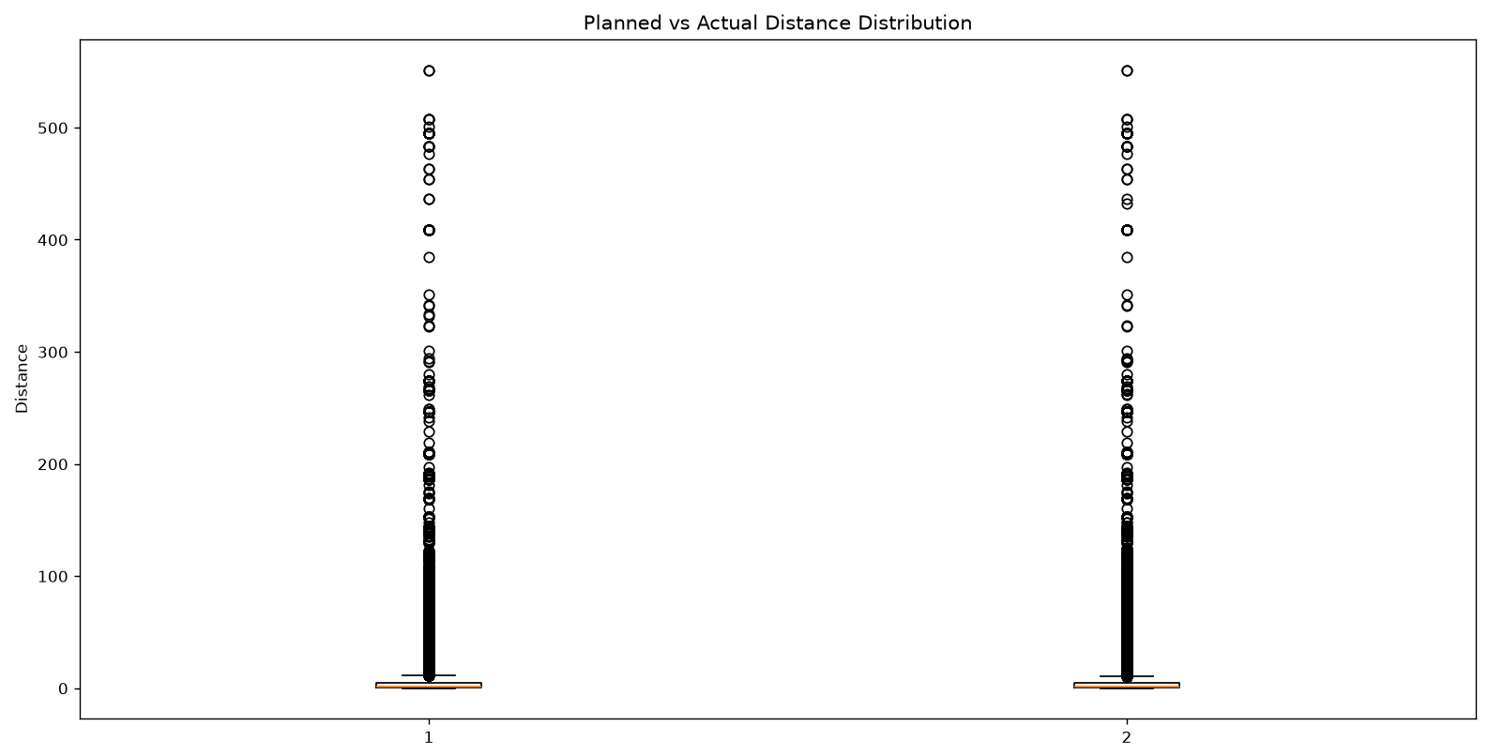
Interpretation:
The boxplot compares the distributions of planned and actual route distances. It shows the median, spread, and extreme observations for both variables. The median values of planned and actual distance are relatively close, while the presence of higher values indicates substantial variation in some route segments. These extreme observations should be investigated further rather than automatically treated as incorrect data.

6. Correlation Analysis
Correlation analysis is used to measure the strength and direction of linear relationships between numerical logistics variables. It helps identify variables that move together and provides an initial understanding of operational relationships. In this project, Pearson correlation is calculated for DistanceP, DistanceA, IndexP, IndexA, and Arrived Time.

6.1 Python Code
import pandas as pd

# Load dataset
df = pd.read_excel("routes_performance.xlsx")

# Select numerical variables
corr_cols = [
"DistanceP",
"DistanceA",
"IndexP",
"IndexA",
"Arrived Time"
]
# Calculate correlation matrix
correlation_matrix = df[corr_cols].corr()
# Display correlation matrix
print(correlation_matrix)

6.2 Correlation Results
Variable Pair | Correlation | Interpretaion
DistanceP vs DistanceA | 0.8654 | Strong positive relationship
IndexP vs IndexA | 0.8514 | Strong positive relationship
DistanceP vs IndexP | -0.1215 | Weak negative relationship
DistanceA vs IndexA | -0.1179 | Weak negative relationship.
DistanceA vs Arrived Time
  0.0043
  Very weak/negligible linear relationship

6.3 Graph 3 – Correlation Heatmap
A correlation heatmap provides a visual representation of the relationships between numerical logistics variables. It makes strong positive, weak, and negative relationships easier to identify and compare

Graph Output
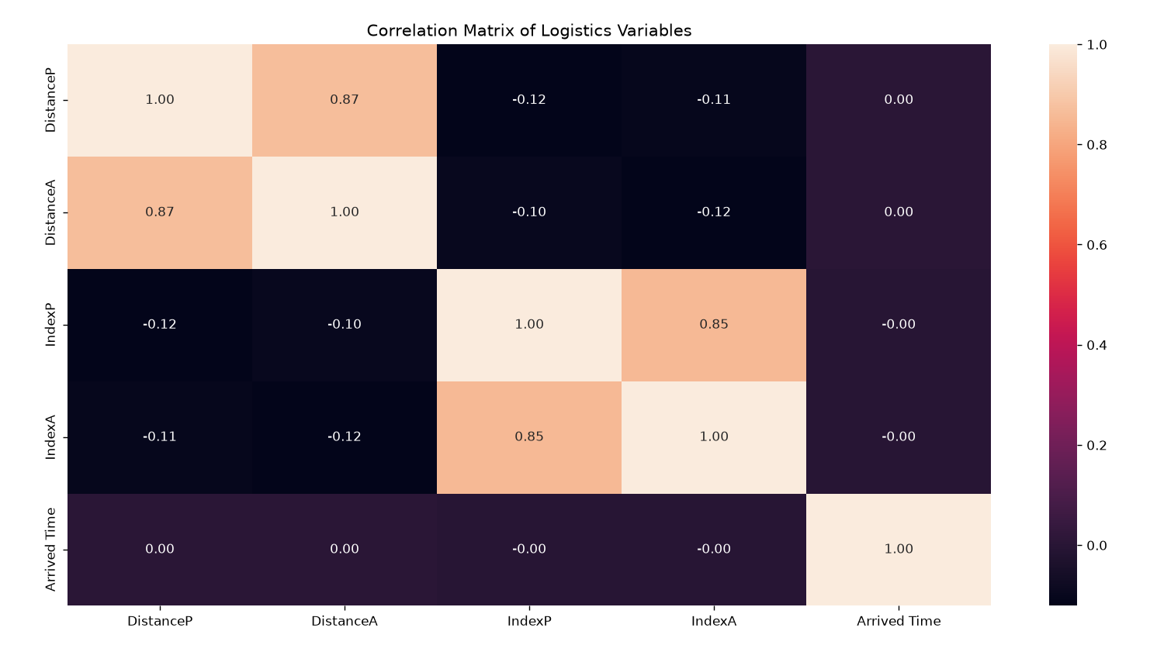

Interpretation:
The heatmap shows a strong positive relationship between DistanceP and DistanceA (0.8654), indicating that planned and actual distances are closely related. IndexP and IndexA also show a strong positive relationship (0.8514), indicating similarity between planned and actual stop sequences. The relationship between DistanceA and Arrived Time is negligible (0.0043).

7. Planned vs Actual Analysis
Planned and actual route values are compared to understand how closely the executed routes follow the planned routes. Differences between planned and actual distance can indicate route deviations or changes during route execution.
7.1 Graph 4 – Planned vs Actual Distance Scatter Plot
The scatter plot is used to examine the relationship between planned and actual route distance and to identify observations that differ substantially from the general pattern.

Python Code
import pandas as pd
import matplotlib.pyplot as plt
# Load dataset
df = pd.read_excel(r'D:\DataAnylitics\Yuva_Intrnship\routes_performance.xlsx')
# Select positive distance values
sample = df[
(df["DistanceP"] > 0) &
(df["DistanceA"] > 0)
].sample(
n=min(10000, len(df)),
random_state=42
)
# Create scatter plot
plt.scatter(
sample["DistanceP"],
sample["DistanceA"],
alpha=0.3
)
plt.xlabel("Planned Distance")
plt.ylabel("Actual Distance")
plt.title("Planned vs Actual Distance")

plt.show()
Graph Output
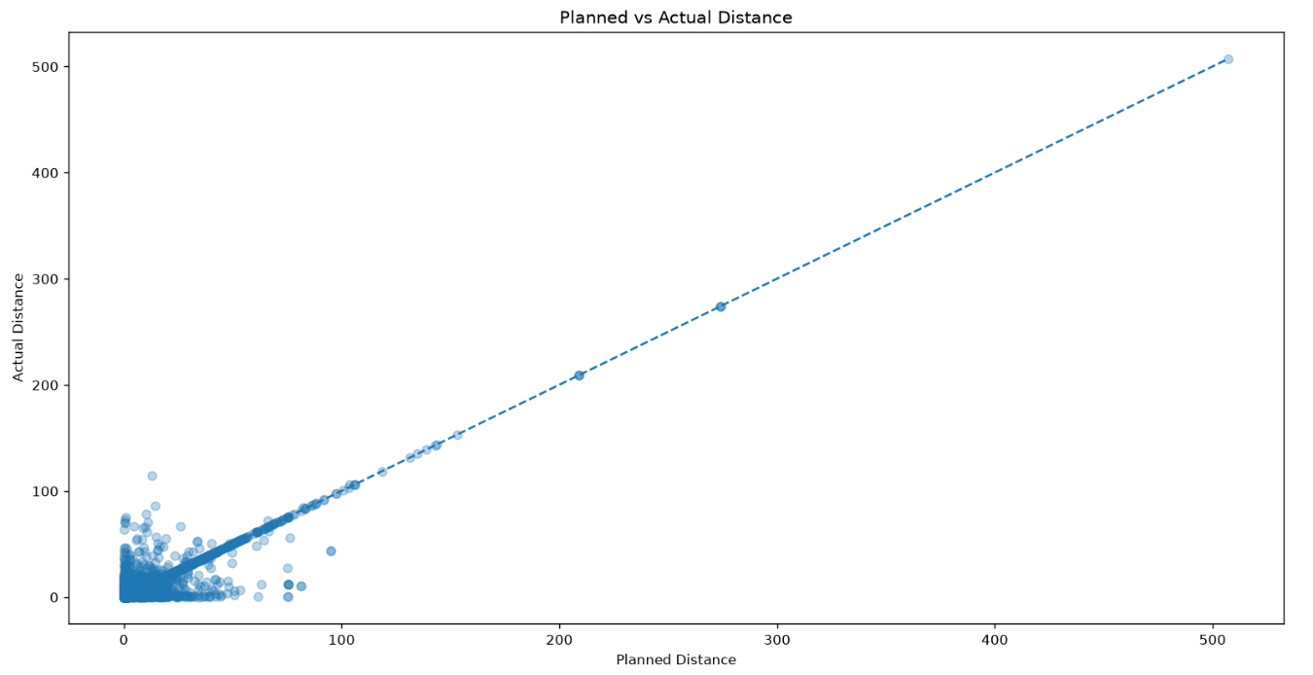

Interpretation:
The scatter plot shows the relationship between planned and actual distance. Most points follow a positive pattern, indicating that higher planned distances are generally associated with higher actual distances. Points that differ noticeably from the general pattern may represent route deviations and require further investigation.

8. Day-wise Analysis
Day-wise analysis is performed to identify differences in route distance patterns across the days of the week. Average planned distance and average actual distance are compared from Monday to Sunday to identify recurring operational patterns that may require further investigation.
8.1 Average Planned vs Actual Distance by Day
A grouped bar chart is appropriate for comparing planned and actual average distance across discrete categories such as days of the week.
Python Code
import pandas as pd
import matplotlib.pyplot as plt

# Load dataset
df = pd.read_excel(r'D:\DataAnylitics\Yuva_Intrnship\routes_performance.xlsx')

day_order = [
"Monday",
"Tuesday",
"Wednesday",
"Thursday",
"Friday",
"Saturday",
"Sunday"
]

day_summary = (
df.groupby("Day of Week")[["DistanceP", "DistanceA"]]
.mean()
.reindex(day_order)
)

print(day_summary)
Result

Day | DistanceP | DistanceA
Monday | 4.627344 | 4.514312
Tuesday | 5.290600 | 5.225023
Wednesday | 5.028061 | 4.972781
Thursday | 5.573881 | 5.462798
Friday | 4.783415 | 4.728349
Saturday | 5.296493 | 5.279714
Sunday | 3.111193 | 3.362513

Graph Output

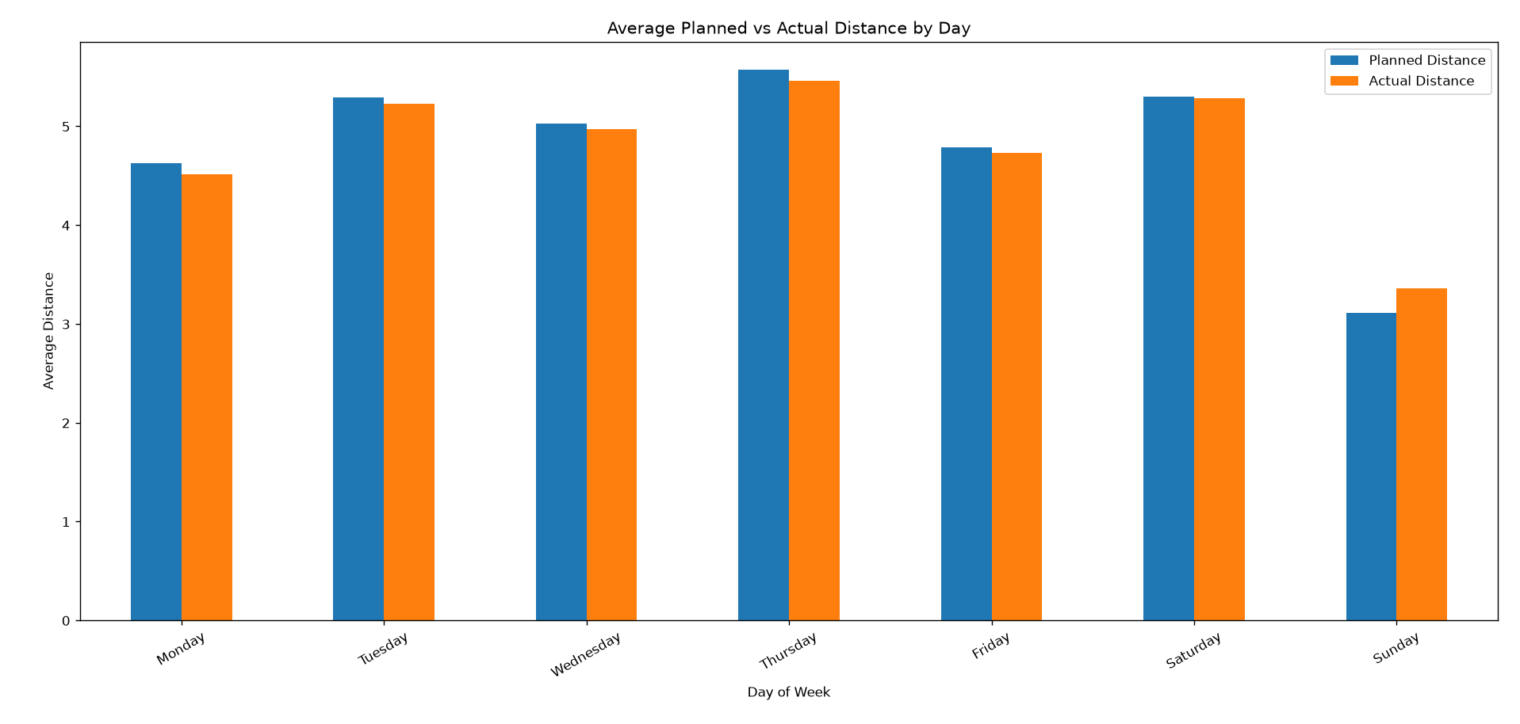
Interpretation:
The grouped bar chart compares the average planned and actual distance across the days of the week. The comparison helps identify days where actual route distance is higher or lower than the planned distance and highlights day-wise variations in route performance.

9. Route Sequence Analysis
Route sequence analysis compares the planned stop-sequence position (IndexP) with the actual stop-sequence position (IndexA). If the two values are different, it indicates that the actual stop sequence differs from the planned sequence. This comparison helps identify variations in route execution.
Variables Used
IndexP – Planned stop-sequence position
IndexA – Actual stop-sequence position

9.1 Create Sequence Change Indicator
A new variable named Sequence_Changed is created by comparing IndexP and IndexA. It returns True when the planned and actual sequence positions are different and False when they are the same.
Python Code
import pandas as pd
# Load dataset
df = pd.read_excel( 'routes_performance.xlsx'
)

# Compare planned and actual sequence
df["Sequence_Changed"] = (
df["IndexP"] != df["IndexA"]
)

# Display sample results
print(
df[
["Route ID", "IndexP", "IndexA", "Sequence_Changed"]
].head(10)
)
Output
Route Id | IndexP | IndexA | Sequence_Changed
0 | 0 | 0 | False
0 | 1 | 4 | True
0 | 2 | 5 | True
0 | 3 | 2
0 | 4 | 1 | True
0 | 5 | 3 | True
0 | 6 | 6 | False
1 | 0 | 0 | False
1 | 1 | 2 | True
1 | 2 | 5 | True

9.2 Overall Sequence Change Rate
The overall sequence-change rate represents the percentage of records where the actual stop-sequence position differs from the planned stop-sequence position.
Python Code
import pandas as pd

# Load dataset
df = pd.read_excel( 'routes_performance.xlsx'
)
# Create sequence change indicator
df["Sequence_Changed"] = (
df["IndexP"] != df["IndexA"]
)

# Calculate overall sequence change rate
sequence_change_rate = (
df["Sequence_Changed"].mean() * 100
)

# Display result
print(
"Overall Sequence Change Rate:",
round(sequence_change_rate, 2),
"%"
)
Output:
Overall Sequence Change Rate: 49.88 %

9.3 Day-wise Sequence Analysis
Day-wise sequence analysis is performed to compare route-sequence changes across different days of the week. This helps identify days on which actual route execution differs from the planned sequence more frequently.
Python Code
import pandas as pd

# Load dataset
df = pd.read_excel('routes_performance.xlsx'
)

# Create sequence change indicator
df["Sequence_Changed"] = (
df["IndexP"] != df["IndexA"]
)

# Define correct day order
day_order = [
"Monday",
"Tuesday",
"Wednesday",
"Thursday",
"Friday",
"Saturday",
"Sunday"
]

# Calculate sequence-change rate for each day
sequence_rate = (
df.groupby("Day of Week")["Sequence_Changed"]
.mean()
.reindex(day_order)
* 100
)

# Display result
print(
sequence_rate.round(2)
)
Output:
Day of week | Value
Monday | 49.86
Tuesday | 49.69
Wednesday | 48.67
Thursday | 49.01
Friday | 50.31
Saturday | 59.65

9.4 Graph 6 – Sequence Change Rate by Day
This bar chart shows how frequently actual stop-sequence positions differ from planned positions across different days of the week. It helps compare route execution patterns and identify days that may require further investigation.
Graph Output
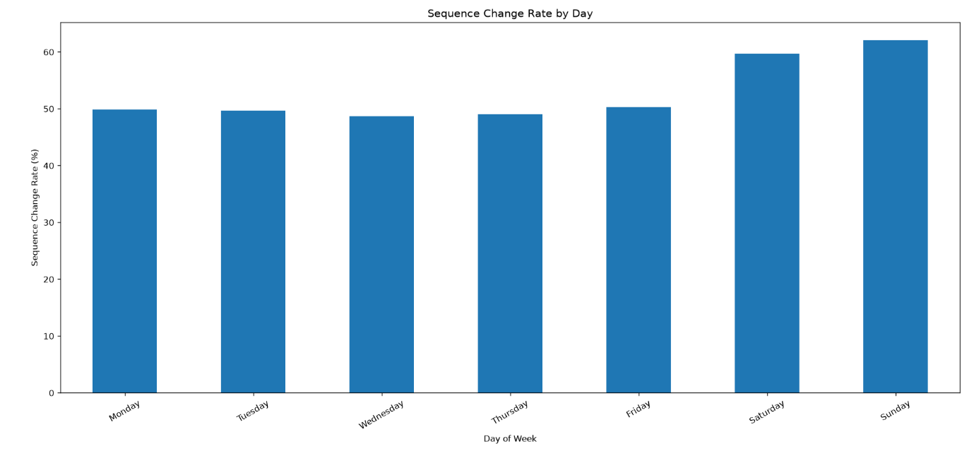
Interpretation:
The bar chart compares the percentage of records where the actual stop-sequence position differs from the planned position across the days of the week. A higher sequence-change rate indicates more frequent differences between planned and actual route execution and may require further operational investigation.
9.5 Operational Relevance
Monitoring planned and actual stop sequences can help logistics teams identify recurring route-execution differences. Routes or days with frequent sequence changes can be reviewed to understand whether the changes are related to operational conditions or legitimate route requirements.

10. Time-window Analysis
Time-window analysis evaluates whether the recorded arrival time falls within the applicable earliest and latest time values. This provides a descriptive indicator of timing performance.
10.1 Create Time-window Indicator
Route Id | Arrived Time | Earliest Time | Latest Time | Within_Time_Window
0 | 42.275 | 0.0 | 360.0 | True
0 | 332.788 | 240.0 | 480.0 | True
0 | 332.956 | 120.0 | 540.0 | True
0 | 244.994 | 60.0 | 540.0 | True
0 | 244.855 | 60.0 | 540.0 | True
0 | 272.121 | 0.0 | 360.0 | True
0 | 373.553 | 240.0 | 480.0 | True
1 | 64.855 | 0.0 | 360.0 | True
1 | 75.520 | 120.0 | 540.0 | False
1 | 324.371 | 120.0 | 540.0 | True

Interpretation
The output shows whether each recorded arrival time falls within the specified earliest and latest time limits. A value of True indicates that the arrival time is within the time window, while False indicates that it falls outside the defined time window.

10.2 Time-window Compliance Rate
The overall time-window compliance rate represents the percentage of records for which the recorded arrival time falls within the specified time window.
Python Code
import pandas as pd

# Load dataset
df = pd.read_excel(
r'D:\DataAnylitics\Yuva_Intrnship\routes_performance.xlsx'
)

# Create time-window indicator
df["Within_Time_Window"] = (
(df["Arrived Time"] >= df["Earliest Time"]) &
(df["Arrived Time"] <= df["Latest Time"])
)

# Calculate compliance rate
compliance_rate = (
df["Within_Time_Window"].mean() * 100
)

# Display result
print(
"Time-window Compliance Rate:",
round(compliance_rate, 2),
"%"
)
Output
Time-window Compliance Rate: 79.53 %
Interpretation
The time-window compliance rate indicates the percentage of records for which the arrival time falls within the defined earliest and latest time limits. A higher compliance rate indicates better adherence to the specified delivery time windows, while a lower rate may indicate potential timing issues requiring further investigation.

11. Analytical Insights
11.1 Key Findings from Exploratory Data Analysis
The exploratory data analysis provided several useful observations about route performance, planned versus actual distance, route-sequence variation, and timing behaviour. The main findings from the analysis are summarized below.
1. Actual Distance Distribution – Graph 1
The histogram shows that most actual-distance observations are concentrated at lower distance values. A smaller number of observations have higher distance values, creating a long right tail in the distribution.
2. Planned vs Actual Distance Distribution – Graph 2
The boxplot shows that the planned and actual distance distributions have relatively similar central values. However, both variables show considerable spread and some extreme observations that require further investigation.
The median planned distance is 0.9362, while the median actual distance is 0.9125.
3. Correlation Analysis – Graph 3
The heatmap shows a strong positive relationship between planned distance (DistanceP) and actual distance (DistanceA), with a correlation of approximately 0.8654. It also shows a strong positive relationship between planned and actual sequence positions (IndexP and IndexA), with a correlation of approximately 0.8514.
4. Planned vs Actual Distance – Graph 4
The scatter plot shows a positive relationship between planned and actual distance. Many observations are close to the diagonal reference line, indicating similar planned and actual distances. Points farther from the line represent greater differences between planned and actual distance.
5. Day-wise Analysis – Graph 5
The day-wise analysis shows that average planned and actual distance varies across the days of the week. The differences between the two measures can help identify days with relatively higher route-distance variation.
The highest average actual distance was observed on Thursday 5.46, while the lowest was observed on Sunday 3.36.
6. Route Sequence Analysis – Graph 6
The sequence-change analysis shows that the actual stop-sequence position differs from the planned position for a portion of the records. The day-wise comparison also shows variation in sequence-change rates across the week. Days with higher sequence-change rates may require further operational investigation
The highest sequence-change rate was observed on Sunday, at approximately 62.1 %.
11.2 Overall Insight
Overall, the analysis shows that planned and actual route behaviour are generally related, but some differences occur in route distance and stop sequence. The visualizations help identify unusual observations, route variations, and day-wise operational patterns that may require further investigation.

12. Operational Efficiency
Operational efficiency in logistics refers to how closely actual route execution follows the planned route while maintaining appropriate distance and delivery timing. In this analysis, operational efficiency is evaluated by comparing planned and actual route distance, monitoring differences in planned and actual stop sequence, and examining time-window performance.
12.1 Planned vs Actual Distance
The comparison of planned and actual distance helps evaluate how closely route execution follows the planned route. A smaller difference between planned and actual distance indicates greater similarity between the planned and executed route, while larger differences may indicate route deviations that require further investigation.
12.2 Planned vs Actual Sequence
Planned and actual stop-sequence positions were compared using IndexP and IndexA. When these values differ, the actual stop position does not match the planned position for that record. Monitoring such sequence changes can help identify variations in route execution.
12.3 Time-window Performance
Time-window analysis evaluates whether the recorded arrival time falls within the specified earliest and latest time limits. A higher time-window compliance rate indicates better adherence to the defined delivery time windows, while records outside the time window may require further operational review.
12.4 Overall Operational Efficiency Assessment
Overall, the analysis provides a descriptive view of operational efficiency by examining route distance variation, sequence changes, and time-window performance. The results indicate that planned and actual route behaviour are generally related, while differences in route distance, stop sequence, and timing highlight areas that can be monitored and investigated for operational improvement.

13. Potential Bottlenecks
13.1 High Actual Distance
Some records show relatively high actual-distance values compared with the general distribution. These observations may indicate longer route segments or unusual route conditions and should be reviewed further.
13.2 Planned vs Actual Distance Difference
Differences between planned and actual distance may indicate route deviations during actual route execution. Larger differences can be considered potential areas for investigation to understand the reasons behind route variation.

13.3 Frequent Sequence Changes
Records where IndexP and IndexA differ indicate differences between planned and actual stop positions. Days or routes with relatively frequent sequence changes may require further investigation to understand the operational reasons for these changes.
13.4 Time-window Exceptions
Records where the arrival time falls outside the defined earliest and latest time values may indicate potential timing-performance issues. These exceptions can be reviewed to understand whether they are related to route conditions or other operational factors.
13.5 Overall Potential Bottlenecks
The analysis identifies high actual-distance observations, larger planned-versus-actual differences, frequent sequence changes, and time-window exceptions as potential areas for further investigation. These observations should not automatically be considered operational failures because they may also result from legitimate route constraints, delivery requirements, or other operational conditions.

14. Recommendations
14.1 Monitor Planned vs Actual Distance
Planned and actual distance should be monitored regularly to identify significant route deviations and understand differences between planned and executed routes.
14.2 Investigate Frequent Sequence Changes
Routes or days with frequent differences between planned and actual stop sequence should be reviewed to understand the reasons for route-order changes.
14.3 Monitor Day-wise Performance
Day-wise route performance should be monitored to identify recurring patterns in distance and route execution and to support better operational planning.
14.4 Review High-distance Observations
High-distance observations should be reviewed in context before making any data-removal or route-adjustment decision, because extreme values may represent legitimate operational situations.
14.5 Track Time-window Performance
Time-window compliance should be tracked regularly to identify records outside the specified delivery window and support timely operational review.
14.6 Future KPI Dashboard
In future stages, a logistics KPI dashboard can be developed to monitor planned versus actual distance, sequence changes, time-window compliance, and day-wise performance in a single reporting view.

15. Conclusion
This analysis demonstrates how exploratory data analysis and visualization can be used to understand logistics route performance. Central tendency measures, distribution analysis, correlation analysis, planned-versus-actual comparisons, day-wise analysis, route-sequence analysis, and time-window analysis provide different perspectives on logistics operations.
The findings help identify operational patterns, route variations, and potential areas requiring further investigation. The analysis also demonstrates how Python-based data analysis and visualization can support data-driven decision-making in logistics.
The results from this stage can provide a foundation for the next stage of the project, including predictive modeling and route optimization.

16. References
- Konovalenko, A., Hvattum, L. M., & Iversen, K. A. H. (2024). Last-mile delivery route deviations dataset: planned vs. actual routes. Mendeley Data, Version 1. https://data.mendeley.com/datasets/kkwgfvmtxn/1 (Mendeley Data)
- Konovalenko, A., Hvattum, L. M., & Iversen, K. A. H. (2026). Data describing planned routes and driven routes from a last-mile delivery vehicle routing problem. Data in Brief, 66, 112744. https://doi.org/10.1016/j.dib.2026.112744 (ScienceDirect)
- Pandas Documentation: https://pandas.pydata.org/docs/ (Pandas)
- Matplotlib Documentation: https://matplotlib.org/stable/ (Matplotlib)
- Seaborn Documentation: https://seaborn.pydata.org/ (Seaborn)

