YuvaIntern – Logistics Data Analyst Intern
WEEK 4 REPORT
PREDICTIVE MODELING AND OPTIMIZATION
IN LOGISTICS SYSTEMS
Project: Delivery Distance Prediction and Route Deviation Screening
Intern | Prajakta Nandkumar Nalawade
Internship | Logistics Data Analyst Intern
Task | Week 4 – Predictive Modeling and Optimization
Primary Dataset | routes_performance.xlsx
Source | Mendeley Data – Last-mile delivery route deviations dataset: planned vs. actual routes
Tools | Python, Pandas, NumPy, Scikit-learn, Matplotlib

Prepared for YuvaIntern Internship Submission

1. Objective
The objective of this task is to apply predictive modeling and optimization concepts to a logistics problem using Python. The project develops a supervised machine-learning model to predict actual route distance from planned route and delivery-window characteristics. The model results are then used to identify route-deviation risk and propose operational optimization strategies. This approach connects prediction, model evaluation, and logistics decision-making in one workflow.

2. Problem Definition and Data Simulation

2.1 Logistics Prediction Problem
The logistics problem is to estimate the actual distance of a route segment before the route is executed. Accurate prediction of actual distance can help planners identify routes that may travel farther than planned, review high-risk cases, and prioritize route-planning attention.
Although the task examples mention delivery time or shipment volume, the selected public dataset contains planned and actual distance fields. Therefore, actual distance (DistanceA) is used as the forecast target because it is directly available and has clear operational meaning for route planning.

2.2 Dataset and Simulation Approach
The assignment allows a hypothetical logistics dataset. Instead of inventing artificial logistics values, this project uses the public routes_performance.xlsx dataset as a realistic data source for the prediction exercise. The full workbook contains 249,231 data rows and 16 source columns. For a reproducible internship model demonstration, a random sample of 50,000 complete records was used with random_state=42. This keeps the modeling workflow computationally manageable while preserving a fixed, reproducible sample.
Characteristic | Observed / Applied Value
Full dataset rows | 249,231
Source columns | 16
Modeling sample | 50,000 records
Target variable | DistanceA – Actual distance
Train-test split | 80% training / 20% testing
Random seed | 42

2.3 Features and Target Variable
Variable | Role in Model | Reason
DistanceP | Feature | Planned distance is the main route-planning signal.
IndexP | Feature | Planned stop-sequence position.
Earliest Time | Feature | Earliest applicable delivery-window value.
Latest Time | Feature | Latest applicable delivery-window value.
Time_Window_Width | Feature | Derived as Latest Time – Earliest Time.
Week ID | Feature | Represents week-level variation.
Country | Feature | Coded categorical/binary context.
Depot | Feature | Depot-related indicator.
Delivery | Feature | Delivery indicator.
Day of Week | Feature | Captures day-wise operational variation.
DistanceA | Target | Actual route distance to be predicted.

The actual-execution variables DistanceA, IndexA, and actual arrival-time information are not used as predictive inputs for this pre-execution prediction setup because they are known only after or during execution. This helps reduce information leakage and makes the prediction scenario more realistic.

3. Model Selection and Implementation

3.1 Models Selected
Three regression models were selected so that a simple baseline, a rule-based non-linear model, and an ensemble model could be compared.
Model | Purpose / Rationale
Linear Regression | Baseline model for assessing a simple linear relationship between the selected features and actual distance.
Decision Tree Regressor | Captures non-linear and rule-based relationships without requiring a linear relationship.
Random Forest Regressor | Ensemble of decision trees designed to capture more complex relationships and improve generalization.

3.2 Data Preparation
Numeric variables are passed through a median imputer as a reusable safeguard. The Day of Week field is imputed with its most frequent category and then one-hot encoded. The modeling pipeline keeps preprocessing and model training together so that the same transformations are applied consistently to training and test data.
import pandas as pd
from sklearn.model_selection import train_test_split
from sklearn.compose import ColumnTransformer
from sklearn.preprocessing import OneHotEncoder
from sklearn.impute import SimpleImputer
from sklearn.pipeline import Pipeline
df = pd.read_excel(r"D:\DataAnylitics\Yuva_Intrnship\routes_performance.xlsx")
df["Time_Window_Width"] = df["Latest Time"] - df["Earliest Time"]
features = [
"DistanceP", "IndexP", "Earliest Time", "Latest Time",
"Time_Window_Width", "Week ID", "Country", "Depot",
"Delivery", "Day of Week"
]
target = "DistanceA"
df = df[features + [target]].dropna()
df = df.sample(n=min(50000, len(df)), random_state=42)
X = df[features]
y = df[target]
numeric_features = features[:-1]
categorical_features = ["Day of Week"]
preprocessor = ColumnTransformer([
("num", SimpleImputer(strategy="median"), numeric_features),
("cat", Pipeline([
("imputer", SimpleImputer(strategy="most_frequent")),
("onehot", OneHotEncoder(handle_unknown="ignore"))
]), categorical_features)
])
X_train, X_test, y_train, y_test = train_test_split(
X, y, test_size=0.20, random_state=42
)

4. Model Training and Testing
Each model was placed inside the same preprocessing pipeline and trained on the training portion of the sample. Predictions were then generated for the unseen test portion. The evaluation uses the same test set for a fair comparison of model performance.
from sklearn.linear_model import LinearRegression
from sklearn.tree import DecisionTreeRegressor
from sklearn.ensemble import RandomForestRegressor
models = {
"Linear Regression": LinearRegression(),
"Decision Tree": DecisionTreeRegressor(
max_depth=12, min_samples_leaf=5, random_state=42
),
"Random Forest": RandomForestRegressor(
n_estimators=50, max_depth=14,
min_samples_leaf=5, random_state=42, n_jobs=-1
)
}
for name, model in models.items():
pipeline = Pipeline([
("preprocessor", preprocessor),
("model", model)
])
pipeline.fit(X_train, y_train)
predictions = pipeline.predict(X_test)
print(name, predictions[:5])

5. Evaluation and Validation

5.1 Evaluation Metrics
Metric | Meaning in this project
MAE | Mean absolute prediction error. Lower values indicate smaller average errors.
RMSE | Root mean squared error. Lower values indicate smaller errors and it gives additional weight to large errors.
R² | Proportion of target variation explained by the model. Higher values are preferable.

5.2 Model Performance on Test Data
Model | MAE | RMSE | R²
Linear Regression | 2.4122 | 6.8783 | 0.7728
Decision Tree | 2.7572 | 7.1261 | 0.7561
Random Forest | 2.5987 | 6.5710 | 0.7926
Tuned Random Forest | 2.6156 | 6.5973 | 0.7909

The Random Forest model produced the strongest held-out performance among the three main models, with the highest R² (0.7926) and the lowest RMSE (6.5710). Linear Regression was the second-best on R², while the Decision Tree had the weakest performance of the three on the held-out test sample.
Figure 1. Model comparison by R-squared
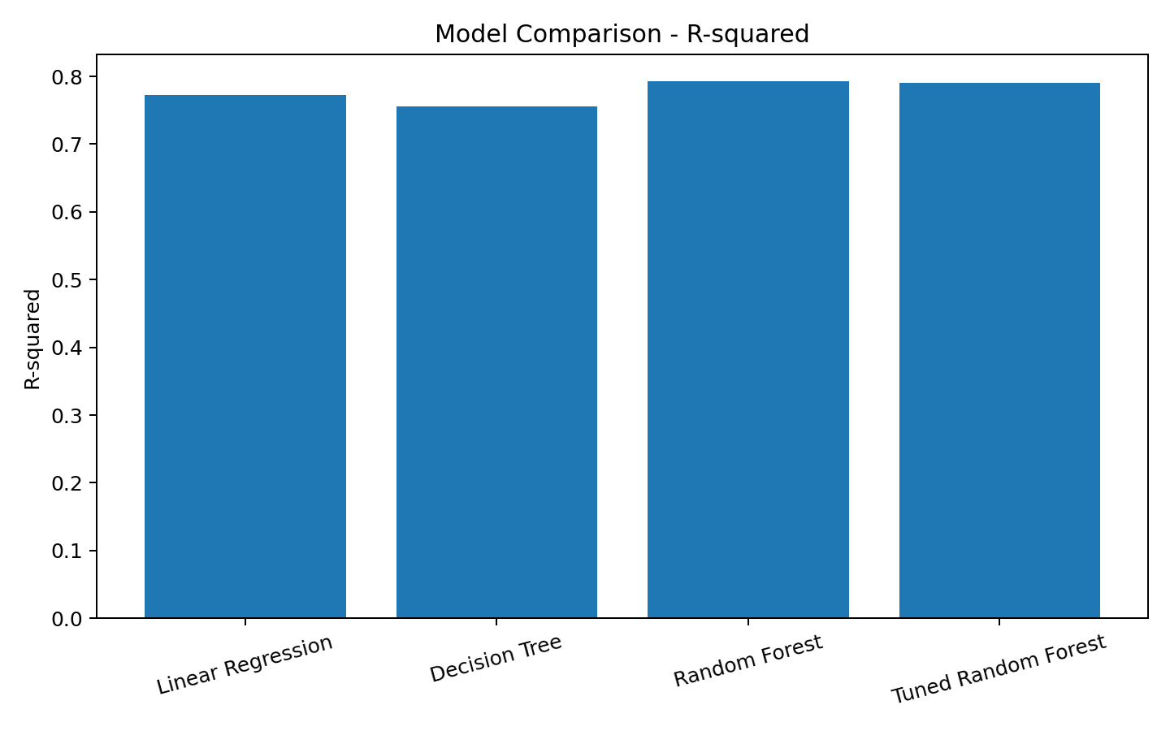

5.3 Cross-validation Strategy
Three-fold cross-validation was performed on a 12,000-record development subset using a Random Forest pipeline. This provides repeated train-validation checks rather than relying on one split. The fold MAE values were 2.7508, 2.7086, and 2.7748, with an average cross-validation MAE of 2.7447.
Fold | MAE
1 | 2.7508
2 | 2.7086
3 | 2.7748
Mean | 2.7447

5.4 Hyperparameter Tuning
RandomizedSearchCV with three-fold cross-validation was used to test combinations of Random Forest hyperparameters. The search varied the number of trees, maximum tree depth, and minimum samples per leaf. The best cross-validation configuration was 40 estimators, max_depth=10, and min_samples_leaf=3, with a best cross-validation MAE of 2.7196 on the development subset.
from sklearn.model_selection import RandomizedSearchCV
parameter_grid = {
"model__n_estimators": [40, 60, 80],
"model__max_depth": [10, 14, 18],
"model__min_samples_leaf": [3, 5, 10]
}
search = RandomizedSearchCV(
rf_pipeline,
param_distributions=parameter_grid,
n_iter=5,
cv=3,
scoring="neg_mean_absolute_error",
random_state=42
)
search.fit(X_dev, y_dev)
print(search.best_params_)
print(-search.best_score_)
The tuned Random Forest did not improve the held-out test result compared with the base Random Forest in this run (R² 0.7909 versus 0.7926). Therefore, the base Random Forest is retained as the final selected model for the operational interpretation, while the tuning exercise is documented as part of validation.

6. Prediction Results and Model Insights

6.1 Actual vs Predicted Distance
The actual-versus-predicted plot is used to visually assess how closely the Random Forest model predictions follow the observed actual-distance values. Points closer to the diagonal indicate more accurate predictions, while larger deviations from the line indicate higher prediction error.
Figure 2. Actual vs Predicted Distance – Random Forest
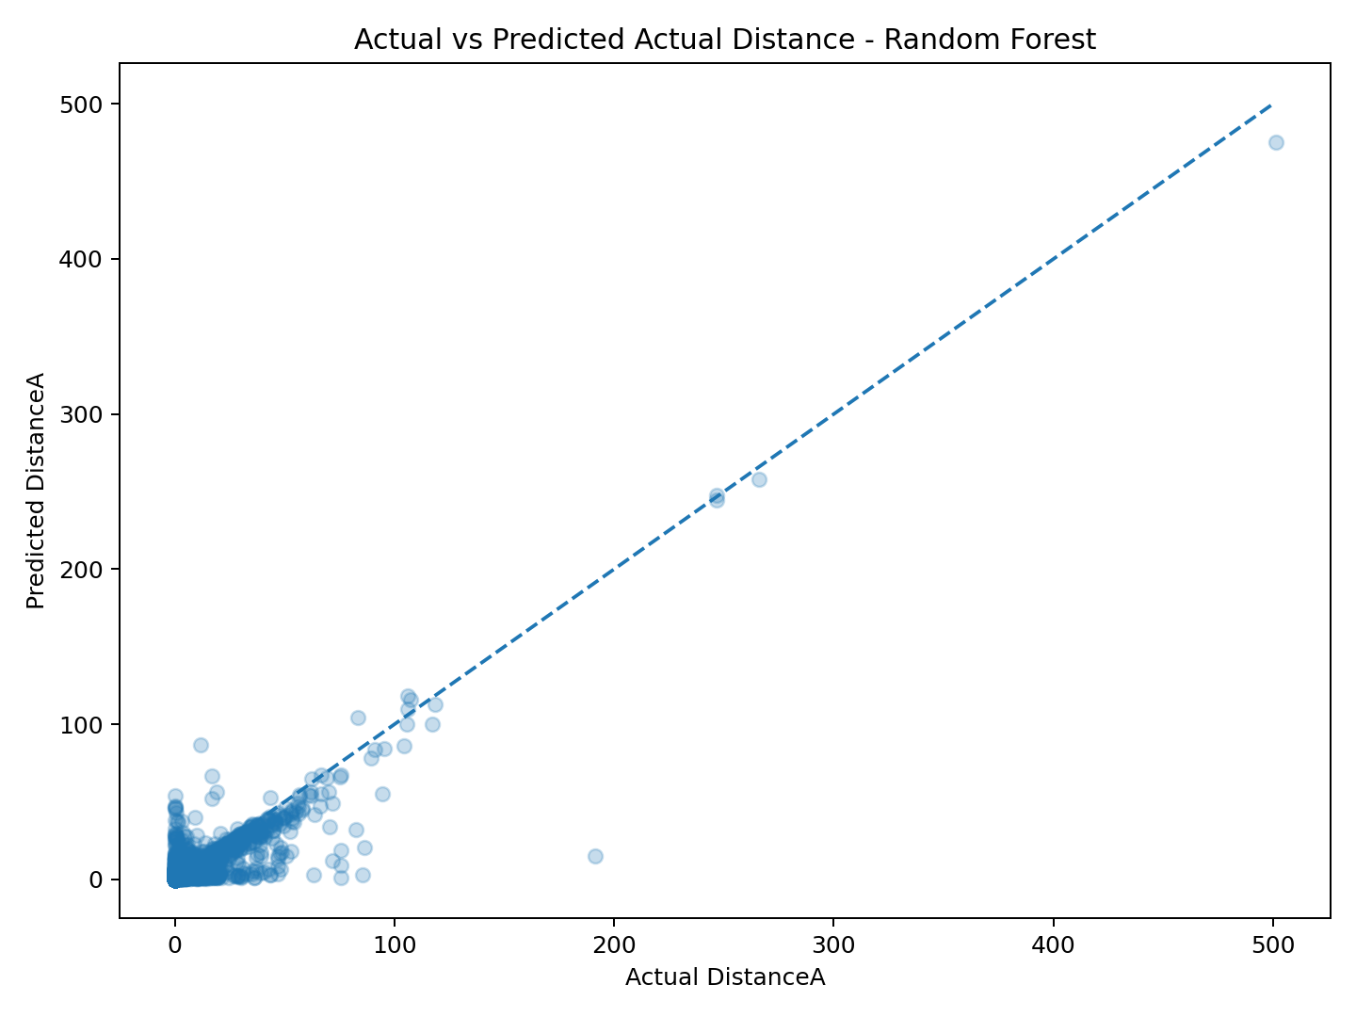

6.2 Sample Prediction Output
DistanceP | IndexP | Latest Time | Actual DistanceA | Predicted DistanceA | Absolute Error
6.982 | 4 | 540.0 | 5.647 | 5.401 | 0.246
3.404 | 21 | 780.0 | 3.404 | 3.427 | 0.024
3.361 | 5 | 600.0 | 3.361 | 3.558 | 0.197
6.929 | 21 | 720.0 | 1.944 | 6.085 | 4.141
17.236 | 5 | 645.0 | 17.236 | 14.236 | 3.000
0.000 | 8 | 540.0 | 0.062 | 0.906 | 0.844
20.583 | 2 | 780.0 | 0.965 | 14.643 | 13.678
0.614 | 10 | 540.0 | 1.098 | 0.991 | 0.107
5.148 | 8 | 690.0 | 7.887 | 4.510 | 3.377
0.036 | 12 | 480.0 | 0.036 | 0.906 | 0.870
1.662 | 7 | 600.0 | 1.109 | 2.044 | 0.935
3.860 | 2 | 720.0 | 3.860 | 4.009 | 0.149

6.3 Feature Importance
Feature | Importance
DistanceP | 0.9278
Time_Window_Width | 0.0149
Latest Time | 0.0148
Week ID | 0.0119
Earliest Time | 0.0110
IndexP | 0.0084
Country | 0.0026
Day: Thursday | 0.0021
Delivery | 0.0015
Day: Monday | 0.0011

DistanceP is the dominant model feature in this run, with an importance of approximately 0.9278. This indicates that planned distance is the strongest predictor of actual distance in the selected feature set. The next most influential features are Latest Time, Time_Window_Width, and Earliest Time, with much smaller contributions.
Figure 3. Top feature importance – Random Forest
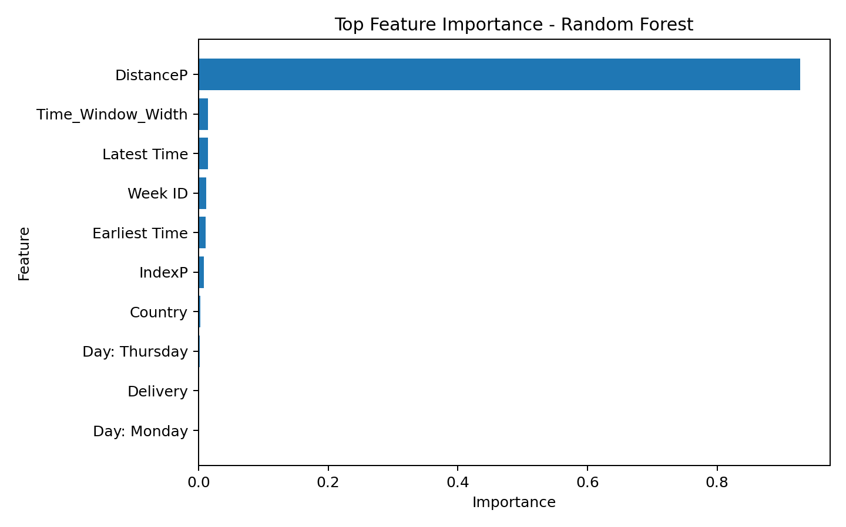

7. Optimization Strategies

7.1 Route-deviation Screening
A practical optimization layer is created by comparing the predicted actual distance with the planned distance. The screening variable is: Predicted_Deviation = Predicted_DistanceA – DistanceP. A positive predicted deviation indicates that the model expects the actual route distance to be higher than the planned distance. These records can be prioritized for route review before execution.
# Calculate predicted route deviation
predicted_deviation = predicted_distanceA - X_test["DistanceP"]
# Flag cases where predicted actual distance exceeds planned distance
high_deviation_flag = predicted_deviation > 0
print("Predicted positive-deviation rate:",
round(high_deviation_flag.mean() * 100, 2), "%")

7.2 Day-wise Optimization Screening
The day-wise screening below shows the proportion of test records for which the predicted actual distance is greater than the planned distance. This is a screening indicator rather than a formal business risk score; it is intended to support prioritization for further route analysis.
Day | Average Predicted Deviation | Positive-Deviation Rate
Tuesday | -0.098 | 74.71%
Thursday | -0.045 | 70.96%
Monday | -0.022 | 69.43%
Friday | 0.038 | 68.60%
Wednesday | -0.130 | 67.86%
Saturday | -0.049 | 66.07%
Sunday | 0.192 | 65.71%

Figure 4. Predicted positive-deviation screening by day
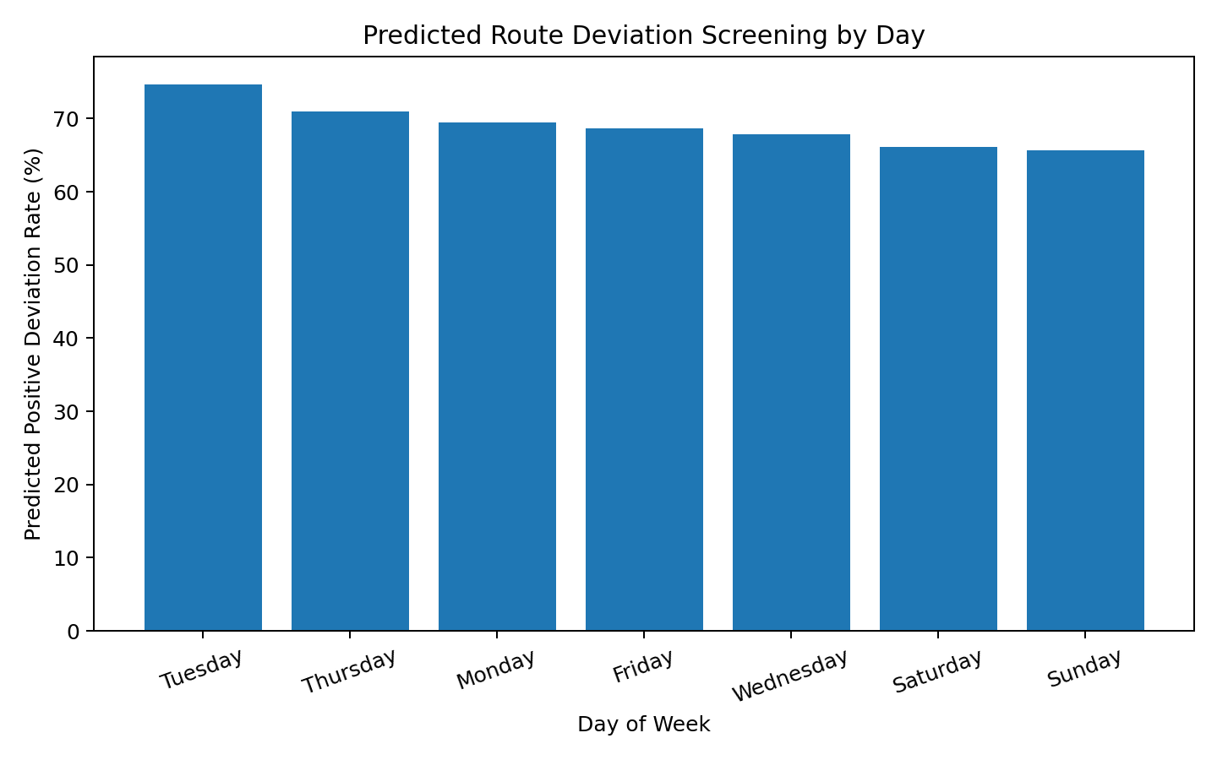

8. Logistics Optimization Recommendations

1. Prioritize routes with positive predicted deviation.
Before route execution, review cases where predicted actual distance exceeds planned distance. These routes can receive additional planning attention or manual route review.

2. Use planned distance as a primary planning signal.
The model indicates that DistanceP is by far the most influential feature in the selected model, so improvements to planned-distance estimation can have a strong effect on prediction quality.

3. Monitor day-wise patterns.
Use day-wise predicted-deviation rates as an operational monitoring view. Tuesday shows the highest positive-deviation rate in this test sample (74.71%), followed by Thursday (70.96%). The day-wise pattern should be interpreted with the exact business context and sample composition rather than treated as a causal effect.

4. Review time-window information during planning.
Latest Time, Earliest Time, and the derived time-window width have smaller but measurable model importance. These features can be retained in planning reviews, especially when route constraints change.

5. Add reliable cost data for cost optimization.
The current dataset does not contain a direct transportation-cost or fuel-cost variable. Therefore, cost reduction should not be quantified from this dataset alone. A future project can combine the prediction model with validated cost data to optimize fuel, distance, or vehicle allocation.

6. Build a KPI dashboard in a later stage.
A future monitoring dashboard can combine predicted distance, planned distance, predicted deviation, model error, and day-wise risk indicators for operational reporting.

9. Limitations and Practical Interpretation
- The model uses a reproducible 50,000-record sample from the full public dataset rather than all 249,231 records.
- Actual-execution variables are excluded from the pre-execution feature set to reduce information leakage.
- The time variables are treated as the numeric values supplied in the source dataset; they are not converted into ordinary clock timestamps.
- The positive-deviation screening rule is a practical prioritization indicator, not a validated business risk threshold.
- No direct transportation-cost or shipment-volume field is available in the selected dataset, so cost and volume claims are outside the evidence of this analysis.
These limitations do not prevent the model from demonstrating the required predictive workflow. They define how the results should be interpreted and where future data expansion would strengthen the optimization stage.

10. Conclusion
This task demonstrates a complete predictive modeling workflow for a logistics problem using Python. A realistic prediction problem was defined, the available public logistics dataset was prepared, three regression models were trained, and their performance was evaluated using MAE, RMSE, and R².
Among the tested models, Random Forest provided the strongest held-out performance, with MAE 2.5987, RMSE 6.5710, and R² 0.7926. Cross-validation and hyperparameter tuning were also applied as part of model validation. The final optimization layer uses predicted actual distance relative to planned distance to identify records that may deserve route-planning attention.
The project therefore connects prediction with an actionable logistics decision process: estimate actual route distance, compare it with the plan, prioritize higher-deviation cases, and monitor day-wise patterns. Future work can extend the model with validated transportation-cost, vehicle-capacity, traffic, weather, or shipment-volume data and can connect the predictions to formal route optimization algorithms.

11. References
1. Konovalenko, A., Hvattum, L. M., & Iversen, K. A. H. (2024). Last-mile delivery route deviations dataset: planned vs. actual routes. Mendeley Data, Version 1. https://data.mendeley.com/datasets/kkwgfvmtxn/1
2. Konovalenko, A., Hvattum, L. M., & Iversen, K. A. H. (2026). Data describing planned routes and driven routes from a last-mile delivery vehicle routing problem. Data in Brief, 66, 112744. https://doi.org/10.1016/j.dib.2026.112744
3. Pandas Documentation. https://pandas.pydata.org/docs/
4. Scikit-learn Documentation. https://scikit-learn.org/stable/
5. Matplotlib Documentation. https://matplotlib.org/stable/

Appendix A – Complete Modeling Pipeline
The following consolidated script demonstrates the end-to-end preparation, training, evaluation, and feature-importance workflow used for this project.
import pandas as pd
import numpy as np
from sklearn.model_selection import train_test_split
from sklearn.compose import ColumnTransformer
from sklearn.preprocessing import OneHotEncoder
from sklearn.impute import SimpleImputer
from sklearn.pipeline import Pipeline
from sklearn.linear_model import LinearRegression
from sklearn.tree import DecisionTreeRegressor
from sklearn.ensemble import RandomForestRegressor
from sklearn.metrics import mean_absolute_error, mean_squared_error, r2_score
# 1. Load dataset
df = pd.read_excel(
r"D:\DataAnylitics\Yuva_Intrnship\routes_performance.xlsx"
)
# 2. Feature engineering
df["Time_Window_Width"] = (
df["Latest Time"] - df["Earliest Time"]
)
# 3. Select variables
features = [
"DistanceP", "IndexP", "Earliest Time", "Latest Time",
"Time_Window_Width", "Week ID", "Country", "Depot",
"Delivery", "Day of Week"
]
target = "DistanceA"
df = df[features + [target]].dropna()
df = df.sample(n=min(50000, len(df)), random_state=42)
X = df[features]
y = df[target]
# 4. Preprocessing
numeric_features = features[:-1]
categorical_features = ["Day of Week"]
preprocessor = ColumnTransformer([
("num", SimpleImputer(strategy="median"), numeric_features),
("cat", Pipeline([
("imputer", SimpleImputer(strategy="most_frequent")),
("onehot", OneHotEncoder(handle_unknown="ignore"))
]), categorical_features)
])
# 5. Train-test split
X_train, X_test, y_train, y_test = train_test_split(
X, y, test_size=0.20, random_state=42
)
# 6. Models
models = {
"Linear Regression": LinearRegression(),
"Decision Tree": DecisionTreeRegressor(
max_depth=12, min_samples_leaf=5, random_state=42
),
"Random Forest": RandomForestRegressor(
n_estimators=50, max_depth=14,
min_samples_leaf=5, random_state=42, n_jobs=-1
)
}
# 7. Train and evaluate
for name, model in models.items():
pipe = Pipeline([
("preprocessor", preprocessor),
("model", model)
])
pipe.fit(X_train, y_train)
pred = pipe.predict(X_test)
mae = mean_absolute_error(y_test, pred)
rmse = mean_squared_error(y_test, pred) ** 0.5
r2 = r2_score(y_test, pred)
print(name, mae, rmse, r2)
# 8. Operational screening with selected Random Forest
rf_pipe = Pipeline([
("preprocessor", preprocessor),
("model", RandomForestRegressor(
n_estimators=50, max_depth=14,
min_samples_leaf=5, random_state=42, n_jobs=-1
))
])
rf_pipe.fit(X_train, y_train)
pred = rf_pipe.predict(X_test)
predicted_deviation = pred - X_test["DistanceP"].to_numpy()
high_deviation_flag = predicted_deviation > 0
print("Positive deviation rate:",
round(high_deviation_flag.mean()*100, 2), "%")

