Experiment No. 9

Aim : Study and Installation of Weka AI tool

Name : Shailesh Narendra Kadu

Roll No. : 51

Sec : 3A

Subject : ET - 2

Theory:



What is Weka?

**Weka** (Waikato Environment for Knowledge Analysis) is a popular suite of machine learning software written in Java. It is developed by the University of Waikato, New Zealand.

**🔹 Key Features:**

* GUI-based and user-friendly
* Supports various machine learning

algorithms (classification, regression, clustering)

* Data pre-processing tools
* Visualization tools
* Supports scripting and Java API for developers

**🔹 Applications:**

* Academic research
* Data mining projects
* Rapid prototyping of ML models
* Teaching and learning machine learning concepts

**🔹 Core Components:**

1. **Explorer** – Main GUI for data analysis
2. **Experimenter** – For running experiments and comparing algorithms
3. **Knowledge Flow** – Visual pipeline-style interface for data flow
4. **Simple CLI** – Command-line interface

Installation of Weka:

**Step-by-step Instructions:**

**🔸 For Windows:**

1. **Go_to_Official_Website**  
   ➤https://www.cs.waikato.ac.nz/ml/weka/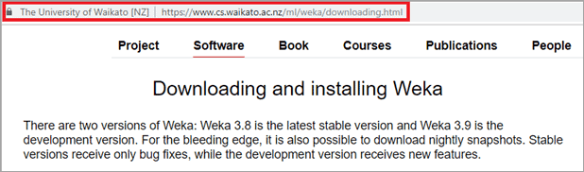
2. **Click on the "Download" tab**
3. **Choose Windows Installer (.exe file)**
4. **Download_and_run_the_installer**  
   ➤ Follow the setup wizard steps (Next → Install → Finish)
5. **Launch Weka** from the Start Menu or desktop icon.

**Running Your First Machine Learning Model in Weka:**

**🔹 Step 1: Open Weka:**

* After installation, launch the **Weka GUI Chooser**.



**🔹 Step 2: Open "Explorer":**

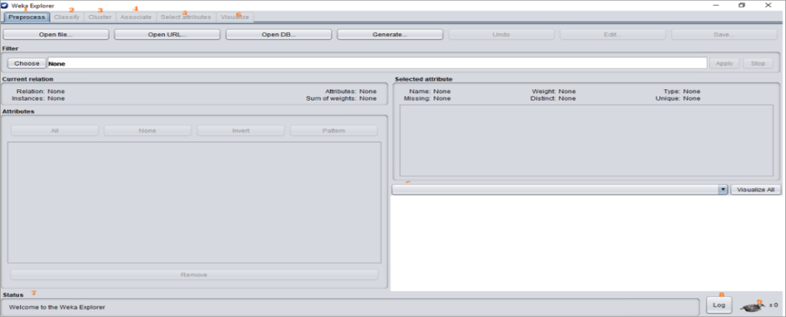

**🔹 Step 3: Load a Dataset:**

* Click **Open File**
* Navigate to: /data/iris.arff
* This is a sample dataset with flower measurements.

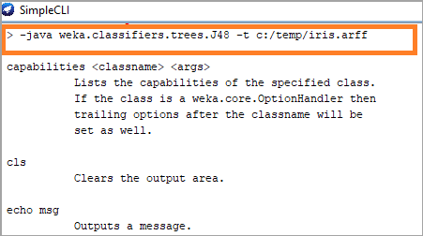

**🔹 Step 4: Choose a Classifier:**

* Go to the **"Classify" tab**
* Click **"Choose"** → **trees** → select **J48 (decision tree)**

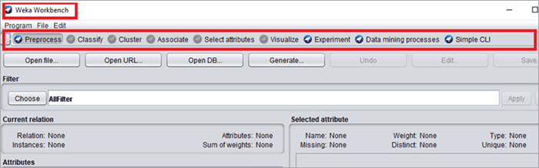

**🔹 Step 5: Click "Start":**

* Weka will train the model and show results like:
  + Accuracy
  + Confusion Matrix
  + Precision, Recall, F-measure

**Advantages of Using Weka:**

* ✅ Easy to use, even for beginners
* ✅ Excellent for quick testing and prototyping
* ✅ Includes many algorithms without needing to code
* ✅ Good for educational and research purposes

**Limitations of Weka:**

* ❌ Not suitable for very large datasets (in-memory only)
* ❌ Limited support for deep learning
* ❌ GUI can feel outdated

**Conclusion:**

* Weka is a valuable tool for anyone learning or experimenting with machine learning. It simplifies data pre-processing, model training, and evaluation through its user-friendly interface. Though it may not be suited for large-scale production systems, it is ideal for teaching, research, and prototyping.