**A**

**MINI PROJECT**

**REPORT ON**

**Company visitor management system**

**Testing using selenium IDE**

**SUBMITTED TO THE SAVITRIBAI PHULE PUNE UNIVERSITY, PUNE.**

**FOR**

**LAB PRACTICE II**

**Software Testing and Quality Assurance**

**BACHELOR OF ENGINEERING (COMPUTER ENGINEERING)**

**SUBMITTED BY**

**Name: Prajakta kamble PRN – 72000288F RollNo-B1921153**

**Name: Rutuja Bachhav PRN – 72000282G RollNo-B1921149**

**Name: Sayama Kazi PRN – 7200089D RollNo-B1921156**



**DEPARTMENT OF COMPUTER ENGINEERING**

**D.Y.PATIL COLLEGE OF ENGINEERING AKURDI, PUNE-44.**

**SAVITRIBAI PHULE PUNE UNIVERSITY, 2021-22 SEM-I**

**INDEX**

|  |  |  |
| --- | --- | --- |
| **SR. NO.** | **TOPIC** | **PAGE NO.** |
| 1. | **Abstract** | 1 |
| 2. | **Introduction**  ● Problem Statement  ● Objective and Scope | 1-2 |
| 3. | **Outcomes** | 2 |
| 4. | **Software/Hardware Requirements**  ● Software Requirement Specifications  ● Hardware Requirement Specification | 3 |
| 5. | **System Design** | 4 |
| 6. | **Test plan and Testing strategies** | 5-22 |
| 7. | **Results**  ● Working Module Screenshot  ● Testing Screenshot | 22-72 |
| 8. | **Advantages** | 73 |
| 9. | **Conclusion** | 73 |
| 10. | **References** | 73 |

**ABSTARCT**

Company Visitor Management System deals with the security provided at company premises from the unauthenticated or unwanted visitors.

Nowadays, in most organizations Visitor management consists of visitors scribbling their name in a paper book.

Instead, Company Visitor Management System will assist you the professionalized way in which you welcome your visitors. This software is a complete Visitor Management service to improve the efficiency, productivity, security.

**INTRODUCTION**

In this we mentioned the software and hardware requirements, which are necessary for successfully running this system. The major element in building systems is selecting compatible hardware and software. The system analyst has to determine what software package is best for the **“Online Company Visitor Management System”** and, where software is not an issue, the kind of hardware and peripherals needed for the final conversion. Company Visitor Management system is a web-based technology that will revolutionize the way your company manages visitors. Visitor Management system is more important to security guards or security company. This web application provides a way to effectively control record & track company visitor traffic. In CVMS we use Python Django and Sqlite database. This is the project which keeps records of visitors who visited in the company.

**PROBLEM STATEMENT**

In present all visitor work done on the paper. The whole year visitor is stored in the registers. We can’t generate reports as per our requirements because its take more time to calculate the visitors report.

**OBJECTIVE**

* The purpose of developing company visitor management system is to computerized the tradition way of visitors.
* Another purpose for developing this application is to generate the report automatically.
* reduce paper work
* Provide accuracy

**FUTURE SCOPE**

Thisweb application involves almost all the basic features of the online company visitor management system. The future implementation will be online help for the visitors and chatting with website administrator.

**OUTCOMES**

Following are the aim of project:

* Secure system by providing admin login.
* Easily manage record
* No chances of loss Information

**SOFTWARE /HARDWARE REQUIREMENTS**

* **Software Requirement Specifications:**

**For development:**

PyCharm

SQLite Database

**For Testing**

Selenium IDE –

*Selenium IDE (Integrated Development Environment) is primarily a record/run tool that a test case developer uses to develop Selenium Test cases.* Selenium IDE is an easy-to-use tool from the [Selenium Test Suite](https://www.browserstack.com/selenium) and can even be used by someone new to developing automated test cases for their web applications. One does not require any special setup to get started with Selenium IDE. You just need to add the extension of your specific browser. Selenium IDE provides you with a GUI (Graphical User Interface) for easily recording your interactions with the website.

* **Hardware Requirement Specification**

Intel Pentium Processor

32 MB RAM or higher

1.2 GB Hard Disk or greater

**SYSTEM DESIGN**

* Use case diagram
* Class Diagram
* Sequence Diagram
* Data flow diagram

**Use Case Diagram:**

* Use case diagram consists of use cases and actors and shows the interaction between them. The key points are:
* The main purpose is to show the interaction between the use cases and the actor.
* To represent the system requirement from user’s perspective.
* The use cases are the functions that are to be performed in the module.

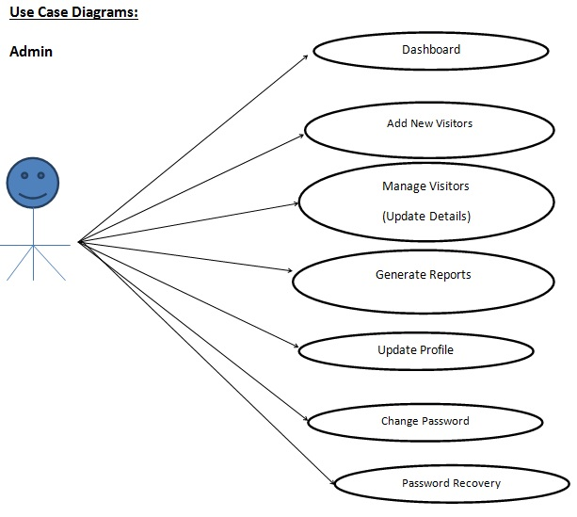

**DFD (Data Flow Diagram)**

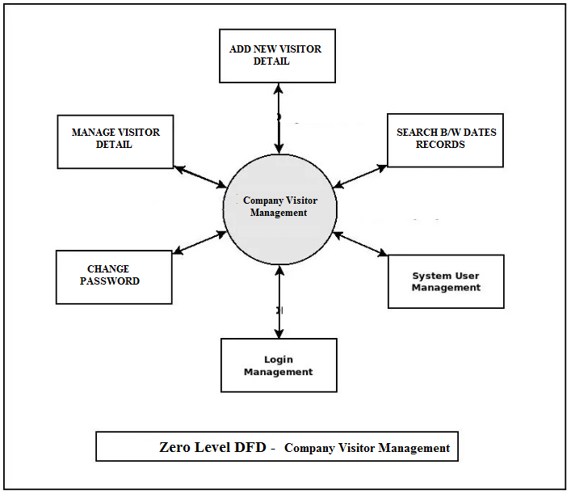

**ER DIAGRAM**

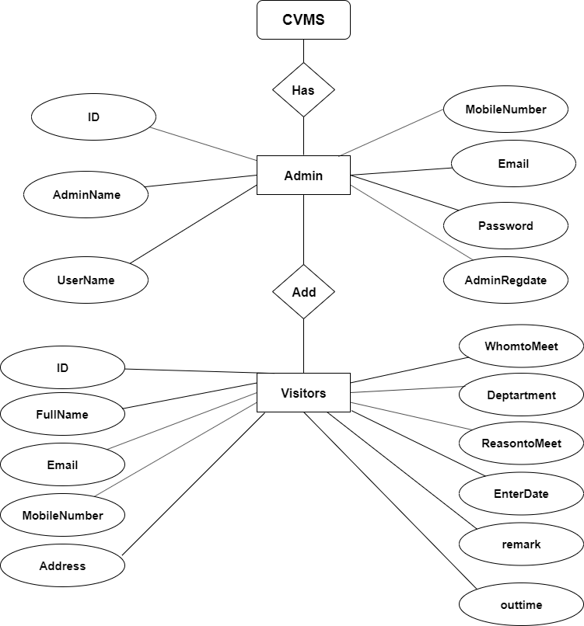

**Sequence Diagram For Administrator**

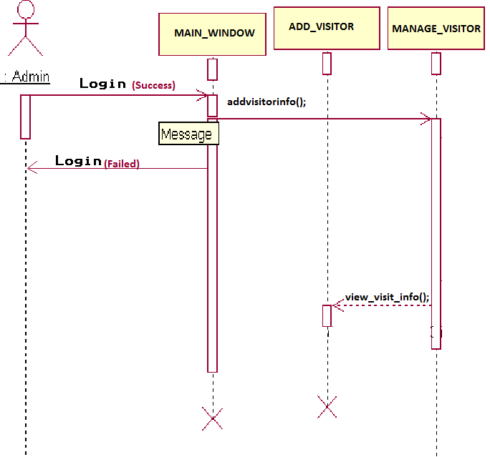

**Administrator**

**Success:hide()**

Fig.5.4

**TEST PLAN**

|  |  |  |  |  |
| --- | --- | --- | --- | --- |
| **Sr. No.** | **Test class** | **Description** | **Expected Result** | **Actual Result** |
| 1 | Admin login | Ensures Admin login page open | Page should open and Admin Login should be done successfully | Page open and Login duone successfully |

**TEST STRATERGY**

**Admin Login**

|  |  |  |  |  |  |  |
| --- | --- | --- | --- | --- | --- | --- |
| **Test case Id** | **Test case objective** | **Steps** | **Input** | **Expected Result** | **Actual Result** | **Status** |
| TC-1 | Login the admin portal | Click on login button | Username:admin  Password:1234 | Login succesfully | Login succesfully | PASS |
| TC-2 | Add Customre | Click on add button | Details | Add succesfully | Add succesfully | PASS |
| TC-3 | Edit Visitor | Click on Edit Button | None | Edit should be done succesfully | Edit done succesfully | PASS |
| TC-4 | Check for the Search visitor | Click on Search button | Date | Visitor shpuld be search succesgully | Search success | PASS |
| TC-4 | Check for the feedback option | Click on feedback option | None | The Feedback of customer should be visible | The Feedback of customer are visible | PASS |
| TC-5 | Check for  Logout button | Click on logout button | None | Logout button should be active and visible | Logout button is active and visible | PASS |

**RESULT**

**Working Module**

**HOME PAGE**

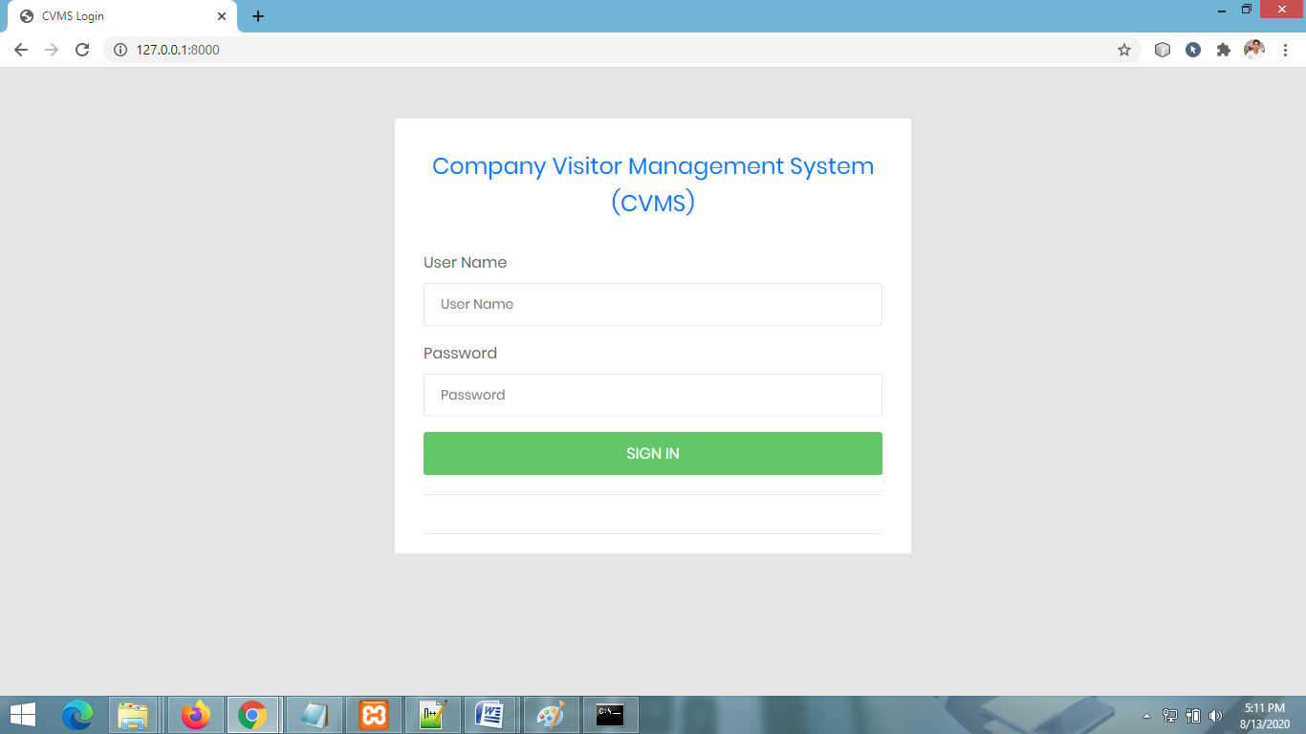

**ADMIN DASHBOARD PAGE**

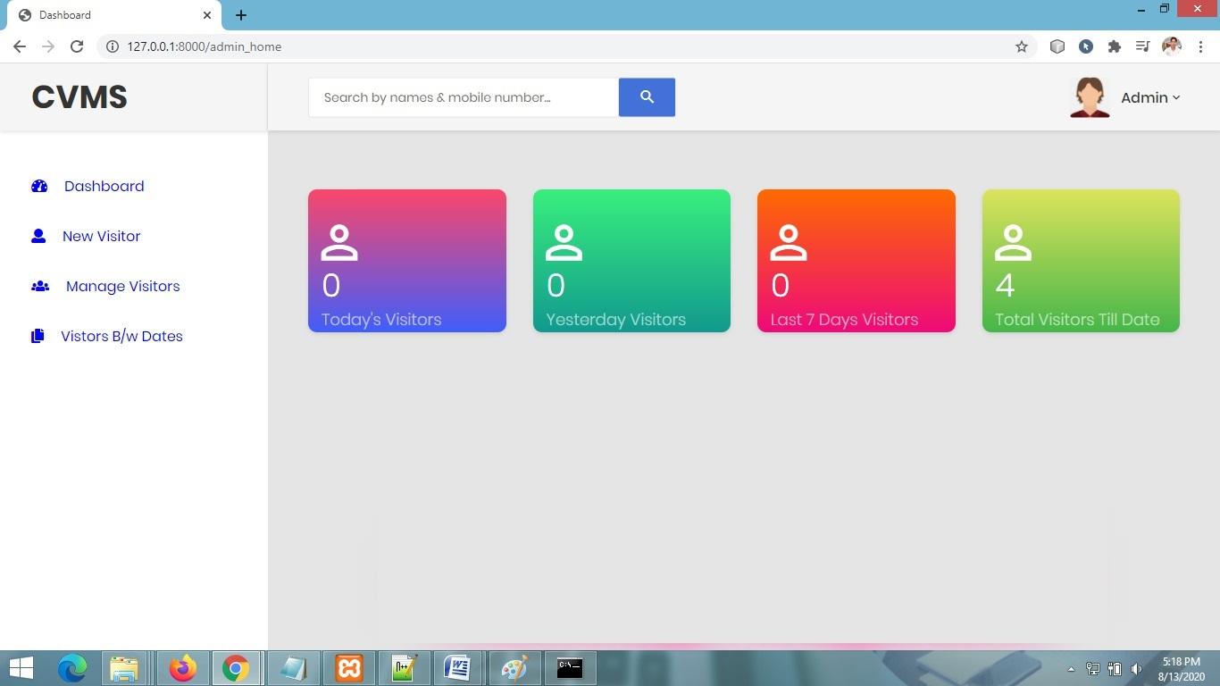

**ADD NEW VISITOR PAGE**

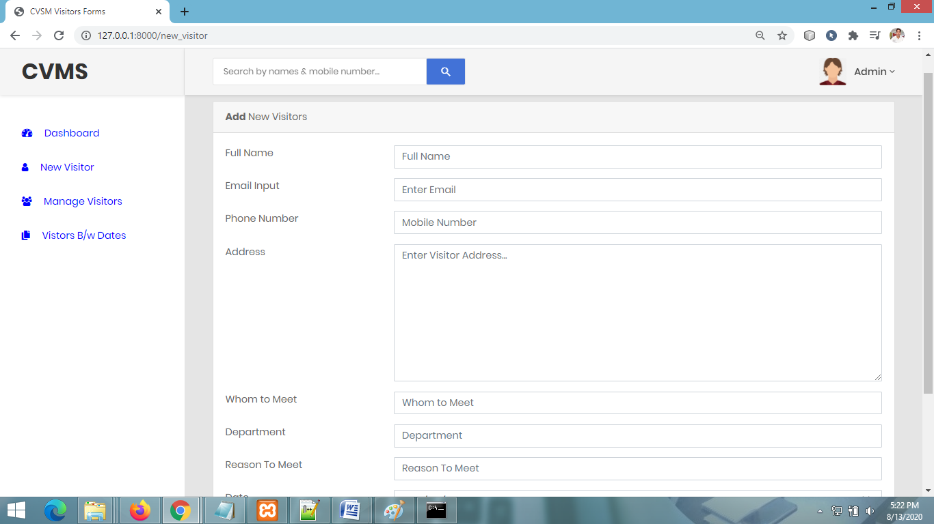

**MANAGE VISITOR PAGE**

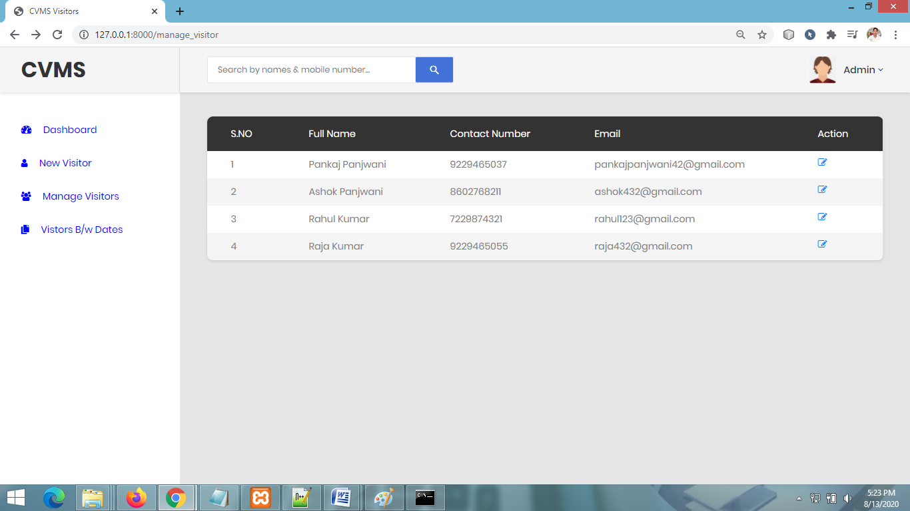

**VIEW VISITOR DETAIL PAGE**

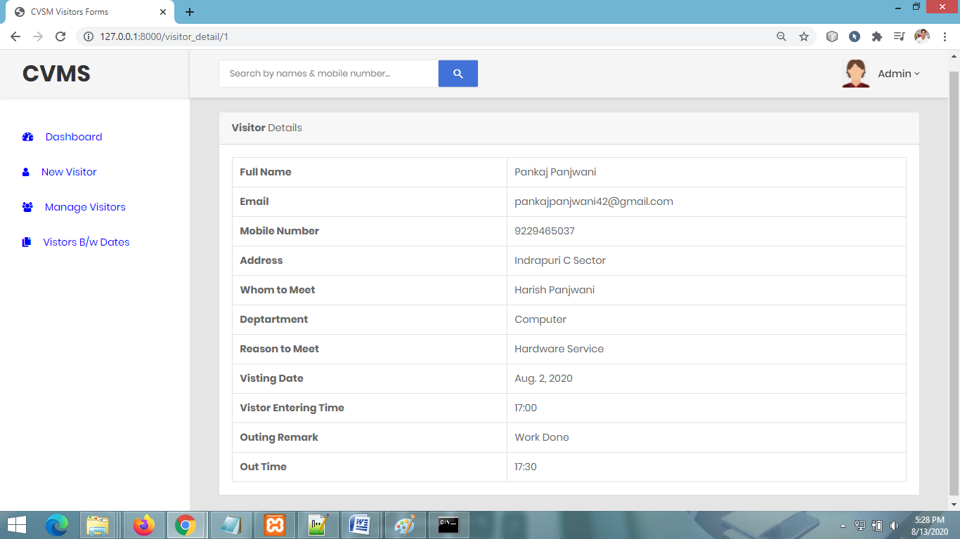

**BETWEEN DATE REPORTS**

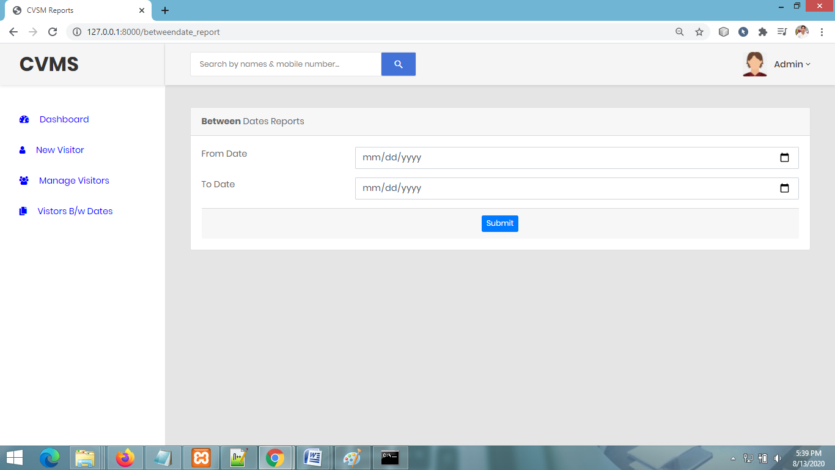

**VIEW BETWEEN DATES REPORTS**

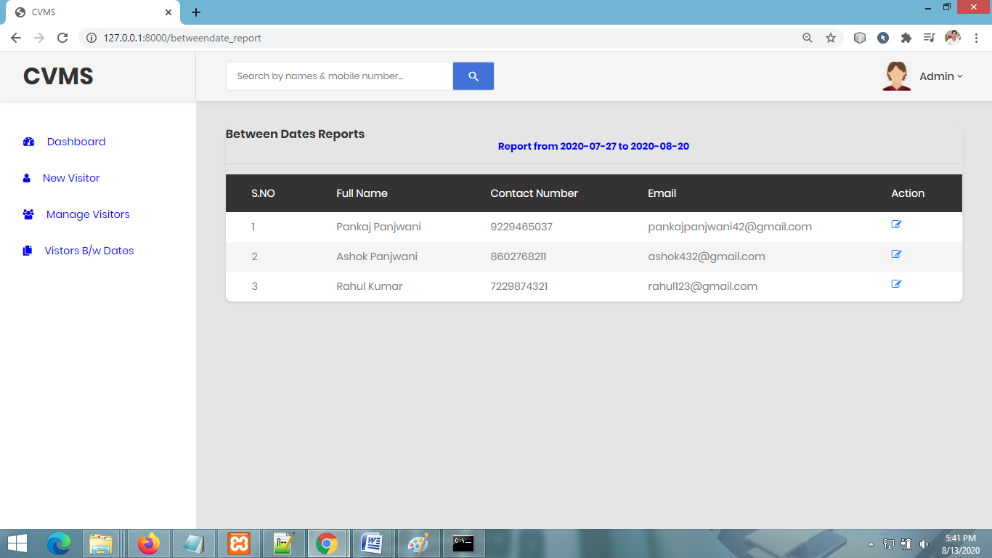

**CHANGE PASSWORD PAGE**

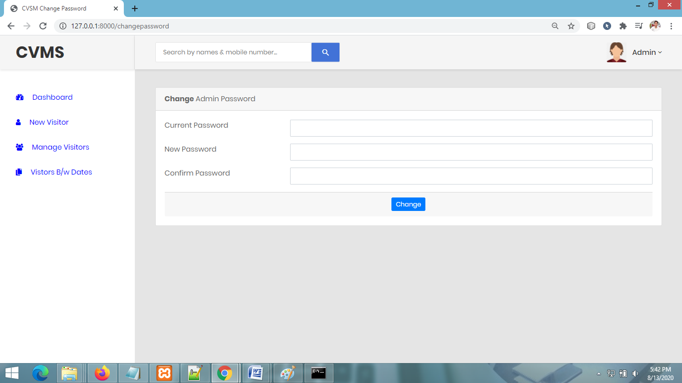

**TESTING**

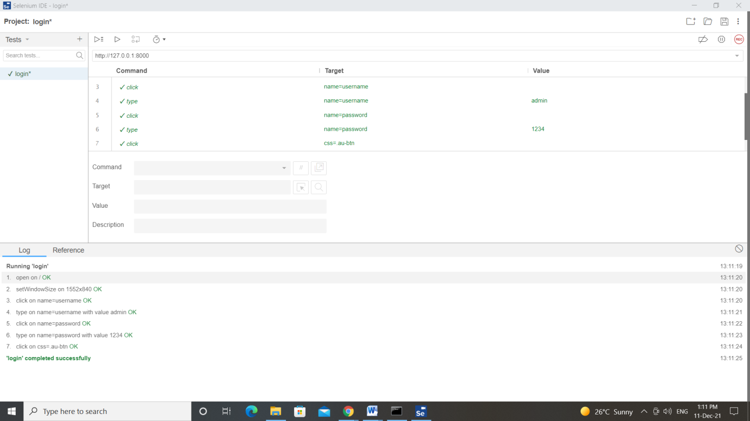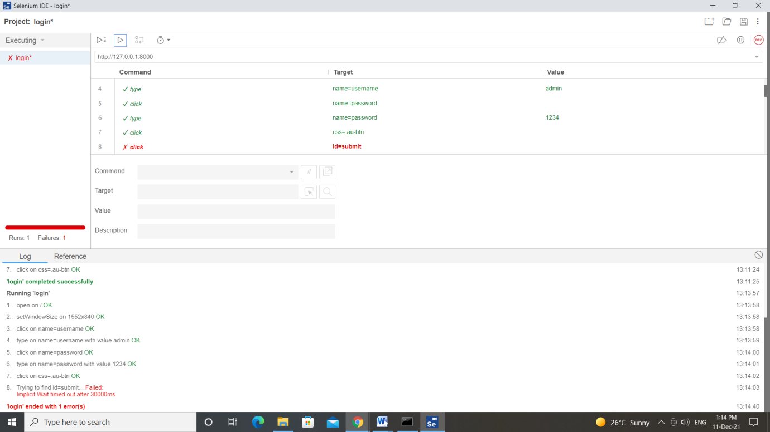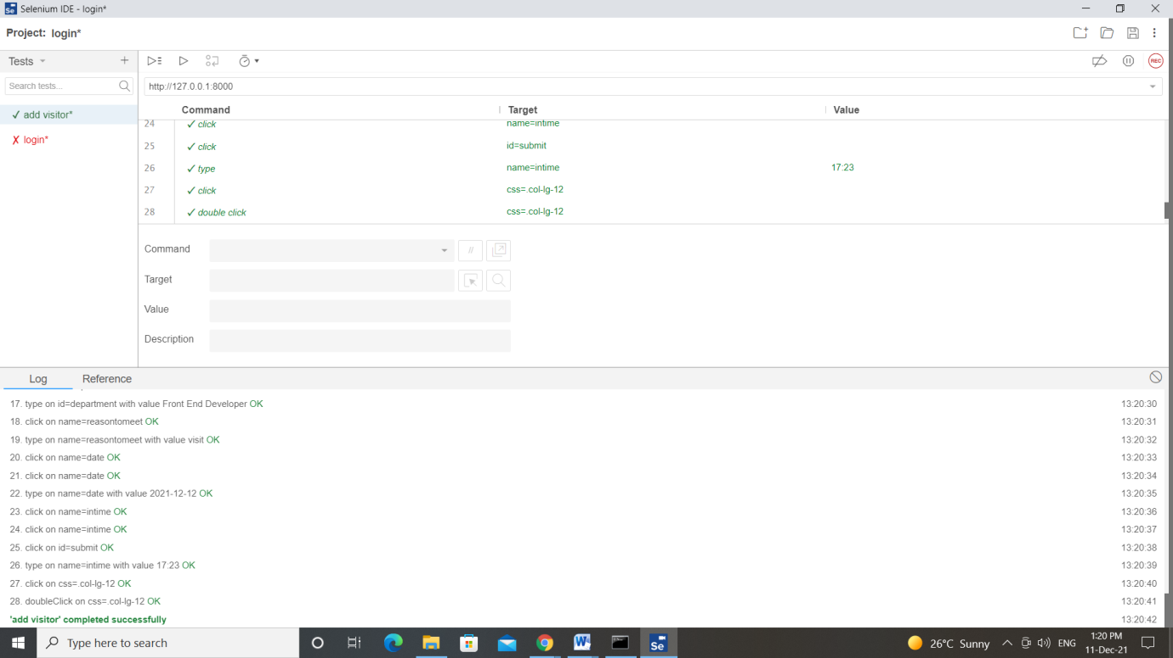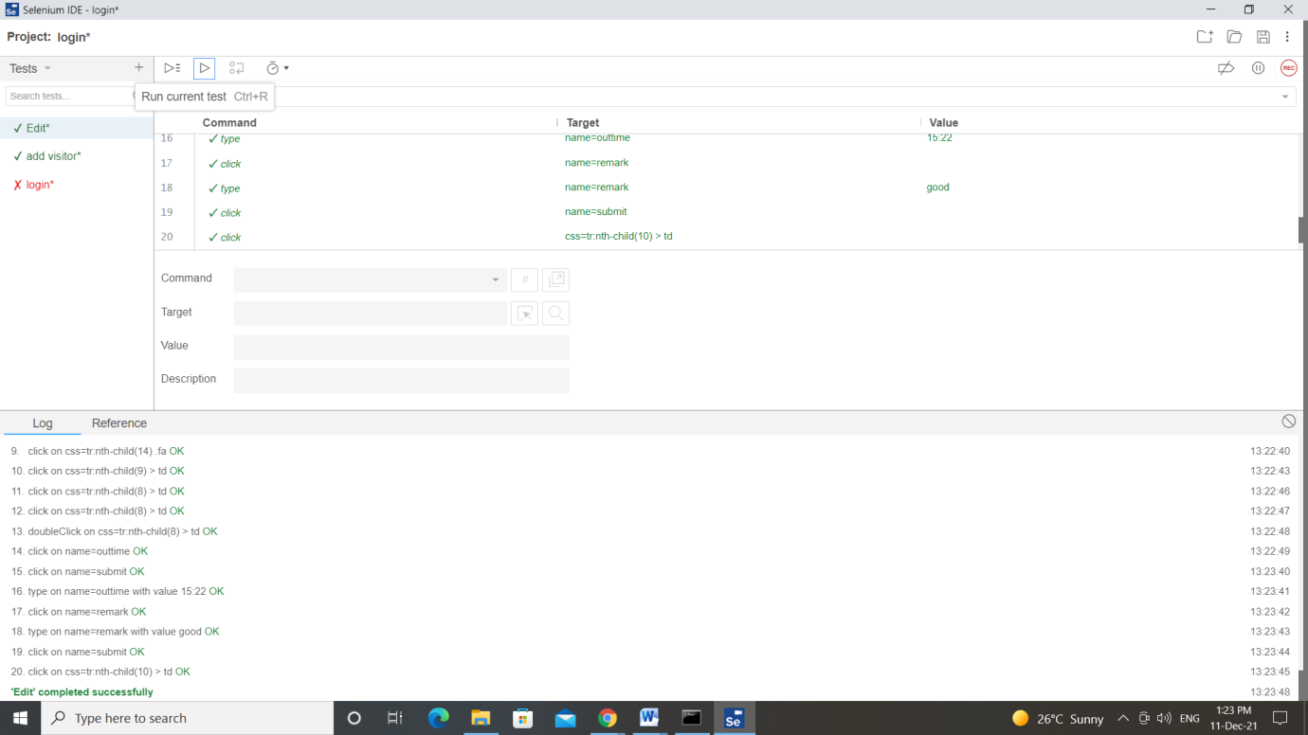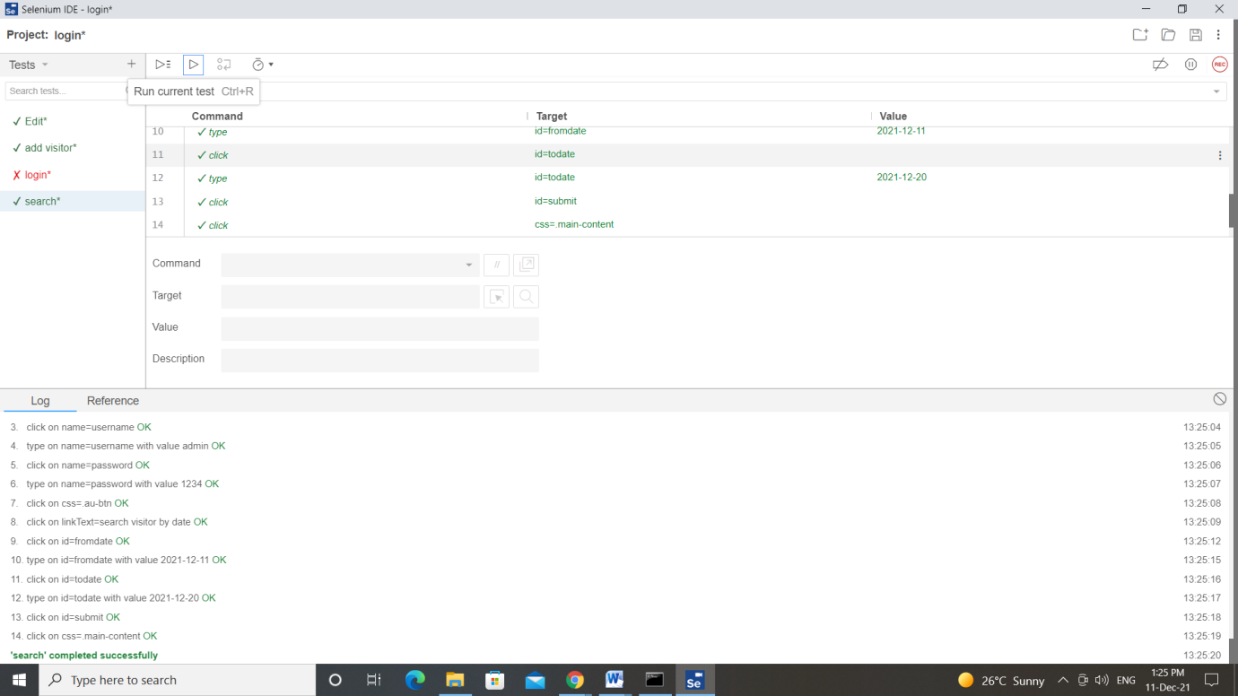

**CODING**

**ADMIN LOGIN PAGE CODING**

**{% load static %}**

**{% block body %}**

**<html Lang="en">**

**<head>**

**<!-- Required meta tags-->**

**<meta charset="UTF-8">**

**<meta name="viewport" content="width=device-width, initial-scale=1, shrink-to-fit=no">**

**<meta name="description" content="au theme template">**

**<meta name="author" content="Hau Nguyen">**

**<meta name="keywords" content="au theme template">**

**<!-- Title Page-->**

**<title>CVMS Login</title>**

**<!-- Fontfaces CSS-->**

**<link href="{% static 'css/font-face.css' %}" rel="stylesheet" media="all">**

**<link href="{% static 'vendor/font-awesome-4.7/css/font-awesome.min.css' %}" rel="stylesheet" media="all">**

**<link href="{% static 'vendor/font-awesome-5/css/fontawesome-all.min.css' %}" rel="stylesheet" media="all">**

**<link href="{% static 'vendor/mdi-font/css/material-design-iconic-font.min.css' %}" rel="stylesheet" media="all">**

**<!-- Bootstrap CSS-->**

**<link href="{% static 'vendor/bootstrap-4.1/bootstrap.min.css' %}" rel="stylesheet" media="all">**

**<!-- Vendor CSS-->**

**<link href="{% static 'vendor/animsition/animsition.min.css' %}" rel="stylesheet" media="all">**

**<link href="{% static 'vendor/bootstrap-progressbar/bootstrap-progressbar-3.3.4.min.css' %}" rel="stylesheet" media="all">**

**<link href="{% static 'vendor/wow/animate.css' %}" rel="stylesheet" media="all">**

**<link href="{% static 'vendor/css-hamburgers/hamburgers.min.css' %}" rel="stylesheet" media="all">**

**<link href="{% static 'vendor/slick/slick.css' %}" rel="stylesheet" media="all">**

**<link href="{% static 'vendor/select2/select2.min.css' %}" rel="stylesheet" media="all">**

**<link href="{% static 'vendor/perfect-scrollbar/perfect-scrollbar.css' %}" rel="stylesheet" media="all">**

**<!-- Main CSS-->**

**<link href="{% static 'css/theme.css' %}" rel="stylesheet" media="all">**

**</head>**

**<body class="animsition" background = "{% static 'images/bg1.jpg' %}">**

**<div class="page-wrapper">**

**<div class="page-content--bge5">**

**<div class="container">**

**<div class="login-wrap">**

**<div class="login-content">**

**<div class="login-logo">**

**<a href="#" style="font-size:24px;">**

**Company Visitor Management System (CVMS)**

**</a>**

**</div>**

**<div class="login-form">**

**<form action="" method="post" name="login">**

**{% csrf_token %}**

**<div class="form-group">**

**<label>User Name</label>**

**<input class="au-input au-input--full" type="text" name="username" placeholder="User Name" required="true">**

**</div>**

**<div class="form-group">**

**<label>Password</label>**

**<input class="au-input au-input--full" type="password" name="password" placeholder="Password">**

**</div>**

**<button class="au-btn au-btn--block au-btn--green m-b-20" type="submit" name="login">sign in</button>**

**<div class="social-login-content">**

**</div>**

**</form>**

**</div>**

**</div>**

**</div>**

**</div>**

**</div>**

**</div>**

**<!-- Jquery JS-->**

**<script src="{% static 'vendor/jquery-3.2.1.min.js' %}"></script>**

**<!-- Bootstrap JS-->**

**<script src="{% static 'vendor/bootstrap-4.1/popper.min.js' %}"></script>**

**<script src="{% static 'vendor/bootstrap-4.1/bootstrap.min.js' %}"></script>**

**<!-- Vendor JS -->**

**<script src="{% static 'vendor/slick/slick.min.js' %}">**

**</script>**

**<script src="{% static 'vendor/wow/wow.min.js' %}"></script>**

**<script src="{% static 'vendor/animsition/animsition.min.js' %}"></script>**

**<script src="{% static 'vendor/bootstrap-progressbar/bootstrap-progressbar.min.js' %}">**

**</script>**

**<script src="{% static 'vendor/counter-up/jquery.waypoints.min.js' %}"></script>**

**<script src="{% static 'vendor/counter-up/jquery.counterup.min.js' %}">**

**</script>**

**<script src="{% static 'vendor/circle-progress/circle-progress.min.js' %}"></script>**

**<script src="{% static 'vendor/perfect-scrollbar/perfect-scrollbar.js' %}"></script>**

**<script src="{% static 'vendor/chartjs/Chart.bundle.min.js' %}"></script>**

**<script src="{% static 'vendor/select2/select2.min.js' %}">**

**</script>**

**<!-- Main JS-->**

**<script src="{% static 'js/main.js' %}"></script>**

**</body>**

**</html>**

**<!-- end document-->**

**{% ifequal error "no" %}**

**<script>**

**alert('logged in successfully');**

**window.location=('{% url 'admin_home' %}');**

**</script>**

**{% endifequal %}**

**{% ifequal error "yes" %}**

**<script>**

**alert('Invalid Login Credentials,Try Again...');**

**</script>**

**{% endifequal %}**

**{% endblock %}**

**ADMIN HOME PAGE CODING**

**{% load static %}**

**{% block body %}**

**<html Lang="en">**

**<head>**

**<!-- Required meta tags-->**

**<meta charset="UTF-8">**

**<meta name="viewport" content="width=device-width, initial-scale=1, shrink-to-fit=no">**

**<meta name="description" content="au theme template">**

**<meta name="author" content="Hau Nguyen">**

**<meta name="keywords" content="au theme template">**

**<!-- Title Page-->**

**<title>Dashboard</title>**

**<!-- Fontfaces CSS-->**

**<link href="{% static 'css/font-face.css' %}" rel="stylesheet" media="all">**

**<link href="{% static 'vendor/font-awesome-4.7/css/font-awesome.min.css' %}" rel="stylesheet" media="all">**

**<link href="{% static 'vendor/font-awesome-5/css/fontawesome-all.min.css' %}" rel="stylesheet" media="all">**

**<link href="{% static 'vendor/mdi-font/css/material-design-iconic-font.min.css' %}" rel="stylesheet" media="all">**

**<!-- Bootstrap CSS-->**

**<link href="{% static 'vendor/bootstrap-4.1/bootstrap.min.css' %}" rel="stylesheet" media="all">**

**<!-- Vendor CSS-->**

**<link href="{% static 'vendor/animsition/animsition.min.css' %}" rel="stylesheet" media="all">**

**<link href="{% static 'vendor/bootstrap-progressbar/bootstrap-progressbar-3.3.4.min.css' %}" rel="stylesheet" media="all">**

**<link href="{% static 'vendor/wow/animate.css' %}" rel="stylesheet" media="all">**

**<link href="{% static 'vendor/css-hamburgers/hamburgers.min.css' %}" rel="stylesheet" media="all">**

**<link href="{% static 'vendor/slick/slick.css' %}" rel="stylesheet" media="all">**

**<link href="{% static 'vendor/select2/select2.min.css' %}" rel="stylesheet" media="all">**

**<link href="{% static 'vendor/perfect-scrollbar/perfect-scrollbar.css' %}" rel="stylesheet" media="all">**

**<!-- Main CSS-->**

**<link href="{% static 'css/theme.css' %}" rel="stylesheet" media="all">**

**</head>**

**<body class="animsition">**

**<div class="page-wrapper">**

**<!-- HEADER MOBILE-->**

**<!-- MENU SIDEBAR-->**

**{% include 'sidebar.html' %}**

**<!-- END MENU SIDEBAR-->**

**<!-- PAGE CONTAINER-->**

**<div class="page-container">**

**<!-- HEADER DESKTOP-->**

**{% include 'header.html' %}**

**<!-- HEADER DESKTOP-->**

**<!-- MAIN CONTENT-->**

**<div class="main-content">**

**<div class="section__content section__content--p30">**

**<div class="container-fluid">**

**<?php**

**//todays visitors**

**$query=mysqli_query($con,"select ID from tblvisitor where date(EnterDate)=CURDATE();");**

**$count_today_visitors=mysqli_num_rows($query);**

**?>**

**<div class="row m-t-25">**

**<div class="col-sm-6 col-lg-3">**

**<div class="overview-item overview-item--c1">**

**<div class="overview__inner">**

**<div class="overview-box clearfix">**

**<div class="icon">**

**<i class="zmdi zmdi-account-o"></i>**

**</div>**

**<div class="text">**

**<h2>{{tv}}</h2>**

**<span>Today's Visitors</span>**

**</div>**

**</div>**

**</div>**

**</div>**

**</div>**

**<?php**

**//Yesterdays visitors**

**$query1=mysqli_query($con,"select ID from tblvisitor where date(EnterDate)=CURDATE()-1;");**

**$count_yesterday_visitors=mysqli_num_rows($query1);**

**?>**

**<div class="col-sm-6 col-lg-3">**

**<div class="overview-item overview-item--c2">**

**<div class="overview__inner">**

**<div class="overview-box clearfix">**

**<div class="icon">**

**<i class="zmdi zmdi-account-o"></i>**

**</div>**

**<div class="text">**

**<h2>{{yv}}</h2>**

**<span>Yesterday Visitors</span>**

**</div>**

**</div>**

**</div>**

**</div>**

**</div>**

**<div class="col-sm-6 col-lg-3">**

**<div class="overview-item overview-item--c3">**

**<div class="overview__inner">**

**<div class="overview-box clearfix">**

**<div class="icon">**

**<i class="zmdi zmdi-account-o"></i>**

**</div>**

**<div class="text">**

**<h2>{{ls}}</h2>**

**<span>Last 7 Days Visitors</span>**

**</div>**

**</div>**

**</div>**

**</div>**

**</div>**

**<div class="col-sm-6 col-lg-3">**

**<div class="overview-item overview-item--c4">**

**<div class="overview__inner">**

**<div class="overview-box clearfix">**

**<div class="icon">**

**<i class="zmdi zmdi-account-o"></i>**

**</div>**

**<div class="text">**

**<h2>{{totalv}}</h2>**

**<span>Total Visitors Till Date</span>**

**</div>**

**</div>**

**</div>**

**</div>**

**</div>**

**</div>**

**{% include 'footer.html' %}**

**</div>**

**</div>**

**</div>**

**</div>**

**</div>**

**<!-- Jquery JS-->**

**<script src="{% static 'vendor/jquery-3.2.1.min.js' %}"></script>**

**<!-- Bootstrap JS-->**

**<script src="{% static 'vendor/bootstrap-4.1/popper.min.js' %}"></script>**

**<script src="{% static 'vendor/bootstrap-4.1/bootstrap.min.js' %}"></script>**

**<!-- Vendor JS -->**

**<script src="{% static 'vendor/slick/slick.min.js' %}">**

**</script>**

**<script src="{% static 'vendor/wow/wow.min.js' %}"></script>**

**<script src="{% static 'vendor/animsition/animsition.min.js' %}"></script>**

**<script src="{% static 'vendor/bootstrap-progressbar/bootstrap-progressbar.min.js' %}">**

**</script>**

**<script src="{% static 'vendor/counter-up/jquery.waypoints.min.js' %}"></script>**

**<script src="{% static 'vendor/counter-up/jquery.counterup.min.js' %}">**

**</script>**

**<script src="{% static 'vendor/circle-progress/circle-progress.min.js' %}"></script>**

**<script src="{% static 'vendor/perfect-scrollbar/perfect-scrollbar.js' %}"></script>**

**<script src="{% static 'vendor/chartjs/Chart.bundle.min.js' %}"></script>**

**<script src="{% static 'vendor/select2/select2.min.js' %}">**

**</script>**

**<!-- Main JS-->**

**<script src="{% static 'js/main.js' %}"></script>**

**</body>**

**</html>**

**<!-- end document-->**

**{% endblock %}**

**ADD NEW VISITOR PAGE CODING**

**{% load static %}**

**{% block body %}**

**<html Lang="en">**

**<head>**

**<!-- Required meta tags-->**

**<meta charset="UTF-8">**

**<meta name="viewport" content="width=device-width, initial-scale=1, shrink-to-fit=no">**

**<meta name="description" content="au theme template">**

**<!-- Title Page-->**

**<title>CVSM Visitors Forms</title>**

**<!-- Fontfaces CSS-->**

**<link href="{% static 'css/font-face.css' %}" rel="stylesheet" media="all">**

**<link href="{% static 'vendor/font-awesome-5/css/fontawesome-all.min.css' %}" rel="stylesheet" media="all">**

**<link href="{% static 'vendor/font-awesome-4.7/css/font-awesome.min.css' %}" rel="stylesheet" media="all">**

**<link href="{% static 'vendor/mdi-font/css/material-design-iconic-font.min.css' %}" rel="stylesheet" media="all">**

**<!-- Bootstrap CSS-->**

**<link href="{% static 'vendor/bootstrap-4.1/bootstrap.min.css' %}" rel="stylesheet" media="all">**

**<!-- Vendor CSS-->**

**<link href="{% static 'vendor/animsition/animsition.min.css' %}" rel="stylesheet" media="all">**

**<link href="{% static 'vendor/bootstrap-progressbar/bootstrap-progressbar-3.3.4.min.css' %}" rel="stylesheet" media="all">**

**<link href="{% static 'vendor/wow/animate.css' %}" rel="stylesheet" media="all">**

**<link href="{% static 'vendor/css-hamburgers/hamburgers.min.css' %}" rel="stylesheet" media="all">**

**<link href="{% static 'vendor/slick/slick.css' %}" rel="stylesheet" media="all">**

**<link href="{% static 'vendor/select2/select2.min.css' %}" rel="stylesheet" media="all">**

**<link href="{% static 'vendor/perfect-scrollbar/perfect-scrollbar.css' %}" rel="stylesheet" media="all">**

**<!-- Main CSS-->**

**<link href="{% static 'css/theme.css' %}" rel="stylesheet" media="all">**

**</head>**

**<body class="animsition">**

**<div class="page-wrapper">**

**<!-- HEADER MOBILE-->**

**{% include 'sidebar.html' %}**

**<!-- END MENU SIDEBAR-->**

**<!-- PAGE CONTAINER-->**

**<div class="page-container">**

**<!-- HEADER DESKTOP-->**

**{% include 'header.html' %}**

**<!-- MAIN CONTENT-->**

**<div class="main-content">**

**<div class="section__content section__content--p30">**

**<div class="container-fluid">**

**<div class="row">**

**<div class="col-lg-12">**

**<div class="card">**

**<div class="card-header">**

**<strong>Add</strong> New Visitors**

**</div>**

**<div class="card-body card-block">**

**<form method="post" enctype="multipart/form-data" class="form-horizontal">**

**{% csrf_token %}**

**<p style="font-size:16px; color:red" align="center">**

**<div class="row form-group">**

**<div class="col col-md-3">**

**<label class=" form-control-label">Full Name</label>**

**</div>**

**<div class="col-12 col-md-9">**

**<input type="text" id="fullname" name="fullname" placeholder="Full Name" class="form-control" required="">**

**</div>**

**</div>**

**<div class="row form-group">**

**<div class="col col-md-3">**

**<label class=" form-control-label">Email Input</label>**

**</div>**

**<div class="col-12 col-md-9">**

**<input type="email" id="email" name="email" placeholder="Enter Email" class="form-control" required="">**

**</div>**

**</div>**

**<div class="row form-group">**

**<div class="col col-md-3">**

**<label class=" form-control-label">Phone Number</label>**

**</div>**

**<div class="col-12 col-md-9">**

**<input type="text" id="mobilenumber" name="mobilenumber" placeholder="Mobile Number" class="form-control" maxlength="10" required="">**

**</div>**

**</div>**

**<div class="row form-group">**

**<div class="col col-md-3">**

**<label class=" form-control-label">Address</label>**

**</div>**

**<div class="col-12 col-md-9">**

**<textarea name="address" id="address" rows="9" placeholder="Enter Visitor Address..." class="form-control" required=""></textarea>**

**</div>**

**</div>**

**<div class="row form-group">**

**<div class="col col-md-3">**

**<label class=" form-control-label">Whom to Meet</label>**

**</div>**

**<div class="col-12 col-md-9">**

**<input type="text" id="whomtomeet" name="whomtomeet" placeholder="Whom to Meet" class="form-control" required="">**

**</div>**

**</div>**

**<div class="row form-group">**

**<div class="col col-md-3">**

**<label class=" form-control-label">Department</label>**

**</div>**

**<div class="col-12 col-md-9">**

**<input type="text" id="department" name="department" placeholder="Department" class="form-control" required="">**

**</div>**

**</div>**

**<div class="row form-group">**

**<div class="col col-md-3">**

**<label class=" form-control-label">Reason To Meet</label>**

**</div>**

**<div class="col-12 col-md-9">**

**<input type="text" name="reasontomeet" placeholder="Reason To Meet" class="form-control" required="">**

**</div>**

**</div>**

**<div class="row form-group">**

**<div class="col col-md-3">**

**<label class=" form-control-label">Date</label>**

**</div>**

**<div class="col-12 col-md-9">**

**<input type="date" name="date" class="form-control" required="">**

**</div>**

**</div>**

**<div class="row form-group">**

**<div class="col col-md-3">**

**<label class=" form-control-label">In Time</label>**

**</div>**

**<div class="col-12 col-md-9">**

**<input type="time" name="intime" placeholder="In Time" class="form-control" required="">**

**</div>**

**</div>**

**<div class="card-footer">**

**<p style="text-align: center;"><button type="submit" name="submit" id="submit" class="btn btn-primary btn-sm">Submit**

**</button></p>**

**</div>**

**</form>**

**</div>**

**</div>**

**</div>**

**</div>**

**</div> </div>**

**</div>**

**</div>**

**</div>**

**<!-- Jquery JS-->**

**<script src="{% static 'vendor/jquery-3.2.1.min.js' %}"></script>**

**<!-- Bootstrap JS-->**

**<script src="{% static 'vendor/bootstrap-4.1/popper.min.js' %}"></script>**

**<script src="{% static 'vendor/bootstrap-4.1/bootstrap.min.js' %}"></script>**

**<!-- Vendor JS -->**

**<script src="{% static 'vendor/slick/slick.min.js' %}">**

**</script>**

**<script src="{% static 'vendor/wow/wow.min.js' %}"></script>**

**<script src="{% static 'vendor/animsition/animsition.min.js' %}"></script>**

**<script src="{% static 'vendor/bootstrap-progressbar/bootstrap-progressbar.min.js' %}">**

**</script>**

**<script src="{% static 'vendor/counter-up/jquery.waypoints.min.js' %}"></script>**

**<script src="{% static 'vendor/counter-up/jquery.counterup.min.js' %}">**

**</script>**

**<script src="{% static 'vendor/circle-progress/circle-progress.min.js' %}"></script>**

**<script src="{% static 'vendor/perfect-scrollbar/perfect-scrollbar.js' %}"></script>**

**<script src="{% static 'vendor/chartjs/Chart.bundle.min.js' %}"></script>**

**<script src="{% static 'vendor/select2/select2.min.js' %}">**

**</script>**

**<!-- Main JS-->**

**<script src="{% static 'js/main.js' %}"></script>**

**</body>**

**</html>**

**<!-- end document-->**

**{% ifequal error "no" %}**

**<script>**

**alert('Visitors Detail has been added');**

**window.location=('{% url 'manage_visitor' %}');**

**</script>**

**{% endifequal %}**

**{% ifequal error "yes" %}**

**<script>**

**alert('Something Went Wrong. Please try again');**

**</script>**

**{% endifequal %}**

**{% endblock %}**

**MANAGE VISITORS PAGE**

**{% load static %}**

**{% block body %}**

**<html Lang="en">**

**<head>**

**<!-- Required meta tags-->**

**<meta charset="UTF-8">**

**<meta name="viewport" content="width=device-width, initial-scale=1, shrink-to-fit=no">**

**<meta name="description" content="au theme template">**

**<meta name="author" content="Hau Nguyen">**

**<meta name="keywords" content="au theme template">**

**<!-- Title Page-->**

**<title>CVMS Visitors</title>**

**<!-- Fontfaces CSS-->**

**<link href="{% static 'css/font-face.css' %}" rel="stylesheet" media="all">**

**<link href="{% static 'vendor/font-awesome-5/css/fontawesome-all.min.css' %}" rel="stylesheet" media="all">**

**<link href="{% static 'vendor/font-awesome-4.7/css/font-awesome.min.css' %}" rel="stylesheet" media="all">**

**<link href="{% static 'vendor/mdi-font/css/material-design-iconic-font.min.css' %}" rel="stylesheet" media="all">**

**<!-- Bootstrap CSS-->**

**<link href="{% static 'vendor/bootstrap-4.1/bootstrap.min.css' %}" rel="stylesheet" media="all">**

**<!-- Vendor CSS-->**

**<link href="{% static 'vendor/animsition/animsition.min.css' %}" rel="stylesheet" media="all">**

**<link href="{% static 'vendor/bootstrap-progressbar/bootstrap-progressbar-3.3.4.min.css' %}" rel="stylesheet" media="all">**

**<link href="{% static 'vendor/wow/animate.css' %}" rel="stylesheet" media="all">**

**<link href="{% static 'vendor/css-hamburgers/hamburgers.min.css' %}" rel="stylesheet" media="all">**

**<link href="{% static 'vendor/slick/slick.css' %}" rel="stylesheet" media="all">**

**<link href="{% static 'vendor/select2/select2.min.css' %}" rel="stylesheet" media="all">**

**<link href="{% static 'vendor/perfect-scrollbar/perfect-scrollbar.css' %}" rel="stylesheet" media="all">**

**<!-- Main CSS-->**

**<link href="{% static 'css/theme.css' %}" rel="stylesheet" media="all">**

**</head>**

**<body class="animsition">**

**<div class="page-wrapper">**

**<!-- HEADER MOBILE-->**

**{% include 'sidebar.html' %}**

**<!-- END HEADER MOBILE-->**

**<!-- MENU SIDEBAR-->**

**<!-- END MENU SIDEBAR-->**

**<!-- PAGE CONTAINER-->**

**<div class="page-container">**

**<!-- HEADER DESKTOP-->**

**{% include 'header.html' %}**

**<!-- END HEADER DESKTOP-->**

**<!-- MAIN CONTENT-->**

**<div class="main-content">**

**<div class="section__content section__content--p30">**

**<div class="container-fluid">**

**<div class="row">**

**<div class="col-lg-12">**

**<div class="table-responsive table--no-card m-b-30">**

**<table class="table table-borderless table-striped table-earning">**

**<thead>**

**<tr>**

**<tr>**

**<th>S.NO</th>**

**<th>Full Name</th>**

**<th>Contact Number</th>**

**<th>Email</th>**

**<th>Action</th>**

**</tr>**

**</tr>**

**</thead>**

**{% for i in visitor %}**

**<tr>**

**<td>{{forloop.counter}}</td>**

**<td>{{i.fullname}}</td>**

**<td>{{i.mobileno}}</td>**

**<td>{{i.emailid}}</td>**

**<td><a href="{% url 'visitor_detail' i.id %}" title="View Full Details"><i class="fa fa-edit fa-1x"></i></a></td>**

**</tr>**

**{% endfor %}**

**</table>**

**</div>**

**</div>**

**</div>**

**</div>**

**</div>**

**</div>**

**</div>**

**</div>**

**<!-- Jquery JS-->**

**<script src="{% static 'vendor/jquery-3.2.1.min.js' %}"></script>**

**<!-- Bootstrap JS-->**

**<script src="{% static 'vendor/bootstrap-4.1/popper.min.js' %}"></script>**

**<script src="{% static 'vendor/bootstrap-4.1/bootstrap.min.js' %}"></script>**

**<!-- Vendor JS -->**

**<script src="{% static 'vendor/slick/slick.min.js' %}">**

**</script>**

**<script src="{% static 'vendor/wow/wow.min.js' %}"></script>**

**<script src="{% static 'vendor/animsition/animsition.min.js' %}"></script>**

**<script src="{% static 'vendor/bootstrap-progressbar/bootstrap-progressbar.min.js' %}">**

**</script>**

**<script src="{% static 'vendor/counter-up/jquery.waypoints.min.js' %}"></script>**

**<script src="{% static 'vendor/counter-up/jquery.counterup.min.js' %}">**

**</script>**

**<script src="{% static 'vendor/circle-progress/circle-progress.min.js' %}"></script>**

**<script src="{% static 'vendor/perfect-scrollbar/perfect-scrollbar.js' %}"></script>**

**<script src="{% static 'vendor/chartjs/Chart.bundle.min.js' %}"></script>**

**<script src="{% static 'vendor/select2/select2.min.js' %}">**

**</script>**

**<!-- Main JS-->**

**<script src="{% static 'js/main.js' %}"></script>**

**</body>**

**</html>**

**{% endblock %}**

**VIEW VISITOR DETAIL PAGE CODING**

**{% load static %}**

**{% block body %}**

**<html Lang="en">**

**<head>**

**<!-- Required meta tags-->**

**<meta charset="UTF-8">**

**<meta name="viewport" content="width=device-width, initial-scale=1, shrink-to-fit=no">**

**<meta name="description" content="au theme template">**

**<meta name="author" content="Hau Nguyen">**

**<meta name="keywords" content="au theme template">**

**<!-- Title Page-->**

**<title>CVSM Visitors Forms</title>**

**<!-- Fontfaces CSS-->**

**<link href="{% static 'css/font-face.css' %}" rel="stylesheet" media="all">**

**<link href="{% static 'vendor/font-awesome-5/css/fontawesome-all.min.css' %}" rel="stylesheet" media="all">**

**<link href="{% static 'vendor/font-awesome-4.7/css/font-awesome.min.css' %}" rel="stylesheet" media="all">**

**<link href="{% static 'vendor/mdi-font/css/material-design-iconic-font.min.css' %}" rel="stylesheet" media="all">**

**<!-- Bootstrap CSS-->**

**<link href="{% static 'vendor/bootstrap-4.1/bootstrap.min.css' %}" rel="stylesheet" media="all">**

**<!-- Vendor CSS-->**

**<link href="{% static 'vendor/animsition/animsition.min.css' %}" rel="stylesheet" media="all">**

**<link href="{% static 'vendor/bootstrap-progressbar/bootstrap-progressbar-3.3.4.min.css' %}" rel="stylesheet" media="all">**

**<link href="{% static 'vendor/wow/animate.css' %}" rel="stylesheet" media="all">**

**<link href="{% static 'vendor/css-hamburgers/hamburgers.min.css' %}" rel="stylesheet" media="all">**

**<link href="{% static 'vendor/slick/slick.css' %}" rel="stylesheet" media="all">**

**<link href="{% static 'vendor/select2/select2.min.css' %}" rel="stylesheet" media="all">**

**<link href="{% static 'vendor/perfect-scrollbar/perfect-scrollbar.css' %}" rel="stylesheet" media="all">**

**<!-- Main CSS-->**

**<link href="{% static 'css/theme.css' %}" rel="stylesheet" media="all">**

**</head>**

**<body class="animsition">**

**<div class="page-wrapper">**

**<!-- HEADER MOBILE-->**

**{% include 'sidebar.html' %}**

**<!-- END HEADER MOBILE-->**

**<!-- MENU SIDEBAR-->**

**<!-- END MENU SIDEBAR-->**

**<!-- PAGE CONTAINER-->**

**<div class="page-container">**

**<!-- HEADER DESKTOP-->**

**{% include 'header.html' %}**

**<!-- HEADER DESKTOP-->**

**<!-- MAIN CONTENT-->**

**<div class="main-content">**

**<div class="section__content section__content--p30">**

**<div class="container-fluid">**

**<div class="row">**

**<div class="col-lg-12">**

**<div class="card">**

**<div class="card-header">**

**<strong>Visitor</strong> Details**

**</div>**

**<div class="card-body card-block">**

**<p style="font-size:16px; color:red" align="center">**

**<table border="1" class="table table-bordered mg-b-0">**

**<tr>**

**<th>Full Name</th>**

**<td>{{visitor.fullname}}</td>**

**</tr>**

**<tr>**

**<th>Email</th>**

**<td>{{visitor.emailid}}</td>**

**</tr>**

**<tr>**

**<th>Mobile Number</th>**

**<td>{{visitor.mobileno}}</td>**

**</tr>**

**<tr>**

**<th>Address</th>**

**<td>{{visitor.address}}</td>**

**</tr>**

**<tr>**

**<th>Whom to Meet</th>**

**<td>{{visitor.whomtomeet}}</td>**

**</tr>**

**<tr>**

**<th>Deptartment</th>**

**<td>{{visitor.department}}</td>**

**</tr>**

**<tr>**

**<th>Reason to Meet</th>**

**<td>{{visitor.reasontomeet}}</td>**

**</tr>**

**<tr>**

**<th>Visting Date</th>**

**<td>{{visitor.vdate}}</td>**

**</tr>**

**<tr>**

**<th>Vistor Entering Time</th>**

**<td>{{visitor.intime}}</td>**

**</tr>**

**{% if visitor.remark == "" %}**

**<form method="post">**

**{% csrf_token %}**

**<tr>**

**<th>Outing Remark :</th>**

**<td>**

**<textarea name="remark" placeholder="" rows="12" cols="14" class="form-control wd-450" required="true"></textarea></td>**

**</tr>**

**<tr>**

**<th>Out Time :</th>**

**<td>**

**<input type = "time" name="outtime" rows="12" cols="14" class="form-control wd-450" required="true"></td>**

**</tr>**

**<tr align="center">**

**<td colspan="2"><button type="submit" name="submit" class="btn btn-primary btn-sm">Update</button></td>**

**</tr>**

**</form>**

**{% else %}**

**<tr>**

**<th>Outing Remark </th>**

**<td>{{visitor.remark}}</td>**

**</tr>**

**<tr>**

**<th>Out Time</th>**

**<td>{{visitor.outtime}}</td>**

**{% endif %}**

**</tr>**

**</table>**

**</div>**

**</div>**

**</div>**

**</div>**

**</div>**

**</div>**

**</div>**

**</div>**

**<!-- Jquery JS-->**

**<script src="{% static 'vendor/jquery-3.2.1.min.js' %}"></script>**

**<!-- Bootstrap JS-->**

**<script src="{% static 'vendor/bootstrap-4.1/popper.min.js' %}"></script>**

**<script src="{% static 'vendor/bootstrap-4.1/bootstrap.min.js' %}"></script>**

**<!-- Vendor JS -->**

**<script src="{% static 'vendor/slick/slick.min.js' %}">**

**</script>**

**<script src="{% static 'vendor/wow/wow.min.js' %}"></script>**

**<script src="{% static 'vendor/animsition/animsition.min.js' %}"></script>**

**<script src="{% static 'vendor/bootstrap-progressbar/bootstrap-progressbar.min.js' %}">**

**</script>**

**<script src="{% static 'vendor/counter-up/jquery.waypoints.min.js' %}"></script>**

**<script src="{% static 'vendor/counter-up/jquery.counterup.min.js' %}">**

**</script>**

**<script src="{% static 'vendor/circle-progress/circle-progress.min.js' %}"></script>**

**<script src="{% static 'vendor/perfect-scrollbar/perfect-scrollbar.js' %}"></script>**

**<script src="{% static 'vendor/chartjs/Chart.bundle.min.js' %}"></script>**

**<script src="{% static 'vendor/select2/select2.min.js' %}">**

**</script>**

**<!-- Main JS-->**

**<script src="{% static 'js/main.js' %}"></script>**

**</body>**

**</html>**

**{% ifequal error "no" %}**

**<script>**

**alert('Visitors Detail has been updated');**

**</script>**

**{% endifequal %}**

**{% ifequal error "yes" %}**

**<script>**

**alert('Something Went Wrong. Please try again');**

**</script>**

**{% endifequal %}**

**<!-- end document-->**

**{% endblock %}**

**BETWEEN DATES REPORTS PAGE CODING**

**{% load static %}**

**{% block body %}**

**<html Lang="en">**

**<head>**

**<!-- Required meta tags-->**

**<meta charset="UTF-8">**

**<meta name="viewport" content="width=device-width, initial-scale=1, shrink-to-fit=no">**

**<meta name="description" content="au theme template">**

**<meta name="author" content="Hau Nguyen">**

**<meta name="keywords" content="au theme template">**

**<!-- Title Page-->**

**<title>CVSM Reports</title>**

**<!-- Fontfaces CSS-->**

**<link href="{% static 'css/font-face.css' %}" rel="stylesheet" media="all">**

**<link href="{% static 'vendor/font-awesome-5/css/fontawesome-all.min.css' %}" rel="stylesheet" media="all">**

**<link href="{% static 'vendor/font-awesome-4.7/css/font-awesome.min.css' %}" rel="stylesheet" media="all">**

**<link href="{% static 'vendor/mdi-font/css/material-design-iconic-font.min.css' %}" rel="stylesheet" media="all">**

**<!-- Bootstrap CSS-->**

**<link href="{% static 'vendor/bootstrap-4.1/bootstrap.min.css' %}" rel="stylesheet" media="all">**

**<!-- Vendor CSS-->**

**<link href="{% static 'vendor/animsition/animsition.min.css' %}" rel="stylesheet" media="all">**

**<link href="{% static 'vendor/bootstrap-progressbar/bootstrap-progressbar-3.3.4.min.css' %}" rel="stylesheet" media="all">**

**<link href="{% static 'vendor/wow/animate.css' %}" rel="stylesheet" media="all">**

**<link href="{% static 'vendor/css-hamburgers/hamburgers.min.css' %}" rel="stylesheet" media="all">**

**<link href="{% static 'vendor/slick/slick.css' %}" rel="stylesheet" media="all">**

**<link href="{% static 'vendor/select2/select2.min.css' %}" rel="stylesheet" media="all">**

**<link href="{% static 'vendor/perfect-scrollbar/perfect-scrollbar.css' %}" rel="stylesheet" media="all">**

**<!-- Main CSS-->**

**<link href="{% static 'css/theme.css' %}" rel="stylesheet" media="all">**

**</head>**

**<body class="animsition">**

**<div class="page-wrapper">**

**<!-- HEADER MOBILE-->**

**{% include 'sidebar.html' %}**

**<!-- END HEADER MOBILE-->**

**<!-- MENU SIDEBAR-->**

**<!-- END MENU SIDEBAR-->**

**<!-- PAGE CONTAINER-->**

**<div class="page-container">**

**<!-- HEADER DESKTOP-->**

**{% include 'header.html' %}**

**<!-- HEADER DESKTOP-->**

**<!-- MAIN CONTENT-->**

**<div class="main-content">**

**<div class="section__content section__content--p30">**

**<div class="container-fluid">**

**<div class="row">**

**<div class="col-lg-12">**

**<div class="card">**

**<div class="card-header">**

**<strong>Between</strong> Dates Reports**

**</div>**

**<div class="card-body card-block">**

**<form method="post" enctype="multipart/form-data" class="form-horizontal" name="bwdatesreport">**

**{% csrf_token %}**

**<div class="row form-group">**

**<div class="col col-md-3">**

**<label for="text-input" class=" form-control-label">From Date</label>**

**</div>**

**<div class="col-12 col-md-9">**

**<input type="date" id="fromdate" name="fromdate" value="" class="form-control" required="">**

**</div>**

**</div>**

**<div class="row form-group">**

**<div class="col col-md-3">**

**<label for="email-input" class=" form-control-label">To Date</label>**

**</div>**

**<div class="col-12 col-md-9">**

**<input type="date" id="todate" name="todate" value="" class="form-control" required="">**

**</div>**

**</div>**

**<div class="card-footer">**

**<p style="text-align: center;"><button type="submit" name="submit" id="submit" class="btn btn-primary btn-sm">Submit**

**</button></p>**

**</div>**

**</form>**

**</div>**

**</div>**

**</div>**

**</div>**

**</div>**

**</div>**

**</div>**

**</div>**

**<!-- Jquery JS-->**

**<script src="{% static 'vendor/jquery-3.2.1.min.js' %}"></script>**

**<!-- Bootstrap JS-->**

**<script src="{% static 'vendor/bootstrap-4.1/popper.min.js' %}"></script>**

**<script src="{% static 'vendor/bootstrap-4.1/bootstrap.min.js' %}"></script>**

**<!-- Vendor JS -->**

**<script src="{% static 'vendor/slick/slick.min.js' %}">**

**</script>**

**<script src="{% static 'vendor/wow/wow.min.js' %}"></script>**

**<script src="{% static 'vendor/animsition/animsition.min.js' %}"></script>**

**<script src="{% static 'vendor/bootstrap-progressbar/bootstrap-progressbar.min.js' %}">**

**</script>**

**<script src="{% static 'vendor/counter-up/jquery.waypoints.min.js' %}"></script>**

**<script src="{% static 'vendor/counter-up/jquery.counterup.min.js' %}">**

**</script>**

**<script src="{% static 'vendor/circle-progress/circle-progress.min.js' %}"></script>**

**<script src="{% static 'vendor/perfect-scrollbar/perfect-scrollbar.js' %}"></script>**

**<script src="{% static 'vendor/chartjs/Chart.bundle.min.js' %}"></script>**

**<script src="{% static 'vendor/select2/select2.min.js' %}">**

**</script>**

**<!-- Main JS-->**

**<script src="{% static 'js/main.js' %}"></script>**

**</body>**

**</html>**

**{% endblock %}**

**<!-- end document-->**

**CHANGE PASSWORD PAGE CODING**

**{% load static %}**

**{% block body %}**

**<html Lang="en">**

**<head>**

**<!-- Required meta tags-->**

**<meta charset="UTF-8">**

**<meta name="viewport" content="width=device-width, initial-scale=1, shrink-to-fit=no">**

**<meta name="description" content="au theme template">**

**<meta name="author" content="Hau Nguyen">**

**<meta name="keywords" content="au theme template">**

**<!-- Title Page-->**

**<title>CVSM Change Password</title>**

**<!-- Fontfaces CSS-->**

**<link href="{% static 'css/font-face.css' %}" rel="stylesheet" media="all">**

**<link href="{% static 'vendor/font-awesome-5/css/fontawesome-all.min.css' %}" rel="stylesheet" media="all">**

**<link href="{% static 'vendor/font-awesome-4.7/css/font-awesome.min.css' %}" rel="stylesheet" media="all">**

**<link href="{% static 'vendor/mdi-font/css/material-design-iconic-font.min.css' %}" rel="stylesheet" media="all">**

**<!-- Bootstrap CSS-->**

**<link href="{% static 'vendor/bootstrap-4.1/bootstrap.min.css' %}" rel="stylesheet" media="all">**

**<!-- Vendor CSS-->**

**<link href="{% static 'vendor/animsition/animsition.min.css' %}" rel="stylesheet" media="all">**

**<link href="{% static 'vendor/bootstrap-progressbar/bootstrap-progressbar-3.3.4.min.css' %}" rel="stylesheet" media="all">**

**<link href="{% static 'vendor/wow/animate.css' %}" rel="stylesheet" media="all">**

**<link href="{% static 'vendor/css-hamburgers/hamburgers.min.css' %}" rel="stylesheet" media="all">**

**<link href="{% static 'vendor/slick/slick.css' %}" rel="stylesheet" media="all">**

**<link href="{% static 'vendor/select2/select2.min.css' %}" rel="stylesheet" media="all">**

**<link href="{% static 'vendor/perfect-scrollbar/perfect-scrollbar.css' %}" rel="stylesheet" media="all">**

**<!-- Main CSS-->**

**<link href="{% static 'css/theme.css' %}" rel="stylesheet" media="all">**

**</head>**

**<body class="animsition">**

**<div class="page-wrapper">**

**<!-- HEADER MOBILE-->**

**{% include 'sidebar.html' %}**

**<!-- END HEADER MOBILE-->**

**<!-- MENU SIDEBAR-->**

**<!-- END MENU SIDEBAR-->**

**<!-- PAGE CONTAINER-->**

**<div class="page-container">**

**<!-- HEADER DESKTOP-->**

**{% include 'header.html' %}**

**<!-- HEADER DESKTOP-->**

**<!-- MAIN CONTENT-->**

**<div class="main-content">**

**<div class="section__content section__content--p30">**

**<div class="container-fluid">**

**<div class="row">**

**<div class="col-lg-12">**

**<div class="card">**

**<div class="card-header">**

**<strong>Change</strong> Admin Password**

**</div>**

**<div class="card-body card-block">**

**<form action="" method="post" enctype="multipart/form-data" class="form-horizontal" name="changepassword" onsubmit="return checkpass();">**

**{% csrf_token %}**

**<div class="row form-group">**

**<div class="col col-md-3">**

**<label class=" form-control-label">Current Password</label>**

**</div>**

**<div class="col-12 col-md-9">**

**<input type="password" id="currentpassword" name="currentpassword" value="" class="form-control" required="">**

**</div>**

**</div>**

**<div class="row form-group">**

**<div class="col col-md-3">**

**<label class=" form-control-label">New Password</label>**

**</div>**

**<div class="col-12 col-md-9">**

**<input type="password" id="newpassword" name="newpassword" value="" class="form-control" required="">**

**</div>**

**</div>**

**<div class="row form-group">**

**<div class="col col-md-3">**

**<label class=" form-control-label">Confirm Password</label>**

**</div>**

**<div class="col-12 col-md-9">**

**<input type="password" id="confirmpassword" name="confirmpassword" class="form-control" maxlength="10" value="" required="">**

**</div>**

**</div>**

**<div class="card-footer">**

**<p style="text-align: center;"><button type="submit" name="submit" id="submit" class="btn btn-primary btn-sm">Change**

**</button></p>**

**</div>**

**</form>**

**</div>**

**</div>**

**</div>**

**</div>**

**</div>**

**</div>**

**</div>**

**</div>**

**<!-- Jquery JS-->**

**<script src="{% static 'vendor/jquery-3.2.1.min.js' %}"></script>**

**<!-- Bootstrap JS-->**

**<script src="{% static 'vendor/bootstrap-4.1/popper.min.js' %}"></script>**

**<script src="{% static 'vendor/bootstrap-4.1/bootstrap.min.js' %}"></script>**

**<!-- Vendor JS -->**

**<script src="{% static 'vendor/slick/slick.min.js' %}">**

**</script>**

**<script src="{% static 'vendor/wow/wow.min.js' %}"></script>**

**<script src="{% static 'vendor/animsition/animsition.min.js' %}"></script>**

**<script src="{% static 'vendor/bootstrap-progressbar/bootstrap-progressbar.min.js' %}">**

**</script>**

**<script src="{% static 'vendor/counter-up/jquery.waypoints.min.js' %}"></script>**

**<script src="{% static 'vendor/counter-up/jquery.counterup.min.js' %}">**

**</script>**

**<script src="{% static 'vendor/circle-progress/circle-progress.min.js' %}"></script>**

**<script src="{% static 'vendor/perfect-scrollbar/perfect-scrollbar.js' %}"></script>**

**<script src="{% static 'vendor/chartjs/Chart.bundle.min.js' %}"></script>**

**<script src="{% static 'vendor/select2/select2.min.js' %}">**

**</script> <!-- Main JS-->**

**<script src="{% static 'js/main.js' %}"></script>**

**</body>**

**</html>**

**<!-- end document-->**

**{% ifequal error "yes" %}**

**<script>**

**alert('Password Changed.....');**

**window.location=('{% url 'logout' %}')**

**</script>**

**{% endifequal %}**

**{% ifequal error "not" %}**

**<script>**

**alert('New Password and Confirm Password are not match');**

**</script>**

**{% endifequal %}**

**{% endblock %}**

**ADVANTAGE**

“Company Visitor Management System” provides various features, which complement the information system and increase the productivity of the system. These features make the system easily usable and convenient. Some of the important features included are listed as follows:

* Intelligent User Forms Design
  + - Data access and manipulation through same forms
    - Access to most required information
* Data Security
* Restrictive data access, as per login assigned only.
* Organized and structured storage of facts.
* Strategic Planning made easy.
* No decay of old Records.
* Exact financial position of the business.

**CONCLUSION**

The project entitled “Online Company Visitor Management System” is developed using HTML, CSS and Bootstrap as front end and Python Django and Sqlite database in back end to computerize the process of company visitor management. This project covers only the basic features required.

**REFERENCES**

* Wikipedia
* <https://www.geeksforgeeks.org/python-django/>
* <https://www.javatpoint.com>
* <https://www.python.org/>
* <https://www.tutorialspoint/>