

UNIVERSITY OF MUMBAI

A PROJECT REPORT ON

**ROBOTIC ARM USING SCILAB-ARDUINO INTERFACE**

Submitted in partial fulfilment of the requirements of the degree of

THIRD year of Bachelors of Engineering

By

Meenakshi Uikey (16104A0042)

Prajakta Lonkar (16104A0068)

Prashast Yadav (16103A0010)

Pranav Kharche (16104A0050)

Under the Guidance of

Dr. Prof. Saurabh Mehta



Department of Electronics and Telecommunication Engineering

Vidyalankar Institute of Technology, Wadala (E), Mumbai

**CERTIFICATE**

This is to certify that

Meenakshi Uikey (16104A0042)

Prajakta Lonkar (16104A0068)

Prashast Yadav (16103A0010)

Pranav Kharche (16104A0050)

Have successfully completed the project titled

# “Robotic Arm Using Arduino”

The project was undertaken as a part of the curriculum in partial fulfilment

of

T.E. Degree in Electronics & Telecommunication Engineering.

(University Of Mumbai)

For the Academic year 2018-2019

Internal Examiner External Examiner

## **DECLARATION**

We (Meenakshi Uikey, Prajakta Lonkar, Prashast Yadav, Pranav Kharche) declare that this written submission represents our own ideas in our own words and where other’s ideas or words have been used, we have adequately cited and referred the original sources. We also declare that we have adhered to all principles of academic honesty and integrity and have not misrepresented or fabricated or falsified any idea/ data/ fact/ source in our submission. We understand that any violation of the above will be cause for disciplinary action by the Institute and also evoke penal action from the sources which have thus not been properly cited from whom proper permission has not been taken.

## **ACKNOWLEDGEMENT**

We take this opportunity to express our gratitude to the people who have helped us in the due course of making this report. We are thankful to our guide Dr. Prof. Saurabh Mehta, for his suggestions and constructive criticism which has proved immensely helpful in the proper execution of the presented work and writing of this report. We are also thankful to Vidyalankar Institute of Technology, for providing us with infrastructure for fulfilment of our project requirements.

Lastly, we thank almighty, our parents, our family and friends for their constant encouragement.

Meenakshi Uikey (16104A0042)

Prajakta Lonkar (16104A0068)

Prashast Yadav(16103A0010)

Pranav Kharche(16104A0050)

**TABLE OF CONTENT**

|  |  |  |
| --- | --- | --- |
| **Sr. No.** | **Chapterization** | **Page No.** |
| **1** | **Introduction**   * Motivation * Advantages * Applications | 6 |
| **2** | **Implementation**   * Block Diagram * Program flow graph * Requirements * Steps * Connections | 9 |
| **3** | **Problems faced** | 21 |
| **4** | **User Guide** | 22 |
| **5** | **Conclusion** | 23 |
| **6** | **References** | 24 |
| **7** | **Project Expenditure** | 25 |

**INTRODUCTION**

Haptics is the science of applying touch sensation and control for interaction with virtual or physical applications.

In combination with a visual display, haptics technology can be used to train people for tasks requiring hand-eye coordination, such as Robotic Tele Surgery and Space- ship maneuvering.

It can also be used for games in which you feel as well as see your Interactions with images.

The Dexterous Hand (from the NASA’s collection of Humanoids) has haptic sensors embedded in every joint and in every finger pad which relay information to a central computer for processing and analysis.

  ‘**Arduino’** is an open-source microcontroller board and an electronics prototyping platform popular in academia as well as in industry.

**MOTIVATION**

The robotic arm is one of the most useful pieces of technology to be introduced in the 20th century, and quickly became a cornerstone in many areas of manufacturing. It can be used for many different jobs and functions that may be too tedious, difficult or dangerous for a human to do. You might first think of the automobile industry when thinking about robotic arms, but they can be used for many other useful tasks besides welding and painting auto parts.

While working in a fashion similar to the human arm, robot arms can still have a much wider range of motion since their design can be purely up to the imagination of their creator. The joint that connects the segments of a robotic arm, for example, can rotate as well as moving like a hinge.

Smart boards are interactive boards which create a better vision and understanding of the topic being told. It helps the reader retain the information for a longer time.

This mini- project will help the students in understanding the basics of Arduino programming.

Moreover, working with Arduino and programming will be a new experience to us. We will get to know about new advances in the Microcontroller related areas.

**ADVANTAGES:**

It allow interactivity in real-time with virtual objects.

Can be applied in remote rual areas so as to carry out operations.

Robotic arms can be used for a variety of purposes. If you are speaking about a prosthetic arm, it not only gives people their arm back but can also give them improved abilities, like not getting injuries on their arm or even making them stronger. For industrial purposes, the fact that arms can be automated gives the productivity of an endless amount of workers that never tire, never get bored, and need very little supervision. In the future, they may be able to even make replicas of themselves, and i believe there already are some self-replicating robots.

Retrieving suspicious objects without endangering humans.

A source of entertainment and education.

**APPLICATION:**

Robots are not as suitable for making complicated decision.

The characteristics of a robotic arm are:

- its extension: how far from its base it can operat

- its positioning: can it control its wrist position, orientation, with what precision, what speed

- the tools and objects it can carry

Therefore they can be used as:

-Painting (cars)

- soldering (cars) - act in a human-designed environment: send the arm on a mobile base to a damaged/radioactive building and use the arm to open the door and manipulate the tools (by itself or remote controlled)

**BLOCK DIAGRAM**

ARDUINO CODE

ARDUINO NANO

MOTOR DRIVERS

ROBOTIC ARM HARDWARE

POWER SUPPLY

(FIGURE 1)

**BLOCK DIAGRAM OF ARDUINO ARM CONTROLLING ROBOT**

**CIRCUIT DIAGRAM**

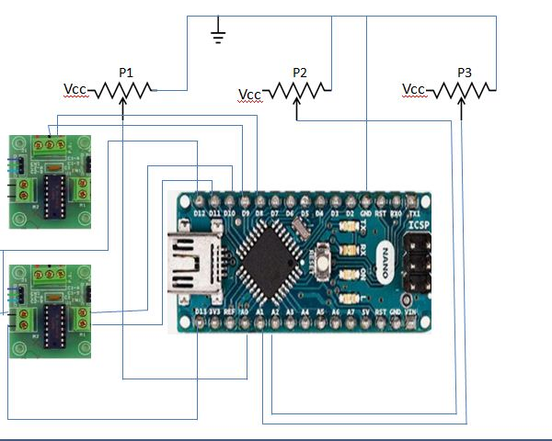

Motor

3

Motor

1 & 2

(FIGURE 2)

**CIRCUIT DIAGRAM ARDUINO ARM CONTROLLING ROBOT**

**REQUIREMENTS**

**Hardware Requirements:**

* DC Motor(3)
* Motor drivers(3)
* Potentiometer(3)
* Robotic arm assembly(1 set)
* Battery for DC supply(3)
* USB cable for programming(3)
* Arduino Nano board
* Nuts,bolts,etc

**Software Requirements:**

* Arduino

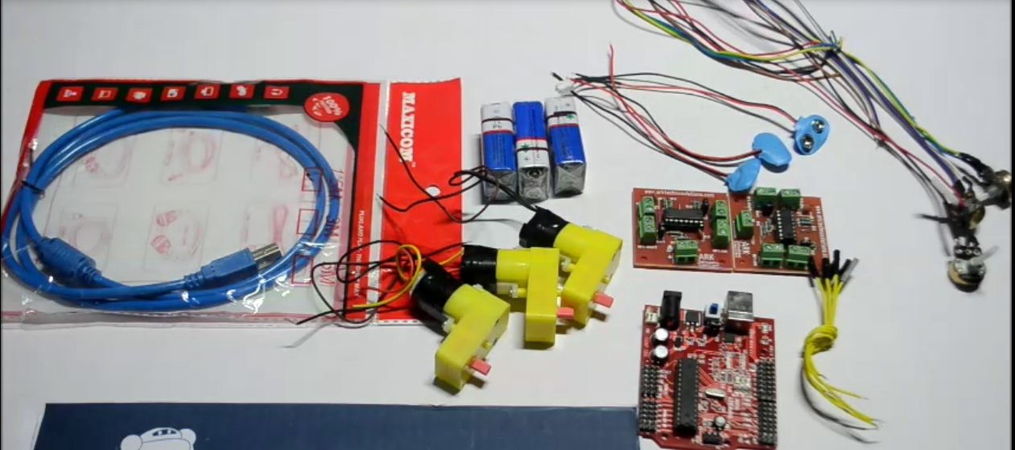

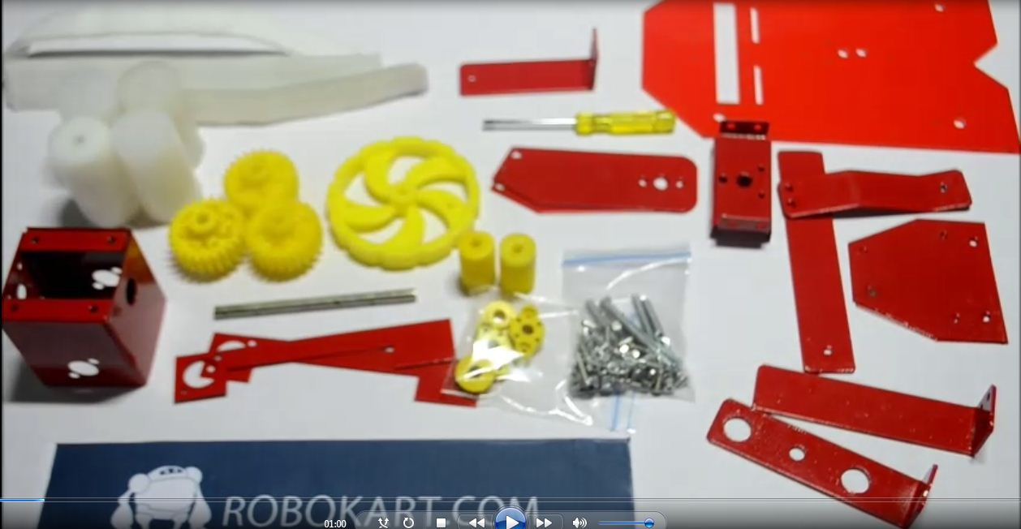

(FIGURE 3)

**HARDWARE PART**

**HARDWARE DESCRIPTION**

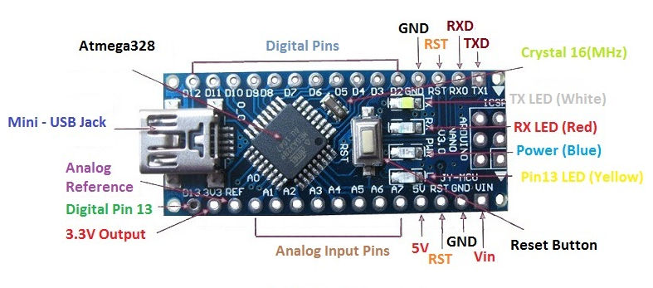(FIGURE 4)

**ARDUINO**

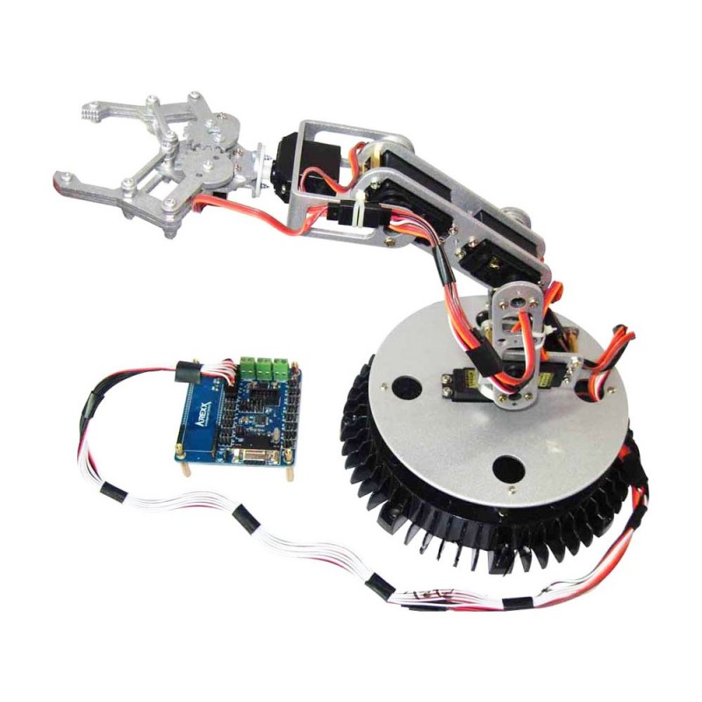

(FIGURE 5)

**ARDUINO ARM CONTROLLING ROBOT**

|  |  |  |
| --- | --- | --- |
| PIN NO. | TYPE | FUNCTION |
| A0 | Input | Analog Input Channel 0 |
| A1 | Input | Analog Input Channel 1 |
| A2 | Input | Analog Input Channel 2 |
| A3 | Input | Analog Input Channel 3 |
| A4 | Input | Analog Input Channel 4 |
| A5 | Input | Analog Input Channel 5 |
| A6 | Input | Analog Input Channel 6 |
| A7 | Input | Analog Input Channel 7 |
| D0/RX | I/O | Digital I/O Pin, Serial RX Pin |
| D1/TX | I/O | Digital I/O Pin, Serial TX Pin |
| D2 | I/O | Digital I/O pin |
| D3 | I/O | Digital I/O pin |
| D4 | I/O | Digital I/O pin |
| D5 | I/O | Digital I/O pin |
| D6 | I/O | Digital I/O pin |
| D7 | I/O | Digital I/O pin |
| D8 | I/O | Digital I/O pin |
| D9 | I/O | Digital I/O pin |
| D10 | I/O | Digital I/O pin |
| D11 | I/O | Digital I/O pin |
| D12 | I/O | Digital I/O pin |
| D13 | I/O | Digital I/O pin |
| RESET | Input | Reset(Active Low) |
| GND | Power | Supply ground |
| Vin | Power | Supply Voltage |
| +5V | I/P or O/P | +5V Output (From On-board Regulator) or +5V (Input from External Power Supply |
| MISO | I/P or O/P | Master In Slave Out |
| Vcc | Output | Supply Voltage |
| SCK | Output | Clock From Master To Slave |
| MOSI | I/P or O/P | Master Out Slave In |

**PROGRAMMING:**

The Arduino Uno can be programmed with the (Arduino Software (IDE)).The ATmega328 on the Arduino Uno comes preprogrammed with a bootloader that allows you to upload new code to it without the use of an external hardware programmer. It communicates using the original STK500 protocol.

**POWER:**

The Arduino Uno board can be powered via the USB connection or with an external power supply. The power source is selected automatically. External (non-USB) power can come either from an AC-to-DC adapter (wallwart) or battery. The adapter can be connected by plugging a 2.1mm center-positive plug into the board's power jack. Leads from a battery can be inserted in the GND and Vin pin headers of the POWER connector.

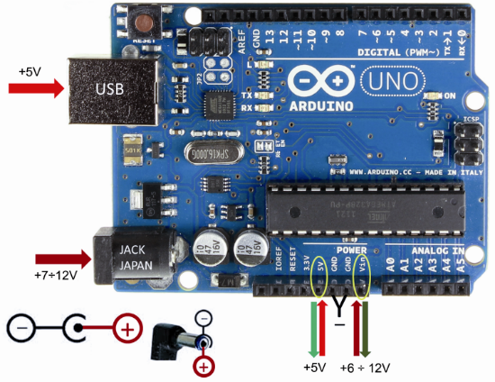

(FIGURE 6)

**ARDUINO UNO**

**MECHANICAL DESIGN**

The mechanical design of the robot arm is based on a robot manipulator with similar functions to a human arm . The links of such a manipulator are connected by joints allowing rotational motion and thelinks of the manipulator is considered to form a kinematic chain. The business end of the kinematic chain of the manipulator is called the end effector or end of arm tooling and it is analogous to the human hand. Following figure shows the Free Body Diagram for mechanical design of the robotic arm.

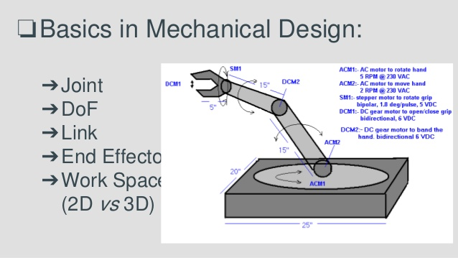

(FIGURE 7)

**MECHANICAL DESIGN OF ARM CONTROLLING ROBOT**

**STEPS OF ACTION**

1. The hardware of robotic arm was assembled.
2. The arm was coded for movements by the finger, wrist and forearm.
3. The code was verified and uploaded on the arduino nano board.
4. The movements in the hand assembly made the robot to move.
5. Further the robot was to be run by scilab software for which Scilab 5.4.1 version was downloaded.
6. Loader file of arduino was downloaded and run on scilab. A message of “Arduino Start” appears on the console screen.
7. After this, arduino library gets added in Xcos of Scilab.
8. Block Diagram is made and run on Xcos using the arduino library.
9. The robotic arm shows the movements when the Xcos block diagram is run.

**CONNECTIONS**

* The analog pins A0, A1 and A2 of arduino board are connected to the centre pin of potentiometer 1,3 and 2 respectively.
* The other two ends of potentiometers 1, 2 & 3 are connected to the Vin & GND terminals of the arduino board.
* The digital pins D8 and D9 of arduino board are connected to the LED & +5V terminals of the 3rd motor driver.
* The digital pins D10 and D11 of arduino board are connected to the LED & +5V terminals of the 1st and 2nd motor drivers.
* The digital pins D12 and D13 of arduino board are connected to the LED & +12V terminals of the 1st and 2nd motor drivers.
* Battery clips are connected to the inputs of both the motor drivers.

**ARDUINO CODE**

digitalWrite(8, HIGH);

digitalWrite(9, LOW);

delay(1500);

}

if (p1 < l1)

{

Serial.println(p1);

x1 = p1;

digitalWrite(9, HIGH);

digitalWrite(8, LOW);

delay(1500);

}

if (p1 < h1 || p1 > l1)

{

Serial.println(p1);

x1 = p1;

digitalWrite(8, LOW);

digitalWrite(9, LOW);

delay(1500);

}

if (p2 > h2)

{

Serial.println(p2);

x2 = p2;

digitalWrite(10, HIGH);

digitalWrite(11, LOW);

delay(1500);

}

if (p2 < l2)

{

Serial.println(p2);

x2 = p2;

digitalWrite(11, HIGH);

digitalWrite(10, LOW);

delay(1500);

}

if (p2 < h2 || p2 > l2)

{

Serial.println(p2);

x2 = p2;

digitalWrite(10, LOW);

digitalWrite(11, LOW);

delay(1500);

}

if (p3 > h3)

{

Serial.println(p3);

x3 = p3;

digitalWrite(12, HIGH);

digitalWrite(13, LOW);

delay(1500);

}

int count = 0;

if (p3 < l3)

{

Serial.println(p3);

x3 = p3;

digitalWrite(13, HIGH);

digitalWrite(12, LOW);

delay(1500);

}

if (p3 < h3 || p3 > l3)

{

Serial.println(p3);

x3 = p3;

digitalWrite(12, LOW);

digitalWrite(13, LOW);

delay(1500);

}

}

int x1, x2, x3;

void setup()

{

Serial.begin(9600);

pinMode(A0, INPUT);

pinMode(A1, INPUT);

pinMode(A1, INPUT);

pinMode(8, OUTPUT);

pinMode(9, OUTPUT);

pinMode(10, OUTPUT);

pinMode(11, OUTPUT);

pinMode(12, OUTPUT);

pinMode(13, OUTPUT);

digitalWrite(5, HIGH);

digitalWrite(6, HIGH);

digitalWrite(7, HIGH);

digitalWrite(2, LOW);

digitalWrite(3, LOW);

digitalWrite(4, LOW);

}

void loop()

{

int p1 = analogRead(A0);

int p2 = analogRead(A1);

int p3 = analogRead(A2);

count = count + 1;

if (count == 1)

{

int x1 = p1;

int x2 = p2;

int x3 = p3;

}

int h1 = (x1 + 5);

int l1 = (x1 - 5);

int h2 = (x2 + 5);

int l2 = (x2 - 5);

int h3 = (x3 + 5);

int l3 = (x3 - 5);

if (p1 > h1)

{

Serial.println(p1);

x1 = p1;

**DETAILS OF SOFTWARE USED**

**Arduino**

**Arduino** is an [open-source hardware](https://en.wikipedia.org/wiki/Open-source_hardware) and [software](https://en.wikipedia.org/wiki/Open-source_software) company, project and user community that designs and manufactures [single-board microcontrollers](https://en.wikipedia.org/wiki/Single-board_microcontroller) and [microcontroller](https://en.wikipedia.org/wiki/Microcontroller) kits for building digital devices and interactive objects that can sense and control objects in the physical and digital world.

Arduino board designs use a variety of microprocessors and controllers. The boards are equipped with sets of digital and analog [input/output](https://en.wikipedia.org/wiki/Input/output) (I/O) pins that may be interfaced to various expansion boards or [breadboards](https://en.wikipedia.org/wiki/Breadboards) (*shields*) and other circuits.

The boards feature serial communications interfaces, including [Universal Serial Bus](https://en.wikipedia.org/wiki/Universal_Serial_Bus) (USB) on some models, which are also used for loading programs from personal computers. The microcontrollers are typically programmed using a dialect of features from the programming languages [C](https://en.wikipedia.org/wiki/C_(programming_language)) and [C++](https://en.wikipedia.org/wiki/C%2B%2B).

In addition to using traditional [compiler](https://en.wikipedia.org/wiki/Compiler) [toolchains](https://en.wikipedia.org/wiki/Toolchains), the Arduino project provides an [integrated development environment](https://en.wikipedia.org/wiki/Integrated_development_environment) (IDE) based on the [Processing](https://en.wikipedia.org/wiki/Processing_(programming_language)) language project.

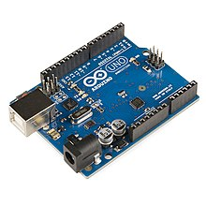

(FIGURE 8)

**ARDUINO UNO**

**LESSONS LEARNT**

1) The working of the program in Arduino.

2) Intermediate knowledge of Arduino software.

3) Team work

**PROBLEMS FACED**

**Problem:** We had a little issue with sensitivity. (Sensitivity is very low)

**Solution**: By understanding this problem, we will increase the sensitivity.

**CONCLUSION**

This project gave us an idea as to how the Arduino program is converted into scilab and implemented. It makes us know as to how the program should be tested and also how to rectify the faults in them.

The main focus of this work was to design, and programme robotic arm the robot arm was designed with five degrees of freedom and talented to accomplish accurately simple tasks, such as light material handling the robot arm is equipped with several servo 40 motors which do links between arms and perform arm movements. A microcontroller that drives the servo motors with the capability of modifying position.

We learnt software which were required to make this project work: Arduino required for making program.

As a result, after all the trial and error, we have successfully completed our sem 5 Mini project.

**REFERENCES**

[1] C. F. Olson, Lab. JP, Technol. CIo, Pasadena, ―Probabilistic self-localization for mobile robots‖; IEEE Transactions on Robotics and Automation 16,1, 55-66, 2000.

[2] R.B. Gillespie, J. E. Colgate, M. A. Peshkin, ―A general framework for robot control‖; IEEE Transactions on Robotics and Automation, 17,4, 391-401, 2001.

[7]. Six-servo Robot Arm‖ from www.arexx.com.cn

[8]. Robotic Arm‖ - www. NASA explores. com

[9]. Robot software‖ from Wikipedia, the free encyclopedia

[10]. ATMEL – short notes‖, [www.atmel.com](http://www.atmel.com)

[11]. Arduino MCU‖, - [www.arduino.com](http://www.arduino.com)

[12]. Servomotors & system design components‖, - www.bhashaelectronics. Com

[13]. Robert J. Shilling "Fundamentals of robotics analysis and control ".

[14]. GORDON McCOMB" The robot builders' bonanza ".

[15]. www.wikipedia.com/robotic.

**PROJECT EXPENDITURE**

|  |  |  |  |
| --- | --- | --- | --- |
| SR.NO. | PARTICULARS | QUANTITY | AMOUNT |
| 1 | Arduino Nano | 1 | 450 |
| 2 | Potentiometer | 3 | 30 |
| 3 | 9V Battery | 2 | 20 |
| 4 | Battery clip | 2 | 10 |
| 5 | Arduino cable | 1 | 50 |
| 6 | Motors | 3 | 180 |
| 7 | Motor driver | 2 | 370 |
| 8 | Robotic arm assembly parts | 1 set | 170 |
|  |  | TOTAL | 1280 |