Assignment – 10

Joining a Table to Itself.

1. Write a query that produces all pairs of salespeople who are living in the same city. Exclude combinations of salespeople with themselves as well as duplicate rows with the order reversed.

mysql> SELECT s1.Sname AS Salesperson1, s2.Sname AS Salesperson2, s1.City

-> FROM salespeople s1

-> JOIN salespeople s2 ON s1.City = s2.City AND s1.Snum < s2.Snum;

+--------------+--------------+--------+

| Salesperson1 | Salesperson2 | City |

+--------------+--------------+--------+

| Peel | Motika | London |

+--------------+--------------+--------+

1 row in set (0.00 sec)

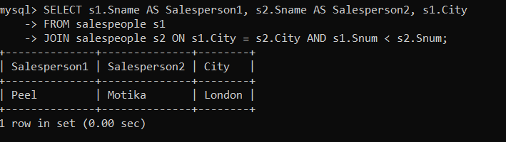

1. Write a query that produces the names and cities of all customers with the same rating as Hoffman.

mysql> select Cname, City

-> from customers

-> where Rating = (select Rating from customers where Cname ='Hoffman');

+---------+--------+

| Cname | City |

+---------+--------+

| Hoffman | London |

| Clemens | London |

| Pereria | Rome |

+---------+--------+

3 rows in set (0.01 sec)

