Assignment –4

Retrieving Information from Tables

Q. 1. Write a select command that produces the order number, amount, and date for all rows in the Orders table.

Answer = mysql> select Onum ,Amt , Upper(DATE_Format(Odate, '%d-%b-%Y' )) as Odate from orders;

+------+---------+-------------+

| Onum | Amt | Odate |

+------+---------+-------------+

| 3001 | 18.69 | 03-OCT-1990 |

| 3003 | 767.19 | 03-OCT-1990 |

| 3002 | 1900.10 | 03-OCT-1990 |

| 3005 | 5160.45 | 03-OCT-1990 |

| 3006 | 1098.16 | 03-OCT-1990 |

| 3009 | 1713.23 | 04-OCT-1990 |

| 3007 | 75.75 | 04-OCT-1990 |

| 3008 | 4723.00 | 05-OCT-1990 |

| 3010 | 1309.95 | 06-OCT-1990 |

| 3011 | 9891.88 | 06-OCT-1990 |

+------+---------+-------------+

10 rows in set (0.01 sec)

2) Write a query that produces all rows from the Customers table for which the salesperson’s number is 1001.

mysql> select * from salespeople

-> where Snum = 1001;

+------+-------+--------+------+

| Snum | Sname | City | Comm |

+------+-------+--------+------+

| 1001 | Peel | London | 0.12 |

+------+-------+--------+------+

1 row in set (0.00 sec)

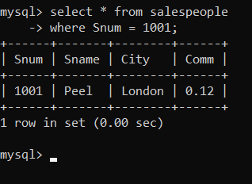

3) Write a query that displays the Salespeople table with the columns in the following order: city, sname, snum, comm.

mysql> select City,Sname,Snum,Comm from salespeople;

+-----------+---------+------+------+

| City | Sname | Snum | Comm |

+-----------+---------+------+------+

| London | Peel | 1001 | 0.12 |

| San Jose | Serres | 1002 | 0.13 |

| London | Motika | 1004 | 0.11 |

| Barcelona | Rifkin | 1007 | 0.15 |

| New York | Axelrod | 1003 | 0.10 |

+-----------+---------+------+------+

5 rows in set (0.00 sec)

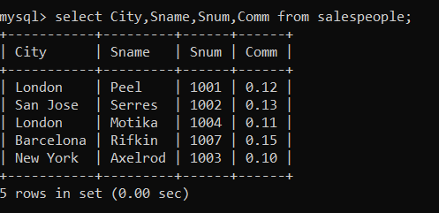

4) Write a select command that produces the rating followed by the name of each customer in San Jose.

mysql> select Rating,Cname from customers

-> where City = 'San Jose';

+--------+----------+

| Rating | Cname |

+--------+----------+

| 200 | Liu |

| 300 | Cisneros |

+--------+----------+

2 rows in set (0.00 sec)

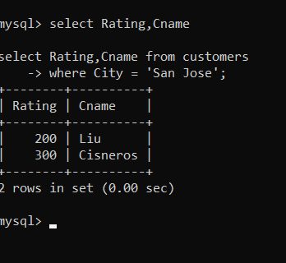

5) Write a query that will produce the snum values of all salespeople (suppress the duplicates) with orders in the Orders table.

mysql> select distinct Snum from orders;

+------+

| Snum |

+------+

| 1007 |

| 1001 |

| 1004 |

| 1002 |

| 1003 |

+------+

5 rows in set (0.00 sec)

